Developing relationships and workplace achievement
BMSW5102

Student name: Ioan Francisc Tamas
Student number: 1919182
Lectures name: Sujeewa Herath

Executive Summary
Building the relationship in the workplace helps the employees to perform well in the combined work. The training and program have helped the employees to motivate themselves so that they can show their interest in their work. It also helps them to gain knowledge about various subjects. Barclays offer some training programs to train their employees so that they can handle the individual work properly. The reward scheme of Barclays gives a huge benefit to the employees. It helps to improve the organizational performance so that the organization can provide better service to the customers.

Table of Contents
Introduction 3
Component 1 3
1. Critically discuss the different motivation factors that organizations should use to develop employees for the future and evaluate the Role and the Importance of Employee Motivation in Performance Enhancement using your chosen organization. 3
2. Critically evaluate the importance of training and development in the chosen organization and how it supports employee satisfaction and business performance 6
3. Critically evaluate how reward makes an impact on organizational performance using your chosen organization. 7
Component 2 9
1. Generate a detailed plan (Personal Development Plan: PDP) to meet the identified development needs of an individual working in your chosen organization 9
Conclusion 12
References 13

Introduction
Developing relationships in the workplace is important as it helps the employees to perform well in the combined projects. It is important to have teammates who can respect each other so that they can be motivated while executing their work (Sanchez and Terlizzi, 2017). It is important to access the potential benefits of the organization so that the employees can improve themselves in their personal development. In this report, the researcher is going to discuss the different motivation factors so that the company can develop their employees for the future. Barclays is selected for analyzing the requirements of this report. The importance of training and development of Barclays is also going to discuss in the report. The researcher is going to discuss that how the training program supports employee satisfaction and business performance. A discussion of reward in the organizational performance is going to be included in the report. The researcher is going to discuss that how these reward facilities are creating an impact on organizational performance. A Person development plan is going to be implemented in this report so that the researcher can meet the identified needs of individual working.

Component 1

1. Critically discuss the different motivation factors that organizations should use to develop employees for the future and evaluate the Role and the Importance of Employee Motivation in Performance Enhancement using your chosen organization.
Motivation is a very important source of encouragement in the persons so that they are able to give their best to reach certain goals of the organization that enhances their overall performance. Motivation in a positive way has the potential to increase the efficiency of the employees. It helps them with their overall personal development. Motivation increases the willingness of the employees to work with their maximum energy towards the welfare of the organization and achieve the goals productively (Your Article Library, 2015). However, there are various motivation factors that help Barclays to develop their employees for the future that including the
Herzberg’s Two Factor Theory of Motivation
Herzberg led the two-factor theory of motivation to explain the concept of the factors required for influencing the motivation at workplace. According to this theory of motivation, the two factors include motivators and hygiene factors. This theory was considered to get to the roots of motivation at the workplace. The motivator factor is very effective in encouraging the employees to work harder whereas the hygiene factor is considered to instill maximum job satisfaction among the employees. The motivator factors include the achievement of the employees, their recognition, their work, their responsibilities, and their growth. The hygiene factors include the policies of the company, their work conditions, the remuneration, salary, and security of the employees. According to this theory, each of these factors is very essential for the motivation of the employees. Barclays effectively use this theory of motivation in its company that makes their employees more motivated and satisfied and there are very fewer grievances in the minds of the employees (Expert Program Management, 2018).
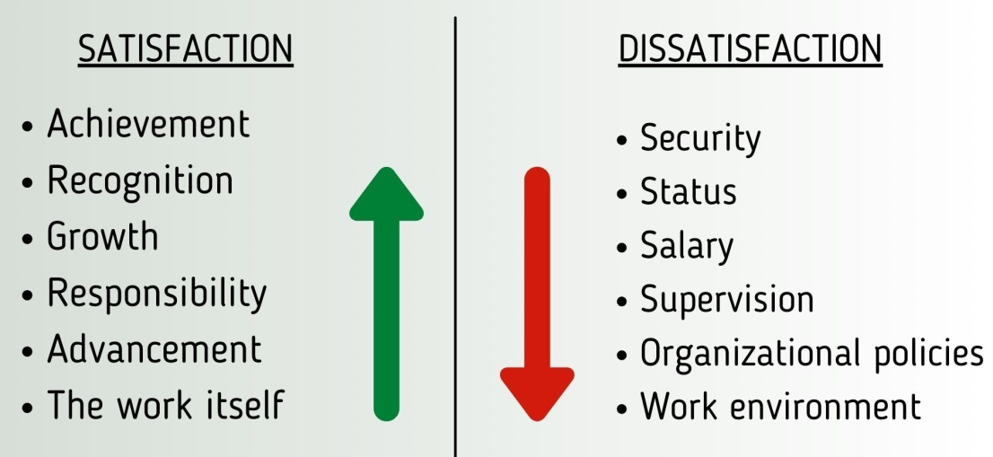
Figure 1: Herzberg’s Two factor theory
(Source: Expert Program Management, 2018)
Maslow’s hierarchy theory
According to McLeod et al. (2020), this theory was led forward by Maslow to highlight the need for satisfying the lower level of needs first before focusing on the higher-level needs first. Organizations should continuously focus on fulfilling the needs of the employees so that they are totally satisfied. When these needs of the employees are met, the motivation of the employees increases respectively. This theory helps Barclays to increase the engagement of the employees significantly. This theory instills a sense of actualization, esteem, belonging, and safety amongst the employees of Barclays. Therefore, this theory helps Barclays for the overall development of their employees.
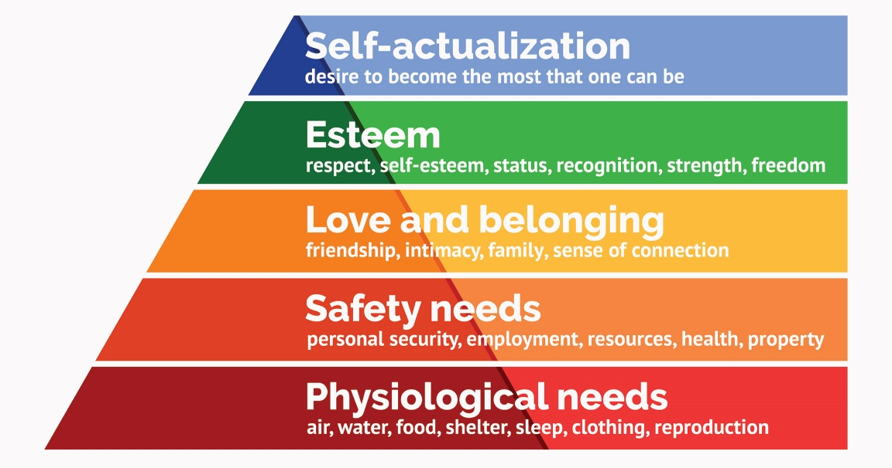
Figure 2: Maslow’s theory of Motivation
(Source: McLeod et al. 2020)
Importance of Employee Motivation in Performance Enhancement using your chosen organization
Motivation is the key to keeping the employees driven and happy. It is a very important factor to attract and retain employees in the organization (BBC, 2021). Having a motivated workforce improves the overall relationship between the management and workforce of the employees that increases the productivity and profitability of the company. The Motivation factors have also promoted numerous advantages to the Barclays that include:
Increased Employee Commitment
Motivations help the Employees to apply their maximum efforts in the task assigned to them on daily basis. They are more committed to their task goals, and they carry forward the work with great passion that improves their output of work (Inside 6Q, 2016).
Increased Employee Satisfaction
Motivation instills a sense of positivity amongst the employees that lead to their growth and also promotes better growth for Barclays as a whole (Inside 6Q, 2016).
Employee Development
Motivation helps the employees of Barclays to reach their goals very effectively that help them in the process of self-development. Once they feel motivated, they attain equilibrium between their efforts and their results. They are then successful at giving quality work to Barclays (Inside 6Q, 2016).
Improved Employee Efficiency
Motivation helps the employees to maintain a good balance between the employees’ ability to work and their willingness to work. This balance helps the Employees of Barclays to improve their work potential and increase their efficiency (Inside 6Q, 2016).

2. Critically evaluate the importance of training and development in the chosen organization and how it supports employee satisfaction and business performance
The training and development provide many benefits. It helps to boost employee productivity, reduce employee turnover, and improve company culture and so on. Training gives every employee a great understanding of his or her responsibilities. It is an integral part of the whole management program with all the activities functionally inters related (mmantc.in, 2021). The training and development methods are important for an organization as it helps to take the benefits of improvements, changes, and techniques. It also helps the employees to make the best use of the overall worth of employees to the organization. Barclays build competencies that help the young generation to achieve success in the future.
Barclays also bring excitement into the learning so that the employees can gain experience to handle all the situations. Barclays has aimed in improving the employability skills of the youth through Rubicon’s “Connect with work” training program. This program is going to train the students by the corporate trainers to enhance their life skills. It can help them to significantly increase their chance by succeeding in their job interview (home.barclays., 2021). The training that is provided by Barclays is interactive. It is seen that many employees have given proper reviews about the training program. They have also stated that the program has helped to build their careers and made them more confident to face the challenges.
These kinds of training take a minimum time of 12 weeks where Barclays can identify their capabilities. It helps the organization to match the talent of the employees according to their specific job role requirements. Barclays believe that engaged culture in the workplace is important where every employee should be recognized properly (livemint.com, 2020). Therefore, the management always tries to build programs where the employees can understand the importance of engaged culture. Rubicon’s connect with work training program has collaborated with several universities. This has helped the organization to share its knowledge about financial business with the students. The Rubicon training program has also helped Barclays to hire new employees from the universities. Barclays has also offered several attractive and comprehensive programs to their employees for supporting their professional life journey. The training has also helped their employees to increase their potential.
The training programs are also made by depending on the five global diversity agendas. It helps to support those candidates in their life and work through their well-being activities (Jurado-Caraballo et al. 2020). Barclays is also having Discovery Employability programs to tackle the unemployment of young people. People who want to find long-term employment can apply for this training program. The charity partner of Barclays can make sure that the candidates can take full part in the program from home. This is the reason for which Barclays has allowed the employees to take their online programs from their homes. Barclays also provide training to newcomers to the company (Newton and Barnes, 2020). They provide a training period to the employees so that they can learn about their job roles. The organization also gives a great opportunity to be a part of their learning and development support. It can help the fresher to gain experience [Appendix 1].

3. Critically evaluate how reward makes an impact on organizational performance using your chosen organization.
The reward system refers to the psychological, non-monetary and monetary payments. Companies provide reward facilities to the employees in exchange for the work they perform. The schemes lead to high-level motivation and staff job satisfaction to influence the overall performance of the company. It helps to increase the job satisfaction of the strong performers and acts as an incentive for the low performers (biospace.com, 2018). People who receive immediate rewards for completing the small tasks give more interest and enjoyment to the work. The reward skills can also help to attract and retain highly skilled workers. The systems also help to promote equity and fairness to the employees so that they can help the company to achieve success. The reward schemes help to support the goals of the organization by aligning the goals of employees. It also helps the company to align with the legal regulations. Another purpose of reward schemes is to align the risk preferences of the managers and employees in the organization. The performance of every employee is an important discussion for the human resource department. The workers can become reluctant to put their best at the job sites despite the longevity and qualification of service (accaglobal.com, 2021).
Several workers within the boundaries of their job specifications do not put additional effort into driving the organizational goals. It takes away the creativity of the employees and limits improvement and innovation. Barclays offer a reward package so that the employees can fulfil their requirements (home.barclays., 2021). The organization adds benefits such as private healthcare, share plans, childcare scheme and so on. These rewards are added with the competitive salary, discretionary annual bonus and retirement or pension funds. The reward schemes, which are offered to the employee of Barclays, are mentioned below.
Health reward in Barclays
The well of employees is an important factor to Barclays. The bank offers a range of well-being and health benefits to the employees. The reward scheme of Barclays includes discount rates at the gym, health screening, and employee assistance programs and so on. Proper eligibility for this benefit is dependent on the serving area and job location of the employees.
Holidays
Barclays offer a competitive holiday allowance to the employees depending on their organizational performance. It is also available for those employees who are working in the company for a long period.
Share plans
The employees of Barclays can participate in the success of the company by buying shares. The firm gives up to $600 worth after matching the shares (tractorsinfo.com, 2021). The Share slave plan of Barclays in the United Kingdom gives a discount of 20% to the employees for purchasing the shares.
Discounts
The colleagues of Barclays can enjoy discounts on a various range of services and products. The employees get to benefit from the theatre tickets, care facilities and so on. The employees can also get access to the services of Barclays depending on the preferential terms. The new bonus structure of Barclays has affected more employees in the business banking decision and UK retail. The bank has started this initiative so that their employee can give their best to execute work. Barclays want their employees to be more productive so that they can establish their position in the banking industry (Mansaray, 2020). Several candidates try to join Barclays for their reward facilities. The incentive facilities of the employees in Barclays are based on their customer satisfaction.

Component 2

1. Generate a detailed plan (Personal Development Plan: PDP) to meet the identified development needs of an individual working in your chosen organization
The development plan is needed to address the future needs of the organization. They are important to analyze the growth of the employees personally and ensure development in their ability to achieve maximum work output so that they can achieve the goals of the organization successfully. The development plan reduces the overall cost of the recruitment and training of the employees (Investors In People, 2019). The steps carried forward by Barclays that is necessary for the development of the employees include
Step 1 Establishment of personal and career development plan
This step helps in the encouragement of the employees to think universally and look forward to different perspectives of their development. The work goals provided to the employees can be goal-oriented related to public speaking, skill-oriented and relationship-oriented. It’s important for Barclays to consider this step as part of their daily work routine (Investors In People, 2019).
Step 2 Establishment of work development needs
This step ensures that the development plan led forward by Barclays is in accordance with the organizational goals.
Step 3 Development of action plan
After the establishment of work development needs, the company needs to develop an action plan that is based on the fact that 70 percent of the learnings come from the job experiences gained from the other companies and the remaining 10 percent of the learnings come from the qualification or training.
Step 4 Changing the path of the development
After the action plan, the employees of the company need to implement a few changes in work that can be a little bit difficult task for them, as they are required to make changes to an already established system. For this step, the employee needs the directions of the managers (Investors In People, 2019).
Step 5 Reflection of the efficacy of the plan
Both managers and employees need to check what went well and they need to check whether any specifications are required in the development program led forward by Barclays.

Strengths | Weakness
-Persistent -Punctual  -Devoted -Hardworking  -Responsible -Optimist  -Honest -Problem solving | -Leak of discipline  -Poor English level  -Poor communication skills  -Poor social skills
Opportunity | Threat
-Self improvement  -Life quality grow  -Educational  -Inner happiness | -Communication difficulties in Work,  Business and Social  -Developing unhealthy behaviors  -Leak of happiness
Action Plan
Attending English classes to improve communication skills
Attending self-improvement seminars, and developing healthy behavers like healthier diet and life stile
These actions have to be realized by December 2022

Conclusion

This study has highlighted the importance of developing relationships in the workplace in maintaining the productivity of the overall workforce. This study has evaluated different motivation theories adapted by Barclays to effectively increase the motivation of the employees in the organization and the role and importance of these factors in the enhancement of the employee’s performance. This study also evaluated the importance of the training and development in Barclays and its support in the satisfaction of the employees and overall performance of the company. Furthermore, this study has explained the impact of reward on the performance of the employees. Moreover, this study has generated a detailed plan to meet the identified development needs of an individual working in your chosen organization.

References

accaglobal.com, 2021. Reward schemes | P5 Advanced Performance Management | ACCA Qualification | Students | ACCA | ACCA Global, Accaglobal.com. Available at: <https://www.accaglobal.com/lk/en/student/exam-support-resources/professional-exams-study-resources/p5/technical-articles/reward-schemes-for-employees-and-management.html> [Accessed 13 November 2021].
Bbc. Co. uk. Motivation. Available at: < https://www.bbc.co.uk/bitesize/guides/zdn992p/revision/1> [Accessed November 12 2021].

biospace.com., 2018. New Research Suggests Frequent Rewards Can Improve Motivation, Performance at Work. Available at <https://www.biospace.com/article/new-research-suggests-frequent-rewards-can-improve-motivation-performance-at-work> [Accessed 13 November 2021].
Expertprogrammemanagement. Com. 2018. Herzberg’s Motivation Theory – Two Factor Theory. Available at: < https://expertprogrammanagement.com/2018/04/herzbergs-two-factor-theory/> [Accessed November 12 2021].

home.barclays., 2021. Why work for Barclays? | Barclays. Available at <https://home.barclays/careers/working-at-barclays> [Accessed 13 November 2021].
home.barclays., 2021. Why work for Barclays?. Available at <https://home.barclays/careers/working-at-barclays> [Accessed 12 November 2021].
Inside. 6q. io. 2016. Why Employee Motivation Is Important (& How to Improve It). Available at: < https://inside.6q.io/employee-motivation-important/> [Accessed November 12 2021].
Investorsinpeople. Com. 2019. Employee development plan – everything you need to know. Available at: < https://www.investorsinpeople.com/knowledge/employee-development-plan/> [Accessed November 12 2021].
Jurado-Caraballo, M.Á., Quintana-García, C. and Rodríguez-Fernández, M., 2020. Trends and opportunities in research on disability and work: An interdisciplinary perspective. BRQ Business Research Quarterly, p.2340944420972715.
livemint.com., 2020. Barclays addresses skills gap through Connect with Work programme, mint. Available at <https://www.livemint.com/brand-stories/barclays-addresses-skills-gap-through-connect-with-work-programme-11582974270042.html> [Accessed 12 November 2021].
Mansaray, H., 2020. Organizational Strategies and Performance in the Banking Industry Focused on the Transnational Banks in Sierra Leone: An Ex Post Facto Study. Budapest International Research and Critics Institute-Journal (BIRCI-Journal), pp.3185-3196.
Mcleod, S, 2020. Maslow's Hierarchy of Needs. Available at: < https://www.simplypsychology.org/maslow.html> [Accessed November 12 2021].
mmantc.in., 2021. Rubicon's "Connect With Work" program by Barclays. Available at <https://www.mmantc.in/event/rubicons-connect-work-program-barclays> [Accessed 12 November 2021].
Newton, L. and Barnes, V., 2020. Women, uniforms and brand identity in Barclays bank. Business History.
Sanchez, O.P. and Terlizzi, M.A., 2017. Cost and time project management success factors for information systems development projects. International Journal of Project Management, 35(8), pp.1608-1626.

tractorsinfo.com., 2021. Barclays Employee Benefits and Perks 2021. Available at <https://tractorsinfo.com/barclays-employee-benefits> [Accessed: 13 November 2021].
Yourarticlelibrary. Com. 2015. Motivation: Meaning, Definition, Nature and Types. Available at: < https://www.yourarticlelibrary.com/entrepreneurship/motivation-entrepreneurship/motivation-meaning-definition-nature-and-types/53285> [Accessed November 12 2021].

Appendix


