LCLM4002_BIRM Digital Skills Task 3
Website Evaluation

Student Number |  | Student Name
Website Chosen
Insert hyperlink to website
Evaluation
Respond to each question
Section 1 – Usability

(75 words maximum for each answer)
Question 1a - How quickly and easily does the website load?

Answer: The website loads quickly. Images appear without delay giving a smooth browsing experience.

Question 1b - Does the website contain many sub-pages? How does a prospective customer navigate these?

Answer: Yes, there`s a couple subpages like Services, Gallery, FAQs, and Contact.

Question 1c - Can a customer make a booking via the webpage?

Answer: No, direct bookings aren't available. Customers need to fill out a contact form or call to request a quote.

Question 1d - What improvements could be made to the usability of the website?

Answer: Adding an online booking tool or instant quote calculator would improve the site.

Section 2 – Pleasure – Customer Experience

(75 words maximum for each answer)
Question 2a – How pleasant does the webpage look? Are there any differences in appearance on a mobile phone versus a computer?

Answer: The website looks modern. It works well on both desktop and mobile, but text feels smaller on smaller screens.

Question 2b - How does the website use imagery, video and colour?

Answer: It uses high quality images especially in the Gallery. There are no videos, and colours are mostly black, white, and grey to keep it basic and simple.

Question 2c – Has the website made use of an online chat tool on the website? How effective is this to enquire about the product or service?

Answer: No the chat tool is not included. Users must use a form, phone, or email, which could slow down communication.

Question 2d – How effective are the social media links on the website?

Answer: Social media icons are available at the bottom of the site. They work well.

Section 3 – Perceived Value

(75 words maximum for each answer)
Question 3a - How are the services offered by the company made clear to customers?

Answer: The homepage and Services section clearly explains what they do, mainly vehicle wrapping. The FAQ and quote request page offer more detail.

Question 3b - How are customer reviews made available? Are these up to date?

Answer: Reviews appear on the homepage and Gallery section. They seem positive but don’t show dates so therefore might not be up to date.

Question 3c – How is the service presented as high quality? For what reasons would you use the company’s service or recommend to a friend or family member?

Answer: They highlight quality vinyl, great attention to detail, and good customer care. Photos and reviews prove a professional service.

Question 3d - Are prices made clear to customers? If yes, do the prices reflect the quality of service shown? If no, why do you think the company has chosen not to include prices?

Answer: No the prices are not shown. The prices are not fixed but quote based depending on the job.

Section 4 – Searchability

Question 4a - What three words would you type into Google to find this type of service? |  |  | 1. Car wrapping
 |  |  | 2. Vinyl wrap Birmingham
 |  |  | 3. Vehicle styling
Question 4b - When you type these words into google, does the company’s website appear in the top ten websites?

Answer: 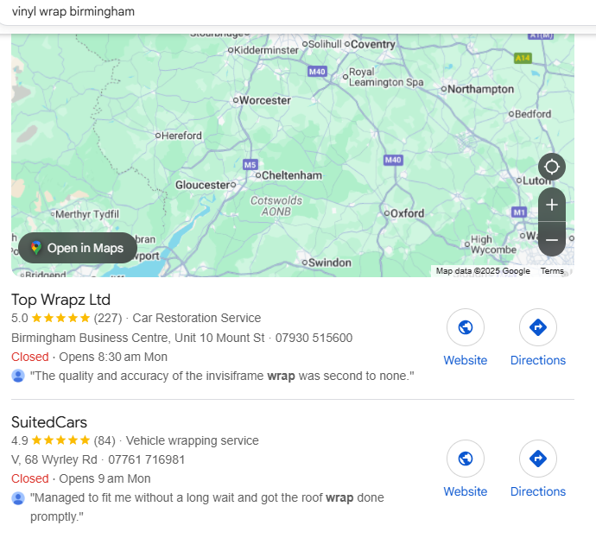yes the website comes up when I type in Vinyl wrap Birmingham.

Section 5 – Reflection and conclusion

(120 words maximum for each answer)
Question 5a - Do you feel that websites still have relevance in modern UK business? Explain your answer.
Answer: Yes, websites are still useful. They let people find out what a business does and how to contact them. A website also helps the business look more trustworthy and professional.

Question 5b - If you were to make one recommendation about how to improve the website of your chosen company, what would it be? Why have you suggested this improvement?

Answer: Adding an easy booking or instant quote tool would help. It would make things quicker for customers and could bring in more business.

Reference List

