
LEVEL 7 ASSESSMENT SPECIFICATION
Submitted by:
Vijaybhai Ramabhai Goraniya
Rhif Myfyriwr / Student Number: 2612131

Programme: Master of Business Administration
Module: Human Capital Management
Module Code: LCMB7023
Contribution to Overall Module Assessment: 50%
Lecturer: Eno Maycock (Birmingham)
Assignment Title:
Assessment Component 1: Individual Report
Word Count: 2,500 (±10%)
Submission Deadline:
Week 6, Thursday 15th October 2026, by 2 PM

Table of Contents
Introduction 3
1. TASK A: Designing Innovative Working Practices 3
1.1 Critical Evaluation of Traditional and Contemporary Work Design 4
1.2 Recommended Innovative Working Practices for NHSX 6
2. TASK B: Breeding an Environment Where Talent May Grow 8
2.1 Critical Evaluation of Environments Where Talent Flourishes 8
2.2 Strategic Talent Growth Strategy for NHSX 10
3. TASK C: Reflective Report 12
3.1 Reflective Analysis of AI Use 12
3.2 Personal Capability Development Plan 13
References 14

Introduction
NexSpace Health Systems (NHSX) operates within a rapidly evolving digital healthcare environment, where organisational success increasingly depends on the effective integration of people, technology and innovative working practices. Its growth throughout the United Kingdom, India and the United Arab Emirates, as well as its investment in artificial intelligence (AI), have opened doors for innovation and posed a huge challenge to its workforce. Innovation can be supported by flexible working if it is given the right opportunities and coordination, whereas traditional hierarchical structures can limit decision making and employee involvement (Jiang et al., 2023). However, there is emerging evidence that uncoordinated hybrid working can have a negative impact on collaboration and innovative activity (Gibbs et al., 2024). NHSX will need to reimagine work and enhance employee development, wellbeing and retention.
This report critically assesses the current working practices and is used to establish a strategic talent environment for NHSX. Task A looks at agile, hybrid and flexible working, autonomy and collaboration of employees. Task B develops a talent growth strategy based on learning, psychological safety and employee development. Task C is a reflection on AI and professional skills and employability.

TASK A: Designing Innovative Working Practices
The necessity to make swift decisions and innovate has grown as NexSpace Health Systems (NHSX) expands globally and invests in AI, necessitating a redesign of working practices. While traditional work design offers control and responsibilities, too much hierarchy can impede employee involvement and response time. Autonomy, cooperation, flexibility and adaptability are all highlighted as key factors in contemporary approaches. What NHSX is not looking to do is to take away structure, but to mix in employee engagement and team decision-making.

1.1 Critical Evaluation of Traditional and Contemporary Work Design
Traditional work design is based on the principle of a hierarchy of authority and distinct roles, as well as centralised decision making. Consistency and accountability are important, as NHSX will need to take clinical quality, data protection and regulation into account, as these arrangements do. But too much managerial oversight can stifle the use of special knowledge and experimentation. This is an issue because NHSX is reliant on specialist digital expertise. The main differences between traditional and contemporary work design are summarised in Table 1.
Table 1: Comparison of Traditional and Contemporary Work Design
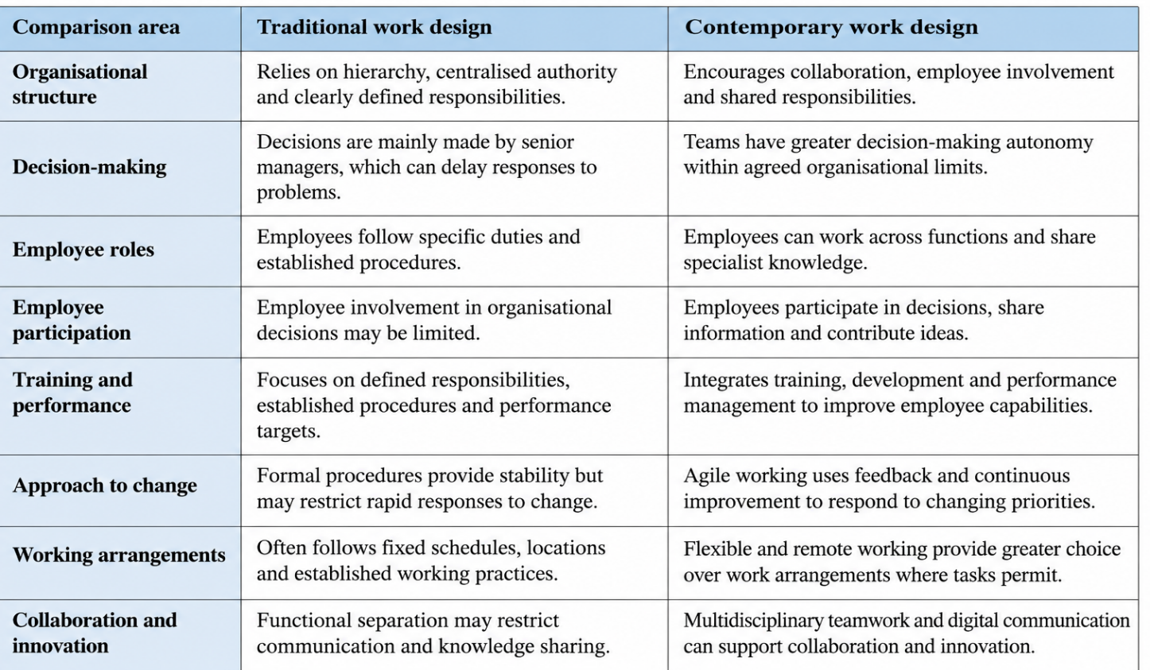
Source: Author’s own table, informed by Kaushik and Mukherjee (2022), Nguyen et al. (2024), Gibbs, Mengel and Siemroth (2024), and Steegh et al. (2025).
The High-Performance Work System (HPWS) joins employee development, performance management, training, recruitment and involvement to enhance the capacity of organisations. Agility and technology adoption have been identified as new traits of HPWS, but the effect of these traits on outcomes is contingent on the congruence of HR practices and employees' needs (Kaushik and Mukherjee, 2022). NHSX can enhance capability via training and development using HPWS. An excessive focus on measurable performance, however, may lead to pressure and negatively affect wellbeing. HPWS should therefore help to promote sustainable performance and not just productivity.
High-Involvement Work Systems (HIWS) focus on employee participation, sharing of information, power to make decisions and knowledge. New research indicates that these are all conducive to creativity, knowledge sharing and resilience online (Nguyen et al., 2024). This is important for NHSX as specialist employers might have knowledge which senior managers don't. Improved decision quality and innovation, then, may result from greater team influence. But it takes skills, information and accountability to be involved. The possibilities of decentralisation without governance might lead to different decisions being made in the UK, India and UAE.
Another modern choice is ‘agile working'. Agile approaches allow the team to work in an iterative manner, be able to incorporate feedback and change priorities. In 71 agile teams, evidence of agile working was positively associated with adaptive team performance, and in part explained by goal specificity (Steegh et al., 2025). NHSX should therefore be able to give clear outcomes and flexibility to implementation.
While work-life balance and autonomy may be achieved through flexible and hybrid working, this does not necessarily ensure a corresponding improvement in innovation. A study by Gibbs, Mengel and Siemroth (2024) of over 48,000 workers in an IT organisation in India indicates that innovation levels are lower during times of remote and hybrid working, especially when teams are poorly aligned. NHSX should therefore introduce a structured flexible-working policy supported by clear communication and coordinated team activities to maintain collaboration and innovation.

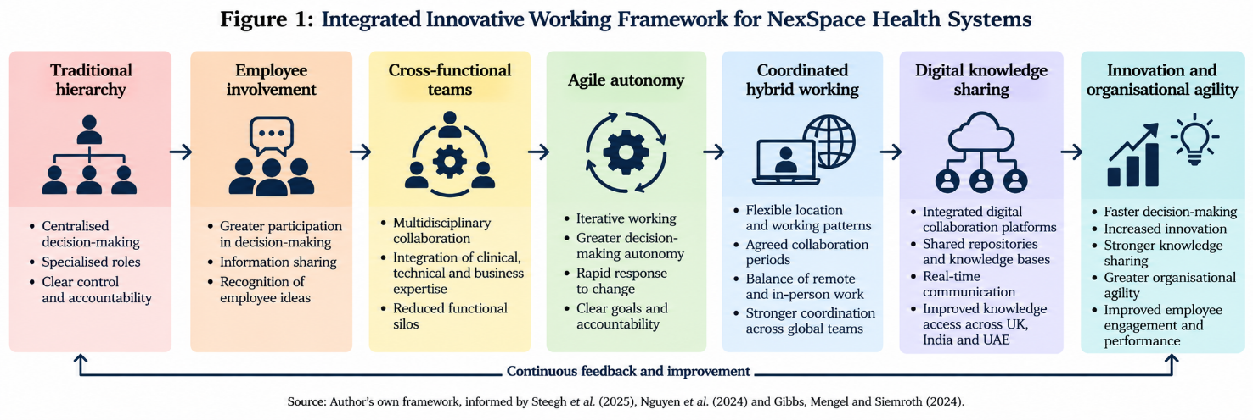
Figure 1: Integrated Innovative Working Framework for NexSpace Health Systems
Source: Author's own framework, informed by Steegh et al. (2025), Nguyen et al. (2024)

1.2 Recommended Innovative Working Practices for NHSX

NHSX should implement an integrated Agile-Connected Work Framework to address the lack of collaboration and innovation through five complementary practices.
First, NHSX needs to create agile multidisciplinary teams to tackle the lack of collaboration and innovation. The members of these teams should be AI experts, software developers, health care professionals, data analysts, and project managers. These experts can be united to share knowledge, minimising functional silos and enabling clinical and technical knowledge to contribute at the earliest stages of product development.
Second, NHSX needs to have a clear flexible working policy to facilitate coordination issues with current hybrid working arrangements. There should be flexibility around where the worker can work, depending on their role, and there should be set core working hours for teams to meet, for workshops and knowledge sharing. Good communication and a shared understanding of how work will be arranged can help to ensure there is continuity without relying on unrestricted remote working (Gibbs, Mengel and Siemroth, 2024).
Third, NHSX needs to adopt agile decision-making processes to rectify the situation of delays caused by excessive managerial control. Multidisciplinary teams should be established to make operational decisions and staff members should be empowered to solve operational issues with their specialized expertise. Managers need to set out clear strategic goals, quality goals and risk limits and give teams freedom to devise strategies to reach agreed outcomes. This can enhance responsiveness, employee ownership and accountability (Nguyen et al., 2024).
Fourth, NHSX should build agile project teams to deal with the need to respond to evolving clinical and technological needs. The teams should adopt short cycles of development, schedule regular reviews and seek feedback from relevant stakeholders. Within each project there should be clear objectives and agreed priorities which enable teams to identify problems at an early stage and adapt their work if appropriate (Steegh et al., 2025).
Finally, NHSX needs to improve digital collaboration tools to overcome communication and knowledge-sharing challenges in the UK, India and UAE. Platforms need to be integrated to facilitate project management, sharing and collaboration between multidisciplinary teams. Organisational knowledge may be accessed more easily through a digital repository and online meetings can be planned to facilitate discussion and coordination. These tools should be used to enhance agile and flexible working and not to replace direct employee interaction.
Overall, the Agile-Connected Work Framework can contribute to NHSX's goals of tackling collaboration and innovation issues with coordinated flexible working, delegated decision making and digital collaboration support. Clear objectives, governance and accountability should ensure that employee autonomy does not affect the quality or the coordination of activities and does not mean a loss of organisational performance.

TASK B: Breeding an Environment Where Talent May Grow
NexSpace Health Systems (NHSX) needs a talent ecosystem where employees are able to learn, share their ideas and grow their career. If high-performing staff have been leaving, it means that recruitment is not enough. Learning, autonomy, psychological safety and development needs to be integral to NHSX's day to day work. The ability to be resilient and engaged is what learning organisations can do to support innovation (Mohammad, Sağsan and Şeşen, 2024). NHSX needs to shift its focus from nurturing current talent to building a culture that facilitates learning, experimenting, growing.

2.1 Critical Evaluation of Environments Where Talent Flourishes
The Learning Organisation approach centers on learning and sharing of knowledge. It applies to NHSX because the absence of learning opportunities may hinder employees to learn the skills they need for AI and digital health care. Integrating learning into the everyday work can help NHSX to foster staff knowledge-sharing and implementation of new skills. But without opportunities to put the training to the test in actual work situations, it may not boost performance.
Psychological safety is the workplace atmosphere where employees are free to voice their opinions and ask questions even if they disagree with the decision or think it's a bad idea without fear of being made to look foolish. It could have implications for NHSX as staff wellbeing can be impacted if staff does not feel able to raise concerns or discuss mistakes. Managers should foster respectful communication, constructive feedback and open discussion in order to create a sense of support among employees. Psychological safety, however, should not be without accountability as NHSX is in the digital health space and must uphold clinical, technical and ethical standards (Jin and Peng, 2024).
The theory of job crafting is a theory that states that employees can make adjustments to their work tasks, working relationships and use of resources in order to make the work more pleasant. It's applicable to NHSX because poor career progression can demoralise and diminish staff retention. Cross-functional projects and training opportunities to build new skills and assign appropriate responsibilities to employees can aid in professional development. But job crafting needs to be managed carefully as altering the job demands can also lead to an increase in workload, which can have a negative impact on the employee's wellbeing (Holman et al., 2024).
According to Self-Determination Theory, the three psychological needs that impact on employee motivation and wellbeing are autonomy, competence, and relatedness. Providing staff with the right level of control over their work, the opportunity to build skills and supportive working relationships could enhance their experience of work at NHSX. Job Crafting also supports this theory as it requires employees to have enough autonomy and assistance to enable them to "craft" certain sections of their jobs to grow and get better. To prevent higher pressure on employees, autonomy must be accompanied by clear responsibilities and manageable workloads, though (Tiffin et al., 2024).
Table 1: Critical Evaluation of Talent Development Approaches for NHSX
Organisational problem | Approach | Critical limitation
Lack of learning opportunities | Learning Organisation | Training may not improve performance unless employees apply their learning in practice.
Employee wellbeing concerns | Psychological Safety | Open communication must be balanced with accountability and professional standards.
Limited career progression | Job Crafting | Changes to job responsibilities may increase workload if not managed carefully.
Motivation and autonomy concerns | Self-Determination Theory | Autonomy without sufficient guidance and support may increase employee pressure.
Source: Author's own table, informed by Mohammad, Sağsan and Şeşen (2024), Jin and Peng (2024), Holman et al. (2024), and Tiffin et al. (2024).
The four approaches are related but touch on different kinds of talent-management issues at NHSX. The Learning Organisation approach is about continuous learning, Psychological Safety is about employee wellbeing, Job Crafting is about career progression and Self-Determination Theory is about autonomy and motivation. These can serve as a foundation for establishing a favorable work climate, but their success is contingent on proper implementation and management.

2.2 Strategic Talent Growth Strategy for NHSX
NHSX needs to create an NHSX Talent Growth Ecosystem with five pillars.
First, NHSX has to overcome the deficiency in the provision of learning opportunities through the integration of learning and capability development into everyday work. Training should focus on AI and data analytics, digital healthcare and leadership and be supported by digital learning, certifications and peer learning. The knowledge needs to be applied through practical projects and quarterly capability reviews will uncover skills gaps and additional development needs. In this way, continuous learning and innovation in the organizations can be supported (Mohammad, Sağsan and Şeşen, 2024).
Second, NHSX should work to overcome poor career progression by creating clear and transparent career paths. Technical staff members should be afforded means of advancement to an increased level of specialization or managerial responsibilities without the loss of technical skills. By means of mentoring, coaching and clear promotion guidelines, employees should be supported in discovering development opportunities and planning their own career. These actions can positively affect employee motivation and retention by providing greater opportunities for professional development (Almashyakhi, 2024). Continuing professional development and workplace training may also support employee retention by reducing employees’ intention to leave their jobs (Shiri et al., 2023).
Thirdly, NHSX should foster better employee wellbeing by developing a psychologically safe working environment. Foster disagreement respectfully, offer constructive criticism and don't be afraid to criticize employees without embarrassment. Frequent innovation forums to discuss what fails can be a channel for ideas and learning from failures. But experimentation should be limited to the clinical, technical and ethical parameters. These practices can help to promote employee wellbeing and innovative performance (Jin and Peng, 2024).
Fourth, a structured approach to job crafting opportunities should be encouraged by NHSX to promote career development and employee autonomy. Staff should be encouraged to work on projects with others and acquire new skills and appropriate duties within the context of their career aspirations. The setting of clear goals, monitoring workloads and offering guidance are important areas in which managers can assist while simultaneously giving workers some latitude in how they perform their work. This can also help build employee motivation, professional development, and minimize excessive workload and employee strain (Holman et al., 2024; Tiffin et al., 2024).
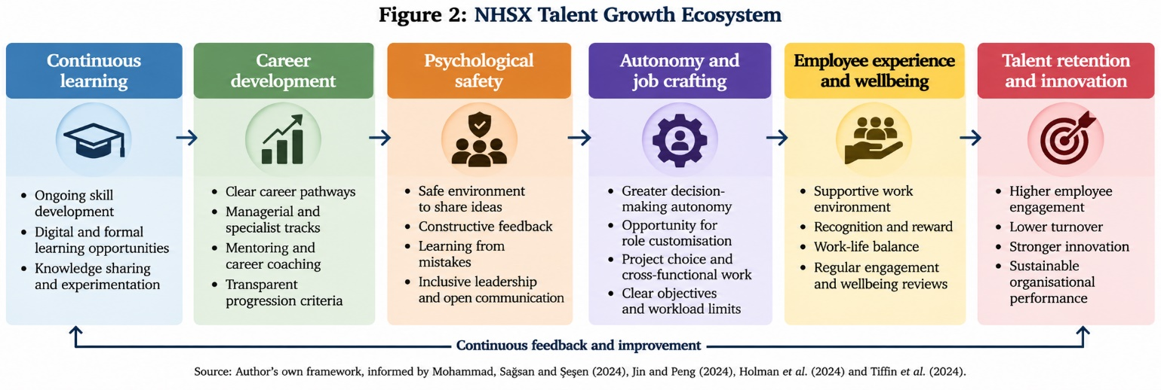Figure 2: NHSX Talent Growth Ecosystem
Source: Author's own framework, informed by Mohammad, Sağsan and Şeşen (2024), Jin and Peng (2024), Holman et al. (2024) and Tiffin et al. (2024).
Fifth, the employee experience and employee retention should be the monitored continuously. The engagement survey, career discussions and wellbeing review should be used by NHSX to explore barriers to retention. Ability gaps and retention risk are some things that talent analytics can help uncover, but should only complement managerial judgment. Turnover, promotion, learning and engagement should be included amongst the indicators.
In summary, NHSX should integrate learning opportunities, psychological safety, career development and employee autonomy into its talent strategy. Development gaps can be addressed through regular training, supportive management and career pathways can help improve employee wellbeing and support employee retention. Engagement, participation in learning and staff turnover will be tracked to assess the effectiveness of these measures.

TASK C: Reflective Report
Recruitment, workforce planning, learning, performance and retention decision-making can be reinforced with Artificial Intelligence (AI) and Human Resource Management (HRM). Studies point out the potential benefits of AI in enhancing HR tasks and the issues it poses regarding human involvement and accountability (Dima et al., 2024). AI should be used as a tool for decision-making, not decision-making itself, however. Algorithmic recruitment can generate fairness issues if the algorithm fails to mitigate biases in the information used, or if managers are too dependent on the recommendations provided by the algorithm (Cai, Zhang and Zhang, 2024). Hence, HR must review the outputs generated by AI, uphold confidentiality, take care of employee situations and maintain accountability. There is still a need for human empathy as factors like emotions, relationships, and circumstances in employment decisions are not fully comprehended by AI. Agency, transparency and ethical responsibility must be maintained with human oversight (Haipeter et al., 2024). A human-centred approach to AI implementation is also important because HR professionals must consider employee needs, trust and ethical implications when integrating AI into workplace processes (Fenwick et al., 2024).

3.1 Reflective Analysis of AI Use
The first time I used AI is when I was researching for academic purposes. I applied AI to find themes, organise information, and come up with perspectives. This was a improved efficiency and made me think about things that otherwise I would not have thought about. But assimilation of information produced without checking may lead to a decrease in critical thinking. Thus, I developed my ability to ask questions about outputs and examine evidence on my own.
My second application was in the form of academic writing. AI contributed to enhancement of structure, clarity and grammar. This deepened my communication as I was able to identify similarities and areas for improvement. But too much reliance might decrease my capacity to argue on my own. I thus considered AI more of an editor and learning assistant than an author.
My third use of AI involved problem-solving and decision supporting. Utilized AI for task structuring and alternatives comparison. Helped me to be able to divide up problems into smaller parts. However, AI recommendations may seem convincing, if the underlying assumptions are not correct. This helped to cement my scepticism and reaffirmed the importance of human judgment.

3.2 Personal Capability Development Plan

Development area | Planned action | Intended outcome
AI literacy | Practise using AI tools and evaluating the accuracy and potential bias of their outputs. | Develop the ability to use AI critically in HR-related tasks.
Excel | Practise spreadsheet functions, data organisation and basic data analysis. | Improve the ability to organise and interpret workforce data.
HR analytics | Learn to analyse employee turnover, engagement and training data. | Develop the ability to use workforce information to support HR decisions.
Source: Author's own work.

References
Almashyakhi, A.M. (2024) ‘Talent Management Practices and Employee Retention: Does It Make a Difference?’, Merits, 4(4), pp. 453–462. https://doi.org/10.3390/merits4040032.
Cai, F., Zhang, J. and Zhang, L. (2024) ‘The Impact of Artificial Intelligence Replacing Humans in Making Human Resource Management Decisions on Fairness: A Case of Resume Screening’, Sustainability, 16(9), 3840. https://doi.org/10.3390/su16093840.
Dima, J., Gilbert, M.-H., Dextras-Gauthier, J. and Giraud, L. (2024) ‘The effects of artificial intelligence on human resource activities and the roles of the human resource triad: opportunities and challenges’, Frontiers in Psychology, 15, 1360401. https://doi.org/10.3389/fpsyg.2024.1360401. Frontiers
Fenwick, A., Molnar, G. and Frangos, P. (2024) ‘Revisiting the role of HR in the age of AI: bringing humans and machines closer together in the workplace’, Frontiers in Artificial Intelligence, 6, 1272823. https://doi.org/10.3389/frai.2023.1272823.
Gibbs, M., Mengel, F. and Siemroth, C. (2024) ‘Employee innovation during office work, work from home and hybrid work’, Scientific Reports, 14, 17117. https://doi.org/10.1038/s41598-024-67122-6.
Haipeter, T., Wannöffel, M., Daus, J.-T. and Schaffarczik, S. (2024) ‘Human-centered AI through employee participation’, Frontiers in Artificial Intelligence, 7, 1272102. https://doi.org/10.3389/frai.2024.1272102.
Holman, D., Escaffi-Schwarz, M., Vasquez, C.A., Irmer, J.P. and Zapf, D. (2024) ‘Does job crafting affect employee outcomes via job characteristics? A meta-analytic test of a key job crafting mechanism’, Journal of Occupational and Organizational Psychology, 97(1), pp. 47–73. https://doi.org/10.1111/joop.12450.
Jiang, L., Pan, Z., Luo, Y., Guo, Z. and Kou, D. (2023) ‘More flexible and more innovative: the impact of flexible work arrangements on the innovation behavior of knowledge employees’, Frontiers in Psychology, 14, 1053242. https://doi.org/10.3389/fpsyg.2023.1053242
Jin, H. and Peng, Y. (2024) ‘The impact of team psychological safety on employee innovative performance: a study with communication behavior as a mediator variable’, PLOS ONE, 19(10), e0306629. https://doi.org/10.1371/journal.pone.0306629.
Kaushik, D. and Mukherjee, U. (2022) ‘High-performance work system: a systematic review of literature’, International Journal of Organizational Analysis, 30(6), pp. 1624–1643. https://doi.org/10.1108/IJOA-07-2020-2282.
Mohammad, S., Sağsan, M. and Şeşen, H. (2024) ‘The Impact of “Learning Organizations” on Innovation: The Mediating Role of “Employee Resilience” and Work Engagement’, SAGE Open, 14. https://doi.org/10.1177/21582440241289185.
Nguyen, M., Malik, A., Sharma, P., Kingshott, R. and Gugnani, R. (2024) ‘High involvement work system and organizational and employee resilience: Impact of digitalisation in crisis situations’, Technological Forecasting and Social Change, 205, 123510. https://doi.org/10.1016/j.techfore.2024.123510.
Steegh, R., Van De Voorde, K., Paauwe, J. and Peeters, T. (2025) ‘The agile way of working and team adaptive performance: A goal-setting perspective’, Journal of Business Research, 189, 115163. https://doi.org/10.1016/j.jbusres.2024.115163.
Shiri, R., El-Metwally, A., Sallinen, M., Pöyry, M., Härmä, M. and Toppinen-Tanner, S. (2023) ‘The role of continuing professional training or development in maintaining current employment: A systematic review’, Healthcare, 11(21), 2900. Available at: https://doi.org/10.3390/healthcare11212900.
Tiffin, P.A., Cabrera, R., Dexter-Smith, S. and Van den Broeck, A. (2024) ‘Capturing autonomy, competence, and relatedness at work: further examining and validating an English language version of the work-related basic need satisfaction scale’, Frontiers in Psychology, 15, 1304309. https://doi.org/10.3389/fpsyg.2024.1304309.

