
The Impact of Virtual Learning Environment (VLE)-Moodle on Students’ Learning Experience at the University of Wales Trinity Saint David London Campus
Module | Digital Skills and Research Methods
Module code | BMSW4003_LON
Lecturer | Koushik Modak
Student | Camilla Torello
Student ID | 2010042

Table of Contents

Introduction ……………………………………………. page 2
Rationale ……………………………………………. page 2
Research Objective …………………………………… page 2
Literature Review ……………………………………… page 2-3
Methodologies …………………………………………. page 4
Population, Sample and Sample size ………………. page 4
Ethics in Data Collection………………………………. page 5
The Survey……………………………………………… page 5-13
Summary of the findings………………………………. page 13
Conclusion and recommendations…………………… page 14
Appendix………………………………………………… page 15-18
References ……………………………………………... page 19-20

Introduction
Modern day has seen technologies play a key part in everyone’s lives, becoming vital tools in many environments, resulting in the methodology of work and study changing throughout the years. This led to the development of the Virtual Learning Environment (VLE). VLE is described as a “set of teaching and learning tools designed to enhance a student's learning experience by including computers and the internet in the learning process” (Rouse, 2011). Education has benefited from VLE in recent decades as it is designed to facilitate learning by including people with different geographical locations or backgrounds. VLE provides opportunities as a virtual interactive space encompassing different topics and collaborating with different systems or entities with ease.
This text will consider the impact of VLE on students’ lives at the University of Wales Trinity Saint David in London Campus (UWTSD). I will use primary data collection such as: questionnaire and survey and, I will use external secondary data collection like literature reviews to compare my findings. I will explain my survey outcome with graphs, charts or excel tables for easy and practical understanding.
Rationale
This report aims to analyse the impact of the VLE on the students’ lives using factual analysis and surveys. I will then perform primary research collection, a questionnaire, with a set sample size and I will also review articles and journals as a secondary source. The outcome will determine students’ opinions on the University system (called Moodle) and it will show how it could be improved.
Research objective
I will try to understand how effective VLE is in education and students’ reactions to it. I will analyse different authors and explain my survey results using graphs and charts to highlight the outcome - this will help resolve the report objective. I will achieve a factual and fundamental outcome on how students are impacted by VLE and their opinions on it.
Literature review
I will analyse different articles and summarise: the intention of the report, methodology they decide to adopt and what was achieved with their data collection. All reports had this topic; the Impact of VLE. “Active learning promotes the critical thinking skills essential for the transfer/use of classroom-acquired knowledge into the clinical setting. A VLE forms an increasingly vital component of clinical skills development in a range of disciplines” (Eimar, Poole, 2019). In this article the authors compare two teaching sessions: one using the VLE and the other without. Using a questionnaire, they test students’ knowledge (primary quantitative data). The findings are that with VLE students are more engaged and become more knowledgeable compared to students taking the physical lesson. In the article “The impact of student activity in a virtual learning environment on their final mark” (Mogus, Đurđević, Nenak, 2012). The authors are investigating if the time on Moodle can affect student’s marks, using a survey (primary quantitative data collection) with 111 responses. They discover that students’ activity log-in positively correlated with their final mark. Similar outcomes in the “The Influence of Virtual Learning Environments in Students Performance” (Becerra, García, Chávez, 2011). This analysed the same topic as the previous authors but with a bigger population (primary data collection) declaring that VLE “facilitate interaction and interrelation within a continuous communication process, thus enhancing the construction and reconstruction of knowledge and meanings as well as the formation of habits and attitudes within a framework that is common to all the ones involved in the educational process” (Becerra, García, Chávez, 2011). Barker and Grossmans’ report “The Learning Impact of a Virtual Learning Environment: Students views” concluded lecturers should consider that VLE is not universally accessible, rather, teachers need to encourage the use indirectly - students prefer more flexibility and control over their VLE. They review literature (secondary data collection) and create a survey within a population of students (primary qualitative and quantitative data collection). “VLE has an impact on student achievement, that the use of a VLE encourages independent learning, and that the use of a VLE increases students’ motivation to learn.” (Barker, Grossman, 2013). The impact of VLE has been considered also by Leonardo Mosquera in “Impact of Implementing a Virtual Learning Environment (VLE) in the EFL Classroom”. This report specialised in the impact VLE in English for foreign language (EFL) students. His population included students and teachers. He set his sample size to 5 teachers and 210 students and used literature analysis - so used both data collection systems (secondary and primary) in both formats (qualitative and quantitative for primary and internal and external for the secondary). His findings conclude the need for support for different categories of students (based mainly on age) but also, most of the sample size found VLE a positive tool.
Summary
All the reports I analysed have similar outcomes - overall, the findings and opinions regarding VLE are positive, regardless of the dimension. Most forms can cater to students and can accommodate the majority of UWTSD students. My research has similarities based on methodology and achievement as my report has an overall positive score regarding the impact and the student considerations on VLE.

Different types of Methodologies
I previously analysed literature so, I already used secondary data collection; for precision I used the external secondary data collection in my previous paragraph. Secondary data is described as “Secondary data are data that have been previously collected or gathered for other purposes than the aim of the academic article’s study. This type of data is already available, in different forms, from a variety of sources” (expert journals, 2017). There are 2 types of secondary data:
- internal secondary data research, company internal sources or data provided by my organisation
- external secondary data research such as: journals or external research, articles, or journals from different Universities.
For the research I will apply my primary data collection, described as “Primary data represent data originated for the specific purpose of the study, with its research questions. The methods vary on how authors and researchers conduct an experiment, survey or study, but, in general, it uses a particular scientific method” (expert journals, 2017). There are 2 types of primary data:
- Quantitative research, a research based on numbers or measurable information
- Qualitative research, a data that can be based on certain characteristics or opinions.
I will use both primary data, as I collected quantitative answers and I will analyse it in quantitative form, including graphs and chart and analysing the result of each question proposed. My primary data has been collected by email. I created a questionnaire and I emailed it to collect data for my surveys.
Population, Sample and Sample Size
Population is as described: “a population is the entire pool from which a statistical sample is drawn.” (Klenton, 2020). In my analysis my population will be the students of UWTSD London campus, approximately 2500 students.
Sample is “a subset of a population that is used to represent the entire group as a whole.” (Cherry, 2020). My sample is comprised specifically of the students in my class.
Although I will base my research on a sample size. “The sample size of a survey most typically refers to the number of units that were chosen from which data were gathered” (Lavrakas, 2008). Sample size is set at 20. I will consider the 20 answers which I have received.

Ethics in Data Collection
“Most research data can be shared ethically and legally if researchers employ strategies of informed consent, anonymity and controlling access to data. Researchers obtaining data from people are expected to maintain high ethical standards and comply with the relevant legislation” (Hibbert, 2019). I will adhere to the data protection act 1998 and the GDPR, having the consent from the University and from the students that partake. I will keep all the responses anonymous and I will use answers just for research purposes.
The Survey
I investigated the impact of Moodle on UWTSD students. Moodle is the primary VLE used at our organisation. Moodle is described as “a learning platform designed to provide educators, administrators and learners with a single robust, secure and integrated system to create personalised learning environments” (Moodle, 2020). I asked 8 questions and I will now analyse them with pie charts or graph bars for an easy comprehension. Question 4 and question 7 were open questions, so I will address them at the end of my analysis.
Q.1. Did you Know Moodle Before?
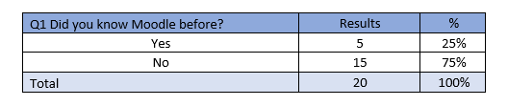
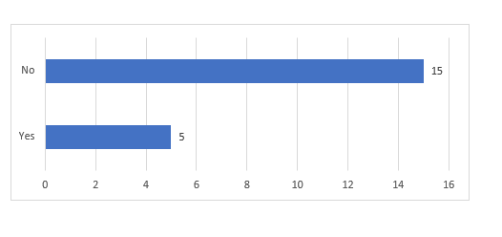

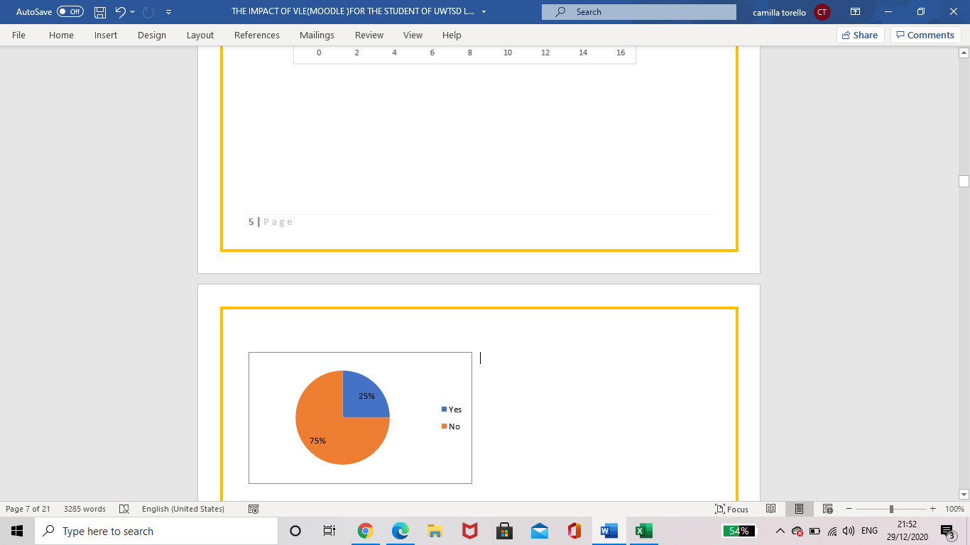
Analysis: 5 students knew Moodle before joining this University, 15 did not know what Moodle was.75% of the chosen sample size did not know Moodle.
As result we can say: Moodle is largely unknown outside of University organisations, as it is mainly used in an educational environment. As an improvement Moodle could be expanded to other corporations to increase awareness and usage.

Q.2. How important (from 1 being the least and 10 being the most) is it for you to have an online platform for class materials?
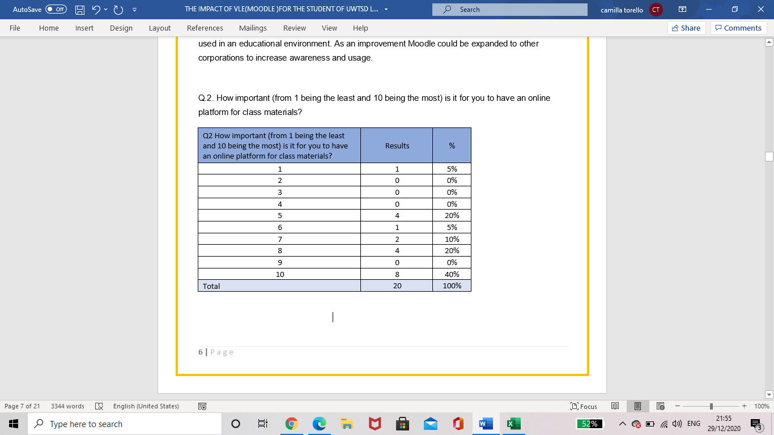
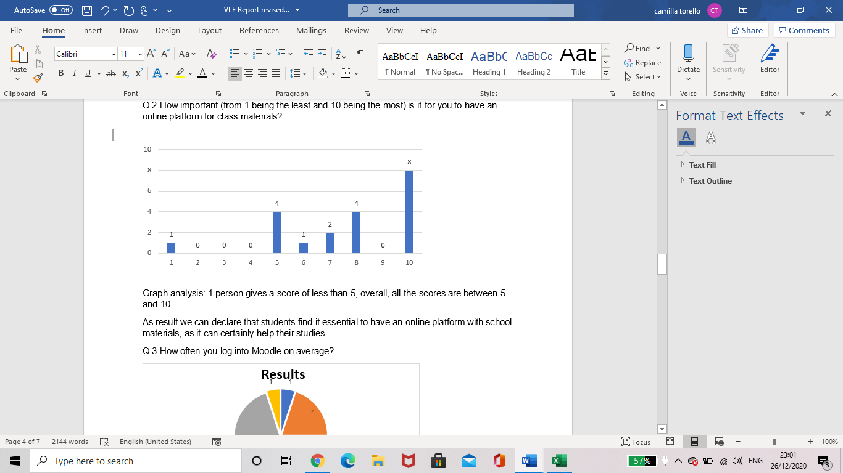
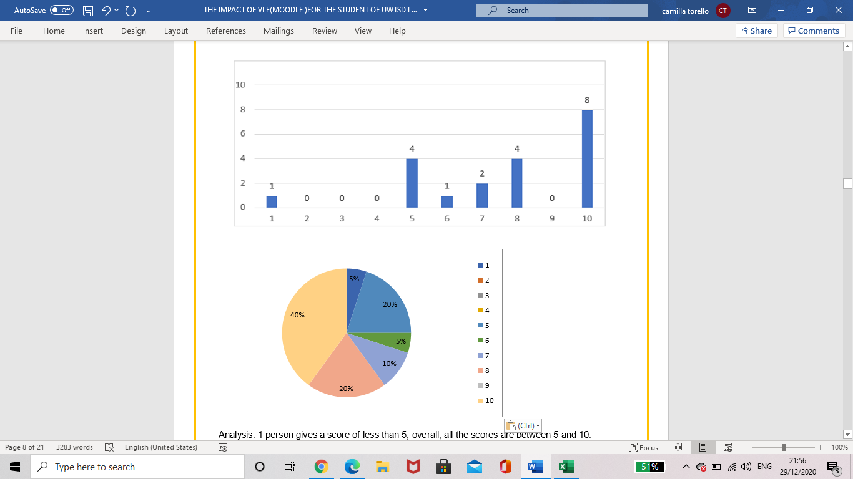
Analysis: 1 person gives a score of less than 5, overall, all the scores are between 5 and 10.
As result we can declare that students find it essential to have an online platform with school materials, as it can certainly help their studies. My sample size certainly found the fact that the material is available anytime and universally, is a benefit.

Q.3 How often you log into Moodle on average?
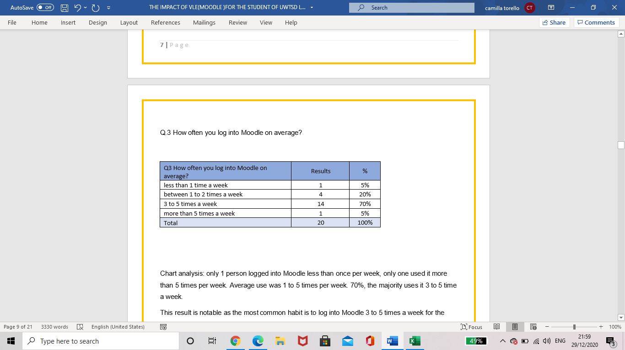

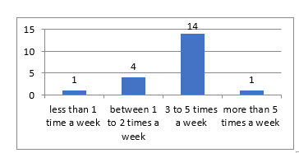
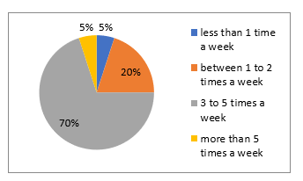

Analysis: only 1 person logged into Moodle less than once per week, only one used it more than 5 times per week. Average use was 1 to 5 times per week. 70%, the majority uses it 3 to 5 time a week.
This result is notable as the most common habit is to log into Moodle 3 to 5 times a week for the UWTSD students. It shows that Moodle is considered, by the majority, an essential tool and it is used outside of the lesson. (Lessons are twice weekly).

Q.5 Do you feel that there are enough materials on the platform for you to complete the study?
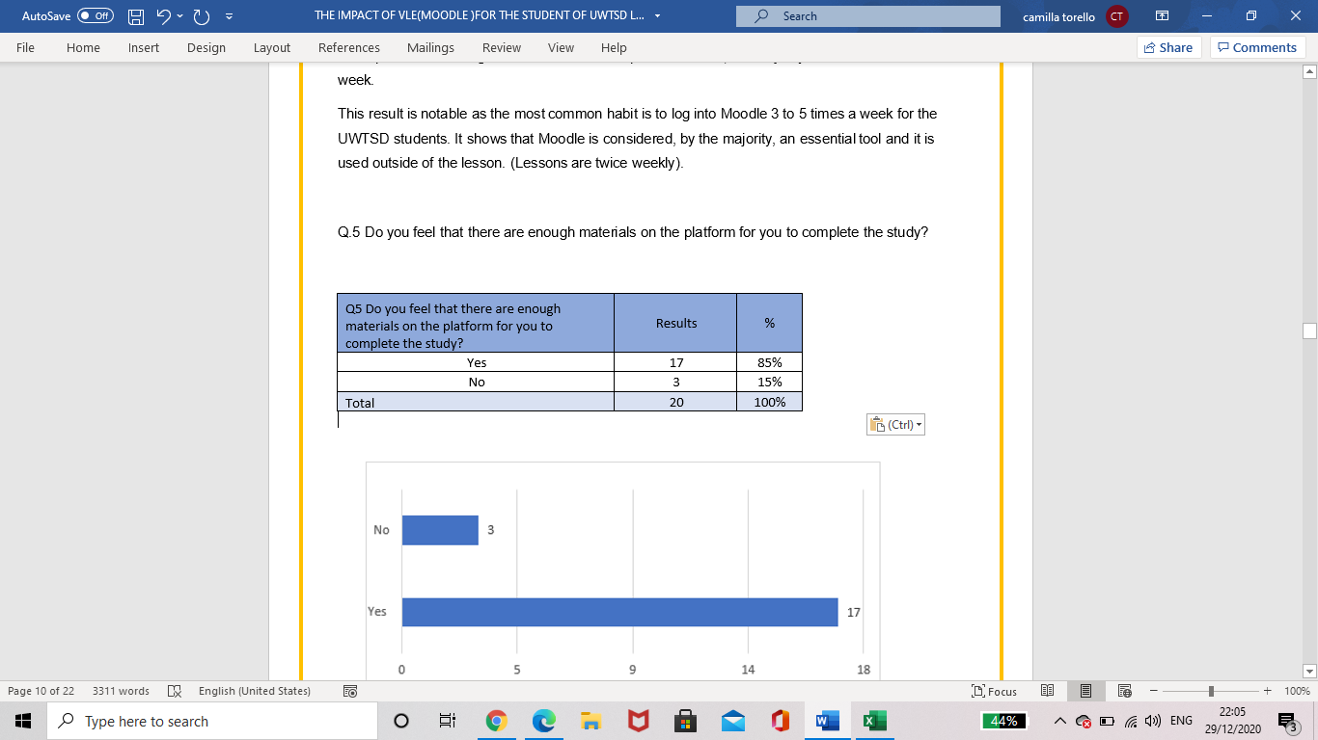

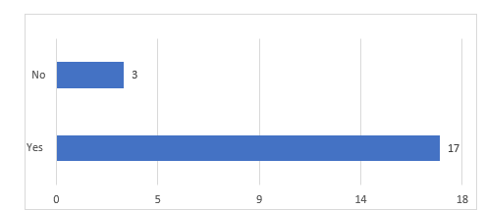
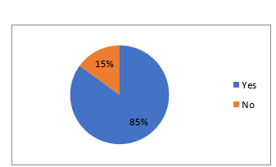
Analysis: three people are not satisfied with the material meanwhile the other 17 feel that the content is satisfactory.
As a result, it is noticeable that the students are satisfied with what the organisation has provided for us on Moodle. It would be useful to have a specialised space for students’ feedback as the university would benefit from knowing why student are not satisfied.

Q.6 Did you have to contact the support team for technical issues related to the system? If so describe.
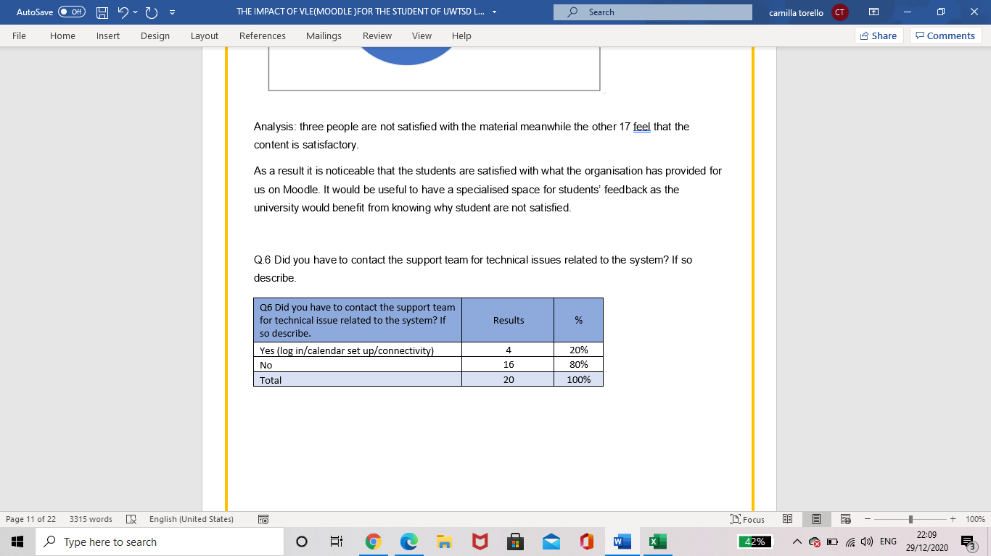
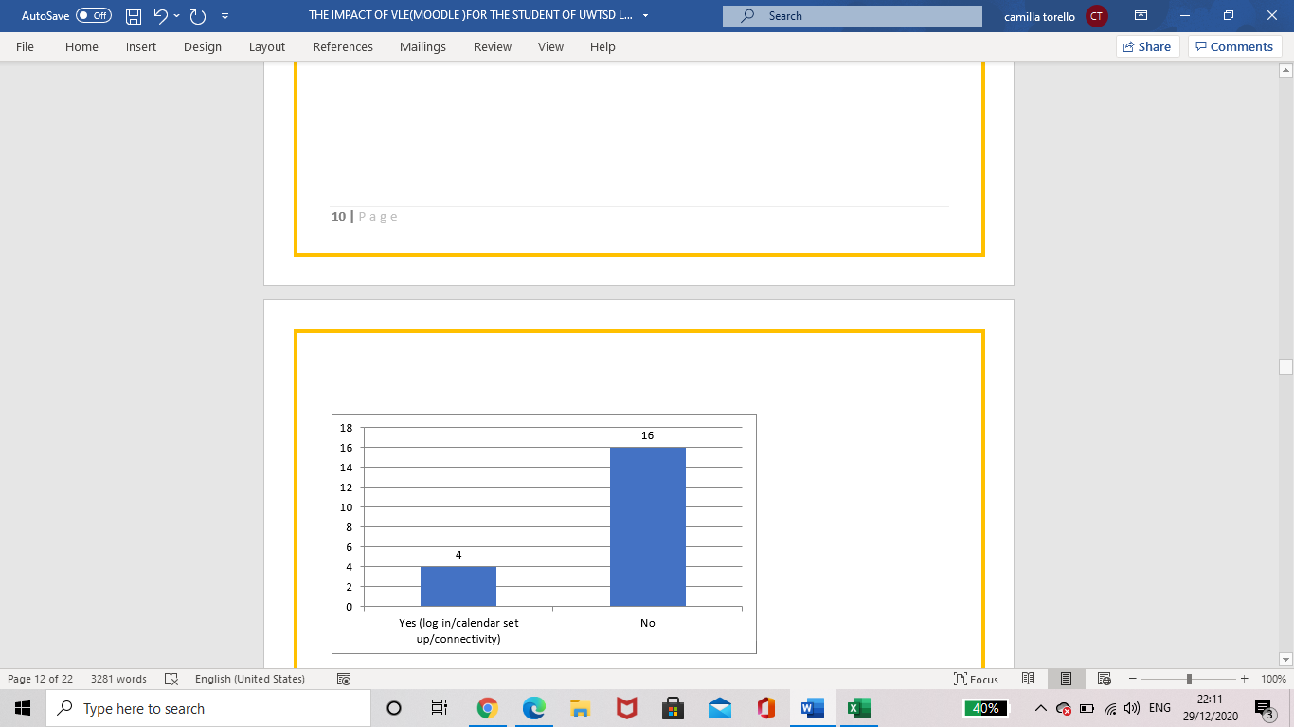
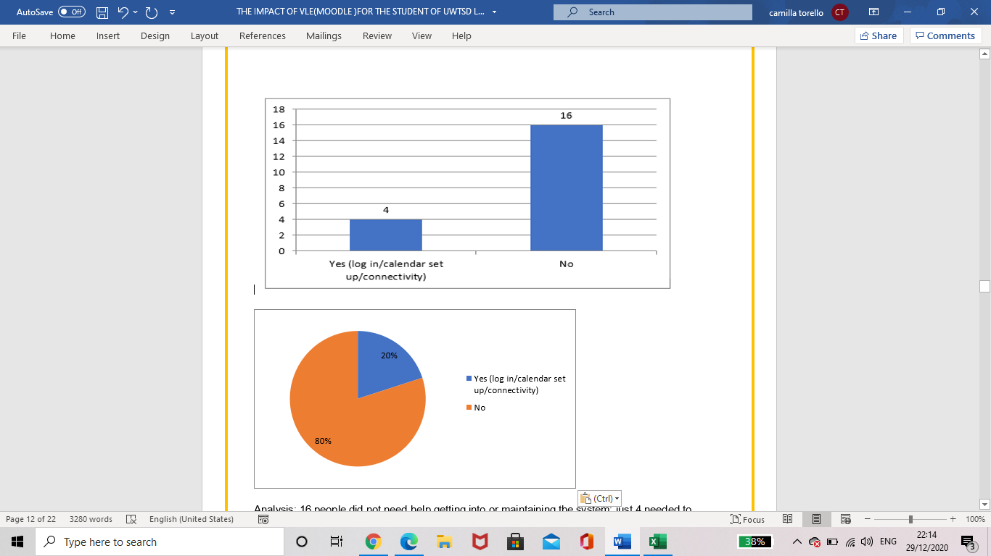
Analysis: 16 people did not need help getting into or maintaining the system; just 4 needed to contact the support team.
As result it can be said that Moodle is considered easy to use, and the people that had to contact the Support Team had a main issue related to connectivity or setting up.

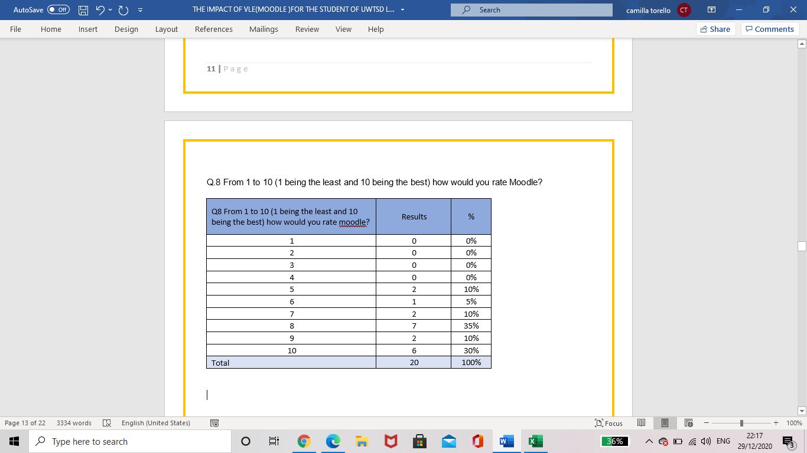
Q.8 From 1 to 10 (1 being the least and 10 being the best) how would you rate Moodle?

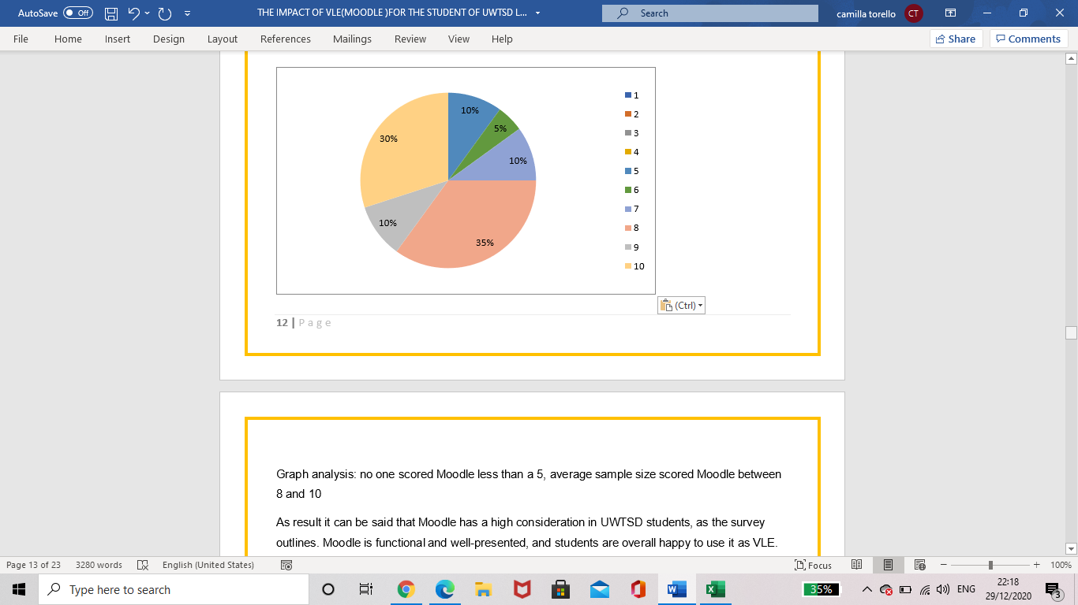
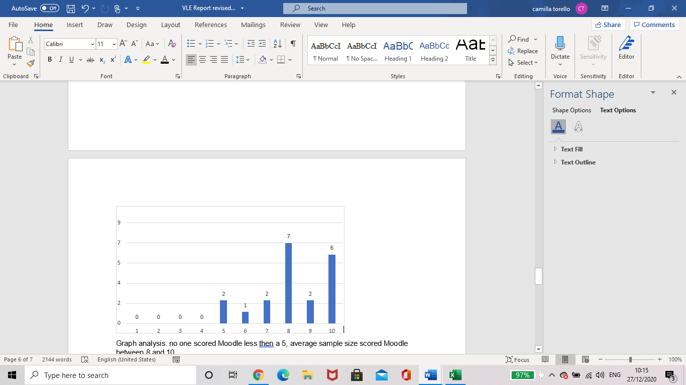

Analysis: no one scored Moodle less than a 5, average sample size scored Moodle between 8 and 10.
As result it can be said that Moodle has a high consideration in UWTSD students, as the survey outlines. Moodle is functional and well-presented, and students are overall happy to use it as VLE.
To analyse with a better vision on the Impact of UWTSD VLE I also proposed two different open questions, as following:
‘Is there anything that you would like to change or improve? If so describe.’ 16 students didn’t find it necessary to improve anything on Moodle but, 4 of the sample suggested that different tools such as a troubleshooting section, a live chat or an app version could make the system run smoother.
My other open question was ‘Can you please give an honest opinion of what you think about Moodle?’. This question had 13 positive responses such as: straightforward, easy to access and helpful. These responses highlighted the difficulties that different people can find on the system because 7 people rated negatively; describing it as confusing and having poor information and difficult to use.
The open questions revealed that Moodle is considered a good tool and described as useful but, some students are not fully satisfied with the VLE. As proposed before, an instant feedback for the materials or for the platform would be beneficial for the University and for Lecturers to get a better understanding of students’ point of view.

Summary of the findings:
It can be said that Moodle VLE focusses on education, that most students use it on a weekly basis and infrequently goes unused as it stores useful information and enough class materials. Most of the students also appreciate it as they become more familiar and the main negative feedback is related to problems regarding general connectivity or maintenance. Although Moodle is highly rated, there are improvements suggested which relate to adding features - not about the system functionality or the program.

Conclusion and Recommendation:
My research had the aim to give a better understanding of UWTSD London Campus point of view and try to emphasise that Moodle is an effective, functional, and, though not described as easy to use by every student, a good alternative to class books or physical material - especially with the impact Covid-19 has had on University life. It can be said that VLE in UWTSD has been taken on board and challenged in a positive manner, even if improvement, such as a live chat or troubleshooting system could make it even more proficient.

Appendix
- The excel tables

Q1 Did you know Moodle before? | Results | %
Yes | 5 | 25%
No | 15 | 75%
Total | 20 | 100%
Q2 How important (from 1 being the least and 10 being the most) is it for you to have an online platform for class materials? | Results | %
1 | 1 | 5%
2 | 0 | 0%
3 | 0 | 0%
4 | 0 | 0%
5 | 4 | 20%
6 | 1 | 5%
7 | 2 | 10%
8 | 4 | 20%
9 | 0 | 0%
10 | 8 | 40%
Total | 20 | 100%
Q3 How often you log into Moodle on average? | Results | %
less than 1 time a week | 1 | 5%
between 1 to 2 times a week | 4 | 20%
3 to 5 times a week | 14 | 70%
more than 5 times a week | 1 | 5%
Total | 20 | 100%
Q4 Can you please give an honest opinion of what you think about moodle? | Results | %
easy/helpful/good/useful/straightforward/ amazing | 13 | 65%
confusing/easy/challenging /lack of information | 7 | 35%
Total | 20 | 100%
Q5 Do you feel that there are enough materials on the platform for you to complete the study? | Results | %
Yes | 17 | 85%
No | 3 | 15%
Total | 20 | 100%
Q6 Did you have to contact the support team for technical issue related to the system? If so describe. | Results | %
Yes (log in/calendar set up/connectivity) | 4 | 20%
No | 16 | 80%
Total | 20 | 100%
Q7 Is there anything that you would like to change or improve? If so describe. | Results | %
Yes (interaction/live chat/simpler/as an app) | 4 | 20%
No | 16 | 80%
Total | 20 | 100%
Q8 From 1 to 10 (1 being the least and 10 being the best) how would you rate moodle? | Results | %
1 | 0 | 0%
2 | 0 | 0%
3 | 0 | 0%
4 | 0 | 0%
5 | 2 | 10%
6 | 1 | 5%
7 | 2 | 10%
8 | 7 | 35%
9 | 2 | 10%
10 | 6 | 30%
Total | 20 | 100%

- The questionnaire proposed to students via email
In-Class exercise: Questionnaire Design
Student Name: __Camilla Torello Student ID:2010042 ____________________
Module Name: Digital Skills and Research Methods (H&Sc) Term 1 Group: 2 _____________

Aim: This exercise is aimed to help you in your questionnaire design. Please note, you need to use this questionnaire to conduct a survey which is also one of the important parts of your research report.

Please write down your questions that you are going to use in your primary data collection. Try to have different types of questions such as close-ended question, open ended question, multiple choice question, Likert-scale question.

Question 1:

Did you know of Moodle before?
Yes
No

Question 2:

How important (from 1 being the least and 10 being the most) is for you to have an online platform for class material?
1-2-3-4-5-6-7-8-9-10

Question 3:
how often you log in into Moodle on average?
Less than 1 a week
Between 1 to 2 times a week
3 to 5 times a week
More than 5 times a week

Question 4:
Can you please give an honest opinion of what you think about your Moodle experience?

Question 5:
Do you feel that there are enough materials on the platform for you to complete your study?

Question 6:
Did you had to contact the Support Team for technical issue related to the system? If so, please describe
Question 7:
There is anything that you would like to change or improve it? what will you change? please describe
Question 8:
From 1 to 10 (1 being the least and 10 be the best) how will you rate Moodle?
1-2-3-4-5-6-7-8-9-10

References
Alves Paulo, Miranda Luisa, Morais Carlos, (2017), The Influence of Virtual Learning Environments in Students’ Performance, Universal Journal of Educational Research 5(3): 517-527, Polytechnic Institute of Bragança, [Online Pdf]. Available at: https://files.eric.ed.gov/fulltext/EJ1134444.pdf [Accessed 25 November 2020].
Barker J., Gossman P. (2013) The Learning Impact of a Virtual Learning Environment: Student’s view. Semantic Scholar, [Online pdf], Available at: https://core.ac.uk/download/pdf/29422368.pdf [Accessed 25 November 2020].
Chowdhry Sandeep, Sieler Karolina, Alwis Lourdes, (2014), A Study of the Impact of Technology-Enhanced Learning on Student Academic Performance, Journal of Perspective in Academic Practice, volume 2, Issue 3, page 3-15, Edimburgh Napier University.

Eimear Ryan, Claire Poole, (2019), Impact of Virtual Learning Environment on Students’ Satisfaction, Engagement, Recall, and Retention, Volume 50 Issue 3, Elsevier Inc, [Online].
Available at: https://www.sciencedirect.com/science/article/abs/pii/S1939865418304636 [Accessed 21 November 2020].

Expert Journals(2017),How to Write a Research Methodology for Your Academic Article, Spirit investify.[Online] Available at: http://expertjournals.com/how-to-write-a-research-methodology-for-your-academic-article/ [Accessed 12 November 2020].

Firefly Learning Ltd (2018), What is a Virtual Learning Environment (VLE)? [Online]. Available at: https://www.fireflylearning.com/what-is-a-virtual-learning-environment-vle [Accessed:20 November 2020].
Free Essays-PhDessay (2020), Impact of Virtual Learning Environment Education Essay. [Online]. Available at: https://phdessay.com/impact-of-virtual-learning-environment-education-essay/ [Accessed 12 December 2020].
Herrera Mosquera, Leonardo. (2017). Impact of Implementing a Virtual Learning Environment (VLE) in the EFL Classroom. Íkala, Revista de Lenguaje y Cultura, 22(3), 479-498. [Online Pdf].Available at: http://www.scielo.org.co/pdf/ikala/v22n3/0123-3432-ikala-22-03-00479.pdf .[Accessed 25 November 2020].
Hurix, (2019), 10 Benefits of Moodle based Learning Management System (LSM), Hurixdigital, [Online]. Available at: https://www.hurix.com/benefits-moodle-based-learning-management-system/. [Accessed 27 November 2020].
Kendra Cherry,(2020) Sample Types and Errors in Research, verywell mind, [Online].Available at: https://www.verywellmind.com/what-is-a-sample-2795877 [Accessed on 12 December 2020].
Klenton Will, Gordon Scott (2020),Population Definition, Investopedia, Dotdash, [Online].Available at: https://www.investopedia.com/terms/p/population.asp [Accessed 25 November 2020].
Lavrakas, Paul J., (2008). Sample Size, Encyclopaedia of Survey Research Methods, Sage Publications,[Online]. Available at: https://methods.sagepub.com/reference/encyclopedia-of-survey-research-methods/n507.xml [Accessed 27 November 2020].
Moodle, (2020), About Moodle, Moodle Tm,[Online]. Available at: https://docs.moodle.org/310/en/About_Moodle [Accessed 27 November 2020].

Mogus Ana, Durdevic Babic Ivana ,Suvak Nenak ,(2012). The impact of student activity in a virtual learning environment on their final mark, Researchgate Gmbh,[Online].Available at: https://www.researchgate.net/publication/258124481_The_impact_of_student_activity_in_a_virtual_learning_environment_on_their_final_mark [Accessed 25 November 2020].

Rouse Margaret, (2011). Virtual Learning Environment (VLE) or Managed Learning Environment (MLE). Techtarget. [Online]. Available at: https://whatis.techtarget.com/definition/virtual-learning-environment-VLE-or-managed-learning-environment-MLE#:~:text=A%20virtual%20learning%20environment%20%28VLE%29%20is%20a%20set,computers%20and%20the%20Internet%20in%20the%20learning%20process. [Accessed on 27 November 2020].
Surbhi S. (2020), Difference Between Primary and Secondary Data, Key Difference , [Online]. Available at: https://keydifferences.com/difference-between-primary-and-secondary-data.html [Accessed 27 November 2020].
Wikipedia (2020). Moodle. Wikipedia Foundation Inc. [Online]. Available at: https://en.wikipedia.org/wiki/Moodle#:~:text=Moodle%20was%20originally%20developed%20by%20Martin%20Dougiamas%20to,released%20on%2020%20August%202002%20%2818%20years%20ago%29 [Accessed 24 November 2020].

