Networks and Cybersecurity Essentials (ACCA4024) Lab6
Escalating privileges to the root level by entering sudo su command followed by the password.
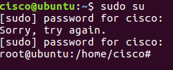
Adding new user group names HR. root@ubuntu:/home/cisco# groupadd HR.
Verify group with cat etc/group.
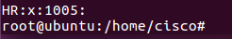
Add the following groups and record your output
MGT
EMPGA
EMPGB
EMPGC
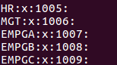
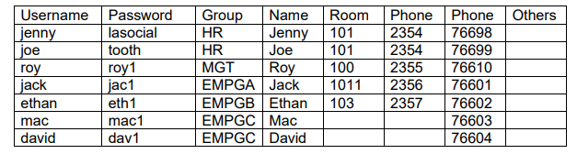
Adding new users.
root@ubuntu:/home/cisco# adduser jenny
When prompted for a new password, type lasocial. Press Enter.
When prompted again, type lasocial. Press Enter.
When prompted for a full name, type Jenny. Press Enter.
When prompted for other details, refer to the above table and enter the
details.
If you don’t have the details, press Enter without adding the details.
Type Y for yes and press Enter
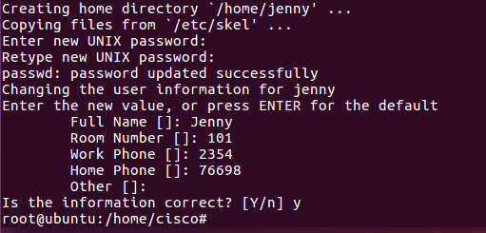
Repeat the same for all the other users listed in the table.
Place the user jenny in the HR group. root@ubuntu:/home/cisco# usermod –G HR jenny
Verify the users using cat /etc/passwd
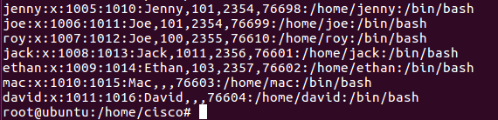
View the created users in the shadow file.
root@ubuntu:/home/cisco# cat /etc/shadow
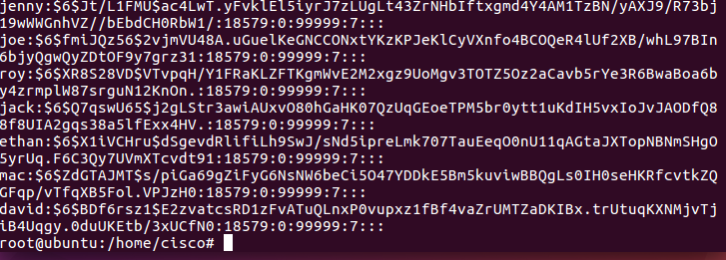

Using Symbolic Permissions
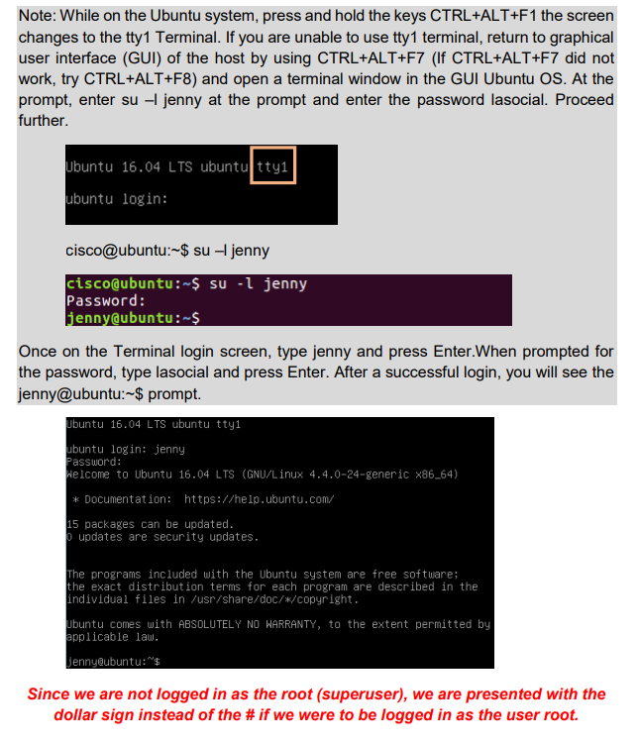
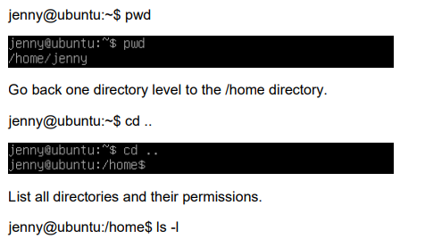
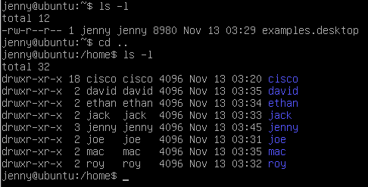
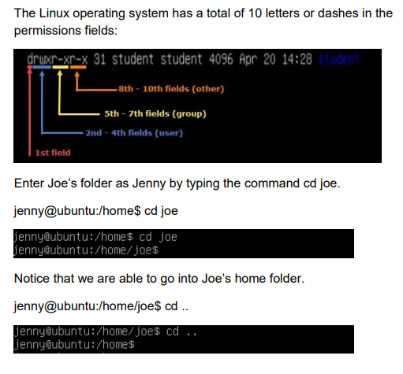
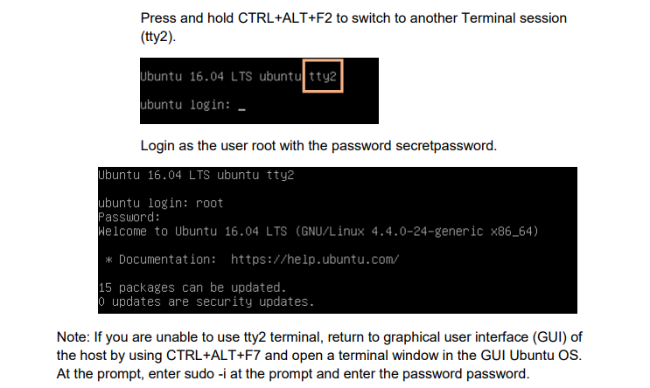
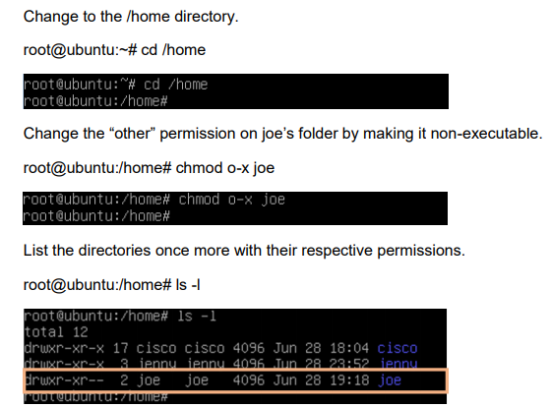
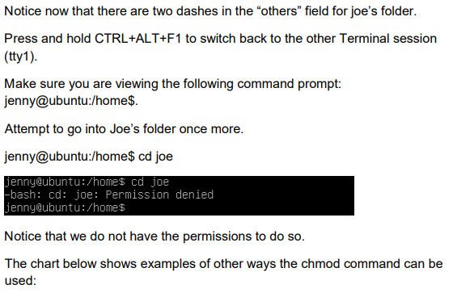

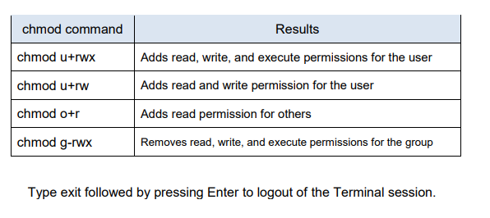
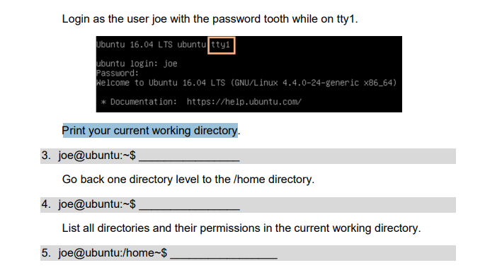
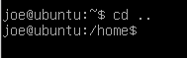
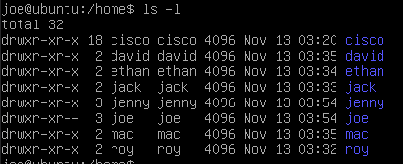
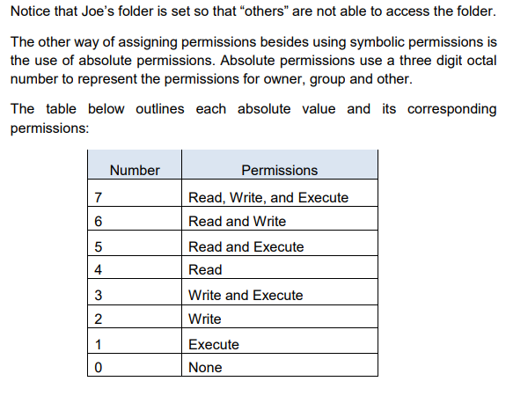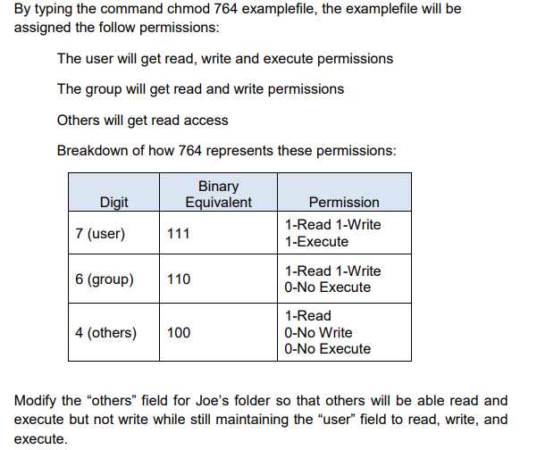
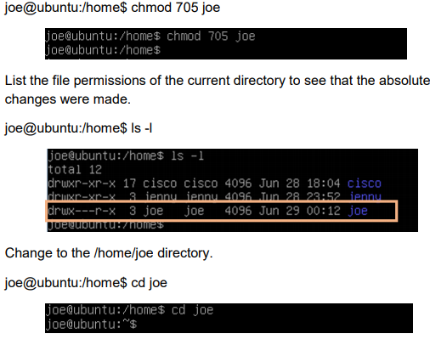
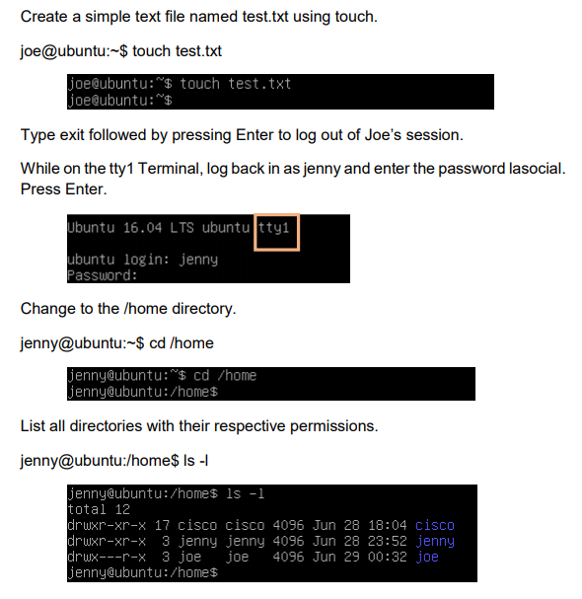
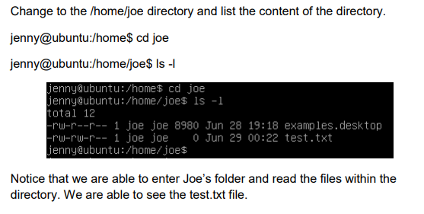
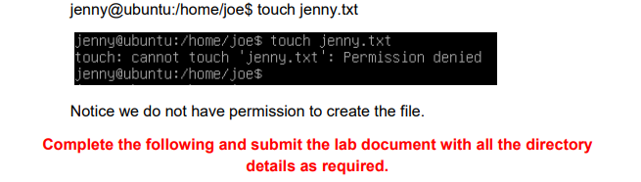
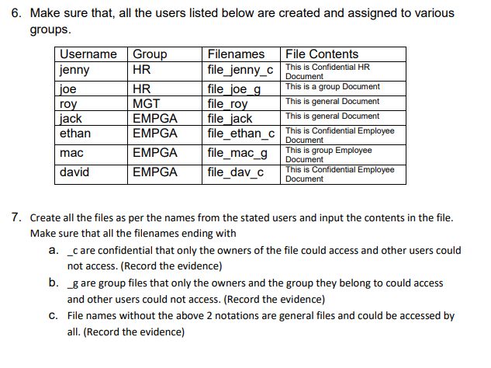
Making so only Joe and the HR group have permissions.
Making is so that everyone can access roy’s file.
Making it so that only Jenny can access her file.

