Building a Strong Foundation for Data Protection and Security
Zoe Selina Clark
Student University of Wales Trinity St David, Swansea, Wales
97011450@student.uwtsd.ac.uk
Abstract- This paper focuses on digital data, information (processed data) security and human interaction affecting its use, or protection. It explores strategies, frameworks, and tools for safeguarding data, emphasising compliance, governance, risk management, and evolving technological approaches.
Section I evaluates key issues, including analysis of Intrusion Detection and Prevention Systems (IDPS) and other security tools. Section II presents an approach to establishing the Information Security Unit. The fictional organisation ByteBoutique aims to enhance its security posture, ensure compliance, improve operational efficiency, and increase resilience in a dynamic technological and threat environment.
A UK medium-sized retail company based in the UK, ByteBoutique's requirements will be explored and evaluated against current issues and technological developments. Findings from Section I are applied where relevant in Section II.
Keywords—Compliance, Risk Management, Contingency Planning, IDPS, Security Tools, Data Protection, AI, Cloud Security, Cyber Resilience, Security Architecture

- A Strong Foundation: Exploring Modern Data Security

Introduction
Data drives modern organisations. They and criminals aim to harness technology to thrive. As data shifts to digital formats, it becomes a more valuable target, challenging organisations to protect it against threats while maintaining operations, reputation, and objectives.
Effective security strategy involves dynamic tools and methodologies. Navigating technology, governance, risk management techniques, and compliance requirements. Organisational purpose, strategy and security appetite may also add varying focus. managers, customers and the data security community may have different concepts of importance around securing data This section explores the challenges, including third party involvement and tailoring approaches.

Why Organisations Need to Protect, Detect, React and Safeguard
Organisations invest considerably in key assets and outputs with technology. Significant benefits help firms stay competitive [1] but introduces new risks (potential for incidents). Legal obligations e.g. the Data Protection Act 2018 (DPA 2018) [2] require data is used fairly, lawfully, and transparently. Regulatory breaches risk financial penalties.
- Laws and Frameworks- examples relevant to UK organisations [2-6]
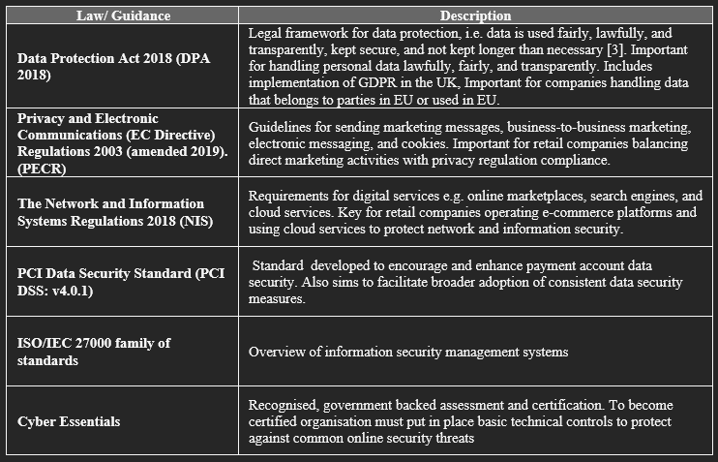
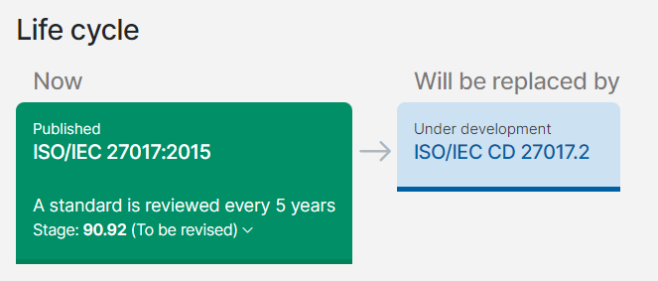
Figure 1: Standards Lifecycle - Screenshot highlighting continual review and updates timelines, here for ISO standards as of July 2024. Standard relates to cloud services [7]
The standard ISO/IEC 27000:2018 [8], refers to the principles of Confidentiality, Integrity and Availability (CIA). This concept helps organisations balance accessible operations with protection of people and information assets [9]:
- Confidentiality: No account protection to prevent unauthorised use e.g. no layers of controls to deter or prevent.
- Integrity: Data is not backed up and lost in a fire or can be amended without restriction.
- Availability: Customers can’t access account information or website.
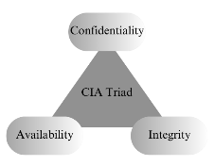
Figure 2: CIA Triad - Illustrates the fundamental balance of data protection Confidentiality, Availability and Integrity [9]
Consistent compliance is essential to avoid civil and criminal proceedings. Risk Management and Governance gives oversight helping avoid penalties and loss of reputation that can impact revenue streams. Staying updated with regulatory and guidance (Table I and fig. 1), helps organisations manage and align these with policies and procedures effectively. Frameworks and guidelines are available to help develop security-focused policies and practices aimed at supporting operational needs. Secure governance supports key objectives while protecting investments. The consequences of failing to implement countermeasures include loss of services, revenue loss, reputational damage, imprisonment, or even organisational collapse. [10]
Frameworks, although not mandatory, aid strategic and risk planning. Consumer confidence through assurance and certification. (Table I). Research analysis highlights ineffective implementation often has costly impacts, emphasising the need for review and consistent best practice. The study is limited by inconsistent breach recording across countries. Seeking UK-based, recognised expertise (e.g. National Cyber Security Centre), could assist relevant understanding of guidance. [11].
Organisations may be hindered or reluctant to invest due to assessment and implementation costs. Failing to secure data could be even more costly through losses or missed opportunities to mitigate costs, as illustrated in Fig 3, Fig 4.
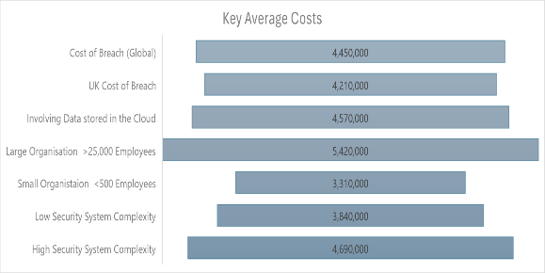
Figure 3: Key costs of breaches, 2023. Notably for small organisations average costs are still sizeable and costs are higher for systems with higher complexity [12]

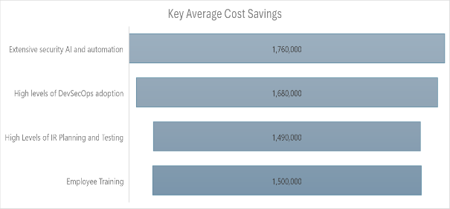
Figure 4: Key Savings against breaches - Reduction achieved through secure practice in 2023 Adoption of automation and Artificial Intelligence (AI)is a clear benefit. Also worth noting savings simply through staff training. [12]
UK Small and medium-sized enterprises (SMEs) research indicates an increased technology uptake with a lag in security measures. Highlighting the importance of identifying, assessing, and treating risk, information security (protecting against unauthorised access), and cyber resilience (continuity and recovery despite cyber incidents). Strengthening cyber posture, through awareness, improved business practices, and certifications like NCSC’s Cyber Essentials is essential [13] as "With digital transformations, interconnectivity, and intelligent systems, digital breaches have become more severe and widespread" [14].
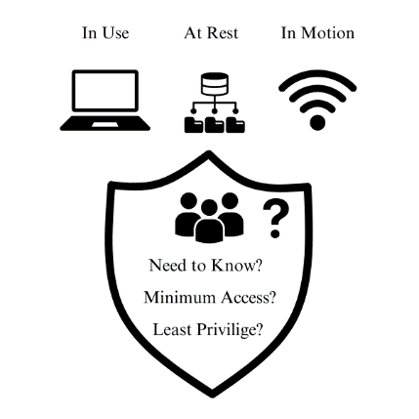
Figure 5: States of data and right of access - What and where is data, who needs it and why? Image created by Z Clark. [15] [16]
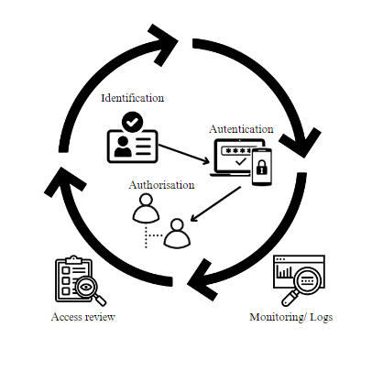
Figure 6: Access Control - Illustrates identification (IDs), authentication (Multi-Factor Authentication), and authorisation (Role-Based Access Control) by user role. Image by Z. Clark. [15] [16]
Data, as illustrated in Fig 5 exists at every level, so involving people, technology, and processes is essential. A strong Chief Information Security Officer (CISO) gives strong top-down security leadership for compliance. Aligning measures with company vision, engaging stakeholders, and ensuring responsibilities are clear. Competence, flexibility and expertise is needed to manage changing internal and external data security needs and expectations [17]. Whilst the study is not UK based, it has relevance due to globally recognised practices mentioned. [5]
Factors shown in Fig 7 indicate key considerations to develop[and maintain a secure environment and perceptions in the security community around priorities for secure practice.
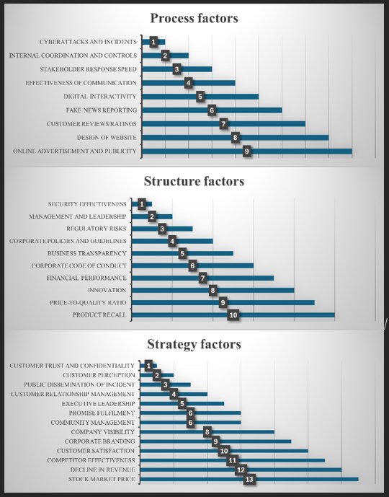
Figure 7: Key Factors Influencing Organisational Cyber Reputation Across Strategy, Structure, and Process, Based on Experts' Rankings [18]
Current and emerging technology could be exploited by malicious actors, mishandled due to a lack of awareness, poor implementation, or inadequate training. Threats sources vary, happen by design or error. They include misuse of technology, undiscovered vulnerabilities (zero-day newly released software), and malicious activity (hacking, ransomware, and denial-of-service attacks). [19] Fig 8 illustrates the scale and range of attacks and countermeasures. The lists are not exhaustive, threats can change in nature and popularity. Identification is supported through publicly available threat intelligence sites e.g. Cisco Talos [20] and Microsoft [21]. These list known vulnerability information to help with identification and applying effective controls.
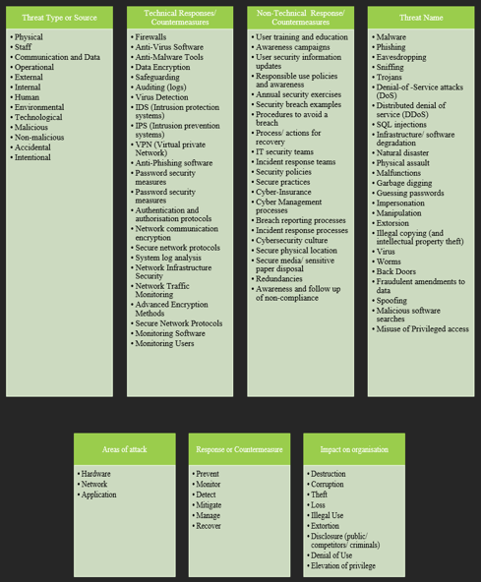
Figure 8 Examples of common threats, what areas they impact and how. The list of threats is long, but so is the countermeasures list [22]
Third-party threats complicate security controls. The Synnovis attack, affecting linked healthcare trusts and critical services, demonstrates the nature of such attacks. As noted, “This is a harsh reminder that this sort of attack can happen to anyone at any time and that, dispiritingly, the individuals behind it have no scruples about who their actions might affect” [23][24].

Importance of Secure Systems and Infrastructure
For effective controls, the organisation must understand its assets and the complexity of its environment, including regulations, people, systems, and architecture, all tailored to specific business needs.
Proactive, cyclical review ensures adaptability to emerging technologies and risks, supported by defined roles, documented plans, and audit trails for compliance. Effective strategies include proactive risk management, early system security, and comprehensive threat modelling [14][25].
Awareness and understanding of protections and deployment is as important as the tools used. Everyone must understand responsibilities and the importance of adherence to mitigate threats, reduce errors, and deter opportunists [26]. Regular training, clear communication, and a culture of security mindfulness engage staff effectively [27]. Errors in applying processes or tools introduce weaknesses. Security tools support monitoring and practical implementation of security plans. Vulnerabilities can arise in design and implementation and operations Moving services to the cloud adds additional challenges.
- Cloud service architecture options for software, platforms and infrastructure [28] [29]
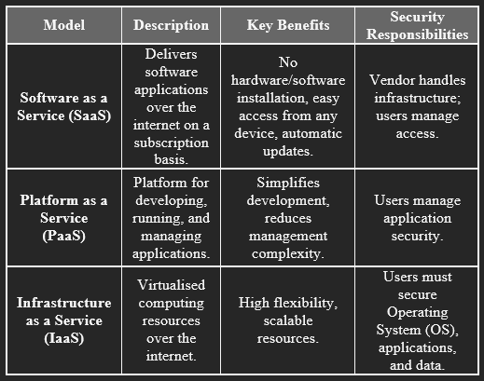
Comparing studies suggests cloud migration is flexible and cost-effective but brings data migration complexity and security concerns, which can be mitigated by a strong security posture and up-to-date methods [28-29]. These models offer varying levels of control and scalability, essential for organisations needing flexibility and protection.

Overview of Security Tools
Digital interactions and the nature of stored information, shape security needs. A one-size-fits-all solution is impractical, due to diversity in assets and technologies. Technological solutions defend against threats. Tools to prevent unauthorised access, detect malicious activities, protect sensitive data, and ensure system integrity.

Intrusion Detection and Prevention Systems (IDPS)

IDPS deter, detect, prevent unauthorised access and malicious activities across networks and systems. They may differ in detection method. (Table III)

- IDPS Detection methods – Strengths and Weaknesses [30] [31]
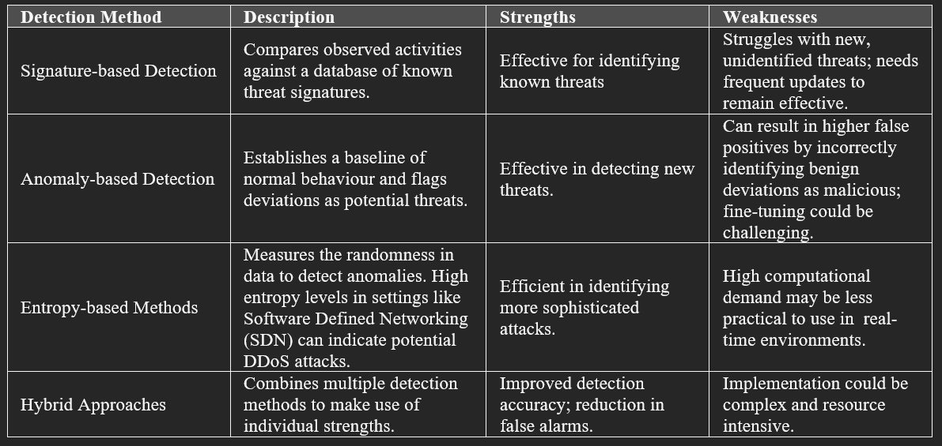
Machine Learning (ML) integration has been explored to enhance IDPS detection accuracy. These algorithms improve intrusion detection by processing vast data and identifying subtle patterns but require significant computational resources and expertise, limiting their feasibility for smaller organisations [32].
IDPS are crucial for safeguarding organisational networks and systems from unauthorised access and malicious activities. Signature-based and anomaly-based methods provide foundational capabilities, while advanced techniques like entropy-based methods and hybrid approaches offer improved detection and mitigation. ML models further enhance detection accuracy but require significant computational resources and expertise. Organisations must balance these advanced methods to ensure their approach aligns with their unique security environment, budget and objectives.
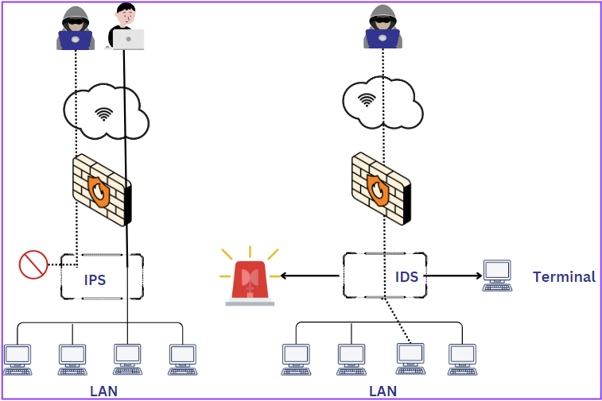
Figure 9: Intrusion Detection System (IDS) and Intrusion Protection System (IPS) comparison. IPS Allowing Only Authorised, Authenticated Access (Prevention) and IDS Detecting a Breach and Triggering an Alert (Detection) [33]

Security Information and Event Management (SIEM)
IDPS are part of a broader security strategy which also includes SIEM systems centralising security data collection, analysis, and reporting from various sources within an organisation. Integrating IDPS and other tools enhances the efficiency of detecting and responding to complex attacks.
Recent research explores SIEM capabilities further. Integrating Splunk Enterprise centralises log collection and real-time monitoring which streamlines malicious activity detection (e.g. IoT malware infections). [34] The study demonstrates simplified incident detection and response. Advanced Persistent Threat (APT) detection, used in the study, correlates alarms from rule-based systems to identify sophisticated threats that might bypass conventional measures [35].
Integrating advanced methods into SIEM systems presents challenges like handling vast data and ensuring real-time processing. Effective SIEM management requires continuous updates and skilled personnel. Exploration into automations assist could be cost effective balance where expert staff cannot be hired, however the technique is limited to organisational knowledge. [36].

Deception Tools
Honeypots mimic vulnerable systems, adding security layers and gathering threat intelligence to identify vulnerabilities. They are cost-effective, when using old machines, but static honeypot effectiveness can decrease over time. Honeypots remove genuine activity ‘noise,’ making identification of probes and intrusion attempts efficient. Low-interaction honeypots provide quantitative data with minimal risk. High-interaction honeypots use real-time systems to engage sophisticated attackers. Both types are easy to set up with tools like IDS, supporting incident investigation. [37].
A Security Orchestration, Automation, and Response (SOAR) engine deploys honeypots based on attacker behaviours, increasing engagement and alerting security teams [38].
Exploratory work includes quantum computations, though accuracy issues need further development [39]. Traditional approaches might be considered, but prioritising review of ethical and legal implications of honeypots is essential, as shown in Tables III and IV. While Table IV highlights the legal implications of incorrect use.
- Honeypot types - Definitions and descriptions of honeypots used to divert attack and monitor activity [40]
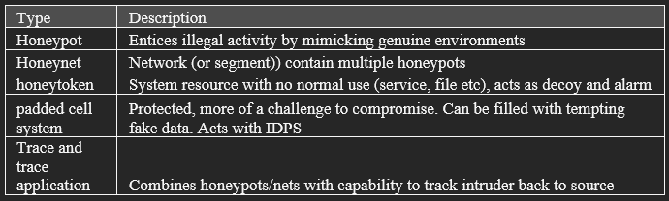

- HHoneypot Legal and ethical issues - [40]
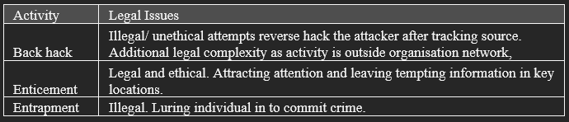

Antivirus/Antimalware

Antivirus and antimalware software protect against viruses, worms, Trojans, and ransomware. While traditional methods like signature detection handle known threats, advanced techniques like heuristic analysis and behaviour blockers are needed for emerging threats. As malware evolves, antivirus solutions must continuously update and incorporate sophisticated detection methods. [41].
AI and ML are both part of the problem and solution for antivirus tools. Recent research on GPT-3 misuse indicates adaptive antivirus systems are needed. AI can generate and obfuscate malware while heuristic and behavioural analysis could detect previously unknown threats. [42].
Leading antivirus providers like Kaspersky, Norton, and McAfee have different focus. Heuristic scanning (Kaspersky) , Regular updates (Norton) and effective virus scanning (McAfee) [41]. No product offers complete protection due to evolving malware, so regular updates and multi-layered security are needed.

Vulnerability Scanners
Vulnerability scanners identify weaknesses in an organisation's infrastructure by scanning networks, systems, and applications, helping to prioritise and address security gaps. Regular scanning is essential for maintaining security and compliance.
Active scanners send probing packets to quickly identify active hosts and services, causing network noise, latency, and triggering IDS alerts. Passive scanners monitor traffic using sniffers without probes, avoiding noise and performance impacts but being slower and unable to detect inactive hosts. Active discovery can cause network congestion, while passive discovery provides slower, less intrusive data gathering [43].
The growth in web application volume and diversity creates a need to explore new methods for identifying vulnerabilities. Traditional approaches, such as Black-box testing for Cross-Site Scripting (XSS) [44] and those described in Table VI, have limitations. Fuzzers, input varied data to uncover vulnerabilities and face complexity challenges in web applications. [45].
- Vulnerability Scanner types - Names reflect the level of access, useful considerations when protecting applications.[45]
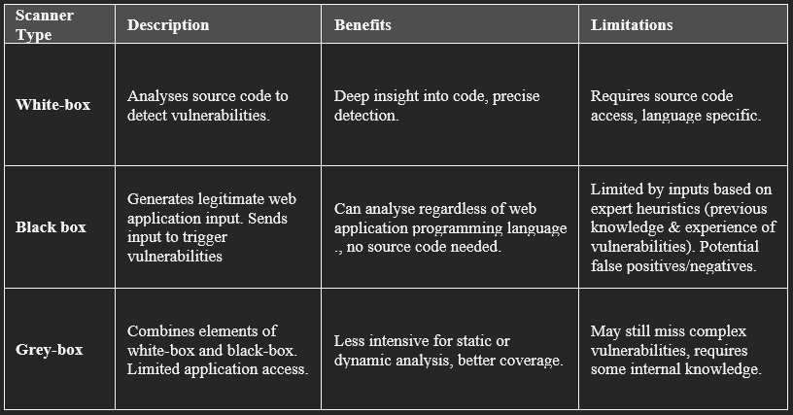

Choosing Security Tools and Processes
IoT technology challenges security due to diverse devices and protocols. The large data volumes from IoT devices strain traditional IDS, making advanced solutions like ML and AI desirable for non-standardised environments [A]. Even advanced tools can fail and create security gaps if not well-matched to the IT environment.
Effective and cost-efficient security requires a careful assessment of needs to align with appropriate tools and processes. Cloud migration to third-party Cloud Service Providers (CSPs) requires a specific understanding of cloud environments and their integration with internal networks. “The IT industry’s rapid cloud growth means customers rent computing power from CSPs but must fully trust them” [46].
AI’s impact on cybercrime and cybersecurity necessitates updating standard approaches. Remote work and BYOD policies demand flexible security measures to address new vulnerabilities.
Identifying security threats early in new systems ensures cost-effective mitigation. Formal methods (FM) using model-based approaches and mathematics offer robust security [47]. Recent incidents, such as CrowdStrike’s, highlight the need for integrating security from design through updates, emphasising the importance of understanding the IT environment for effective incident response and recovery. This underscores the crucial role of continuity and recovery plans when unexpected issues arise.
CrowdStrike's incident illustrates the risks and costs associated with third-party vendors. Improving interactions, understanding, and regular reviews can mitigate these risks. Strategies such as diversity, compartmentalisation, robust backups, and effective testing with phased rollouts protect services and reduce the impact of provider failures. In a BBC interview, Stephanie Hare noted:

“I think this was a process error; this should never have been allowed to happen because you should be testing your software updates and making sure everything is fine before you roll them out... we have had a really big wake-up call about how lacking in resilience our IT systems are” [48].

Effective IT security involves more than just deploying advanced tools; it requires a clear understanding of the architectural complexity, for example setting up of appropriate access controls to areas of the network, strategic planning, and aligning tools with organisational needs and cost considerations. Balancing the CIA triad and managing third-party dependencies are essential components. External security expertise can enhance protection, but it must be complemented by a well-understood and managed internal environment.
A castle relies on visibility (sentries, watchtowers), not simply walls. Likewise organisations need clarity, visibility and monitoring capabilities across their IT environments. By embedding security throughout every stage and making informed decisions on tool deployment, organisations can protect the whole environment.

Securing the Future at ByteBoutique.

Introduction
As ByteBoutique expands its online sales, robust security measures are essential. With a loyal customer base, including some in the EU, maintaining our reputation is crucial. The board is interested in adopting cloud-based services and AI to boost sales and operational efficiency.
This report outlines a roadmap for establishing an information security unit. Providing recommendations, defining key areas and structures. The unit will deliver a secure framework aligned with business strategies during and after transformation, meeting legal commitments [18] [3] and other standards (Table I). NCSC’s 10 Steps to Cyber Security guidance has been reviewed to ensure best practice and due diligence [49-51].
This strategic investment will enhance efficiency, establish a reputable online presence and support ByteBoutique’s future success in a competitive digital landscape.
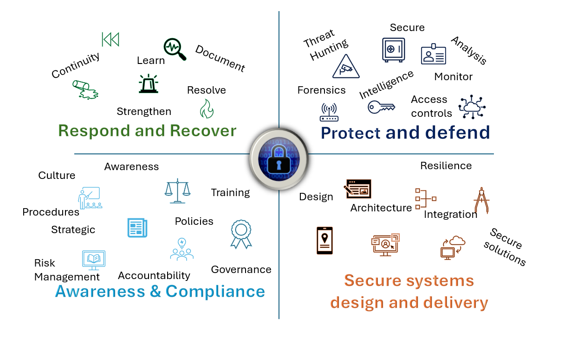
Figure 10 Information Security Unit Aims - ‘Respond and Recover’, ‘Protect and Defend’, ‘Awareness and Compliance’ and ‘Security systems design and delivery.’ Image designed by Z Clark [50]

Approach to Establish the Information Security Unit

Organisational Structure
Effective security strategies involve an evolving array of tools and methodologies (Introduction). For ByteBoutique, clearly defined organisational structure, demonstrated in Fig. 10, is essential to this, particularly during initial phases of online sales platform delivery, expanding cloud-based services and exploring AI.
The proposed organisational structure includes the role of a CISO providing a centralised leader to coordinate and oversee the diverse security requirements, ensuring consistency and strategic alignment by reporting directly to the Chief Executive Officer (CEO) as shown in Fig. 11 (and discussed in Sec. I, B Recruitment should appoint
this role as soon as possible, since the CISO will need to provide leadership and direction from the initial stages (Fig 11, Fig 12).
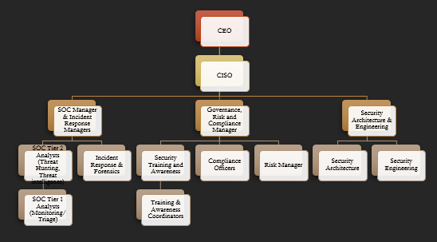
Figure 11: Proposed Organisational Structure - Reporting structure for individual roles. Central managers shown will be central to the stakeholder steering group with the CISO, in addition to heading up departments.

The three main section managers shown in Fig 10 will report directly to and work closely with the CISO and CEO for oversight and coordination of security strategy and governance (Sec. B). These roles will not update policies directly but review with the CISO.
Table VI explains the main roles and responsibilities in further detail. Grouping teams under section managers gathers work with a similar focus and brings expertise in related disciplines together, where working closely may be beneficial for a more co-ordinated approach.
- Role responsibilities and purpose.
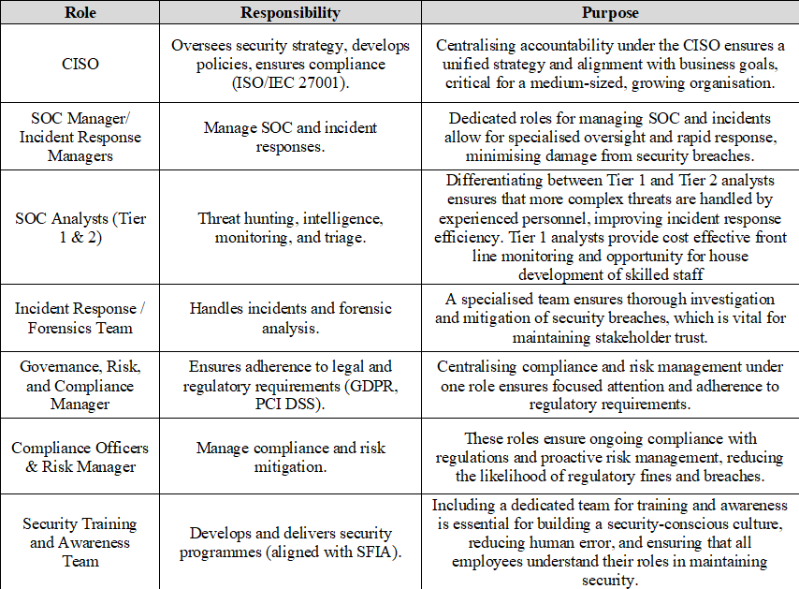
As ByteBoutique develops and launches new applications, it is recommended to include specialists such as Security Operations Centre (SOC) Analysts, Incident Response Teams, and dedicated Security Training and Awareness staff. This will enhance network protection, improve security tool knowledge, and ease transition by building understanding. (Fig 11).
SOC focuses on protection through prevention and identification, managing live incident data. It operates with two layers: a larger Tier 1 for initial detection and a smaller, skilled Tier 2 for in-depth analysis of complex issues. This structure helps balance initial security budgets with effective incident management. While security is vital, spending must be proportionate, investing in the right tools and skilled staff to meet business needs. This setup integrates directly with incident management. This area feeds directly across to incident management.
Incident Management focuses on responding to incidents as they arise and conducting follow-up assessments. Forensics, aligned with incident management, provides essential analysis to understand breaches, gather evidence, and support mitigation.
Governance, Risk, and Compliance (GRC) oversees training, risk identification, development of secure policies, and ensuring compliance with regulatory requirements. Training initiatives develop a culture of security awareness among employees. This includes deterrence of insider threats by accident or design through awareness of responsibilities and consequences of non-compliance. It also feeds across into all the other areas to ensure the organisation and unit itself is compliant (Fig. 11)
Security Architecture and Engineering roles are vital for protecting the organisation during development and deployment. Although some tasks may be outsourced due to cost and expertise, a dedicated role within ByteBoutique is essential to address security concerns and ensure alignment with organisational goals. The CrowdStrike incident, as discussed in Section 1, underscores the risks and impacts at network entry points. Understanding these impacts on our architecture is crucial for effective security management [50].
As ByteBoutique has limited IT hiring experience across specialised roles The Skills Framework for the Information Age (SFIA) [50] is recommended for defining and hiring skilled data owners and decision-makers (Section I, B). Supported by the CISO's expertise, HR will effectively establish these roles, ensuring organisational structure supports strategic objectives.
The proposed structure aims to improve oversight and efficiency by clearly defining responsibilities, preventing gaps and overlaps. It will enhance communication and decision-making, ensuring timely information flow to protect ByteBoutique's assets and reputation. This approach will enable swift responses to security incidents and promote a strong security culture among employees.
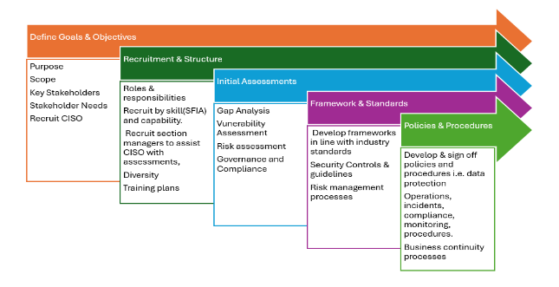
Figure 12: Proposed steps for Setting up the Security Unit. May involve overlapping activities; however, there is a suggested initiation point to ensure a methodical approach and the correct resources skills and expertise available. Image designed by Z Clark [51]

Policies and Procedures
Clear, comprehensive policies and procedures is essential for legal compliance and effective security. These documents must be accessible to all staff and provide a consistent framework for security practices. The CISO will oversee this, collaborating with the CEO and board to align practices with business needs. The Risk and Compliance Manager will report to the CISO and ensure policies are up to date
- Key Policies Table - Standards and guidance cover a range of suggested policies the size of the table demonstrating the need for skilled specialised staff [8][52]
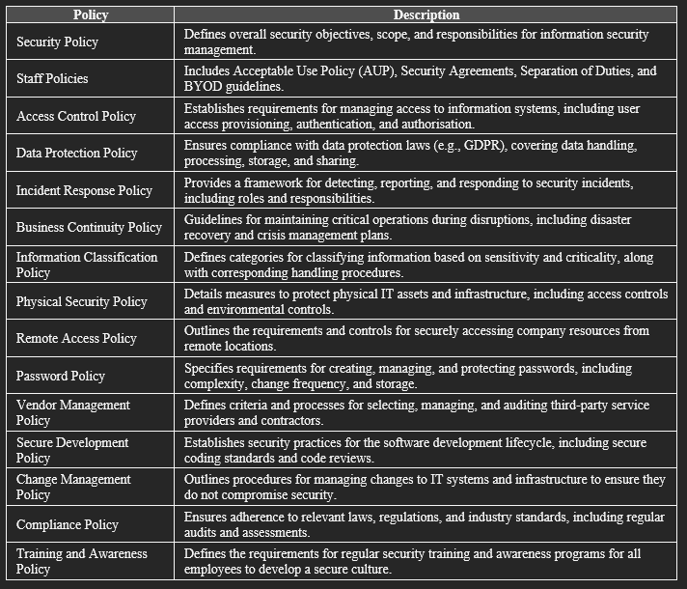
- Standards for consideration [5 ] [8] [53]
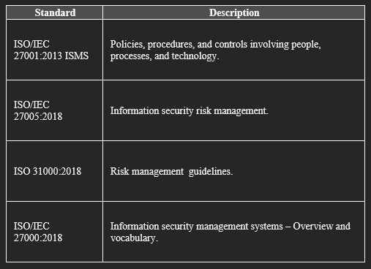
Key policies should be developed in alignment with industry standards [8], as highlighted in Tables 1 and 8. ByteBoutique’s managers have expressed interest in Software as a Service (SaaS) solutions (See Table II) and third-party developers, clear guidelines and controls to manage these relationships are needed. Drawing on the discussion in section 2.6, responsibilities and expectations around risk management, access and practice should be set out all involved. Ensuring compliance [2] [4] builds trust with customers and partners, protecting ByteBoutique’s reputation and finances. GDPR [55], applies to the EU customers (based on their location not the data’s). It also meets duty of care to customers, staff and stakeholders, aligning well with ByteBoutique’s ethical business model.
Continuous monitoring of legislative changes is essential for maintaining compliance and avoiding potential penalties. By proactively planning for new regulations, cost-effective solutions can be implemented.

Governance and Strategic Planning for Security
The importance of governance is discussed in section 1.1, effective governance ensures consistent implementation and adherence of strategy, policies and procedures. It ensures accountability by defining roles and responsibilities and supporting data owners across the business.
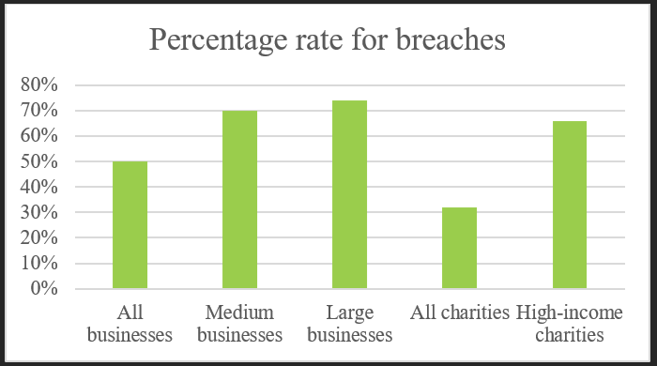
Figure 13: Rate of breach by business type – Statistics showing common breaches or attacks, in the last 12 months (Published 9 April 2024). [56]
The Governance team will work closely with the security steering committee which involves key stakeholders from various departments. This committee will oversee strategy and high-level decisions. Working on their direction, Governance and Compliance can assist with security reports and metrics, updating policy and procedural documentation for review and communication of changes. This also feeds into the work of risk e.g. review of control effectiveness from compliance.
Applying the NCSC's governance principles ensures that security measures are robust, align with the overall business strategy, and foster a culture of security awareness and continuous improvement.

Secure by Design
‘Secure by Design’ builds in security considerations from design to deployment to maintenance. It addresses potential vulnerabilities early and systematically reducing risk. During the design phase, security requirements are set out with the functional requirements. Threat modelling can identify potential vulnerabilities.
In the development phase, secure coding practices should be enforced, and code reviews should include security assessments. Testing phases should involve security testing, including penetration testing and code analysis, to identify and rectify vulnerabilities.
Finally, deployment and maintenance should involve continuous monitoring and regular security audits to ensure ongoing security compliance and address new threats. [50] [57] This approach aligns with best practices and frameworks mentioned in Table I.

Cloud and AI Considerations
Adopting cloud-based services and AI presents unique security challenges and opportunities. As discussed in Sec. I, C and responsibilities explained in Table VII ByteBoutique must ensure these technologies are deployed securely to maximise benefits while minimising risks. Responsibilities should be considered as seen in Table VII
For cloud security, data protection measures should include encryption to secure data at rest and in transit, with access controls implemented to ensure that only authorised users can access sensitive data. Compliance with relevant regulations must be ensured, with regular audits and assessments conducted to verify compliance. Standard ISO/IEC 27017:2015 [7] is suggested as relevant for review as part of establishing the security unit and setting out its strategies and scope.
For AI security, data privacy must be ensured, complying with data protection regulations and data anonymisation techniques where appropriate. AI models must be protected to protect training data. Ethical considerations are important to ByteBoutique so specific conversations and reviews will be needed early to ensure decisions made by AI implementations are transparent and fair, with safeguards implemented to prevent bias and discrimination in AI systems. [58].

Tailored Security Solutions for ByteBoutique: Finding the Right Tools and Techniques
IDPS are essential for detecting and preventing unauthorised access and malicious activities. Reviewing Sec.1 and considering Table III, it is recommended that a hybrid approach be explored. This option can improve detection and reduce false alarms allowing staff to focus more on threats. ByteBoutique needs a solution that align with its specific needs and resource capabilities. Snort is one example of open-source model that may be a cost-effective option. As the organisation expands further review of more advance technology integration may be more practical so budget and expertise requirements. It is recommended that early conversations are held with the CISO and SOC Manager & Incident Response Managers
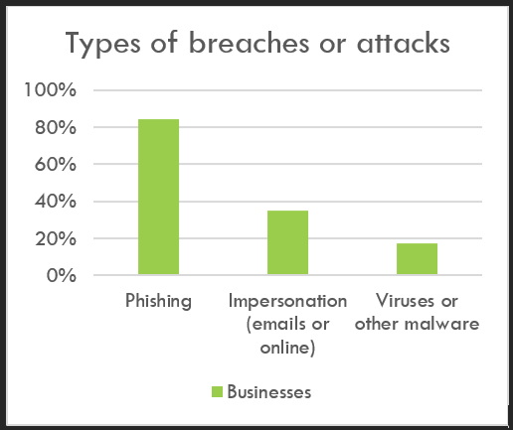
Figure 14: Rate of breach by type – Statistics showing common breaches or attacks, in the last 12 months (Published 9 April 2024). [56]
Using the NCSC's principles, and threat intelligence (Sec D) a range of controls and tools (Sec D) can be adopted and aligned with the overall business strategy. Honeypot are not recommended at this stage due to current limited expertise which could impact understanding of legal complexities as discussed in section 3. The CISO will be able to provide more direction on this.

Risk Management
Proactive risk management processes identify, assess, and mitigate security risks. Regular evaluations are conducted to identify vulnerabilities and threats, prioritising them. The matrix in Fig 16 uses horizontal and vertical scales to review potential impact to the organisation and likelihood of it occurring. Items with high occurrence and impact stand out as clear priorities for resource and urgency. Identifying key activities will be important and the ISO family of standards is recommended as a starting point for this process. Implementing technical, procedural and physical controls to manage the risks as described in Fig. 8, under ‘Response or Countermeasure’. Fig 15 shows the cyclical process with feedback making continual improvements before the steps are repeated.
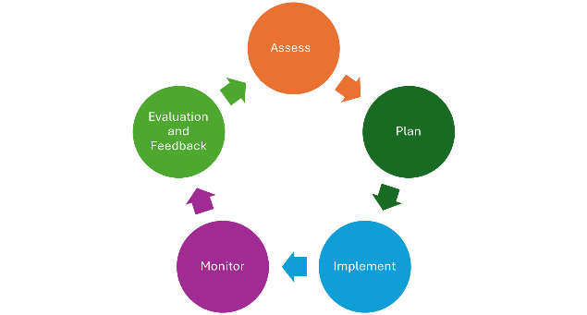
Figure 15: Risk Management Cycle. Process cycles through each step. Evaluation feed into assessment for improvement. Image designed by Z Clark [40]
Regular evaluations are needed to identify vulnerabilities and threats, prioritised based on potential impact and likelihood, (as detailed in the risk assessment section in Section 1. Risk assessments help us understand the nature of risks, the potential impacts, and decide on risk treatment (listed in Figure 8), usually documented in a risk register. This proactive approach reduces unexpected issues and maintains the balance of confidentiality, integrity, and availability (CIA). However, despite thorough planning, not all risks can be predicted, and new threats will continue to emerge.
The CEO working with the CISO will define the risk appetite which will influence the approach to mitigation/ countermeasures. Timely and effective communication of risks to stakeholders, supported by regular updates and training programmes, ensures that all stakeholders are aware of potential risks and their roles in mitigating them.
Using a RAG (Red, Amber, Green) matrix helps document and highlight risk focus areas, enabling quick identification and prioritisation of actions based on their severity (Fig 16). Regular risk assessments help understand risks and the likelihood of them becoming incidents to prioritise mitigation.
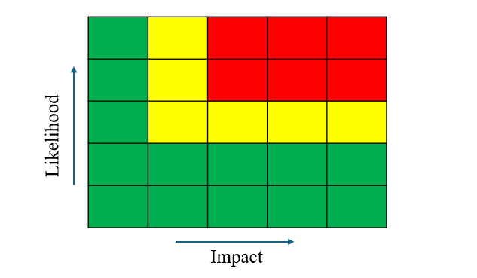
Figure 16: Risk matrix - Prioritising method using Red, Amber and Green based on likelihood of risk occurring and impact on the business. Assessment can be qualitative (narrative and context) or quantitative (numerical). Image designed by Z Clark [59].

VII. Contingency Planning
Contingency planning will allow ByteBoutique to maintain key operations during unforeseen events. This involves preparing for a range of emergencies and establishing plans to mitigate disruptions informed by the examples in table 8.
The Business Continuity Plan (BCP). Identifies critical business functions and dependencies, with procedures and resources for maintaining operations during disruptions while the Disaster Recovery Plan (DRP) guides recovering data and systems, including strategies for data backup, system recovery, and restoration. The Crisis Management Plan. Details communication and decision-making procedures during a crisis, ensuring a coordinated response.
Regular drills and updates ensure the effectiveness and currency of contingency plans. Regular testing ensures that contingency plans are practical and effective, providing confidence in the organisation's ability to handle crises and the steering committee can co-ordinate lessons learned discussions.
Compliance with UK laws, frameworks, and standards, as shown in tables 1 and 9 will form a useful base when establishing planning scope and initial processes/ plans.

Protection Mechanisms

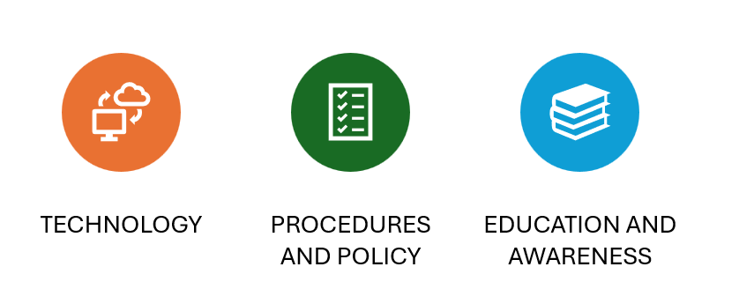
Figure 17: Methods of protection – proposed overall goals for alignment with Information security unit strategy. Image by Z. Clark.
Several topics should be presented to the CISO for initial discussion.
Implementing Multi-Factor Authentication (MFA) could add an extra layer of security, preventing unauthorised access e.g. if passwords are compromised. Trialling MFA within the new unit will enhance security for sensitive access and provide valuable feedback from staff with additional expertise.
Endpoint protection across the network should be reviewed to include antivirus and anti-malware solutions as outlined in Sec 4. The network, responsible for data movement, is vulnerable to breaches from unwanted communications and threats, as in Figure 8. Enhancing email security and other entry points can be addressed using the proposed expertise shown in Fig 11.
Regular patching and updates are crucial to keeping systems and applications secure by addressing vulnerabilities, as demonstrated by the CrowdStrike incident in Sec. E. The unit will manage the planning, testing, and rollout of these updates to mitigate potential risks.
Robust controls are vital for safeguarding information and systems against cyber threats. Advanced security measures will ensure data integrity, confidentiality, and availability.

Conclusion
As cyber threats evolve, proactive planning and informed response will have the best chance of success in protecting data security. The CrowdStrike incident highlights the importance to ByteBoutique of integrating security measures across all processes and having robust recovery plans.
As cyber threats evolve, proactive planning and informed responses will have the best chance of success in protecting data security. The CrowdStrike incident highlights the importance for ByteBoutique of integrating security measures across all processes and having robust recovery plans.
Future-focused strategies should address emerging threats and security innovations. Effective IT security involves more than advanced tools; it requires understanding and reducing architectural complexities. Aligning security tools with organisational needs and balancing confidentiality, integrity, and availability (CIA) are central to this strategy.
The new unit will establish robust frameworks and controls to protect data, prevent disruptions, and safeguard revenue. By implementing regular updates, conducting continuous reviews, and fostering an informed security culture at every level, ByteBoutique will enhance its resilience and strengthen customer trust. This proactive approach will enable the organisation to focus on driving growth and thriving in the industry.

Further work
Future research would look to explore the impact of third-party services, such as cloud services, AI-driven tools or Security as a Service (SecaaS) on security strategies. This research would also examine the roles in these areas of risk transfer, duty of care, and contracts in supporting effective controls.
REFERENCES
[1] H. Li, Y. Wu, D. Cao, and Y. Wang, “Organizational mindfulness towards digital transformation as a prerequisite of information processing capability to achieve market agility,” Journal of business research, vol. 122, pp. 700–712, 2021, doi: 10.1016/j.jbusres.2019.10.036
[2] The National Archives, “Data Protection Act 2018”, legislation.gov.uk. [Online] Available: https://www.legislation.gov.uk/ukpga/2018/12/contents/enacted pub The national archives [Accessed Jun 16, 2024]
[3] The National Archives, “Data Protection Act 2018”, legislation.gov.uk. [Online] Available: https://www.legislation.gov.uk/ukpga/2018/12/contents/enacted pub The national archives [Accessed Jun 16, 2024]
[4] PCI Security Standards Council, “PCI DSS: v4.0?”, pcisecuritystandards.org, (Mar, 2022) [Online] Available: https://www.codecademy.com/resources/blog/kernel/ [Accessed Jun 16, 2024]
[5] ISO, “ISO/IEC 27000 family”, iso.org,[Online] Available: https://www.iso.org/standard/iso-iec-27000-family [Accessed Jun 16, 2024]
[6] NCSC, “Cyber Essentials Overview”, ncsc.gov.uk, [Online] Available: https://www.ncsc.gov.uk/cyberessentials/overview [Accessed Jul, 7, 2024]
[7] ISO, “ISO/IEC 27017:2015”, iso.org,[Online] Available: https://www.iso.org/standard/43757.html [Accessed Jun 16, 2024]
[8] ISO, “ISO/IEC 27003:2017”, iso.org,[Online] Available: https://www.iso.org/standard/63417.html [Accessed Jun 16, 2024]
[9] ISO, “ISO/IEC 27000:2018(en)”, iso.org, [Online] Available: https://www.codecademy.com/resources/blog/kernel/ [Accessed Jul 13, 2024]
[10] K. Razikin and B. Soewito, “Cybersecurity decision support model to designing information technology security system based on risk analysis and cybersecurity framework,” Egyptian informatics journal, vol. 23, no. 3, pp. 383–404, 2022, doi: 10.1016/j.eij.2022.03.001. p383
[11] M. Suorsa, & P. Helo, “Information security failures identified and measured – ISO/IEC 27001:2013 controls ranked based on GDPR penalty case analysis,” Information Security Journal: A Global Perspective, vol. 33, no. 3, pp. 285–306, 2023, doi: 10.1080/19393555.2023.2270984
[12] IBM, “Cost of a Data Breach Report 2024”, ibm.com, [Online] Available: https://www.ibm.com/reports/data-breach?utm_content=SRCWW&p1=Search&p4=43700075239447581&p5=e&p9=58700008280240525&gad_source=1&gclid=Cj0KCQjwtZK1BhDuARIsAAy2Vzs6L9xmXPcHVBYIk6E5-Lg9ADcs0in37H4UIMjrIUtdTmMfVbo5MZQaAlVEEALw_wcB&gclsrc=aw.ds [Accessed Jun 23, 2024]
[13] NCSC, “Cyber Essentials Overview”, ncsc.gov.uk, [Online] Available: https://www.ncsc.gov.uk/cyberessentials/overview [Accessed Jul, 7, 2024]
[14] H. E. Amin et al, "An Integrated Approach to Cyber Risk Management with Cyber Threat Intelligence Framework to Secure Critical Infrastructure," Journal of Cybersecurity and Privacy, vol. 4, (2), pp. 357, 2024.
[15] A. Mughaid, I. Obeidat, L. Abualigah, S. Alzubi, M. S. Daoud, and H. Migdady,
“Intelligent cybersecurity approach for data protection in cloud computing based Internet of Things,” International journal of information security, vol. 23, no. 3, pp. 2123–2137, 2024, doi: 10.1007/s10207-024-00832-0.
16] NCSC, “Device Security Guidance”. ncsc.gov.uk, [Online] Available: https://www.ncsc.gov.uk/collection/device-security-guidance/infrastructure/enterprise-authentication-policy [Accessed Jul, 7, 2024]
[17] K. Jawaharrani, R. S. Lekshmi, G. Nirmala, and K. Dheenadhayalan, "Role of CISO - Cyber Security & Risk Management," 2023 International Conference on Advances in Computing, Communication and Applied Informatics (ACCAI), Chennai, India, 2023, pp. 1-5, doi: 10.1109/ACCAI58221.2023.10200017.
[18] S. Perera, X. Jin, A. Maurushat, and D.-G. J. Opoku, “Factors Affecting Reputational Damage to Organisations Due to Cyberattacks,” Informatics (Basel), vol. 9, no. 1, pp. 28-, 2022, doi: 10.3390/informatics9010028. Page 13 (derived from tables 4, 5, 6,)
[19] A. S. and S. D., “Understanding insiders in cloud adopted organizations: A survey on taxonomies, incident analysis, defensive solutions, challenges,” Future generation computer systems, vol. 158, pp. 427–446, 2024, doi: 10.1016/j.future.2024.04.033.
[20] Codecademy Team, “About Cyber Essentials?”, talosintelligence.com, [Online] Available: https://talosintelligence.com/ [Accessed Jul, 24, 2024]
[21] Microsoft, “Security Update Guide” microsoft.com, [Online] Available: https://msrc.microsoft.com/update-guide/vulnerability [Accessed Jul, 24, 2024]
[22] A. Jeyaraj, A. Zadeh, and V. Sethi, “Cybersecurity Threats and Organisational Response: Textual Analysis and Panel Regression,” Journal of Business Analytics, vol. 4, no. 1, pp. 26–39, 2021. doi: 10.1080/2573234X.2020.1863750. – pages 27-29
[23] Financial Times, “London hospitals declare critical incident after cyber attack” ft.com, [Online] Available: https://www.ft.com/content/64ac2bd3-7bff-4323-9263-c70fa0b6ca51 [Accessed Jun, 15, 2024]
[24] Synnovis “Security Update Guide” synnovis.co.uk, [Online] Available: https://www.synnovis.co.uk/news-and-press/synnovis-cyberattack [Accessed Jun, 15, 2024]
[25] R. Pereira, J. B. de Vasconcelos, Á. Rocha, and I. S. Bianchi, “Business process management heuristics in IT service management: a case study for incident management,” Computational and mathematical organization theory, vol. 27, no. 3, pp. 264–301, 2021, doi: 10.1007/s10588-021-09331-2.
[26] [L] M. Thangavelu, V. Krishnaswamy, and M. Sharma, “Impact of comprehensive information security awareness and cognitive characteristics on security incident management – an empirical study,” Computers & security, vol. 109, pp. 102401-, 2021, doi: 10.1016/j.cose.2021.102401
[27] Radu Moisescu and Aurel – Mihail Țîțu, “Improving intellectual property data security at the organizational level as a result of streamlining quality management,” Journal of Research and Innovation for Sustainable Society, vol. 6, no. 1, pp. 88–97, 2024, doi: 10.33727/JRISS.2024.1.11:88-97.
[28] S. N, G. T, R. S. R, A. Sungheetha, C. R, and S. Hamsanandhini, "Secured and Optimized Application Delivery Service in Public Cloud," 2024 4th International Conference on Innovative Practices in Technology and Management (ICIPTM),
[29] P. T. Kalpeshkumar, S. Patel, K. Krimilkumar, B. D. Anilbhai, A. Patel, and A. Nayak, "Navigating the Cloudscape: Framework and Strategies for Seamless Migration to the Cloud," 2024 3rd International Conference on Applied Artificial Intelligence and Computing (ICAAIC), Salem, India, 2024, pp. 1298-1302, doi: 10.1109/ICAAIC.2024.00050.
[30] V. Bhatia, S. Choudhary and K. R. Ramkumar "A Comparative Study on Various Intrusion Detection Techniques Using Machine Learning and Neural Network," presented at the 2020 8th International Conference on Reliability, Infocom Technologies and Optimization (ICRITO), Noida, India, 2020, pp. 232-236, doi: 10.1109/ICRITO48877.2020.9198008.
[31] C. Fan, N. M. Kaliyamurthy, S. Chen, H. Jiang, Y. Zhou, and C. Campbell, “Detection of DDoS Attacks in Software Defined Networking Using Entropy,” 2021.
[32] B. J. Saunders, P. Kisanga, G. H. S. Carvalho, and I. Woungang, “A Graph Convolutional Networks-Based DDoS Detection Model,” in 2024 IEEE International Systems Conference (SysCon), IEEE, 2024, pp. 1–5. doi: 10.1109/SysCon61195.2024.10553611.
[33] M. A. Hossain,Working Principle of IDPS” researchgate.net, [Online] Available: https://www.researchgate.net/publication/348269149_SDN_based_Intrusion_Detection_and_Prevention_Systems_using_Manufacturer_Usage_Description_A_Survey/figures?lo=1 [Accessed Jul, 9, 2024]
[34] M. Hristov, M. Nenova, G. Iliev and D. Avresky, "Implementation of Splunk Enterprise SIEM for Improved Security Posture," presented at the 2021 IEEE 20th International Symposium on Network Computing and Applications (NCA), Boston, MA, USA, 2021, pp 1-5 doi: 10.1109/NCA53618.2021.9685977.
[35] T. Krüger, L. Faulhaber, L. Hermerschmidt, S. Mödersheim, "Securing Your Crypto-API Usage Through Tool Support - A Usability Study," in Proc. 2023 IEEE Secure Development Conference, San Diego, CA, USA, 2023, pp. 1-8, doi: 10.1109/SecureDev.2023.1234567.
[36] S. D. Çakmakçı, H. Hutschenreuter, C. Maeder and T. Kemmerich, "A Framework For Intelligent DDoS Attack Detection and Response using SIEM and Ontology," 2021 IEEE International Conference on Communications Workshops (ICC Workshops), Montreal, QC, Canada, 2021, pp. 1-6, doi: 10.1109/ICCWorkshops50388.2021.9473869. p6
[37] S. M. Z. U. Rashid, A. Haq, S. T. Hasan, M. H. Furhad, M. Ahmed, and A. B. Ullah, “Faking smart industry: exploring cyber-threat landscape deploying cloud-based honeypot,” Wireless networks, vol. 30, no. 5, pp. 4527–4541
[38] U. Bartwal, S. Mukhopadhyay, R. Negi, and S. Shukla, "Security Orchestration, Automation, and Response Engine for Deployment of Behavioural Honeypots," 2022 IEEE Conference on Dependable and Secure Computing (DSC), Edinburgh, United Kingdom, 2022, pp. 1-8,
[39] N. Nagy et al., “Quantum Honeypots,” Entropy (Basel, Switzerland), vol. 25, no. 10, pp. 1461-, 2023, doi: 10.3390/e25101461.
[40] M. E. Whitman and H. J. Mattord, Principles of information security, Seventh edition. Boston, MA: Cengage, 2022.
[41] C. Rohith and G. Kaur, "A Comprehensive Study on Malware Detection and Prevention Techniques used by Anti-Virus," 2021 2nd International Conference on Intelligent Engineering and Management (ICIEM), London, United Kingdom, 2021, pp. 429-434, doi: 10.1109/ICIEM51511.2021.9445322.
[42] M. Botacin, "GPThreats-3: Is Automatic Malware Generation a Threat?," 2023 IEEE Security and Privacy Workshops (SPW), San Francisco, CA, USA, 2023, pp. 238-254, doi: 10.1109/SPW59333.2023.00027.
[43] E. Chikohora and L. Mogomeli, "A Study on the Impact of Network Vulnerability Scanners on Network Security," 2021 3rd International Multidisciplinary Information Technology and Engineering Conference (IMITEC), Windhoek, Namibia, 2021, pp. 1-4, doi: 10.1109/IMITEC52926.2021.9714598.
[44] T. Zhang, H. Huang, Y. Lu, K. Zhu, and J. Zhao, “State-Sensitive Black-Box Web Application Scanning for Cross-Site Scripting Vulnerability Detection,” Applied sciences, vol. 13, no. 16, pp. 9212-, 2023, doi: 10.3390/app13169212.
[45] T. Krüger, L. Faulhaber, L. Hermerschmidt, and S. Mödersheim, "Witcher: A Novel Web Vulnerability Discovery Framework," presented at the 2023 IEEE Symposium on Security and Privacy (SP), San Francisco, CA, USA, May 21-25, 2023. Available: doi: 10.1109/SP46215.2023.10179317.
[46] M. Li, Y. Yang, G. Chen, M. Yan, and Y. Zhang, “SoK: Understanding Design Choices and Pitfalls of Trusted Execution Environments,” in Proceedings of the 19th ACM Asia Conference on Computer and Communications Security, New York, NY, USA: ACM, 2024, pp. 1600–1616. doi: 10.1145/3634737.3644993.
[47] T. Kulik et al., “A Survey of Practical Formal Methods for Security,” 2022, doi: 10.1145/3522582.
[48] S. Hare, "Fallout from the CrowdStrike Global IT Outage," BBC Breakfast, N. Munchetty and C. Stayt, 20 Jul. 2024. [Online]. Available: https://www.bbc.co.uk/iplayer/episode/m0021c4d/breakfast-20072024.
[49] NCSC, “10 Steps to Cyber Security?”, ncsc.gov.uk, [Online] Available: https://www.ncsc.gov.uk/collection/10-steps [Accessed Jul, 28, 2024]
[50] - QA Ltd., “BCS Certificate in Information Security Management Principles (CISMP),” Remote Course, V6.0 PDF notes, QA Ltd., based on BCS CISMP 3rd edition, Jan.–Mar. 2024.
[51] - A. Taylor, D. Alexander, A. Finch, D. Sutton, and A. Taylor, Information Security Management Principles, 3rd ed., Swindon, U.K.: BCS, The Chartered Institute for IT, 2020.
[52] ISO/IEC 27002:2013, "Information technology — Security techniques — Code of practice for information security controls," ISO, 2013.
[53] [2] ISO, “ISO/ IEC 27005:2022”. www.iso.org, [Online] Available: https://iso.org/standard/80585.html [Accessed Jul, 20, 2024]
[54] ISO, “ISO 31000:2018 - Risk management A practical guide”. iso.org, [Online] Available: https://www.iso.org/publication/PUB100464.html [Accessed Jul, 20, 2024]
[55] ICO, “Overview – Data Protection and the EU”. ico.org, [Online] Available: https://ico.org.uk/for-organisations/data-protection-and-the-eu/overview-data-protection-and-the-eu/ [Accessed Jul, 20, 2024]
[56] Department for Science Innovation and Technology, “Cyber security breaches survey 2024”. gov,uk, (Apr, 9, 2024) [Online] https://www.gov.uk/government/statistics/cyber-security-breaches-survey-2024/cyber-security-breaches-survey-2024#chapter-3-approaches-to-cyber-security [Accessed Jul, 25, 2024]
[57] [2] NIST, “Security and Privacy Controls for Information Systems and Organizations”, nist.gov, (Dec 19, 2023) [Online] Available: https://csrc.nist.gov/pubs/sp/800/53/r5/upd1/final#:~:text=This%20publication%20provides%20a%20catalog,human%20errors%2C%20natural%20disasters%2C%20structural/ [Accessed Jun, 20, 2024]
[58] European Commission, “Ethics guidelines for trustworthy AI”, ec.europa.eu, (Apr 08, 2019) [Online] Available: https://digital-strategy.ec.europa.eu/en/library/ethics-guidelines-trustworthy-ai [Accessed Jul, 28, 2024]
[59] - G. Gray et al., “Assessing aeromedical risk: a three-dimensional risk matrix approach,” Heart (British Cardiac Society), vol. 105, no. Suppl 1, pp. s9–s16, 2019, doi: 10.1136/heartjnl-2018-313052

