
ApproAch to innovation and organisational change
ACMA5007 – Management, Innovation and Sustainability

May 11, 2025
University of Wales Trinity Saint David

Executive Summary
The purpose of this report is to analyse the effect of “shift culture” and years of limited management during out-of-hours proceedings. An in-depth analysis reveals that unsustainable management practices such as abrupt dismissals of employees without the correct transitional support have resulted in a toxic work environment. The practices used by Dow Chemical not only undermine their long-serving employees but also destabilise the company’s operational efficiency.
To dissect the challenges of a negative “shift culture”, the report utilises a range of change management models including Lewin’s Force Field Analysis and Three Step Model, Kotter’s Eight Step framework and Vroom’s Expectancy Theory. By using these models as a basis for comparison to the way Dow faced this organisation change, it becomes clear that the failure to implement structured change strategies has magnified the existing issues. For instant, the approach of dismissing long-serving employees has lowered the trust between the shop-floor employees and management. This has led to employees being disengaged, unmotivated and even looking for work elsewhere. Although the use of these management models could have provided Dow with the necessary framework to transform these challenges into opportunities. Key recommendations include having clear communication channels, implementing support systems, and allowing employees to learn from their first mistakes.
The report recommends that Dow Chemical should consider using these management models in any future organisational change, as they ensure that higher management takes into account the opinions of middle managers and shop floor employee’s perspectives. Even though technicians understand that sleeping during a nightshift is not allowed, wearing the incorrect PPE and failing to get a permit breaking Dow’s cardinal rule. Dismissing employees for the first mistake they have made in over a decade long career at the company does not reflect well on the company.

Table of Contents
Executive Summary 1
Introduction 3
Main Findings 4
Driving Forces behind the change 5
Lewin’s Force Field Analysis 6
Top-Down Change 6
Management Models 7
Lewin’s Three Step Process 7
Kotter’s 8-step Change Model 9
Motivational Models 10
V.H Vroom Expectant Theory 10
Conclusion 11
Bibliography 12

Introduction
Dow Chemical is an American company that produces silicone. The company has operated its Barry site in South Wales for over fifty years. Employing over 850 staff and 550 contracted labours, the site produces silicone-based products which get sold to several different companies across many industries. This site is considered a top-tier COMAH site, this rating is used to prevent any major accidents involving dangerous substances and to mitigate the effects on people and the environment (HSE , 2025).
Within the on-site Mechanical Maintenance Department, there are ten shift technicians, eleven-day shift technicians and five rotating equipment technicians. Within one month four shift technicians were dismissed. Higher management witnessed the lack of procedure usage and behaviours during out-of-hours shifts, and wanted to make a change. To implement this change they sent a clear message by terminating employment of individuals that did not follow the correct rules. Although employees believe that these dismissals were unfair as it was the four individuals first mistake. Leading to a negative organisational change and damaging the relationship between management and technicians.
Change management models offer a structured approach to guide companies during difficult transitions, such as moving away from the rigid “shift culture” and addressing the lack of procedure usage during out-of-hours operations. Approaches like Lewin’s change model and Kotter’s 8-step process provide a structured approach to implementing and planning an organisational change (HRM Handbook, 2025).

Main Findings
The site operates twenty-four hours a day, shift workers are scheduled from 6:00 to 18:00 and follow a five-week pattern, while the day techs work Monday to Friday from 8:00 to 16:30. Consequently, there is an extended period when management is not present for shift workers, resulting in a significant gap in out-of-hours supervision. This gap has led to two serious incidents within a short period.
Within one month, four shift technicians were suspended on full pay due to related incidents and later dismissed. On the nightshift of September 5th 2024, at approximately 11pm, a shift technician broke into a strainer which was full of chlorosilanes, this chemical is highly corrosive and when made contact with eyes and skin it can severely irritate them (New Jersey Department of Health and Safety , 2004). This individual made the mistake of opening the wrong strainer without notifying the operator therefore, working without a permit and entered the plant without permission. Subsequently this strainer was not isolated and not ready for maintenance which resulted in a large chemical spill. Moreover, the individual was wearing the inappropriate PPE for the job, the PPE required for working with chlorosilanes is full level B which is the second-highest level of protection (SafeOpedia, 2018). As seen from the table below level B is a significant amount of PPE and the individual had the minimum PPE required to be on site with an additional dust suit which is not chemically resistant.
Level B – PPE | Individuals PPE
Chemical wellies | Steel toe capped boots
Chemical suit and hood | Dust suit (not chemical retardant)
Respirator with chemical filters

Chemical gloves | Cut proof gloves
Duct tape around ankles and wrists

When an incident like this occurs, the individuals should immediately stand underneath a safety shower for at least 15 minutes, this ensures thorough decontamination (Youth Filter, 2022). The shower also acts as an alarm which is sent to the gatehouse and to the on-site BERT (Barry Emergency Response Team). BERT are on-site shift technicians that are trained to respond to these calls. The shift partner activated the shower although the technician who experienced the spill walked back to the workshop. Roughly 170 yards to the male changing room and had a shower there. As shown in figure 1, this walk would have taken two minutes. Not following site standards of using the safety shower was anther protocol broken.
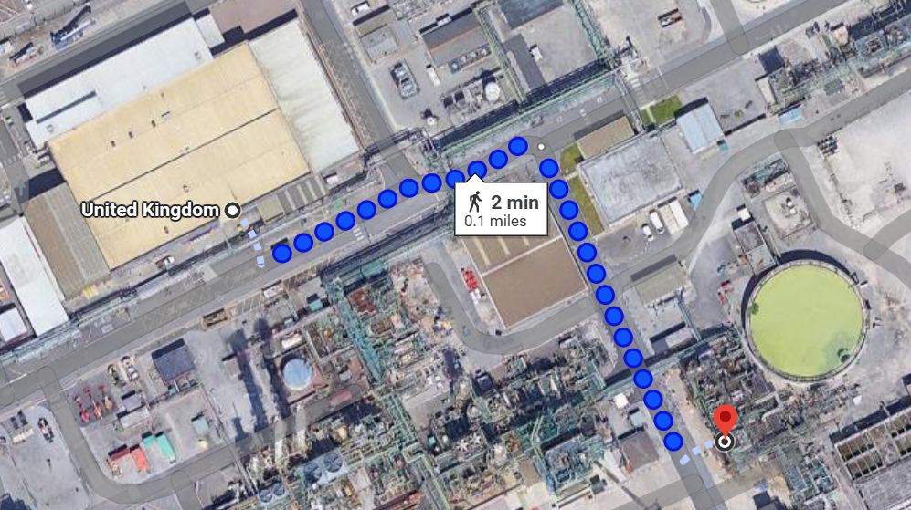
Figure 1 – Google Maps

Driving Forces behind the change
This incident sparked an opportunity for a larger investigation into the out-of-hours and so called “shift culture” on site. The “shift culture” is the unwritten rules for how shift workers behave (Saffron, 2024). Higher management could not comprehend why a Dow shift technician with over twenty years’ experience on site would;
- Work without a permit
- Fail to contact the operators to inform them of any ongoing maintenance activity
- Wear the incorrect PPE when dealing with such harmful chemicals
With the annual site shutdown scheduled in two weeks, higher-management decided to ensure that a manager was present on site at all times throughout the eight-week period. The shutdown began on 20th September 2024. During the nightshift of 25th of September, the site manager discovered that between 3am-5am employees would sleep. The site manager found two mechanical technicians sleeping in the break room with lights off and boots off. As expected, he found this behaviour appalling and decided a change was required.

Lewin’s Force Field Analysis
Lewin’s forcefield analysis is a powerful framework that helps resolve a need for change within an organisation (6 sigma, 2024). It’s a powerful tool used to understand and manage a change within an organisation (Ricardo, 2024).
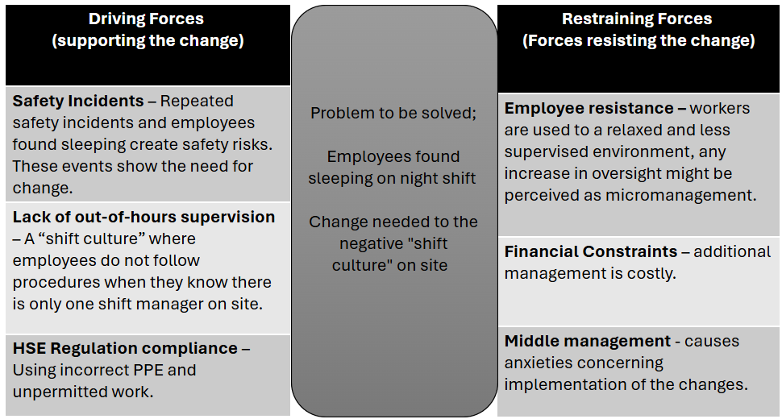
This model is used to help companies transition from one fixed state to another, also known as equilibrium (Tahir, 2019). Change occurs either by strengthening the driving forces or by weakening the restraining forces (Tahir, 2019). To assist this transition, Dow should focus on strengthening the driving forces. Leveraging the safety incidents and HSE regulatory compliance failures as concreate evidence as the need for change. Although restraining forces may be “stuck in their ways”, these safety incidents clearly indicate that change is necessary because not all current behaviours are beneficial. According to Change Management Insight, the model is easy to use and provides a professional tool for companies to better understand the situation (Tahir, 2019). However, SixSigma.us argues that participants may focus too narrowly on the forces they directly control, rather than considering every aspect of the influencing forces (6 sigma, 2024).

Top-Down Change
This type of change is referred to as top-down, where higher management drives and implements the transformation (Panorama Consulting Group , 2024). The decision was made at an executive level and communicated down the hierarchy. The leader defines the strategy and outline the requirements employees must follow to achieve a desired change (Panorama Consulting Group , 2024). In this case, the site manager set the vision to ensure management monitoring out-of-hours proceedings throughout the site shutdown. As a result, the site manager himself witnesses first-hand the current “shift culture” and decided to implement a site-wide change. Top-down management has both advantages and disadvantages. One advantage is the clear direction and control provided by higher management, which often has a clear vision of the company’s needs (Panorama Consulting Group , 2024). In this situation, the company required change to reduce safety concerns and to ensure compliance with HSE procedures. The authority and accountability with decisions made from the top are clear and have backing from offsite managers. However, a disadvantage of this approach is decision making is limited at the top as they lack information (Anderson, 2020). Top-down change can be less adaptable for employees affected by the transformation. Adjusting the change strategy mid-course can cause challenges, as it required further input from senior managers (Panorama Consulting Group , 2024). Initially, higher management focused on ensuring that out-of-hours employees completed the correct paper work for each job such as permits to work, pre-task analysis, safety isolation lock-on. However, the strategy shifted once they gained clear understanding of how little protocols were being followed when evaluating out-of-hours work.

Management Models

Lewin’s Three Step Process
Lewin’s developed this management model in the 1940s, its regarded as the cornerstone for understanding organisational change (Channell, 2021). To stay competitive organisations, need to continuously change (Denis, 2025), this process assists the change. This three-stage process was viewed as unfreezing a block of ice, pouring it into a mould and refreezing into a new shape (Channell, 2021).
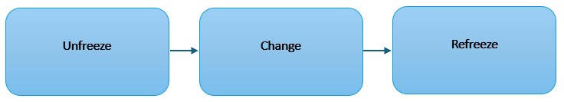
The first step is to unfreeze, which sets the groundwork for the change. The company identifies a need for change and prepares both a plan and its employees for the upcoming change (MBA Management Models, 2021). This recognition of change encourages a challenge to the status quo and can cause disruptions (Prosci, 2025). Once the organisation is ready to implement the change, they enter the second phase (Channell, 2021). This is when the focus shifts to implementing the change. New systems and behaviours are introduced to employees and the teams affected by the change begin to adjust (Prosci, 2025). The third stage of the process is refreeze, where the company aims to ensure the change is stabilised and implemented by its employees. This stage is important to ensure that employees do not revert to the old ways of proceedings (Prosci, 2025).
Lewin’s Three-Step change model was applied at Dow. Management recognised that change was necessary and positioned senior management on every night shift to observe and assess behaviours. This initiative revealed a significant issue resulting in the highest-ranking manager on site discovered three employees sleeping during one night shift. These individuals were also part of the BERT team, which further infuriated management, as in an emergency these individuals would be the first responders, and sleeping without their work boots on would significantly slow down their reaction time. All on-site management agreed that change was necessary, and they communicated this to off-site management to gain their support (Raza, 2024). Their endorsements can help further implement the change. Throughout the site shutdown, management highlighted to employees the safety concerns, policy breaches and potential long-term consequences for those who violated the protocols. By sharing these facts early, it prepared employees to recognise that change was coming.
In response, management decided to implement strict punishments designed to set an example and eradicate the behaviours normalised in this so-called “shift culture”. Management set out to review paperwork from past and present nightshifts to ensure employees were following the correct procedure for each task. The change was introduced gradually, incorporating 24-hour surveillance and additional cameras around site. A safety training was rolled out for every employee, reiterating the importance of correct PPE and ensuring paperwork was completed before starting intrusive work. This includes permits to work, isolation lockout and personal pre-task analysis forms for each maintenance activity. Management used these training sessions to encourage employees to take responsibility for themselves and ensure that they complete the correct paperwork required within their job role. Because if they do not and are caught, they can face termination.
The organisation is currently in the “refreeze” phase, working towards stabilising the improvements by ensuring employees are compliant with the new practices (Prosci, 2025). Management is monitoring the change by ensuring paperwork matches the shift report after each shift, and by having personnel monitor the surveillance cameras 24/7. Hiring additional maintenance technicians to meet the minimum staffing requirements across both shift and day technicians is one of the next phases required. This would positively impact the maintenance department, as the change had resulted in significant negative morale among the team.

Kotter’s 8-step Change Model
Kotter eight-step change model focused on implementing and sustaining change within an organisation (Tahir, 2019). According to Kotter, the first step is to create a sense of urgency, as inspiring people to act on a situation builds momentum (Kotter, 2014). This can be achieved by presenting data and facts that highlight how the current “shift culture” has resulted in serious safety incidents and employees losing their job due to behaviours that should not be normalised. The second step is to form a coalition, a group of committed employees helps guide, coordinate and communicate the change with others (Kotter, 2014). The third step is to form a new vision and initiatives by clearly defining expectations for shift staff, these expectations should be communicated to all employees. The fourth step is to enlist a volunteer army, as making employees excited about change will make then willing to contribute towards it (BBC Bitesize , 2025). Encouraging employees to participate in the change can help implement the change. Dow did not take this approach, instead they did the opposite by turning employees against management. The company decided to dismiss the employees who were caught sleeping, despite the fact that all four had no previous warnings or disciplinary action. This caused large controversy, as each employee had worked at Dow for over ten-years. Their strong relationships with colleagues resulted in shop-floor employees rallying around them, creating widespread resentment towards management. The fifth step, according to Kotter’s is to enable action by removing barriers, this involves identifying and eliminating obstacles that could affect the change process. Since Dow did not complete step four, moving forward proves challenging. Middle management attempted to support employees by offering “takeaway” and paying for a work “night out”, but these offers were rejected. The sixth step is to generate short-term wins because these quick wins build momentum, and provides the change efforts value (Six Sigma, (2025)). Dow has not implemented this step, though doing so could improve employee morale. The seventh step is to evaluate the change and make necessary adjustments. Dow’s initial success in implementing change stemmed from making an example of employees. They maintained this approach by continually communicating expectations to employees. The final step of Kotter’s eight-step change model is to institute the change (Change Models, 2023), embedding shift workers expectations into policies so they become the new norm. Dow could accomplish this by implementing a rewards system. However, rather than reinforcing change through motivation they have instead relied on fear of job loss. Shift workers strictly follow procedures and complete all necessary paperwork, as they are aware management conduct random paperwork checks.

Motivational Models
The recent changes implemented shows a decline in employee morale. Many employees feel undervalued and overworked, resulting in disengagement and a diminished sense of company loyalty. This toxic work environment has resulted in three mechanical technicians leaving the company. When morale is low, employee engagement declines and employees may struggle to stay motivated (Pinel, 2024).

V.H Vroom Expectant Theory
This theory was inspired by the realisation that employee performance is based on individual factors such as personality, past experiences, skills, confidence and knowledge (Pilat, 2025). This theory might explain why Dow has experienced low morale among employees following the dismissal of long-serving colleagues. The expectancy theory consists of three key factors;
Motivation = Expectancy x Instrumentality x Valence (Francis, 2024)
Expectancy - The belief that effort leads to better performance (Pilat, 2025). When employees see that Dow will terminate their contract over their first mistake, they begin to doubt whether their effort and company loyalty are worthwhile.
Instrumentality - The belief that performance will result in rewards or a desired outcome (Pilat, 2025). When Dow created an environment where a single mistake resulted in job termination, the link between good performance and receiving positive rewards was disrupted.
Valence – How desirable or undesirable is a particular outcome to an individual (Neuhaus, 2024). For most employees, job security, recognition and a positive work environment hold high valence. However, the anxiety of losing your job over a mistake outweighs any benefit of performing well, further reducing motivation and morale.

Conclusion
In conclusion, the challenges faced by Dow Chemical surrounding its negative “shift culture” highlight the critical need for effective change. Through our examination of models such as Lewin’s force field analysis, Lewin’s three step model, Kotter’s eight-step framework and Vrooms expectancy theory, this report has demonstrated that unsustainable management practices, such as dismissals without proper transitional support can cause more harm rather than benefit the organisation. This type of approach reduces employee trust and created an environment of fear, leading to decreased morale and lower productivity.
By integrating the management models discussed within this report, Dow could have transformed these challenges into opportunities for growth and improvements. A well-planned change implementation strategy might have enabled the company to address critical issues related to workforce management and safety concerns. Moving forwards a balanced understandings of the needs of both employees and management, the company should have communicated better and understood that the “shift culture” was not initiated by the employees caught but the consequences of poor management over many years.

Bibliography
6 sigma, (2024). Lewins force field analysis in change management. [Online]
Available at: https://www.6sigma.us/six-sigma-in-focus/lewin-force-field-analysis-in-change-management/
[Accessed 4 May 2025].
Anderson, N., (2020). balancing top down and bottom up approaches to successful change. [Online]
Available at: https://thecrispianadvantage.com/top-down-ro-bottom-up-approaches-to-change/
[Accessed 5 May 2025].
BBC Bitesize , (2025). Kotters 8 step change model, explained. [Online]
Available at: https://www.bitesizelearning.co.uk/resources/kotters-8-step-change-model
[Accessed 6 May 2025].
Change Models, (2023). what is the kotter 8 step model and how does it work?. [Online]
Available at: https://changestrategists.com/what-is-the-kotter-8-step-model-and-how-does-it-work/
[Accessed 4 May 2025].
Channell, M., (2021). Lewin's change management model: How to implement organisational change. [Online]
Available at: https://www.tsw.co.uk/blog/leadership-and-management/lewins-change-model/
[Accessed 4 May 2025].
Denis, (2025). Unfreeze, change, refreeze. [Online]
Available at: https://expertprogrammanagement.com/2021/09/unfreeze-change-refreeze/
[Accessed 8 May 2025].
Francis, A., (2024). Theories of Motivation. [Online]
Available at: https://www.mbaknol.com/management-concepts/theories-of-motivation-vrooms-valence-expectancy-theory/
[Accessed 7 May 2025].
HRM Handbook, (2025). Change Management Models. [Online]
Available at: https://hrmhandbook.com/hrt/change-management/models/
[Accessed 9 May 2025].
HSE , (2025). Health and Safety Executive. [Online]
Available at: https://www.hse.gov.uk/comah/notification/index.htm#existing
[Accessed 09 April 2025].
Kotter, D., (2014). The 8 Step for Leading Change. [Online]
Available at: https://www.kotterinc.com/methodology/8-steps/
[Accessed 6 May 2025].
MBA Management Models, (2021). Lewins three step change model. [Online]
Available at: https://www.mbamanagementmodels.com/lewins-three-step-change-model/
[Accessed 6 May 2025].
Neuhaus, M., (2024). Victor Vroom's Expectancy Theory of Motivation. [Online]
Available at: https://positivepsychology.com/expectancy-theory/#:~:text=Expectancy%20Theory%20posits%20that%20motivation%20is%20driven%20by,leads%20to%20outcomes%29%20%26%20valence%20%28value%20of%20outcomes%29.
[Accessed 7 May 2025].
New Jersey Department of Health and Safety , (2004). Hazardous substance fact sheet. [Online]
Available at: https://www.nj.gov/health/eoh/rtkweb/documents/fs/0404.pdf
[Accessed 09 April 2025].
Panorama Consulting Group, (2024). Top down vs Bottom up change management. [Online]
Available at: https://www.panorama-consulting.com/top-down-vs-bottom-up-change-management-which-is-better/#:~:text=The%20top%2Ddown%20change%20management,to%20achieve%20the%20desired%20change.
[Accessed 22 April 2025].
Pilat, D., (2025). Expectancy Theory. [Online]
Available at: https://thedecisionlab.com/reference-guide/psychology/expectancy-theory
[Accessed 8 May 2025].
Pinel, F., (2024). Understanding and addressing low employee morale. [Online]
Available at: https://blog.buddieshr.com/understanding-and-addressing-low-employee-morale/#:~:text=When%20morale%20is%20low%2C%20engagement%20decreases%20significantly%2C%20and,reduced%20productivity%2C%20missed%20deadlines%2C%20and%20declining%20work%20quality.
[Accessed 4 May 2025].
Prosci, (2025). What is Lewin's change theory?. [Online]
Available at: https://www.prosci.com/blog/lewins-change-theory
[Accessed 24 April 2025].
Raza, M., (2024). Lewins 3 Stage Model of Change Explained. [Online]
Available at: https://www.bmc.com/blogs/lewin-three-stage-model-change/
[Accessed 9 May 2025].
Ricardo, R., (2024). Kurt Lewins force field analysis. [Online]
Available at: https://studylatam.com/kurt-lewins-force-field-analysis-definition-process-example/
[Accessed 4 May 2025].
SafeOpedia, (2018). Level B clothing. [Online]
Available at: https://www.safeopedia.com/definition/85/level-b-clothing#google_vignette
[Accessed 9 May 2025].
Saffron, A., (2024). Behaviour change from the top down, the middle-out and botton-up. [Online]
Available at: https://www.europeanbusinessreview.com/behaviour-change-from-the-top-down-the-middle-out-and-the-bottom-up-how-to-drive-culture-change-at-all-levels-and-why-its-so-important/
[Accessed 9 May 2025].
Six Sigma, (2025). Kotters 8 step change model. [Online]
Available at: https://www.6sigma.us/six-sigma-in-focus/kotters-8-step-change-model/
[Accessed 4 May 2025].
Tahir, U., (2019). Kotters 8 step model of change management. [Online]
Available at: https://changemanagementinsight.com/kotters-8-steps-model-of-change-management/
[Accessed 6 May 2025].
Tahir, U., (2019). Lewins forcefield analysis. [Online]
Available at: https://changemanagementinsight.com/lewins-force-field-analysis-change-management/
[Accessed 5 May 2025].
Youth Filter, (2022). Chemical Shower Room Safety. [Online]
Available at: https://youthfilter.com/news/chemical-shower-room-safety-10-essential-protocols/#:~:text=In%20this%20comprehensive%20guide%2C%20we%27ll%20explore%20ten%20essential,and%20maintenance%20to%20emergency%20procedures%20and%20training%20requirements.
[Accessed 9 May 2025].

