

Assessment 1 – Reading Task Template
PART 1: Upload your photo of your A3 in-class notes here:
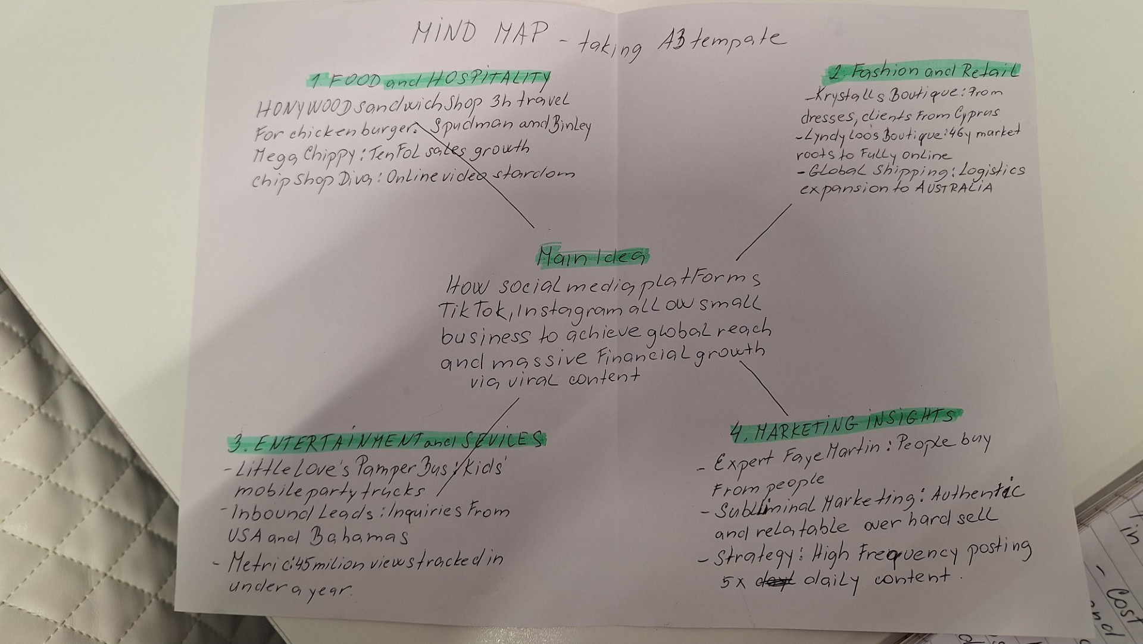

PART 2:
- Answer every question below in 1-3 full sentences.
- Use your own words. Do not use generative AI to answer these questions.
- Include a specific detail from the text when asked.
REMINDER
- The main idea is the overall message of the whole text.
- A key point helps to explain the main idea.
- A s pacific detail or example from the text shows that the key point is true.

- What is the main idea of the whole text?

The text describes how modern social media platforms like TIK TOK and Instagram
Have transformed business promotion by enabling small, independent
Enterprises to achieve global reach and massive financial growth through viral content
- What is one key point that supports the main idea, and which specific example from the text shows this?
One key point is that viral videos can instantly attract long distance customer and drastically boost a local business revenue. For example, the
Honeywood Sandwich Shop experienced a massive surge in popularity after
Customer generated TIK TOK videos prompted people to travel up to three
Hours just to try their chicken burger.
- What is a different key point that supports the main idea, and which specific example from the text shows this?
Another key point is that social media allows traditional market traders to transition into highly successful ,fully online global operations. This is demonstrated by LINDA Hunter of Lindy Loos Boutique, who used online platforms during the pandemic to move her business entirely online and now ships clothes worldwide ,including to Australia

- Which part of the text do you think is most important, and why?
The concluding section featuring marketing expert Faye Martin is the most
Important because it explains the psychological shift behind this trend, stating That people buy from people. This insight highlights that authentic, relatable Content is far more effective at building brand awareness and trust than traditional ,aggressive advertising.
Reflection:
- What did you find difficult in this task (including in-class components), and why was it difficult?
The most difficult part was scanning the entire article to extract distinct key
Points without repeating the same general ideas, as many of the featured
Businesses shared very similar success stories. Additionally ,condensing these
Detailed entre perineurial narratives into a strict limit of one to three sentences
Required a lot of careful editing.

- What helped you with this difficulty, and how did it help you?
Creating the A3 mind map helped immensely by visually separating the main
Themes from the specific details of each case study. This structured overview made it much easier to select contrasting examples and write clear, concise answers for the final template

