

LEVEL 5

SEMESTER 1 & 2

MODULE CODE: SHSS5084
Expedition Skills

aSSESSMENT TYPE: Project
Assessment/Component: 2
COMPONENT WEIGHTING: 70%
WORD COUNT: 5,000 WORDS
MODULE TUTOR: DENISE LEONARD

Expedition Portfolio

Produce a detailed log of the planning for the expedition. This will include comprehensive risk assessments, route plans, emergency procedures, transport arrangements, medical forms, pre-expedition training/ preparation and any other relevant details. Further information related to this assessment can be found on Moodle under Expedition Portfolio Resources as well as on-going tutorial support.

SUBMISSION DETAILS:

Deadline:
Date: 16th February 2018
Time: 3.00pm
Portal: Turnitin

School of Sport, Health & Outdoor Education

Assessment Feedback Sheet

Student No./Name: Emily Wilkinson
Module: SHSS5084
Module Code: Expedition Skills

Personal Evaluation – to support your academic progress please complete the section below BEFORE submitting your work.
What do you consider to be the best aspects of this work? |  |  | My aims and objectives
Which aspects do you consider could have been improved in this piece of work? |  |  | Planning our recky better
What have you found most satisfying whilst undertaking this submission? |  |  | Getting all the documents together
ASSESSMENT CRITERIA | Learning  Outcomes |  | GRADE
ASSESSMENT CRITERIA |  |  | Poor  0 – 25% | Unsatisfactory  26-39% |  | Satisfactory  40 – 49% | Good  50 – 59% | Very Good  60 – 69% | Excellent  70 – 85% |  | Exceptional  86– 100% | %
Produce a well presented and comprehensive expedition planning log with logical format and clarity of purpose | 1,2,4,6 |  |  |  |  |  |  |  |  |  |  | 100%
It is expected that students will present work that is proof read, correctly referenced and adheres to the Assessment Checklist. Therefore a range of 0 – 10 marks will be deducted for non-completion of any of the points on the checklist below.
TUTOR COMMENTS:

Submission date:  via Turnitin |  | Return date:  (at least within 4 weeks) |  |  | Tutor: Denise Leonard |  |  |  |  | Mark:

Assignment Checklist

- Please complete the Personal Evaluation section of the Assessment Feedback sheet, add your name and details, and paste the whole of this assignment document into the front of your assignment

- Submission is a single word file, clearly labelled with your name and module code
- Font style - Times New Roman, size -12 for text and 14 for headings
- Ink colour – black only
- Line spacing – 1.5 line spacing and 2cm- 2.5cm page margins
- Quotations more than three lines to be indented 1 line spacing
- One line space between paragraphs, paragraphs must be left aligned
- Pagination (your assignment should have page numbers)
- All tables and figures are internally referenced and have a title
- Word count checked and written at end of text (before references and any appendix)
- Assignment is within 10% of the word limit (excluding references and any appendices)
- All references in the text are included in the reference list
- Correct referencing following the Harvard style, as described in the Palgrave study skills book ‘Cite them Right’.
- Correct spelling using UK English
- Correct use of punctuation
- Grammar and syntax correct- double check anything that has a green line under it
- I have read my assignment out loud to myself and it makes sense and is easy to read
- Somebody else has read my work and it makes sense to him or her!
- I have checked and I have not plagiarised
Failure to follow these guidelines will cost you marks!
Expedition Contract I Emily Wilkinson will run my expedition between the dates of 30th March – 3rd April 2018. I will at all times, conduct myself as professionally as possible, adhering to the University’s Code of Conduct, and only operate within the agreed parameters of my signed-off expedition, as outlined below. I will be running an expedition by foot.
The aims and objectives of my expedition are:
- To explore environmental aspects of a coastal path in Britain
- To demonstrate how accessible outdoor education can be to individuals who consider themselves novices
- To develop a passion for outdoor education for future teachers.

My appointed assistant leader is: Vanessa Evans
The members of my expedition group are: Daniel Prothore and Molly Finn
I have checked the abilities of all expedition group members and deem them able to partake in the expedition. I have collected relevant and up-to-date medical details from each expedition group member and am aware of any condition that may affect their ability during the expedition. In signing this document I agree to everything listed overleaf. I understand that I must adhere to all the documents and risk assessments I have submitted for which my expedition has been signed off.
Module Staff Expedition Leader:
Name: Name:
Signed: Signed:
Date: Date:

Sign off matrix
Expedition overview
Vanessa Evans and I are planning to run an expedition along the south west coastal path from St. Ives to Lands End, Cornwall. The expedition will be ran over five days from Friday 30th March – Tuesday 3rd April. The first and last day of the expedition will be spent travelling down and back from Cornwall. Over the first day of walking from Rosemergy carpark (SW 422 365) in St. Ives to Botallack campsite (SW 374 337) we will of waked 6.7km, on the second day of walking on our expedition we will be walking 7.9km and camp in a campsite Crippas Hill, St Just Campsite (SW 375 302). The third day of our route is the furthest and it is 9.4km we will finish in Lands End and stay in a Sea View holiday park campsite (SW 358 251) before returning back to Carmarthen the following day.
Aims and objectives
My aims and objectives for my expedition are to explore environmental aspects of a coastal path in Britain, to demonstrate how accessible outdoor education can be to individuals who consider themselves novices and to develop a passion for outdoor education for future teachers.
Throughout my expedition I am focusing on the environment of Cornwall and the coastal path from St.Ives to Lands End. My aim is to show Dan and Molly that the environment has a massive impact on us and how accessible the outdoors is to us. At the beginning of the expedition I will be giving both Molly and Dan an ispy chart (see in appendix 1) which will include different kinds of fauna and flora which they will be able to see on the coast path throughout our expedition, they will then have to tick them off when they see each one. I have decided to do this as they are both not very interested in the environment so this will give them a chance to learn more about their surroundings in a more enjoyable way than me simply just talking to them about it. There are also parts on the coast path that have had to be rerouted due to erosion on cliffs of the coast path, I think this will be very interesting for both Molly and Dan to see.
How will you meet your Aims and Objectives?
To reach my aims and objectives that I have mentioned previously I will research about the wildlife and the environment on the Cornwall coast path from St. Ives to Lands End. To get our participants (Molly and Dan) more involved in their surroundings and the environment to do this I have made an Ispy chart which they can cross off each plant or animal that they see along the way (appendix 1).
Expedition Leader Profiles
I currently do not hold walking qualifications, however I have attended both Hill Skills and Mountain Skills course and I am First Aid trained (see certificate in appendix 3). I am also lowland leader trained and hopefully lowland leader assessed by the time of my expedition so I can lead it with the correct qualifications. Additionally to that I have had experience with walking in different locations and different weather conditions, and I have also been wild camping so I know the respectable behaviour.
Training Timeline
To make sure our participants are prepared and able to walk the whole route without trouble as they both do not have much practice with walking we have organised 3 training days on the way up to our expedition. I first one is on the 20th January then the 3rd February and finally the 3rd March. By having training days this will hopefully prevent our participants having injuries and make the expedition easier for them, especially with carrying an expedition ruck sack for 5 days.

Assistant Leader Profile
Vanessa is my assistant leader for the expedition, she is also doing the expedition with me and we are leading alternative days except from the first day which we are splitting into half and running a section each. Vanessa currently does not gold any walking qualifications but has also completed her low land leader training but has not been assessed yet. She also has her first aid certificate (see appendix 3)
Expedition Team Profiles
Name | Course Studied | Experience | Goals for exped | Medical
Molly Finn | Primary Education (QTS) |  | Learn about the environment | N/A
Daniel Protheroe | Dance |  | Learn about the history and culture | N/A

Expedition Support Person
Clayton Evans (Vanessa’s dad) is our support person for our expedition as he is the closest person we know to us through the expedition.
Expedition Contact Details
Below are the contact details of the people on the expedition including the leaders and the expedition support person. We will be giving a copy of the contact details to Thomas Moore and to Clayton Evans in case they need to contact us. See below for the expedition team contact details (appendix 2)
First Aid Provisions
The Royal Geographical Society state that ‘The first rule of expedition first aid is to prevent further injury to the victim or injury to the rescuers’, as our expedition is being ran over 5 days we need to be alert at all times of the well-being of our participants as a slight injury on day 1 could end up as a serious injury. Vanessa and I are both first aid trained and will be carrying a group and personal first aid kit on the expedition (see appendix 3 for first aid certificates). Below is a list of what Vanessa and I will be carry with us and what the group will be carrying with them.
Leaders
- Leader first aid kit: General (glow sticks, scissors, safety pins), Medication (paracetamol, ibuprofen), Bandages, Tapes and Dressings.
- Group shelter large enough for whole group
- Survival bag
- Mobile phone
- Phone battery pack
- Spare layers for group
- Roll mat
- Head torch
Group members
- Personal booklet (includes emergency contact numbers, first aid tips)
- Personal first aid kit
- Survival bag
- Whistle
- Head torch
Below is both leaders first aid certificates (appendix 3)
Participants Helpful Bag
As our participants don’t have much experience with walking Vanessa and I have decided to give them a bag of helpful accessories to make the expedition as easy as possible for them. The bag will include:
- Bivi bag
- Ispy chart
- Camel pack
- How to pack a bag sheet (appendix 4)
By the participants knowing how to pack their bag properly it will make it easier for them to access what is necessary quickly, it will also help them to use the space efficiently and more comfy on their backs.

Kit List
We have written out a kit list form which we are going to give each participant to help them pack the right kit for the expedition. This form will help them pack productively and also has kit which they will need to borrow from stores. The kit list form is in appendix 5.
Equipment Request Form
As our group members aren’t that used to walking they do not have the needed equipment and kit so we will have to borrow a lot of kit from stores which will make the expedition easier and more enjoyable for them. Below is a copy of the equipment request form that we will hand in. (appendix 6)
Generic Risk Assessment
I have four generic risk assessments for our expedition, one for walking the coast path, another for camping, one for when we do a rock pool session on the final day at White sands Bay and finally a one for when we’re on the beach. The generic risks assessments are below (appendix 7).
Site Specific Risk Assessment
Vanessa and I were meant to do the reconnaissance of the route on Tuesday 13th February, however we did not look at the weather report for Cornwall or the news on the day so we got past Swansea and turned around due to looking at the news on the way and not feeling safe to drive down to Cornwall in the weather conditions. The same day a car crash happened on the M5 at 7am and the road was still not clear when we were on the way, this was another reason as to why we turned back and decided not to go to Cornwall. However we are planning to do our reconnaissance in the near future but with better planning and organisation. Nevertheless we have done a site specific risk assessment through an OS map of our walk from St. Ives to Lands End. The site specific risk assessment is presented below. (appendix 8)
Medical declaration forms
Below is a signed copy of Molly’s and Daniels declaration form (appendix 9)
Assumption of Risk Forms
Below is a signed copy of the assumption of risk form signed by Molly and Daniel (appendix 10)
Behavioural Expectations
We have given our team members a form that states that their behaviour on the expedition needs to be appropriate as they are representing the university, the form also states that they can drop out at any point or that at any point they do not want to do anything that is fine as it is challenge by choice. Vanessa and I also have signed the form saying that we will also stick to the behavioural expectations and not put them in a situation that they are not comfortable in. See appendix 11 for the signed behavioural expectation form.

Route Cards
For the first day Vanessa will drive us down to Rosemergy car park, this night is our wild camping night (SW 422 365). On the second day we will walk from the car park to our second campsite, which is Botallack campsite (SW 374 337), during this day we will cover 6.7km and this day will be led by Vanessa Evans. On day 3 we will be walking from Botallack campsite to Crippas Hill and staying at St Just campsite (SW 375 302), throughout this day we will walk 7.9km and we will split this day into halfs and lead one each. On day 4 which is our final day which will be led by me, throughout this day we will walk 9.4km and at Whitesands Bay we will have a rock pooling session to break the day up and have a look at nature from a more hands on perspective. We will spend the night at Sea View holiday park (SW 358 251) and then drive back the following day. See appendix 12 for our route cards.
Escape Routes
We have these escape routes in case of emergencies and it will take us to the closest place where we could sort something out, or if the group is struggling on a day and cannot make it to the destination on that day. The escape routes is written on our route cards (see appendix 12)
Campsites
This is a plan of the campsites we’re staying at, the first night of the expedition we’re wild camping this will be on national trust property. When we go down to Cornwall for our reconnaissance of the route we are going to talk to the national trust to see if it is possible to wild camp on the land, if not we will find a campsite for that night.
Day 1: 30th March
Venue: Botallack Grid Ref: SW 422 365
This evening will be a wild camp in this area.

Day 2: 31st March
Venue: Trevaylor Caravan and Camping Park Grid Ref: SW 374 337

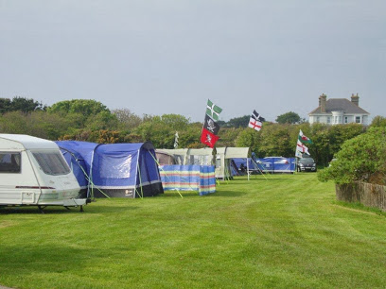
Address:
Botallack, Penzance TR19 7PU
Email: cornishcamping.co.uk
Contact number: 01736 787016
Total Price for the night: £21

Day 3: 1st April
Venue: St Just Campsite Grid Ref: SW 375 302
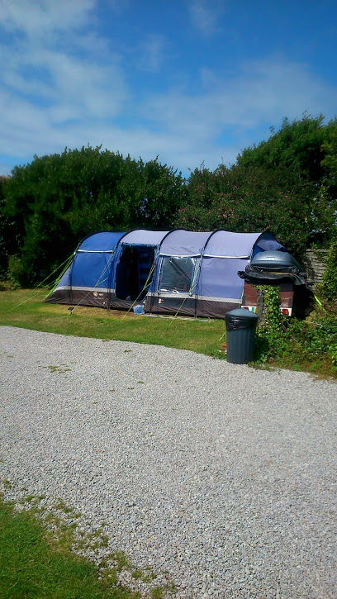
Address: Bosavern House, St Just,
Penzance TR19 7RD
Email: secretbosavern.com
Contact number: 01736 788301
Price for the night:
Backpacker (1 person/1 tent) £8.00 +
Extra persons £4.00= £24

Day 4: 2nd April
Venue: SeaView Holiday Park Grid Ref: SW 358 251
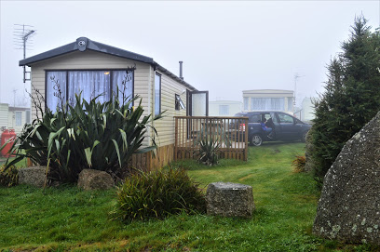
Address: Sennan, Penzance TR19 7AD
Email: seaview.org.uk
Contact number: 01736 871266
Price for the night: Out of season per night
Adults £3 each +Tent £10 each = Total: £32

Weather Forecasting Sources
For my expedition I will be using a variation of different websites to check the weather forecasts and the surf due to our walk being on a coast path and spending time on the beach during our expedition. We have chosen to use more than one weather forecast source, this will make it more accurate and reliable throughout the expedition. The main one we will be using is met office and magic seaweed. Below is the list of sources we will be using and the strengths and weaknesses, see appendix 13.
Roadworthiness of vehicle
As our expedition is in Cornwall Vanessa will be driving there and back. Throughout the expedition she will be leaving her car in our first destination which is a National Trust carpark. Below is a copy of Vanessa’s driving license and Tax and MOT, see appendix 14.

Appendix
Ispy Chart (1)
Flora and Fauna | Most commonly found | How many?
Puffin  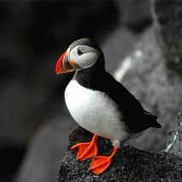 | - North Devon
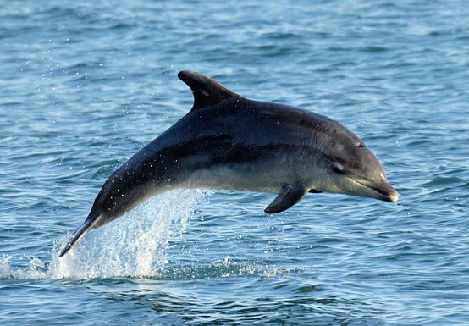  Bottlenose Dolphin | - St. Ives
Chough  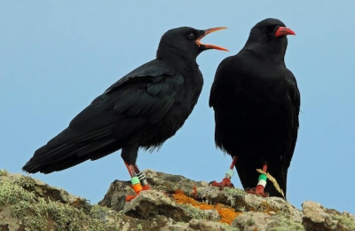 | - The Lizard Peninsula  - Coast path from Porthgwarra to Lands End
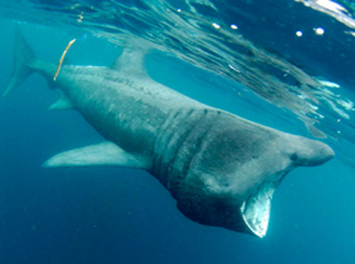  Basking shark | - Lizard Penisula
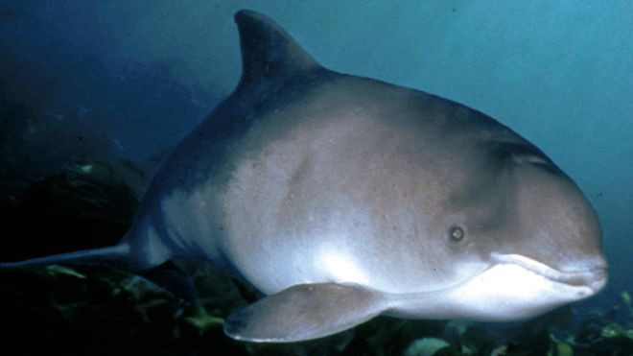  Harbour Porpoise | - Mount’s Bay, Penzance
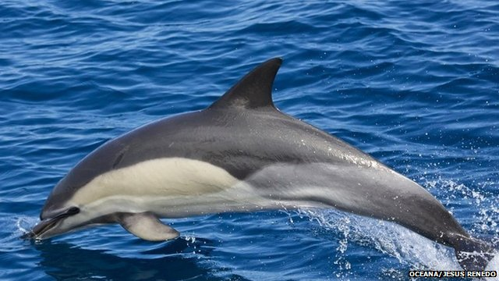  Common Dolphin | - Cornish Coast
Lotus corniculatus  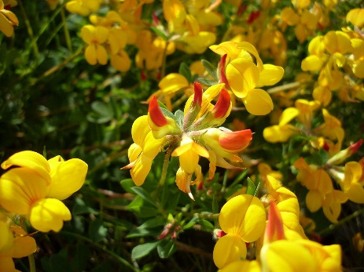 | - Cornwall coast path
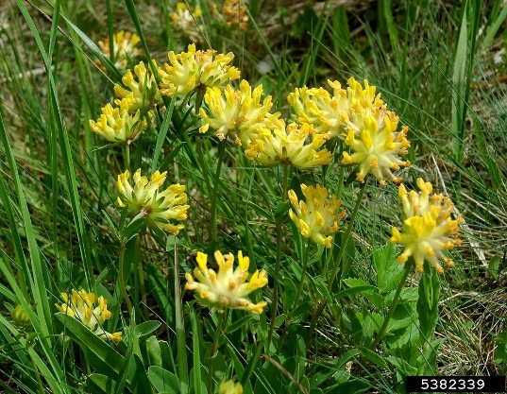  Anthyllis vulneraria (also known as Kidney Fetch) | - Cornwall coast path
Bulbous Buttercup  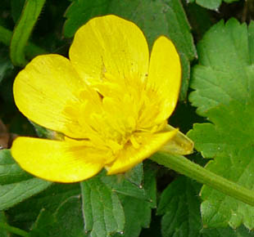 | - Cornwall coast path

Expedition Team Contact Details (2)

Expedition Leader:
Name: Vanessa Evans Number: 07473393319

Expedition Leader:
Name: Emily Wilkinson Number: 07946297243

Expedition Support Person:
Name: Clayton Evans (Vanessa’s Dad) Number: 07957367797

Expedition Team Member:
Name: Daniel Protheroe Number: 07533783837

Expedition Team Member:
Name: Molly Finn Number: 07979310226

Expedition Date: 31st March to 3rd April 2018
Venue: St Ives to Lands End, Cornwall, England

Campsite 1 Date: 31st March 2018
Location: SW 422 365 Campsite/ Porthemore

Campsite 2 Date: 1st April 2018
Location: SW 374 337 Botallack Campsite

Campsite 3 Date: 2nd April 2018
Location: SW 375 302 Crippas Hill Campsite

Campsite 4 Date: 3rd April 2018
Location: SW 358 251 Campsite Trevoxan

First Aid Certificates (3)
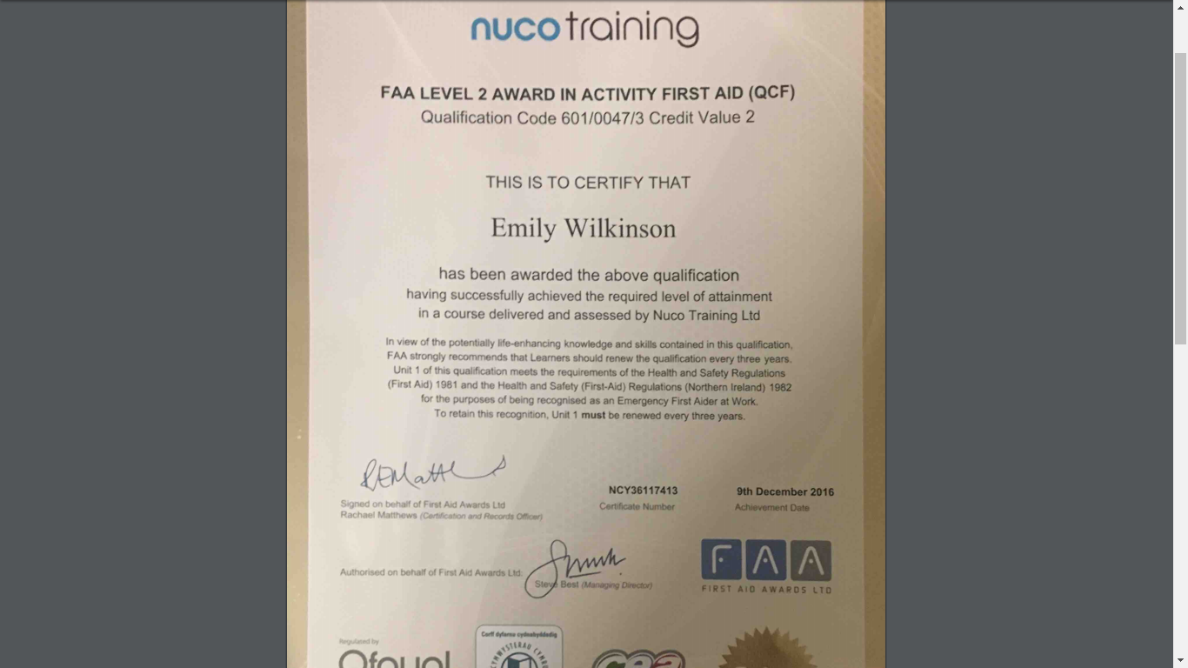
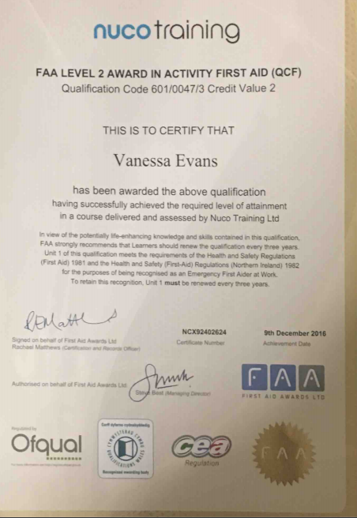

How to pack an expedition bag (4)
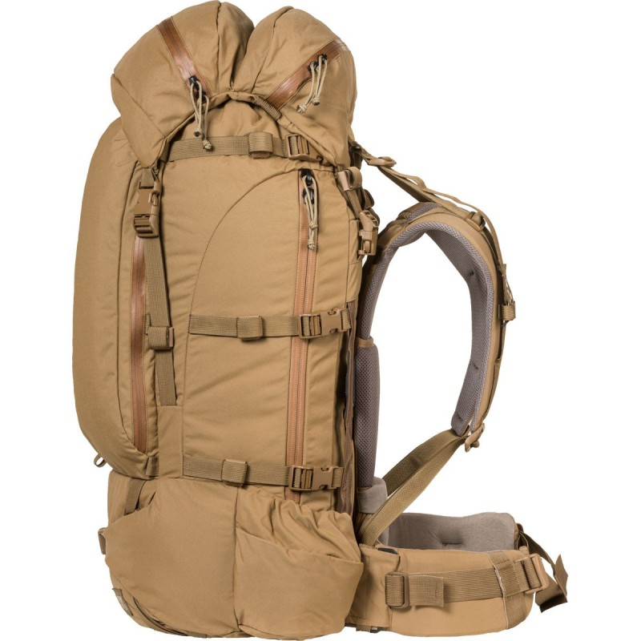
Hat, gloves, sunglasses, sun cream
Snacks
Cooking gas
Head Torch

Water
First Aid Kit and medication

Tent poles/pegs
Waterproofs, top and bottoms

Roll mat
Heavy cooking equipment
Key
Light Blue: Hood of the bag, easy to quickly assess little items
Dark Blue: Very top of bag, easy to access important items quickly
Red: Middle of the bag will take the heaviest items without putting strain on your back
Yellow: Bottom of the bag for the light, ‘stuffable’ items
Purple: Inside the bag, against the side and as far back as possible, stops poles from bending and keeps your roll mat dry.
Green: Waterproof bag liner to keep all your items dry, can also be used as a survival bag in an emergency
Overnight things
Tent inner/ outer
Food
Clothes
Survival bag used as a waterproof bag liner
Sleeping bag

Medical DExpedition Kit List (5)
Kit List (5)

Dear Participants,
Below is a list of kit that will be needed for this expedition, please tick the relevant boxes and return to the expedition leaders so that the kit needed to be borrowed can be organised. If you wish to bring other items please do, however remember that whatever you take will need to be carried with you throughout the whole expedition. Group kit shall be shared out and carried between the group. If you have any questions, please do not hesitate to ask.

Quantity | Kit | Own | Borrow | Buy
 | ESSENTIAL (Clothes)
x1 | Walking boots (Warn in)
x2 | Pairs of walking socks
x2-3 | T-shirts
x2 | Fleece layer
X2 | Walking trousers (not jeans)
 | Underwear
 | Nightwear
X1 | Sun hat
X1 | Waterproof jacket
X1 | Waterproof trousers
 | OPTIONAL
X1 | Thermal top
X1 | Thermal trousers
X1 | Shorts
X1 | Warm hat
 | ESSENTIAL (PERSONAL)
X1 | Roll mat
X1 | Survival bag
X1 | Whistle
X1 | Torch with spare batteries
X1 | Personal first aid kit
X1 | Expedition bag
X1 | Sleeping bag
X1 | Water bottle
X1 | Mug, Plate/Bowl, Cutlery
X1 | Towel
X1 | Wash kit
X1 | Sun cream
X1 | Personal medication (if needed)
 | ESSENTIAL (GROUP)
 | Tent (Shall be assigned to you)
 | Toilet paper
 | Cooking stoves
 | Cooking pans
 | Cooking gas
 | Matches
 | Food

SHSS5084 EXPEDITION LEADERSHIP
Equipment Request Form (6)

Name: Emily Wilkinson and Vanessa Evans

Dates of Expedition: 30th March – 3rd April

Date of collection: Before Easter holidays

Date of Return: After Easter holidays

Item/s |  |  | Serviceable check or | Date of Return
X1 two man tent
X2 Waterproofs
X2 Expedition ruck sacks
X2 Cooking stoves
X2 Cooking pans

I have checked and agree that all the equipment is complete and serviceable.

Signature:

Date:
Generic Risk Assessment (7)
1.Walking-Coastal Path
Hazard | Likelihood of risk | Control measures
Bad weather  -High Winds  -Extreme temperatures  -Snow, Ice | Medium | Groups kit shall be assessed before expedition.  Weather forecasts appropriately considered.
Falling | Medium | Coaching and care, participants briefed before activity
Medical Emergency | Low | Leaders to have first aid kits and be first aid trained  Complete list of leaders and groups medical information to be completed before expedition and available throughout expedition.
Blisters/ twisted ankles | High | Appropriate footwear, correctly fitting  Participants to be briefed on ‘how to walk’ if leaders observe them having difficulties.
Sunburn/ sunstroke | Low | Thorough weather forecast before the expedition and participants encouraged to wear sun cream and drink plenty throughout expedition.
Panic Attack/ Refusal to move | Medium | Coaching and care, participants briefed before activity and aware of challenge by choice
Misleading instructions | Medium | Coaching and care, participants briefed before activity and aware of challenge by choice
Being lost | Low | Leaders and group to agree on a lost procedure  All group members to have mobile contact numbers
2. Camping
Hazard | Likelihood of risk | Control measures
-Bad weather  -High Winds  -Extreme temperatures  -Snow, Ice | Medium | Group kit shall be assessed before expedition.  Weather forecasts appropriately considered.
Falling (ie. Tripping over tent guide lines) | Medium | Coaching and care, participants briefed before activity-  Guide lines shall be used only in windy conditions.
Medical Emergency | Low | Leaders to have first aid kits and be first aid trained  Complete list of leaders and groups medical information to be completed before expedition and available throughout expedition.
Fire | High | Leaders and group to agree on a designated cooking area which is a safe distance from the tents
Misleading instructions | Medium | Coaching and care, participants briefed before activity and aware of challenge by choice
Being Lost | Medium | Leaders and group to agree on a lost procedure  All group members to have mobile contact numbers
Toilet arrangements | Medium | Use site facilities if provided when at a campsite  Make sure you’re a suitable distance from a river or water source and tents.
Failing equipment (ie. Cooking stoves) | Low | Check all equipment before expedition.  Handel equipment with care

3. Rock Pooling
Hazard | Likelihood of risk | Control measures
Incoming Tides | Low | Check tide time tables before hand
Slippery surfaces | High | Rock pooling area to be assessed for any areas particularly covered in Seaweed or Algae  Suitable footwear to be worn at all times
Creature bite | Low | Brief the group to not touch the creatures in the rock pool  Wear suitable footwear  Leaders to have first aid kits and be first aid trained
Creature sting | Low | Brief the group to not touch the creatures in the rock pool  Wear suitable footwear  Leaders to have first aid kits and be first aid trained
Dead creatures | Low | Brief the group to not touch or pick up the creature
Sunburn | Low | Bring sun cream and wear appropriate clothing for the weather

4. Beach
Hazard | Likelihood of risk | Control measures
Incoming Tides | Low | Check tide time tables before hand
Drowning | High | Keep participants away from the sea
Creature bite | Low | Brief the group to not touch the creatures in the rock pool  Wear suitable footwear  Leaders to have first aid kits and be first aid trained
Creature sting | Low | Brief the group to not touch the creatures in the rock pool  Wear suitable footwear  Leaders to have first aid kits and be first aid trained
Dead creatures | Low | Brief the group to not touch or pick up the creature
Sunburn | Low | Bring sun cream and wear appropriate clothing for the weather
Tripping (ie. Tripping on a rock) | Medium | Wear suitable footwear  Be aware when walking on the beach

Site Specific Risk Assessment (8)
Draft using OS map before Reconnaissance of Route.
The highlighted points on the risk assessment refer to the things to be checked during the reconnaissance.
Evening 1 and Day 2 Rosemergy to Botallack Campsite (in Hillside)
Location  Six Digit Grid Reference | Hazard | Risk | Level of Risk | Risk to who | Control Measure | Level of risk after control measures
SW 422 365  Rosemergy | Finding a safe place to wild camp in the evening | Can cause slips, trip on uneven terrain.  Can lead to disorientation and getting lost | High | Group, Leaders, | Leaders to find suitable places to camp during reconnaissance of route. | Medium
SW 418  367  Porthmoina Cove | Big difference between High water and low water in the cove | Tide coming in will prevent access for participants to leave site safely | Medium | Group, Leaders | Thorough weather forecast before the session also appropriate knowledge of egress points of site.  Dynamic Risk assessment on day to establish where the tide is and how safe the cove is | Low
SW 402 359  Morvah cliff | Path is close to a very steep cliff | Falling | High | Group, Leaders, Kit | Thorough weather forecast to check wind direction and speed.  Reconnaissance of route to check quality of footpath. | Low
SW 377 351  Tin Mine 1  (disused mine) | Old mine may contain old machinery or unsafe steel works | Objects falling, cuts from sharp, rusty objects | Medium | Group, Leaders, Kit | Reconnaissance of route to check safety of site  Coaching and care | Low
SW 375 339  Hillside | Walking through small village with narrow roads | Being hit by traffic | Medium | Group, Leaders | Agree to abide by highway code (behavioural expectations)  Coaching and care to remind group to stay on the right side of road and walk in single file | Low

Day 3- Day 3- Botallack to Crippas Hill
Location  Six Digit Grid Reference | Hazard | Risk | Level of Risk | Risk to who | Control Measure | Level of risk after control measures
SW 372 338  Levant Road | Walking along a road | Being hit by traffic | Medium | Group, Leaders | Agree to abide by highway code (behavioural expectations)  Coaching and care to remind group to stay on the right side of road and walk in single file | Low
SW 364 333  Botallack mine | Old mine may contain old machinery or unsafe steel works | Objects falling, cuts from sharp, rusty objects | Medium | Group, Leaders, Kit | Reconnaissance of route to check safety of site  Coaching and care | Low
SW 375 302  St Just Campsite | Walking to the campsite means walking along a B road | Being hit by traffic | Medium | Group, Leaders | Agree to abide by highway code (behavioural expectations)  Coaching and care to remind group to stay on the right side of road and walk in single file | Low

Day 4- Crippas Hill to Lands End

Location  Six Digit Grid Reference | Hazard | Risk | Level of Risk | Risk to who | Control Measure | Level of risk after control measures
SW 375 302  St Just Campsite | Walking back to Cot Mill means walking along a B road | Being hit by traffic | Medium | Group, Leaders | Agree to abide by highway code (behavioural expectations)  Coaching and care to remind group to stay on the right side of road and walk in single file | Low
SW 359 283  Aire Point | Path is close to a very steep cliff | Falling | High | Group, Leaders, Kit | Thorough weather forecast to check wind direction and speed.  Reconnaissance of route to check quality of footpath. | Low
SW 362 275  Whitesand Bay | Big difference between High water and low water in the cove | Tide coming in will prevent access for participants to leave site safely | Medium | Group, Leaders | Thorough weather forecast before the session also appropriate knowledge of egress points of site.  Dynamic Risk assessment on day to establish where the tide is and how safe the cove is | Low
SW 356 263  Sennen Cove/ Car Park | Route passes through a car park | Being hit by traffic | Medium | Group, Leaders | Coaching and care  Reconnaissance of route to check how busy car park is and whether footpath can avoid car park | Low
SW 357 254 | Footpath crosses an A road | Being hit by traffic | High | Group Leaders | Coaching and care to cross at designated crossing  Reconnaissance of route to check where the crossing is | Low

Medical Declaration Form (9)

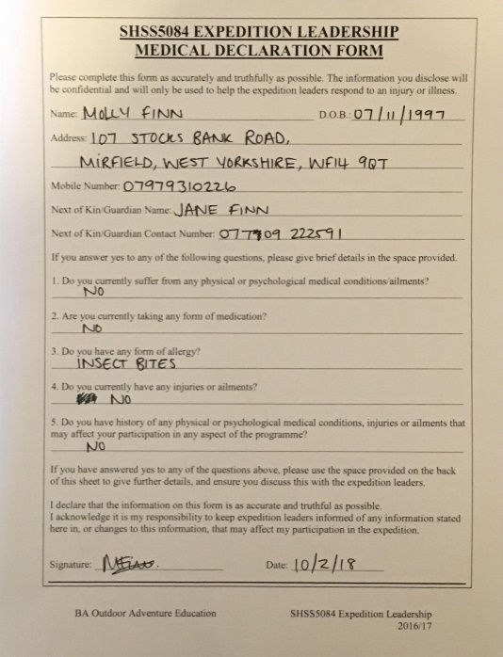
Molly Finn

Daniel Protheroe
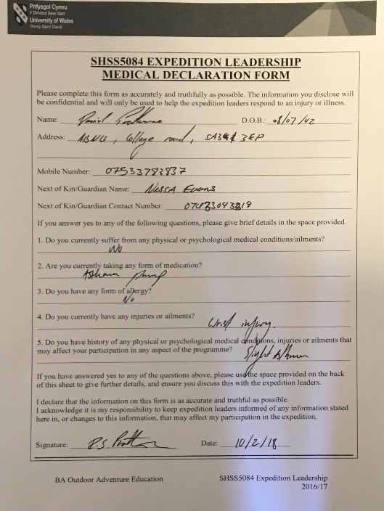

Assumption of Risk Forms (10)
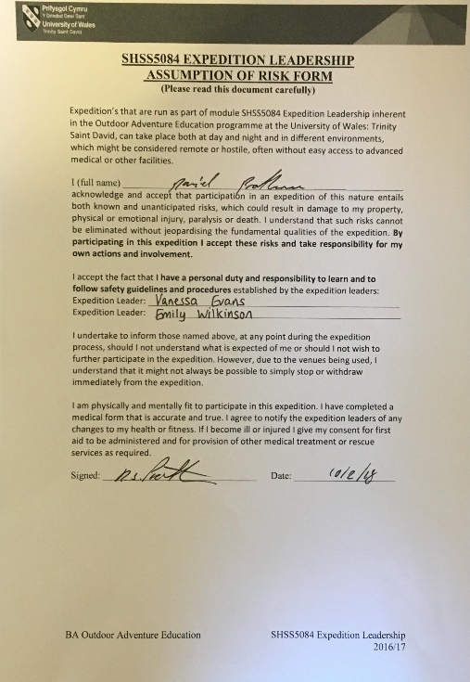
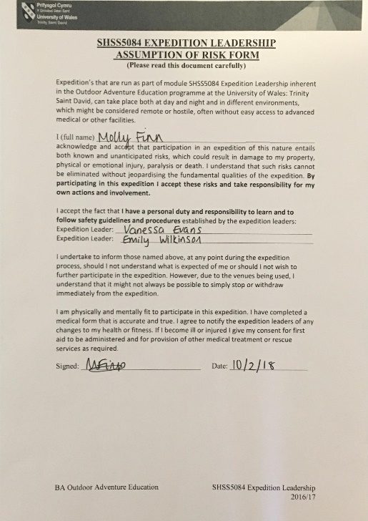
Molly Finn Daniel Protheroe

Behaviour expectation form (11)

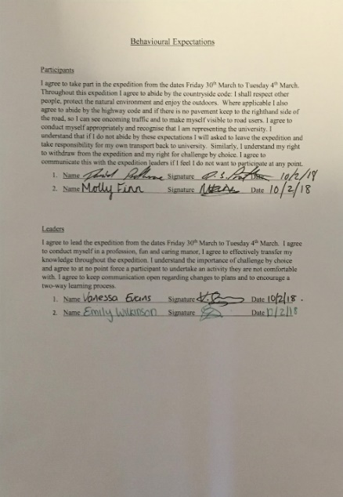

Route Cards (12)
Day 1 Driving from UWTSD, Carmarthen Campus to Porthemor, Cornwall
Day 2 Rosemergy to Botallack Campsite (in Hillside)

Leg No. | Start of leg  Grid Ref. and description | End of leg  Grid Ref. and description | Distance (km) | Height Climbed (m) | Estimated time to end of leg (mins) | Escape to:
1 | SW 422 365  Campsite/ Rosemergy Car Park | SW 418  367  Coastal path at  Porthmoina Cove | 0.8 | -20 | 14 | SW 422 365  Campsite/ Rosemergy Car Park
2 | SW 418  367  Coastal path at  Porthmoina Cove | SW 402 359  Morvah cliff | 1.8 | 0 | 21 | SW 402 354  Telephone assistance
 | SW 402 359  Morvah cliff | SW 388 358  Portheras Cove | 1.4 | -20 | 23 | SW 387 354  Portheras Farm
3 | SW 388 358  Portheras Cove | SW 377 351  Tin Mine 1  (disused mine) | 1.2 | 15 | 19 | SW 380 347  Lower Boscaswell
4 | SW 377 351  Tin Mine 1  (disused mine) | SW 378 346  Geevor Mine | 0.5 | 30 | 11 | SW 378 346  Geevor Mine
5 | SW 378 346  Geevor Mine | SW 374 337  Botallack Campsite | 1.0 | -10 | 16 | SW 374 337  Botallack Campsite

Day 3- Botallack to Crippas Hill

Leg No. | Start of leg  Grid Ref. and description | End of leg  Grid Ref. and description | Distance (km) | Height Climbed (m) | Estimated time to end of leg | Escape to:
1 | SW 374 337  Botallack Campsite | SW 365 340  Waterfall | 1.00 | -35 | 19 | SW 374 337  Botallack Campsite
2 | SW 365 340  Waterfall | SW 364 333  Botallack mine | 0.80 | -20 | 14 | SW 368 332  Manor Farm
2 | SW 364 333  Botallack mine | SW 357 325  Cairn circle | 0.7 | 20 | 13 | SW 369 326  Campsite Truthworth Lane
3 | SW 357 325  Cairn circle | SW 350 318  Lookout Station | 1.5 | -10 | 23 | SW 354 317  Carpark
4 | SW 350 318  Lookout Station | SW 357 303  Gribba Point | 2.0 | 30 and -20 | 36 | SW 357 309  Carpark
5 | SW 357 303  Gribba Point | SW 365 305  Cot Mill | 1.0 | 20 | 20 | SW 365 305  Cot Mill
6 | SW 365 305  Cot Mill | SW 375 302  Crippas Hill, St Just Campsite | 1.0 | 30 | 18 | SW 375 302  Crippas Hill, St Just Campsite

Leg No. | Start of leg  Grid Ref. and description | End of leg  Grid Ref. and description | Distance (km) | Height Climbed (m) | Estimated time to end of leg | Escape to:
1 | SW 375 302  St Just Campsite | SW 365 305  Cot Mill | 1.0 | -30 | 18 | SW 375 302  Crippas Hill, St Just Campsite
2 | SW 365 305  Cot Mill | SW 357 303  Gribba Point | 1.0 | 20 | 20 | SW 365 305  Cot Mill
3 | SW 357 303  Gribba Point | SW 359 283  Aire Point | 2.2 | -20 | 35 | SW 368 294  Trevegan Farm
4 | SW 359 283  Aire Point | SW 362 275  Whitesand Bay (rockpooling) | 0.5 | -40 | 12 | SW 368 276  Trevedra Farm Campsite
5 | SW 362 275  Whitesand Bay | SW 356 263  Sennen Cove/ Car Park | 0.7 | 40 | 20 | SW 356 263  Sennen Cove/ Car Park
6 | SW 356 263  Sennen Cove/ Car Park | SW 349 257  Maen Castle | 1.3 | -10 | 20 | SW 356 263  Sennen Cove/ Car Park
7 | 349 257  Maen Castle | SW 344 249  Lands End | 1.0 | 10 | 16 | SW 344 250 Telephone and carpark
9 | SW 344 249  Lands End | SW 358 251  Campsite/ SeaView Holiday Park | 1.75 | 20 | 30 | SW 358 251  Campsite/ SeaView Holiday Park

Day 4- Crippas Hill to Lands End

Weather Forecasting Sources (12)
Name | Description | Link | Strengths | Weaknesses
Met Office | UK National government weather service | https://www.metoffice.gov.uk/ | Official site which is used to inform other weather services. | A lot of information is presented which takes time to read and understand
Magic Seaweed | Provides surf reports and surf forecasts | https://magicseaweed.com/ | Uses webcams at certain sites so that you can visual what the weather will be like | Can be considered bias as the users of this site are surfers therefore the site wants to promote forecasts will appeal to this audience.
Windy ty | Surface pressure chart which forecasts wind direction and speed | https://www.windyty.com/ | Bright, colourful and simply to understand.  Provides temperature and rainfall forecast as well. | Wind speed and gusts are given in kt not mph.
Mountain Weather Information Service | Weather forecast specific to mountainous regions | http://www.mwis.org.uk/home | Downloadable PDF which explains how weather will effect individuals in mountains | Not relevant for this expedition as we shall be on a coastal path which is not covered within this forecast.
BBC Weather | General weather forecast for a local area | https://www.bbc.co.uk/weather/0/5928065 | Brief overview of weather forecast. Provides a video of a map demonstrating change in temperature and weather conditions. | Little detail and not specific enough to use as the only source of weather forecast.

Road Worthiness of Vehicle (14)
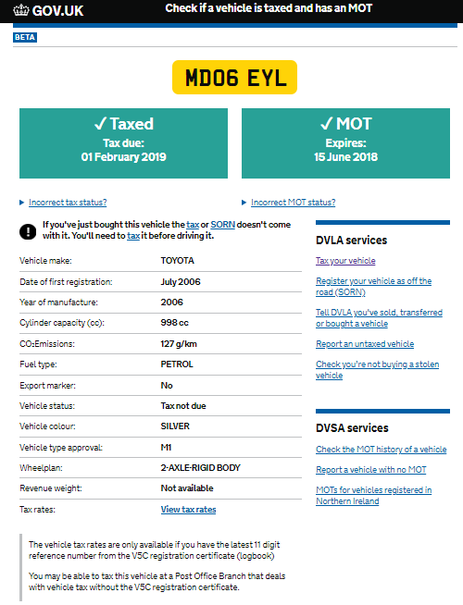


Driving Licence

Word count: 5135

References
BBC News. (2018). Two serious crashes force M5 closures. [online] Available at: http://www.bbc.co.uk/news/uk-england-43043162 [Accessed 14 Feb. 2018].
Expedition and Training. (n.d.). First Aid.
Magicseaweed.com. (2018). Surf Reports, Surf Forecasts and Surfing Photos - Magicseaweed.com. [online] Available at: https://magicseaweed.com/ [Accessed 16 Feb. 2018].
Met Office. (2018). Weather and climate change. [online] Available at: https://www.metoffice.gov.uk/ [Accessed 16 Feb. 2018].

