

Applied Leadership and Management in the Workplace
Module Assignment Submission
Student Name: | Anna Vakulenko
Student Number: | 2532402
Module No: | BMSK4012
Module Title: | Enterprise and Intrapreneurship

Statement of Confirmation of Authenticity
By the act of making this submission, the student declares that this is the work of the student named above. The work has not, in whole or in part, been knowingly presented elsewhere for assessment, or where assessment has been built on a previous assessment, this has been identified. Where materials have been used from other sources it has been properly acknowledged. If this statement is untrue, the student acknowledges that an assessment offence has been committed.
Attention is drawn to the plagiarism and unfair practice policies of both the University and of ILM.

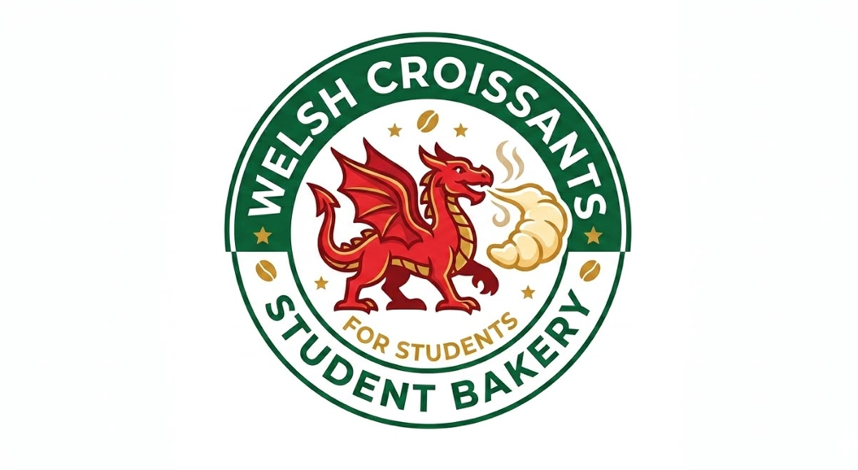

Freshly baked. Freshly brewed. Made for students.

Welsh Croissants coffee shop
Anna Vakulenko
Sole trader
Swansea
Welshcroissants_uk@gmail.com
Table of Contents
1. Executive Summary 4
2. Introduction and Business Identity 5
2.1. Business Overview 5
2.2. Business Structure 5
2.3. Mission Statement 5
2.4. Business Objectives 5
2.5. Owner's Skills and Experience 6
3. Market Analysis 6
3.1.Target Market, Market Size, Customer Groups and Business Opportunity 6
3.2. PESTLE Analysis 7
3.3. SWOT analysis 8
3.4. Competitor Analysis 8
3.5. Unique Selling Point 9
4. Marketing Strategy 9
4.1. Marketing Objectives 10
4.2. Operations 11
5. Financial information 12
5.1. Start-up Costs 12
5.2. Pricing strategy 13
5.3. Cash Flow 13
5.3. Break-even Analysis 15
5.4. Capacity 15
6. Conclusion 15
References 17
Appendix A: Anna Vakulenko – Curriculum Vitae (CV) 18
Appendix B: Price List 20

1. Executive Summary
Welsh Croissants – Students Bakery is a proposed sole trader coffee shop and artisan bakery located near the University of Wales Trinity Saint David in Swansea, Wales. The business aims to provide freshly baked croissants and speciality coffee for university students, university staff, and residents. The concept responds to the growing demand for convenient, high-quality food and beverages in a welcoming environment that supports studying, social interaction, and everyday campus life.
Unlike large coffee shops, Welsh Croissants – Students Bakery will specialise in freshly prepared croissants with both sweet and savoury fillings, complemented by premium coffee, teas, and cold drinks. The coffee shop will focus on creating a relaxed atmosphere with free Wi-Fi, charging facilities, comfortable seating, and student-friendly prices. A loyalty rewards programme and European menu will encourage repeat visits and help build long-term customer relationships.
The business will operate from a leased retail unit within walking distance of the University of Wales Trinity Saint David, making it easily accessible to thousands of students and staff. The owner, Anna Vakulenko, will manage the business herself on a full-time basis.
The primary target market consists of the University of Wales Trinity Saint David students aged between 18 and 30 who seek affordable, convenient, and high-quality food throughout the academic year. Secondary customers include university employees, local office workers, and nearby residents. Research indicates that the University of Wales Trinity Saint David (which includes its Swansea campuses) has a total of about 15 000 students (University of Wales Trinity Saint David Ranking UK 2026 / 2027 - Complete University Guide, 2026).
The business requires an estimated start-up investment of approximately £15,000 , covering premises refurbishment, commercial kitchen equipment, furniture, initial inventory, licences, branding, and working capital. Based on projected sales, the coffee shop is expected to achieve operational break-even during its first year and establish a loyal customer base through excellent customer service, effective social media marketing, and strong community engagement (IBISWorld, 2026).
The long-term vision is to develop Welsh Croissants – Students Bakery into one of Swansea's most recognised independent student coffee shops, with opportunities to expand the product range, introduce online ordering and delivery services, and potentially open additional locations in other university cities across Wales.

2. Introduction and Business Identity

2.1. Business Overview
Welsh Croissants – Students Bakery is a proposed independent coffee shop and bakery established to meet the needs of students seeking fresh, affordable, and high-quality food in a comfortable and welcoming environment. The business will be located close to the University of Wales Trinity Saint David .
The coffee shop will specialise in artisan croissants prepared fresh each day using premium ingredients. The menu will include traditional butter croissants alongside a variety of sweet and savoury options such as chocolate, almond, ham and cheese, smoked salmon and cream cheese, and vegetarian fillings. The bakery products will be complemented by a range of speciality coffees, teas, hot chocolate, fresh juices, and cold beverages.

2.2. Business Structure
Welsh Croissants – Students Bakery will operate as a sole trader business. This legal structure has been selected because it offers a simple and cost-effective method of establishing a small independent enterprise while allowing the owner to retain full control over decision-making, pricing, purchasing, staffing, and customer service. The owner will register as self-employed with HM Revenue and Customs and will be responsible for maintaining accurate financial records, complying with food safety regulations, and meeting all legal and tax obligations (Government Digital Service, 2014).

2.3. Mission Statement
The mission of Welsh Croissants – Students Bakery is to provide freshly baked artisan croissants and exceptional coffee at affordable prices while creating a welcoming environment where students can study, socialise, and relax.

2.4. Business Objectives
During its first year of operation, Welsh Croissants – Students Bakery aims to achieve the following objectives:
- Successfully launch the business before the start of the academic year.
- Achieve average daily sales of approximately 80–100 customers within the first six months.
- Reach monthly revenue sufficient to cover operating costs and achieve break-even within the first year.
- Build an active online community of more than 2,500 followers across Instagram and TikTok.
- Develop partnerships with the University of Wales Trinity Saint David student societies and local organisations.
- Achieve an average customer satisfaction rating above 4.5 out of 5 on Google Reviews.
- Establish a customer loyalty programme that encourages repeat purchases and strengthens long-term customer relationships.

2.5. Owner's Skills and Experience
The owner, Anna Vakulenko, possesses strong organisational, communication, and customer service skills together with a genuine passion for baking and hospitality. Previous experience in teamwork, time management, and interacting with customers provides a solid foundation for operating a successful coffee shop. The full CV attached in Appendix A. The owner is committed to maintaining high standards of food quality, cleanliness, and customer satisfaction while continuously improving the business through customer feedback, market research, and innovation.

3. Market Analysis
Swansea is an attractive location for a student-focused coffee shop due to the presence of the University of Wales Trinity Saint David, which attracts thousands of undergraduate and postgraduate students from the UK and overseas every year. The university community generates consistent demand for breakfast, lunch, snacks, coffee, and comfortable study spaces throughout the academic year. Students often seek coffee shops where they can socialise, complete coursework, or relax between lectures, creating an excellent opportunity for Welsh Croissants – Students Bakery.
Unlike traditional bakeries, the proposed business will combine artisan croissants with premium coffee in a modern environment designed specifically for students. This niche positioning enables the business to differentiate itself from national coffee chains while maintaining competitive pricing.

3.1.Target Market, Market Size, Customer Groups and Business Opportunity
Category | Description
Target Market | The primary target market is undergraduate and postgraduate students at the University of Wales Trinity Saint David aged 18–30. The business also targets university staff, local professionals, and residents looking for high-quality coffee and freshly baked pastries.
Market Size | The University of Wales Trinity Saint David has approximately 15,000 students, together with academic and professional staff, creating a large and stable customer base. The café aims to attract 80–100 customers per day during its first year of operation.
Customer Group | Students seeking affordable breakfasts, lunches, snacks, and speciality coffee; lecturers and university staff looking for convenient meal options; local office workers and residents who value fresh bakery products and a comfortable café environment.
Customer Needs | Affordable prices, fresh food, premium coffee, fast service, free Wi-Fi, comfortable seating, charging points, healthy options, and student discounts.
Business Opportunity | Welsh Croissants – Students Bakery will meet these trends by offering freshly baked artisan croissants, premium coffee, student-friendly pricing, loyalty rewards, and a welcoming study environment close to the University of Wales Trinity Saint David.

The analysis shows that Welsh Croissants – Students Bakery is well positioned to meet the needs of its target customers by offering affordable prices, fresh products, and a welcoming environment specifically designed for the university community.

3.2. PESTLE Analysis
Factor | Impact on Business
Political | Government food safety regulations, business taxation, and employment legislation must be followed. Compliance ensures legal operation and customer confidence.
Economic | Inflation and increasing ingredient costs may reduce profit margins. However, student demand for affordable food remains relatively stable throughout the academic year.
Social | Growing coffee culture, increased demand for artisan bakery products, and preference for independent cafés create opportunities for business growth. Students increasingly seek cafés that provide study-friendly environments.
Technological | Online ordering, digital payment systems, social media marketing, and loyalty apps improve customer convenience and operational efficiency.
Legal | Compliance with Food Standards Agency regulations, food hygiene certification, allergen labelling, employment law, and GDPR is essential.
Environmental | Customers increasingly value environmentally responsible businesses. Sustainable packaging, recycling, and reducing food waste can improve brand reputation.

Overall, the external environment presents favourable opportunities for Welsh Croissants – Students Bakery. Although inflation and competition create challenges, increasing demand for premium coffee, artisan bakery products, and independent cafés provides significant growth potential.

3.3. SWOT analysis
Strengths | Weaknesses
Unique student-focused concept | New business with limited brand awareness
Freshly baked croissants daily | Limited financial resources
Affordable student pricing | Small product range initially
Prime location near the University of Wales Trinity Saint David | Reliance on university academic calendar
Friendly study environment | Limited seating capacity
Opportunities | Threats
Growth in speciality coffee market | Strong competition from Costa, Starbucks and Greggs
Partnerships with student societies | Rising food and energy prices
Delivery services | Changes in consumer spending
Social media marketing | New competitors entering the market
Expansion to additional university locations | Economic uncertainty

The analysis demonstrates that Welsh Croissants – Students Bakery has several competitive advantages through its student-focused positioning, high-quality products, and convenient location. While competition from established chains remains significant, the business can differentiate itself by offering fresh artisan products, personalised customer service, and an atmosphere designed specifically for university students.

3.4. Competitor Analysis
The coffee shops market surrounding the University of Wales Trinity Saint David includes several established competitors.
Competitor | Strengths | Weaknesses
Costa Coffee | Strong brand recognition, extensive menu, loyalty scheme | Higher prices, less personalised customer experience
Starbucks | International reputation, premium beverages, digital rewards | Expensive for students, crowded during peak hours
Greggs | Low prices, convenient takeaway food | Limited café atmosphere, standardised products
Independent Local Cafés | Personal service, local identity | Smaller marketing budgets and less consistent product offerings

Welsh Croissants – Students Bakery will differentiate itself by combining:
- artisan croissants baked fresh every morning;
- premium coffee at student-friendly prices;
- discounts for the University of Wales Trinity Saint David students;
- loyalty rewards programme;
- comfortable study environment with Wi-Fi and charging points;
- locally inspired seasonal menu items.
Rather than competing solely on price, the business will compete by delivering superior value, freshness, convenience, and a customer experience tailored to university life.

3.5. Unique Selling Point
he unique selling proposition of Welsh Croissants – Students Bakery is:
"Freshly baked artisan croissants and premium coffee served at affordable student prices in a welcoming study-friendly café located near the University of Wales Trinity Saint David ."
Unlike major coffee chains, the business is designed specifically around the needs of students. Every morning, fresh croissants will be baked on-site, ensuring high product quality and freshness. The menu will combine traditional French pastries with fillings inspired by local Welsh ingredients, creating a distinctive identity.
The café will also offer free Wi-Fi, charging stations, comfortable seating, student discounts, and a loyalty rewards programme. Together, these features create a customer experience that goes beyond food and beverages, positioning Welsh Croissants – Students Bakery as both a convenient place to eat and a welcoming space to study, collaborate, and socialise.
This USP supports the overall mission of providing high-quality products, excellent service, and outstanding value while building a loyal customer community around the University of Wales Trinity Saint David.

4. Marketing Strategy
Welsh Croissants – Students Bakery will implement a customer-focused marketing strategy based on the 7Ps Marketing Mix. The strategy aims to attract students and university staff by offering high-quality products, competitive prices, effective promotion, and excellent customer service.
Marketing Mix (7Ps) | Strategy
Product | The coffee shop will offer freshly baked croissants, including butter, chocolate, almond, ham and cheese, vegetarian, and seasonal Welsh-inspired flavours. The menu will also include speciality coffee, tea, hot chocolate, fresh juices, sandwiches, and meal deals. Vegan and gluten-free options will be introduced to meet diverse dietary needs.
Price | A competitive pricing strategy will be adopted to remain affordable for students. Student discounts (10%), and a digital loyalty card (buy 9 coffees, get the 10th free) will encourage repeat purchases.
Place | The coffee shop will be located within walking distance of the University of Wales Trinity Saint David , providing convenient access for students and staff. Customers will be able to dine in, take away, or order through delivery platforms such as Uber Eats and Deliveroo.
Promotion | Promotion will focus on Instagram, TikTok, Facebook, and university social media groups. Marketing activities will include opening-week discounts, student ambassador partnerships, giveaways, seasonal campaigns, and collaborations with the University of Wales Trinity Saint David societies.
People | Friendly employee will provide excellent customer service and create a welcoming atmosphere. Staff will receive training in food hygiene, coffee preparation, communication, and customer care to ensure a consistent customer experience.
Process | Customers will benefit from quick ordering, contactless payments, online pre-ordering, and efficient service during busy periods. Standard operating procedures will ensure food quality, hygiene, and fast preparation times.
Physical Evidence | The coffee shop will feature a modern interior with comfortable seating, free Wi-Fi, charging points, Welsh-inspired decor, visible branding, sustainable packaging, and an open bakery area where customers can see croissants being prepared and baked.

4.1. Marketing Objectives
The marketing objectives for Welsh Croissants – Students Bakery are designed to increase brand awareness, attract customers, and build long-term customer loyalty during the first year of operation.
Marketing Objective | Target | Timeframe
Increase brand awareness among students | Reach at least 70% of students through social media campaigns, promotional events, and campus partnerships | Within 12 months
Build a strong social media presence | Achieve 3,000 Instagram followers, 2,000 TikTok followers, and maintain regular engagement | Within 12 months
Attract new customers | Achieve an average of 80–100 customers per day | Within the first 6 months
Increase customer loyalty | Register 500 members in the digital loyalty programme | Within the first year
Develop university partnerships | Collaborate with at least five of the University of Wales Trinity Saint David societies to promote the café and sponsor student events | Within the first year
Maintain customer satisfaction | Achieve an average rating of 4.5/5 or above on Google Reviews and social media platforms | Ongoing

These marketing objectives support the overall business strategy by focusing on attracting students, increasing brand recognition, and encouraging repeat business. As the primary target market consists of the University of Wales Trinity Saint David students, digital marketing through Instagram and TikTok, together with collaborations with university societies, will be the main promotional channels. Student discounts, loyalty rewards, and high-quality customer service will help build long-term relationships and encourage positive word-of-mouth marketing. Achieving these objectives will strengthen the competitive position of Welsh Croissants – Students Bakery and contribute to sustainable business growth.

4.2. Operations
Welsh Croissants – Students Bakery will operate as an independent coffee shop and bakery located within walking distance of the University of Wales Trinity Saint David. The business will focus on providing freshly baked croissants, speciality coffee in a welcoming environment designed for students, university staff, and residents.
The coffee shop will open Monday to Saturday from 7:30 a.m. to 6:00 p.m., with extended opening hours during examination periods to meet increased student demand. The owner will manage the daily operations and oversee customer service, inventory management and financial administration.
Fresh croissants will be baked every morning using high-quality ingredients supplied by trusted local wholesalers. Coffee beans will be sourced from a reputable UK coffee supplier to ensure consistent quality. Daily deliveries of fresh ingredients will minimise food waste and maintain product freshness.
The business will initially be owner-operated, with the owner responsible for managing daily operations, customer service, purchasing, and administrative tasks.
Customer orders will be processed efficiently through a modern point-of-sale (POS) system that accepts cashless and mobile payments. Customers will have the option to dine in, order takeaway, or purchase selected products through delivery platforms such as Deliveroo and Uber Eats.
Strict food safety procedures will be followed in accordance with UK Food Standards Agency regulations.

5. Financial information

5.1. Start-up Costs
Item | Estimated Cost (£)
Business registration and licences | 300
Premises deposit | 2,500
Shop refurbishment and decoration | 2,500
Coffee machine | 2,000
Commercial oven | 1,500
Refrigeration equipment | 800
Furniture and seating | 1,500
POS system and payment terminal | 600
Kitchen equipment and utensils | 800
Initial stock (ingredients, coffee and packaging) | 1,000
Branding, signage and menu boards | 500
Website and social media marketing | 500
Insurance | 500
Contingency fund | 500
Total Estimated Start-up Cost | £15,000

The estimated start-up cost for Welsh Croissants – Students Bakery is £15,000. This budget is based on opening a small independent coffee shop close to the University of Wales Trinity Saint David using leased premises and essential commercial equipment. The highest costs include the rental deposit, refurbishment of the coffee shop, and the purchase of key equipment such as a coffee machine and commercial oven.
The remaining budget covers furniture, kitchen equipment, initial stock, branding, insurance, and marketing activities to support the launch of the business. A contingency fund has also been included to manage any unexpected expenses during the start-up phase. By keeping initial costs relatively low and focusing on essential resources, the business can begin operating efficiently while reducing financial risk during its first year.

5.2. Pricing strategy
Welsh Croissants – Students Bakery will use a competitive pricing strategy to attract students while maintaining profitability. Prices are set slightly below those of major coffee chains such as Costa Coffee and Starbucks but reflect the high quality of freshly baked artisan croissants and premium coffee (Appendix B).

5.3. Cash Flow
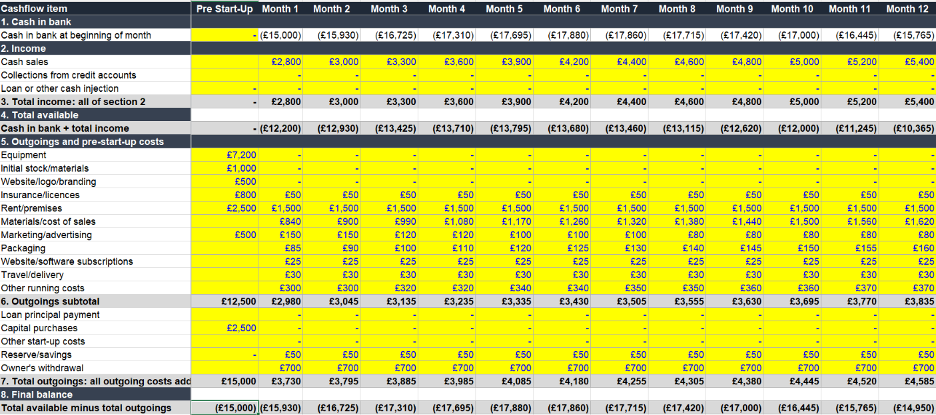

The business starts with a negative cash balance of £15,000, reflecting the initial investment required before operations begin. Monthly sales gradually increase from £2,800 in Month 1 to £5,400 by Month 12, showing steady revenue growth.
Operating expenses remain relatively stable, with monthly outgoings increasing slightly from £3,730 to £4,585 as sales grow. Major one-time start-up costs include:
- Equipment: £7,200
- Initial stock: £1,000
- Rent deposit/premises: £2,500
- Capital purchases: £2,500
Recurring expenses mainly consist of rent (£1,500/month), materials, marketing, packaging, subscriptions, transport, and other operating costs.
Despite increasing sales, the business does not generate enough cash to reach a positive balance within the first year. The closing cash balance improves only slightly, from -£15,930 in Month 1 to approximately -£14,950 by Month 12.

5.3. Break-even Analysis
The business is not expected to reach break-even within the first 12 months. Although monthly sales increase steadily from £2,800 in Month 1 to £5,400 in Month 12, they remain higher than the available cash generated after covering fixed and variable operating costs. Significant start-up expenses, including equipment (£7,200), capital purchases (£2,500), and premises (£2,500), delay profitability. Based on the forecast, the business will require additional funding or higher sales volumes to achieve break-even beyond the first year.

5.4. Capacity
The projected sales growth demonstrates that the business has sufficient operational capacity to meet increasing demand. Sales are forecast to grow gradually from £2,800 to £5,400 per month, while operating costs increase only moderately, indicating efficient use of resources. The business has the capacity to expand production or service delivery without major additional investment during the first year. However, as demand continues to grow beyond the forecast period, further investment in equipment, staff, or inventory may be required to support future expansion.

6. Conclusion
The financial forecast indicates that the business has the potential for long-term growth, supported by a steady increase in monthly sales throughout the first year. Although the business is not expected to reach break-even within the first 12 months due to significant start-up costs and ongoing operating expenses, the gradual improvement in cash flow demonstrates positive business development. To achieve profitability, the business will need to increase sales, carefully manage costs, and secure sufficient working capital during the start-up phase. With effective financial management and continued growth in demand, the business is expected to become financially sustainable in the future.

References
- University of Wales Trinity Saint David Ranking UK 2026 / 2027 - Complete University Guide. (2026). Thecompleteuniversityguide.Co.Uk. https://www.thecompleteuniversityguide.co.uk/universities/university-of-wales-trinity-saint-david
- Government Digital Service. (2012, July 3). Become a sole trader. GOV.UK. https://www.gov.uk/become-sole-trader
- IBISWorld. (2026). Cafes & Coffee Shops in the UK - Market Research Report (2016-2031). Ibisworld. https://www.ibisworld.com/united-kingdom/industry/cafes-coffee-shops/6242/
‌

Appendix A: Anna Vakulenko – Curriculum Vitae (CV)

Anna Vakulenko
Phone: +44 7865788659
Email: anna.vakulenko@gmail.com
LinkedIn: anna.vakulenko
Location: United Kingdom

Professional Profile
Results-driven Sales and Business Development professional with experience in customer relationship management, lead generation, sales support, and client engagement. Skilled in identifying customer needs, building long-term business relationships, negotiating solutions, and achieving sales targets. Strong communication, organisational, and problem-solving skills with the ability to work effectively in fast-paced environments. Motivated to contribute to business growth while delivering exceptional customer service.

Core Competencies
- Sales and Business Development
- Customer Relationship Management (CRM)
- Lead Generation and Prospecting
- Account Management
- Client Relationship Building
- Negotiation and Closing
- Market Research
- Customer Service Excellence
- Communication and Presentation Skills
- Microsoft Office (Excel, Word, PowerPoint)
- Time Management and Organisation
- Teamwork and Collaboration
Professional Experience
Sales / Customer Service Representative
Company Name | CSA Recruitment
Key responsibilities:
- Developed and maintained strong relationships with new and existing customers.
- Identified customer requirements and recommended appropriate products and services.
- Managed sales enquiries and followed up on potential business opportunities.
- Achieved individual and team sales targets.
- Processed customer orders and maintained accurate CRM records.
- Worked closely with colleagues to improve customer satisfaction and business performance.
Professional Training
- Sales Techniques and Negotiation
- Customer Service Excellence
- CRM Systems
- Microsoft Office
Languages
- English – Professional Working Proficiency
- Ukrainian – Native
- Russian – Native
References
Available upon request.

Appendix B: Price List
Category | Product | Price (£)
Croissants | Butter Croissant | 2.50
 | Chocolate Croissant | 3.00
 | Almond Croissant | 3.20
 | Ham & Cheese Croissant | 4.20
 | Smoked Salmon & Cream Cheese Croissant | 4.80
 | Spinach & Feta Croissant (Vegetarian) | 4.00
Coffee | Espresso | 2.50
 | Americano | 3.00
 | Cappuccino | 3.40
 | Latte | 3.50
 | Flat White | 3.60
 | Mocha | 3.80
Tea & Other Drinks | English Breakfast Tea | 2.50
 | Green Tea | 2.70
 | Hot Chocolate | 3.50
 | Fresh Orange Juice | 3.20
 | Bottled Water | 1.50
 | Soft Drinks | 2.00
Meal Deals | Croissant + Regular Coffee | 5.50
 | Filled Croissant + Coffee | 6.80
 | Student Breakfast Deal | 7.50
Extras | Extra Espresso Shot | 0.50
 | Oat or Soy Milk | 0.50
 | Syrup (Vanilla, Caramel, Hazelnut) | 0.60

