Joshua Ford
1701602
Project Management
Assignment 3
Sue Maw

Disaster scenario project
Individual Report

Contents
1. Introduction 3
2. Risk Management 3
3. Code of practise: sustainability issues 6
3.1 First order sustainability issues 6
3.2 Second order sustainability issues 6
3.3 Third order sustainability issues 6
4. Code of practise: Ethical and Legal issues 7
5. Quality assurance 8
6. Conclusion 9
7. References 10
8. Appendix 11
8.1 Disaster Database website screenshots 11

Introduction
This report will talk about the risks of the project that was created. The author will talk about the risks that might appear and how to get around them and the general talk about the different types of risks that might come up during the process of the project. It will also cover the sustainability issues for the project and the legal and ethical issues for the project and how they will be overcome.

Risk Management
Risk Management is about looking at the project and looking at if there are any risks and if they will get in the way of the project or disrupting the progress of the project.
‘Risk management involves understanding, analysing and addressing risk to make sure organisations achieve their objectives’ [1]
This cite backs up the author in that analysing the risks in a project are important because knowing all the risks that could possibly happen is vital because you can then decide if action is needed with these risks. It is also looking at the scale of the risks and what risks rank in bad to very bad. Some risks can be bad but manageable, but some can be vital and could disrupt a project massively. In the authors case, risks could be vital in the project succeeding in the project created.

Likelihood
Certain

Likely |  |  |  | R2
Moderate |  |  | R3 | R4  R5  R6
Unlikely | R1 |  | R7
 | Low | Moderate | Significant | High

Consequences

After the making of the Risk evaluation matrix, the author now has a better idea of what risks are more important and what shall be done with more importance and with them being more secure in some cases. ‘Risk matrix is a widely applied tool for semi-quantitative risk assessment’ [2], this explains that a risk matrix is a very common but useful tool to look at risks and manage then to work out which ones are the most important.
R1 - Time management
Time management is a risk that is important but manageable because a project must be planned and when completing the project, the author must make sure that each step must be done correctly and in order. If you organise your way of completing the project, it will make it much more efficient.
‘, deciding which events are the most important and realizing that other activities will have to be scheduled around them’ [3]
The author of the book helps backs up the point made about managing and planning in order, so it is done in an efficient way. The way that this risk is going to be managed is using a plan, making a plan on what will be completed each week and at the end of each week, the author and the team will get together and see if they have planned it well, so they are not behind on schedule. Time management was put in the unlikely column for likeliness and low for consequences, this was because the author planned the project so that they have enough time for overrunning on the project, this is so if one of the members becomes ill or cannot attend the meeting, they will still have time to complete that task of the project.

R2 - data protection act
Another risk is the data protection act. They are laws that restrict the use of personal data being processed, which means that the author and the group will have to be careful when making the website and the way they will have to process the user’s data.
‘requiring personal data to be processed lawfully and fairly, on the basis of the data subject's consent or another specified basis,’ [4]
This cite shows the law that a person’s data must be processed fairly and with the user’s permission. This means that the website will have to let the user know that they are giving their data/information to the authors website with their consent.
The strategy for this could be a box and information letting the user know that when entering their information into the box, they are giving their consent. This risk was placed in the likely column for the likeliness of it happening because, there are a lot of laws with data misuse. It is then placed in the high consequences column because if data is being misused, it is a serious problem.

R3 - SQL injection
SQL injection is a risk because if a user wanted to get passed the login page, they could use a piece of code which will log them into the website, and they could potentially harm the website. This way of logging in was by using a piece of code into the username and password box and it would simply log into any account.
‘Injecting SQL code into a web application requires little effort by those who understand both the semantics of the SQL language and CGI scripts’ [5], this backs up the point made by the author that it is a simple way of bypassing the security of a website with a form.
The strategy that will be used is more security will be used on the website when created, more code will be added to the username and password box so that when the SQL injection is inputted into the username and password box, it will correctly reject them stating the wrong username and password has been used. It has been put in the moderate column for likeliness because there is surely someone out there that will try this technique. It is then in the significant column for consequences because they can then look and delete data which can be fatal.
R4 - database not working (down)
The database could be down or an error in the code could not be connecting the website to the database. This means that when the user will be inputting data into the website, it will not be going into the database. This would then mean that the information will be lost. This wold mean that the user would think that their safe, but the admins will not have seen their information.
The strategy for this would be to check the database and website once every week to check that data is not being lost. It is in the moderate column for likeliness because technology is bound to have a blip every now and again. It is then in the high consequences column because if it were to happen, data will be lost.

R5 - No internet connection
Having no internet would simply mean that the website would be unusable, not data would be able to be inputted because they would not be able to connect and declare that they are safe.
The strategy for this will to be make sure that there is a backup for when it does go down and someone on site to fix it when it is broken while the backup is working. This is a problem which likely to happen sometime but if it dies it will cause a lot of problems.

R6 - Servers destroyed or down
If the servers are destroyed, the data that is on the servers will all be lost which would mean that data will have to be collected again. This is also a financial problem in that it will cost a lot to replace these and maybe even relocate these, so it doesn’t happen again.
The strategy for this is to make sure a backup is stored in a safe location so that if it dies, they can just carry on using the data which is up to date and just on a separate server. Due to the website being used for disaster scenarios, the likeliness of this happening again is moderate, but the consequences will be vital.

R7 - users taking advantage of website
Users taking advantage of the website will mean the website being harmed and also mean possibly losing data. Users could also just mess around on the website and add lots of false data, this would mean adding validation.
Validation would help make the website more secure and stop users entering false data. This could mean entering a valid email address or phone number. This would be a moderate chance of it happening but a significant consequence.

Code of practise: sustainability issues

3.1 First order sustainability issues
First order sustainability issues for the project would be that the entire group are working on computers and in some ways this is better than working on paper. Although working on computers can have some disadvantages on the environment, a lot of computers are thrown away every year and can have a massive effect on the environment, this refers to e-waste.
‘We discard 20 to 50 million tons of techno trash worldwide every year, which amounts to about 5% of all solid waste’, [6]
This cite backs up the point made by the author about e-waste being a big problem. When also having team meeting sometimes even some tasks were completed on portable devices such as mobile phones and laptops and with these devices,
‘of the 152 million mobile devices thrown away in 2010, only 11% were collected for recycling.’ [6]
This also backs up the point that even though that it seems that it is a very sustainable way of completing work, there are some very worrying issues about the recycling of electronic products. There are also lost of chemicals that are inside of e-waste that when thrown away they are just left to rot and harm environment.
‘E-waste contains heavy metals e.g. cadmium, lead, and mercury),’ [7]

3.2 Second order sustainability issues
Second order sustainability issues that tie in with the project are that as stated that in the last point about that the group works on computers, instead of using paper and throwing away lots of paper, it means that using computers a lot of other things will have to be thrown away. Overtime this will add up to components like RAM, graphics cards and other components being disposed of and probably not being recycled.

3.3 Third order sustainability issues
Third order issues that because of the project will have third order effects will be, if the project becomes bigger it will mean that the group will then need a headquarters that all of the members of the team can locate al of their stuff and depending on where it is located, it might then need more parking, new roads or more room which will effect structural changes to a lot of things.

Code of practise: Ethical and Legal issues
Ethical and legal issues are what the author can and cannot do in a project, legal issues are what is the law and cannot be done when completing the project. Ethical issues are things that cannot be done with the group members or anyone associated with the group. Some legal issues that will affect the project are firstly, the data protection act. This issue was brought up by the author in the previous point made about the way that data is processed. This means that when the user is processing data into the website, the website must let the user know that when they enter their data into the website, they are giving their consent for the website to see and use their data. The BCS (British Computer Society) code of conduct are the standards that should be looked at when part of a project. The sections that need to be looked at when using this is Public interest, Professional competence and integrity, duty to relevant authority and Duty to the profession.
Public interest is to ‘have regard for public health, privacy, security, and wellbeing of others and the environment’ [8]. This means that this section talks about the regard for the users and the health and wellbeing of the user. Also talks about security which is a big factor because the website must be secure because personal data is being transported through the website and if in the wrong hands it can have consequences. There must be no discrimination on the website because there will be lots of different people using the website and having offending content on the website, will make people from using the website and also break the code of conduct.
Professional competence and integrity is when something is relevant to what is being complete, in the authors case, if the group is asked to add something to the website to help the users, the code of conduct states that ‘only undertake to do work or provide a service that is within your professional competence’ [8]. This backs up the point that no work should be produced if it is out of reach. Ensuring that knowledge about legalisation is known before starting something due to laws and the consequences for the website and especially as the website will be carrying personal data.
Duty to relevant authority is,
‘carrying out your professional responsibilities with due care and diligence in accordance with the relevant authority’s requirements whilst exercising your professional judgement at times’ [8]. This is the project that the group has made is the responsibility of the group for any case.
Duty to the profession talks about that the author will ‘uphold the reputation of the profession and not take any action which could bring the profession into dispute’ [8]. This is important for the author because the author will have to manage the project correctly and to the code of conduct to stay by the rules.

The IEEE Code of Conduct is a set of rules that must be met when running or for the author when part of the project. It has different rules for lots of different situations which follow:
‘Be respectful to others’, this rules is that when in a group helping the project all members must be treated with equal respect, and must act professional. ‘Treat people fairly’, no members of the group will be treated with disrespect, discrimination or bullying. This means that no discrimination including skin colour, age or disability. ‘Avoid injuring others, their property, reputation or employment’ for the project, these mean that members must not ‘injuring member’s property, data reputation or employability’. ‘refrain from retaliation’, no members will retaliate against other members of the group.
The impact of Brexit on third sector organisations will massively affect a lot of third party organisations and will mean that every organisation will have a financial uncertainty. Third sector organisations that deal with countries abroad like charities will have difficulty because due to Brexit, the value of the pound is dropping, then what the charities send abroad will then be worth significantly less. Third sector IT organisations that will be dealing with other organisations abroad will have to go by different laws on security when working because of the now different laws of being out of the EU.
‘, together with a boost in UK participation in international standards development to ensure maximised UK capabilities and an integrated security strategy.’ [9], this cite from the British Computer Society digital Brexit report states that an ‘Integrated security strategy’ will have to be ensured, meaning that new laws and standards will have to be passed which for organisation could cost time and money.

Quality assurance

The importance of the quality of the website is important because the users need to trust the author and the group members that the website is trusted because the user will be inputting sensitive information. The website must have a minimal amount of errors because if so the users will stop using the website. With having less errors in the first place, if errors are found after it has been released, it will be difficult to remove them.
The quality in use of the website is important because like the last point made by the author, the website is effective so that the user can complete the tasks that the website was designed to do.
Using the smart objectives to set goals for the website was a good way. Specific, the goal must be specific, for instance the goal was for the website to be effective and had all the features that the user needed. Measureable, the goal needed to be measureable, this could be measured by the amount of people that would use it. Realistic, the goal must be realistic, in this instance, the goal for it to be effective for the user to complete tasks that it was designed to complete is a realistic task that can be completed. Time Bound, the goal was one of many goals that was set by the author and all of the goals had deadlines. There are different qualities in the ISO 25010 software qualities and these qualities have different characteristic which can be measured to what has been completed by the group that designed the website, which are, functionality, it suits the needs and the requirements set, also security controls access to the website. Reliability, the frequency due to faults could be due to servers or internet going down. Recoverability is important because if it was to go down it could be backed up if it has a quick back up which could make it back up and running soon. Usability, the website was designed so that it was easy to navigate around, also understanding the website was designed to be easy because the website is for a disaster and in a disaster the user would not want to be figuring out how to use the website.
The product quality could be achieved by if the website solved the problem that it was meant to solve, in this case to help locate the user and state whether they are safe or not. When making sure the quality of the project is assured, the author must make sure that there are no errors and the errors that exist have been removed or fixed.

Conclusion
In conclusion to what the author has completed in the website, the risks that were in the project have been covered and have been given a plan on how they have been managed, and what risks needed to be completed first and the severity of them by putting the risks into a risk evaluation matrix, this helped the author create the plan and what order to complete the risks in. Also the sustainability issues helped with the learning of the different sustainability issues that will be created when completing the project, also the ethical and legal issues that must be taken into place when working on a project and the laws and rules that must be taken into account. And finally looking at all of the processes the author had to look at when quality assuring the project was suitable for use.

References

[1] | “About risk management,” [Online]. Available: https://www.theirm.org/the-risk-profession/risk-management.aspx. [Accessed 16th January 2019].
[2] | “some extensions on risk matrix aproach,” saftey science , vol. 48, no. 10, p. 1278, 2010.
[3] | L.-A. M. Hellsten, Time management, InTech, 2012.
[4] | “data protection act 2018,” 2018. [Online]. Available: https://www.legislation.gov.uk/ukpga/2018/12/section/2.
[5] | B. S.W., “SQLrand: Preventing SQL Injection Attacks,” Applied Cryptography and Network Security, vol. 3089, p. 2, 2004.
[6] | L. Soltan, “Sad Facts on Technotrash or E-waste,” 2016. [Online]. Available: http://www.digitalresponsibility.org/sad-facts-on-technotrash. [Accessed 16th January 2019].
[7] | L. Poppenheimer, “E-Waste Health Hazards and Environmental Impacts,” 29th May 2013. [Online]. Available: https://greengroundswell.com/e-waste-health-hazards-and-environmental-impacts/2013/05/29/. [Accessed 16th January 2019].
[8] | “BCS Code of Conduct,” [Online]. Available: https://www.bcs.org/category/6030. [Accessed 16th January 2019].
[9] | “UK's future success outside the EU underpinned by choices on major digital issues - BCS Brexit Report,” 21st February 2017. [Online]. Available: https://www.bcs.org/content/conWebDoc/57412. [Accessed 17th January 2019].

Appendix

8.1 Disaster Database website screenshots

Home page
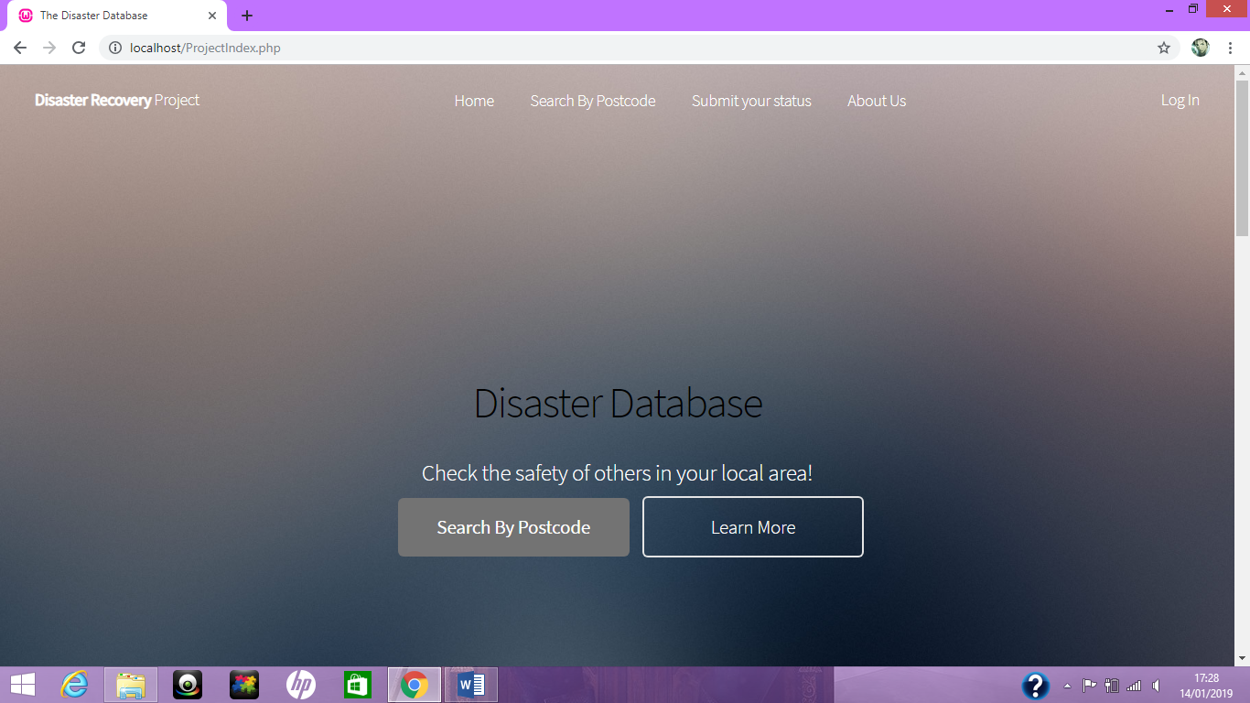
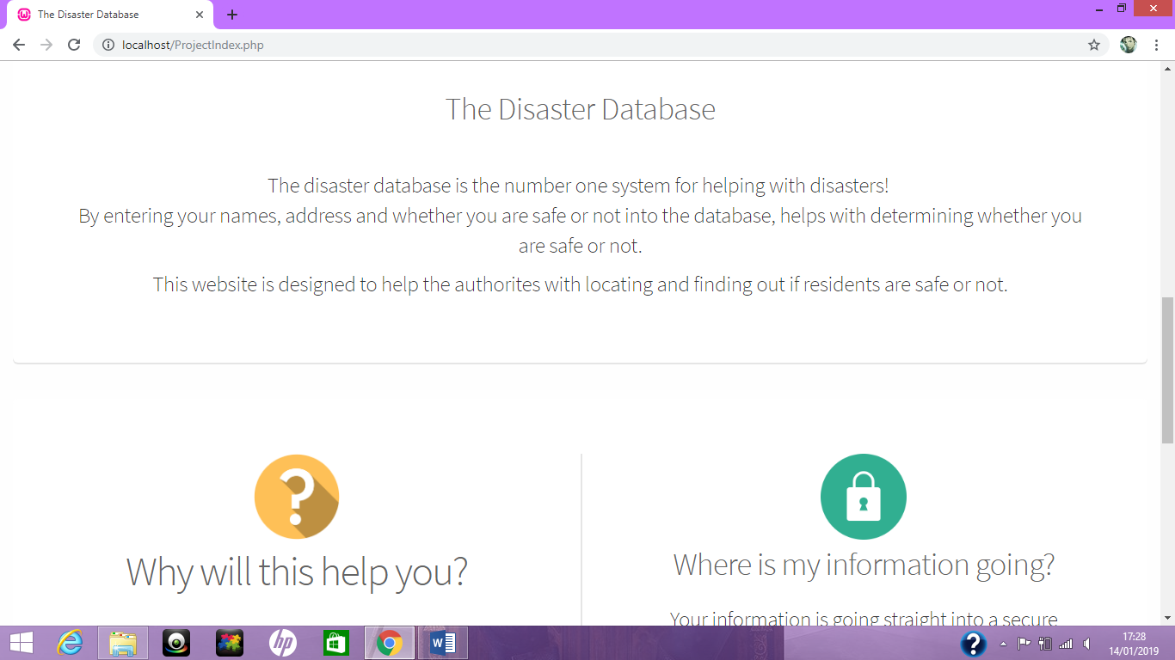

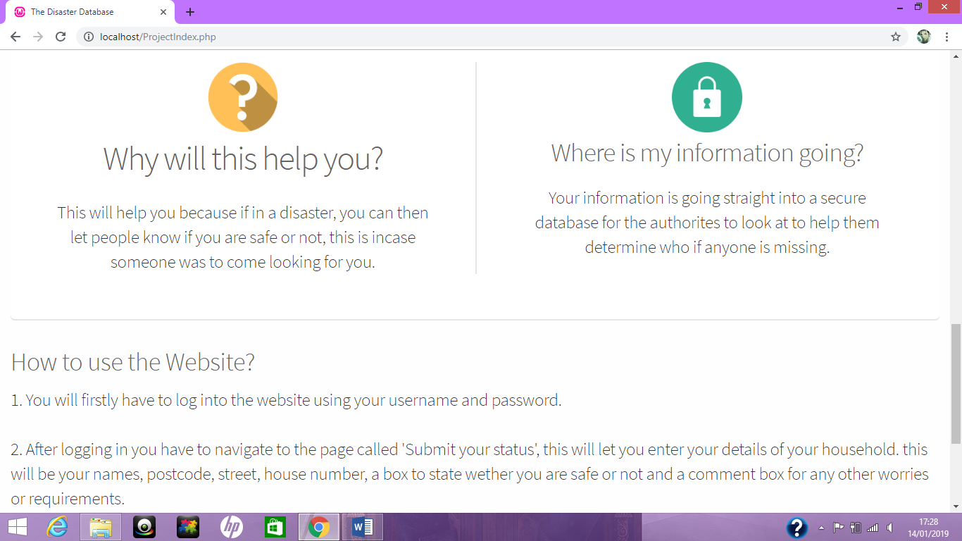
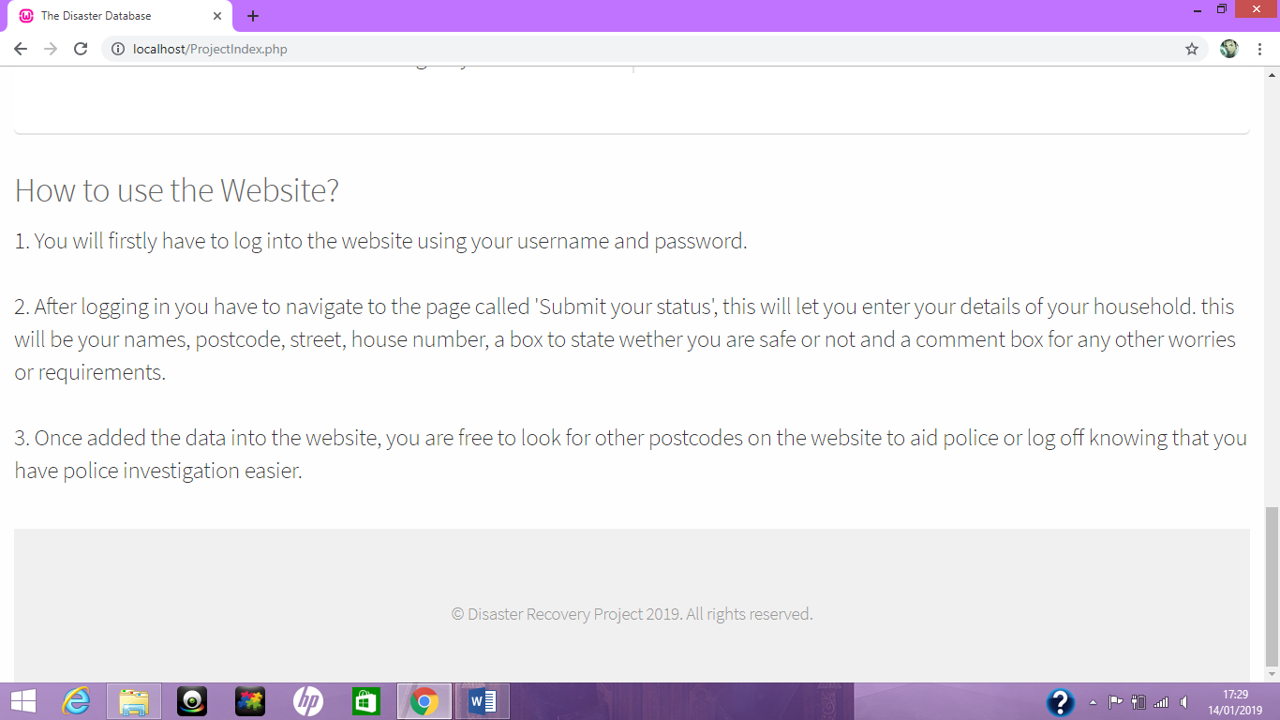

Login page
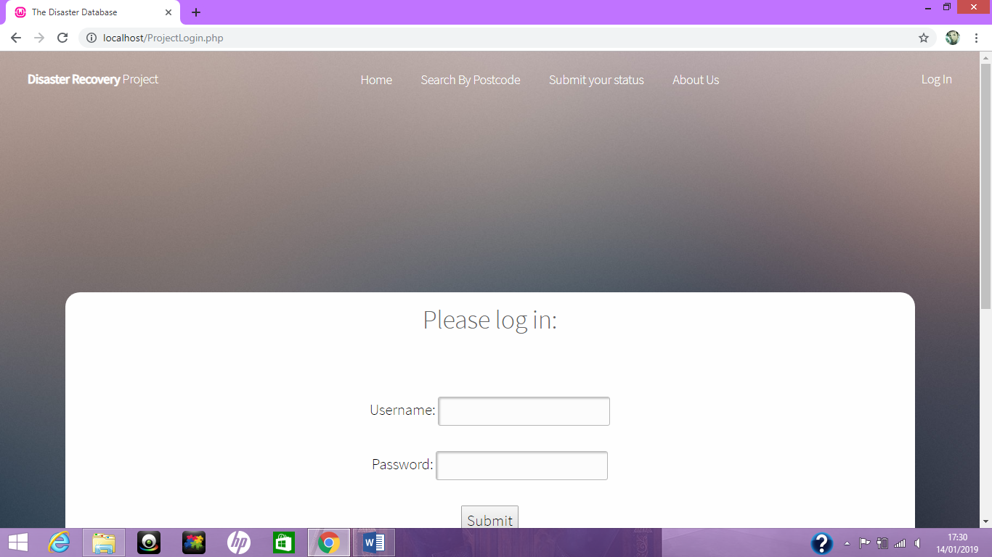
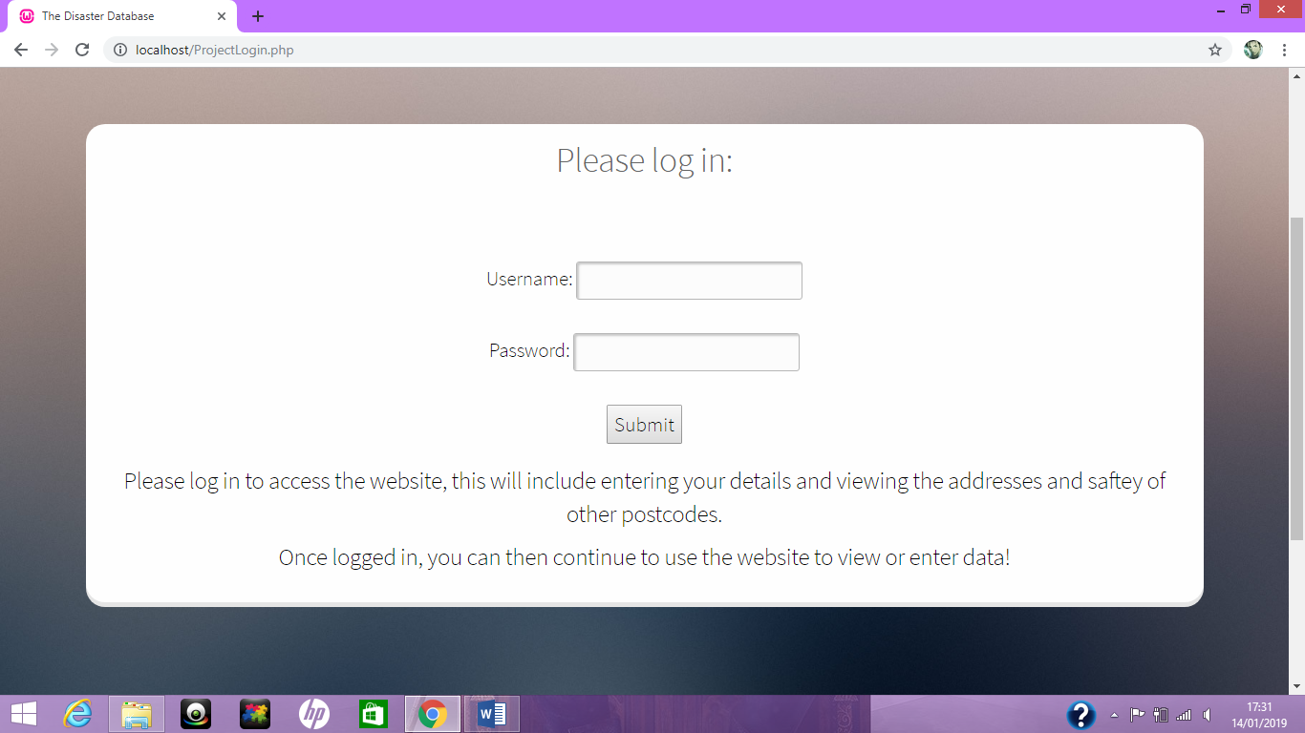

Check login
Correct credentials


Incorrect credentials


Enter data
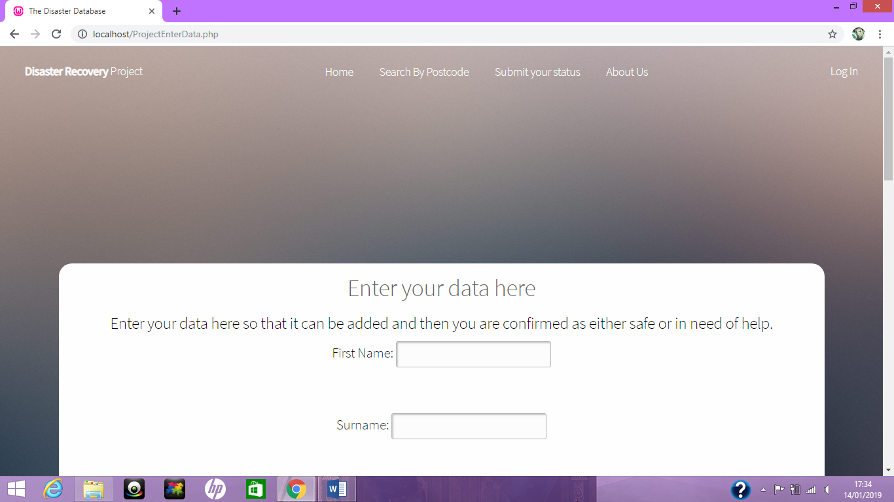
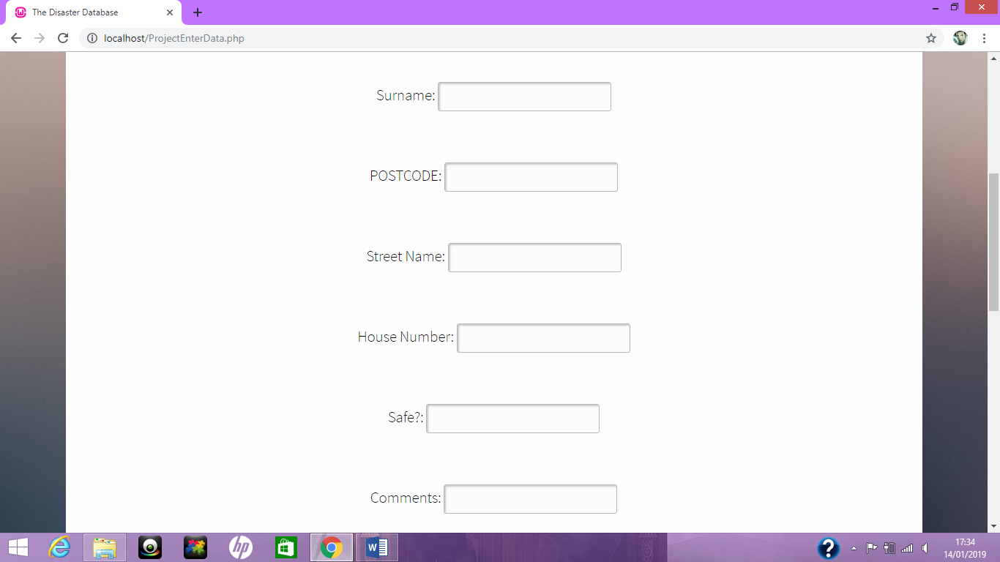

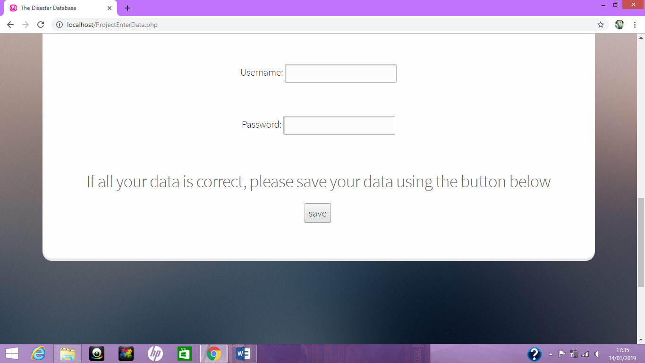

Search postcode

Not logged in
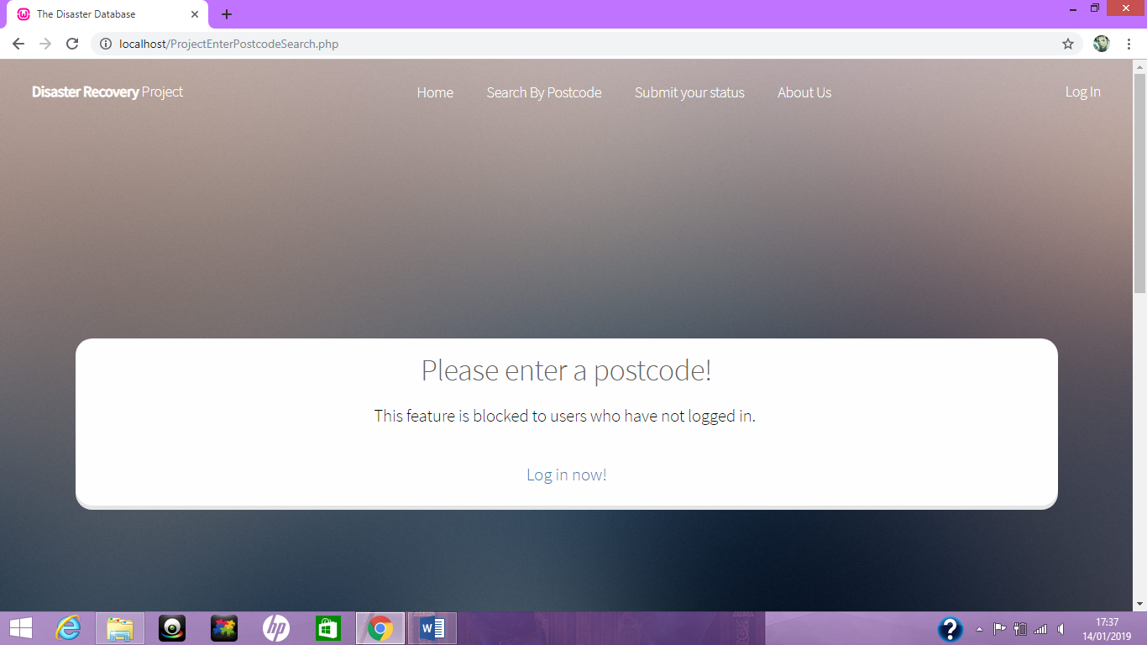

Logged in
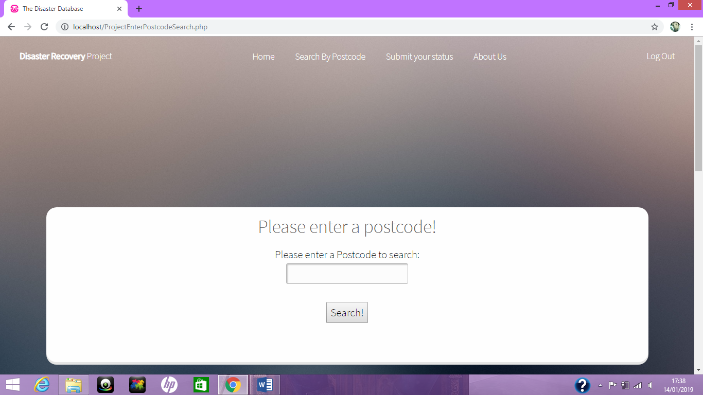

Search results
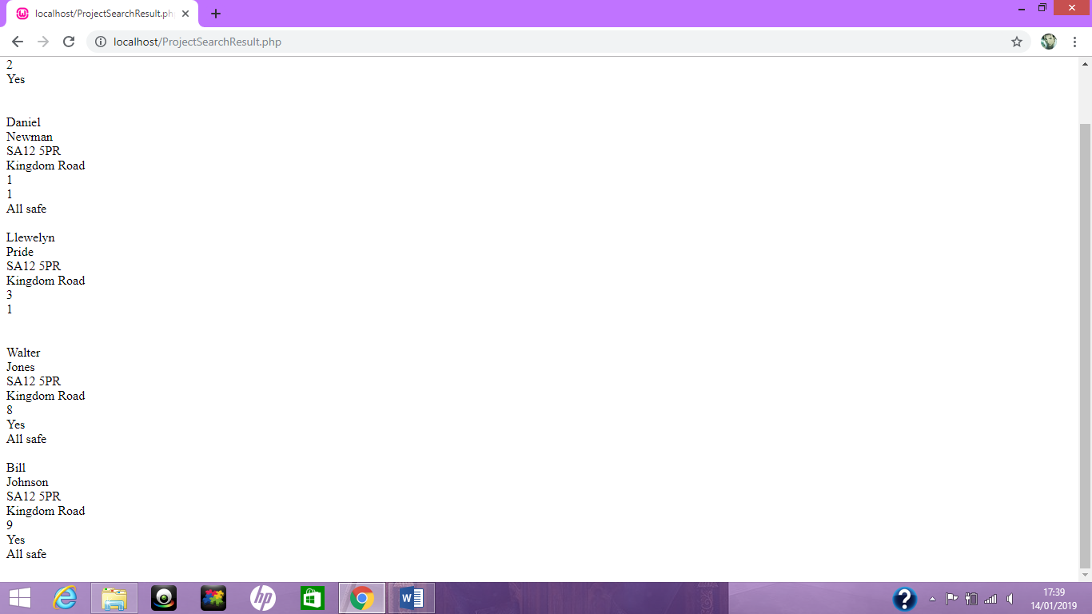

About us


