Crime and Charisma? Psychopathology and Society (HPAN5040/HPAN6040) Feature Article: Marcus Rashford
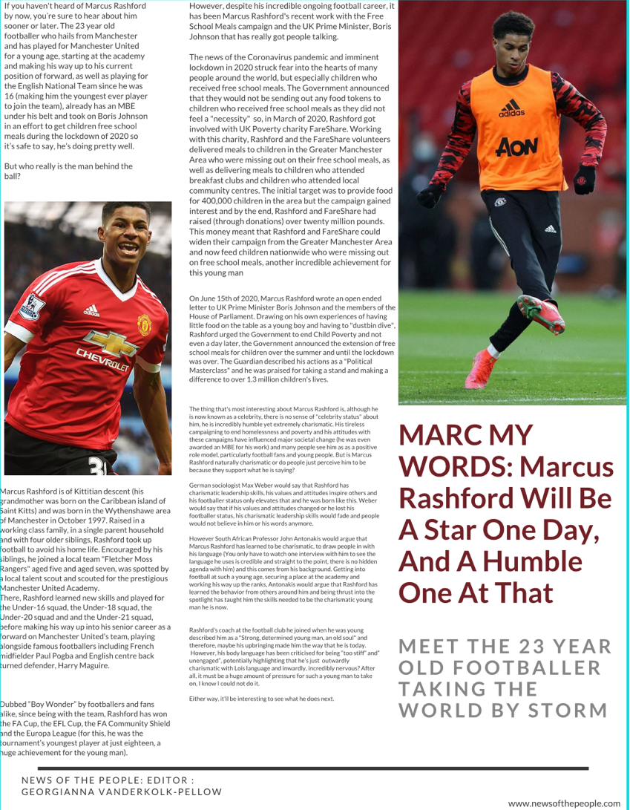
References:

Antonakis, J., Fenley, M. and Liechti, S., 2021. Learning Charisma. [online] Harvard Business Review. Available at: <https://www.google.com/amp/s/hbr.org/amp/2012/06/learning-charisma-2> [Accessed 14 June 2021].

BBCiPlayer, 2020. Marcus Rashford: Feeding Britain's Children.. [video] Available at: <https://www.bbc.co.uk/iplayer/episode/m000qq41/marcus-rashford-feeding-britains-children> [Accessed 14 June 2021].

Film, T., Edition, U., News, C., Edition, S., Film, T. and NEWSLETTER, H., 2020. Marcus Rashford. [online] HELLO!. Available at: <https://www.google.com/amp/s/www.hellomagazine.com/celebrities/20201113100742/marcus-rashford-hello-magazine-kind-list/%3fviewas=amp> [Accessed 14 June 2021].

Forsey, Z., 2020. Inside Marcus Rashford's Tough Childhood: Shopping At Poundworld and Going Hungry. [online] The Mirror. Available at: <https://www.google.com/amp/s/www.mirror.co.uk/sport/football/news/inside-marcus-rashfords-tough-childhood-22200348.amp> [Accessed 14 June 2021].

Pandit, D., 2021. Marcus Rashford names his best Manchester United 6-a-side team. [online] Sport Skeeda. Available at: <https://www.google.com/amp/s/www.sportskeeda.com/amp/football/news-marcus-rashford-names-best-manchester-united-6-a-side-team> [Accessed 14 June 2021].

Student, S., 2020. Understanding Max Weber's Charismatic Leadership | Social Student. [online] Social Student. Available at: <https://www.socialstudent.co.uk/understanding-max-webers-charismatic-leadership/> [Accessed 14 June 2021

