Dissertation – Proposal
LCBB6000
BA (Hons) Business Management
Nikola Bachvarov
Student Number:1914252
Proposed research title: Impact of social media (Facebook) on consumer behaviour: A case study on Zara

Contents
Chapter 1: Introduction 3
Background of the topic 3
Significance of the topic 3
Purpose of the study 3
Research aim 4
Research Objectives 4
Chapter 2: Literature Review 5
Chapter 3: Research Methodology 7
Chapter 4: Conclusion 10
Chapter 5: References 11

Chapter 1: Introduction

Background of the topic
As a result of the information technology sector's and digital marketing channels' rapid expansion, modern customers have changed their priorities. Social media has changed how consumers and company promoters connect (Leung et al., 2019). Additionally, it is easy to communicate, engage with others, and share information thanks to the popularity and convenience of social media, all of which influence customer purchase decisions and product reviews. Social networking sites like Facebook, Twitter, and Pinterest provide users a new method to learn about things and make judgments about whether to buy them (Eslami et al., 2022). Given the exponential surge in internet use, it is not surprising that social media has ingrained itself into its users' daily routines. In the fourth quarter of 2020, there were 4.66 billion active internet users, with Asia accounting for 51.8% of them. Global internet users in 2020 spent an average of 145 minutes per day on social media, up from 142 minutes in 2019 (Statista, 2022).

Significance of the topic
In a world of 4.26 billion social media users, which is projected to become 6 billion in 2027, the significance of it on consumer behaviour and consumer decision-making is immense (Statista, 2022). There is more advertising, content-making, and promotional campaign on social media platforms compared to that a decade ago. At the same time, the advertising and popularity of mainstream TV and print media have decreased to a great extent. With the greater influence of social media on people’s everyday life, the significance of this research topic is immense. Marketers, promotional managers, business organisations, and other stakeholders need to know the influence of social media to use them more effectively and efficiently.

Purpose of the study
The purpose of this study is to find out an in-depth analysis of the social media platforms on consumer purchase decisions and purchase behaviour. The product purchase decisions of a consumer involve several steps and segments. The purpose of this study is to determine how consumers utilize social media throughout each stage of the decision-making process for the purchase of items, including luxury goods, commodities, apparel, and beauty products, as well as the amount to which these choices are impacted by social media.

Research aim
The aim of this research is to fill the existing research gap of finding out the impact of Facebook in the consumer purchase decision-making process from the perspectives of Zara. Thus, this research aim is a company (Zara) and platform (Facebook) specific.

Research Objectives
- To find out the information-gathering process of the consumer before the purchase.
- To find out the influence of Facebook in the decision-making process of the consumer.
- To compare the effectiveness of Facebook marketing with that of the traditional marketing process.

Chapter 2: Literature Review
This section of the literature review gathers and presents the important terms, definitions, existing research outcomes, models, and different aspects of this research. A brief literature review has been presented here.
Terms and definition
According to leading media and communication authors, a social media platform can be referred to as a technology platform that can be used to create and share essential information, idea, content, interests, and any other forms of personal expression (Bughin, 2015). There are many social media platforms that are widely popular among people. These include LinkedIn, Skype, Microsoft Teams, Reddit, Instagram, Facebook, WhatsApp, and WeChat. This chronological order has been organised from the most popular to the least used base. Facebook tops the list with 4.24 billion and LinkedIn bottoms the list with only 250 million users (Zeng & Gerritsen, 2014).
Consumer purchase decision involves several steps including the feeling of the need to purchase, gathering information about suitable products and services, building alternative products, and finally making the purchase decision.
Consumer decision-making process
Social media platforms have been the place of reviews, opinion, information, and features of products and services. The researcher found a positive correlation between the amount of time people spend on social media and the time they spend researching specific products, such as foods, lifestyles, cosmetics, personal care, clothing, and other items.
Engel, Kollat, and Blackwell Model
According to this Engel, Kollat, and Blackwell’ Model, there are five steps in the total consumer product purchase decision. The process consists of need recognition, searching for relevant information about the products, evaluating the information, finalising the purchase decision, and the final outcome of the process. This process is considered the most popular process of consumer product purchase decisions (Darley et al., 2010). Social media platforms and their opinions in the form of reactions, reviews, and opinions are influential stimuli in the purchase process of consumers.
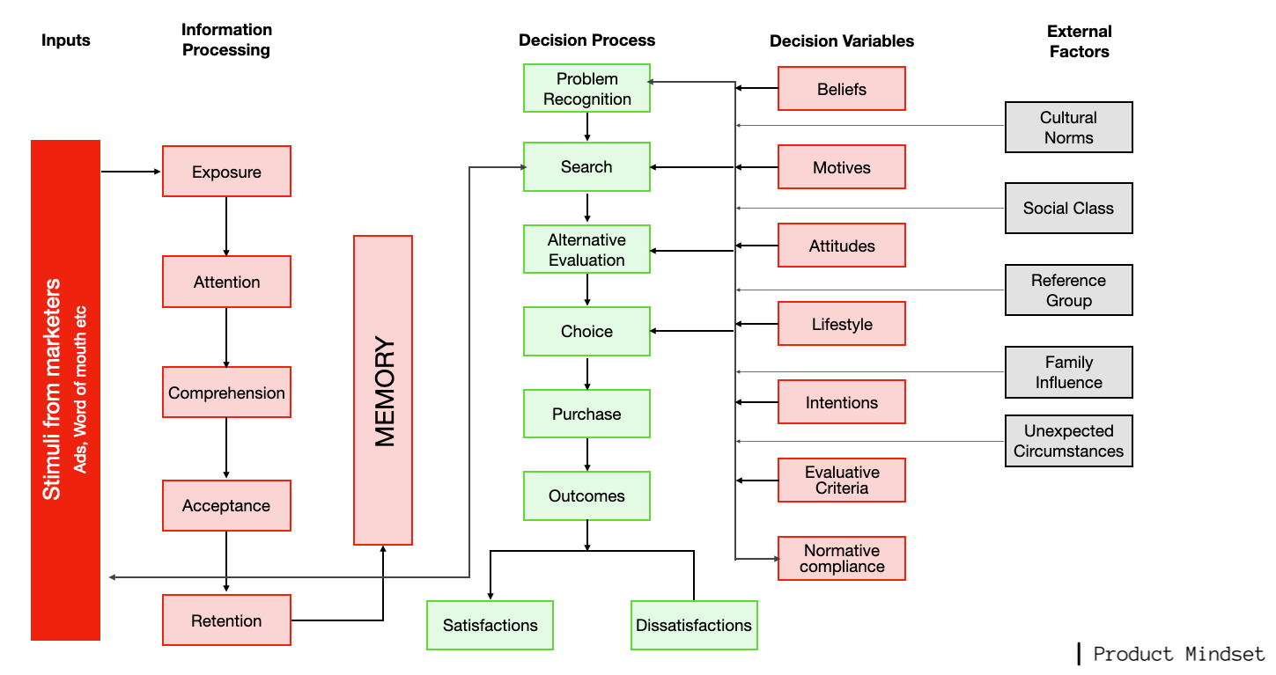
Figure 01: Engel, Kollat, and Blackwell Model
Source: (Darley et al., 2010)
Howard and Seth Model
The Howard and Seth Model only has three phases, in contrast to the Engel, Kollat, and Blackwell model. These are routine response behavior, comprehensive problem-solving, and restricted problem-solving (Bughin, 2015). In the first stage, the consumers do not have sufficient knowledge of the products and services. As a result, they start looking for relevant information about the products. In the second stage, they find out various alternatives that suit their criteria and expectations. And in the final stage of the model, the consumers make their final purchase decisions (Suhari, 2012).
Advantages
Social media platforms provide a wide range of advantages in making product purchase decisions. It provides them with adequate information in a single click of their phones, laptops, or tablets. It saves a lot of time and energy for the consumers (Suhari, 2012). However, they can also build up a large number of alternative products in a short period of time through surfing on social media platforms.
Challenges
Along with useful and effective information, social media platforms are also sources of fake and fabricated content. Doctored colour, design, and product description can mislead consumers to a great extent. Thus, the misinformation and mismatch with the real products have put challenges in the purchase decision-making process of the consumers (Suhari, 2012). The prices on social media platforms are also shown higher than the actual prices.
Research gap
An extensive search of the literature shows that there is a huge gap exists in the consumer decision-making process. There are numerous kinds of research on the impact of social media on consumer purchase decisions in general. However, there is no company-specific research to find out the impact of Facebook on the consumer purchase decisions of Zara customers. Hence, this research aims at filling the research gap.

Chapter 3: Research Methodology
This chapter of the research illustrates the research methodologies of the research project. The research methodology has been described following the Saunders’ Research Onion.
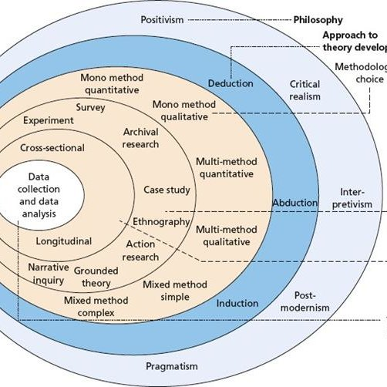
Figure 02: Saunders’ Research Onion
Source: (Gupta & Gupta, 2022)
Research philosophy: Interpretivism philosophy will be applied to this research project since the secondary research of this project requires interpretation.
Research paradigm: Positivism is the paradigm of this research since it will explain the research project from the existing opinions and data (Zhang, 2022).
Research approach: Among qualitative, quantitative, and mixed approaches to research, this research project will apply the quantitative research approach since it will collect and analyse different publicly available data and numerical information.
Research methodology: Mono method quantitative will be the research methodology for this research project. Because only quantitative data is adequate to answer the research objective.
Research strategy: Archival research is the research strategy since the publicly available data will be analysed to find out the outcome of this research.
Sampling method: There is no sampling method is required. Since this research is based on secondary research.
Data collection methods and tools: Only secondary data will be collected and analysed in this research project. The secondary data will be collected from published journals, research articles, business reports, annual reports, data banks, and other financial reports that provide adequate data and information for this research project (Daniel & Sam, 2011). Secondary data is essential for this research because answering the research questions requires the use of secondary research. Also, the use of secondary data is more convenient in terms of money, time, and energy for academic research.
Interpreting data: The secondary data will be interpreted from graphs, charts, and tables. The descriptive interpretation method will be applied to interpret the secondary data to find out the research outcomes.
Time period of the research: This research will take 3 months to be completed fully from the research proposal to the completion of the final research project starting from 1st December 2022 to the 28th February, 2023.
Milestones/Week | W1 | W2 | W3 | W4 | W5 | W6 | W7 | W8 | W9 | W10 | W11 | W12
Research proposal
Literature Review
Research Methodologies
Data collection
Data analysis
Data interpretation
Writing report
A Gantt Chart has been prepared below:
Figure 03: Gantt Chart of the research
Source: (Gantt, 2015)
Ethical considerations: There are no significant ethical considerations of this research project since secondary data will be collected and analysed throughout the research and no human participation is required. However, to ensure the reliability and authenticity of the data collection, the sources of data will be provided. Also, the required permissions will be taken from the authority in the process of acquiring the data. No living animal or person will be harmed during the course of data collection.

Chapter 4: Conclusion
The research proposal contains the systematic breakdown of the research literature review, methodologies, aims, objectives, and purpose of the study. This research is based on secondary data which will be collected through annual reports, log books, research articles, business reports, and data banks which are publicly available.

References

- Bughin, J., 2015. Getting a sharper picture of social media’s influence. McKinsey Quarterly, 3, pp.8-11.
- Daniel, P.S. and Sam, A.G., 2011. Research methodology. Gyan Publishing House.
- Darley, W.K., Blankson, C. and Luethge, D.J., 2010. Toward an integrated framework for online consumer behavior and decision making process: A review. Psychology & marketing, 27(2), pp.94-116.
- Eslami, S.P., Ghasemaghaei, M. and Hassanein, K., 2022. Understanding consumer engagement in social media: The role of product lifecycle. Decision Support Systems, 162, p.113707.
- Gantt, H., 2015. Gantt chart.
- Gupta, A. and Gupta, N., 2022. Research methodology. SBPD Publications.
- Leung, X.Y., Sun, J. and Bai, B., 2019. Thematic framework of social media research:state of the art. Tourism Review.
- Stankevich, A., 2017. Explaining the consumer decision-making process: Critical literature review. Journal of international business research and marketing, 2(6), pp.7-14.
- Statista (2022). Statista - The Statistics Portal for Market Data, Market Research and Market Studies. [online] Statista.com. Available at: https://www.statista.com/.
- Suhari, Y., 2012. E-Commerce: Model Perilaku Konsumen.
- Zeng, B. and Gerritsen, R., 2014. What do we know about social media in tourism? A review. Tourism management perspectives, 10, pp.27-36.
- Zhang, Y., 2022. Research methodology. In Assessing Literacy in a Digital World (pp. 51-71). Springer, Singapore.

