

LOCATION: Swansea | LLEOLIAD: abertawe
LEVEL 7 | LEFEL 7
EXAMINATION PERIOD | CYFNOD ARHOLIADAU
January 2020 | IONAWR 2020

MODULE CODE: ACCA7009
Data Security
TIME: 2 HOURS

answer THREE quESTIONs out of Four

Equipment or materials required – None
Adnoddau neu ddefnyddiau sydd eu hangen - Dim

ANSWER THREE QUESTIONS

Q1.

With reference to risk treatment in information security:

- Name and discuss five risk treatment strategies.
(20 marks)
Answers:
(1 mark for naming 4 marks each for discussing 4 or more points):
  - Defense
  - Transference
  - Mitigation
  - Acceptance
  - Termination

Defense
- The defense risk treatment strategy attempts to prevent the exploitation of the vulnerability
- This is the preferred approach and is accomplished by means of countering threats, removing vulnerabilities in assets, limiting access to assets, and adding protective safeguards
- This approach is sometimes referred to as “avoidance”
- Three common methods of risk defense:
  - Application of policy
  - Application of SETA programs
  - Implementation of technology

Transference
- The transference risk treatment strategy attempts to shift risk to another entity
- This goal may be accomplished by rethinking how services are offered, revising deployment models, outsourcing to other organizations, purchasing insurance, or implementing service contracts with providers
- When an organization does not have adequate security management and administration experience, it should consider hiring individuals or firms that provide expertise in those areas (outsourcing)

Service Level Agreement
- The key to an effective transference risk control strategy is the implementation of an effective service level agreement (SLA)
- In some circumstances, an SLA is the only guarantee that an external organization will implement the level of security the client organization wants
- The FDIC suggests that, to create a successful SLA, organizations use the following four steps:
  - Determining objectives
  - Defining requirements
  - Setting measurements
  - Establishing accountability
Mitigation
- The mitigation risk treatment strategy is the treatment approach that focuses on planning and preparation to reduce the impact or potential consequences of an incident or disaster
- This approach includes four types of plans:
  - Disaster recovery (DR) plan
  - Incident response (IR) plan
  - Business continuity (BC) plan
  - Crisis Management (CM) plan
- Mitigation derives its value from its ability to detect and respond to an attack as quickly as possible
Acceptance
- The acceptance risk treatment strategy is the decision to do nothing beyond the current level of protection to protect an information asset from risk, and to accept the outcome from any resulting exploitation
- While the selection of this treatment strategy may not be a conscious business decision in some organizations, the unconscious acceptance of risk is not a productive approach to risk treatment
- This strategy assumes that it can be a prudent business decision to examine the alternatives and conclude that the cost of protecting an asset does not justify the security expenditure
- Acceptance is recognized as a valid strategy only when the organization has:
  - Determined the level of risk posed to the information asset
  - Assessed the probability of attack and the likelihood of a successful exploitation of a vulnerability
  - Estimated the potential impact (damage or loss) that could result from a successful attack
  - Evaluated potential controls using each appropriate type of feasibility
  - Performed a thorough risk assessment, including a financial analysis such as a CBA
  - Determined that the costs to treat the risk to a particular function, service, collection of data, or information asset do not justify the cost of implementing and maintaining the controls
Termination
- Like acceptance, the termination risk treatment strategy is based on the organization’s intentional choice not to protect an asset
- Here, however, the organization does not wish the information asset to remain at risk and so removes it from the environment that represents risk
- Sometimes, the cost of protecting an asset may outweigh its value, or it may be too difficult or expensive to protect an asset, compared to the value or advantage that asset offers the company

- With the aid of a flow chart outline risk-handling action points.
(5 marks)
Answers:

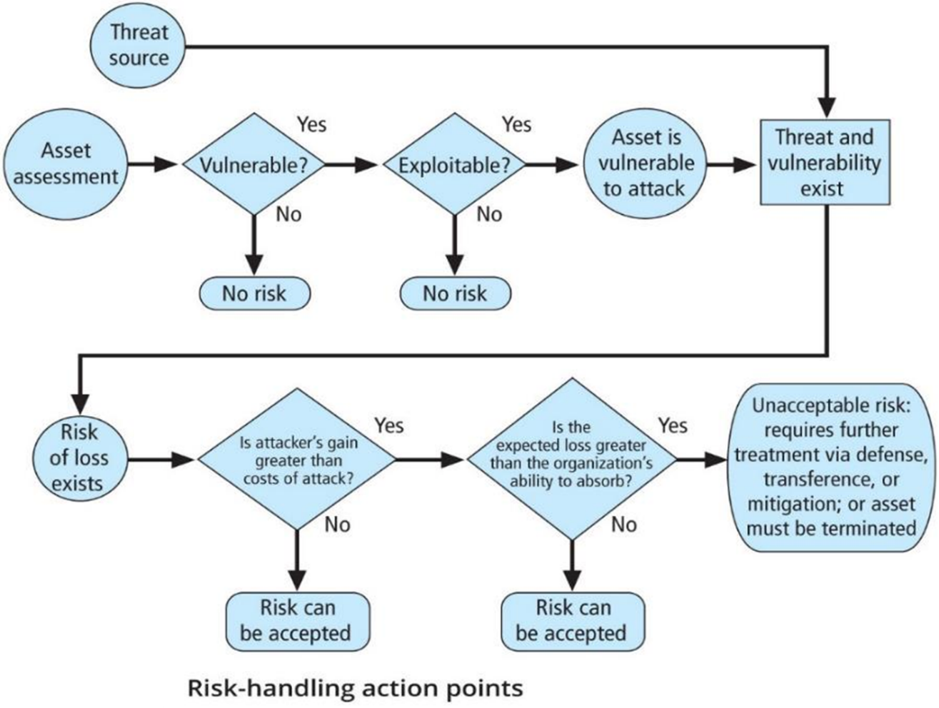

Q2.

- Outline the Contingency Planning Policy components and identify individuals and teams involved in the contingency planning process. Diagrams may be used.
(16 marks)
Answers:

Components (9 marks):
- An introductory statement by senior management
- The scope and purpose of the CP operations
- A call for periodic risk assessment and BIA by the CPMT
- A description of the major components of the CP
- A call for, and guidance in, the selection of recovery options and business continuity strategies
- A requirement to test the various plans on a regular basis
- Identification of key regulations and standards that impact CP planning and a brief overview of their relevancy
- Identification of key individuals responsible for CP operations
- An appeal for support to the individual members of the organizations
- Additional administrative information

Teams including (7 marks):
  - Champion
  - Project Manager
  - Team Members
    - Business managers
    - Information technology managers
    - Information security managers
    - Representatives of the supplemental teams (IR, DR, BC)
- Incidence Response (IR) Team
- Disaster Recover (DR) Team
- Business Continuity (BC) Team

- Explain the following as it relates to planning for contingencies in information security:
  - Disaster Recovery
  - Business Continuity Planning
  - Crisis Management
(9 marks)
Answers (3 marks each for any three points explained):

Disaster recovery
- Disaster recovery planning (DRP) entails preparation for and recovery from a disaster, whether natural or man-made
- In general, an incident is a disaster when:
  - the organization is unable to contain or control the impact of an incident, or
  - the level of damage or destruction from an incident is so severe the organization is unable to quickly recover
- The key role of a DR plan is defining how to reestablish operations at the location where the organization is usually located (primary site)

Business Continuity Planning
- Sometimes, disasters have such a profound effect on the organization that it cannot continue operations at its primary site until it fully completes all DR efforts, which requires business continuity (BC) strategies
- BC planning (BCP) ensures critical business functions can continue in a disaster, and is most likely managed by the CEO or COO of the organization
- BCP is activated and executed concurrently with the DRP when needed
- While BCP reestablishes critical functions at an alternate site, DRP focuses on reestablishment at the primary site

Crisis Management
- Another process that many organizations plan for separately is crisis management (CM), which focuses more on the effects that a disaster has on people than its effects on information assets
- While some organizations include crisis management as a subset of the DR plan, the protection of human life and the organization’s image is such a high priority that it may deserve its own committee, policy, and plan
- According to Gartner Research, the crisis management team is responsible for managing the event from an enterprise perspective and performs the following roles:
  - Supporting personnel and their loved ones during the crisis
  - Keeping the public informed about the event and the actions being taken to ensure the recovery of personnel and the enterprise
  - Communicating with major customers, suppliers, partners, regulatory agencies, industry organizations, the media, and other interested parties
- The crisis management planning team (CMPT) should establish a base of operations or command center near the site of the disaster as soon as possible
- The CMPT should include individuals from all functional areas of the organization in order to facilitate communications and cooperation
- The CMPT is charged with three primary responsibilities:
  - Verifying personnel status
  - Activating the alert roster
  - Coordinating with emergency services

Q3.

CaribbeanCoffee sells Blue Mountain Peak coffee from Jamaica, one of the best and most sought-after blends in the world. CaribbeanCoffee has extensive presence around the globe. The company uses cloud services to deliver IT services to its staff and clients. It is estimated that almost 95% of the company's network is wireless based. The company also has a massive online presence and social media presence to promote its activities.
Owing to its large staff and international customer base, the company has recently come under immense pressure to allow both its staff and customers to use their personal devices to access the company's network/resources. Security of personal staff data and client data is the company's major concern. The company is also concerned about protecting its intellectual property, which is worth billions. Information security is a priority to the company, but everything is in disarray. There is no established policy covering their security need.

- Based on the scenario on CaribbeanCoffee above. You are commissioned to design and discuss your own approach to meet the need of the company utilising information on frameworks, standards and models covered in class and research tasks. Tables and diagrams may be used in your approach.

Some factors to consider in aiding appropriate solution(s):
- Security Policies
- Risk Management
- Security Management Models and Practices
- Contingencies Planning
- Protection Mechanisms
- Service Level Agreement

You must state all assumptions made and justify your decisions.

(25 marks)
Solutions:
Answers will vary:
- Some may choose to outline/design approaches:
  - Blueprints of the company network (this should be explained), frameworks and security models
  - to security implementation using a top-down approached, initiated by top management
  - Governance processes such as ISO/IEC or other framework
  - Some may use the SDLC
- Some may discuss more on the Laws and ethics such as computer crime laws
- Risk management process and roles
- More on Policies
- Identifying people, procedure and data assets
- Etc.

Q4.

- Discuss any three protection mechanisms for managing network security
(15 marks)
Answers:
5 marks for any three in the following categories but not limited to them:
- Firewalls
  - Packet filtering firewalls
  - Application layer proxy firewalls
  - Stateful packet inspection firewalls
  - Unified Threat Management (UTM) devices
- ISD/IPS
  - Host-based
  - Network-based
  - Signature-based
  - Anomaly-based
- Scanning and Analysis tools
  - Port scanners
  - Vulnerability scanners
  - Packet sniffers
  - Trap and Trace

- What is cryptography? Describe any two cryptography techniques. Diagrams may be used.
(10 marks)

Answers
Two marks for stating what is crytography and 4 marks each for any techniques:

Cryptology, the science of encryption, encompasses two disciplines: cryptography and cryptanalysis
Cryptography—from the Greek words kryptos, meaning “hidden,” and graphein, meaning “to write”—describes the processes involved in encoding and decoding messages so that others cannot understand them.

Symmetric Encryption:
- Each of the methods of encryption and decryption described requires that the same algorithm and key are used to both encipher and decipher the message, known as private key encryption, or symmetric encryption
- Symmetric encryption methods are usually extremely efficient, requiring easily accomplished processing to encrypt or decrypt the message
- One challenge in symmetric key encryption is getting a copy of the key to the receiver, a process that must be conducted out-of-band to avoid interception
- One of the most familiar symmetric cryptosystems is Data Encryption Standard (DES), developed in 1977 by IBM and based on the Data Encryption Algorithm (DEA), which uses a 64-bit block size and a 56-bit key
- Triple DES (3DES) was developed as an improvement to DES after DES was publicly cracked. 3DES used three keys instead of one and performs three encryption operations
- The current industry and government standard in symmetric encryption is the Advanced Encryption Standard (AES), based on the Rijndael Block Cipher, which features a variable block length and a key length of 128, 192, or 256 bits

Asymmetric Encryption
- Asymmetric encryption, or public key encryption, uses two different but related keys, either of which can be used to encrypt or decrypt the message
- However, if Key A is used to encrypt the message, then only Key B can decrypt it; and vice versa
- This technique is most valuable when one of the keys is private and the other is public
- The problem with asymmetric encryption is that it requires four keys to hold a single conversation between two parties, and the number of keys grows geometrically as parties are added

Digital Signature
- When the asymmetric process is reversed—the private key encrypts a message, and the public key decrypts it—the fact that the message was sent by the organization that owns the private key cannot be refuted
- This nonrepudiation is the foundation of digital signatures
- Digital signatures are encrypted messages that are independently verified by a central facility (Registry) as authentic

Digital certificate
- A digital certificate is an electronic document, similar to a digital signature, attached to a file certifying that the file is from the organization it claims to be from and has not been modified from the original format
- A certificate authority (CA) is an agency that manages the issuance of certificates and serves as the electronic notary public to verify their origin and integrity

Public Key Infrastructure
- Public key infrastructure (PKI) is the entire set of hardware, software, and cryptosystems necessary to implement public key encryption
- Common implementations of PKI include:
  - Systems that issue digital certificates to users and servers
  - Systems with computer key values to be included in digital certificates
  - Tools for managing user enrollment, key generation, and certificate issuance
  - Verification and return of certificates
  - Key revocation services
  - Other services associated with PKI that vendors bundle into their products

Hybrid System
- Pure asymmetric key encryption is not widely used except in the area of certificates; instead, it is typically employed in conjunction with symmetric key encryption, creating a hybrid system
- One hybrid process in widespread use is based on the Diffie-Hellman key exchange method, which provides a way to exchange private keys using public key encryption without exposure to any third parties
- In this method, asymmetric encryption is used to exchange symmetric keys so that two organizations can conduct quick, efficient, and secure communications based on symmetric encryption

Diwedd/End

