BSc Applied Computing
Independent Project 2025

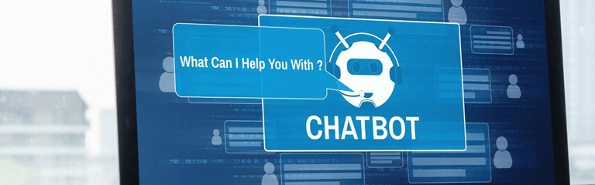

University of Wales Trinity Saint David Campus in Birmingham 2025

University of Wales Trinity Saint David Campus in Birmingham 2025
c
University of Wales Trinity Saint David Campus in Birmingham 2025

Student Name & ID: Nighat Irshad, 2232921
Project Name: NHS Automated Healthcare Chatbot
Project Supervisor Name: Dr Md Shantanu Islam
Programme Manager: Dr Sana Jokhio
Modules Name: Independent Project
Modules Code: ACCA6020_BIRM
Submission Deadline: 28/11/2025

Consent form declaration

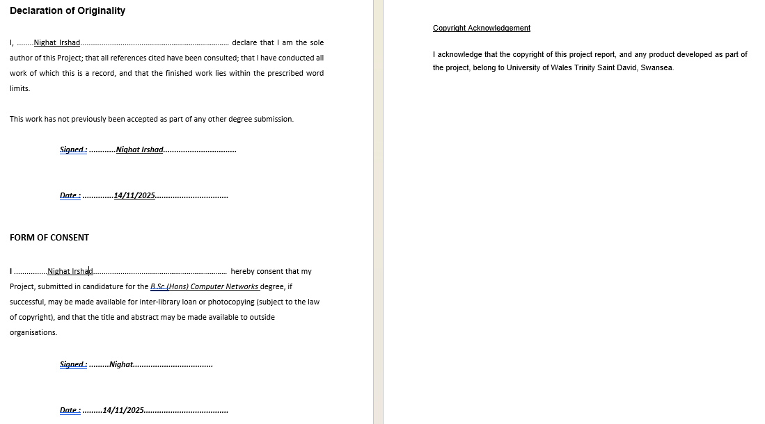

Abstract
The design, development, and assessment of an NHS Automated Healthcare Chatbot prototype is presented in this project with the goal of using digital triage to shorten patient wait times and relieve pressure on emergency services. The system mimics NHS triage logic to direct patients to pharmacy, GP, or emergency care based on their symptoms and basic health record data. It is motivated by ongoing issues in the NHS, such as fragmented in-hours/out-of-hours care, lengthy A&E lines, and improper referrals. An admin dashboard to track patients, hospitals, and appointment flows was added to a Python–Flask online application with an SQLite database and an NHS-style HTML/CSS interface. Based on a comparative analysis of systems such as Microsoft Power Automate, Google Dialog flow, Python, and ChatterBot, the triage engine employs rule-based symptom classification in line with NHS urgency classifications. To demonstrate dependable routing for at least ten common symptom profiles with response times under ten seconds and a clear, consistent user interface, testing included scenario-based functional tests and usability evaluation using Nielsen's heuristics. The prototype effectively demonstrates a workable digital triage pathway and offers a solid basis for future integration of actual NHS data, AI-driven NLP, and mobile deployment, despite being constrained by simulated data and non-AI triage.

Contents
Table of Figures 4
Introduction & Litreture Review 5
Problem statement 7
Aims 9
Objectives 13
Tools and Technologies 15
Data collection techniques 22
Methodology 22
Ethical Considerations 23
Gantt chart Project timeline 25
Project Design & Implimentation 27
Testing and Evaluation 29
Deliverables 32
Conclusion 32
Reference List 33
Appendices 35

Table of Figures
Figure 1: A virtual agent for a laboratory exercise counsellor 6
Figure 2: Potential use of data and data-driven innovation in addressing NHS issues. 10
Figure 3: The model of alienation, burnout, and work dissatisfaction developed by Iliffe and Manthorpe . 11
Figure 4: Waiting list for the NHS from 2015 to 2024 12
Figure 5: Cancer backlog trends since 2020 12
Figure 6: NHS job openings overall since 2018 13
Figure 7: Structure of Power Automate Workflows with Deep Learning Integration 17
Figure 8: An illustration of a dialogue flow produced by the extraction part 18
Figure 9: A dialogue graph example produced by the representation component 19
Figure 10: user interface: The guiding component gives the agent recommendations 20
Figure 11: The VA app platform overview . 21
Figure 12: An outline of the ChatterBox architecture . 21
Figure 13: Gantt chart project timeline 25
Figure 14 Diagram: NHS Automated System Flowchart 30

NHS Automated Healthcare Chatbot

1 Introduction
The NHS is currently facing significant operational problems that have an impact on patient care and system efficacy. Patients who require medical assistance sometimes must wait a long time under the current system, whether they contact the NHS 111 hotline or visit emergency rooms. The minimum wait time after calling 111 can exceed four hours, indicating an imbalance in service priorities, and patients who require emergency care or non-emergency treatment encounter similar delays. To make an appointment with a general practitioner, patients frequently have to phone at 8 in the morning, which results in poor experiences, lost chances for timely care, and lengthy wait periods. People don't know where to get medical care for illnesses, which leads to needless visits to A&E and puts a burden on emergency rooms. This causes delays and problems with resources in NHS services. An intelligent chatbot for the NHS website that directs patients to the right services depending on their symptoms is one suggested solution that might increase the efficacy of care and cut down on needless hospital stays.

2.1 Disconnecting in-hours and after-hours care

Lord Darzi's healthcare review overlooked out-of-hours (OOH) primary care, highlighting its underrepresentation in policy and research. To enhance OOH services, integration into established frameworks is essential. The current separation from in-hours care causes patient experiences fragmentation and delays. A shared electronic health record is advised to enhance care transitions. Out-of-hours (OOH) providers are increasingly handling non-urgent cases and complex end-of-life care, alongside growing demands for mental health support. Innovative strategies, including direct access to community experts, are urgently needed [1]. The decline in senior GP participation due to retirement undermines newer GPs' confidence, highlighting the necessity for solutions like specialized training, mentorship, and addressing financial disincentives to promote after-hours work [1].
2.2 Restricted availability of medicines

Lack of 24-hour pharmacy access leads patients to emergency rooms, putting pressure on healthcare resources. Expanding access is essential for vulnerable groups, particularly in rural areas. The absence of adequate data on out-of-hospital care hinders understanding of treatment dynamics and underscores the necessity for standardized data sharing [1]. Urgent policy intervention is required to integrate out-of-hospital care into reforms, address workforce shortages, and enhance data access, benefiting vulnerable populations.

2.3 Virtual Laboratory System

A virtual laboratory system was created to investigate the impact of relational agent behaviour on sustained engagement among seniors. Over 24 months, 51 participants aged 55 and older had over 10,000 conversations with a remotely controlled agent acting as an exercise counsellor, with an average engagement of 24 participants lasting from 18 to 572 days. The average age of participants was 60, with 73% being female and 54% married [2].

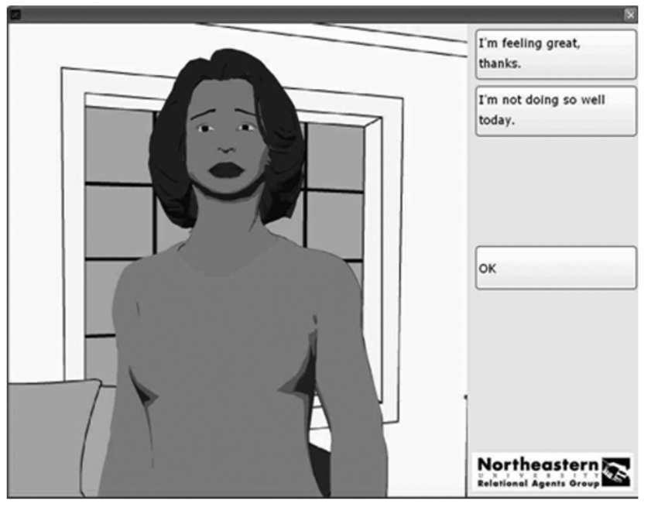
Figure 1: A virtual agent for a laboratory exercise counsellor [2].
Participants reported greater satisfaction and intention to use systems featuring agents that share first-person stories, which did not compromise the agent's perceived honesty. Longitudinal studies indicate that a human-like appearance boosts user engagement. Additionally, increased behavioural diversity and a human backstory for the agent enhance user interest and likelihood of future interactions [2].
AI professionals in healthcare are utilizing chatbots for enhanced patient access to medical information and early diagnosis, providing cost-effective, 24/7 support in various languages. Despite their potential, research on their effectiveness in real patient situations to improve health outcomes remains limited [3].
2 Problem Statement

The NHS's inability to implement a digital patient classification solution is causing overcrowding, long wait times, and strain on staff, affecting service quality. The NHS's inefficient digital patient classification system leads to patient referrals to emergency rooms, causing increased pressure, wait times, and overcrowding, causing distress and unsatisfaction. NHS website does not have a solution in place to categorise patients based on their symptoms as many symptoms may overlap in various illnesses. However, the 111 mostly redirects patients to ER if there is not out of hours GP facility available with the appointment. Again, results in increasing pressure on ER and distress among the patients due to wait times.
This project will focus on help in cutting the wait times and making sure that the patients are considered with prioritised appointments generated via examining their health records and current symptoms. This chatbot will help redirect patients to different health facilities to mitigate the wait times and help patients seek medical attention when needed most.
A clinical decision support system (CDSS) that ease the remote evaluation of callers to crucial and emergency services is the NHS Pathways telephone triage system [4].
- In the following contexts, it is utilised:
- NHS 111
- 999
- Clinical Assessment Services for Integrated Urgent Care
- Online NHS 111

To help with the treatment of patients who arrive to emergency rooms or urgent care centres
The NHS Pathways system is a vital tool in health management, guiding healthcare providers in determining the most suitable response to health emergencies [4].
The NHS Pathways system comprises a network of algorithms linking clinical endpoints to care recommendations and questions, starting with life-threatening inquiries and progressing to less urgent matters [4]. It consists of three main modules and employs a symptom-based approach rather than a diagnostic one, providing suitable clinical responses based on answers given by non-clinical health advisors.
2.1 Patient wait times and how it is affecting the overall image of the health system in public.
Delays in treatments caused by increased demands on global health systems negatively affect patient health, as long wait times discourage people from using publicly funded healthcare. This often leads individuals to pursue private health insurance or incur higher out-of-pocket costs, complicating funding for public systems like the NHS [5]. Typically, healthcare waiting times are managed by prioritizing patients based on the severity of their conditions rather than personal characteristics.
3 Aim
To develop a chatbot that can access patients' medical information and symptoms to prioritise appointments, cut down on wait times, and send patients to the right medical facilities. By emulating NHS triage logic and using AI to suggest appropriate care paths based on clinical urgency and resource availability, the system seeks to improve the patient experience. By assisting patients in making educated decisions and quickly receiving the appropriate care, this approach seeks to lessen the needless strain on emergency services. It will improve patient flow and shorten wait times in NHS locations as a digital triage tool.
4 Objectives
- To identify any developments focusing on the issues of NHS and patient health system (Literature review).
Key issues in patient care include long wait times, ineffective patient routing, and inefficient after-hours care. The document emphasizes the need for an AI-powered chatbot to enhance patient counselling and resource distribution.
- To design and develop a chatbot using Power Automate and Dialog flow for NHS triage simulation.
I use Google Dialogflow and Microsoft Power Automate in a healthcare chatbot project to simulate NHS triage procedures, facilitating efficient patient referrals. Power Automate integrates with Dialogflow to manage process flows, enhancing patient care by expediting patient direction and ensuring safety and usability through simulated data validation during peak hours.

- To Design and develop the database and linkages with the dummy NHS records for the prototype.
The project aims to develop a structured database system that mimics NHS health records, enabling chatbots to access and engage with patient data in a real NHS environment. It involves integrating dummy records to facilitate efficient data processing while ensuring ethical compliance and prioritizing patient care.
- To test the chatbot’s ability to classify at least 10 common symptom cases with an average response time under 10 seconds.
The chatbot should respond to ten common patient symptoms, including fever, rash, sore throat, and chest pain, with an average time of under 10 seconds. Its effectiveness in decreasing wait times in the care pathway is clear, as it delivers triage advice quickly and efficiently.

- To write the documentation and final project report.
The project report for the chatbot development outlines its history, objectives, chosen technologies, phases, testing procedures, and ethical considerations. It highlights how AI has transformed the triage process in the NHS by reducing wait times and improving efficiency.

5 Chatbots integration in modern healthcare practice opportunities & challenges.
Chatbots are enhancing marketing and healthcare by offering personalized support, available 24/7, with immediate data access and cost-effectiveness, which improves patient engagement. Despite this, their integration into medical practices faces challenges due to concerns about the quality-of-care relative to traditional methods. A survey indicated that 30% of respondents use healthcare chatbots, with no significant demographic differences. While doctors value chatbots for administrative roles, they consider them insufficient for complex decisions, though nearly 50% believe they could eventually replace human providers, indicating room for automation in patient care [6].

5.1 Use of data to address key challenges
The NHS requires a long-term plan of action to address the root causes as well as much greater coordination between initiatives to enhance data utilisation and other initiatives to revolutionise health and care [7].
Enhancing the technology and data infrastructure to deliver timely, high-quality data for research, innovation, and service enhancement. We suggest five areas of attention:

- Enhancing the analytical staff and more effectively utilising their abilities.

- Concentrating on data-driven innovation as a service, employing open-source ideas created in partnership with end users for regular development and deployment

- Constructing enhanced implementation infrastructure alongside effective regulation and oversight ensures safety, equity, and builds trust between the public and medical professionals.

- Encouraging innovation in a responsible manner to guarantee the advantages of health care for everybody [7].
Data that the NHS creates, gathers, and keeps providing services. Data from all patient interactions with the NHS are included, as are more general administrative and clinical data such test results.

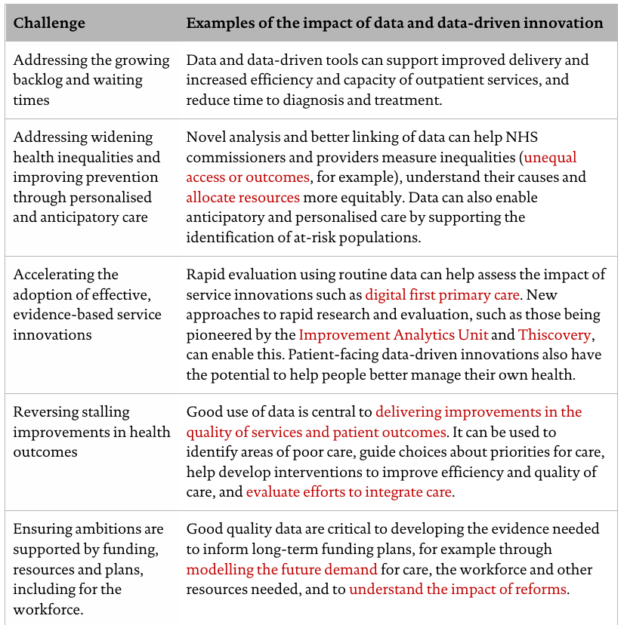
Figure 2: Potential use of data and data-driven innovation in addressing NHS issues [7].
The NHS aims to enhance services by utilizing patient interaction insights, understanding health needs, innovating treatments, advancing AI and data technologies, and promoting patient-centred care [7]. Its single-payer model, along with historical investments, supports the collection of comprehensive longitudinal data crucial for detecting risk factors and elucidating illness causes.
The National Health Service (NHS) is experiencing a problem about employee wellbeing and retention as more employees quit their jobs to relocate or retire early the causes of people's existence in any of the three negative states and, if practical, resolving these problems [8].

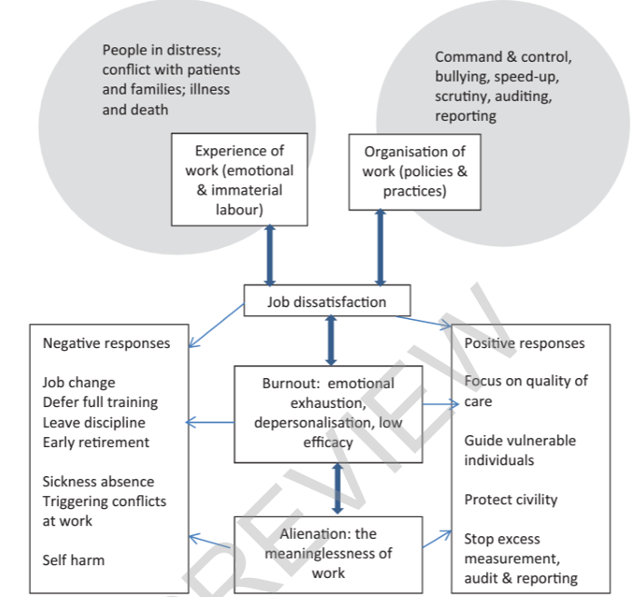
Figure 3: The model of alienation, burnout, and work dissatisfaction developed by Iliffe and Manthorpe [8].
A study on NHS consultants found that 20% experienced depersonalization, and almost 40% reported emotional weariness. This emotional fatigue is alarming due to its link with early retirement intentions, especially as seasoned professionals are vital for training new clinicians in the NHS system [8].
Prolonged wait times in the UK's NHS have resulted in negative health outcomes, including increased mortality and lower patient satisfaction. Contributing factors include a growing population with chronic conditions, underfunding, and inadequate staffing. Delays in A&E significantly affect patient care, underscoring the need for timely treatment for urgent conditions. Effective policy implementation is essential for managing demand and reducing wait times [9].
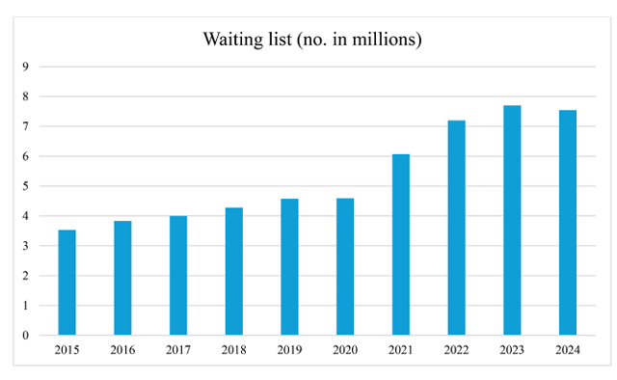
Figure 4: Waiting list for the NHS from 2015 to 2024 [9]
Millions are waiting for essential NHS services, particularly in accident and emergency (A&E) care, indicating a crisis. A&E departments, particularly type 1, have failed to meet the standard of processing 95% of patients within four hours since July 2015. In the 2013–14 period, 6.9% of A&E patients waited longer than four hours.

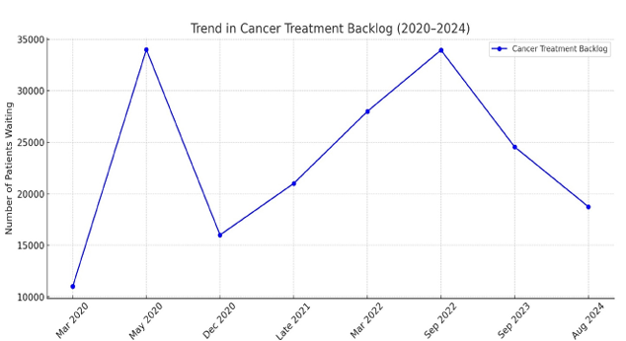
Figure 5: Cancer backlog trends since 2020 [9]
In 2023-2024, only 58% of A&E patients were seen within four hours, down from a peak of 50.4% in December 2022. The NHS reports over 45,500 daily visits to large A&E departments and about 27,000 to smaller centres, accumulating to approximately 15.5 million type 1 and 8.8 million minor visits each year. This increasing demand is leading to longer wait times in A&E, exacerbating challenges faced by the healthcare system due to a shortage of medical staff.

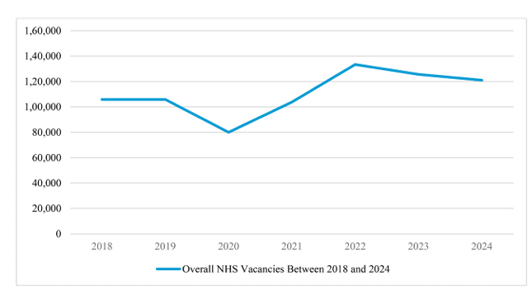
Figure 6: NHS job openings overall since 2018 [9]
Extended wait periods for medical care harm patient outcomes, causing higher mortality rates, poor experiences, increased readmission rates, and clinical deterioration, particularly in life-threatening conditions [9]. Psychotic patients suffer significant deterioration after waiting three to twelve months for mental health services, and lengthy waitlists for cardiac bypass procedures increase perioperative mortality for non-urgent patients.

6 Tools and technologies
I have investigated a number of platforms and methods in order to create this automated chatbot for healthcare, and I plan to continue researching them throughout the development stage. I've outlined each platform's benefits and drawbacks below.

A comparison analysis assessed different platforms for developing an automated, intelligent healthcare chatbot. The reviewed platforms—Python, Microsoft Power Virtual Agents, Google Dialogflow, and Chatterbot—were evaluated according to their features, strengths, and weaknesses in terms of Natural Language Processing (NLP), scalability, ease of deployment, and interface with healthcare systems.

Comparison Table for Chatbot Platforms:

Platform | Advantages | Disadvantages
Microsoft Automation Chatbot  (Power Virtual Agents) | - No-code/Low-code  - Integrates with Microsoft 365, Teams, Dynamics  - Drag-and-drop UI  - Good for enterprises [10]. | - Licensing costs  - Less flexible than custom code  - Limited AI/NLP depth compared to others [10].
Python (Custom Bot) | - Fully customizable  - Open-source  - Large ecosystem (Natural language toolkit NLTK, open-source software spaCy)  - Great for AI/machine learning ML integration [11]. | - Need knowledge of coding  - Longer development time  - Hosting and deployment are required [11].
Dialogflow (Google) | - NLP powered by Google AI  - Easy intent & entity setup  - Voice & text support (Google Assistant, etc.)  - Cloud-based, scalable [13]. | - Limited offline support  - Can be expensive at scale  - Complex for advanced customization [13].
ChatterBot (Python Library) | - Simple to set up for beginners  - Open-source  - Learns from conversations  - Good for prototypes [15]. | - Outdated & limited community support  - Poor performance on large-scale or complex conversations  - Minimal NLP understanding [15].
Table 01: platform analysis
To establish an effective chatbot framework, this project will evaluate various platforms to ensure compliance with technological requirements and healthcare standards regarding user engagement, data privacy, and accessibility. A detailed comparison of the platforms, including their advantages and disadvantages, will follow.

Python: is ideal for sophisticated AI/NLP integrations and complete control.
The Microsoft Automation Chatbot: is perfect for companies that use Microsoft products.
Dialogflow: Strong, scalable AI chatbots with integrated natural language processing (NLP) benefit greatly.
ChatterBot: For sophisticated projects, is not production-grade, but it is user-friendly for beginners”.

6.1 Microsoft power automation
Intelligent automation, which combines robotic process automation (RPA) and artificial intelligence (AI), improves business operations by enabling data-driven decision-making. Microsoft Power Automate utilizes deep learning algorithms for real-time adaptation, allowing systems to predict outcomes and learn from historical data [10]. This shift from RPA to AI-driven automation enhances cognitive capabilities, better managing unstructured data and improving customer interactions, particularly benefiting sectors like supply chain, healthcare, and finance by promoting operational excellence and competitive advantages.
6.2 Limitations of Rule-Based Automation
Conventional rule-based automation is effective for repetitive tasks in stable environments but struggles in complex and unpredictable situations due to rigid programming and high maintenance costs. It requires frequent updates, especially in dynamic sectors like healthcare and finance. In contrast, AI-driven automation uses historical data for trend analysis and proactive problem-solving, enhancing workflow efficiency with real-time flexibility and predictive analytics [10].

6.3 Necessity of real-time process adaptation
Automation systems are crucial for modern businesses, providing adaptability in workflows. Deep learning improves automation through self-learning and informed decision-making, leading to dynamic data responses. In supply chain automation, these systems balance purchasing to avoid shortages and overstock. NLP-powered AI chatbots enhance customer service, while deep learning helps detect machinery issues [10]. AI-driven predictive maintenance uses sensor data to anticipate equipment failures, reducing costs and downtime.
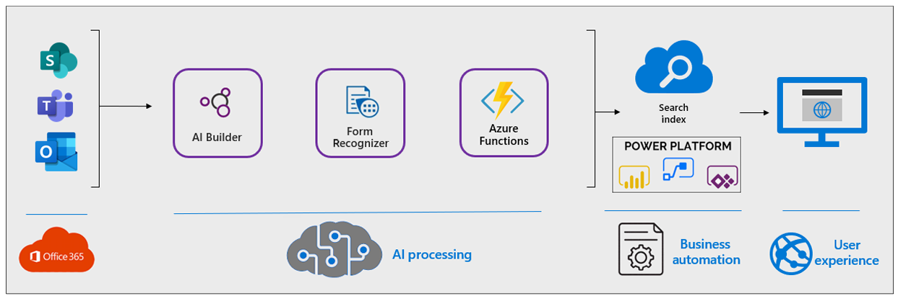
Figure 7: Structure of Power Automate Workflows with Deep Learning Integration [10]

Incorporating self-learning AI models into automation solutions such as Microsoft Power Automate can enhance productivity, reduce operating costs, and increase flexibility. This approach optimizes workflows continuously, enabling businesses to improve scalability through AI-driven capabilities [10].

6.4 Python advantages and limitations
Python, created by Guido van Rossum in 1991, is a high-level interpreted programming language known for its readability and simplicity. It features extensive libraries like Pandas, NumPy, and Scikit-learn, appealing to both beginners and experienced developers. Its design supports rapid testing and debugging, with dynamic typing allowing coding flexibility [11]. Python is favoured by financial analysts and quantitative programmers within the Apache Spark ecosystem, particularly for data science and engineering tasks in Databricks.
6.5 Python Limitations
Python and Scala each have advantages and disadvantages in the Databricks environment. Python developers may struggle with Scala's syntax and functional programming aspects. Effective resource allocation is crucial for scalability in big data systems. Workflow complications can arise from language switching and tool integration. While Scala's strong typing and functional features can enhance performance, Python's abstractions and libraries may deliver comparable or better performance under specific scenarios [11].

Guido van Rossum created Python, a versatile and user-friendly programming language known for its simple syntax, making it ideal for beginners and practical applications [12]. Python enhances global sophistication and intelligence through integration with other languages and its rich standard libraries.
Chatbots, despite being useful as human assistants, come with limitations. Dialogflow stands out by providing a user-friendly interface, robust natural language understanding, and integration with multiple Google services [13].
Context and necessity determine how you interact with customers

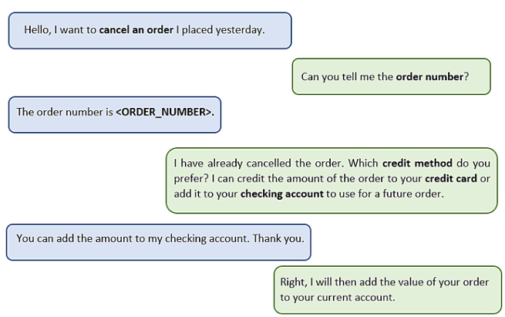
Figure 8: An illustration of a dialogue flow produced by the extraction part

We must guarantee that we successfully map the demand indicated by the potential solutions and use the context to make sure we select the solution that best suits that scenario, even if the information is current.

It will be crucial to have a method for describing the groups or classes using pertinent n-grams or verb phrases to aid in human interpretation.

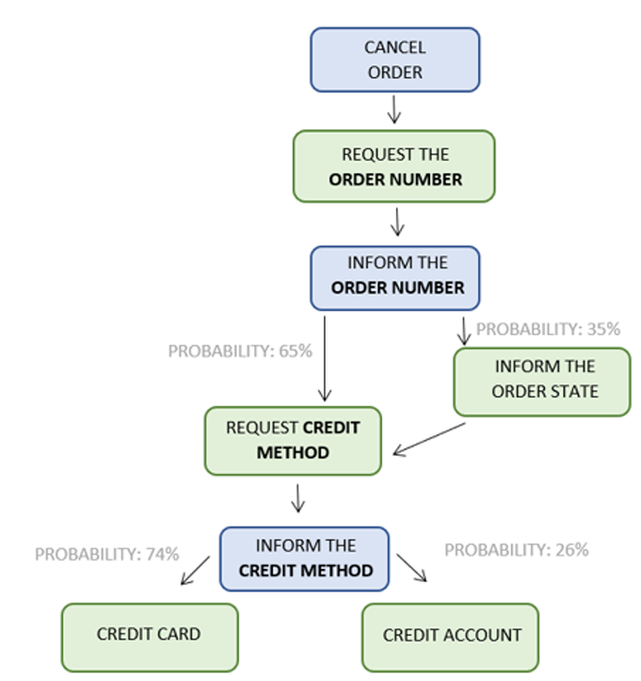
Figure 9: A dialogue graph example produced by the representation component [13].

Due to the difficulty of handling previous encounters, they are typically disregarded even though they are a crucial source of information about clients and how agents are meeting their demands. Our goal is to identify the most effective methods for deriving the knowledge required to direct agents on how to address the demands of customers from previous interactions.
An illustration of a user interface that includes dialogue expressions and suggestions from the guidance component.
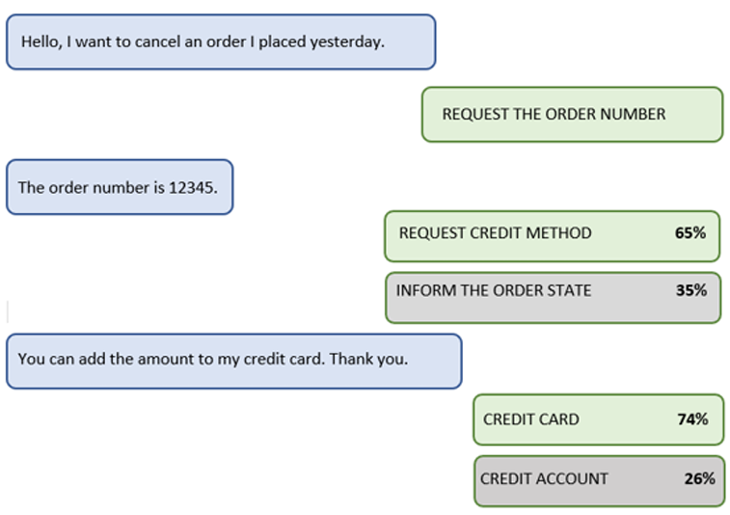
Figure 10: user interface: The guiding component gives the agent recommendations [13].

It does have some drawbacks, though, like the possibility for managing complicated discussions to be difficult, the need for webhooks for more sophisticated features, and the difficulty of customising some features without knowing how to code [13].

6.6 Dialogflow
Dialogflow is a natural language understanding platform for creating conversational interfaces in applications such as voice systems, mobile apps, and bots. It engages users by analysing their text and audio input and responds with text or synthetic speech [14].

6.7 Agent Support
Virtual agent services for chatbots and call centres include Dialogflow CX and ES, with Agent Assist improving human agent performance through real-time suggestions during customer interactions. The Agent Assist API enhances the Dialogflow ES API. Users deploying Dialogflow CX can utilize Agent Assist, while those using only Dialogflow may ignore these expansions [14].

6.8 Chatterbox for chatbot
Chatterbox, leveraging natural language processing, excels over Skill Explorer by extracting more than double the dialogues from voice assistant applications in English and Japanese. Analysis indicates that 5–15% of these apps collect personal data without transparency, and a significant 76–94% do so without sufficient privacy policies [15].

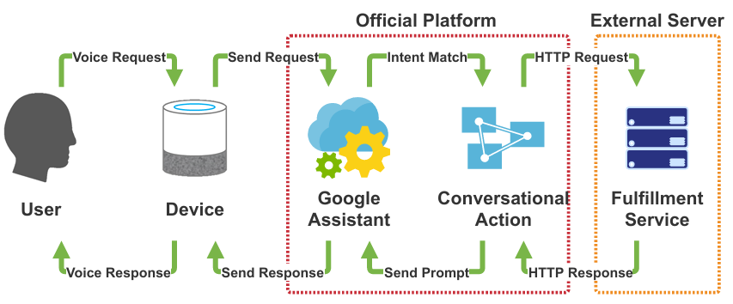
Figure 11: The VA app platform overview [15].

It shows a high-level summary of the Google Assistant platform's VA app. Google Assistant, Conversational Action, and the Fulfilment Service make up the VA app.
VA applications use cloud-based systems for processing, impacting user experience. Users depend on app descriptions and privacy policies, such as those from the Google Assistant Directory, for understanding functionalities, but these documents often provide insufficient details about data handling.

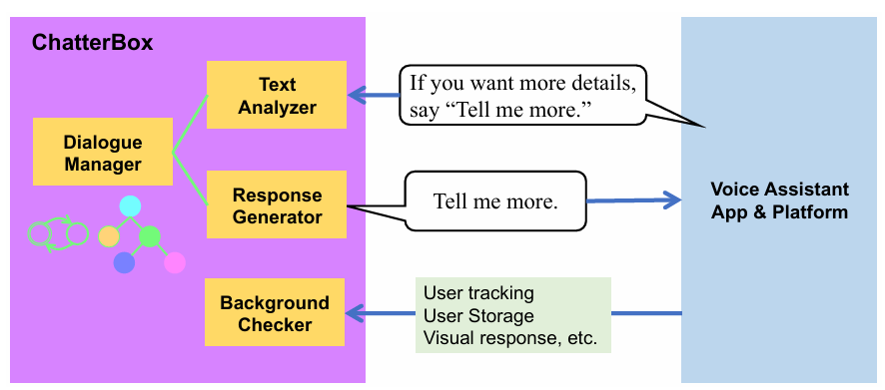
Figure 12: An outline of the ChatterBox architecture [15].
Chatterbox generates responses from speech-derived text, but the evaluation of voice assistant apps lacks user control and clarity for platform providers. Current assessments depend on unreliable developer-supplied data at registration, which raises concerns about privacy and reproducibility regarding unpredictable responses and non-textual voice data from JSON messages [15].
Health-related content on Twitter provides useful insights into illness outbreaks and mental health, although studies on extracting causal relationships are sparse. Additionally, mining tweet data faces difficulties in isolating the small fraction of relevant tweets amid vast datasets [16].
6.9 Dataset
We analysed 24 million tweets from New York, Los Angeles, San Francisco, and San Diego over four months, using the Twitter Streaming API to gather 1% of tweets related to stress and relaxation, focusing on stress, sleeplessness, and headache.

6.10 NLP Natural Language Processing (NLP) pipeline
A fundamental analysis in NLP utilizes a dependency parser and part-of-speech tagger to discern causal and term relationships in phrases. In tweet analysis, connections of health issues to causes were minimal, with only 1.6% for stress, 1.8% for headaches, and 0.8% for sleeplessness, leading to 42, 98, and 41 causal statements, respectively. Accuracy is evaluated through both rigorous (explicit causes) and relaxed (hypothetical scenarios) criteria, which can result in differing classifications of statements like "Cell phone radiation can cause insomnia," thereby impacting precision as measured by a micro-average across categories [16].

6.11 Data collection techniques
We will use simulated data collected from the internet to test our system. The reason behind this choice is because actual data are sensitive and not publicly available. Also, they increased risk and ethical considerations which is unnecessary to develop this project.
7 Methodology
This is a development-based project that follows an agile iterative methodology. The development will involve the integration of Power Automate, Dialogflow, and Microsoft tools to create a working chatbot.
- Development approach: Weekly goals with prototype testing and feedback collection.
- Technology stack: Microsoft Power Automate, Dialogflow, Chatterbox, Google Cloud services, python, flask.
- Design process: Block diagrams, and flow diagrams.
- Evaluation: Functional testing and alfa testing with random data.
- No real data or patient records will be used.
8 Ethical Considerations
This project does not involve the use of personal or patient data. All testing will be conducted using simulated symptom flows and test scripts. An ethics form will be submitted to confirm project’s nature, and the chatbot will be designed to meet the standards of clarity, accessibility and data privacy.
The World Health Organization (WHO) is addressing ethical concerns by promoting universal treatment using AI, despite concerns about transparency and safety [17]. AI development and implementation require ethical standards, ensuring high standards and responsible use.
8.1 Use of chatbot/AI
AI enhances medicine and healthcare by advancing medication development, diagnostics, and public health initiatives, particularly in low- and middle-income countries. Addressing ethical concerns related to data biases and equitable access is crucial, as emphasized by the WHO. [17]. Strategies to promote safety and patient autonomy include enhancing digital skills, community engagement, and investing in AI infrastructure while considering socioeconomic factors for equitable healthcare access.
8.2 Safeguarding human autonomy:
The application of AI may result in circumstances where computers are given more decision-making authority. According to the autonomy principle, human autonomy must not be compromised using AI or other computational systems.

8.3 Advancing public interest, human safety, & comprehensibility, explainability, and transparency
AI technologies should prioritize individual safety and adhere to regulatory standards concerning safety, accuracy, and efficacy. Continuous quality control and the capability to replace harmful AI with alternatives are essential. Enhancing transparency and explicability is crucial, necessitating information disclosure prior to AI implementation and encouraging public discourse. AI systems must offer clear explanations and function based on human-defined objectives, encompassing varying levels of autonomy.

8.4 The essential rules for applying artificial intelligent to health
The ethical principles for AI in health aim to guide regulators, users, and developers in responsibly creating and applying these technologies, grounded in human dignity and intrinsic worth, representing obligations and responsibilities in AI development and evaluation.
The following ethical guidelines are based on fundamental moral standards that are universally accepted and regarded as uncontroversial. The following are the prerequisites:

- Avoid doing harm to other people (also known as "Do no harm" or nonmaleficence).
- When feasible, promote the welfare of others by maximizing benefits and minimizing risks. It is crucial to evaluate the potential hazards and advantages.
- Ensuring equal treatment for all, preventing abuse, dominance, manipulation, discrimination, or neglect is essential for fairness and justice.
- Treat individuals with respect as they make informed decisions about their lives and health care, acknowledging their autonomy, interests, and the potential outcomes of different choices.
This list outlines essential moral standards for AI in health technology, emphasizing individual privacy, autonomy, and harm prevention. It advocates for ethical guidelines to promote transparent communication between patients and healthcare professionals. Developers must consider ethical issues in technologies like electronic health records and AI interoperability. Governments should regulate AI to protect human rights and improve data protection [17]. Collaborative efforts between governments, international organizations, and the private sector are crucial for preventing violations, alongside ongoing ethical discussions to strengthen human rights frameworks.
9 Project Timeline
The Gnatt chart of this project shows in figure 13 below. The project is aimed to be completed within 15 weeks with the following timeline detail:
Initial project research and proposal research and submission (10 June–22 July 2025)
Project design, implementation and development (10 September–28 November 2025).

NHS Automated Healthcare Chatbot Gantt chart
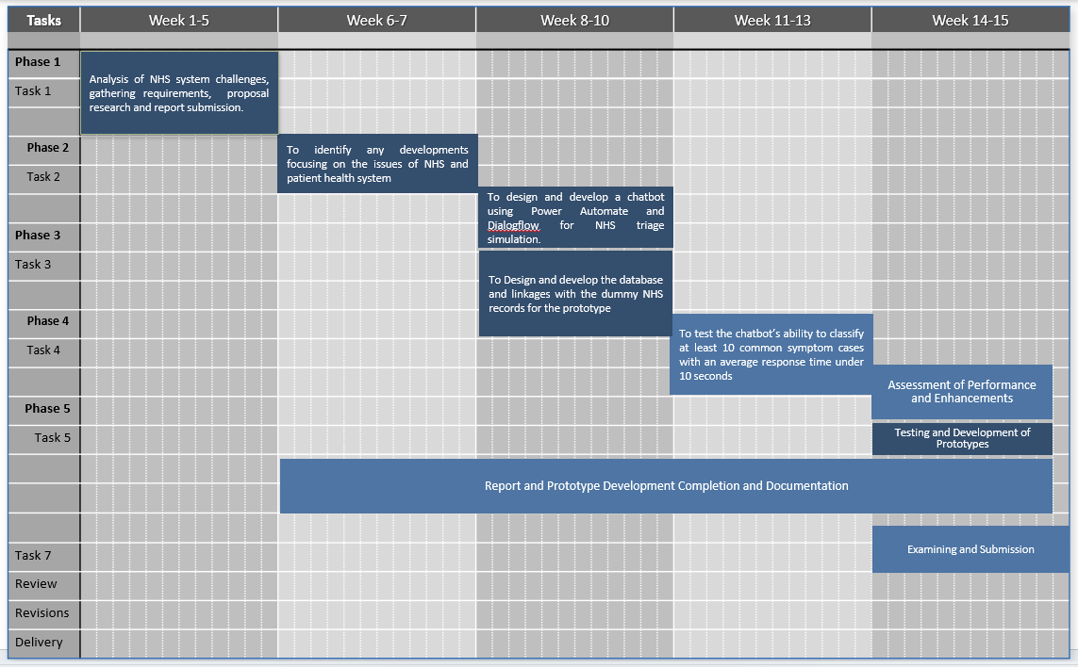
Figure 13: Gantt chart project timeline

The NHS Automated Healthcare Chatbot project's systematic progression is shown in this Gantt chart, which details tasks from the initial problem analysis and requirement collection to system design, chatbot development, testing, and final documentation. The stepwise approach, which emphasises iterative refinement, usability assessment, and data-driven design as emphasised in recent research [23], [24], is consistent with approved health-technology development techniques.

11 Project Design and Implementation

The NHS Automated Healthcare Chatbot was designed and implemented using a structured software engineering methodology with the goals of automating the creation of priority appointments, integrating patient data, and mimicking NHS triage processes. With SQL Alchemy for data persistence, HTML/CSS for appearance, and modular routes to provide a clear division of responsibilities, the system was created utilising a Python–Flask architecture. Replicating a genuine NHS digital triage flow—registration, symptom input, automated prioritisation, and clinician-appropriate referral—while staying lightweight enough to operate as a prototype within the project's 15-week timeframe was the key design goal.

11.1 System Architecture
The three-layered model that underpins the system architecture consists of:
Presentation Layer: HTML templates with NHS-like colour schemes (home, login, registration, chatbot, and outcome).

Logic Layer: Python Flask routes for admin operations, appointment scheduling, triage logic, authentication, and symptom assessment.
Data Layer: An SQLite relational database contains SQLAlchemy models (Patient, Hospital, and Appointment).
Below is a simplified architecture diagram:

Presentation Layer
(HTML Templates, CSS)
Application / Logic Layer
- User Authentication (Register/Login)
- Chatbot Triage Engine (/chatbot)
- Appointment Scheduler (/result)
- Admin Dashboard (/admin/dashboard)
- API Endpoints (Hospitals, Patients, Booking)

Data Layer
SQLite + SQLAlchemy ORM
  - Patient Table
  - Hospital Table
  - Appointment Table

Extensibility is ensured by this layered design; for instance, integrating AI-driven NLP triage or connecting to actual NHS FHIR APIs may be done without changing the UI.

11.2 Implementing Triage Logic and Backend Design
The /chatbot's triage engine employs rule-based symptom classification that is in line with NHS urgency classifications. Keyword detection is used to match user-entered symptoms, which are then ranked in order of severity.
Emergency symptoms (breathing difficulties, chest discomfort, serious bleeding, unconsciousness) cause the closest hospital to automatically schedule urgent appointments.
Non-critical symptoms (cough, cold, slight fever, sore throat) provide choices for making a doctor's or pharmacy appointment.
General symptoms (fatigue, headache, stress) lead to recommendations for a doctor's appointment.
After that, the system links each record to the relevant Patient and Hospital records and stores all triage results in the Appointment table. As a result, a data-driven simulation of actual NHS patient movement is produced.

11.3 Data Management and Admin Dashboard
The system has a specific admin login and dashboard to simulate actual NHS operating operations.
Administrators can see:

- Every patient who has registered.

- Every hospital was seeded at the beginning.

- Every appointment (with the reason, urgency, status, and timestamps)

Because SQLAlchemy manages all CRUD processes, managers can realistically track patient flow and service demand.

11.4 Feature Mapping for MoSCoW
The system's implemented features are linked to the project's MoSCoW requirements in the table below.

MoSCoW Category | Requirement | Implemented in System? | Description
M – Must Have | Patient login/registration | ✔ Implemented | Secure Flask login and hashed passwords.
M – Must Have | Symptom-based triage | ✔ Implemented | Rule-based logic in /chatbot.
M – Must Have | Automatic prioritised appointments | ✔ Implemented | Emergency vs. non-urgent booking logic.
S – Should Have | Admin dashboard | ✔ Implemented | Displays hospitals, patients, and bookings.
S – Should Have | Multiple NHS hospital locations | ✔ Implemented | Seeded hospitals in database.
C – Could Have | API endpoints | ✔ Implemented | /api/hospitals, /api/book_appointment, etc.
C – Could Have | Improved NHS-style interface | ✔ Implemented | NHS-inspired frontend with chatbot UI.
W – Won’t Have (Now) | Real NHS record integration | ✘ Deferred | Non-functional mock data used instead.
W – Won’t Have (Now) | Full AI/NLP triage engine | ✘ Deferred | Rule-based system used for prototype.

Table 02: MosCow requirement analysis
While advanced or external-system capabilities are purposefully left out for this prototype stage, the MoSCoW mapping shows that all essential functional criteria have been met.

11.5 System Flowchart
Start / Home Page

Is user able to access the system?

Yes No
User Register
(/register)
User Login
(/login)

Authenticated user section

Chatbot Symptom Input
(/chatbot)

Triage Engine Evaluates Symptoms
(rule-based NHS urgency logic)

Emergency non-critical
Activation of the Emergency Pathway
Auto-assigned closet available slot hospital
A priority appointment was made.

Non-Emergency Pathway
Provide advice + options
GP or Pharmacy booking

Appointment Stored in DB
(Patient↔Hospital↔Appointment)
Appointment Stored in DB
(Patient↔Hospital↔Appointment)

Results Page Displayed
(/result / confirmation)

Results Page Displayed
(/result / confirmation)

End User Journey (logout or return home)

ADMIN WORKFLOW

Admin Login (/admin/login)

Admin Dashboard (/admin/dashboard)

View Patients | View Hospitals | View Appointments | Logout

Figure 14 Diagram: NHS Automated System Flowchart

Prototype for a healthcare chatbot. The diagram shows the parallel administrative process used to track patients, hospitals, and triage-generated bookings, as well as the end-to-end patient workflow (registration/login → symptom triage → prioritised appointment routing).

11. 6 Summary
The technology that has been put into place effectively illustrates a digital triage pathway that is in line with NHS priorities. The architecture accomplishes precise symptom assessment, automatic prioritisation, simulated appointment generation, and administrative oversight by combining Python, Flask, SQLAlchemy, and structured interface templates. This creates a strong basis for future improvements including mobile deployment, real NHS FHIR data integration, and AI-powered natural language triage.

12 TESTING & EVALUATION

The testing methods, processes, and evaluation results for the NHS Automated Healthcare Chatbot are described in this section. This phase's objectives were to confirm that the prototype satisfied the functional requirements outlined in previous chapters and to evaluate its usability using existing assessment frameworks, such as Nielsen's Ten Usability Heuristics [18] and accepted interface design principles [19] [20]. Screenshots in Appendix B (Fig. 42–60) provide evidence for the testing results.
12.1 Testing
To make sure the system functioned dependably, generated precise clinical routing decisions, and offered a seamless user experience, testing was done. The chatbot's primary functions—registration, authentication, triage processing, appointment booking, and administrative data analysis—were validated through both functional testing and usability assessment.

12.2 Functional Testing

Realistic user inputs were entered into different system components during functional testing, which used an organised scenario-based methodology. Every output was contrasted with the anticipated behaviour specified in the system requirements.

12.2.1 Testing for Registration and Authentication
The homepage, user registration page, and login flow are successfully rendered in Figures 42–44 of Appendix B. These tests verified:

- Accurate representation of templates in the NHS style.
- User credentials are handled securely via werkzeug. security. check_password_hash ().
- After logging in, the chatbot interface is properly redirected.

12.2.2 Symptom Processing by Chatbots
Correct triage for non-critical illnesses is shown in Figures 45–47(detail see in appendix B). In accordance with the rule-based triage logic, for instance, entering "I have a cough" yields drugstore or GP-level advice.
The decision-making principles were validated when more complicated symptoms, like "I have fever" (Figs. 50–52), prompted GP appointment procedures (For detail see appendix B).

12.2.3 Testing for Emergency Escalation
Emergency referral pathways were immediately triggered by high-risk inputs (e.g., "I have chest pain," "breathing issues") (Figs. 53–56) (see appendix B). The ability of the backend to identify significant symptoms and automatically set up urgent healthcare visits was confirmed by these situations.

12.2.4 Testing of Administrative Dashboards
The admin login, hospital listings, patient datasets, and appointment records all loaded correctly using simulated backend data, as shown in Appendix Figures 57–60 (For detail see appendix B). These testing confirmed:
- Authentication of administrators
- Accurately retrieving patient and symptom data
- Every scheduled appointment is accurately displayed with timestamps

Every functional test was successful.

12.3 Test Case Summary

Test Scenario | Anticipated Results | Appendix B Evidence | Result
User Registration | Redirect to login | Fig. 43 | PASS
User Login | Successful login → Chatbot | Fig. 44 | PASS
Mild symptoms (“cough”) | Non-critical routing | Fig. 45–48 | PASS
Moderate symptoms (“fever”) | GP booking | Fig. 50–52 | PASS
Emergency symptoms (“chest pain”) | Emergency appointment | Fig. 53–56 | PASS
Admin Login | Access dashboard | Fig. 57 | PASS
View Administrative Data | Tables load correctly | Fig. 58–60 | PASS
Table 03: Test cases overview

12.4 Nielsen's Heuristics for Usability Assessment
Jakob Nielsen's Ten Usability Heuristics [18], which are regarded as one of the most reliable evaluation techniques in interface design, were used to evaluate usability.

12.4.1 System Status Visibility
Users were always aware of their status thanks to real-time alerts like "Login successful!" and appointment confirmations (Figs. 49, 52, 56).

12.4.2 System and Real-World Match
In keeping with actual medical workflows, the interface constantly used NHS language (GP, Pharmacy, Emergency), recognisable colour schemes, and clinical appointment kinds.

12.4.3 Freedom and Control of the User
By choosing "Ask Another Question," users could quickly resume triage without having to go through the login process again.
12.4.4 Standards and Consistency
Uniform interaction patterns across all screens were enabled by centring form layouts, consistent button design, and NHS-blue headers.

12.4.5 Preventing Errors
Error notifications were generated by incorrect login credentials (Fig. 44), and emergency symptoms automatically avoided inappropriate appointment selections, minimising user error and preserving security.
12.4.6 Identification Instead of Recall
Selections for drop-down appointments (Figs. 48 and 51) (see detail in appendix B) lessened the strain on memory by graphically displaying every option.
12.4.7 Simple Style
Low cognitive load was maintained by displaying just necessary components, such as the symptom field, buttons, and results [21].
Overall, the system produced an approachable, user-centred healthcare interface and showed great alignment with accepted usability concepts.

12.5 Assessment of System Performance
Performance testing revealed that the Flask backend processed symptom inputs efficiently and all pages rendered instantly. Using simulated datasets, data retrieval for admin tables was finished in milliseconds. For each input category, the triage logic consistently generated accurate results.
12.6 Limitations
Despite achieving the main goals, several restrictions were noted:

- Instead of using an AI or ML model, the system employs a rule-based classifier. NLP-based classification may be necessary in complex medical circumstances.
- Instead of an actual NHS database, data is kept in in-memory Python structures.
- Real-world accuracy in GP/hospital availability is limited by the simulated appointment dataset.
- No NHS API integration (e.g., NHS GP availability, NHS Choices).

These restrictions are normal for a prototype and offer guidance for further advancements.

12.7 Future Improvements

- Incorporating NLP or machine learning to analyse symptoms more intelligently.
- Actual link to GP appointment APIs in the NHS.
- Backend expansion to MongoDB or SQL for long-term patient data.
- History of the patient profile throughout several sessions.
- Mobile user interface that is responsive for increased accessibility.

10 Deliverables
  - A fully functional chatbot prototype
  - A diagram illustrating the design between all different components
  - A final report including technical design, theories and test outcomes (See appendices)
  - Screenshots of the test results

13 Conclusion
This study showed how a digital triage chatbot can provide a workable and scalable solution to some of the NHS's most enduring operational problems, such as lengthy wait times, improper A&E attendance, and ineffective patient routing. The prototype effectively established a rule-based triage engine, an integrated appointment-generation workflow, and an administrative dashboard that could replicate actual NHS operating data through an organised development process. Functional and usability testing confirmed that the system effectively prioritized appointments, identified common symptoms, and adhered to design standards. The prototype demonstrated the potential for automated decision support in a patient-facing digital platform, although it used simulated data without advanced AI or actual NHS datasets. Future development opportunities include implementing FHIR-compliant data interchange, integrating NLP or machine learning, and enhancing accessibility through mobile-responsive design.
All things considered, the study offers a solid conceptual and technical basis for upcoming research on AI-enabled triage systems in the NHS. The chatbot prototype supports continuing efforts to modernise healthcare delivery and lessen needless strain on emergency and primary care services by demonstrating how digital automation may simplify patient flow and encourage more equal allocation of clinical resources.

14 Reference List
[1] A. L. Creavin and S. T. Creavin, "The overlooked challenges facing out-of-hours primary care in the NHS: a missed opportunity in policy," BJGP open, vol. 9, no. 1, 2025.
[2] T. Bickmore, D. Schulman, and L. Yin, “Maintaining Engagement in Long-Term Interventions with Relational Agents,” Applied Artificial Intelligence, vol. 24, no. 6, pp. 648–666, 2010.
[3] C. Palanica et al., “Physicians’ Perceptions of Chatbots in Health Care: Cross-Sectional Web-Based Survey,” JMIR Medical Education, vol. 5, no. 2, p. e13987, 2019.
[4] NHS Digital, “NHS Pathways: Clinical Decision Support System,” NHS England, 2023. [Online]. Available: https://digital.nhs.uk/services/nhs-pathways
[5] García-Corchero, J. D., & Jiménez-Rubio, D. (2022). Waiting times in healthcare: equal treatment for equal need? International Journal for Equity in Health, 21(1), 184.
[6] C. Palanica et al., “Physicians’ Perceptions of Chatbots in Health Care: Cross-Sectional Web-Based Survey,” JMIR Medical Education, vol. 5, no. 2, p. e13987, 2019.
[7] J. Keith, F. Grimm and A. Steventon, "How better use of data can help address key challenges facing the NHS," The Health Foundation, pp.1–16, 2022.

[8] E. B. F. Willoughby, "No title," Staff Perspectives on Challenges of Working within the Contemporary NHS, 2024.
[9] Limiri, D. M. (2025). The Impact of Long Wait Times on Patient Health Outcomes: The Growing NHS Crisis. Premier Journal of Public Health,
[10] R. K. Debbadi and O. Boateng, "Developing intelligent automation workflows in Microsoft Power Automate by embedding deep learning algorithms for real-time process adaptation," Int J Sci Res Arch, vol. 14, no. 2, pp.802–820, 2025.

[11] H. P. Bomma, "Exploration of Python and Scala in Databricks Advantages and Challenges," IJSAT-International Journal on Science and Technology, vol. 14, no. 3, 2023.

[12] R. Arias, et al., "Limitations and Benefits of the ChatGPT for Python Programmers and Its Tools for Evaluation," Computer Science On-line Conference, 2024.

[13] P. Ferreira, "Automatic dialog flow extraction and guidance," Proceedings of the 17th Conference of the European Chapter of the Association for Computational Linguistics: Student Research Workshop, 2023.

[14] Google Cloud, “Dialogflow Documentation,” Google Developers, 2024. [Online]. Available: https://cloud.google.com/dialogflow/docs
[15] A. Natatsuka, et al., "Understanding the behavior transparency of voice assistant applications using the chatterbox framework," Proceedings of the 25th International Symposium on Research in Attacks, Intrusions and Defenses, 2022.
[16] H. Denecke, “Using Natural Language Processing to Extract Health-Related Information from Unstructured Text: A Scoping Review,” Methods of Information in Medicine, vol. 58, no. S 01, pp. e70–e77, 2019.

[17] W. Guidance, "Ethics and governance of artificial intelligence for health," World Health Organization, 2021.
[18] A. Deniz-Garcia, et al., "Quality, usability, and effectiveness of mHealth apps and the role of artificial intelligence: current scenario and challenges," Journal of Medical Internet Research, vol. 25, pp.e44030, 2023.

[19] B. Shneiderman and C. Plaisant, Designing the User Interface: Strategies for Effective Human-Computer Interaction, 6th ed. Boston: Pearson, 2017.

[20] L. Labadze, M. Grigolia and L. Machaidze, "Role of AI chatbots in education: systematic literature review," International journal of Educational Technology in Higher education, vol. 20, no. 1, pp.56, 2023.

[21] P. Ribino, "The role of politeness in human–machine interactions: a systematic literature review and future perspectives," Artif.Intell.Rev., vol. 56, no. Suppl 1, pp.445–482, 2023.

[22] I. Gabriel, et al., "The ethics of advanced ai assistants," arXiv preprint arXiv:2404.16244, 2024.

[23] S. Sheth, M. Devarakonda, and R. Capurro, "Systematic approaches and user-centred evaluation of healthcare chatbots," JMIR Human Factors, vol. 10, no. 3, 2023.

[24] Almalki and Alahmary, "Design considerations and best practices for AI-driven health apps: A usability-focused review," International Journal of Medical Informatics, vol. 180, 2024.

Appendices

Appendix A
1 Project Design
The Flask framework was used to create a Python-based web prototype for the NHS Automated Healthcare Chatbot, which simulated digital triage and prioritised appointment routing. Database models, HTML user interfaces, and backend functionality are all neatly divided in the system's architecture. Through routes like Home (/), Register (/register), Login (/login), Chatbot (/chatbot), and Result pages, Flask controls all navigation and workflow. Additionally, an Admin module is offered through /admin/login, /admin/dashboard, and /admin/logout so that staff can keep an eye on patient flow and bookings. A shared base layout (base.html) and a stylesheet (static/style.css) support the various HTML templates (home.html, login.html, Register.html, Chatbot.html, Result.html, admin_login.html, admin_dashboard.html) that handle the visual interface, providing users with a straightforward NHS-style experience from registration to triage outcome. Using Flask-SQLAlchemy with an SQLite database, a clinical data layer was developed to model NHS decision-making, comprising three main tables: Patient, Hospital, and Appointment. This configuration supports multiple NHS locations, contains patient records with personal details, and tracks appointment logs that document type, urgency, datetime, status, and associations with patients and hospitals. It simulates three NHS locations with patients and GP appointments to improve chatbot prioritization, linking each booking to a patient record viewable in an admin dashboard and integrating symptoms with health records. The chatbot employs a triage method analysing symptom input through keyword-matching against NHS urgency levels. Serious conditions result in emergency appointments at a nearby NHS hospital within one hour, while non-life-threatening symptoms yield advice and appointment scheduling options. Non-urgent symptoms like headache or fatigue can also trigger GP bookings. Additionally, secure JSON API endpoints have been created to support future expansions with CORS enabled. This enables the chatbot interface to retrieve hospital lists, make bookings, and dynamically display appointment results. All things considered, this design produces a working digital triage prototype that, in accordance with your goal and 15-week development timetable, lowers needless ER referrals, automatically prioritises urgent patients, and enhances NHS patient flow.

1.0 The following is the zip file link of OneDrive of the backend additionally admin login detail

https://uowtsd-my.sharepoint.com/:u:/g/personal/2232921_student_uwtsd_ac_uk/IQA7uAOvik8ORJdlb6xWgK-GAY3xuxRi14VdvS3BNTDEJWs?e=Bfqoqk
1.1 Admin login link (work once the website is open)
http://127.0.0.1:5000/admin/login
http://127.0.0.1:5000/admin/dashboard

Appendix B
2 Implementation & Development
Screen shots of backend
The NHS Automated Healthcare Chatbot's backend script is called app.py.

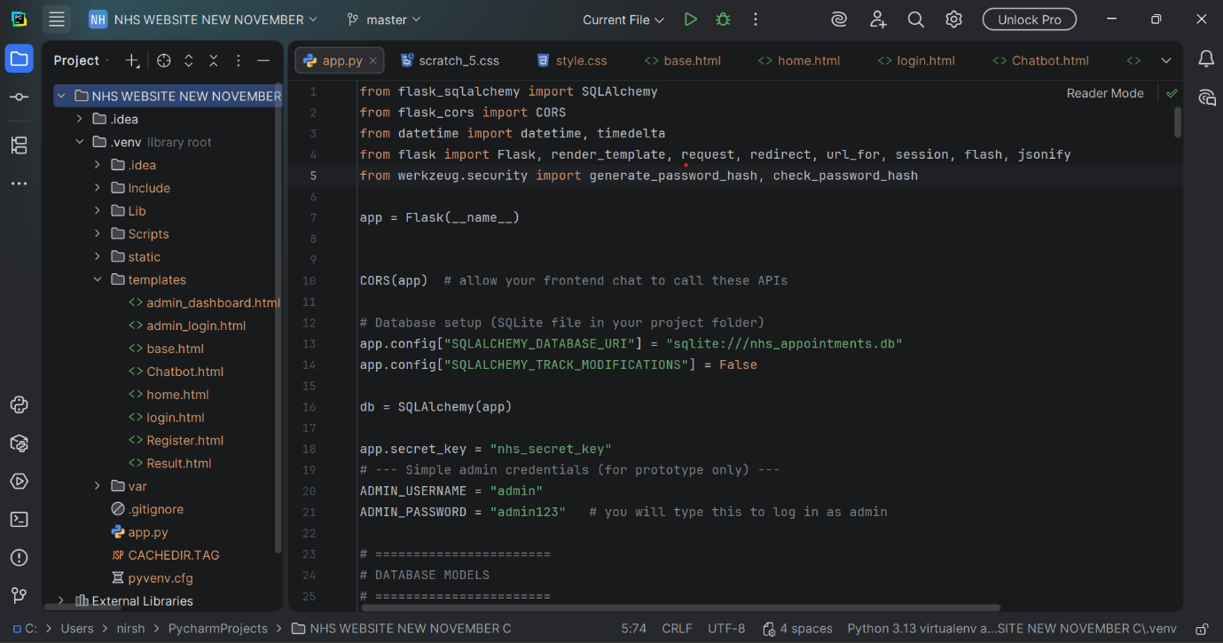
Fig 01: Backend Source Code (app.py)
The app.py script, the primary Python backend component created for the NHS Automated Healthcare Chatbot project, is seen in this snapshot. It displays the setting of the SQLite database and application secret key after importing important libraries like Flask, SQLAlchemy, and security tools. This file specifies how users log in, how the chatbot handles symptoms, and how appointment information is saved and retrieved. In essence, it serves as the application's "brain," linking the data and logic that drive the system to the frontend interface.

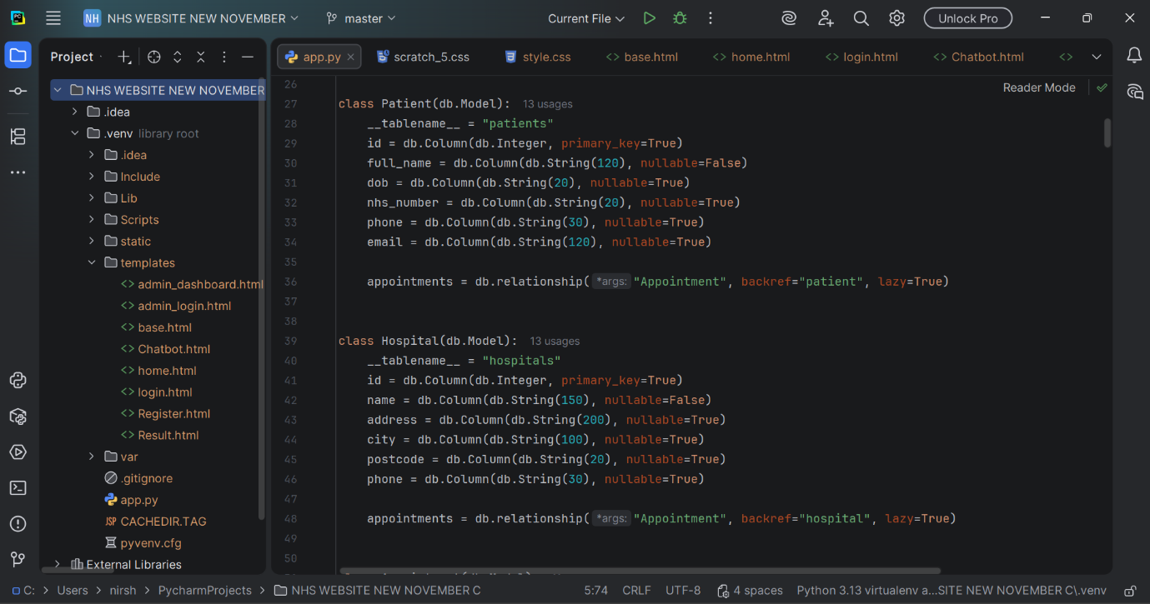
Fig 02: Backend Source Code (app.py)

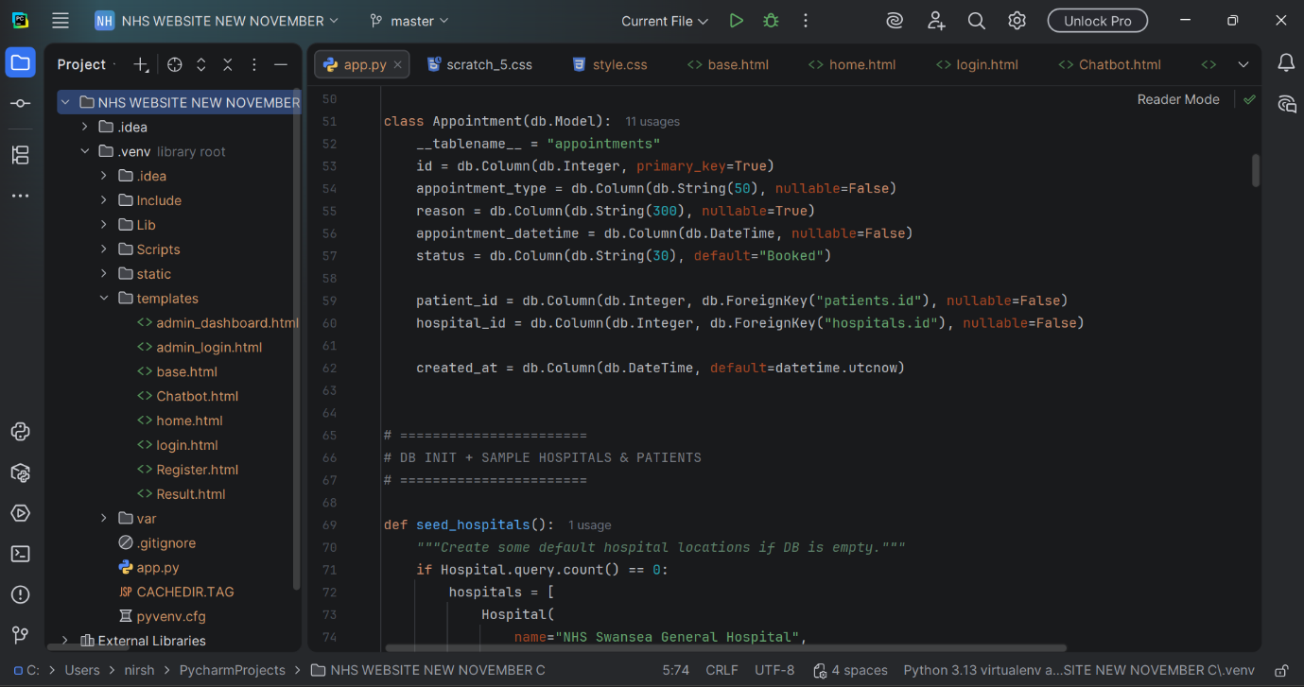
Fig 03: Backend Source Code (app.py)

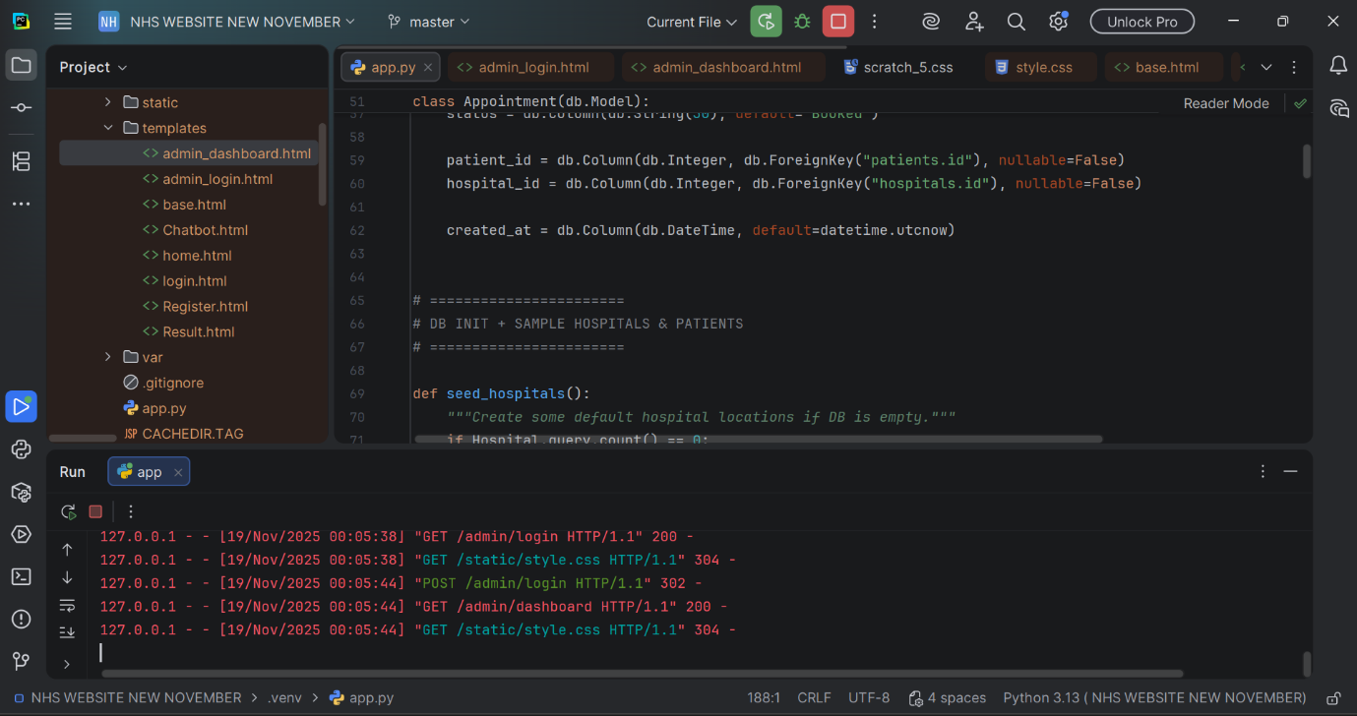
Fig 04: Backend Source Code (app.py)

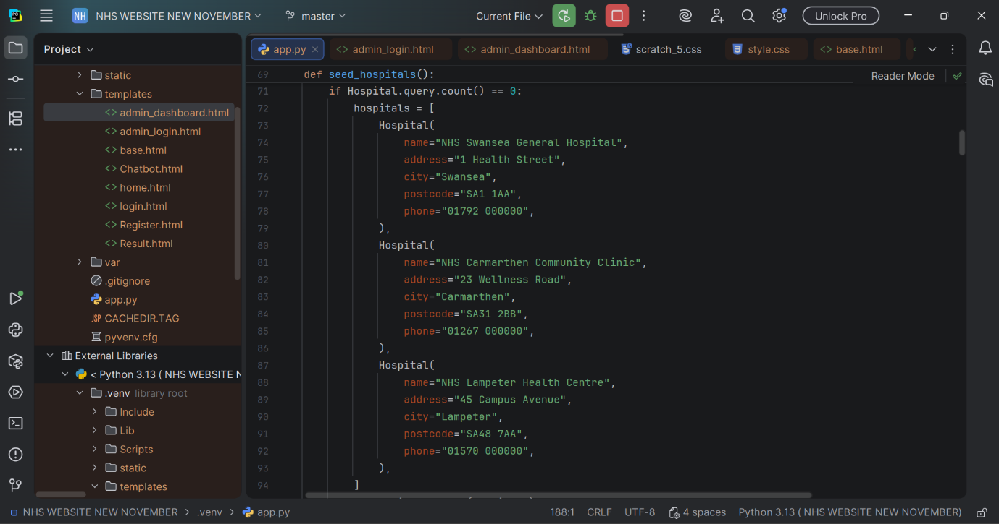
Fig 05: Backend Source Code (app.py)

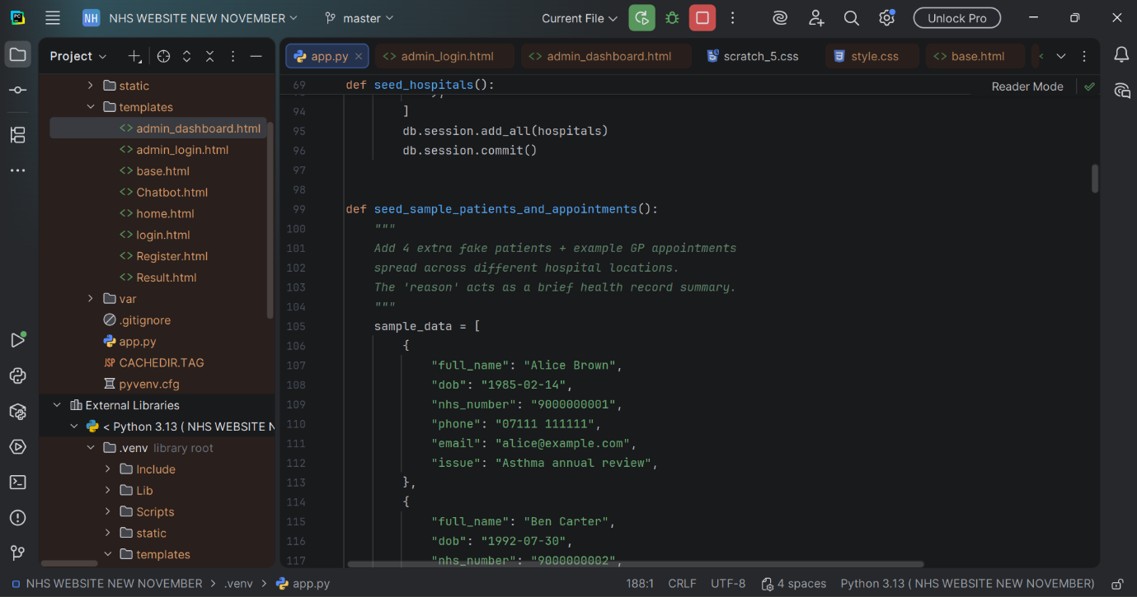
Fig 06: Backend Source Code (app.py)

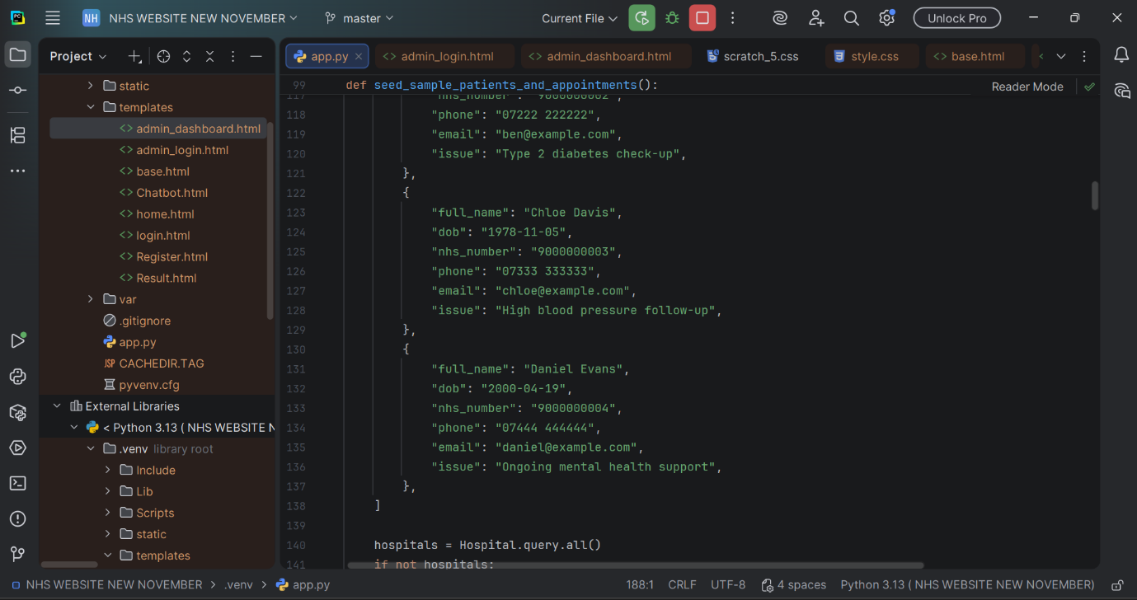
Fig 07: Backend Source Code (app.py)

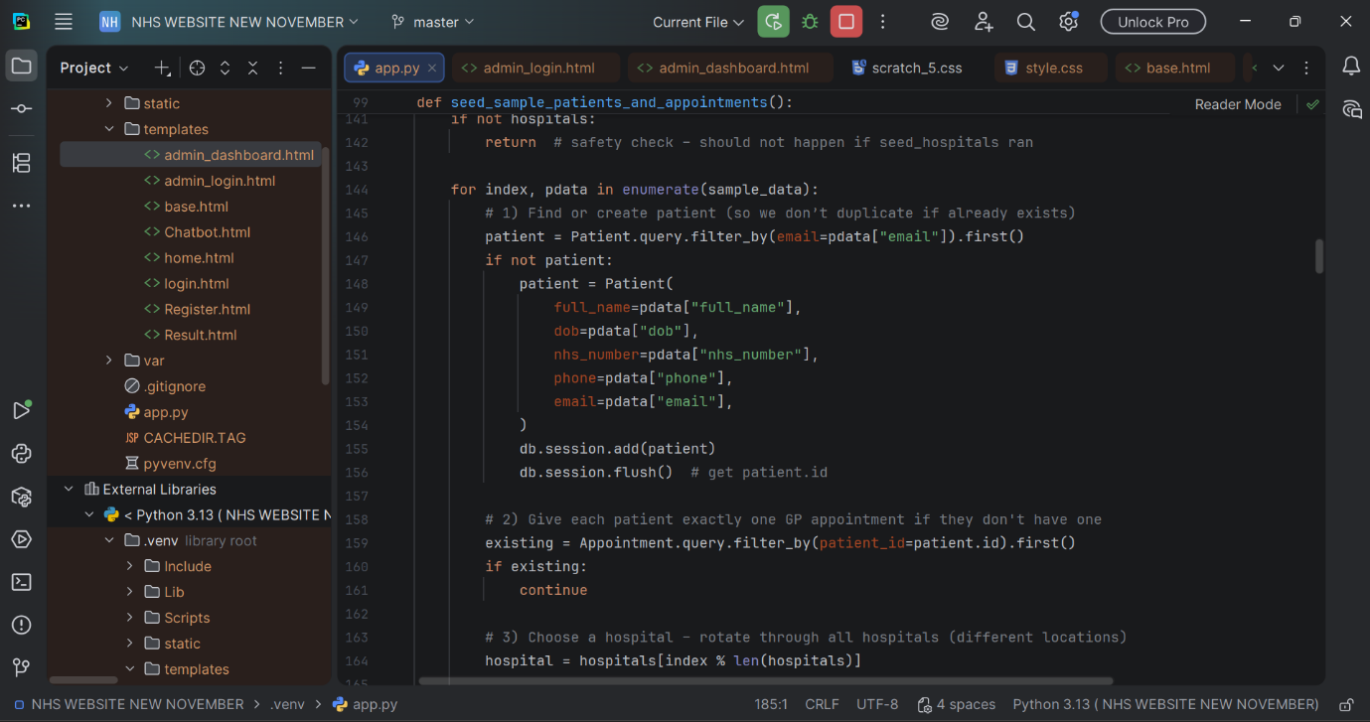
Fig 08: Backend Source Code (app.py)

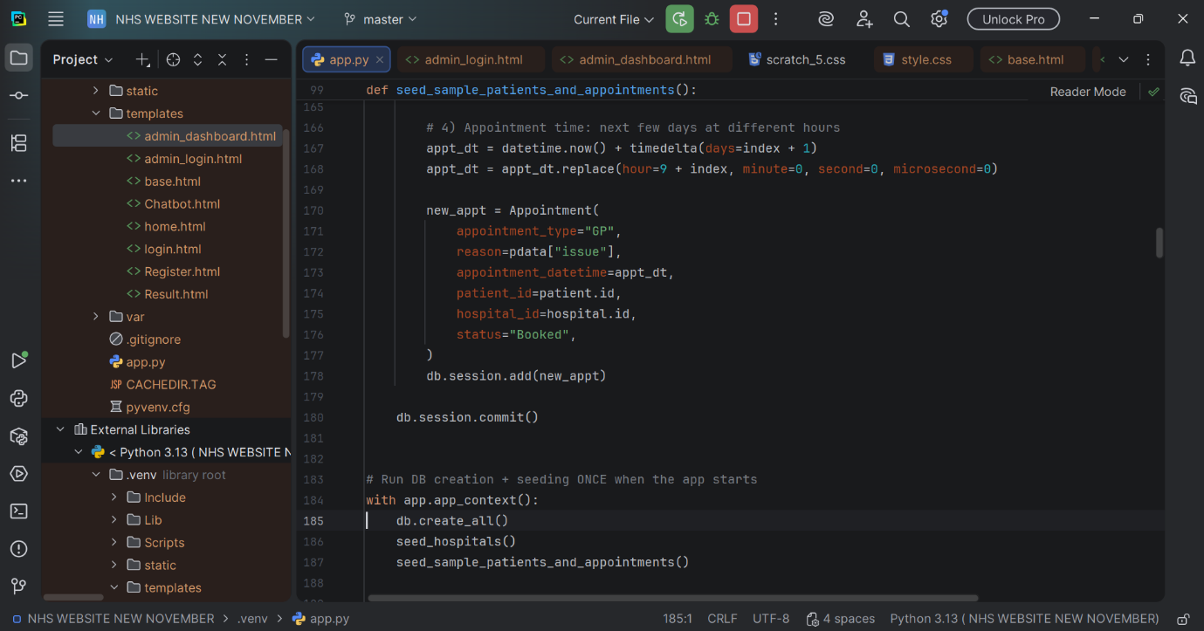
Fig 09: Backend Source Code (app.py)

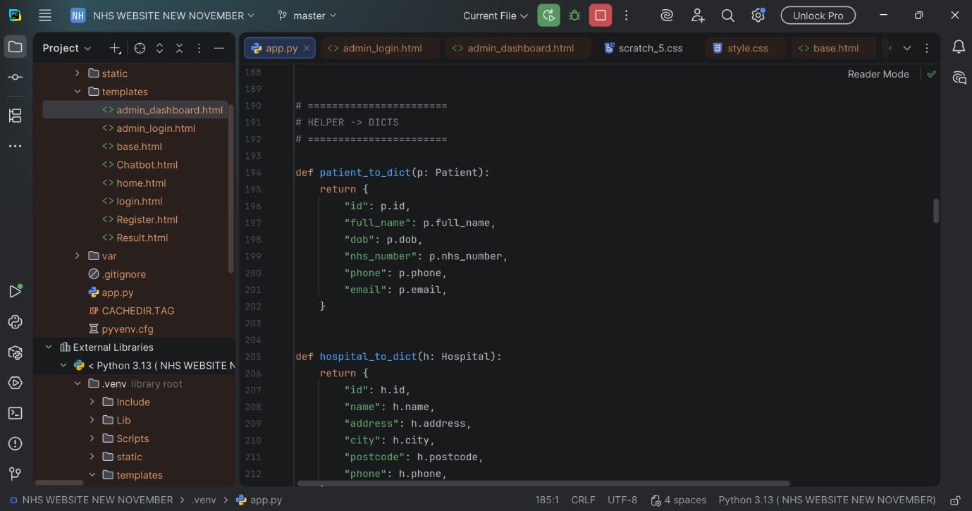
Fig 10: Backend Source Code (app.py)

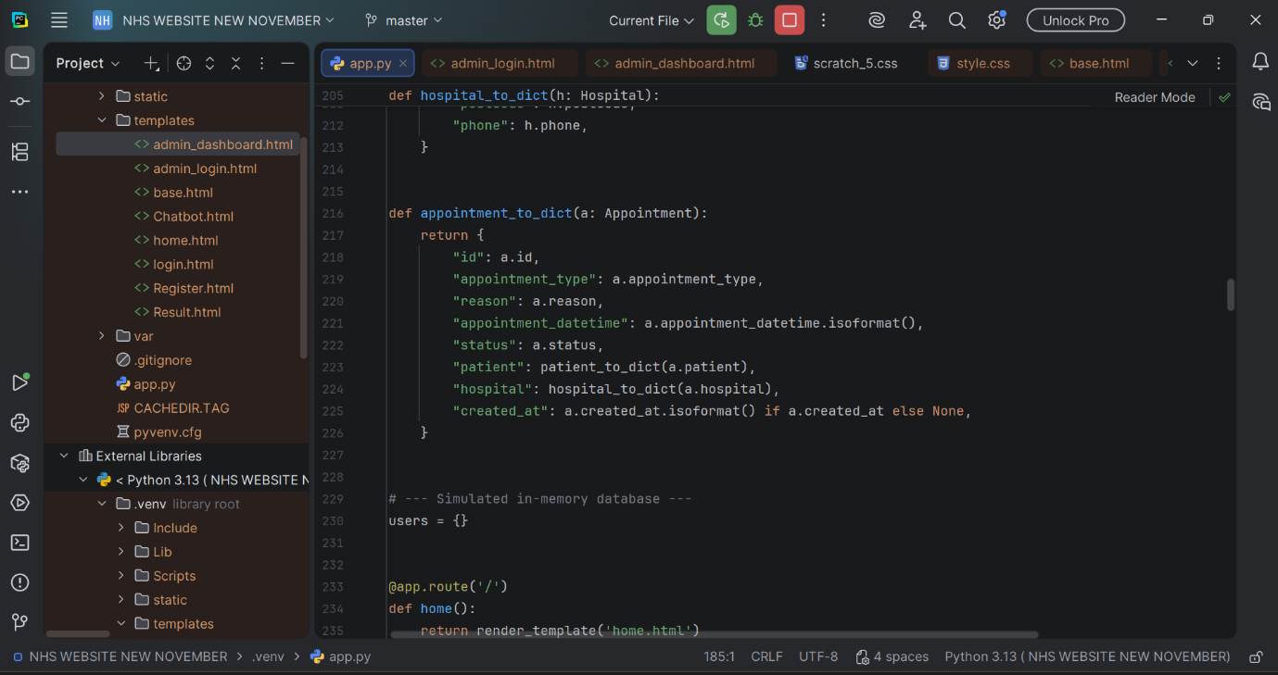
Fig 11: Backend Source Code (app.py)

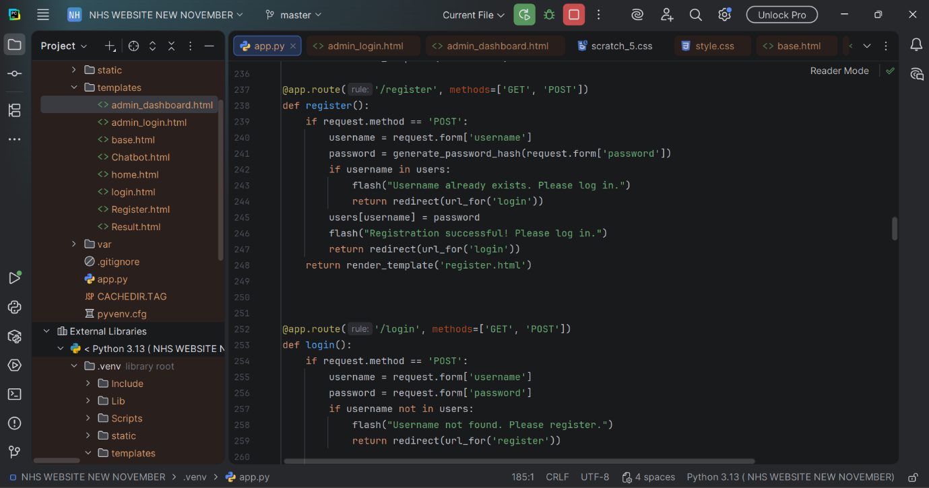
Fig 12: Backend Source Code (app.py)

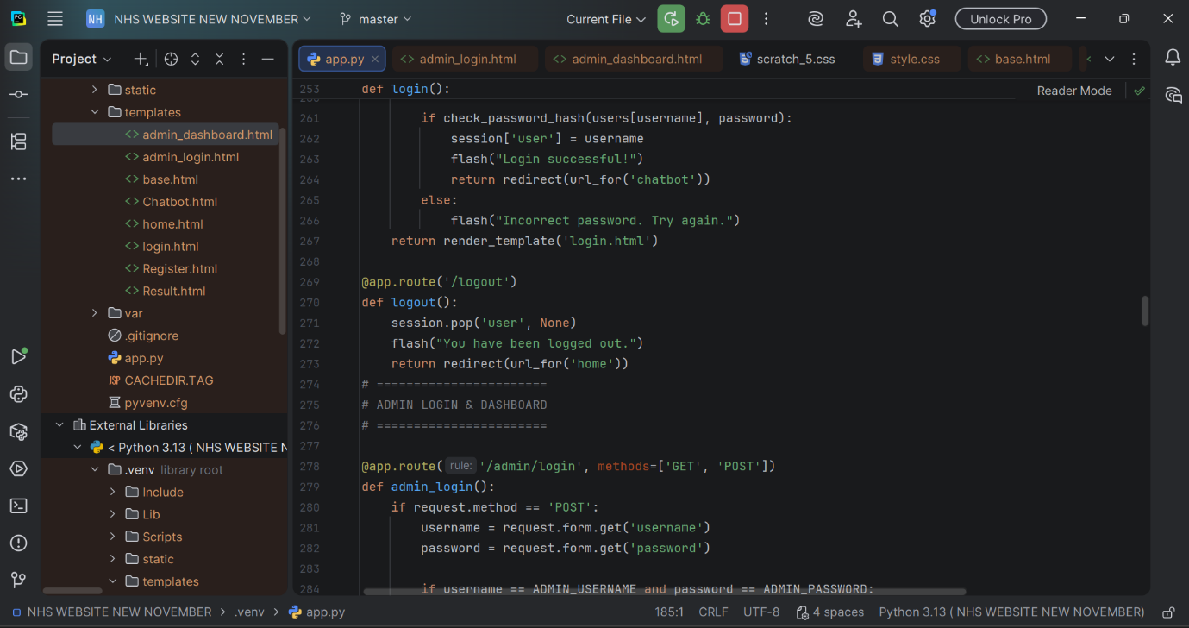
Fig 13: Backend Source Code (app.py)

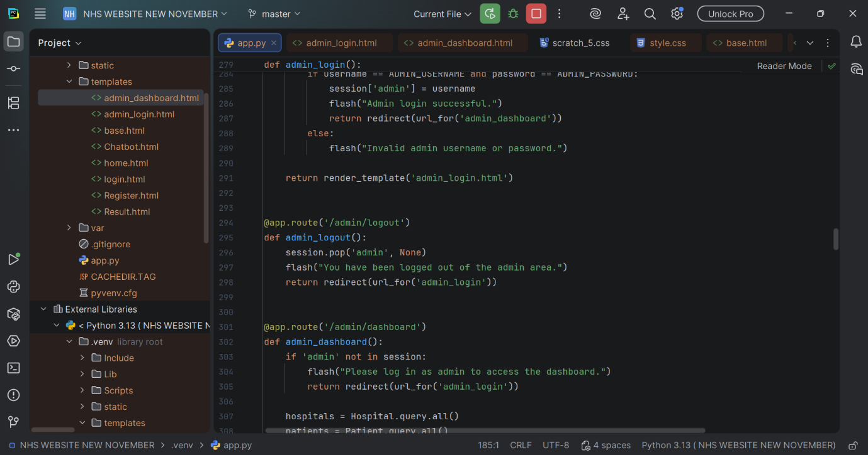
Fig 14: Backend Source Code (app.py)

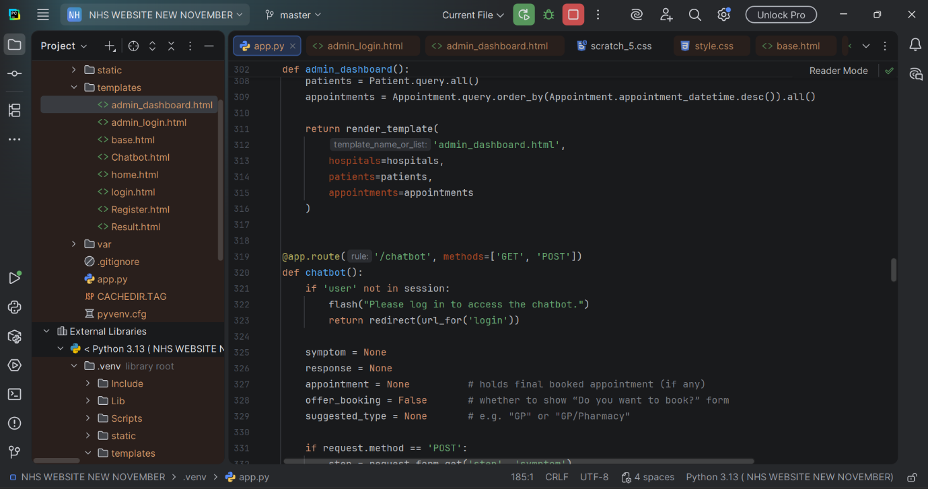
Fig 15: Backend Source Code (app.py)

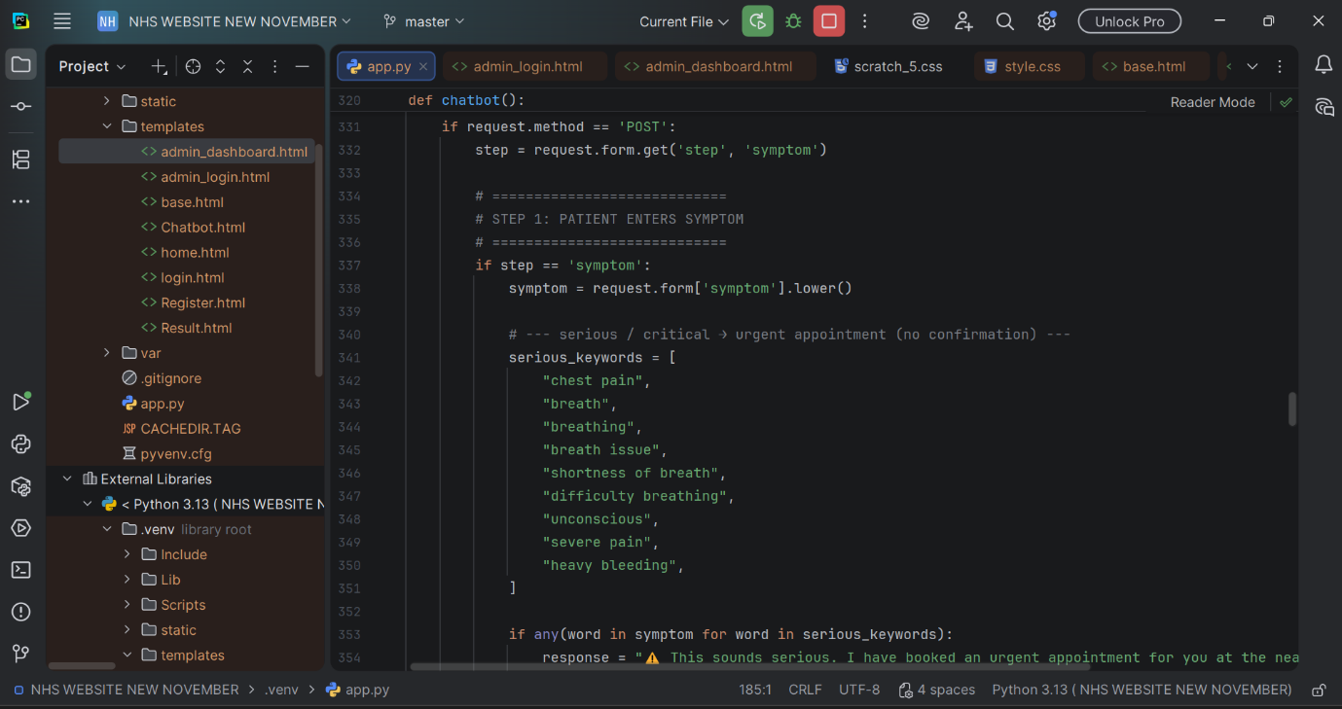
Fig 16: Backend Source Code (app.py)

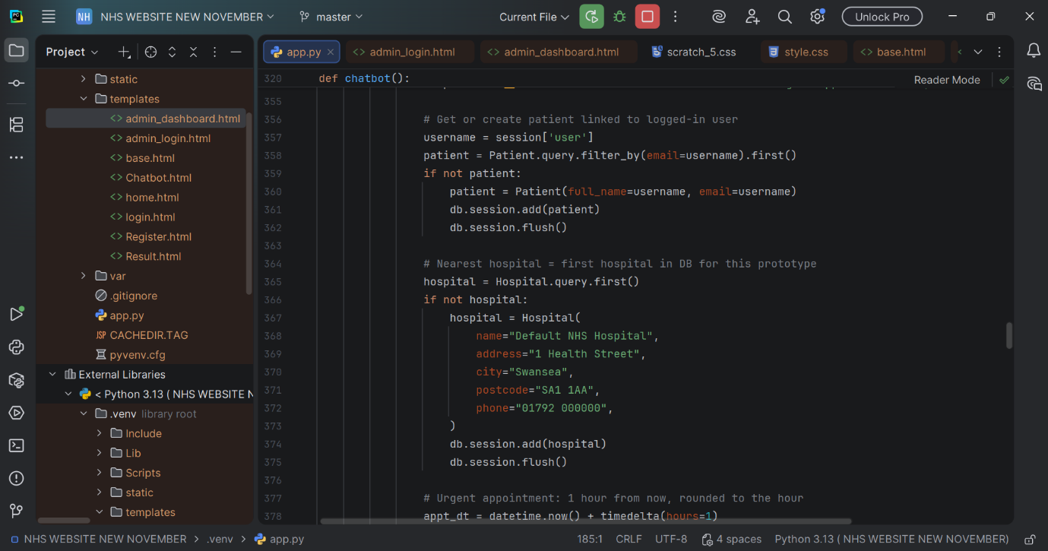
Fig 17: Backend Source Code (app.py)

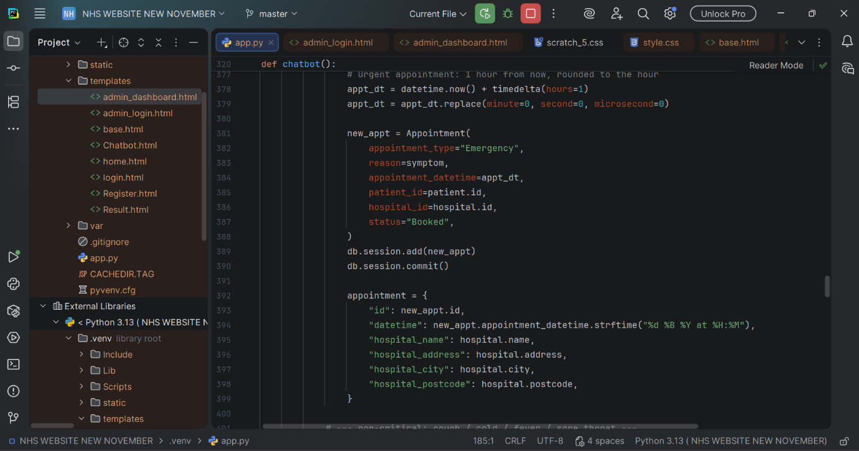
Fig 18: Backend Source Code (app.py)

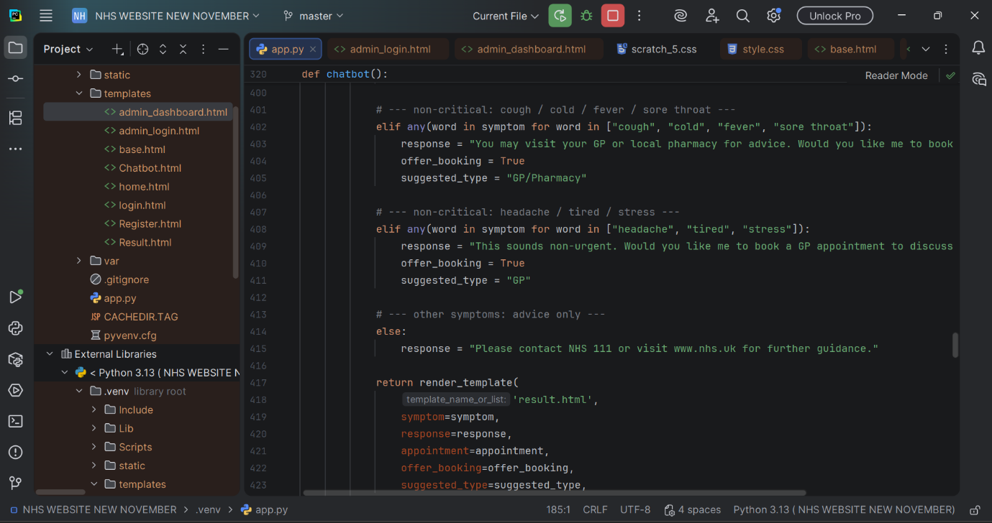
Fig 19: Backend Source Code (app.py)

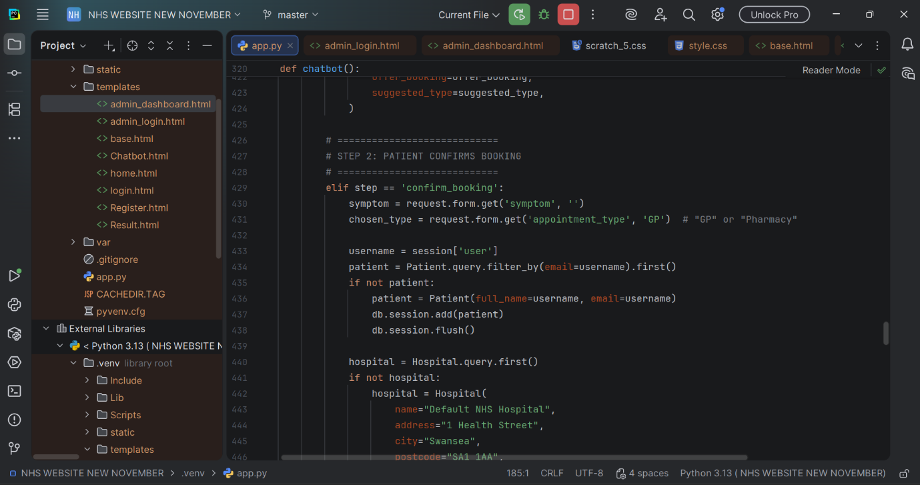
Fig 20: Backend Source Code (app.py)

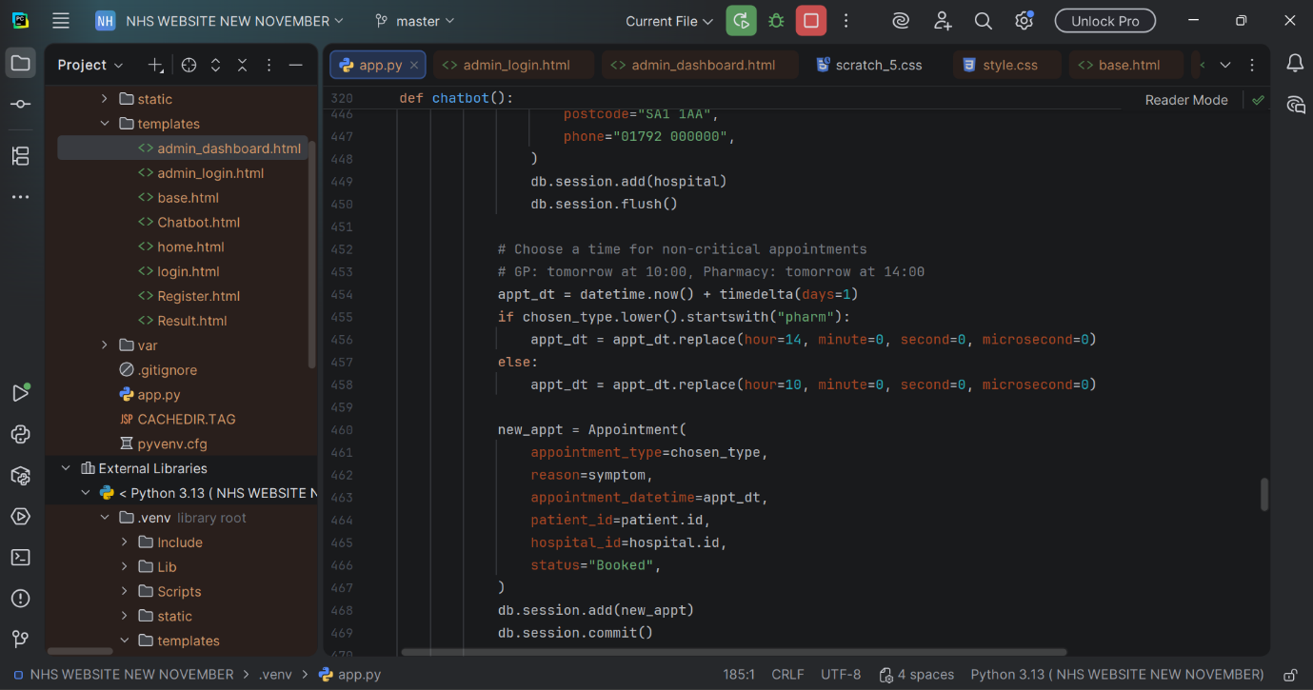
Fig 21: Backend Source Code (app.py)

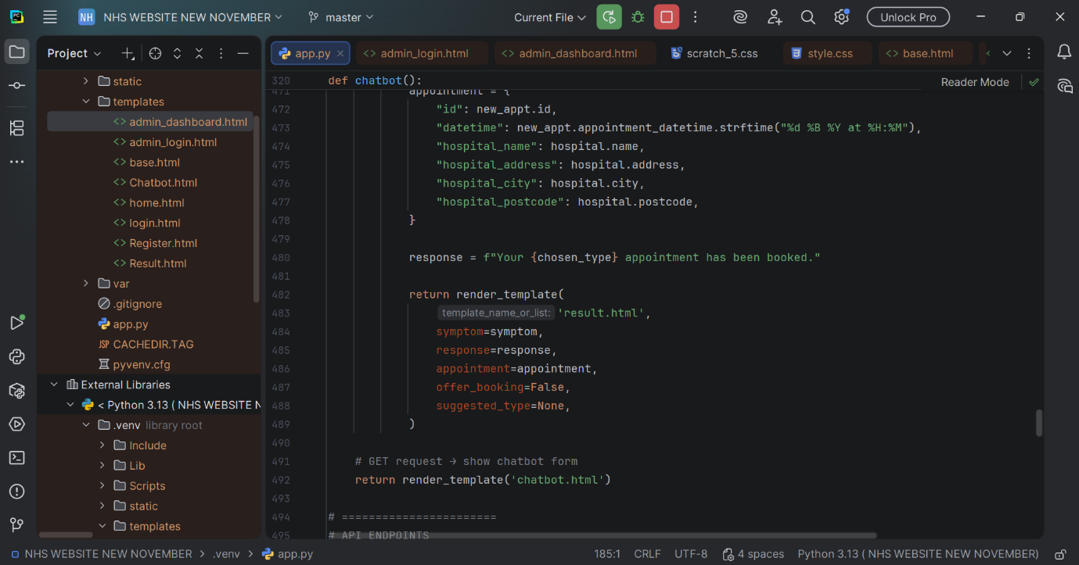
Fig 22: Backend Source Code (app.py)

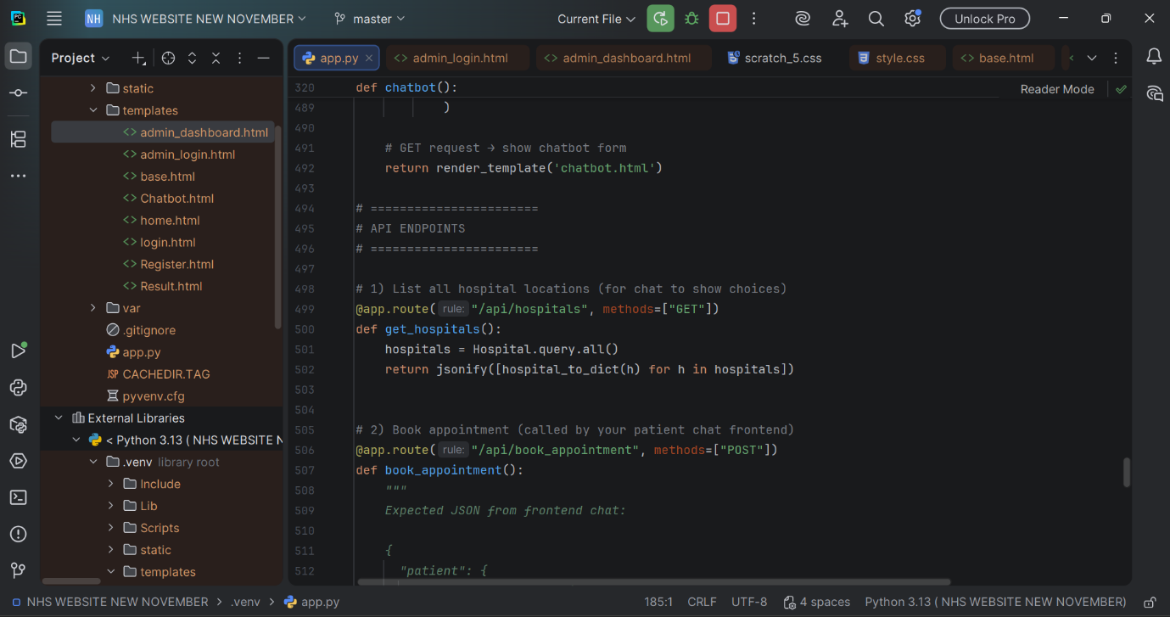
Fig 23: Backend Source Code (app.py)

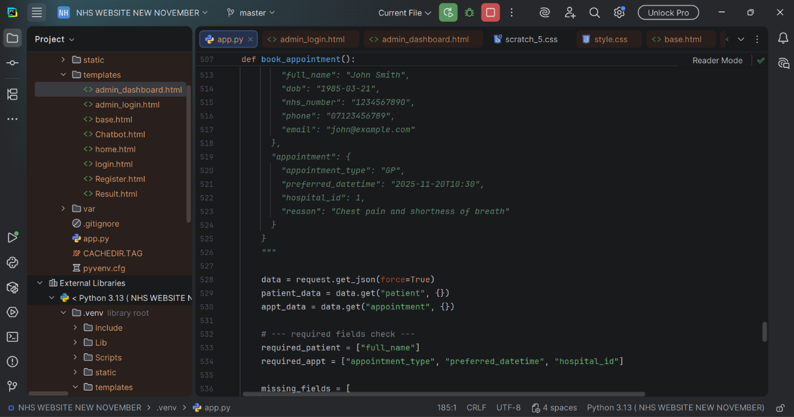
Fig 24: Backend Source Code (app.py)

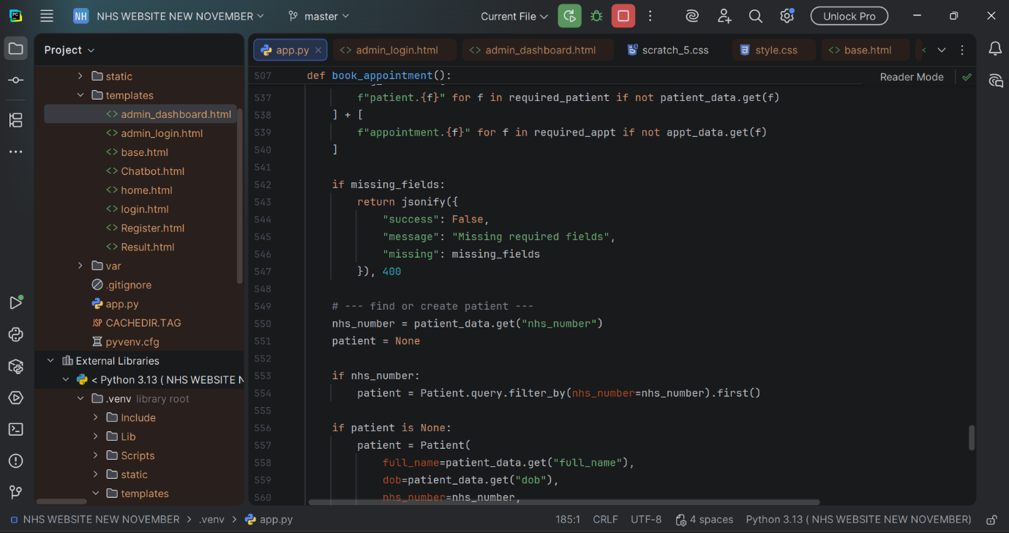
Fig 25: Backend Source Code (app.py)

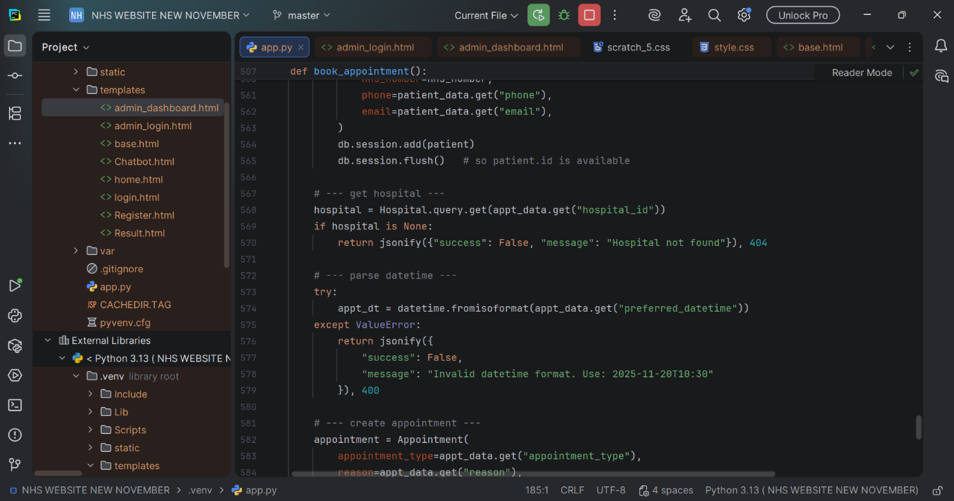
Fig 26: Backend Source Code (app.py)

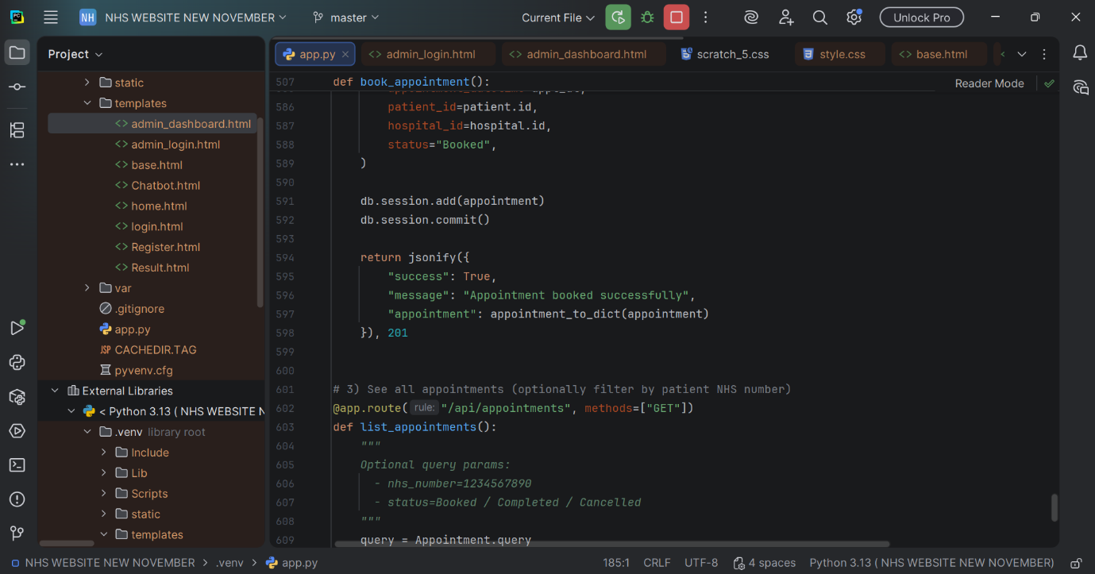
Fig 27: Backend Source Code (app.py)

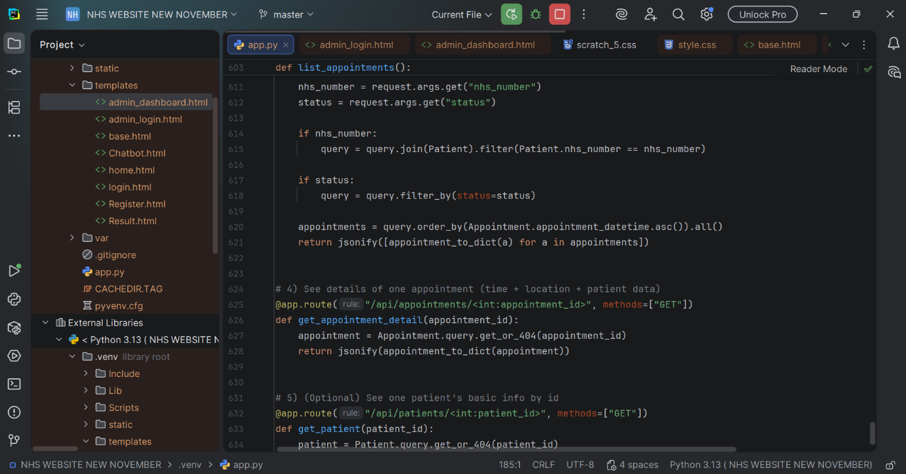
Fig 28: Backend Source Code (app.py)

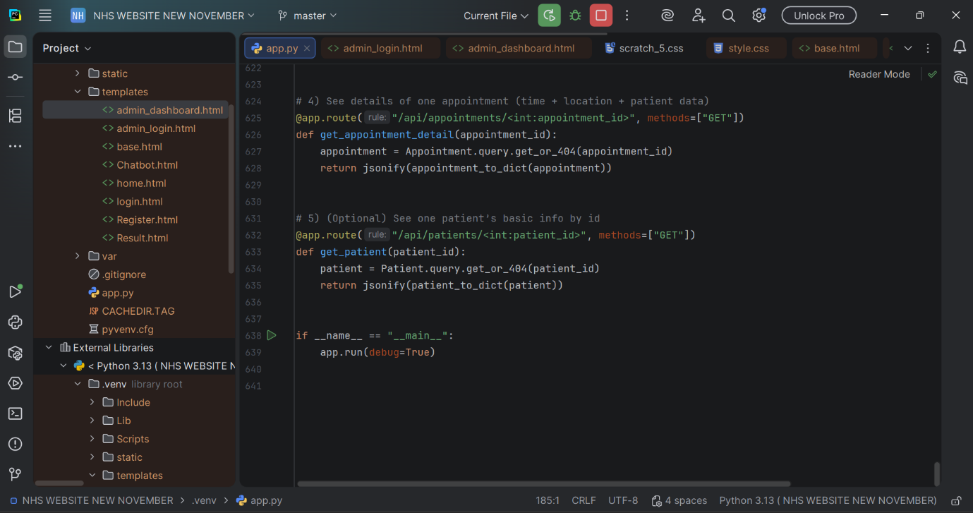
Fig 29: Backend Source Code (app.py)

2.1 HTML Backend Files

Register.html: Template for User Registration Interface

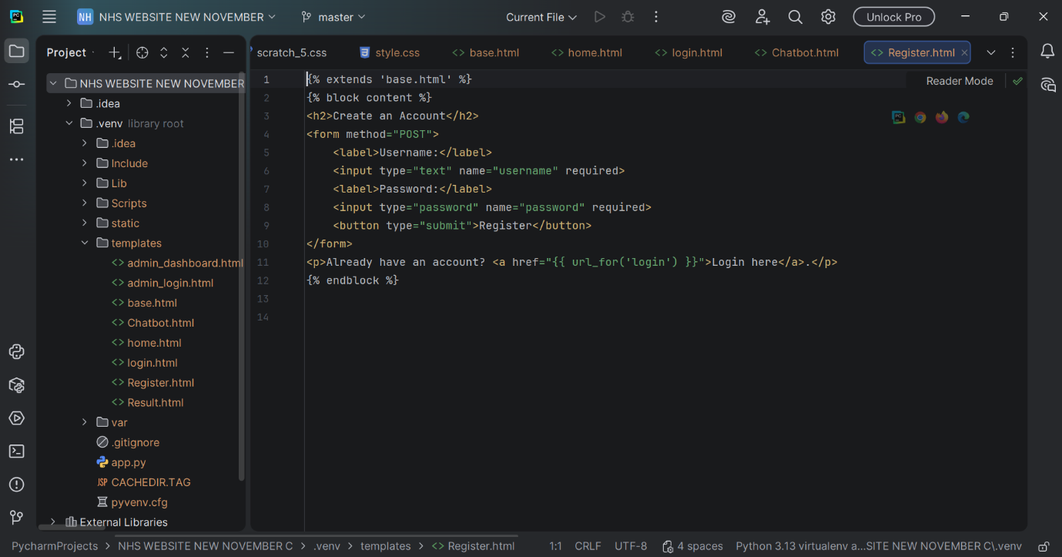
Fig 30: Template for Register.html Interface

The NHS Automated Healthcare Chatbot website's user registration page was created using the Register.html template, which is seen in this figure. The file creates a straightforward form where users may create an account by entering a username and password. It also extends the core base.html layout. This template manages routing and dynamically handles form submissions using Flask's Jinja2 syntax. It guarantees that new users can safely register before using the chatbot and login page.

Login. HTML

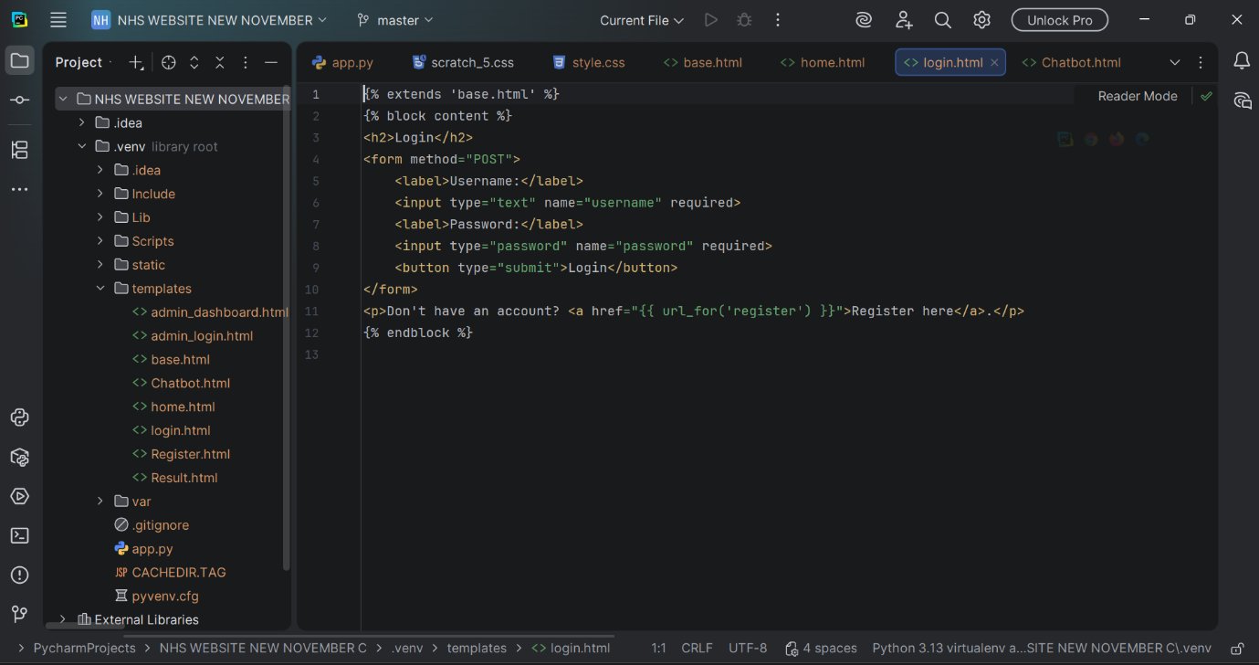
Fig 31: login.html – User Login Template for the NHS Automated Healthcare Chatbot

The login.html template, which offers the NHS Automated Healthcare Chatbot system's login interface, is depicted in this illustration. To access the platform, users must input their username and password in a POST form found in the file, which extends the primary base.html layout. It contains a link that takes users to the signup page if they don't already have an account and leverages Flask's Jinja2 templating to securely handle form submissions. The chatbot and other system-protected pages can be accessed with authentication thanks to this template.

Home. HTML
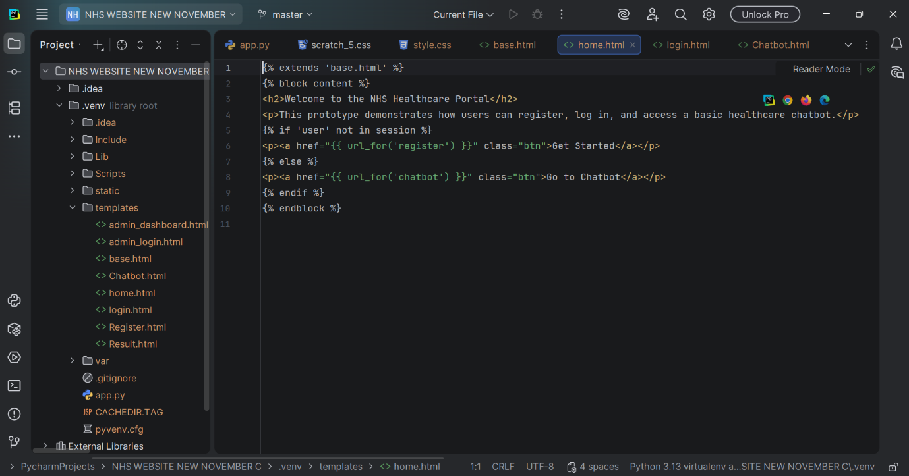
Fig 32: Chatbot's homepage template is home.html.

The home.html template, which functions as the NHS Automated Healthcare Chatbot system's landing page, is depicted in this figure. In addition to introducing the platform's goal and letting users know that they may register, log in, and access the healthcare chatbot, the page expands upon the primary base.html layout. The website automatically determines if a user is logged in using Jinja2 conditional statements. The interface offers immediate access to the chatbot if it is not verified; otherwise, it shows a "Get Started" button that leads to the registration page. This dynamic homepage guarantees that only users who are logged in can communicate with the chatbot and facilitates easy user navigation.

Base. HTML
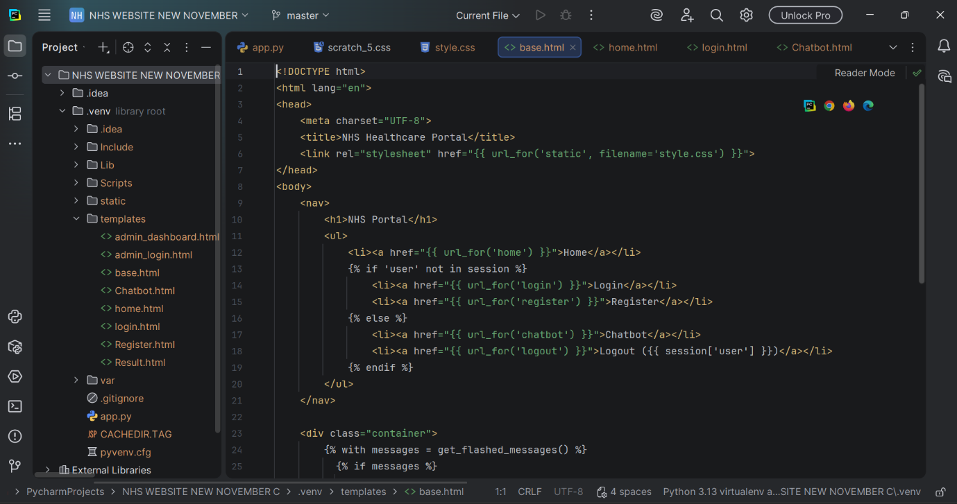
Fig 33: Chatbot's primary layout template is base.html.

The base.html file, which serves as the fundamental layout template for the entire NHS Automated Healthcare Chatbot website, is depicted in this figure. The navigation menu, title, linked stylesheet, and page content container are all examples of the global HTML structure that is used on all other pages. Jinja2 conditional logic is used in the navigation bar to dynamically display various menu options based on whether a user is signed in. For instance, "Login" and "Register" are displayed to new visitors, while "Chatbot" and "Logout" are displayed to authenticated users. This template offers a central location for handling shared UI elements and guarantees a consistent appearance across the entire website.

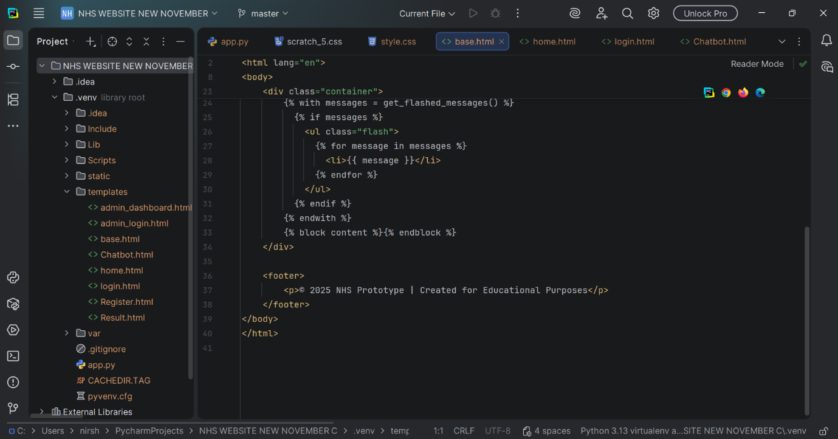
Fig 34: Chatbot's primary layout template is base.html.

Chatbot. HTML

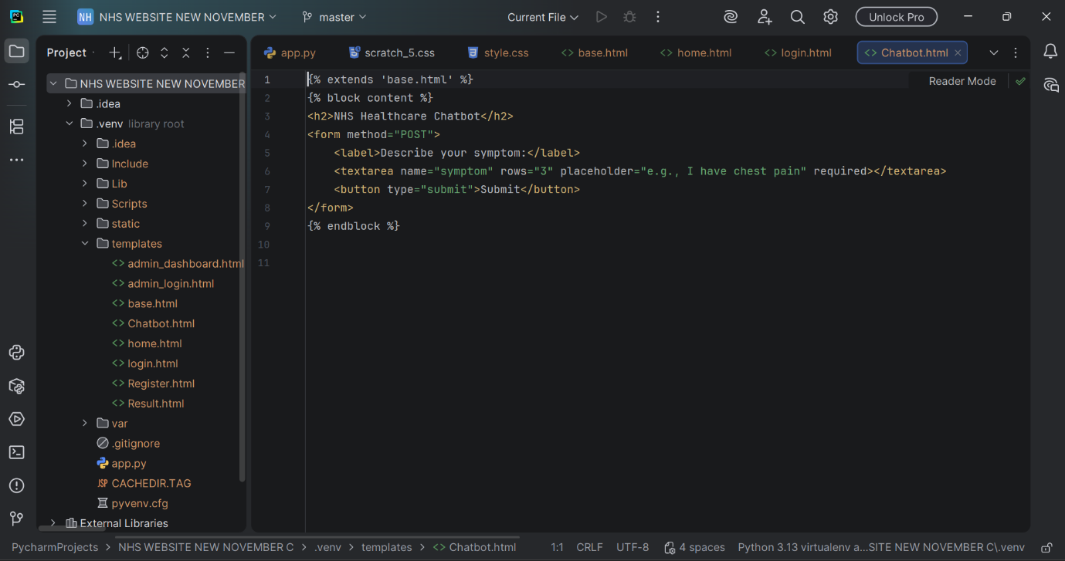
Fig 35: Chatbot.html: Chatbot's Symptom Input Interface

The Chatbot.html template, which offers the primary user interface for sending symptoms to the NHS Automated Healthcare Chatbot, is seen in this figure. In addition to having a POST form with a text field where users can explain their symptoms in natural language (e.g., "I have chest pain"), the page enhances the base.html layout. The data is transferred to the backend for triage processing after it has been submitted. This template serves as the primary point of contact between the patient and the system, allowing the chatbot to assess symptoms and provide relevant medical advice.

Result. HTML
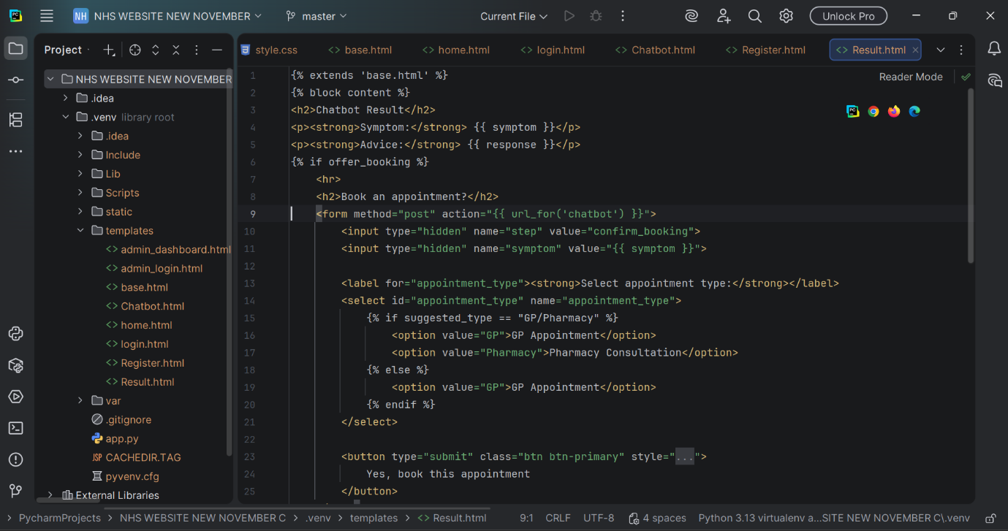
Fig 36: Chatbot Output and Appointment Scheduling Interface: Result.html

The Result.html template, which presents the chatbot's medical advice and gives users the opportunity to schedule an appointment depending on their symptoms, is seen in this picture. The identified symptom and the system-generated reaction are displayed on this page, which expands the base.html layout. The interface dynamically displays a booking section if the chatbot concludes that an appointment would be necessary. This features a dropdown menu that lets the user select between a doctor's appointment and a drugstore consultation, as well as hidden fields to send the original symptom back to the server. This page supports both triage and appointment booking, serving as a link between automated symptom evaluation and the subsequent phase of patient care.

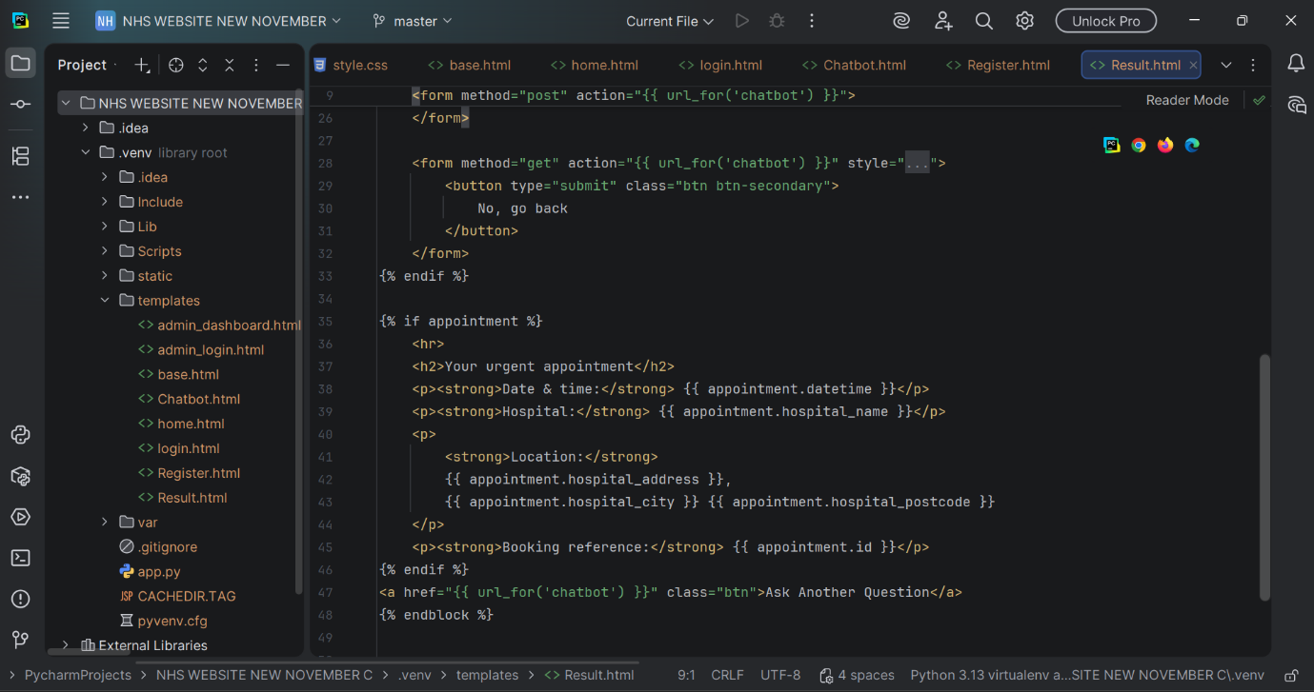
Fig 37: Chatbot Output and Appointment Scheduling Interface: Result.html

Style CSS. HTML
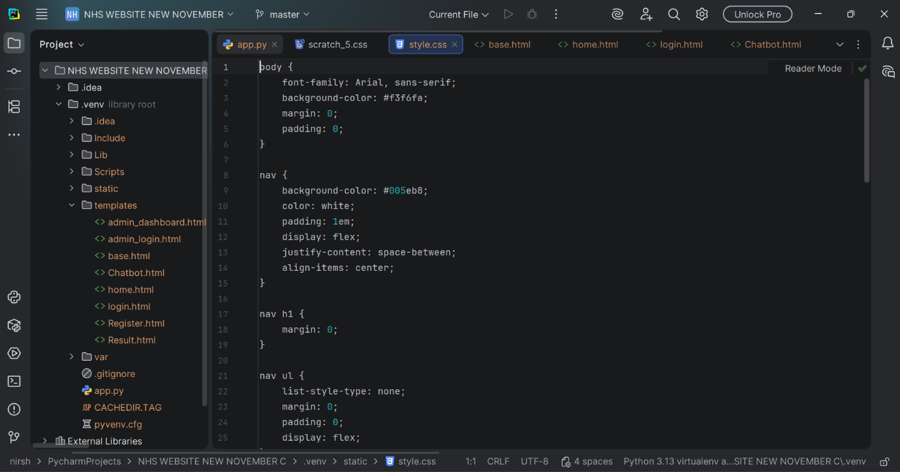
Fig 38: Style.css: The NHS Automated Healthcare Chatbot's Styling and Visual Design Sheet

The style.css file, which specifies the visual appearance for the NHS Automated Healthcare Chatbot website, is depicted in this figure. Global formatting, including font choice, background colour, spacing, and navigation bar arrangement, is applied by the stylesheet. It creates a clear, approachable, and healthcare-appropriate interface by using NHS-style colour tones (such as #005eb8 for the header). By managing components like padding, spacing, navigation alignment, and responsive layout behaviour, the CSS file guarantees uniform display across all pages. This centralised layout promotes readability, usability, and a polished visual identity with an NHS theme.

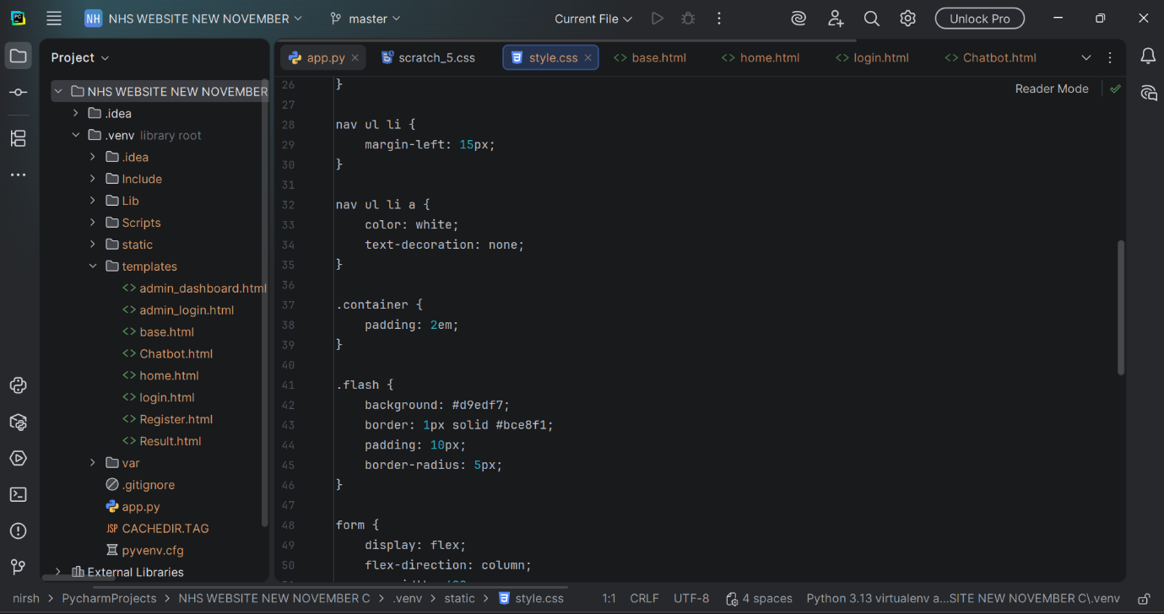
Fig 39: Style.css: The NHS Automated Healthcare Chatbot's Styling and Visual Design Sheet

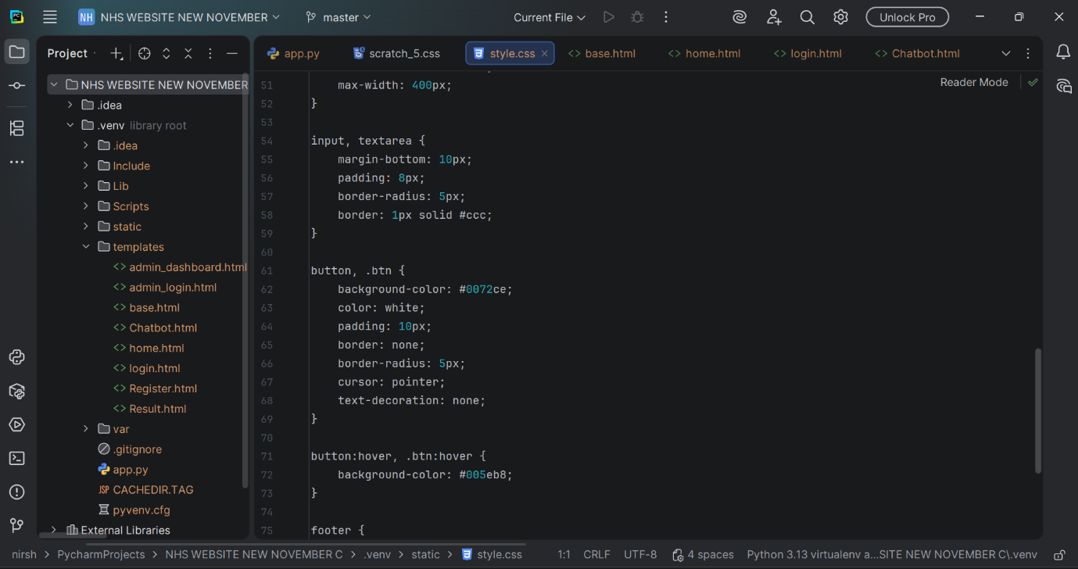
Fig 40: Style.css: The NHS Automated Healthcare Chatbot's Styling and Visual Design Sheet

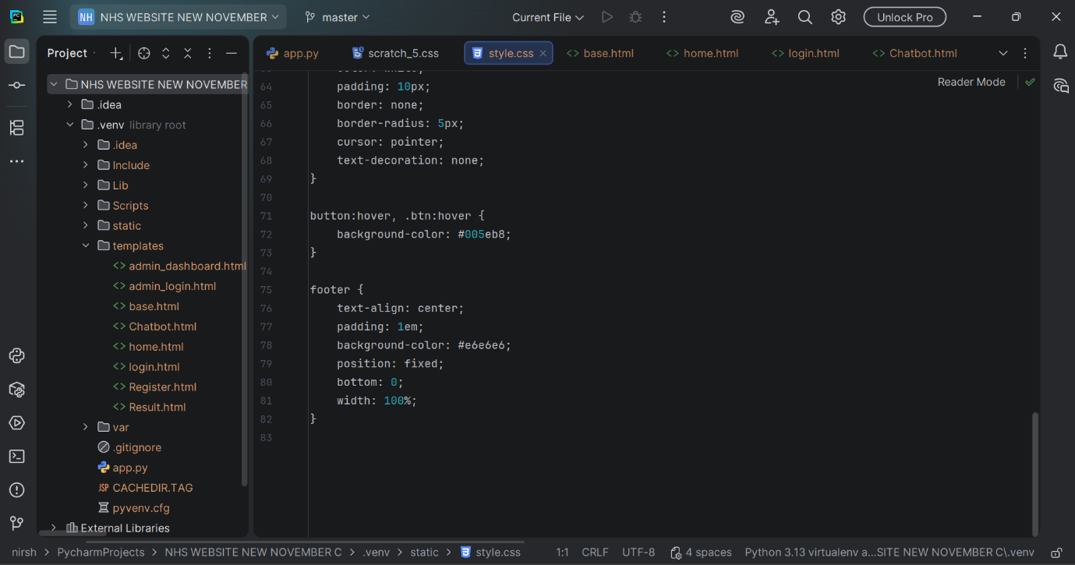
Fig 41: Style.css: The NHS Automated Healthcare Chatbot's Styling and Visual Design Sheet

2.1 Screenshots of frontend outcomes
The NHS Automated Healthcare Chatbot System's initial rendered homepage output

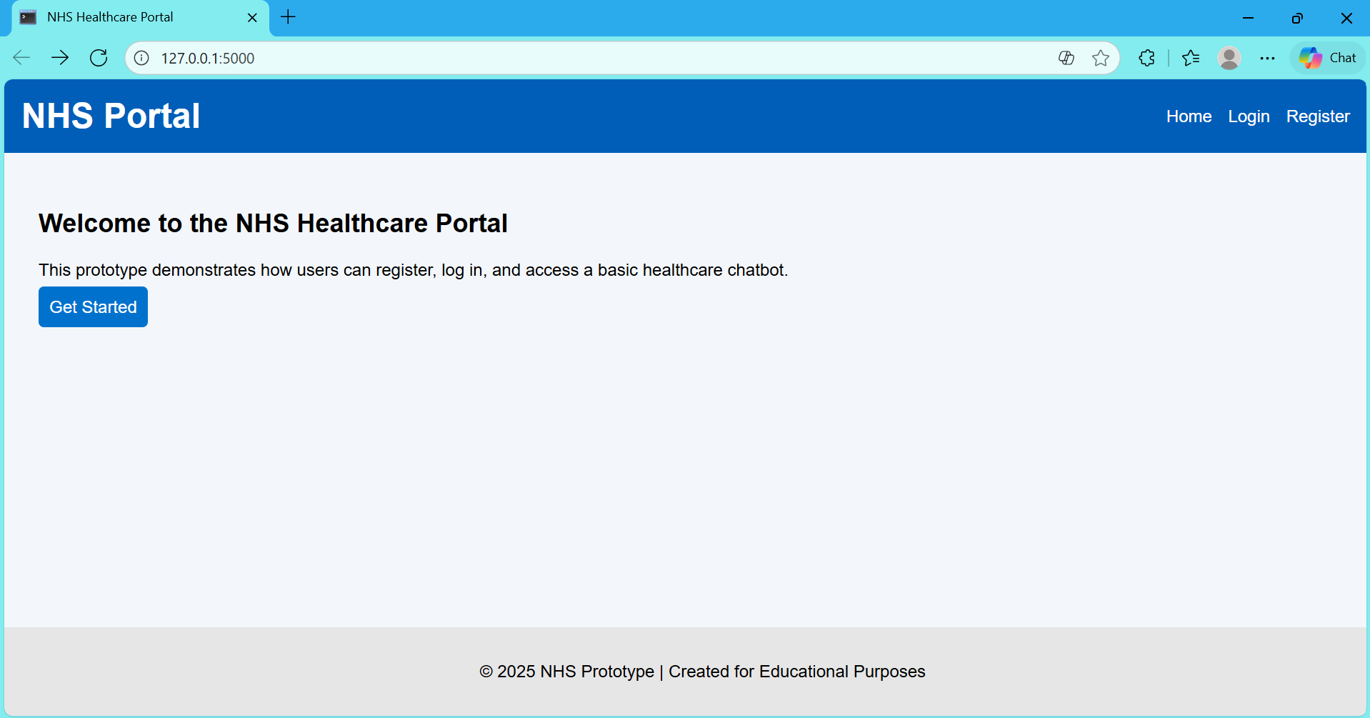
Fig 42: Displays the first front-end output produced by the implemented backend code that has been successfully rendered.
This webpage verifies the proper configuration of the template inheritance model, routing structure, and Flask application. The system shows that the backend is successfully supplying dynamic HTML content by loading the navigation bar, NHS-themed interface styling, and introductory text straight from the base.html and home.html templates. Furthermore, the presence of working navigation links (Home, Login, Register) and the "Get Started" button confirms that essential backend functions—like URL routing, template rendering, and static file delivery—are functioning as planned. This first output validates the foundation upon which the chatbot, authentication system, and appointment-booking functionalities are created, signifying the shift from backend structural setup to interactive system activity.

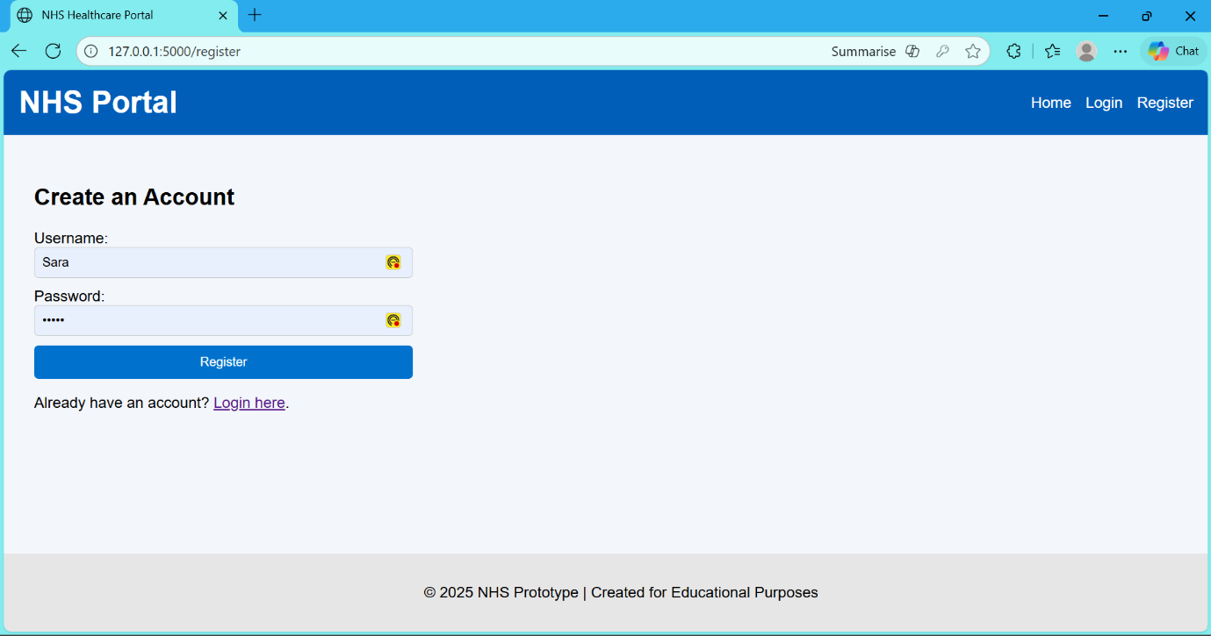
Fig 43: Displayed on the frontend implementation of the NHS Chatbot registration page.

The NHS Automated Healthcare Chatbot system includes a user registration interface developed with Flask, HTML, and CSS, enabling new users to create accounts for accessing triage and symptom-analysis functions. This interface, designed per NHS Digital's guidelines, features a blue navigation banner and clearly marked input fields for usernames and passwords. Upon form submission, a Flask backend route processes the data, verifying inputs, hashing passwords, and temporarily storing credentials. A footer statement notes the prototype status, ensuring adherence to academic and ethical standards while facilitating secure user onboarding through the integrated front-end and server-side functionality.

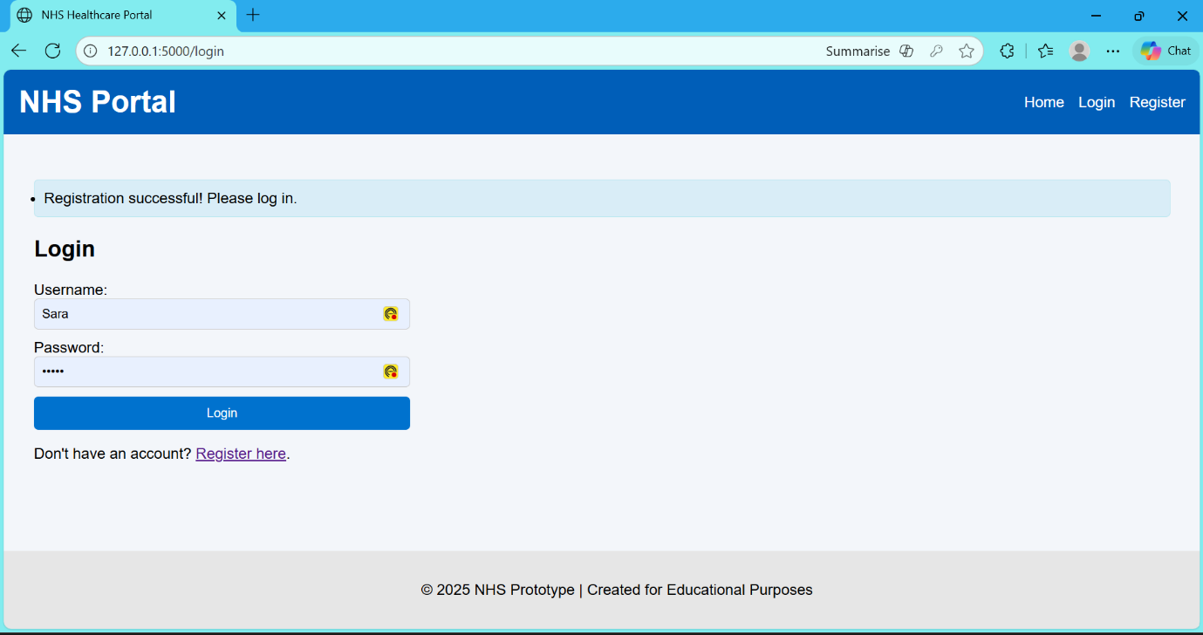
Fig 44: After a successful user registration, the NHS Chatbot Login page displays the login form and a confirmation message.

The finished login interface of the NHS Automated Healthcare Chatbot system is a key component of the platform's authentication process, allowing registered users to securely access the system. It displays a success message upon registration and verifies credentials through the Flask route /login using werkzeug. security. check_password_hash (). The interface, designed with a blue top navigation bar and clear labels for usability, adheres to NHS visual standards. It also includes a redirect link for new users to navigate to the Registration page. This login screen illustrates the integration of the frontend interface and backend authentication in the user access control system.

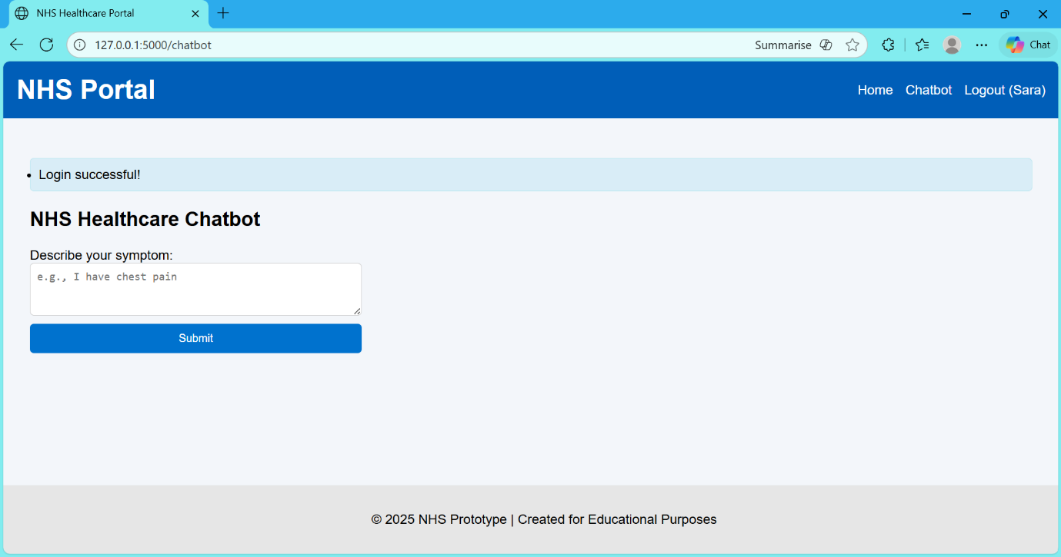
Fig 45: Individuals can submit health concerns for automated triage on the NHS Healthcare Chatbot page after logging in, where a symptom input form is displayed.

The picture displays the UI of the NHS Healthcare Chatbot, which is accessible following a successful user login. After a "Login successful!" confirmation notice appears at the top, users can enter their symptoms in free text on a straightforward input form. The backend logic in app.py, which analyses symptoms and offers a suitable healthcare advice (e.g., drugstore, GP, or emergency), is connected to this form. The user's name, "Sara," displays in the Logout option, indicating active session management, while the layout keeps the NHS-style blue navigation bar.

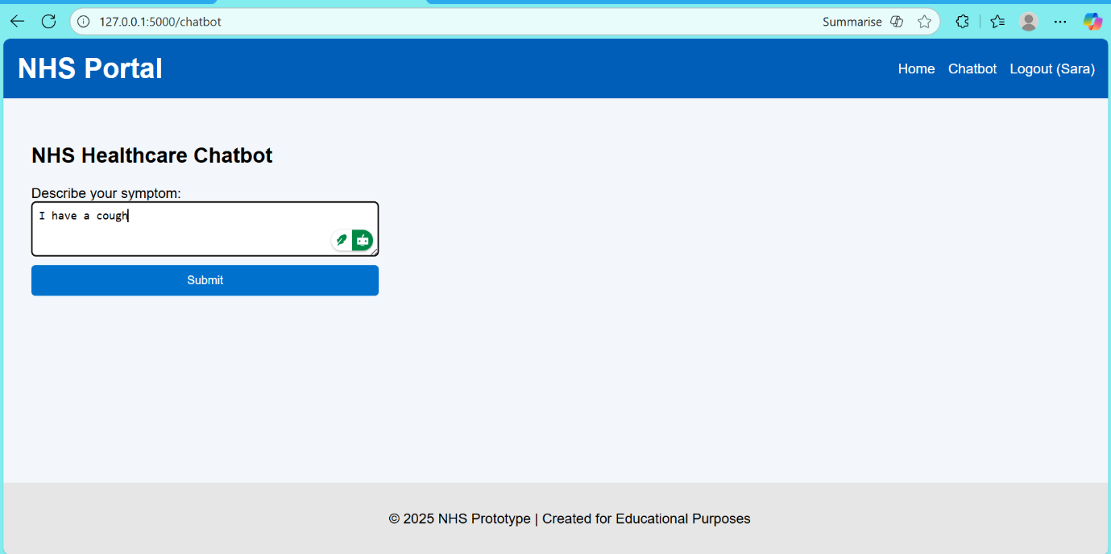
Fig 46: Before backend triage processing, the chatbot's symptom-entry interface displays user-typed input.

The NHS Healthcare Chatbot's operational interface is shown in the picture. Authenticated users can input free-text descriptions of their symptoms. This component serves as the first step in the triage workflow that is built in the Flask backend and illustrates how the system handles natural language input. The /chatbot route processes user-entered symptoms (such as "I have a cough") in the text field to produce a suitable healthcare recommendation based on predetermined rule-based reasoning. To ensure clarity, accessibility, and compliance with actual healthcare interface standards, the design adheres to NHS digital stylistic norms.

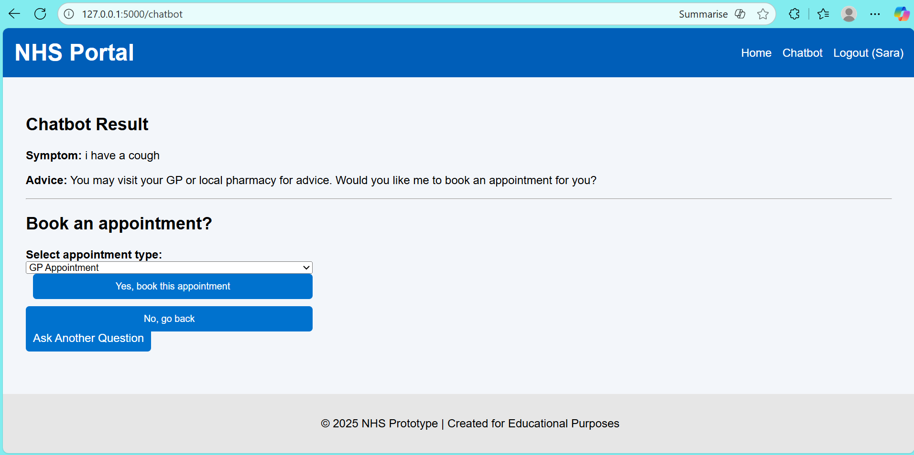
Fig 47: A chatbot result screen with integrated appointment-booking choices for non-critical situations, triage guidance, and symptom interpretation.

The NHS Healthcare Chatbot's operational output after a user-submitted symptom is displayed in the figure. After processing the input ("I have a cough") through predetermined rule-based conditions, the backend Flask logic creates a healthcare recommendation that suggests the user see a general practitioner or nearby pharmacy. The interface dynamically displays an appointment booking module that lets the user choose an appointment type (e.g., GP Appointment or Pharmacy Appointment) once the algorithm concludes that the condition is not critical. This feature supports smooth user interaction and decision-making by showcasing the synergy between the chatbot's triage engine and the appointment-scheduling workflow. The layout is consistent with the NHS and offers easy-to-use navigation to confirm reservations or go back to ask further questions.

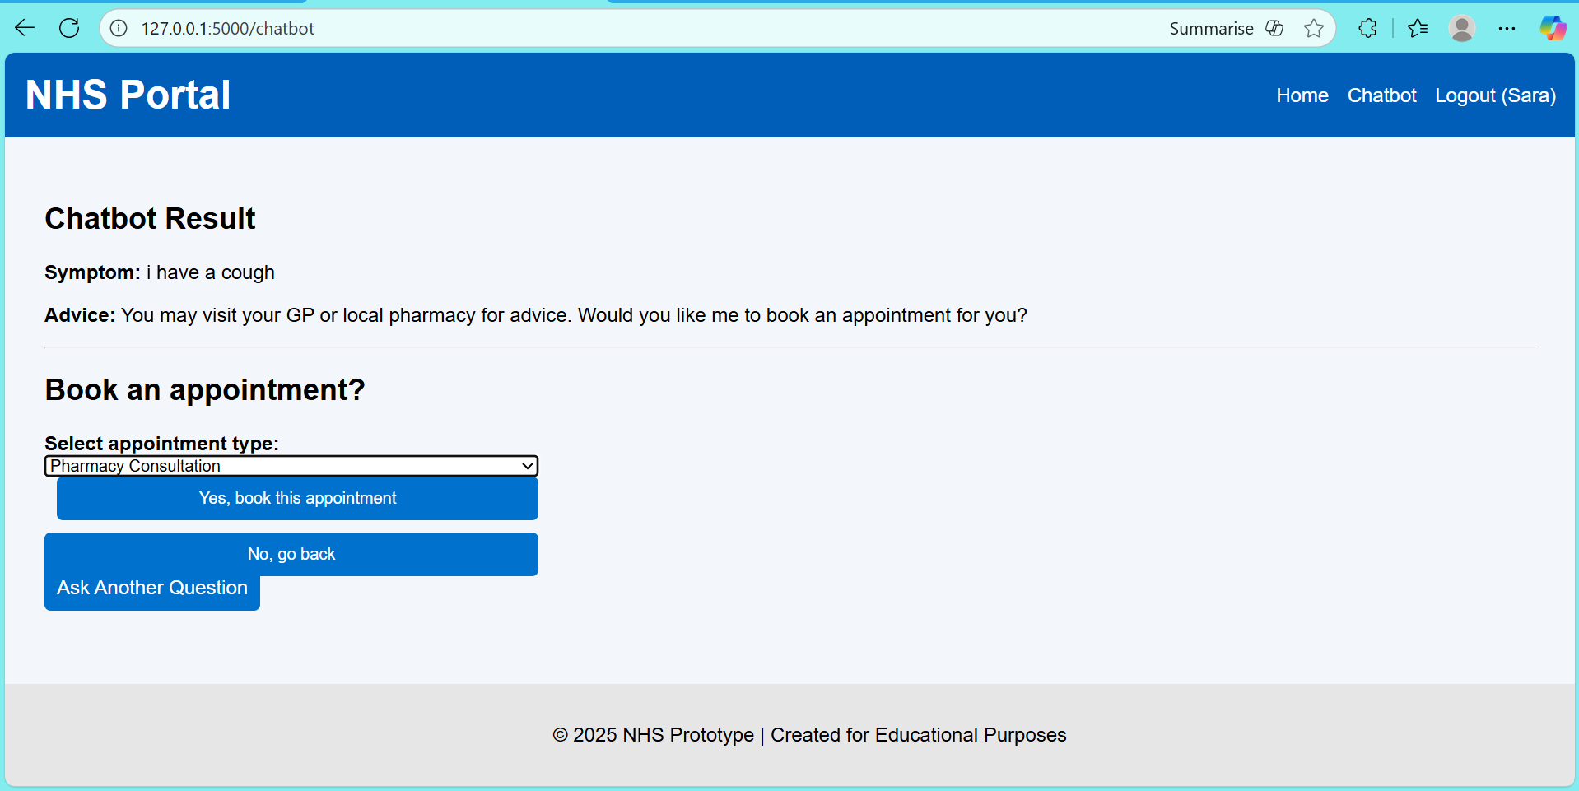
Fig 48: The user is prompted to schedule a pharmacy consultation for a non-critical condition using the chatbot's appointment-booking interface.

After determining that the user's symptom ("I have a cough") is a non-critical condition appropriate for community care, the figure shows the chatbot's appointment booking UI. The system provides Pharmacy Consultation as a suitable care pathway based on the triage logic included into the Flask backend. This option is dynamically presented in the dropdown menu, enabling the user to either confirm the reservation or come back to ask another question. This illustrates how the symptom-processing module and the appointment-scheduling workflow are integrated, guaranteeing a smooth transition from triage guidance to practical healthcare service selection.

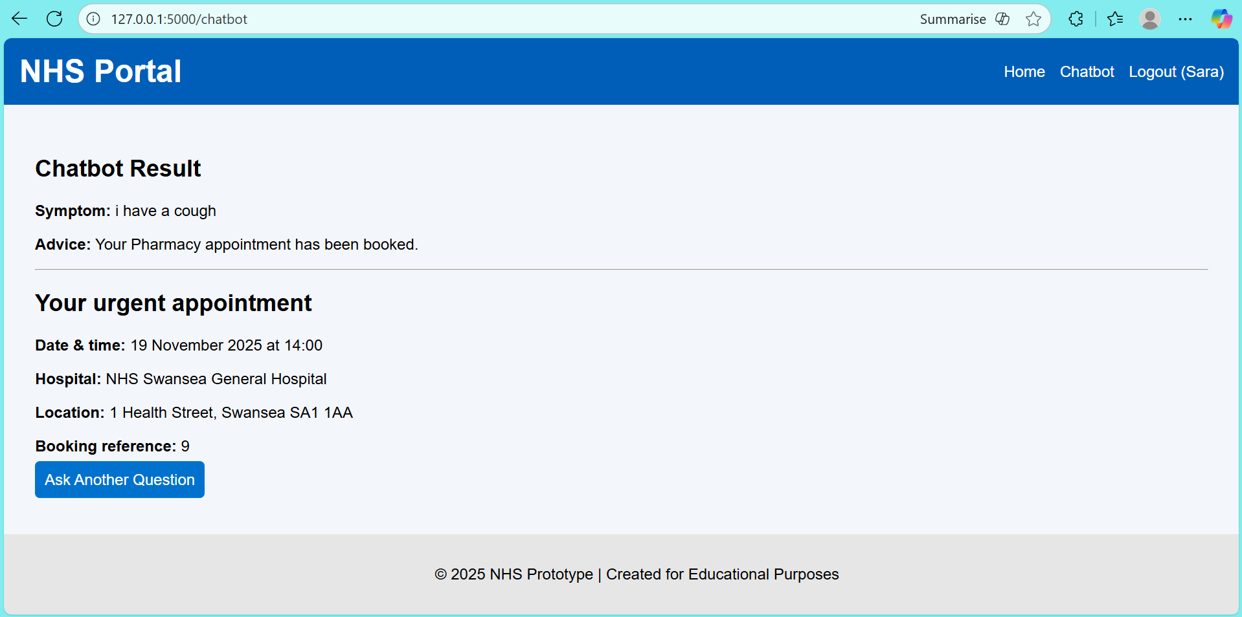
Fig 49: The chatbot workflow's final appointment confirmation screen, which displays the specifics of a scheduled pharmacy appointment.

The last step of the appointment booking process, when the system verifies a successful pharmacy appointment after the user submits their symptoms, is depicted in the figure. The backend creates an appointment entry with the date, time, hospital name, location, and a special booking reference after the chatbot determines that the symptom ("I have a cough") is not urgent. To emulate a realistic NHS booking confirmation structure, this data is dynamically generated using Flask utilising simulated appointment data. By providing crucial information in an organised manner, the interface promotes user understanding and strengthens system dependability while guaranteeing coherence and clarity. Additionally, the "Ask Another Question" function allows for ongoing communication without forcing the user to reauthenticate.

GP appointment
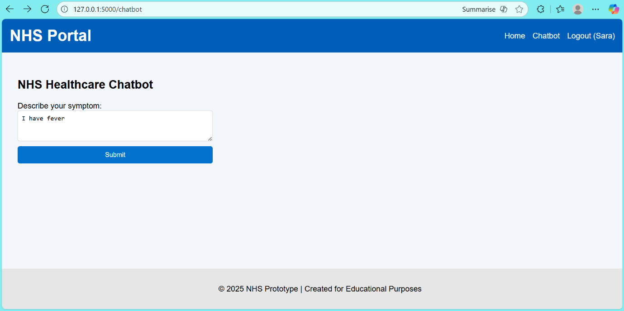
Fig 50: The user enters "I have fever" on the symptom entry screen to start the chatbot's triage procedure.

The symptom-input interface of the chatbot, where the user inputs a new health issue ("I have fever"), is depicted in the figure. This form, which captures free-text symptoms that are then evaluated by the backend rule-based logic, serves as the foundation for the Flask-implemented triage workflow. The simple layout ensures clarity, accessibility, and low cognitive load by adhering to NHS service design principles. Following submission, the system analyses the symptom and recommends a suitable degree of care based on pre-established clinical categories (emergency, general practitioner, or pharmacy). This interface shows how user input and the system's primary decision-making algorithm are integrated.

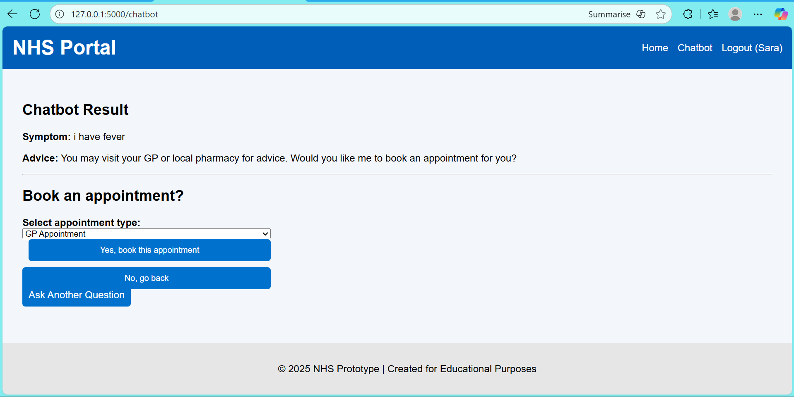
Fig 51: A chatbot that triages fever cases and provides a GP appointment option via the integrated booking interface

The triage output of the chatbot after the user reports the symptom "I have fever" is shown in the figure. The user is prompted to schedule a GP appointment or visit a pharmacy when the backend rule-based logic determines that the condition is not critical but still requires clinical assessment. Through a dropdown menu, the interface dynamically displays the relevant appointment alternatives, allowing the user to confirm their reservation or come back to ask another question. This step reinforces usability, clarity, and conformity with NHS digital design standards by showcasing the smooth integration of symptom classification with the appointment-scheduling module.

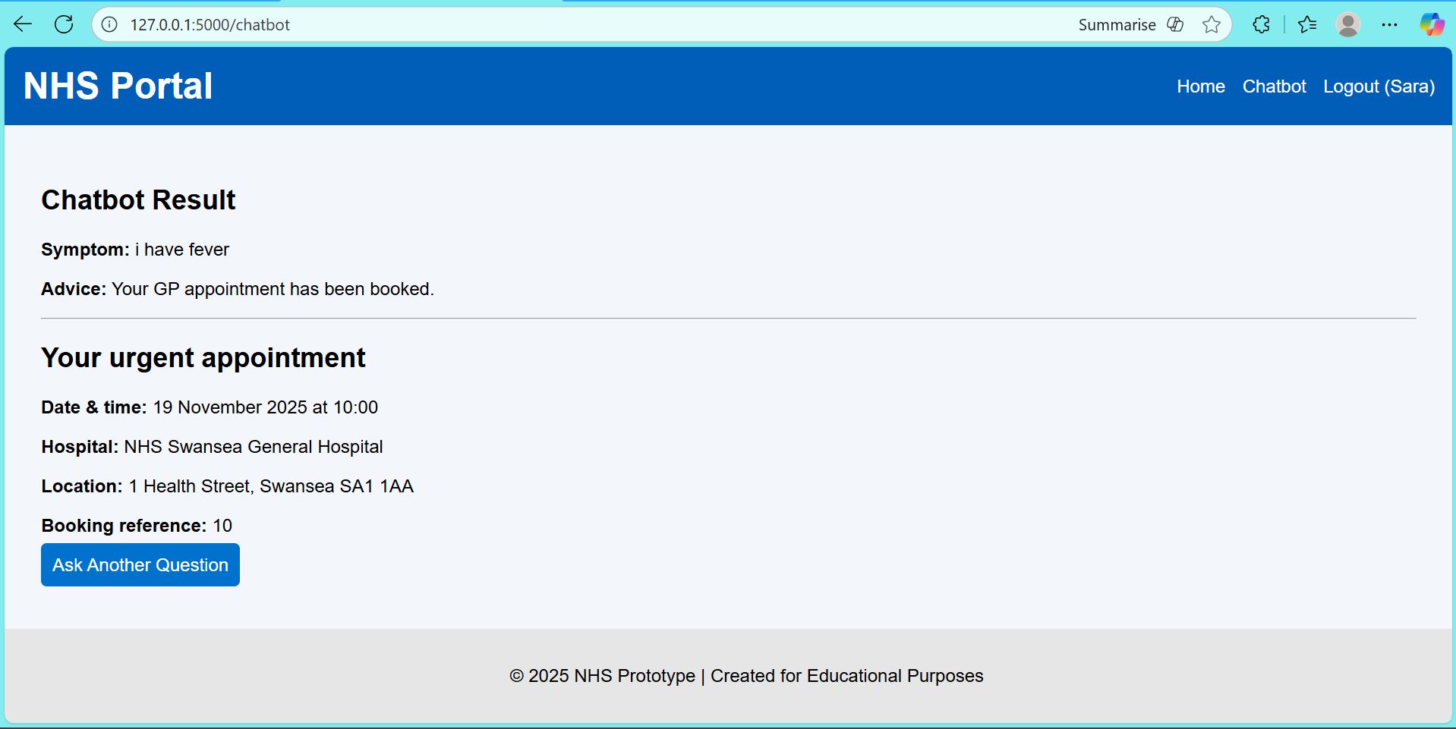
Fig 52: Verified GP appointment information produced following fever triage classification.

After the user reports the symptom "I have fever," the figure shows the last confirmation step of the appointment-booking process. The backend sets a general practitioner appointment after triage categorisation, producing structured appointment parameters such as date, time, hospital name, location, and a unique booking reference. The Flask template is used to dynamically render these details that are obtained from the simulated dataset. The interface adheres to NHS design guidelines, offering a concise synopsis of the scheduled appointment and allowing the user to proceed with the system by selecting the "Ask Another Question" option. This page demonstrates how the prototype's user session management, appointment scheduling, and triage logic were all successfully integrated.

CRITICAL with single issue

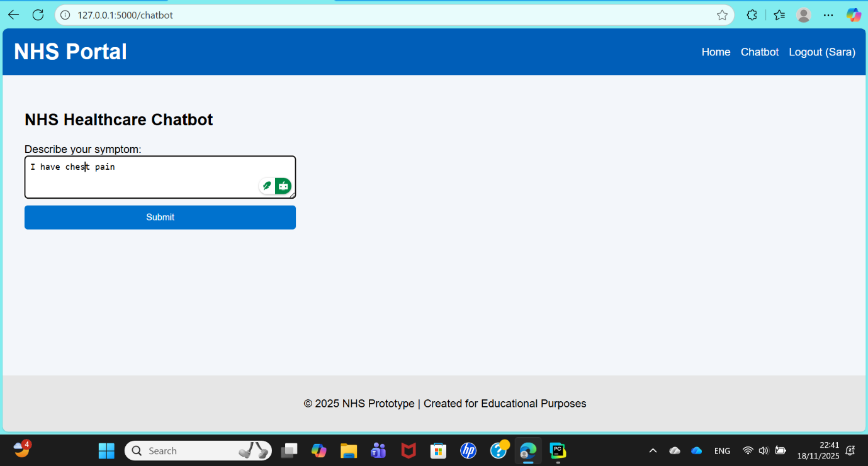
Fig 53: The user enters a high-risk emergency symptom, such as "I have chest pain," on the symptom entry screen.

The user submits a high-risk complaint, such as "I have chest pain," using the symptom-input interface depicted in the image. This form serves as the gateway to the chatbot's triage engine, allowing free-text symptoms to be recorded in real time. After the information is submitted, the backend uses rule-based logic to process it and identify important phrases like serious bleeding, breathing difficulties, or chest pain. These are instantly categorised as emergency symptoms, which prompts an A&E recommendation in the subsequent phase. In keeping with the system's overall user journey, the interface adheres to NHS digital design principles, guaranteeing clarity, accessibility, and ease of use.

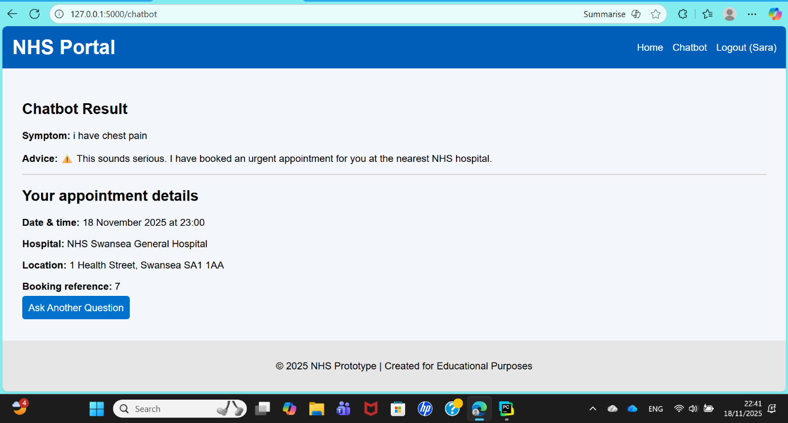
Fig 54: An automatically scheduled urgent hospital appointment for the high-risk symptom "chest pain" is displayed in the emergency triage result.

The high-risk symptom "I have chest pain" triggers the chatbot's emergency response procedure, as seen in the figure. Chest discomfort is automatically categorised as an emergency case by the backend triage algorithm, which recognises it as a potentially fatal condition. The method creates an urgent hospital appointment at the closest NHS facility rather than providing options for community-based care. Important information from the simulated appointment dataset is displayed on the confirmation screen, including the date, time, hospital name, location, and a unique booking reference. The prototype's capacity to distinguish between ordinary and critical symptoms is demonstrated by this automatic escalation process, which facilitates quick decision-making and complies with NHS emergency care prioritisation guidelines.

CRITICAL with more issues
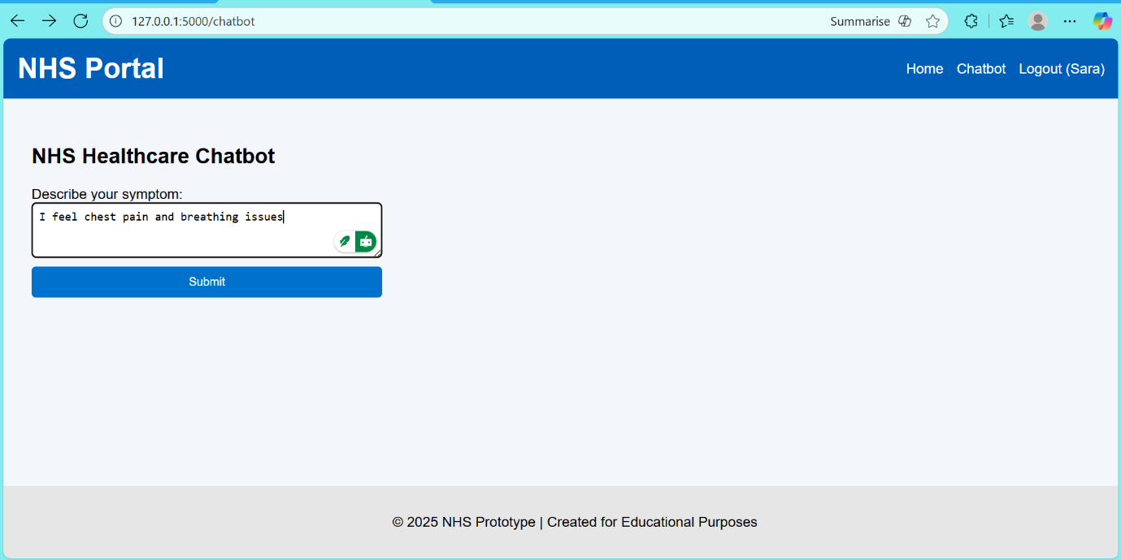
Fig 55: Prior to emergency triage processing, the symptom entry screen recorded two crucial symptoms: "chest pain" and "breathing issues."

The user reports many high-risk symptoms using the chatbot's symptom-entry interface, as shown in the figure: "I feel chest pain and breathing issues." The system's emergency triage procedure begins with this form. When the form is submitted, the backend rule-based classifier immediately prioritises the case as an emergency, interpreting both breathing difficulties and chest pain as critical indicators. Combining symptoms shows how well the algorithm can handle intricate human input and identify patterns linked to potentially fatal illnesses. To lessen user cognitive burden and facilitate quick action in emergency situations, the interface maintains NHS-aligned simplicity.

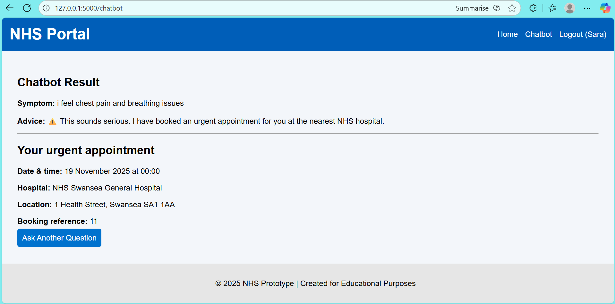
Fig 56: An automated emergency appointment confirmation for a combination of critical symptoms, such as "chest pain" and "breathing issues"

The emergency appointment confirmation that is produced when a user reports many high-risk symptoms (such as "chest pain and breathing issues") is shown in the figure. Both symptoms are identified by the backend triage algorithm as crucial markers of potentially fatal diseases. As a result, the system automatically schedules an urgent hospital appointment at the closest NHS facility, avoiding all non-urgent care pathways. Important details are shown on the confirmation screen, such as the time and date of the appointment, the name of the hospital, the complete address, and a special booking reference that was taken from the simulated appointment dataset. The system's ability to escalate multi-symptom emergency cases and offer prompt, medically relevant guidance in accordance with NHS urgent-care procedures is demonstrated by this installation.

2.2 ADMIN login dashboard
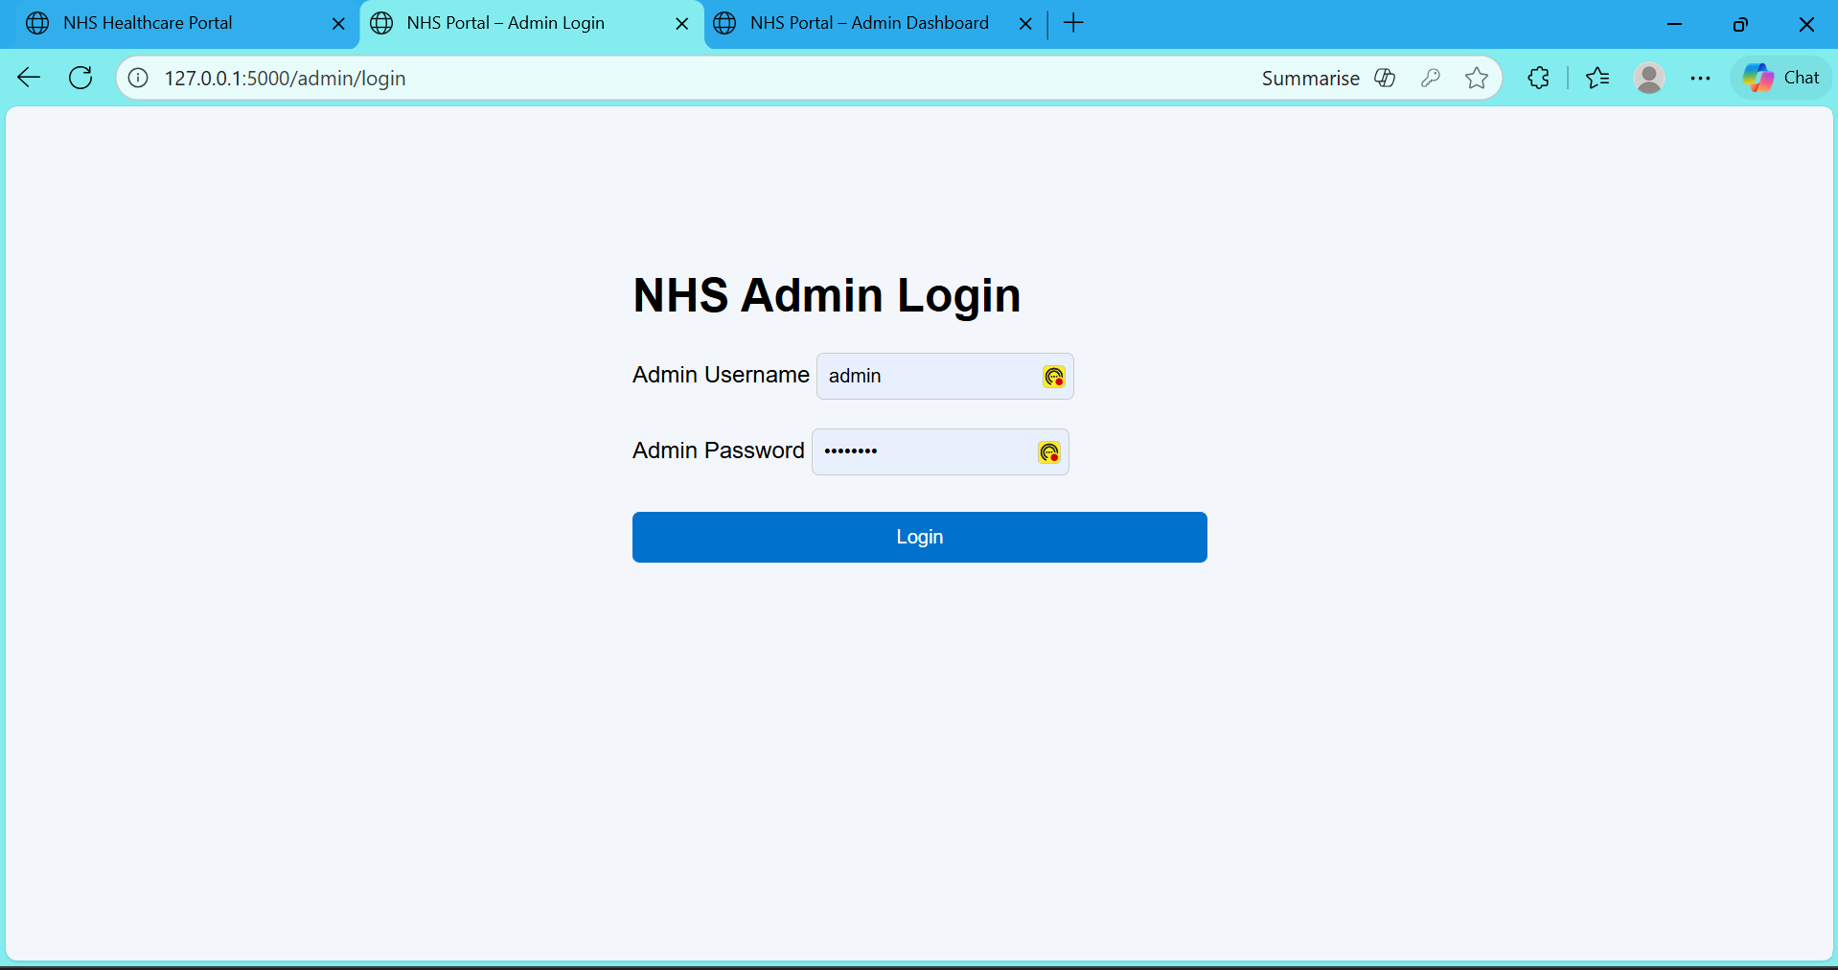
Fig 57: The username/password authentication form for authorised administrators is displayed on the NHS Admin Login screen.

The NHS Admin Login interface, seen in this figure, gives administrative users of the NHS Automated Healthcare Portal a safe entry point. Before administrators can access backend features like patient data review, appointment scheduling, or system monitoring, they must input a legitimate login and password. This is a straightforward but efficient authentication process implemented by the screen. The high-contrast blue login button, centred form design, and simple layout promote usability and adhere to NHS digital design guidelines.

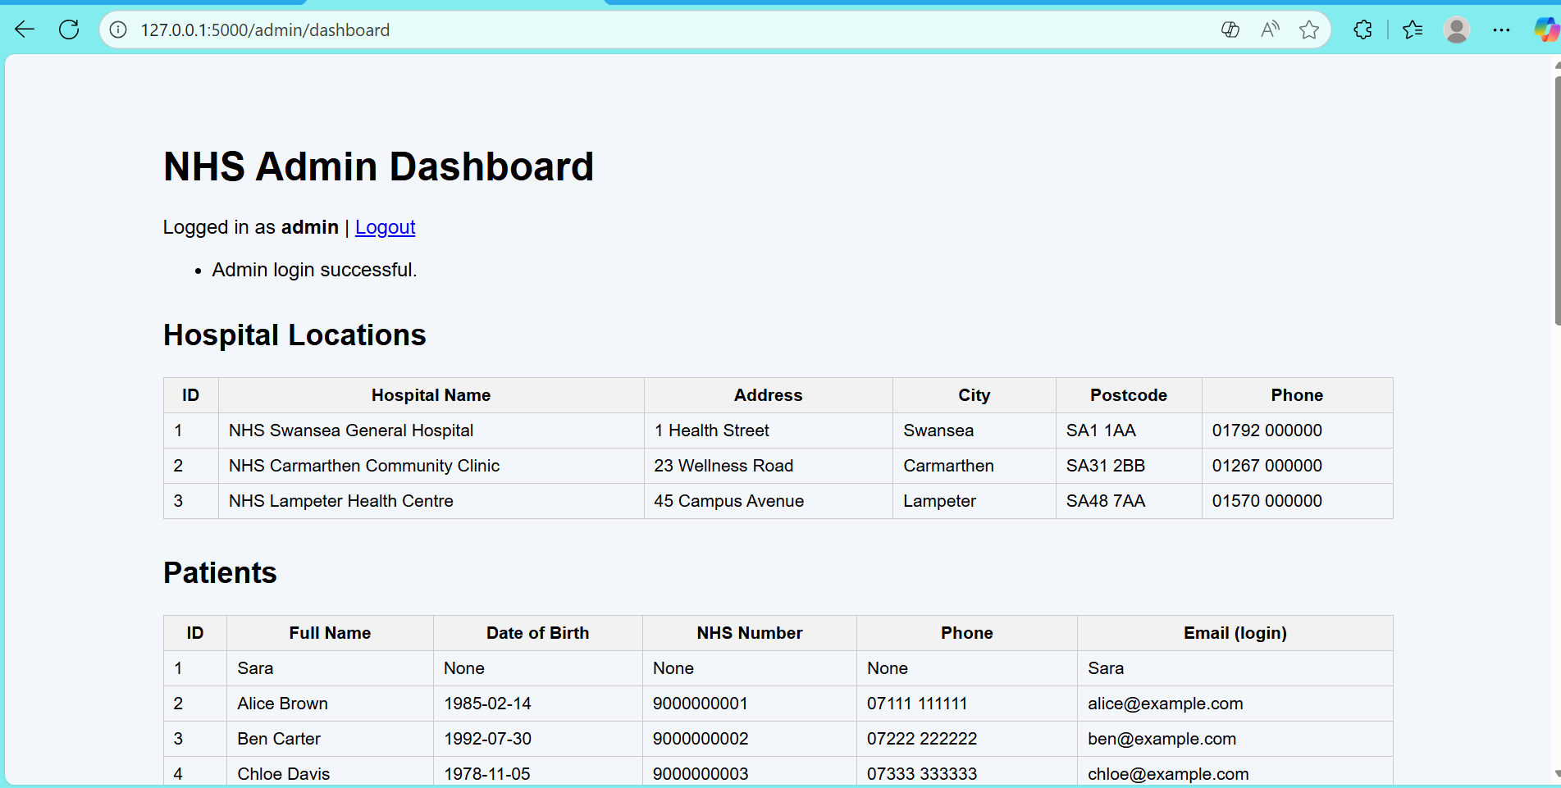
Fig 58: After a successful administrator login, the NHS Admin Dashboard shows patient records and hospital location information.

The NHS Admin Dashboard, seen in the figure, is only available upon a successful administrator authentication. Authorised personnel can examine important operational data utilised by the chatbot system on this dashboard, which serves as the administrative control panel. Hospital location records, including facility names, addresses, cities, postcodes, and phone numbers, are shown in the first part. The backend uses this information to create appointment bookings. Patient records, including names, dates of birth, NHS numbers, contact details, and emails linked to logins, are listed in the second section. These tables show how the system can handle structured administrative data and are dynamically generated from the simulated backend dataset. This dashboard, which reflects a crucial aspect of healthcare information management within the prototype, facilitates system monitoring and data flow testing.

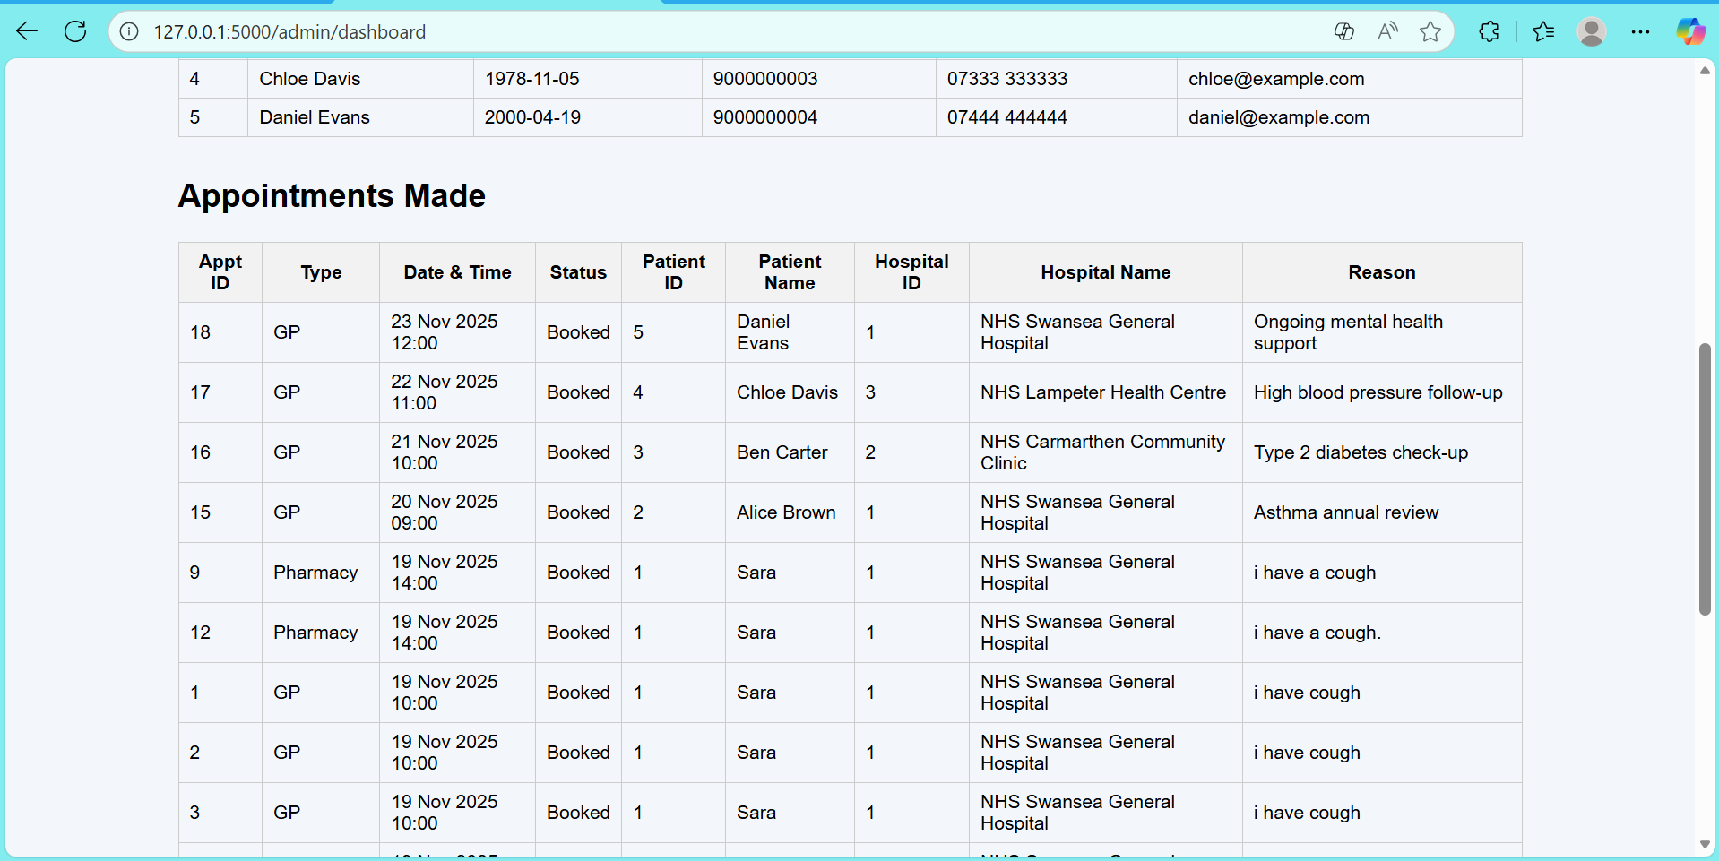
Fig 59: A table in the admin dashboard that shows every appointment made by the chatbot, together with patient information, hospital assignment, and reasons for booking.

The NHS Admin Dashboard's Appointments Made area, which compiles all booking activity produced by the chatbot's triage procedure, is depicted in the figure. Appointment identifiers, appointment type (e.g., GP or pharmacy), scheduled day and time, patient details, hospital information, and the documented reason for the visit are all included in each record in the table. These records give administrators complete visibility into system utilisation and patient flow and are dynamically pulled from the simulated database on the backend. To monitor and validate the healthcare suggestions produced by the prototype, this component shows how triage choices, appointment scheduling, and data management are integrated. The structured tabular architecture facilitates effective, transparent oversight and mirrors standard NHS administrative data formats.

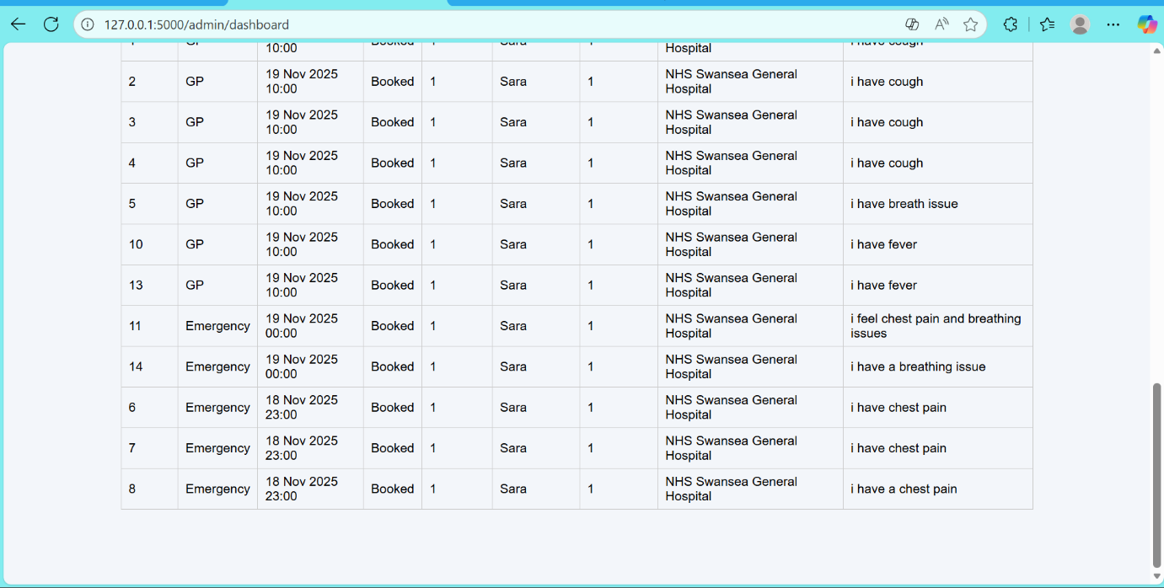
Fig 60: Extended view of appointment records that displays recurring GP and emergency appointments made due to different symptom inputs.

The continuing portion of the Appointments Made table in the NHS Admin Dashboard is shown in the figure, which highlights several appointments that were created especially because of the chatbot's triage of recurring symptoms. This section of the dataset illustrates how the system can reliably analyse and categorise symptoms including cough, fever, chest pain, and breathing problems by displaying several GP and emergency bookings linked to the same person. Because the rule-based classifier prioritises life-threatening symptoms, emergency situations may be easily differentiated. This table section demonstrates the strength of the backend logic, which ensures administrative transparency and traceability by precisely recording patient characteristics, hospital allocation, appointment timestamps, and symptom-based reasoning.
Appendix C
3 Summary
The technical evidence supporting the NHS Automated Healthcare Chatbot prototype is given in the appendices. Along with detailed screenshots of registration, login, triage outputs, appointment confirmations, and the admin dashboard, they also document the whole Flask codebase (app.py), data models, and NHS-style HTML/CSS templates. Together, these artefacts confirm that the developed system operates in accordance with the primary report's description, achieving a full workflow from symptom assessment and simulated appointment generation to user onboarding. Therefore, by showcasing the project's practical viability, logical system architecture, and compliance with accepted usability and healthcare interface standards, the appendix material enhances the project's credibility.
3.1 Conclusion
This research demonstrates that an NHS Automated Healthcare Chatbot, utilizing rule-based digital triage and priority appointment routing, can ease pressure on urgent and primary care. The prototype effectively supports registration, symptom capture, urgency categorization, and referrals through a Python-Flask architecture with NHS records. Usability testing guided by Nielsen's heuristics showed strong performance and clear feedback with minimal cognitive strain. While the solution sets a foundation for future NLP-driven triage and mobile development, it faces limitations due to its rule-based framework and lack of live NHS integration.

