

PROGRAMME: MSC PUBLIC HEALTH AND SOCIAL CARE IN PRACTICE
MODULE: SOCIAL EPIDEMIOLOGY AND PUBLIC HEALTH DEVELOPMENT
MODULE CODE: LCHS7000
Professor name - Mohamed aliyu
ASSIGNMENT TITLE: COMPONENT 2 ANALYTICAL REPORT
Name - Krupal Monpara
Student id - 2537141

Executive summary
This analytical report has explained on the age and health related inequalities across the older people 65 and above in the Task 1. The identified challenges can be dealt by several national orations to provide assistance to the older people. Furthermore, the task 2 has described about dementia as one of the prevalent non-communicable disease across the UK, especially the Havering Borough of the London. The proposed interventions and evaluation have been highlighted here to monitor progress of the interventions of the older people who has dementia.
Table of Contents
Task 1: Social Epidemiological Analysis 4
1.1 Title 4
1.2 Introduction 4
1.3 Contextual background and underlying factor 4
1.3.1 Three diseases/illness: 4
1.3.2 Three social issues: 6
1.4 Explaining the statistics 8
1.5 National Response to reduce health inequalities of the target group 8
1.6 Organisations that support the target population 8
1.6.1 Age UK 8
1.6.2 Independent Age 8
1.6.3 Centre for Ageing Better 8
1.7 Conclusion 9
Task 2: Epidemiological analysis 10
2.1 Introduction 10
2.1.1 Definition 10
2.1.2 Social, cultural and health consequences 10
2.1.3 Global epidemiological burden 11
2.1.4 UK epidemiological burden 12
2.1.5 Target population with epidemiological focus 12
2.2 Main body 13
2.2.1 Public health measures and the 3Ps 13
2.2.2 Key determinants and risk factors 14
2.2.3 Epidemiological studies and health needs assessment 14
2.2.4 Epidemiological surveillance and monitoring 15
2.2.5 Public health impact and consequences 15
2.2.6 Proposed intervention and evaluation 15
2.2.7 Strengths and limitations of the epidemiological approach 16
2.3 Conclusion 17
References 18

Task 1: Social Epidemiological Analysis

1.1 Title
“Analysis of age and health inequalities among older people in the UK: A social epidemiological study”

1.2 Introduction
This epidemiological study has defined the older people aged 65 and above representing a highly important population group in the UK. In line with this, around 8.4 million people has been living alone in the UK in 2024 which represents around 11% higher of the data from 2014 (Fox, 2025). In which, the female population aged 65 and above is higher (40.9%) in households living alone than the male population (27%) of that age in the UK (Fox, 2025).
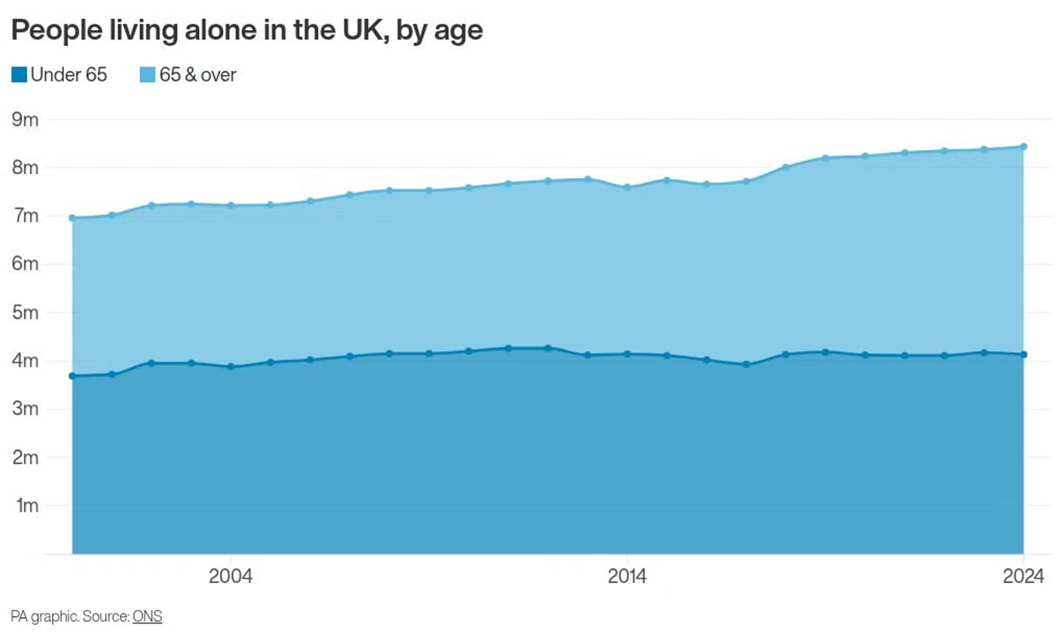
Figure 1: Health inequalities shown by age in the UK
(Source: Fox, 2025)
Furthermore, NHS England (2023) identified health inequalities as avoidable and systematic differences in health between population groups. Furthermore, deprivation substantially affects health outcomes with healthy life expectancy differing by almost decades between the least and most deprived areas.

1.3 Contextual background and underlying factor

1.3.1 Three diseases/illness:
- Higher rates of mental illness:
The risk is highly important for the older people living alone such as 4.6 million people aged 65 years and over lived alone in the UK in 2024 by showing around 51% of the people living alone (My Social Work News, 2025). The prior data of women living alone is higher than that of men living alone in the UK (NHS, 2023). Hence, living alone may not always indicate loneliness, but it can enhance the exposure to social isolation and associated mental illness.
- Low rates of access to healthcare:
Age can interact with disability, mobility limitations, digital exclusion, transport difficulties and deprivation to make unequal access to healthcare. As per the data of Age UK (2024), people over 60s are saying life is harder than five years ago, in which around 1 in 3 older people (31%) is facing loneliness in the UK. Likewise, older people with high social disadvantages may experience difficulties in timely and appropriate services.
- Mortality rates among the elderly group:
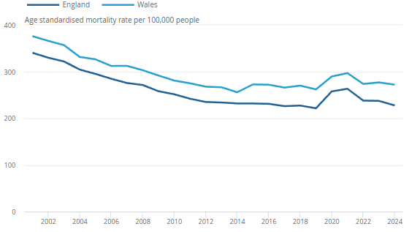
Figure 2: Mortality rate among older people prevalent areas of the UK such as England and Wales
(Source: ONS, 2026)
Mortality inequalities among older populations are strongly influenced by socioeconomic circumstances. In this regard, ONS (2026) reported that avoidable mortality in England was 21.3% and in Wales was 22.8% of all deaths by increasing mortality rate around four times higher in the most deprived areas than the least deprived areas. The avoidable mortality rates age related has been highly seen in the North East areas than the South East of the UK (ONS, 2026). This statistical inferential highlights the relationship between deprivation and unequal survival outcomes in the UK.

1.3.2 Three social issues:
- Social isolation and loneliness:
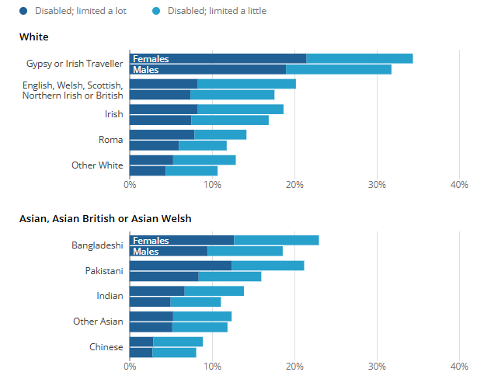
Figure 3: Social inequalities among white and Asians group of the England
(Source: ONS, 2023)
For example, disability prevalence among people aged 65 and above was around white 52.3% for Gypsy or Irish Traveller, Asian 49.9% for Bangladeshi and 44.3% for Pakistani groups identified in 2021 (ONS, 2023). These overlapping disadvantages can be critical for social engagements which results in isolation and loneliness as well.
- Poverty:
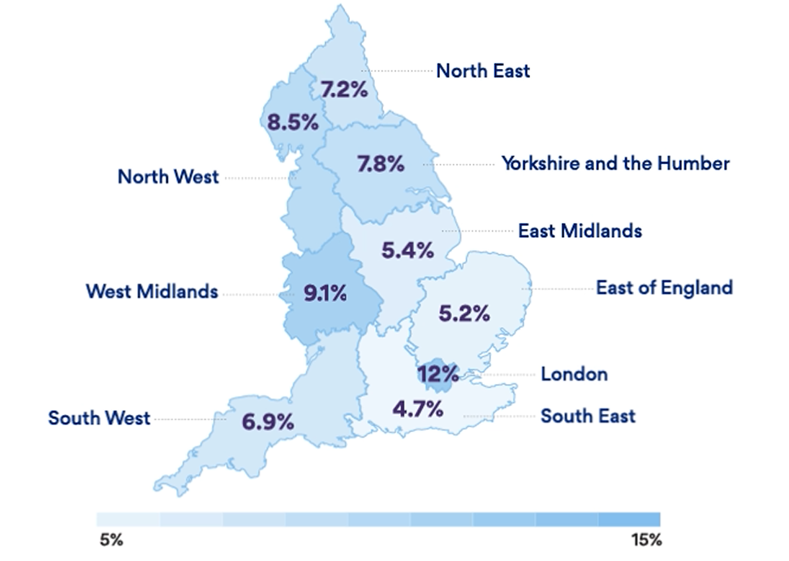
Figure 4: Pensioner deprivation across the UK
(Source: Centre for Ageing Better, 2025)
The financial circumstances can influence negatively on the health of older people by affecting the ability to afford nutritious food, heating, suitable housing and other health-promoting resources to stay healthy.
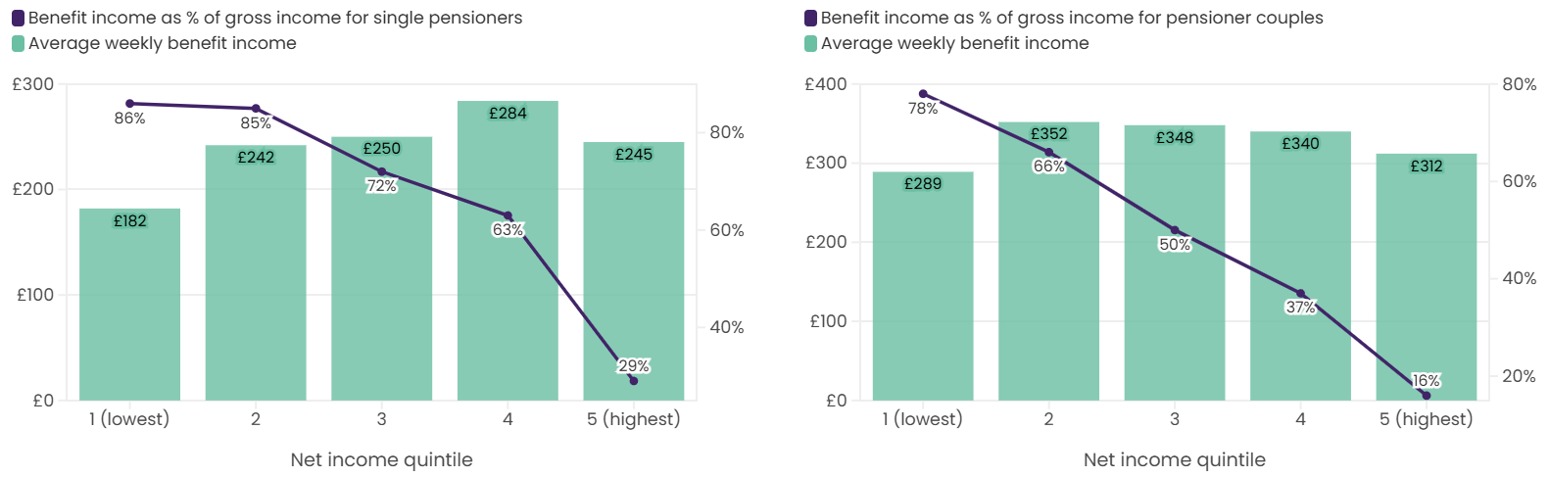
Figure 5: Financial inequalities in pension scheme among single and couples in the UK
(Source: Centre for Ageing Better, 2025)
The pensioner income levels and differences between pensioner groups (Centre for Ageing Better, 2025). This data helps to provide data on older people that are not economically homogeneous.
- Housing issues:
Older people may be vulnerable to unsuitable, inadequately heated homes due to physical limitations and long-term conditions improve the health consequences of poor housing (RSPH, 2026). This finds housing as a wider determinant contributing to differences in health outcomes.

1.4 Explaining the statistics
Life expectancy distinguishes 8.4 years for women and 10.4 years for men between England’s most and least deprived areas (Williams et al., 2022). Furthermore, ONS (2023) asserted that disability affects 52.3% of Gypsy of Irish Traveller people aged 65 and above, increasing vulnerability. The targeted healthcare, housing, income and social-support interventions are needed to overcome these challenges.

1.5 National Response to reduce health inequalities of the target group
National action has been highlighted to reduce inequalities affecting older people through integrated health and social care approaches by settling a £20.5 billion budget between the UK government and NHS. The NHS Long Term Plan supports personalized care particularly for people with multiple long-term conditions to assist the care needs of older adults with accessible services (GOV.UK, 2026). In this similar manner, the Care Act 2014 established duties to promote wellbeing, prevent or delay care needs by reducing inequalities in accessing care and support (BCP, 2026). These measures recognise that age-related inequality is influenced by health, social circumstances by accessing proper support.

1.6 Organisations that support the target population

1.6.1 Age UK
This organization supports older people by providing advice, collaborative services, local support and campaigning on issues such as poverty, loneliness and access to services (Age UK, 2024).

1.6.2 Independent Age
This organisation helps to advise on older people’s income, housing, care and health by campaigning against financial issues in older age (Independent Age, 2026).

1.6.3 Centre for Ageing Better
This organisation addresses structural inequality and ageism by conducting research, policy influence and advocacy particularly for socially deprived or marginalised older groups (Centre for Ageing Better, 2024).

1.7 Conclusion
This task has provided insights on age-related health inequalities amongst the older people shaped by interconnected health and social disadvantages such as mental illness, healthcare access, mortality, loneliness, poverty and housing. This section has also described that these inequalities disproportionately affect disadvantaged groups. Hence, the coordinated national policies, accessible services and sustained support from organizations of the UK can reduce the uncertainty to address social and economic determinants.

Task 2: Epidemiological analysis

2.1 Introduction

2.1.1 Definition
Dementia is a progressive group of neurological conditions characterised by deterioration in memory, thinking, behaviour and the ability to perform regular activities (WHO, 2025). However, aging is the strongest known risk factor, dementia is one of the strongest risk factors by considering the inevitable consequence of aging. Alzheimer’s disease represents around 60-80% of dementia cases globally (Alzheimer’s Association, 2025). Hence, the Regional Epidemiologist needs to take an account based on the recent dementia prevalence among the older people.

2.1.2 Social, cultural and health consequences
Dementia substantially affects independence, communication, quality of life and participation in quality of life (QoL) (Shah et al., 2024). This makes significant responsibilities for informal caregivers based on the high demand for health and social-care services. In this context, Siette et al. (2023) stated that the cultural beliefs, stigma, language barriers and differences in understanding of dementia can influence recognition, help-seeking, diagnosis. The social engagement with available support potentially contributes to inequalities among older adults.

2.1.3 Global epidemiological burden
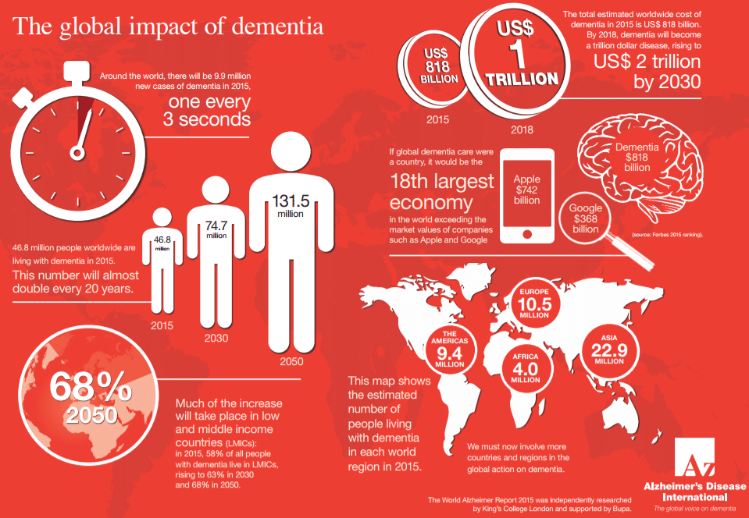
Figure 6: Global prevalence of dementia
(Source: Suri, 2026)
Around 57 million people were living with dementia worldwide in 2021 with almost 10 million new cases occurring annually (Suri, 2026). Dementia is the 7th leading cause of death globally by causing disability and dependency among older people (Amiri et al., 2025). Therefore, dementia represents a major global public health challenge

2.1.4 UK epidemiological burden
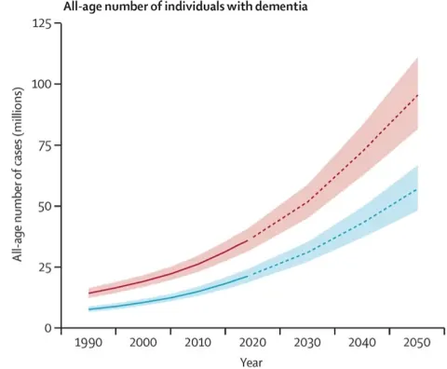
Figure 7: Dementia prevalence in the UK
(Source: Dementia Platform UK, 2025)
The UK also experiences a substantial dementia burden. Additionally, NHS Digital (2025) recorded 513,135 patients with a record dementia diagnosis on 31 March 2026. Among people aged 65 years and over, the estimated diagnosis rate was 66.2% by describing that a proportion of people estimated to have dementia remain undiagnosed (Alzheimer’s Research UK, 2025).

2.1.5 Target population with epidemiological focus
This report focuses on adults aged 65 years and over in the London Borough of Havering. In this similar context, democracy.havering.gov.uk (2025) documented that Havering is suitable because around 3,810 people aged 65 and above were estimated to have dementia in 2025. This will investigate the distribution and determinants of dementia to identify populations at risk through epidemiological evidence and health needs assessed. This report will evaluate surveillance approaches to consider interventions by reducing dementia-related morbidity, dependency and health inequalities.

2.2 Main body

2.2.1 Public health measures and the 3Ps
Havering has implemented several measures to address dementia through prevention, protection and promotion. The 3Ps are as follows:

Figure 8: 3Ps model
(Source: Self-made)
- Prevention focuses on reducing modifiable dementia risks including physical inactivity, smoking, hypertension, obesity, diabetes and excessive alcohol consumption. This is important as WHO’s dementia guidance has shown that addressing 20 modifiable risk factors could prevent or delay a substantial proportion of dementia cases (WHO, 2026).
- Protection involves early identification, timely diagnosis and coordinated care reducing avoidable deterioration and supporting independence. The dementia diagnosis rate was 56.3% with around 335 additional diagnoses required to reach the national 67% ambition describing an important local service gap (Havering Council, 2026).
- Promotion includes dementia-awareness activity, community support and social participation. Havering’s Dementia Support Service and Ageing Well Prevention Service provide opportunities for earlier support, social inclusion and maintenance of independence (Havering London Borough, 2025).

2.2.2 Key determinants and risk factors
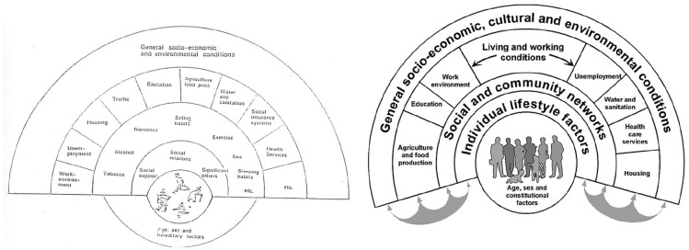
Figure 9: Dahlgren and Whitehead model
(Source: Dyar et al., 2022)
Dementia is shaped by interacting biological, behavioural and socioeconomic determinants. The Dahlgren and Whitehead model is beneficial because it demonstrates what individual characteristics are embedded within wider social and environmental conditions (Dyar et al., 2022). Age is the strongest known risk factor, while hypertension, diabetes, obesity, physical inactivity, smoking, harmful alcohol use, depression, hearing loss, social isolation and air pollution are also associated with dementia. WHO’s recent 2026 guidance estimates that up to 45% of dementia risk could potentially be prevented or delayed through identifying modifiable factors (WHO, 2026). The social disadvantage may additionally restrict access to preventive healthcare and healthy living environments. Therefore, dementia risk in Havering needs to be understood through a life-course and social determinants perspective instead of attributing risk to ageing alone.

2.2.3 Epidemiological studies and health needs assessment
Havering’s 2025 Joint Strategic Needs Assessment (JSNA) provides an important local health-needs assessment by combining demographic, epidemiological and service information, This estimates a substantial dementia burden among residents aged 65 years and over by describing that dementia increases as the borough’s population ages. The JSNA can identify population groups requiring greater diagnosis to support capacity. National epidemiological evidence reinforces this need including NHS England recorded 513,135 people with a dementia diagnosis in 2026, while the estimated to have dementia (NHS Digital, 2025). Likewise, the needs assessment prioritizes older adults at increased risk, undiagnosed residents and people requiring continuing care to consider inequalities in access to diagnosis and support.

2.2.4 Epidemiological surveillance and monitoring
Dementia surveillance in Havering needs to use multiple complementary systems. The OHID Dementia Profile And Public Health Fingertips provide local-authority indicators showing dementia prevalence, estimated diagnosis rates, referrals to memory assessment services, antipsychotic prescribing and care plan provision (fingertips.phe.org.uk, 2026). In addition to this, the NHS England’s Primary Care Dementia Data provides GP-level and local-authority information including diagnosis rates, age, ethnicity, dementia type, medication reviews and care planning (NHS England, 2026). Hospital episode statistics (HES) can monitor dementia-related hospital activity while ONS mortality statistics identify deaths involving dementia. Havering JSNA integrates these sources to support local planning. However, surveillance may underestimate the true burden because undiagnosed cases are not understood in recorded prevalence.

2.2.5 Public health impact and consequences
Dementia produces significant short and long-term consequences for Havering’s older population. Initially, cognitive deterioration can affect memory, communication, medication management, independence and social participation. The progression may enhance falls, hospital utilisation, dependency and demand for formal care. Regarding this, Clare et al. (2025) asserted that the long-term consequences include residential-care requirements, increased pressure on NHS and social care services and substantial emotional and financial burdens for unpaid carers. Globally, WHO (2025) also reported that dementia generated approximately US$1.3 trillion in economic costs in 2019 with around half attributed to informal care. The growing local demand needs proactive epidemiological planning instead of relying solely on reactive treatment.

2.2.6 Proposed intervention and evaluation
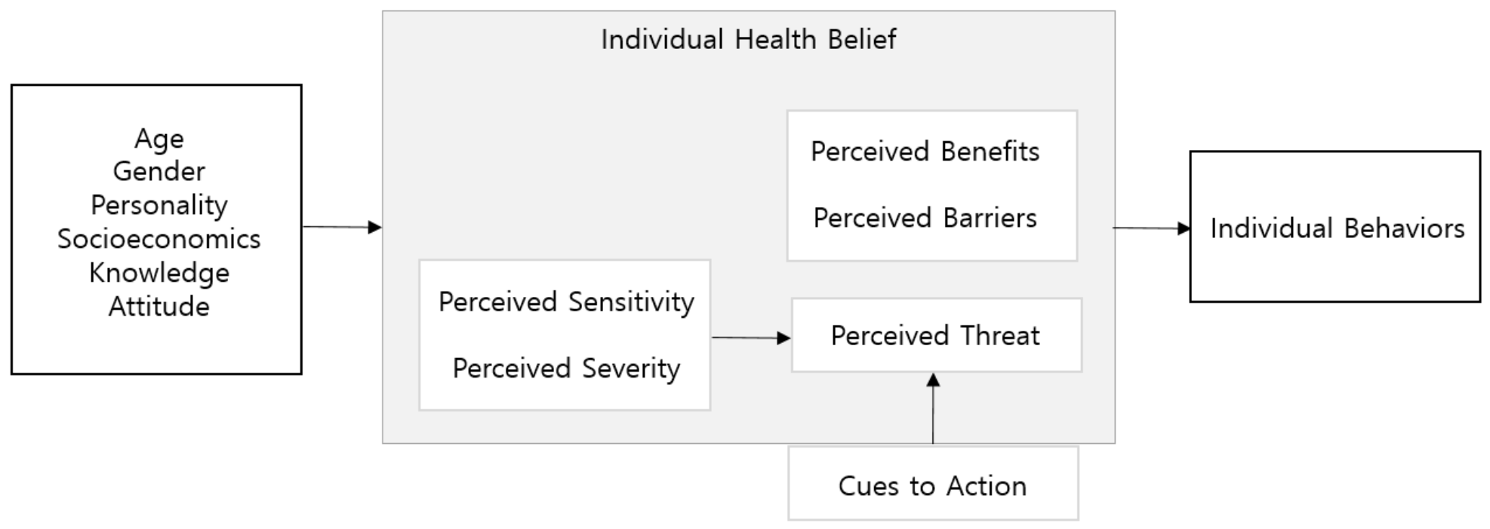
Figure 10: Health Belief Model (HBM)
(Source: Kim et al., 2022)
The Havering Dementia Early Detection and Healthy Ageing programme will be proposed for adults aged 65 and above to prioritise older adults with cardiovascular risk factors, social isolation or suspected cognitive decline. The Health Belief Model (HBM) can guide delivery by addressing perceived susceptibility, perceived severity, perceived benefits and barriers to diagnosis and preventions.
Intervention | Delivery | Evaluation
Early detection | - GP or community case-findings and referral | - Diagnosis rate and referral numbers
Risk reduction | - BP, diabetes, smoking, activity and weight support | - Risk-factor improvement
Awareness | - Community and culturally appropriate education | - Knowledge and attendance
Social support | - Social prescribing and community groups | - Participation and well-being
Care coordination | - Annual reviews and caregiver support | - Care plan coverage
Table 1: Proposed intervention and evaluation
(Source: Self-made)
The 6-12 months of timelines are required to monitor process, outcome and equity indicators disaggregated by age, gender, ethnicity and deprivation through this surveillance interventions.

2.2.7 Strengths and limitations of the epidemiological approach
Strengths
The major strengths are ‘data triangulation’ by using combination of JSNA evidence, primary-care records, fingertips and OHID surveillance, recent hospital and mortality data. This has been beneficial for this assessment to analyse the disease burden, service gaps and population trends through evidence-based procedure. The NHS England data are valuable due to these provide local-authority and GP-level diagnosis information.
Limitations
The underdiagnosis means recorded prevalence may underestimate actual dementia prevalence, The routine datasets may contain incomplete or inconsistent recording, by changes in data collection and geographical boundaries can affect the comparisons. In addition to this, observational epidemiology can describe associations between determinants and dementia but cannot necessarily build causality. Hence, cultural stigma, health literacy and unequal service engagements may also make ascertainment bias by masking inequalities across the Havering.

2.3 Conclusion
This analytical report has represented a significant and increasing public health challenge among the older adults aged 65 and above in the London Borough of Havering. The epidemiological analysis describes that dementia is influenced by ageing along with modifiable behavioural, biological, social and environmental determinants. This evidence-based report has been provided several insights from national data using Havering’s JSNA, NHS England and Public Health Fingertips to describe the significance of recognising the undiagnosed cases, monitoring disease trends to address inequalities in access to diagnosis and continuing support. In addition to this, the use of complementary surveillance systems will be beneficial for regional epidemiologist to evaluate prevalence, service utilization, mortality and changing population needs by supporting evidence-based resource allocation. However, the limitations of underdiagnosis, incomplete routine data, bias and limitations of observational evidence can affect the accuracy of estimates and interpretation of associations. Hence, the targeted ‘Healthy Aging and Early Detection Programme’ combining risk-factor reduction, community awareness, case-findings, social prescribing and coordinated care will enhance strengths of prevention and early disease management. Thus, sustained epidemiological surveillance and equity-focused interventions are essential to reduce dementia-related morbidity, dependency and inequality in Havering.

References
Task 1
Age UK (2024) Befriending services | combating loneliness. Available at: https://www.ageuk.org.uk/services/befriending-services/ (Accessed: 10 August 2026).
Age UK (2024) One in three (31%) over 60s say life is harder than five years ago because more services are now online. Available at: https://www.ageuk.org.uk/latest-press/articles/one-in-three-31-over-60s-say-life-is-harder-than-five-years-ago-because-more-services-are-now-online/ (Accessed: 10 August 2026).
BCP (2026) Our duties and your rights under the CARE act 2014. Available at: https://www.bcpcouncil.gov.uk/adult-social-care-and-health/what-to-expect-from-adult-social-care/our-duties-and-your-rights-under-the-care-act-2014 (Accessed: 10 August 2026).
Centre for Ageing Better (2024) Ageism and inequality. Available at: https://ageing-better.org.uk/ageism-and-inequality (Accessed: 10 August 2026).
Centre for Ageing Better (2025) Financial security | the state of ageing 2025. Available at: https://ageing-better.org.uk/financial-security-state-ageing-2025 (Accessed: 10 August 2026).
Fox, A. (2025) Rise in people living alone in UK driven entirely by over-65s. Available at: https://www.independent.co.uk/news/uk/home-news/office-for-national-statistics-people-b2794419.html (Accessed: 10 August 2026).
GOV.UK (2026) NHS long term plan launched. Available at: https://www.gov.uk/government/news/nhs-long-term-plan-launched (Accessed: 10 August 2026).
Independent Age (2026) How can we help today?. Available at: https://www.independentage.org/ (Accessed: 10 August 2026).
My Social Work News (2025) Social Work News. Available at: https://www.mysocialworknews.com/article/number-of-over-65-s-living-alone-in-uk-rises-by-more-than-one-million-in-a-decade (Accessed: 10 August 2026).
NHS (2023) Loneliness and wellbeing. Available at: https://digital.nhs.uk/data-and-information/publications/statistical/health-survey-for-england/2021-part-2/loneliness-and-wellbeing (Accessed: 10 August 2026).
NHS England (2023) What are healthcare inequalities? Available at: https://www.england.nhs.uk/about/equality/equality-hub/national-healthcare-inequalities-improvement-programme/what-are-healthcare-inequalities/ (Accessed: 10 August 2026).
ONS (2023) Protected characteristics by disability status, England and wales: Census 2021 - office for national statistics. Available at: https://www.ons.gov.uk/peoplepopulationandcommunity/healthandsocialcare/disability/articles/protectedcharacteristicsbydisabilitystatusenglandandwalescensus2021/2023-05-17 (Accessed: 10 August 2026).
ONS (2026) Avoidable mortality in England and Wales. Available at: https://www.ons.gov.uk/peoplepopulationandcommunity/healthandsocialcare/causesofdeath/bulletins/avoidablemortalityinenglandandwales/2024 (Accessed: 10 August 2026).
RSPH (2026) How housing affects our health. Available at: https://www.rsph.org.uk/insights/how-housing-affects-our-health/ (Accessed: 10 August 2026).
Williams, E., Buck, D., Babalola, G. and Maguire, D. (2022). What are health inequalities?. Available at: https://www.kingsfund.org.uk/insight-and-analysis/long-reads/what-are-health-inequalities (Accessed: 10 August 2026).
Task 2
Alzheimer’s Association (2025) What is alzheimer’s disease? [online] Alzheimer’s Association. Available at: https://www.alz.org/alzheimers-dementia/what-is-alzheimers (Accessed: 10 August 2026).
Alzheimer’s Research UK (2025) Diagnosis of dementia. Available at: https://dementiastatistics.org/about-dementia/diagnosis/ (Accessed: 10 August 2026).
Amiri, F., Safiri, S., Shamekh, A., Ebrahimi, A., Sullman, M.J.M. and Kolahi, A.-A. (2025). ‘Prevalence, deaths and disability-adjusted life years due to Alzheimer’s disease and other dementias in Middle East and North Africa, 1990–2021’. Scientific Reports, 15(1), p.7058. Available at: https://doi.org/10.1038/s41598-025-89899-w
Clare, L., Charlwood, C., Quinn, C. and Victor, C., (2025). Living with Dementia Reconsidered. McGraw-Hill Education (UK).
Dementia Platform UK (2022) How are rates of dementia changing? — DPUK. Available at: https://www.dementiasplatform.uk/news-and-media/blog/how-are-rates-of-dementia-changing (Accessed: 10 August 2026).
democracy.havering.gov.uk (2025) LB havering JSNA 2025 living well, Ageing Well & Dying well draft 5 V1 for HWB approval. Available at: https://democracy.havering.gov.uk/documents/s79003/Havering%20JSNA%202025%20Draft%205%20v1%20HWB.pdf (Accessed: 10 August 2026).
Dyar, O.J., Haglund, B.J.A., Melder, C., Skillington, T., Kristenson, M. and Sarkadi, A. (2022). ‘Rainbows over the world’s public health: Determinants of health models in the past, present, and future’. Scandinavian Journal of Public Health, 50(7), pp.1047–1058. Available at: https://doi.org/10.1177/14034948221113147
fingertips.phe.org.uk (2026) Dementia profile – OHID. Available at: https://fingertips.phe.org.uk/profile/dementia (Accessed: 10 August 2026).
Havering Council (2026) Havering Joint Dementia Strategy 2024 - 2029. Available at: https://www.havering.gov.uk/downloads/file/6888/havering-joint-dementia-strategy-2024-to-2029 (Accessed: 10 August 2026).
Havering London Borough (2025) London Borough of Havering. Available at: https://democracy.havering.gov.uk/ieDecisionDetails.aspx?Id=8842 (Accessed: 10 August 2026).
Kim, H.-Y., Shin, S.-H. and Lee, E.-H. (2022). ‘Effects of health belief, knowledge, and attitude toward COVID-19 on prevention behavior in health college students’. International Journal of Environmental Research and Public Health, 19(3), p.1898. Available at: https://doi.org/10.3390/ijerph19031898
NHS Digital (2025) Primary Care Dementia Data, March 2026. Available at: https://digital.nhs.uk/data-and-information/publications/statistical/primary-care-dementia-data/march-2026 (Accessed: 10 August 2026).
NHS England (2026) Primary care dementia data, june 2026. Available at: https://www.gov.uk/government/statistics/primary-care-dementia-data-june-2026 (Accessed: 10 August 2026).
PPD (2025) Dementia awareness month. Available at: https://www.ppd.com/wp-content/uploads/2025/04/NHS-Dementia-Awareness-Presentation.pdf (Accessed: 10 August 2026).
Shah, R., Salek, M.S., Ali, F.M., Nixon, S.J., Otwombe, K., Ingram, J.R. and Finlay, A.Y. (2024). ‘Dementia and its profound impact on family members and partners’. Alzheimer Disease & Associated Disorders, 38(4), pp.338–343. Available at: https://doi.org/10.1097/wad.0000000000000647
Siette, J., Meka, A. and Antoniades, J. (2023). ‘Breaking the barriers: Overcoming dementia-related stigma in minority communities’. Frontiers in Psychiatry, 14(1), p.1278944. Available at: https://doi.org/10.3389/fpsyt.2023.1278944
Suri, S. (2026). Dementia: 57 Million people affected globally, 10 million new cases annually. Available at: https://observervoice.com/dementia-57-million-people-affected-globally-10-million-new-cases-annually-178166/ (Accessed: 10 August 2026).
WHO (2025) Dementia. Available at: https://www.who.int/news-room/fact-sheets/detail/dementia (Accessed: 10 August 2026).
WHO (2026) New WHO guidelines: Up to 45% of dementia risk could be prevented or delayed. Available at: https://www.who.int/news/item/15-07-2026-new-who-guidelines--up-to-45--of-dementia-risk-could-be-prevented-or-delayed (Accessed: 10 August 2026).

