BUSINESS DIGITAL ARTIFACT
BRIGHTTECH REPAIRS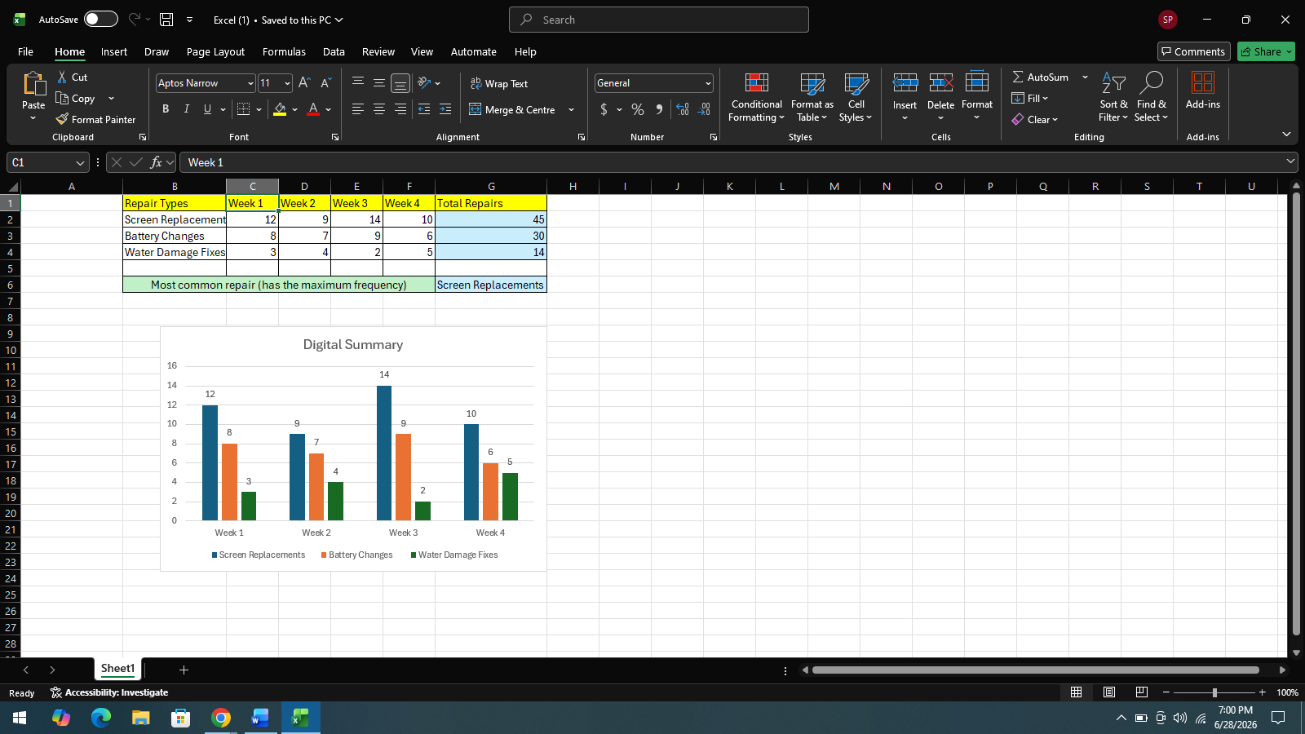
1. Reason for choosing Excel
Microsoft Excel was chosen because it is suitable to organise, analyse and present a numerical set of data. For the Business scenario I had to produce a digital summary of repair jobs done by BrightTech Repairs in a digital format. As most of the data was numerical and recorded for four weeks, it was suitable to use excel to enter the data into a structured table and carry out calculations with the data accurately. Even built-in functions were available such as SUM, which made it easy to perform Total Number Repairs calculation for each type of repair without manually calculating it, which could be prone to errors. Excel provides the facility to visualise information in the form of charts. The use of bar chart gave a clear idea on the performance of BrightTech Repairs in relation to the different repair jobs done.
2. Information Used
I used the information provided by Ms. Nicholson in the business scenario – repair data. The data included the number of water damage fixes, battery changes and screen replacements performed for each of the 4 weeks of a month. I put the weekly data into an Excel spreadsheet, while properly arranging them across rows and columns. Once all the data was entered the monthly totals of each repair category were calculated with the Excel formulae. This allowed me to carry out a report that showed me the most frequent repair type was “Screen replacement.”

3. Changes made
I did a number of enhancements to the spreadsheet of the digital artefact so that it would be clear and easy to visualise. I organised information into a well labeled table that includes headings for each week and repair category. I used the automated SUM function to calculate the total repairs done. Once I had worked out the totals, I added a bar chart to help visually compare the totals of the three types of repairing. In addition, I added a note regarding the most common type of repair. This resulted in the creation of an effective spreadsheet that was meaningful and easily understood by the manager without a lot of time.
4. Ways I improved my work
I took extra time to check the accuracy of my work in terms of the figures entered in the spreadsheet and the accuracy of the formulas used to calculate the results. I reviewed the count totals and some modifications were made to the format to make it easier to understand. I made the spreadsheet look professional by using consistent fonts, appropriate widths of the columns designed, bold text for headings, and a logical layout. The addition of the chart contributed better to the presentation as important information became comprehensible at a glance. Through this task, I was able to increase my confidence in using Microsoft Excel to organise business information, calculate sums and make effective charts and communicate information effectively in the context of a business.

