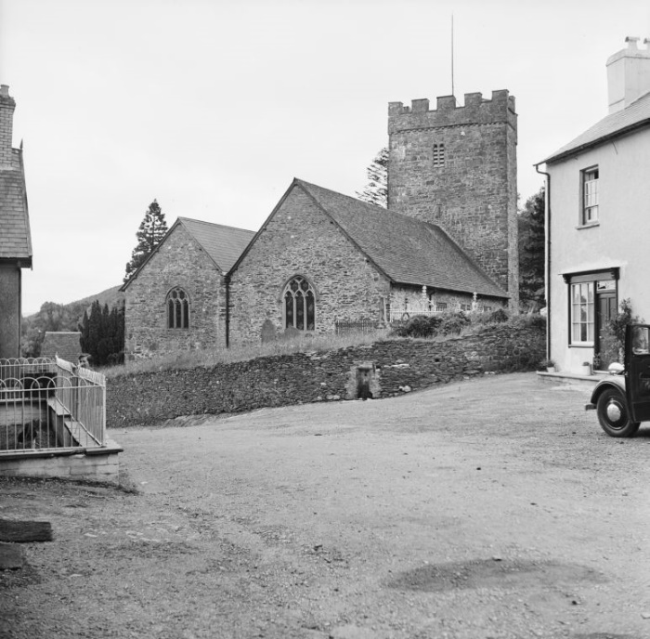

Figure 1: Exterior view of St Teilo’s Church (Credit: Miss Wight, 1965)

Ellie Jones-Higginson
School: University of Wales Trinity St David’s
Student number: 1800454
Course: BSc Architecture
Faculty: Built and Natural Environment
Module code: M6X01986
Year of Completion: 2020/2021

What is the significance of a ‘Llan’ within Llandeilo in the 21st century, and how does this enclosure influence the activities of the structures contained within it?



Copyright Statement

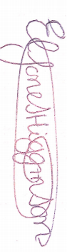
The copyright of this dissertation rests with the University of Wales, Trinity Saint David. No information derived from this dissertation shall be published without the prior written consent of the University.

Signature ……………………………………………………………………………………………
/ / 2021
Date …………………………………………………………………………………………………

Author’s Declaration
I declare that the work in this dissertation was carried out in accordance with the regulations of the University of Wales, Trinity Saint David. The work is original except where indicated by special references in the text and no part of the dissertation has been submitted for any other degree.
Any views expressed in the dissertation are those of the author and in no way represent those of the University of Wales, Trinity Saint David.
The dissertation has not been presented to any other University for examination either in the United Kingdom or overseas.
I hereby give permission for my work, if accepted, to be available for photocopying and inter-library loan, and for the title and summary to be made available to outside organisations.

Signed …………………………………………………………………………………………………
/ / 2021
Date ……………………………………………………………………………………………………

Acknowledgements:
I would like to thank My mentor Ian Standen for supporting and guiding me through this piece of work and his splendid support and knowledge over the last three years.
I would also like to thank Dr Liz Walder for her unconditional support and guidance consistently during this piece of work. Her support and guidance have sent me further into the topic and allowed me to gather data that I would’ve missed if I hadn’t seeked her guidance.
I would also like to thank Cheryl Evans for her guidance at home during the pandemic, allowing me to brainstorm with her and giving her understanding on the topic. The support you have given me has been truly unconditional.
Finally, I would like to thank all the participant who took part in my survey of which allowed me to collect the data to write this piece of work.

Abstract:
My dissertation explores the use of LLans within Llandeilo and the significance of the buildings in the 21st century. This body of work explores the use of the Llans within Llandeilo along with similar case studies across the UK.
Research will be carried out by observing the buildings and the conditions they are in, along with contacting professionals that specialise in the upkeep and maintaining the welsh heritage these buildings hold. These being, The build heritage team of south west wales, CADW and Llandeilo council.
Data will be congregated by using a series of interviews and questionnaires on welsh citizens that have a strong welsh heritage. The research will aim at citizens of Llandielo, of familiar with the area and/ or have a high knowledge on Llans and listed buildings. These interviewees will also include history teachers, lecturers, and members of welsh heritage centers.
As this research requires statistics and historical context, surveys, early os maps, historical data-conservation architects and national welsh history sites will all be used for a stronger understanding of the topic, allowing a wider range of context within the body of work.

Case studies on three chosen Llans from outside my area will be researched and written on, this will allow a comparison on the maintenance and upkeep, along with the use of the buildings. The three case studies are as follows:
1. The New Room Bristol, John Wesley’s Chapel.
2. Rhyton Methodist church, St. Johns
3. All Saints Church, Hereford
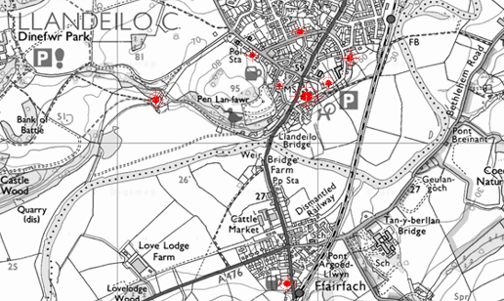

Figure 2: Map of Llans within Llandeilo (credit: Digi maps and Ellie Jones)

Table of contents:
Contents | Page
Acknowledgements | 2
Abstract | 3
List of Illustrations | 5
Authors declaration | 6
Introduction | 7
Methodology | 10
Argument/ discussion:  Historical overview | 12
Chapter 1: External factors that  influence the use of the ‘Llan.’ In the 21st century | 13
Chapter 2: Best practice and lessons learnt. - How the Llans are used within Llandeilo. | 16
Chapter 3: Case studies and comparisons to Llans in Llandeilo | 17
Questionnaire | 26
Questionnaire findings | 27
Questionnaire analysis | 36
Conclusion | 37
The way forward | 38
Limitations | 38
Bibliography | 39
Appendix A | 45
Appendix B | 48

List of illustrations:

Illustrations | Page
Figure 1: Exterior view of St.Teilos Church. | 1
Figure 2: Map of Llans within Llandeilo. | 3
Figure 3: Locations of Llans within llandeilo. | 7
Figure 4: Cross-section reconstruction of the church from the 15th / 16th centuries | 12
Figure 5: Graph showing religious identities. | 13
Figure 6: The New Room Bristol, John Wesley’s Chapel. | 17
Figure 7: John and Charles Wesley, the founding figures in Methodism. | 18
Figure 8: Front view of horeb wesleyan Chapel. | 20
Figure 9: View of Brunswick Methodist church, St. Johns. | 21
Figure 10: Public Hall and Literary Institute | 23
Figure 11: All Saints Church, Hereford. | 24
Figure 12: View of Capel Newydd Congregation Chapel, Llandeilo. | 25
Figure 13: Chart made to show the results taken from the questionnaire. | 29

Introduction:
A Llan is a Religious enclosure/ settlement and the ground surrounding it, EG. the town village around the enclosure.
Llandeilo has been selected as the centre of this study as it contains many Llans, it is a perfect location to have access to for research during the pandemic and it’s a good size to evaluate with the time given. In order to research this topic and have some control over the size of space used. A geographical boundary was set, this being the map as follows. The map also contains the location of each Llan.
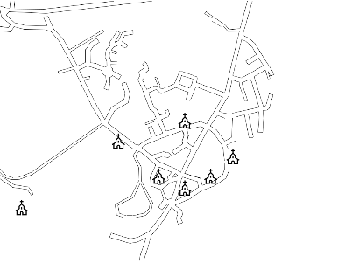

Figure 3: Locations of Llans within llandeilo (Credit:Ellie Jones)

Literature review:
This dissertation aims to understand the perceptions of the importance of conserving our Llans and understand the significance of a Llan within the 21st Century in Llandeilo. The comparison of literature, published opinions, reports and statistic.
Despite the Strong belief of architects and conservation member to maintain, protect and conserve our historical figures, many religious enclosures get neglected by both the public and professionals. Gruff Owen and Neil Sumner both stated in the article’ saving places of worship in wales’ on building conservation.com that:
‘There is continuing concern in Wales about the number of religious buildings that are falling into disrepair, have become redundant, and are being lost through demolition or insensitive conversion’ (Cathedral Communications Limited 2019)
Gruff own and Neil Sumner have both recognized that there are concerns, particularly expressed about the fate of the architecture of wales.

Laws and legislations
Section 16 of National Planning Policy Framework underlines the knowledge and legal characters behind ‘conserving and enhancing historic environment’ (SPAB 2017) this highlights that any harm to listed buildings or loss of heritage assets would not be given consent, unless demonstrations of the high risks are necessary.
The law also states any harm or loss to conserved buildings will be outweigh by the benefit of bringing the conservation area, or site back into use.

Llans
Llans; defined as ‘It means “Church” – or, rather, the enclosed land around the church where Christian converts had settled – and, as far as town or church names are concerned, is often combined with the name of an individual.’ (BBC Wales 2015) would suggest that the chosen site Llandilo is or was once an extremely religious town and that the buildings within the town hold a strong welsh heritage with many Llans and historic wonders.

Aims and objectives:
I will congregate my data by using a series of interviews and questionnaires on welsh citizens that have a strong welsh heritage. I will aim my research at an audience of…

Aims
- To understand the significance of a ‘Llan’ within Llandeilo in the 21st century, and how does this enclosure influence the activities of the structures contained within it.

Objectives
- Establish current conservation officers in Llandeilo and what their responsibilities are for the protection of the historic built environment.

- Issue a structured questionnaire to locals, members, the built heritage team, and local council.

- Review current literature, legislation, news, and media regarding Llandeilo local Llans and what the structures contain now.

Limitations:
I have taken under advisement that this is a broad topic and therefor may be limited to discuss certain issues due to a work count, I have also taken into consideration that my research would have to be spread out of a period of time in order to gather from parts of wales further afield, this will slow the development of my research if not thought of in account. many llans will now be in ruin or not written about I will struggle to find reliable sources of information this will limit my research to Llans of ‘importance’ in welsh history.

Ethical considerations
During my research I need to consider ethics, as welsh citizens might have been born here but don’t hold a strong welsh heritage or understanding of its history, I will also need to consider the lack of knowledge on local Llans as the opinions on the history could vary.

Methodology

The methods of gathering research during this piece of work are varied, from fieldwork surveys to government statistics and documents found in online articles and library resources. All aspects of these methods to collect the research have been chosen in order to assemble a variety of data.

Documentary resources
Resources such as online articles, documents and websites will be a huge part of gathering the research, due to COVID-19 restrictions no buildings will be accessible. Pre COVID-19 brochures, information booklets and leaflets were collected on history within wales, the Llans and information upon Llandeilo. These leaflets although hold little data will give knowledge to find further information upon the topics within them.

Fieldwork survey
Fieldwork surveys will be carried out with a series of questions sent out via google documents, alongside face-to-face interviews (held via Microsoft teams due to the pandemic) and interviews via emails with a series of questions to answer.

Government
Government resources such as CADW will be used, these will help gain a better understanding of the Llans, if they are listed and give reliable statistics to be used in my data. This allows me to look further into the buildings, with reliable data and dates and allows a better understanding of the listed buildings, the upkeep on the buildings and the sole reason they have been chosen as grade buildings.

Library resources
Due to COVID-19 restrictions and the current lockdown, library resources have been limited to online resources, therefore much of the resources I needed I was unable to access, however online some books were available and online lectures from the university librarian in accessing these pages were a significant part of gathering the research for the question.

Key players
As primary research for this dissertation the key players there were liaised with were member of the councils-built heritage team. Their knowledge has contributed to the study by allowing for the shared knowledge of understanding and expanding upon the importance of their roles, giving access to further information regarding the topic and sharing knowledge of their own.
- Nell Hellier - the Senior Built Heritage Officer at Carmarthenshire County Council and have been working in traditional building conservation at the Tywi Centre since 2008
- James Yeandle - the Heritage Skills and Projects Officer, she is able to work with people that share her passion for conserving old buildings to access the training and education they need.
- Tom Duxbury - Built Heritage Officer for Carmarthenshire County Council with responsibility for the protection of the historic built environment including 1,950 listed buildings and 27 conservation areas.
- Helena Burke - working as Conservation Officer for the Brecon Beacons National Park

Argument / Discussion:
Historical overview Of Llandeilo

Llandeilo is a small town in Carmarthenshire, home to approximately 2000 members of the community. The town is situated in the Vale of Towy and is one of the most beautiful valleys within wales.

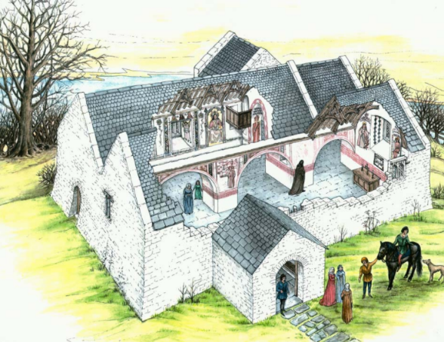
Figure 4: Cross-section reconstruction of the church from the 15th / 16th centuries
(credit: https://medievalheritage.eu/)

The original churches of Llandeilo consisted of St Teilos church, in Llandeilo, Tal-Y-Bont. The original church had been built in the 12th -13th century. Up until 1850’s the church was in regular use. The church’s use decreased to just summer months and eventually was abandoned in 1970’s. Eventually the original church of Llandeilo was dismantled and transferred to St Fagan’s and can be viewed upon their grounds today in the open-air museum.

Chapter 1:
External factors that influence the use of the ‘Llan’ In the 21st century

Parliament
Not only in Llandeilo but across the Uk, Cultural and Environmental factors impact the use of Llans within Llandeilo. In this current age parliament has had a huge role to play on the lives of people and have had a huge impact on the religious aspects.

cultural and environmental
An important aspect of the influence of the use of churches and chapels is the Religious Diversity. The use of Llans started to suffer in the 20th century when worshipers of the church started to decline across Britain. The British society started to become more materialistic and liberal.

Over the last couple of decades, it has been calculated that there has been dramatic decline within people and their religious identities. Christian Faiths have been dramatically declining and those of not Christian faiths and atheism (no religion0 has slowly been increasing.
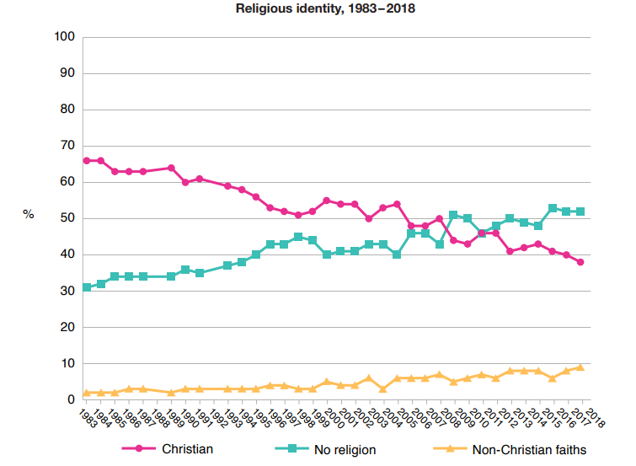

Figure5: Graph showing Religious Identities (credit: The National Centre for Social Research)

Most members of the public reportedly ‘have little time for religion but are prepared to tolerate it’

Community Involvement
Churches are increasingly becoming a multipurpose space for activities and a multipurpose use community building.
Churches now host various activities including scouts, play group for mothers and children, women’s and men’s institutes, drop-in centres, choirs, coffee mornings and due to the pandemic, some have even opened their doors to become test sites and surgeries.
Many churches in and around Llandeilo also provide their services to schools to use as a place to perform Christmas concerts, to give educational visits and to set up charity events such as food banks and money raising with cake stalls.

Grant System
The purpose of a grant is to assist in repairing, maintaining upkeep and conserving the buildings. Grants to assist religious enclosures and listed buildings, along with any building holding several historic artifacts or heritage.
The funding for all the schemes is funded by CADW. CADW is the meaning for preserving in the welsh language. The CADW group work for the government as a team that specialise in historic environmental services to help protect the historic building and the environments within wales. They help maintain facilities that are preserved or important as a communal space to bring people together. Granting is not eligible for new builds and services.
The grant system is to allow a future for historic buildings, to prevent aged buildings become neglected and left to decay.
The grants are determined by the significance of the buildings, there are four areas in which an historic building can be placed under in which has value, these areas being:
-Evidential value: Historical landmarks or sites that can provide evidence of previous human habitancy or activity with historic objects can be supported in this case.
-Historical value: Historical value can cover main categories, how well the building is preserved is a main one, does the buildings architecture show the year it was built? Does it have a story and how can the building be preserved and maintained to carry on the story without causing damage or any disrepair to the original architecture. The historic value can also be its significance to the space, the national significance of the building and the regional significance.
-Aesthetic value: The aesthetic value if the façade of the building if the appearance or the form of the building holds a relationship with its surrounding or settings. If the design style is conscious to its surroundings or if the composition of the architecture and the materials along with the interior design are all part of thew aesthetic appeal.
-Communal value: The economic or social value of an asset to the community. This can also include the spiritual or commemorative value of a place from the people who relate and use the space.

The relationship between planning restrictions and Listed Buildings
There are restrictions in place in planning on listed buildings and religious buildings, this can be because of the significance of the building, the heritage, or the architecture.
National amenity societies, there are statutory consultees and advise people and planning authorities on planning proposals, there proposals could be affecting historic landmarks, buildings or even just historic land.

The Superannuation and other Trust Funds
The legislation Act in which provides funds has been founded since 1927. The Act is to respect trust funds and national funds in order to reduce the National Debt. (Appendix A)

Chapter 2:
Best practice and lessons learnt - How the Llans are used in Llandeilo

Llandeilo is home to many churches, some are still active places of worship, other have been renovated into dwellings, community centres and town halls, schools, and youth group centres.

St Teilos church- St Teilos church is still an active church and the larges church with the most attendees within Llandeilo. The church also accommodated for other social activities outside of prayer times including coffee mornings, charity events, religious teachings to students and the women’s institute group.

Public Hall and literary institute- What once was a chapel became a literary institute, however once the building was no longer needed the use changed, now the use for this building is a growing and successful snooker club, renovations were simple and most of the original architecture still remains.

Horeb Wesleyan Chapel- The former Wesleyan chapel with its Doric columns and porch is no longer used as an active place of worship but instead has been renovated into use for dwellings.

Wesleyan Methodist chapel- this church has now been refurbished into houses however it still has the astatic of the original church with the octagonal tower with a ‘candle sniffer roof’ to the side.

St David’s Catholic Church- the small catholic church is located across from Llandeilo fire station and is still in use today.

Capel Newydd- Capel Newydd is an independent chapel. The style of the building is in the gothic style and was designed by Henry Herbert an architect from Ammanford. The buildings materials are constructed from stand stone and ashlar.

Chapter 3
Case studies and comparisons to Llans within Llandeilo.

Case study 1
John Wesley New Rooms, Bristol, refurbishment into a community centre and museum by Purcell, 2017.

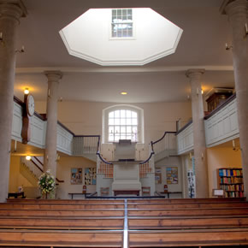

Figure 6: The New Room Bristol, John Wesley’s Chapel (credit: newroombristol.org)

History:
Who are the Wesley brothers?
Both brothers educated at oxford university and formed the ‘holy club’ amongst their fellow peer in 1729.

John Wesley was the Methodist founder; he was a leader of the revival movement within the church of England. Wesley’s main development was to travel to preach outdoors amongst the public. Wesley was known as a Methodist leader of which he took charge of attempting to abolish many social issues of his day, these included the prison reform and the abolition of slavery.

Charles Wesley was the younger brother of John. Charles is known for his hymns; 6500 hymns were written by Charles Wesley. Charles was also an English leader of the Methodist movement; the two brothers were partner of which travelled to convert the Methodist revival through johns preaching and Charles’ singing and hymns.

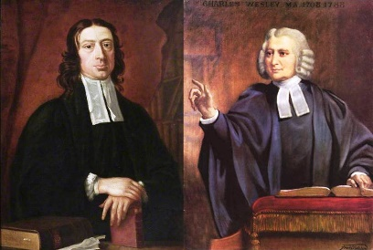

Figure 7: John and Charles Wesley, the founding figures in Methodism (credit: Patrick Comerford)

The New Rooms.
The currently John Wesley building dates from 1748 when the new rooms were doubled in size that is when it got the name John Wesley’s Chapel. The building was built for preaching. in 1739 the miners of Bristol were preached too for the first time by John Wesley this even took place outdoors and John was invited by George Whitefield.

George Whitefield Was an extremely high respected figure within the eighteenth century. Whitefield was a preacher, his words empowered people as the words he spoke with emotion that appealed to all his listeners.

Back in the 1740’s John Wesley created twelve rooms upon the first floor of his building, there were to accommodate himself, and any fellow preachers that were assigned to the Bristol circuit. The new rooms were then built as a meeting space for two of the religious societies. This was the world’s first Methodist building to be created.

The building was used for the poor to be educated, to provide food and clothes for the needy, for the sick to have some medical assistance, and for helping the prisoners in nearby prisons. The building was also first to use the class system of John Wesley’s.

What is the class system?
The class system was for the development and support of those they preached and educated. Members would be divided into sub-groups.

Many famous names that are well known today committed themselves to working at the new rooms, some of these names being: Thomas Webb and Francis Aubrey. The annual conference that created the first Methodist circuit was held within the new rooms along with many more conferences. The new rooms became a launching pad for John Wesley in 1786 when he used it to set off his anti-slavery campaign in which he ordained many preachers to become clergy in America, these preachers were obtained from Bristol.

The ‘green oasis’ in the heart of the city is the Broadmead courtyard on the front façade of the John Wesley new rooms. The courtyard also contains Wesley’s stables and is home to the famous world-wide statue of Wesley on horseback.

Due to many attacks by vandals during the early Methodist revival the ground floor of the building lacked in windows. The lack of windows was a precaution taken against any attacks; the design was to prevent any attackers reaching the preacher.

Development/what the building is now:
The building is used for worship, along with being used for educational and cultural activities, along with exhibitions. The new rooms are to this day known as ‘The cradle of methodism.’

The lower floor of the building is known as the john Wesley chapel and is still in regular use as a place of worship. It is used for other activities including educational purposes, exhibitions and a community hall.

The second floor is now no longer used as sleeping chamber but instead holds the museum of John Wesley’s new rooms. It holds an interactive museum devoted to sharing the story of the Wesley family, their life, the work they achieved and the relevance of today.

In 2017 the old Horsefair Courtyard welcomed a new visitor centre which had also homes an iconic statue of Charles Wesley to its entrance.

The chapel you visit today would have been the same chapel the Wesley brothers seen in 1748, however there has been a singular refurbishment to the appearance of the build, this being the central block of pews.

Comparison to a Llan within Llandeilo:

Horeb Wesleyan Chapel

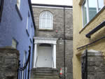

Figure 8: Front view of horeb wesleyan chapel (credit: Llandeilo.org)

The former Horeb chapel was built in 1810. The building was discontinued as a used chapel in 1900 when a new building was constructed.

For several years the building was still used for storage by surrounding Llans and temporarily used as a place of worship by members of the tabernacle until its closure.

Just like the new rooms the Horeb chapel has been converted from a place of worship, The building is now no longer used as a chapel and has been converted into a two-storey private dwelling, the conversion started in the early 1990’s.

Similar to John Wesley’s famous statue in the new rooms the Doric columns are retained as a positive feature linked to the previous use of the building.

Both chapels have undergone serious renovation and hosts very different activities now, however they compare o one another are the traditional element to each building have been kept for the aesthetic.

Case study 2:
Brunswick Methodist Church. Newcastle-upon-Tyne, Tyne and Wear

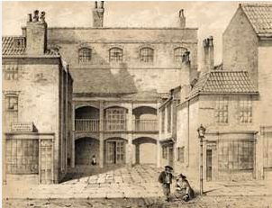

Figure 9: Brunswick Methodist Church. Newcastle-upon-Tyne (credit: Newcastle upon Tyne District Archives)

History:
The First Methodist society was formed in Newcastle after they received a visit from John Wesley in 1742. Brunswick Methodist was known as the orphan house. The original intent of the church for the Methodist chapel was to be used as a home and school place for orphans alongside being a religious enclosure, however this never took place.

A larger chapel was intended in the early 19th century and building started on the new site in Brunswick place in 1820.

Brunswick Methodist chapel is located in Newcastle. The Methodist church is on the national heritage church of England and is also a grade II listed building. The chapels new build started in 1820, with the new stone foundations being laid on the 5th of May. Once the chapels completion it was used greatly for meetings held upon abolition of slavery. The campaigns took place between 1820’s to 1830’s.

The church opened in 1821 and was designed by William Jenkins of who was born in 1763 and died in 1844. Mr William Jenkins was a Wesleyan minister and architect. Brunswick Methodist chapel underwent a major refurbishment in 1981. The Methodist church is a fine example of early 19th century Wesleyan architecture.

Brunswick Methodist church was the mother church of Methodist in north east England and succeeded in the orphan house. Eventually the orphan house has deteriorated, and the site was put up for sale in the mid-19th century. However, the orphan house was unable to make a sale and therefore was demolished.

In 1850’s a new building was built upon the demolished grounds of the orphan house, this building was also used as a school for both everyday educational purposes and Sunday schools.

The orphan house remained in use as just a Sunday school however all services moved over to the New Brunswick place chapel. Anti-slavery meetings were also held in the new Methodist church building

Development/what the building is now:
In 1981 the Methodist church underwent an extreme refurbishment allowing flooring to be placed for the upper gallery creating a first-floor place of worship.
The Wesley room within the building is home to the orphan house memorabilia, several paintings, and portraits.

The ground floor has been refurbished and is now used for used for diverse community activities, these activities include a place to host the children society and a listening post. The building also now hosts a coffee shop in the foyer.

The Methodist church is now home to a collection of paintings, engravings, and memorabilia. Some of the paintings and engravings have been dated back to the time of the Wesley brothers, John, and Charles Wesley. The rooms are now used for educational purposed and host presentations on appointment given by church staff.

The new interior design for the church was to integrate an extended area to allow both a place for worships, a place for sanctuary and a range of communal activities.
The design was intended to create a ‘front of house’ an inviting place for both worshipers and the community to meet off the streets and have a coffee.

The foyer space was redesigned to provide a place for the community to be able to engage with one another, which also allowed a flexible, modern space which would appeal to all the community, and please the large variety of people that used the building.

The Materials were changed within the building’s interior, modern lighting was placed, and they carefully integrated some transparent materials into the décor with some historical features to show respect to the heritage of the build and the site.

Comparison to a Llan within Llandeilo:

Public Hall and Literary Institute, Rhosmaen Street

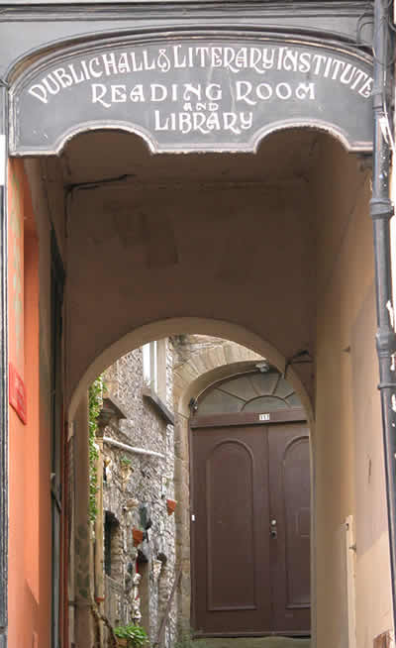

Figure 10: Public Hall and Literary Institute (credit: Llandeilo.org)

The public hall and literary institute were previously a Methodist chapel and has been remodelled internally from the chapel into the institute.

The original building was the oldest Calvinistic Methodist chapel within Llandeilo. The chapel was originally built in 1788 and used for many activities of which benefitted the community. These include:
- literary institute
- library
- youth club
- old age pensioner activities
- Women’s Institute
- market
The current use of the building is no longer a literary institute, the building is currently owned by a charitable trust and is being used as a communal snooker club.

The current plans for the building are to re renovate the old church so it can become a museum and local heritage centre in the heart of Llandeilo.

Both the original Calvinistic church of Llandeilo and Brunswick Methodist church still hold significance within the use of the buildings. Neither buildings are currently used as an active place of worship, however both buildings are now used for diverse community activities and hold significance to their community.

Case study 3:
All Saints Church, Hereford, refurbishment into a café by RRA Architects, 1997.
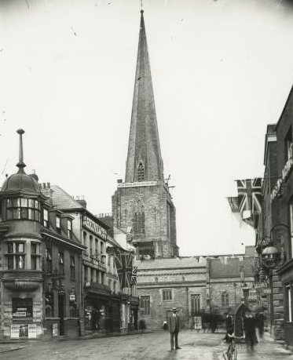

Figure 11: All saints church, Hereford (credit: David Ross and Britain Express)

History:
All saints church, a building of which is over 800 years old. All saints church is a small Parish church of which is part of the church of England. The original building of all saints Dating from 1200AD was damaged by an earthquake and does not stand long.

In 1330AD a new church building had been built and completed, this is the all saint church that stands before us today. As the result of great age the spire is twisted, the spire twisted immediately after being erected, this was caused by the land the church was built upon, the foundations of the tower were built upon a pit of rubbish and manmade ground that could not hold the weight.

In 1996 the church closed, and a restoration project took place as age and decay took over the building. The restoration not only restored the church but transformed it. The building is now used as a community venue with multiple purposes.

Development/what the building is now:
The South Chapel in all saints’ church has been used for many occasions, these include:
-Dinners
-Displays,
-Sales,
-Meetings
-Office lunches

In the 1990’s a project began for restoration and repairs upon the church. All saints Parish church then reopened in 1997 and now has around three thousand visitors attend the chapel a week.

After the renovation project in 1996 and the building becoming a community venue with multiple purposes the building now contains a community centre and a lovely café occupying the interior space.

Comparison to a Llan within Llandeilo:
Capel Newydd Llandeilo
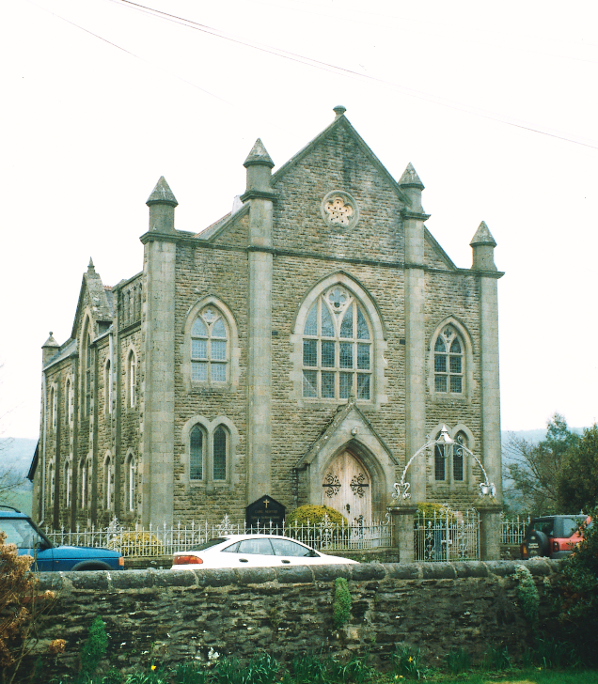
Figure 12: View of Capel Newydd Congregation Chapel, Llandeilo (Credit: Robert Scourfield, 1995)

Capel Newydd are an independent chapel based in Llandeilo, construction on the chapel started in 1901 and completed in 1902. The style of the building is in the gothic style and was designed by Henry Herbert an architect from Ammanford. The buildings materials are constructed from stand stone and ashlar.
Today Capel Newydd is used for local school theatre productions, to hold stalls within the local festivals and fayres of Llandeilo (Festival of senses) and hold communal groups such as play groups, nursery’s, and women’s institutes.
Both buildings have now been renovated into community centers and hold a significance still in their communities to entertain people, although neither churches are used for religious purposes anymore their significance has not decreased just altered in purpose.

Questionnaire:

This questionnaire located in Appendix B consists of 13 questions ranging from discussing their job title and their age range to encouraging their expression of their personal opinions on the conservation of Llans within Llandeilo.

Example1: Following historical knowledge: State the name of the religious enclosure. What type of religious enclosure is it? The year it was built. Is it a listed building, if so what Grade? Is the building well maintained, or is it neglected?

Example 2: In what age range are you?
Under 18
19-30
31-45
46-65
66-80
0ver 81

The examples above allowed for data to be gathered on figures along with suggestions and informal opinions. These were then analysed alongside data found in books and online from sources mentioned throughout this document. By analysing this data and extracting the key information it will allow a better insight into the understanding of conservation in our historic Llans of Llandeilo.

Questionnaire:
Overview:
Several techniques were used and approached to gather data for comparison against the literature review. A questionnaire was sent out via email to tradesmen, heritage officers and local members of Llandeilo. The participants that were chosen were found via the gov.uk websites, the built heritage teams’ websites and being a member of Llandeilo and using connections into Llandeilo council emails were distributed to members of the town.

Approach:
The questionnaire was sent through email in an attached google forms document, the informal way of sending the questionnaire allowed those responding to approach questions as they wished, giving me heavily opinionated responses, and knowledge for further research.

Affecting the data is the response rate, with only a 50% response rate at 25/50 respondents.

The email sent assured the participants that any personal data given would not be shared and email addresses were only asked for in case any extra data was needed after the respondents completed their questionnaire. Through requestion the read receipt response after creating the questionnaire and receiving emails back in response, the data collected is as follows:

- 6 chosen respondents failed to respond due to on holiday leave, via an automated email.
- 1 chosen respondent failed to respond due to sickness leave, via an automated email.
- 10 acknowledged that they had received the email.
- 2 gave further information via email after completing the questionnaire and offered extra resources and guidance.

Low response rates and the possibilities behind them:

- The requests to complete the questionnaires were sent out during the Christmas period, meaning many people were on holiday leave.
- Many of the locals might be picking up extra shifts to survive the harsh COVID-19 times and therefor may not have had the time to respond more complete the questionnaire.

Semi structured interview:
Initially some research was to be collected by a personal interview on each Llan, unfortunately due to COVID-19 circumstances only one personal interview was conducted with the groundskeeper of Llandyfeisant church. After a very productive email of which several bits of data were gathered, the interview technique had proven to be too time consuming, taking 50 minutes via a Microsoft Teams call.

Findings
The questionnaire was sent to several architects, conservation officers, welsh historical officers and the general public around Llandeilo. All participants were of different ethnic backgrounds, different religions and different stages in their career and ages. It was essential to discover the knowledge and opinions from multiple background of those whom both attend and do not attend the buildings. It is also important to get a professional perspective on it as a public opinion of someone who sees the building for its aesthetic and not the historic or ethnical reasons.

Question 1
Data analysed revealed that a wide range of people of whom completed the questionnaire were employed (56%). The data gathered shows a significantly low number of retired participants and responses from unemployed participants. Little to no responses from retired participants were expected due to coronavirus and the questionnaire taken online.

Results:

Question responses | Percentage of responses | Number of responses
Employed | 56% | 14
Self employed | 12% | 3
retired | 0% | 0
Not working | 8% | 2
student | 24% | 6
other | 0% | 0

Many of the participants for the questionnaire are employed, this is expected as participants were found through the built heritage team, Carmarthenshire County Council teams and local tradesmen. No retired participants responded to the survey, this could be due to the questionnaire being shared on and online platform due to coronavirus. As technology has evolved and many retired members are not up to date with, the newest platforms and technology it is possible they were not able to gain access to the questionnaire.

Question 2
The second question aimed to understand the professions of those completing the questionnaire, this would help to understand the responses of those with knowledge of historic buildings and conservation of Llans to those such as students of whom probably don’t attend nore understand the meaning of a Llan.

The diagram below shows the data analysed from question 2.
Results:
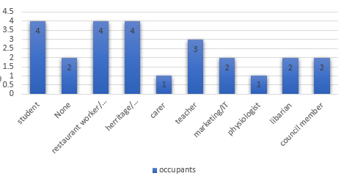
Figure 13: Chart made to show the results taken from the questionnaire (credit: Ellie jones)

As calculated in 2011 Llandeilo is home to a population of 1,795. The data gathered suggests the majority of the Llandeilo population either work in local cafes or attend local schools and colleges. The higher number of heritage officers on the work chart were predicted due to heritage officers being particular chosen for their knowledge on the local preservation of the buildings.

Question 3
Question three was to understand the ages completing the questionnaire, this would help understand the age groups in which have more knowledge on Llans.

Responses:

Age ranges | Percentage of responses | Number of responses
Under 18 | 8% | 2
19-30 | 36% | 9
31-45 | 28% | 7
45-65 | 24% | 6
66-80 | 4% | 1
Over81 | 0% | 0

The outcome on question three was expected from the previous respondence, as no respondence were retired on previous questions the ages with a 0% response rate for over 81 was expected.

Question 4
For question four participants were asked if they were aware of and Llans within Llandeilo.
Results:

Responses to question | Percentage of responses | Number of responses
Yes | 72% | 18
No | 16% | 4
Not sure | 12% | 3

Respondents knowledge was surprising due to all chosen members to complete the questionnaire were either from the local area or had a strong understanding of the area due to them being heritage officers and the local council members.

The results show that 72% of respondence were aware of local Llans. All three participants that voted no answered no to attending religious enclosures also.

As stated at the top of the questionnaire the definition of a Llan
‘A Llan is defined as a religious enclosure/ place and may contain a religious building, such as a church/ chapel within its site.’
The respondence answer to this question and previous questions suggests the respondent did not take the questionnaire seriously, therefor did not read the questions properly affecting the data gathered.

Question 5
The question stated for participants to answer if they attended a religious enclosure or not and if the question was no and not applicable to skip to question 12.

Results:

Responses to question | Percentage of responses | Number of responses
Yes | 20% | 5
No | 80% | 20

The data gathered shows that only 20% of the participants that took part in the survey attended a religious enclosure, this question was important as it shows how much of a religious perspective is placed on the importance of the upkeep of religious buildings.

Question 6
The aim of question 6 was to get an understanding of the number of attendees there are within Llans in Llandeilo.

This question was an open field response where participants could explain how many members attended their religious enclosure. Although the answers were helpful in the gathering of data for attendees the disadvantage of participants only including the data during covid effected the data being fully accurate and reliable.

Responses:

‘30 Precovid’
‘None at the moment’
‘6’
‘N/A’
‘15’
‘Depends on what is on, children’s service or zoom about 30-40’

The responses show that participants did not fully understand the question and that the data being collected was general data and not data during the pandemic. Responses collected mainly included ‘Not applicable’ and ‘none at the moment’.

Participants also failed to notice the ‘if not applicable please skip to question 12’ at the end of question. Due to the participants not fully reading the question many responses for questions 6-12 included many ‘Not applicable ‘answers, which affected the gathering of reliable data.

Question 7
The question was an open response question which allowed participants to write the religious building they attended, the question was not placed as a multiple choice to prevent any religious enclosures not being included and respondence answering as other.
Responses:
Responses to question | Percentage of responses | Number of responses
Chapel | 12% | 3
Church | 12% | 3
N/A | 4% | 1

The data shows that 6 of the 25 participants that completed the questionnaire attended a church or chapel. The not applicable respondent as previously mentioned just shows the responded did not fully read the previous question and therefor will affect question 6-12.

Question 8
Participants were asked to explain the religious enclosure and the name it was referred, for example St. Teilos church in the heart of Llandeilo was named after Teilo the Saint of Llandeilo Fawr.

Responses:
‘Chapel’
‘Llandeilo Church’
‘Capel Seion’--
‘N/A’

The responses show that the respondents just referred to the names of their buildings and not the historic background behind in which the buildings retrieved their names.

Question 9
Question nine was to develop an understanding of the buildings the respondence attended and time taken to tend to the care and upkeep of the buildings.

Results:
Responses to question | Percentage of responses | Number of responses
Yes | 68% | 17
No | 32% | 8

Respondence who responded with ‘yes’ attached comments such as ‘It is well maintained, but upkeep costs are soaring.’

Question 10
The question was intended to directly target the upkeep and care of the Llans to get an understanding on the maintenance of the buildings and if the participants thought their religious settlements were well maintained.
Results:

Responses to question | Percentage of responses | Number of responses
Yes | 56% | 14
No | 0% | 0
Don’t know | 44% | 11

Question 11
Aimed at the members that attend religious enclosures they were asked to specify on their particular Llan. To gain an understanding it was asked if their religious enclosure needed more care and help to maintain the buildings architecture or if it is just the Llans not in use.

A perfect example is Llandyfeisant church, a small church neglected with little maintenance, the church is no longer in use due to the unstable conditions and has very little grants relying on the local community to maintain the grounds and protect the loss of the heritage of the building. The original tower of the small church has been removed and placed on St. Teilos church of which is the centre of Llandeilo. Research shows the parish church of St Teilo uses most the upkeep within Llandeilo leaving other religious enclosures in and around Llandeilo falling into dis-repair.

Results:

Responses to question | Percentage of responses | Number of responses
Yes | 57.1% | 14
No | 28.6% | 7
Don’t know | 14.3% | 4

Of the 25 replies 14 of the provided participants stated that the local Llans are neglected and needs care and attention. This suggests to me that Llans aren’t being given the care and attention that they once got.

As previously stated, local grants and funds are not as easy to allocate, nor are they as simple to apply for. Grants and funds are an extremely key factor in
maintaining the heritage of Llandeilo and the maintenance of the local Llans.

Question 12
To get an understanding of religious buildings and the publics option on the risk of the religious enclosures this question was asked.
‘Do you think religious buildings are at risk?’

Results:

Responses to question | Percentage of responses | Number of responses
Yes | 84% | 21
No | 16% | 4

The results to this question show that most the public members agree that the religious buildings are at risk, this could be astatically or within the upkeep of the grounds. The socking number of responses to the lack of well-maintained Llans within Llandeilo suggests that these facts are due to lack of financial support to the religious buildings in the area. When compared to other data is is clear to see that unless the churches are being developed into multi use buildings like the previous case studies the Llans are left to fall into disrepair.

Question 13
As an opportunity to gather a wider knowledge and understanding of the local welsh Llans and Llandeilo heritage a question was given to participants asking about local welsh heritage and knowledge of any local Llans within Llandeilo.

Results:

Responses to question | Percentage of responses | Number of responses
Yes | 20% | 5
No | 80% | 20

Question 13a:
Question 13 requested people to share the knowledge they had on the Llans in Llandeilo. The responses were analysed many responses of which were invalid giving answers like ‘don’t know’ and ‘I’m not so sure but it’s most likely a listed building.’

The respondence wear asked:
‘Following historical knowledge: State the name of the religious enclosure. What type of religious enclosure is it? The year it was built. Is it a listed building, if so what Grade? Is the building well maintained, or is it neglected?’

Responses:

Respondent 18: ‘At Teilos church, part of the church of wales. Grade 1 listed and is well maintained.’

Respondent 8: ‘Church St Teilo’s Church grade 2 listed.’

Respondent 12: ‘Church within centre of Llandeilo. (St Teilo) I believe it dates to 1850s, and unsure what grade of listing it is, but it’s definitely a listed/protected building. Whilst not a Llan, the tabernacle within Ffairfach Llandeilo also has historical importance and I believe is listed building.’

Respondent 22: ‘St Teilo Church [the reason Llandeilo was called = Church of St Teilo] dates back 5th C rebuild in Victorian Times. there are various chapels around Llandeilo dating back to 1820 onwards and the growth of non-conformist movement St Teilo Respondent 17 ‘Church is Grade1 listed and is within the conservation zone of Llandeilo. St Teilo needs funding to repair and adapt the building.’

Respondent 10: ‘St Teilo’s Church, sixth century. It is listed. It is well maintained, but upkeep costs are soaring.’

Respondent 6: ‘I do not attend any churches but even I can see the importance of maintaining them, St Teilos in the heart of Llandeilo is what ,makes Llandeilo and it needs to be kept in good condition as that is what the town is names after.’

Respondent 12 shared some knowledge to their understanding of local Llans, sharing the dates and their understanding of the building being listed. Many other respondence specified their understanding of local Llans being listed and the maintenance upkeep costs of the buildings being costly.

Questionnaire analysis:
From analysing the data, observations can be made suggesting that there is a significant use of Llans not only for religious purposes but activities. Many expressed how they believed from the aesthetic of the local Llandeilo Llans that buildings are being neglected and need maintenance to maintain the historical context and the heritage the Llans have to the town.

From the results:
Recipients that completed the questionnaire were chosen as they’re one or more of the following categories:
-They are from or around the Llandeilo area.
-They are from a preservation or historical knowledge background and/or work in the field.
-The participants taking the questionnaire showed an overwhelming amount of lack to the attendance of the religious enclosures but despite the lack of attendance within the building the understanding of the importance of conserving the buildings maintained strong and very opinionated.
When analysing the results from the age groups, most of the ages 18-30 expressed that they did not attend the religious enclosures but still expressed they feel that the preservation and the maintenance upkeep for these buildings are still important. This shows that members of the public that don’t use the building still feel they should be maintained for the aesthetic, to maintain such grand buildings in the heart of the towns is to maintain the spirit of the town.
Almost all respondents stated and expressed their concern for the lack of maintenance to the local Llans, although most participants did not attend nor show much knowledge on the topic it was clearly stated that the concern for local Llans and the loss of welsh heritage was strong.

Conclusion
The research carried out and the results analysed from this data suggests that the significance of llans in the 21st century is not that of the 1700’s. In accordance to the data show Llans are now used more of a symbol, they symbolize this history of the towns. 21st century Llans are now used for multipurpose buildings, to educate children, to host community groups and projects and help the local youths by forming clubs and reducing the number of youths around the streets. As previously stated, although most Llans are no longer used for religious purposes anymore their significance has not decreased just altered in purpose. A significance of a Llan has not changed just the way we use them has, Llans within the 21st century hold just as much purpose and even more activities, catering for the whole community and not just those who are religious.
The research has shown that Llans are still significant within the 21st century, they’re significant to the users of which attend youth groups, and the elderly of whom attend the women’s institutes and mothers who attend coffee morning, The buildings are if not now more significant than they were before, although they’re not used as Llans, they’re used for far more purposes and are respected as local historical landmarks by their community.
The current system of the built heritage team and officers has worked well for most areas, however more funding is needed to help maintain the upkeep before anymore Llans fall into disrepair. Current advertisement for the importance of our historic buildings s not strongly supported and needs to be advertised on a greater scale to allow the public to gain a greater knowledge and wider perspective of the significance of the Llans and the heritage they hold.
Almost all the participants of the survey felt that The role of a Llan in the 21st century is extremely important, some emphasized the importance a Llan is for the Llandeilo history, whereas others emphasized their concerns for the lack of maintenance and the loss of the buildings in the future.
The enclosure influences the activities contained within it as the building are seen as a place of peace, a place of respect and forgiveness. All activities that take place within the religious enclosures are that of pure acts. The activities are to benefit people, provide a safe space and bring the community together.
Participants 6’s response to the questionnaire shows the significance of Llans today from the perspective of a member of the community that doesn’t use the enclosures space.

Respondent 6: ‘I do not attend any churches but even I can see the importance of maintaining them, St Teilos in the heart of Llandeilo is what ,makes Llandeilo and it needs to be kept in good condition as that is what the town is names after.’

This data suggests that a Llans definition of significance in the 21st century has changed, the importance of the llans now are preventing them from going into disrepair out of respect for the local community, their heritage, and the historical context each building has.

The Research has shown that restoration projects aren’t supported enough. Many projects are funded by charities or most funds only allow charities to apply, this has been referred to under the legislations and funds sections on page 12. After looking into other restoration projects, it has been noticed that Allchurches Trust are the amin support system for helping renovate and maintain llans. Buildings are at risk as there are little funds given out like the Allchurches trust to support small local churches falling into disrepair. There are limited funds, many funds can only be funded to certain areas, many have terms and conditions. What is needed for help with funds and grants in the 21st century?
‘All applicants need to be a UK registered charity, church or have “exempt” status.’
Many grants and bursaries in the 21st century as not as simple to obtain, affecting the buildings as not enough evidence can be filed to save our heritage.

The way forward
Just like all churches trust, larger churches that do not suffer with the upkeep of the buildings, and larger practices could offer funding to help maintain local heritage. Much like insurance that is offered by large co operations those who pay into maintain the upkeep of these buildings would receive the benefits. By cooperation’s such as large architect firms, or well of churches such as the church of England making monthly payments to small town churches to help maintain the upkeep will allow all churches to be preserved and prevent as many beautiful buildings with strong heritage falling into disrepair. The financial burden of maintaining grade listed buildings such as Llandyfeisant church in Llandeilo does not affect large co-operations or large well-off monasteries, more funding and a wider variant of funding should be accessible to all.

Limitations
The responses that were received via this questionnaire were low, however have been well developed and analysed. The answers have provided a good insight from multiple different backgrounds and opinions for and against Llans and the significance of them in the 21st century.
A more well- developed study extending to local surrounding towns and their opinions could result in a better developed and further progressed study of this research. A further study of the issues of preserving these buildings, and their significance could provide a larger understanding and open a pathway to a larger number of funds available, along with permanently affecting the upkeep of building falling into disrepair, leading to a prevention off loss of our heritage.
Bibliography

A. Anon., (1991) ‘Parsih Church of St Teilo’, British Listed Buildings, 24 June. Available at: https://britishlistedbuildings.co.uk/300011097-parsih-church-of-st-teilo-llandeilo#.X7P6umj7SUl (Accessed: 16 December 2020).

Andrews University (2011) ‘The Impact of Cultural Factors on Leadership in a Global Church’ Journal of Adventist Mission Studies. Available at: https://core.ac.uk/download/pdf/232856222.pdf (Accessed 01 December 2020)

BBC (2021) ‘Religion through time in the UK’ Bitesize. Available at: https://www.bbc.co.uk/bitesize/guides/znjnb9q/revision/6 (Accessed 07 November 2020)

BBC Home (2014) ‘John Wesley at Epworth’ Available at : http://www.bbc.co.uk/humber/famous_folk/wesley/biography.shtml (Accessed: 20 February 2021)

B. Anon., (1994) Llandeilo Town Guide, Llandeilo fawr Town Council: Llandeilo

Coflein (2009) ‘Capel Newydd Welsh Independent Chapel, Crescent Road, Llandeilo‘ Available at: https://coflein.gov.uk/en/site/6328/ (Accessed: 09 march 2020)

Coflein (2009) ‘Salem Welsh Calvinistic Methodist Chapel; Capel Y Morfa, Portland Street, Aberystwyth’ Record. Available at: https://coflein.gov.uk/en/site/7154/ (Accessed 04 October 2020)

Campbell. K (2020) ‘Charles Wesley’, Archives hub. Available at: https://archiveshub.jisc.ac.uk/features/charleswesley/ (Accessed 24 November 2020)

Carradice, P. (2015) ‘Welsh place names’, BBC [blog], 04 March. Available at: https://www.bbc.co.uk/blogs/wales/entries/47c90ff0-7e9f-4666-a0a1-45e113945402 (Accessed: 27 October 2020).

Coombe, T., (2010) St.Teilo's Church Graveyard Survey. Available at https://dyfedarchaeology.org.uk/llandeilograveyard/ (Accessed: 27 September 2020)

Cadw (2021) ‘about us’ Available at: https://cadw.gov.wales/about-us#:~:text=Cadw%20is%20a%20Welsh%20word,'%20or%20'to%20protect'. (Accessed: 27 March 2020)
Cadw (2021) ‘Listed building consent’ Available at: https://cadw.gov.wales/advice-support/historic-assets/listed-buildings/listed-building-consent (Accessed: 28 march 2020)

C. Anon., (2005) ‘All Saint’s Church’, Ibbotson Architects. Available at: http://www.iarch.co.uk/01_AllSaintsChurch.php (Accessed: 3 January 2021).

Curtice, J., (2019), ‘British Social Attitudes: The 36th Report’, London: The National Centre for Social Research. Available at: https://www.bsa.natcen.ac.uk/media/39293/1_bsa36_religion.pdf (Accessed: 08 November 2020)

D. Anon., (2007-2021) ‘Homepage of the Church in Wales’, The Representative Body of the Church in Wales. Available at www.churchinwales.org.uk (Accessed: 17 January 2021)

Discover Carmarthenshire, (2021) ‘Llandeilo and the Tywi Valley’, Marketing & Media of Carmarthenshire County Council. Available at www.discovercarmarthenshire.com/places/llandeilo-and-the-tywi-valley (Accessed: 17 September 2020)

E. Anon., (2012) ‘All Saints House - £9,500,000’, Pricey pads.com. Available at: https://www.priceypads.com/all-saints-house-9500000/ (Accessed: 05 March 2021).

Elmore, J. and Clarke, E., (2020) ‘Alternative Investment Funds Laws and Regulations 2020’, International Comparative Legal Guides, 07 August. Available at https://iclg.com/practice-areas/alternative-investment-funds-laws-and-regulations/england-and-wales (Accessed: 27 April 2020)

F. Anon., (2017) ‘Heritage protection legislation and policy explained’, SPAB. Available at: https://www.spab.org.uk/advice/heritage-protection-legislation-and-policy-explained (Accessed: 01 March 2021)

G. Mcdarby (2020)https://www.gradonarchitecture.com/portfolio/brunswick-methodist-church-refurbishment/ (Accessed 05 march 2020)

G. Anon., (2019) ‘Conservation areas’, Carmarthenshire County Council, 22 March. Available at https://www.carmarthenshire.gov.wales/home/council-services/planning/conservation-countryside/conservation-areas/#.X7P3bmj7SUk (Accessed: 21 December 2020)

Gruff. O (2005) ‘Saving places of worship in wales’, Cathedral communications limited. Available at: https://www.buildingconservation.com/articles/savingworship/savingworship.html (Accessed 04 April 2020)

H. Anon., (2020) ‘Councillors’, Llandeilo Fawr. Available at: http://www.llandeilo.gov.uk/councillors.html (Accessed: 17 December 2020).

Hicks, G. (2021) ‘Llandilo Fawr’, GENUKI UK & Ireland Genealogy, 28 February. Available at: https://www.genuki.org.uk/big/wal/CMN/LlandeiloFawr (Accessed: 1st April 2020).

Hughes. G., (2020) ‘The Historic Environment (Wales) Act 2016’, Institute of Historic Building Conservation, 20 December. Available from https://www.designingbuildings.co.uk/wiki/The_Historic_Environment_(Wales)_Act_2016 (Accessed: 02 March 2021)

Investopedia (2020) ‘What is a government grant?’ https://www.investopedia.com/terms/g/government-grant.asp (Accessed 27 March 2020)

I. Anon., (2021) ‘What we fund’, Allchurches Trust Limited. Available from https://www.allchurches.co.uk/what-we-fund/ (Accessed:09 February 2021)

Jennings. R (2020) Brunswick Methodist church, Newcastle on Tyne, The Methodist church. Available at: https://www.mywesleyanmethodists.org.uk/content/chapels/northumberland/brunswick-wesleyan-methodist-newcastle-on-tyne (Accessed: 07 December 2020)

J. Anon., (2021) ‘Llandeilo Tal y Bont – St Teilo’s Church’, Ancient and Medieval Architecture. Available at https://medievalheritage.eu/en/main-page/heritage/wales/llandeilo-tal-y-bont-st-teilo-church/ (Accessed: 20 November 2020)

Jenkins, T. and Jenkins, D.C. (1986) The diary of Thomas Jenkins of Llandeilo: 1826-1870. 2nd revised edn. Dragon Books: Bala.

K. Anon., (2021) ‘Homepage of Christians Against Poverty’, Christians Against Poverty. Available at www.capuk.org (Accessed:01 March 2021)

Kidd, R. (2020) ‘About’ Norwich Historical Churches Trust site. Available at: https://www.nhct-norwich.org/ (Accessed: 12 April 2020)

L. Anon., (2021) ‘Llandeilo Fawr’, Llandeilo Fawr Town Council. Available at www.llandeilo.gov.uk (Accessed:09 October 2020)

Lloyd, R., Orbach, J., and Scourfield, R., (2006) ‘Llandeilo’, Pevsner Buildings of Wales (Carmarthenshire and Ceredigion). Yale University Press, 2006: London.

Llandeilo Fawr Town Council (1994) ’Buildings and architecture’ Llandeilo history Available at: https://www.llandeilo.org/buildings.php (Accessed: 09 march 2021)
Ministry of Housing, communities & local government (2019) ‘National Planning Policy Framework’ Gov.uk Available at: https://www.gov.uk/government/publications/national-planning-policy-framework--2 (Accessed: 06 November 2020)

M. Anon., (2021) ‘Community space and increasing use’, National Churches Trust. Available at: https://www.nationalchurchestrust.org/community-space-increasing-use (Accessed: 09 February 2021)

Methodist heritage (2013) ‘The new room john Wesley chapel’ Available at: http://www.methodistheritage.org.uk/thenewroom.htm (Accessed 24 march 2020)

Norman, T. (2020) ‘St Teilo (550 AD-*)’, Llandeilo History: People. Available at: https://llandeilo.org/saint_teilo.php (Accessed: 04 May 2020)

Norman, T. (2020) ‘Introduction’, Llandeilo History. Available at: https://llandeilo.org/ (Accessed: 05 May 2020).

Norman, T. (2020) ‘Buildings and Architecture’ Llandeilo History. Available at: https://www.llandeilo.org/buildings.php (Accessed: 17 March 2020)

Norman, T. (2020) ‘Buildings and Architecture’, Llandeilo History. Available at: https://www.llandeilo.org/buildings.php (Accessed: 28 June 2020).

O. Anon., (2021) ‘Homepage of St David's Cathedral’, St Davids Cathedral. Available at https://www.stdavidscathedral.org.uk/ (Accessed: 19 November 2020)

Patrick. L (2021) ‘Getting Permissions’, National Churches Trust. Available at: https://www.nationalchurchestrust.org/how-plan-your-project/getting-permissions (Accessed:6 January 2020)

Patrick. L (2020) ‘The new rooms Bristol’, National churches trust. Available at: https://www.nationalchurchestrust.org/church-of-the-week/new-room-1 (Accessed: 20 February 2020)

P. Anon., (2021) ‘The Built Heritage Team at The Tywi Centre’, Tywi Centre/ Planning Department of Carmarthenshire County Council. Available at: https://www.tywicentre.org.uk/ (Accessed:18 October 2020)

Q. Anon (2017) ‘John Wesley’s Chapel’ The New Room Bristol. Available at: https://www.newroombristol.org.uk/our-story/ (Accessed: 16 February 2020)

RRA Architects (2019) All Saints Chuirch. Available at: https://www.rraarchitects.com/portfolio/all-saints-church/ (Accessed 27 December 2020)

R. Anon (2021) ‘John Wesley’, Christian history, Christianity today Available at: https://www.christianitytoday.com/history/people/denominationalfounders/john-wesley.html Accessed: 09 march 2021)

RCAHMW (2009) ‘Site Record St Teilo Church, Llandeilo Fawr’, Coflein. Available at: https://coflein.gov.uk/en/site/100867/details/st-teilos-church-llandeilo (Accessed: 22 December 2020)

Superannuation and other Trust Funds (Validation) Act 1927. Available at https://www.legislation.gov.uk/ukpga/Geo5/17-18/41 (Accessed: 17 April 2020)
The Methodist church (2013) ‘Brunswick Methodist church’ Methodist heritage available at: http://www.methodistheritage.org.uk/brunswick.htm (Accessed 03 January 2021)

West Hereford Team Ministry (2021) ‘All saints Hereford’, Church of England Hereford Diocese Available at: https://westherefordteam.org.uk/allsaints/ (Accessed: 09 January 2021)

Welsh Government (2019) ‘Criteria for assessing historic buildings for grant assistance’, Cadw. Available at: https://cadw.gov.wales/sites/default/files/2019-10/Assessing%20Grant%20Assistance%202019-20%20English.pdf (Accessed: 25 march 2020)

Video documentaries:

https://www.nhct-norwich.org/wp-content/uploads/2018/01/Neils-NHCT-v-6.mp4

Appendix A:
The Superannuation and other Trust Funds Act 1927
All information below has been quoted verbatim.

Superannuation and other Trust Funds (Validation) Act 1927

Provisions as to Benefit Funds

1 Rule against perpetuities not to apply to registered funds
The rule of law relating to perpetuities shall not apply and shall be deemed never to have applied to the trusts of any fund registered under this Act (in this Act referred to as a "registered fund ").

2 Qualifications for registration of funds
Subject to the provisions of this Act, any fund established under trusts subject to the laws of Great Britain, in connection with an undertaking or combination of undertakings carried on wholly or partly in Great Britain, being a fund of which the main purpose is either—
(a)the provision of superannuation allowances on retirement to persons employed in the undertaking or combination of undertakings in connection with which the fund is established; or
(b)the provision of pensions during widowhood to the widows of persons who are or have been so employed and of periodical allowances to or in respect of children of such persons; or
(c)the assurance of capital sums on the death of persons who have been so employed,
shall be qualified for registration under this Act if the rules of the fund comply with the requirements set out in the Schedule to this Act.

3 Registration
(1)Application for the registration under this Act of any fund may be made in writing addressed to the registrar, signed by the trustees of the fund, and every such application shall specify the address at which communications concerning the fund will be received by the secretary (hereinafter referred to as "the address of the fund") and shall be accompanied by two copies of the rules of the fund and a list of the names and addresses of the trustees of the fund,
(2)Upon application being made in accordance with the provisions of this Act for the registration of any fund, the registrar shall, if he is satisfied that the fund is qualified for registration, register the fund and the rules thereof, and shall enter in the register the address of the fund and the names and addresses of the trustees.
(3)In the event of any amendment of the rules of a registered fund or of any change in the address of such a fund or in the names or addresses of the trustees thereof, the trustees shall, within twenty-one days after the making of the amendment or change, apply for the registration of the amendment or for the correction of the register in respect of the change, as the case may be, by sending an application in writing addressed to the registrar, signed by the secretary of the fund, and accompanied, in the case of an amendment, by two copies thereof signed by one of the trustees of the fund, and in the case of any such change as aforesaid, by the necessary particulars for the correction of the register: no amendment in the rules of a registered fund shall be valid until it has been registered, but, upon application for the registration of any such amendment being made as aforesaid, the registrar shall register the amendment if he is satisfied that the rules as thereby amended would not have disqualified the fund for registration under this Act.
(4)Upon the registration under this Act of any fund or of an amendment of the rules of any registered fund, the registrar shall issue a certificate of registration, and any document purporting to be a certificate issued under this subsection and to be signed or sealed by the registrar shall be received in evidence and be deemed to be so issued, signed or sealed without further proof unless the contrary is shown, and shall be conclusive evidence of the fact certified.
(5)The registration of a registered fund shall not be cancelled unless and until the fund has been wound up, but within fourteen days after the completion of the winding-up of any such fund the trustees shall send notice thereof in writing to the registrar and upon receiving notice that any registered fund has been wound up, the registrar shall, if he is satisfied that the fund has been wound up and the assets thereof applied in accordance with the provisions of the rules of the fund, cancel the registration of the fund.
(6)Such fees shall be payable in respect of the registration of funds, amendments of rules and changes of name or address, and in respect of the issue of certificates under this Act as may be prescribed by regulations made by the Treasury.

4 Power on registration of funds to delete provisions for avoiding the rule against perpetuities
(1)If upon an application for the registration under this Act of any fund whereof the rules were made before the commencement of this Act, the registrar is satisfied that the rules of the fund contain provisions which were inserted only for the purpose of avoiding the application to the trusts of the fund of the rule of law relating to perpetuities, he may, at the request of the trustees making the application, amend the rules by deleting those provisions therefrom and may, upon the like request, make any further amendments that are, in his opinion, proper in consequence of their deletion.
(2) Where the rules of any fund are amended by the registrar under this section, the rules shall, when registered, have effect subject to the amendments so made.

5 Accounts and reports of registered funds
(1)The trustees of every registered fund shall, once in every year, cause to be prepared a statement of accounts and balance sheet of the fund which shall be audited by an auditor, and shall, at least once in every five years, cause an investigation and report to be made by an actuary as to the financial condition of the fund.
(2)A copy of every statement of accounts, balance sheet and report prepared under this section signed by the auditor or actuary, as the case may be, and by the secretary of the fund, shall be sent to the registrar within twelve months after the close of the period to which it relates.

6 Supplementary provisions as to powers of registrar
(1)The registrar may require any person being a trustee, or officer of any fund for the registration of which under this Act application has been made, or of any registered fund, to furnish, either by statutory declaration or otherwise, any information or explanation which may be necessary for the proper exercise and performance of the powers and duties of the registrar under this Act.
(2)In the event of any breach of trust being committed by the trustees of a registered fund by reason of their making any unauthorised investment or by reason of their committing a breach of any rule of the fund being a rule required by this Act as a qualification for registration of the fund thereunder, the Chief Registrar, or in Scotland the assistant registrar for Scotland, shall have the like remedies in all respects for the breach of trust as if he were a person beneficially interested in the fund.

Appendix B:
Primary research questionnaire

This questionnaire is to collect information and statistics for a year 3 dissertation.
A Llan is defined as a religious enclosure/ place and may contain a religious building, such as a church/ chapel within its site.

Question number | Question | Question responses
 | Email address
1 | Are you… | Employed  Self-employed.  Retired  Not working  Student  Other
2 | What is your profession?
3 | In what age range are you? | Under 18  19-30  31-45  46-65  66-80  0ver 81
4 | Are you aware of a Llan within Llandeilo? | Yes  No  Not sure
5 | Do you attend any religious enclosure? *If not please skip to question 12* | Yes (go to question 6)  No (go to question 12)
6 | If you attend any religious enclosure, roughly how many attendees are there?
7 | What type of building is it? (i.e church, chapel, synagogue, mosque)
8 | What is the name of the enclosure you attend?
9 | Do you think that your religious building is well cared for or could your building be improved? | Yes, it is well cared for.  No, it could be improved.
10 | Does your building undergo regular maintenance? | Yes  No  Do not know.
11 | Is your building neglected and needs care and attention? | Yes  No  Do not know.
12 | Do you think religious buildings are at risk? | No  Yes
13 | Do you have any historical knowledge of any Llans in Llandeilo? | No  Yes
13A | Following historical knowledge: State the name of the religious enclosure. What type of religious enclosure is it? The year it was built. Is it a listed building, if so what Grade? Is the building well maintained, or is it neglected?
 | Space for further information
Your response has been recorded, thank you for participating. your email will only be used if any further information is needed to contact you, other than that no other personal information will be shared.

Word count
Bibliography and abstracts, quotes:
2445
Text:
9112
Total:
11557

Gruff. O 2005
SPAB 2017
Ministry of housing, community, and local government 2019
Carradice, P. 2015
Llandeilo Fawr 2021
A. Anon., 1991
Llandeilo Fawr 2021
Andrews University 2011
BBC 2021
Curtice, J. 2019
Investopedia 2020
Cadw 2021
Cawd 2021
Welsh government 2019
Cadw, listed building consent 2021
Trust Funds (Validation) Act 1927
Norman, T. 2020
Norman, T. 2020
Norman, T. 2020
Coflein 2009
BBC Home 2014
Campbell. K
History.com editors 2018
Q. Anon 2017
R. Anon 2021
Methodist heritage 2013
Patrick. L 2020
Patrick. L 2020
Norman, T.(2020)
Jennings. R 2020
The Methodist church 2013
The Methodist church 2013
Jennings. R 2020
Grandon Architecture 20
Llandeilo Fawr Town Council, 1994
West Hereford team ministry 2021
RRA Architects 2019
Coflein 2009
Appendix B
N. Anon 2021

