Application Development

Shamuel Hashan 1803153

Introduction

This report will show how a web app that integrates with a SQL server express local db that stores and manages the data. This report discus about the requirements of the webapp. This report will also discuss how the webapp was designed and implemented. The functions of the webapp will then be tested.

Requirements

The web app will have various requirements that needs to be met. It should reflect on a real word scenario where it could be. There also needs to be at least 3NF that uses at least 3 tables as well as the user tables provided by the .NET framework.
The web app should be able to display the data, allow the user to interact with queries that displays various results. There should also be a form of form validation. CRUD operations must also be used to manage the data.
The web app should allow uses to view details of the shows and reviews of the shows. They should also be able to edit or delete them. They should also be able to read reviews of the shows. The web app should also allow users to add data to the web app as well. It should also include a search bar that allows the users to filter which data is displayed.

Design and implementation

Homepage
The webapp I created consists of 3 tables, 1 for the age rating, tv shows and the reviews.
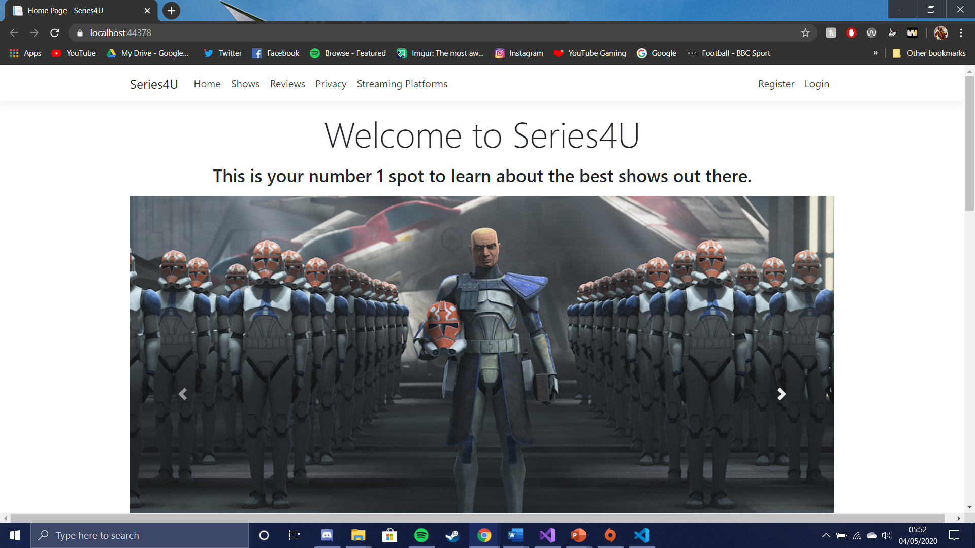
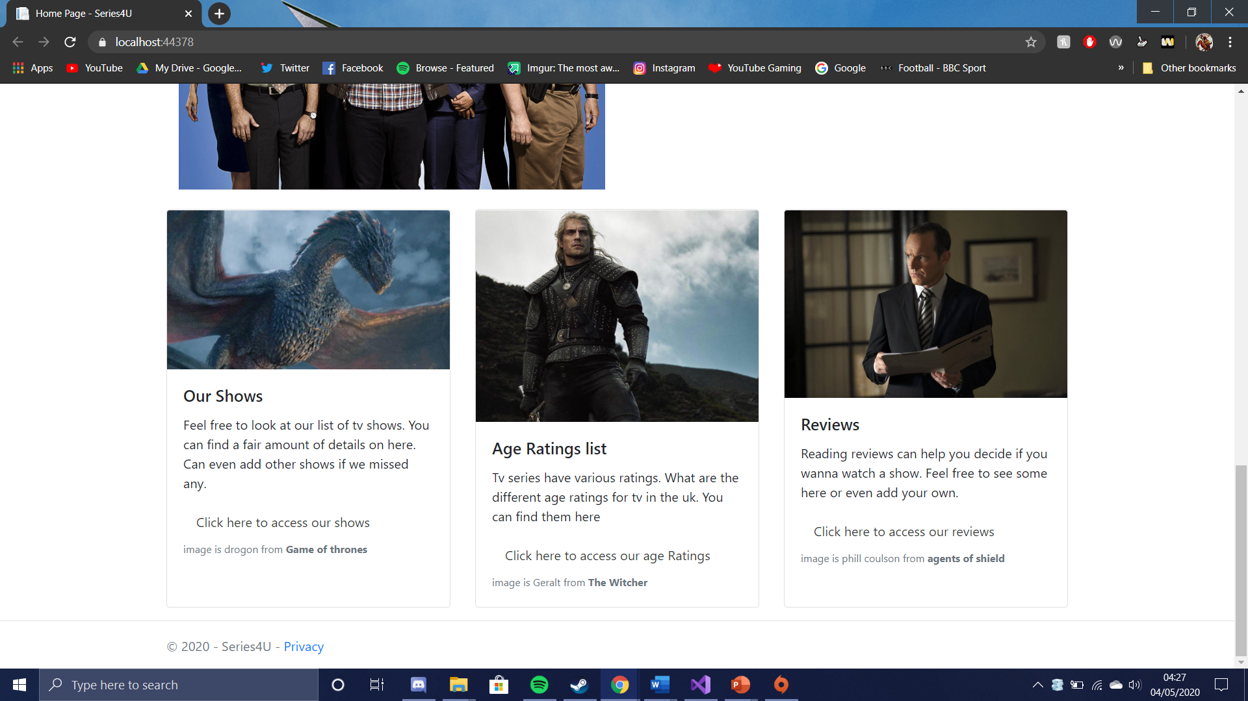
The homepage design was kept quite simple. It has a large image at the top and 2 rows talking about the details of the website. It also features cards with images that describes 3 of the pages that uses tables from the database. It has a link to the shows page, the age ratings page and the reviews page. This page also features a carousel with three images from tv shows. This page also has links towards the login page, register page. This page used css and java from bootstrap. The slide show was done switches through three images.
This is the code for the carousel that was used for the slideshow. This code did use some bootstrap to style it.
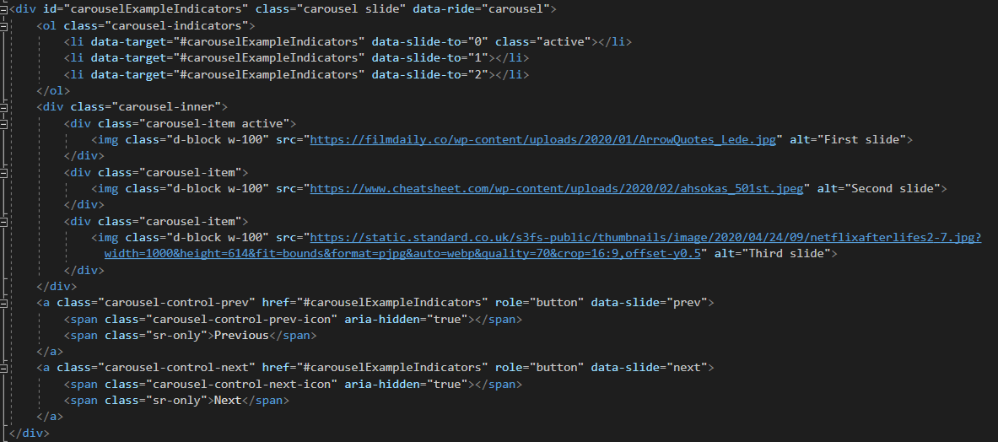
This was the code used for the cards. This was also done using bootstrap.
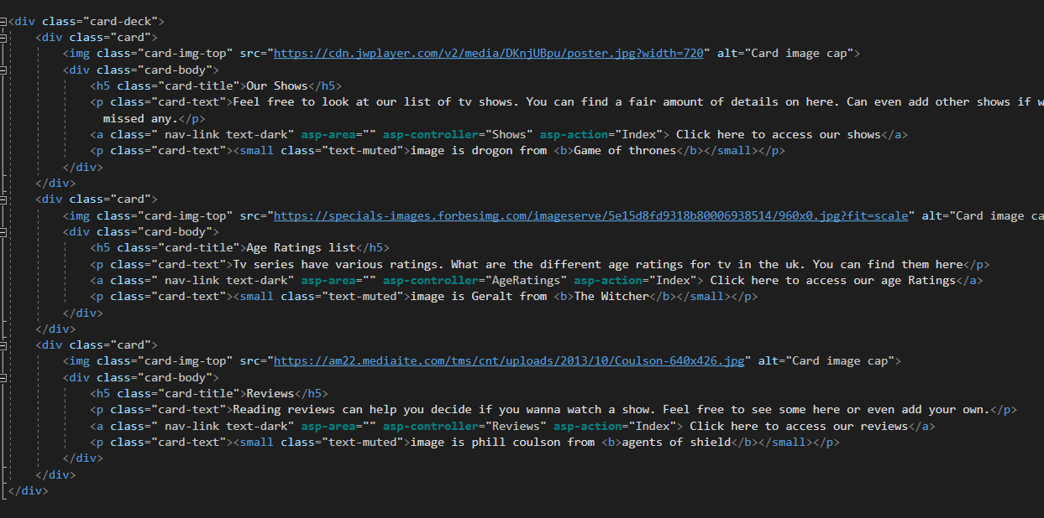

Shows page
The shows page is the page that displays the shows in the database. The user is also able to search or filter the results up for specific data. This page also uses pagination for when there are too many rows for one page. The table is also made to be a dark grey, so it sticks out a bit more.

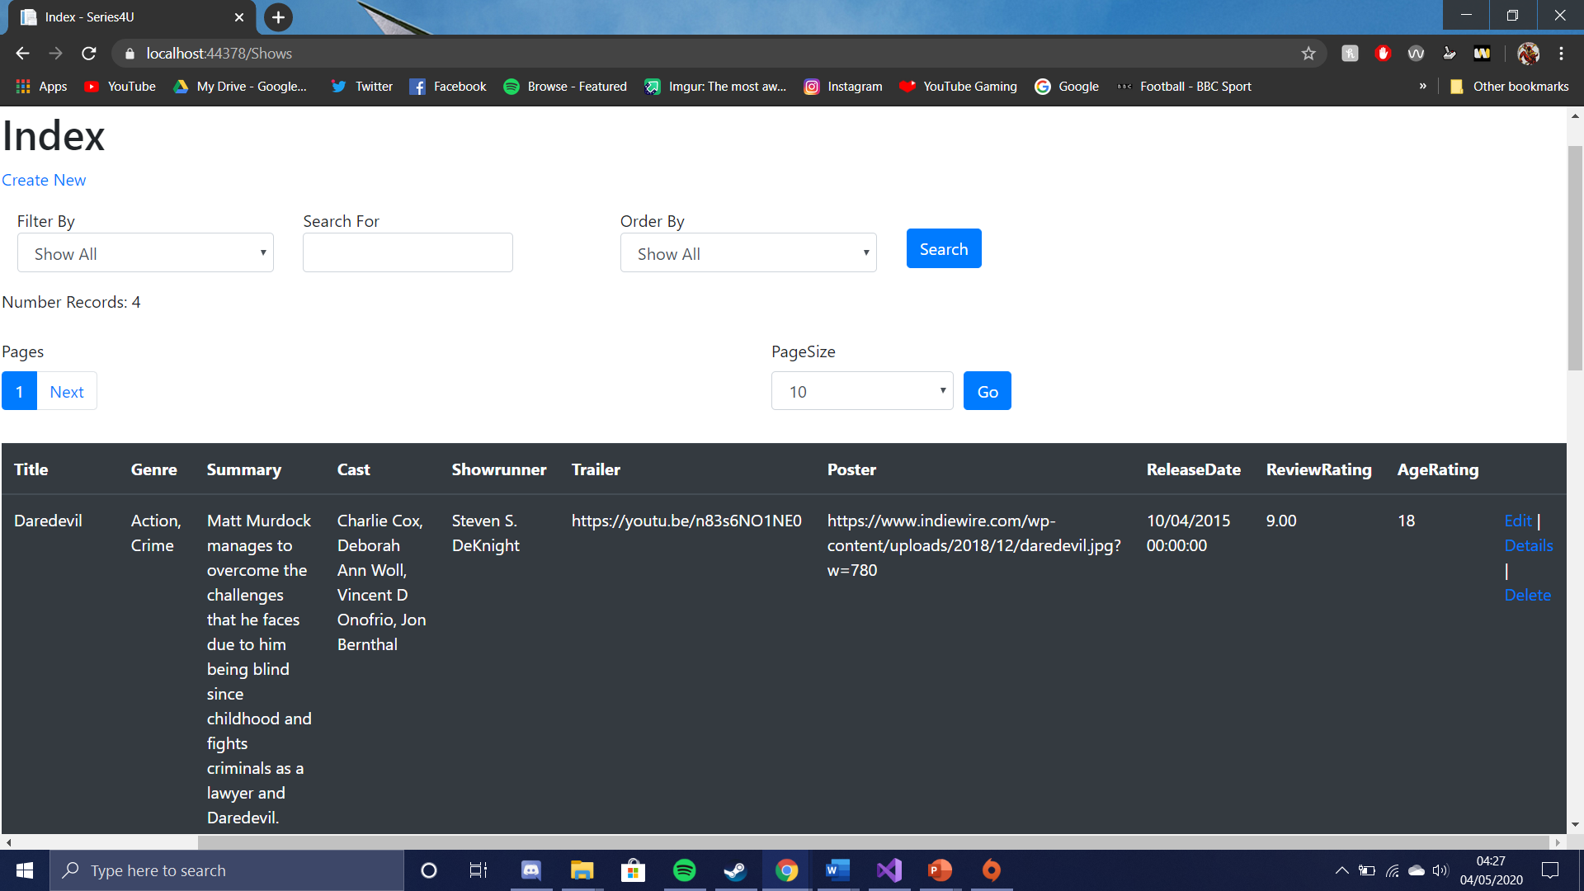
This is the code for the pagination and search.
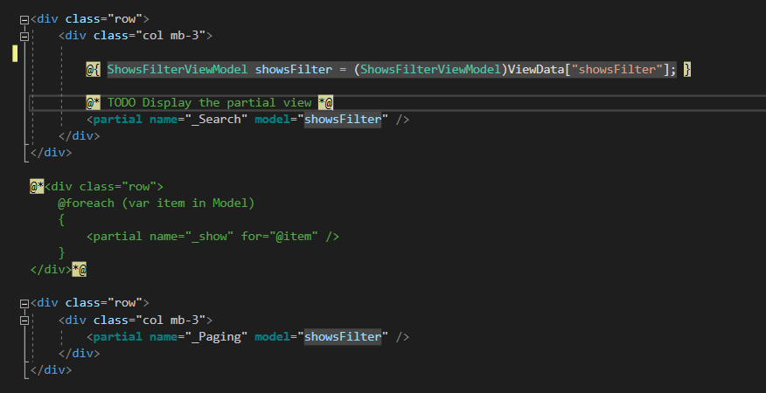
This is the code for the table.
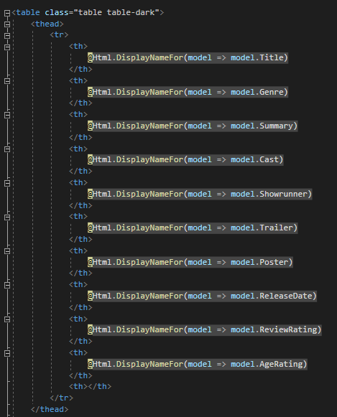

Reviews page

One page on the reviews page displays the reviews on tv shows onto the report. It also allows users to use links to pages that allows them to edit, delete or create a new review. It also allows them to view the all the details of the review.
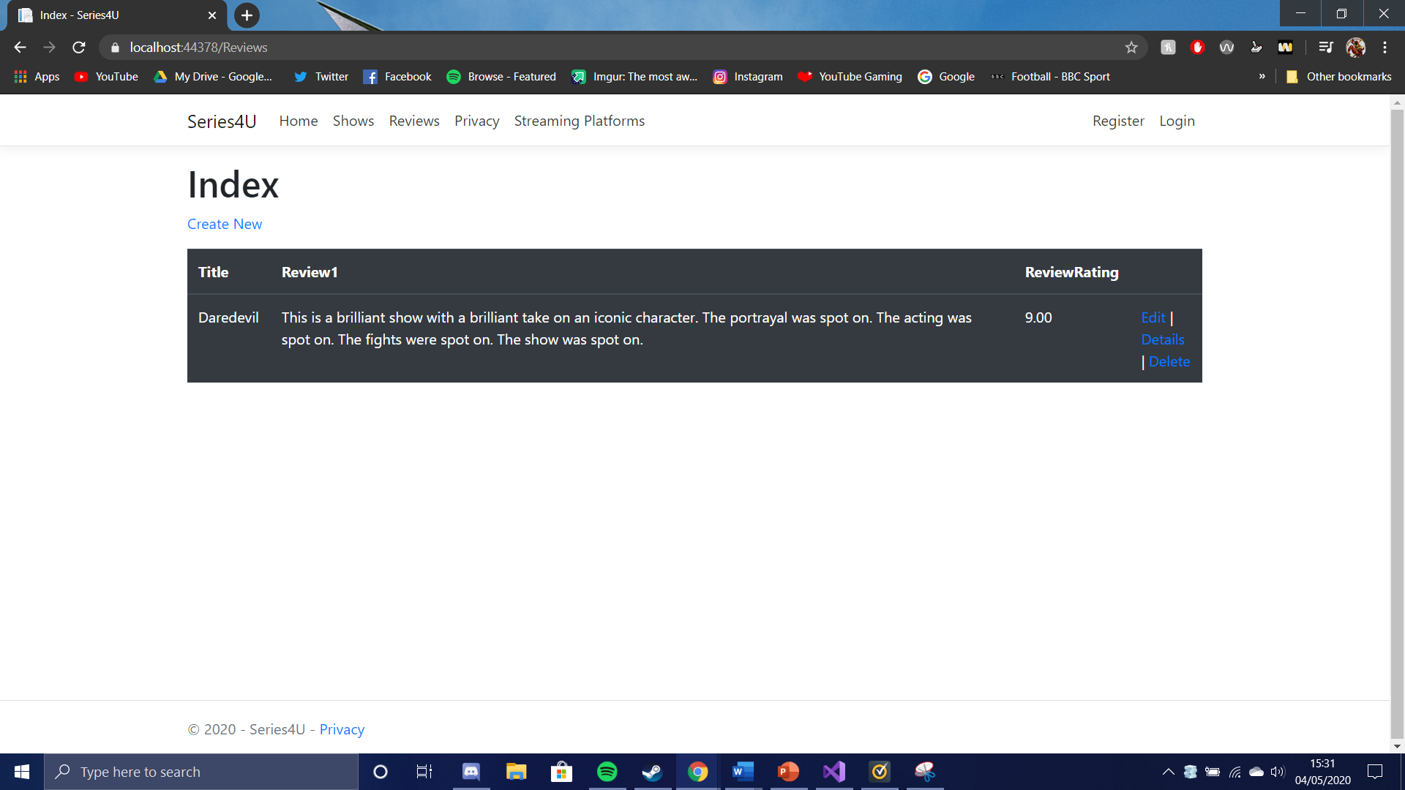
This is the code for the table in the reviews page.
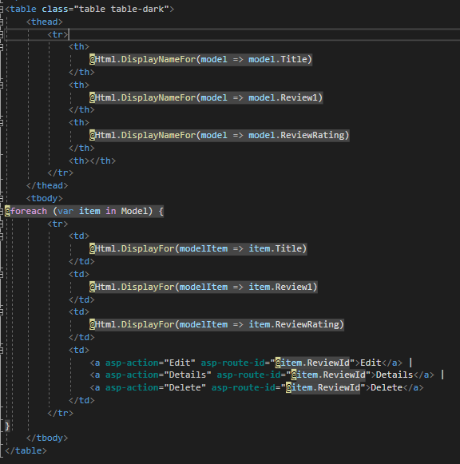

Age rating page
The age rating page is another page on the website. Unlike the shows and reviews page. You cannot edit or create the data as the age ratings are not likely to change. This page is just so the users could see what the different age ratings are.
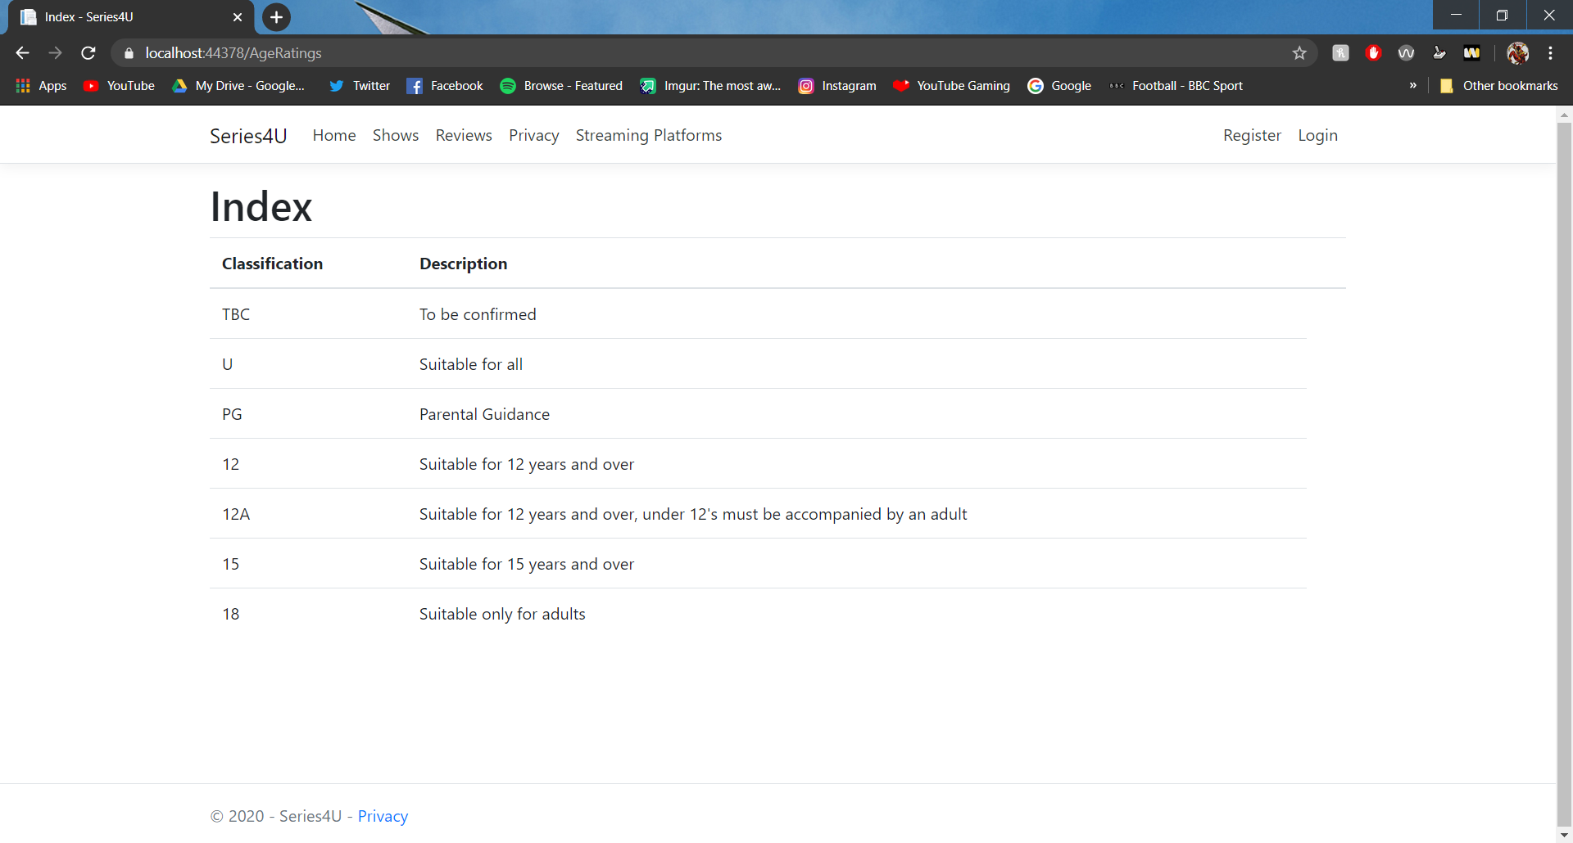
This is the code for the table in the age rating page.
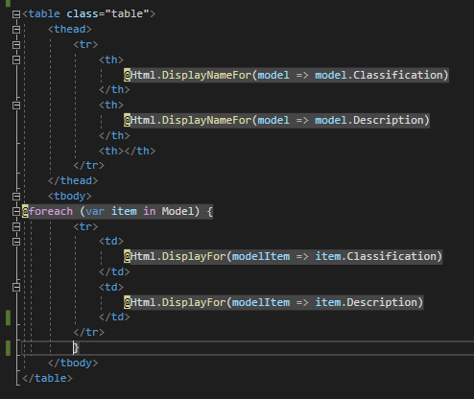

Streaming platforms page
This streaming platform page displays the various streaming services that people use to watch their favourite shows such as amazon or Disney+. This page consists of rows for each platform. The rows would have a column with a link to the platforms page, a column with some description about that platform and a column with an image of the streaming services logo. This was styled using bootstrap.
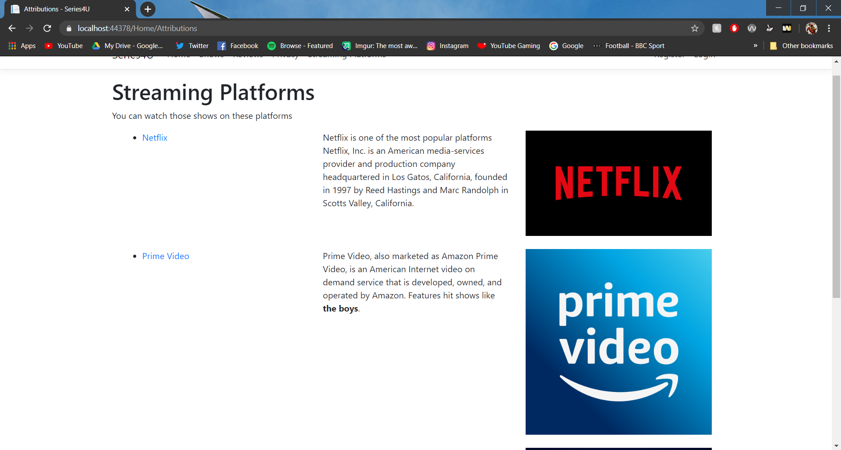
This is the code for the streaming platforms page used in the webapp.
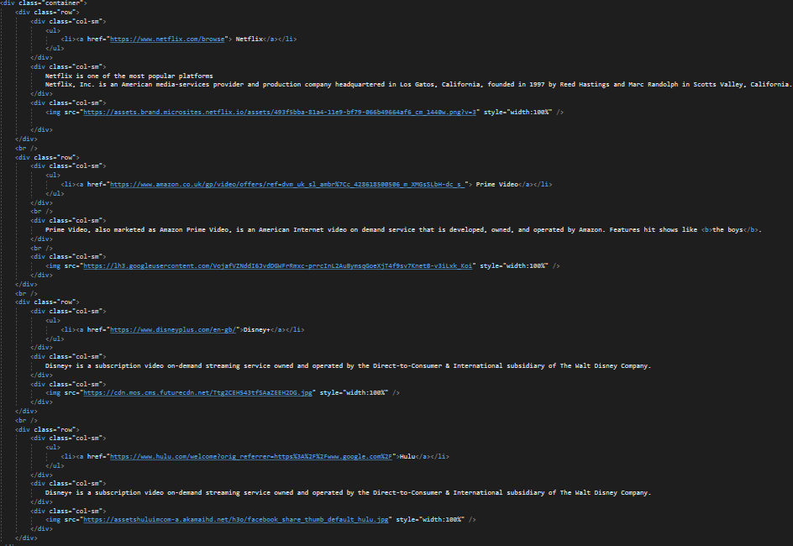
Register page
The register page allows users who don’t have an account to log in and make one. A form is used to ask for an email, a password and it asks for the password again to confirm before it allows the user to register.
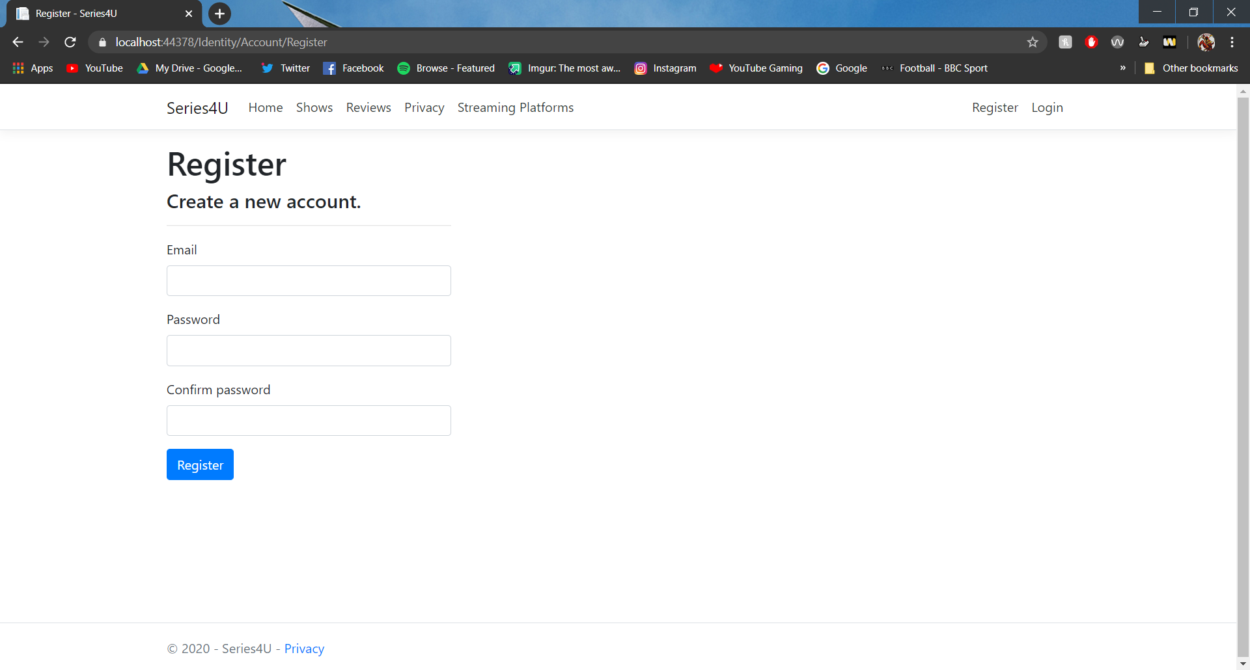Login page
The log in page allows users with an account to log into the website. It asks for the emails and the password. It also does offer services for if you did forget your password. If you have forgotten your password, you can click on the “Forgot your password” link and if you don’t have an account, you can click on the “Register as a new user” link to get sent to the register page.
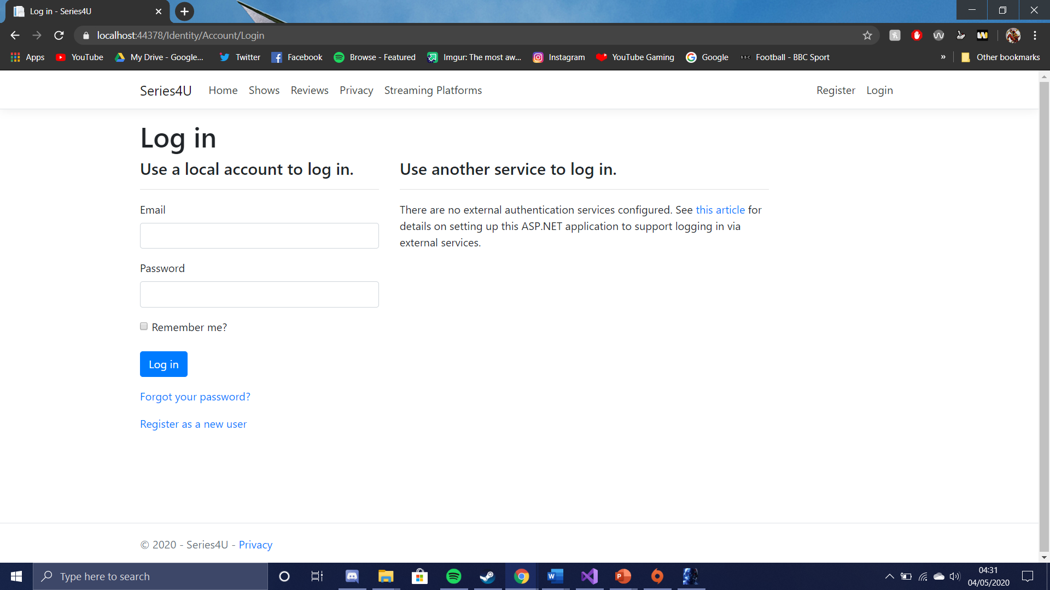

Create new show page
There is also a create page for the shows that can be accessed via a link in the shows page. The create page for the shows allows the users to add a new show to the database.
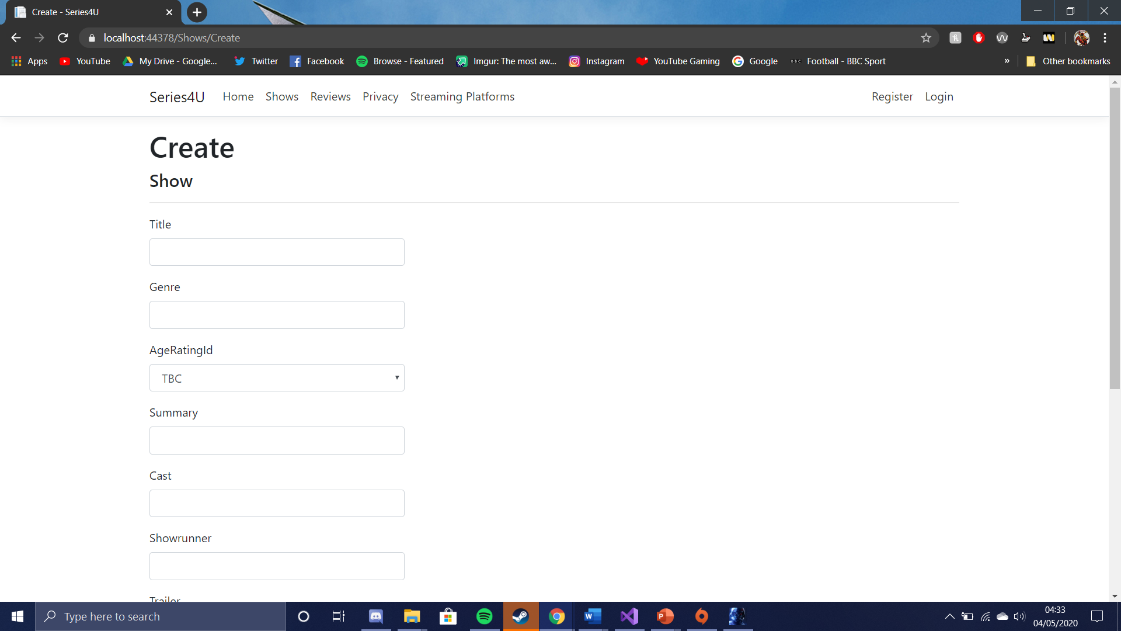

Edit show page
There is also an edit page for the shows that can be accessed via a link in the shows page. The edit page for the shows allows the users to edit the shows details on the database.

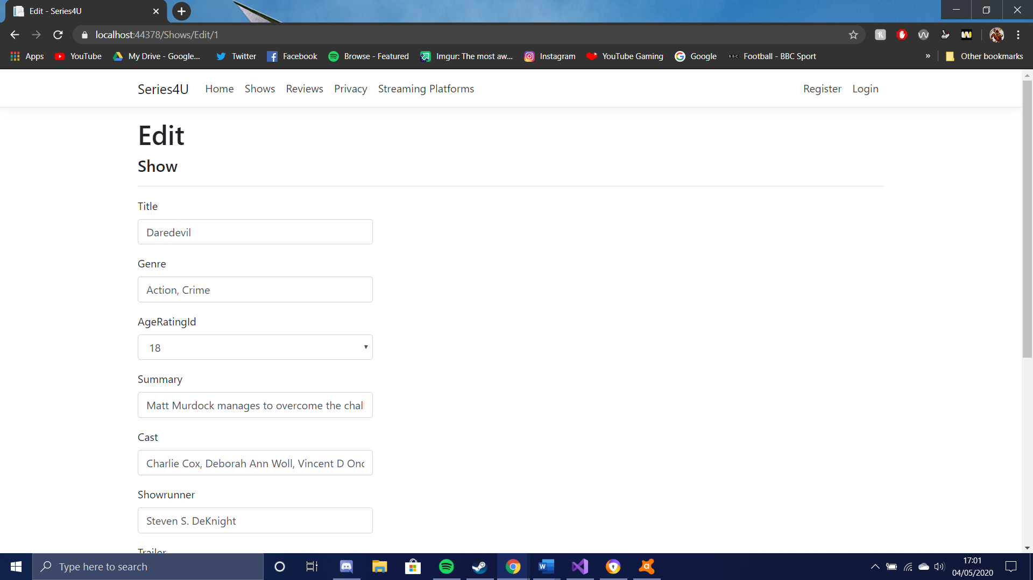
Delete show page
This page allows users to delete shows from the database.
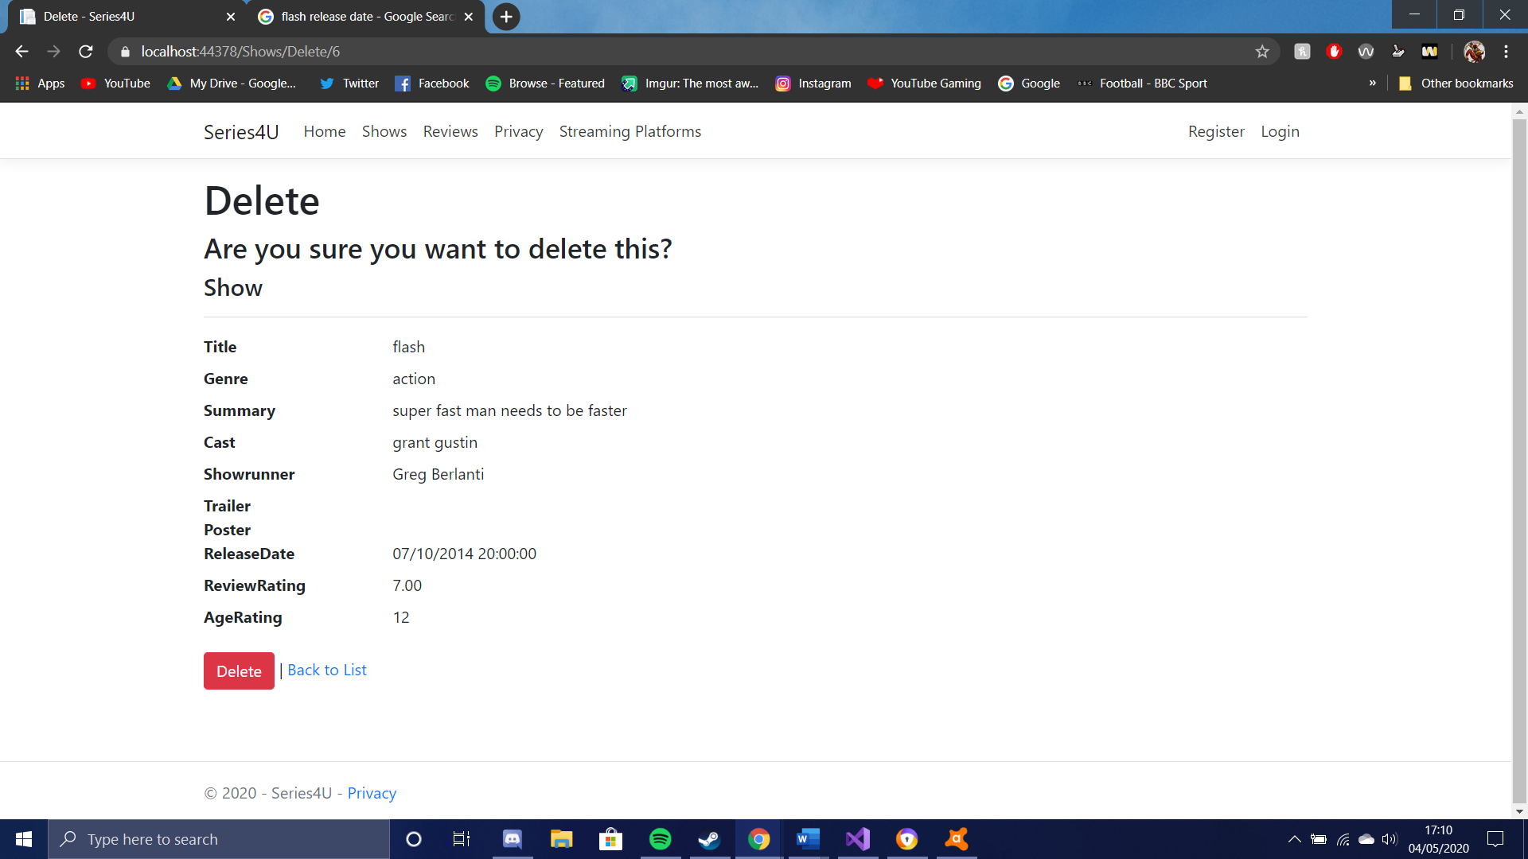

Edit reviews page
This page allows the reviews to be edited.
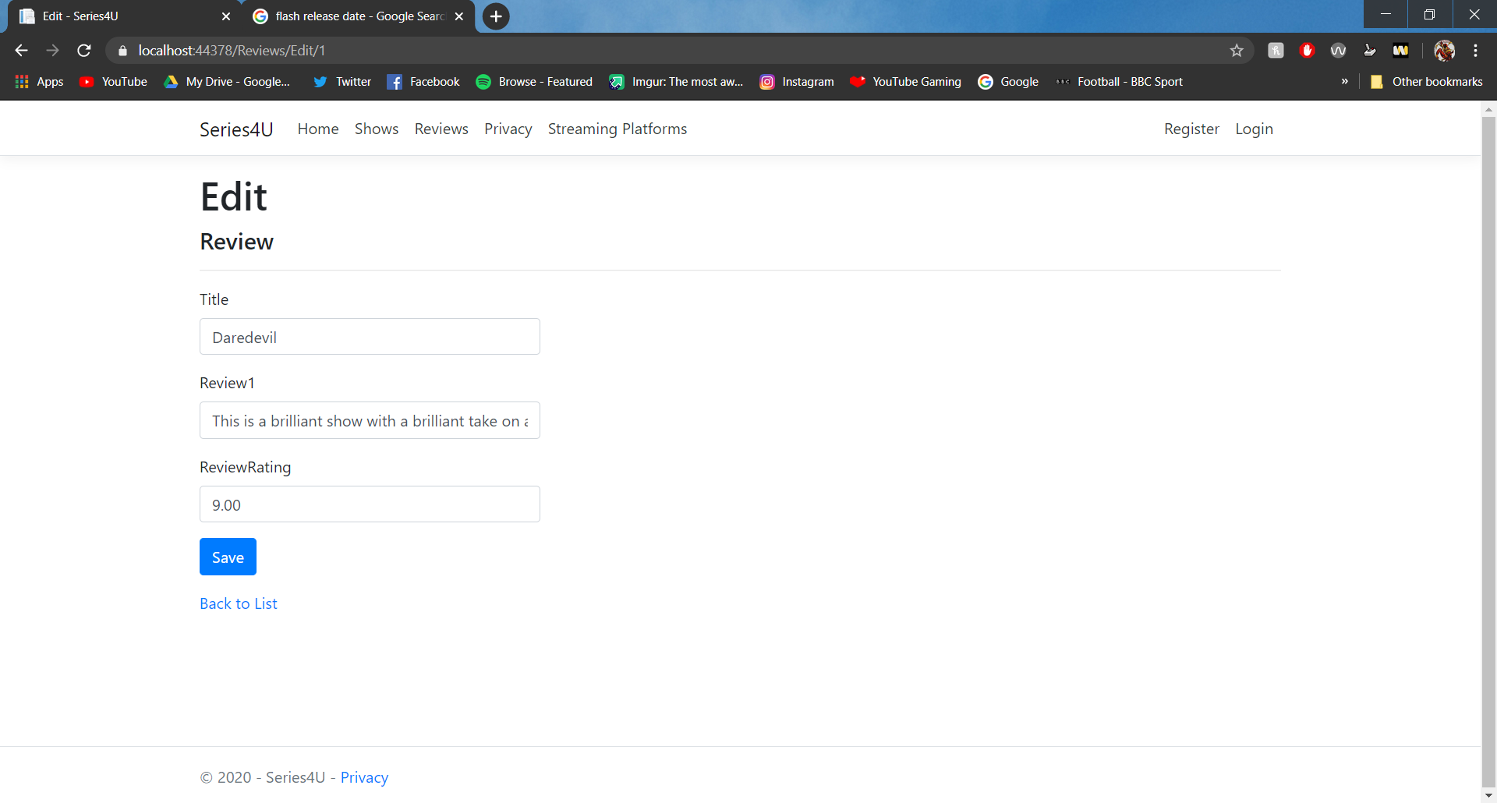

Reviews details page
This page allows the users to view the details of the reviews.
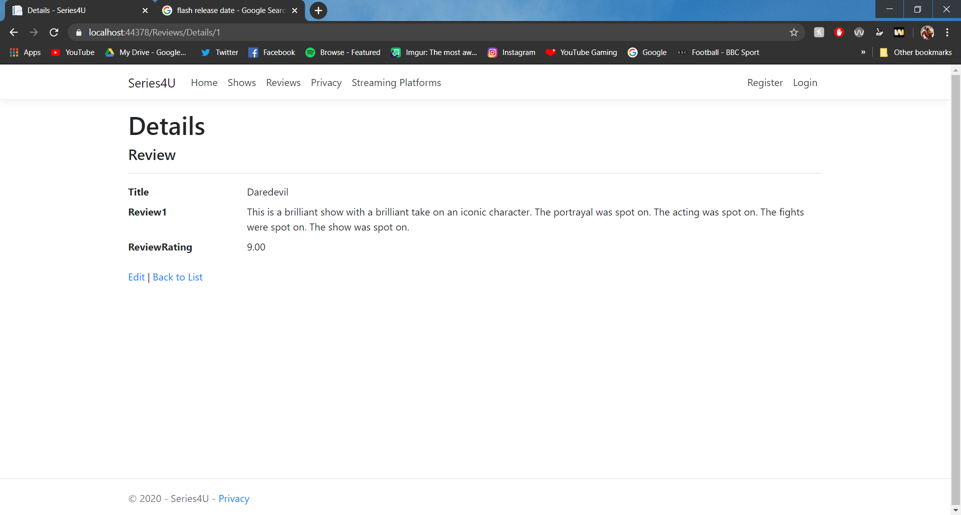
Delete reviews page
This page allows the user to delete the reviews.
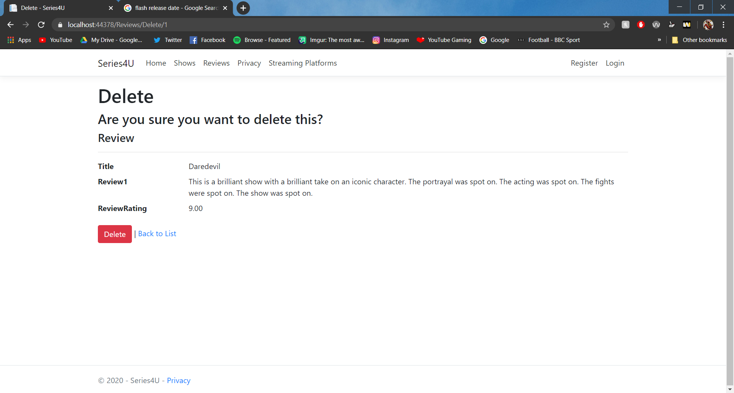

Evaluation

  - Testing
Creating new shows data
The purpose of this test is to add more shows to the database. To this test, I am going to click on create new on the shows page. This should send me to the create page.
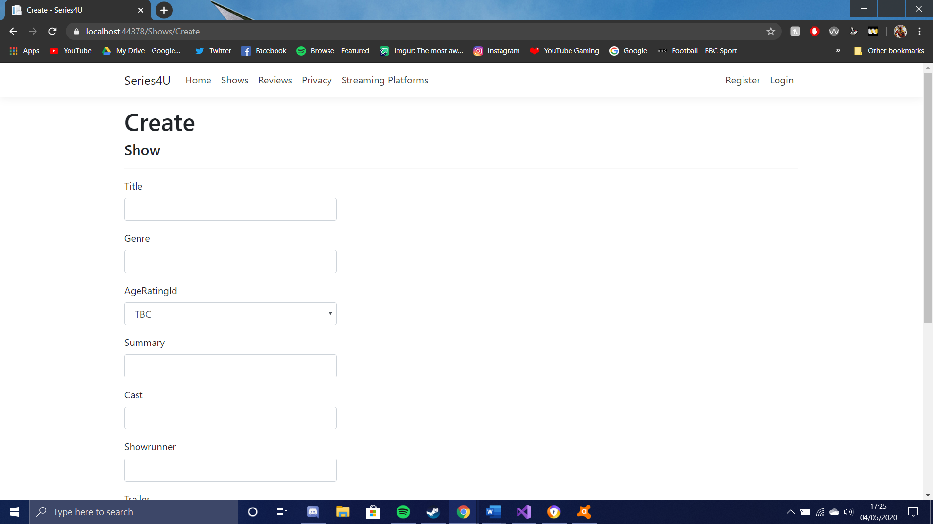
It has sent me to the create page, I am now going to fill in the details.
Once save is pressed then there should be a new row on the website for the show that was just entered.
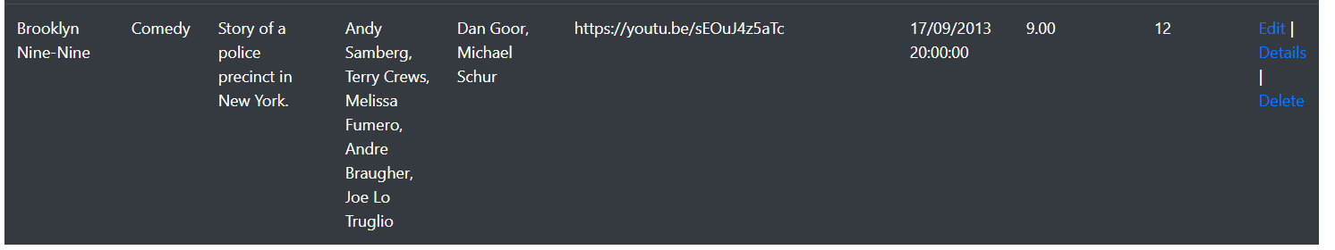
This test was a success as the new data has been added to the database.

Validation
The validation of the input boxes will need to be tested to make sure the incorrect data is not entered. This will be tested by entering the wrong data for the review rating box. I am going to add letters where there should only be numbers. It should say that the value is not valid when I press save
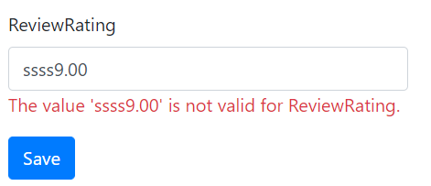
As the screenshot shows, it does not let you add the data to the website. The inputs are validated. This test was a success.

Editing the form
This test will be to test if you are able to edit data on the webapp. To do this, I clicked the edit link on the row about the flash tv show. This sent me to the shows edit page. I then added Tom Cavanagh to the cast.
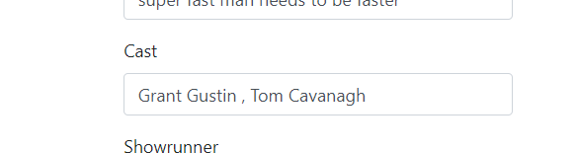
I then pressed save. The cast should display Tom Cavanagh by the cast.
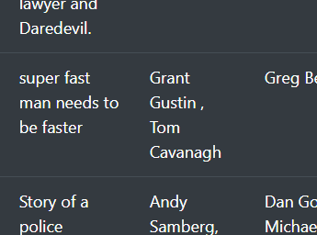
It has added Tom Cavanagh to the database which means the test was a success.

Delete data
This test is to test if some of a row can be deleted from the webapp. To test this, I am going to delete the Flash from the database. I will click on the delete button on the flash row. This should take me to a page asking if I am sure I want to delete it. 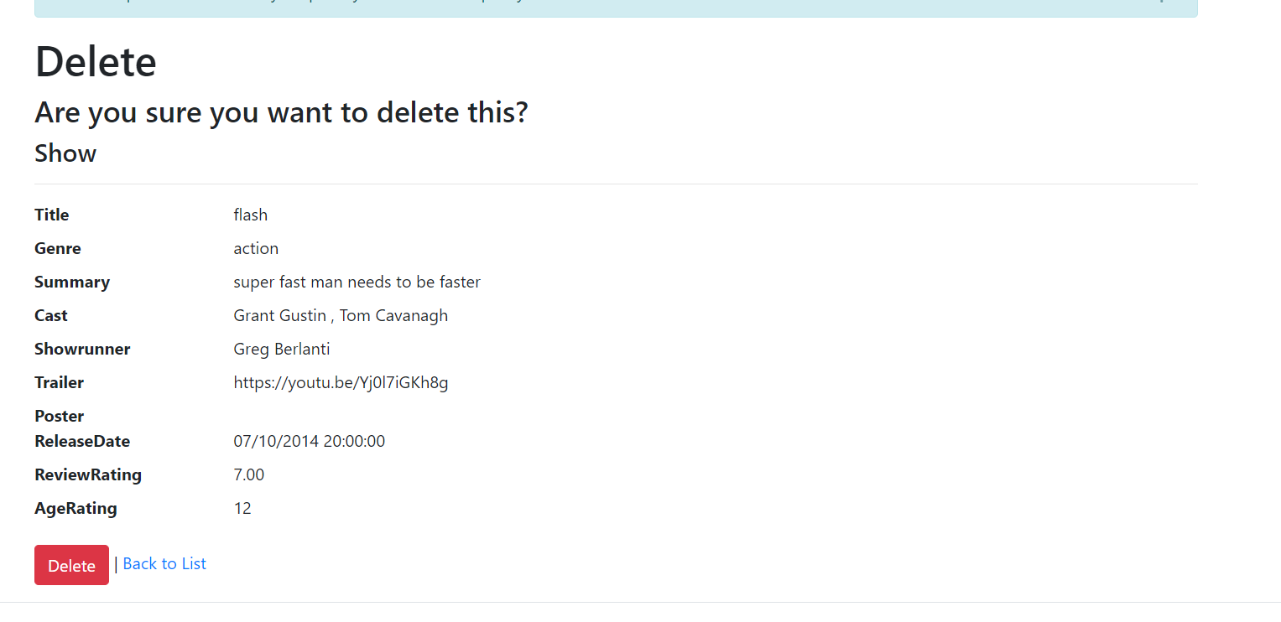
After that. I should press delete and all the data should be gone.
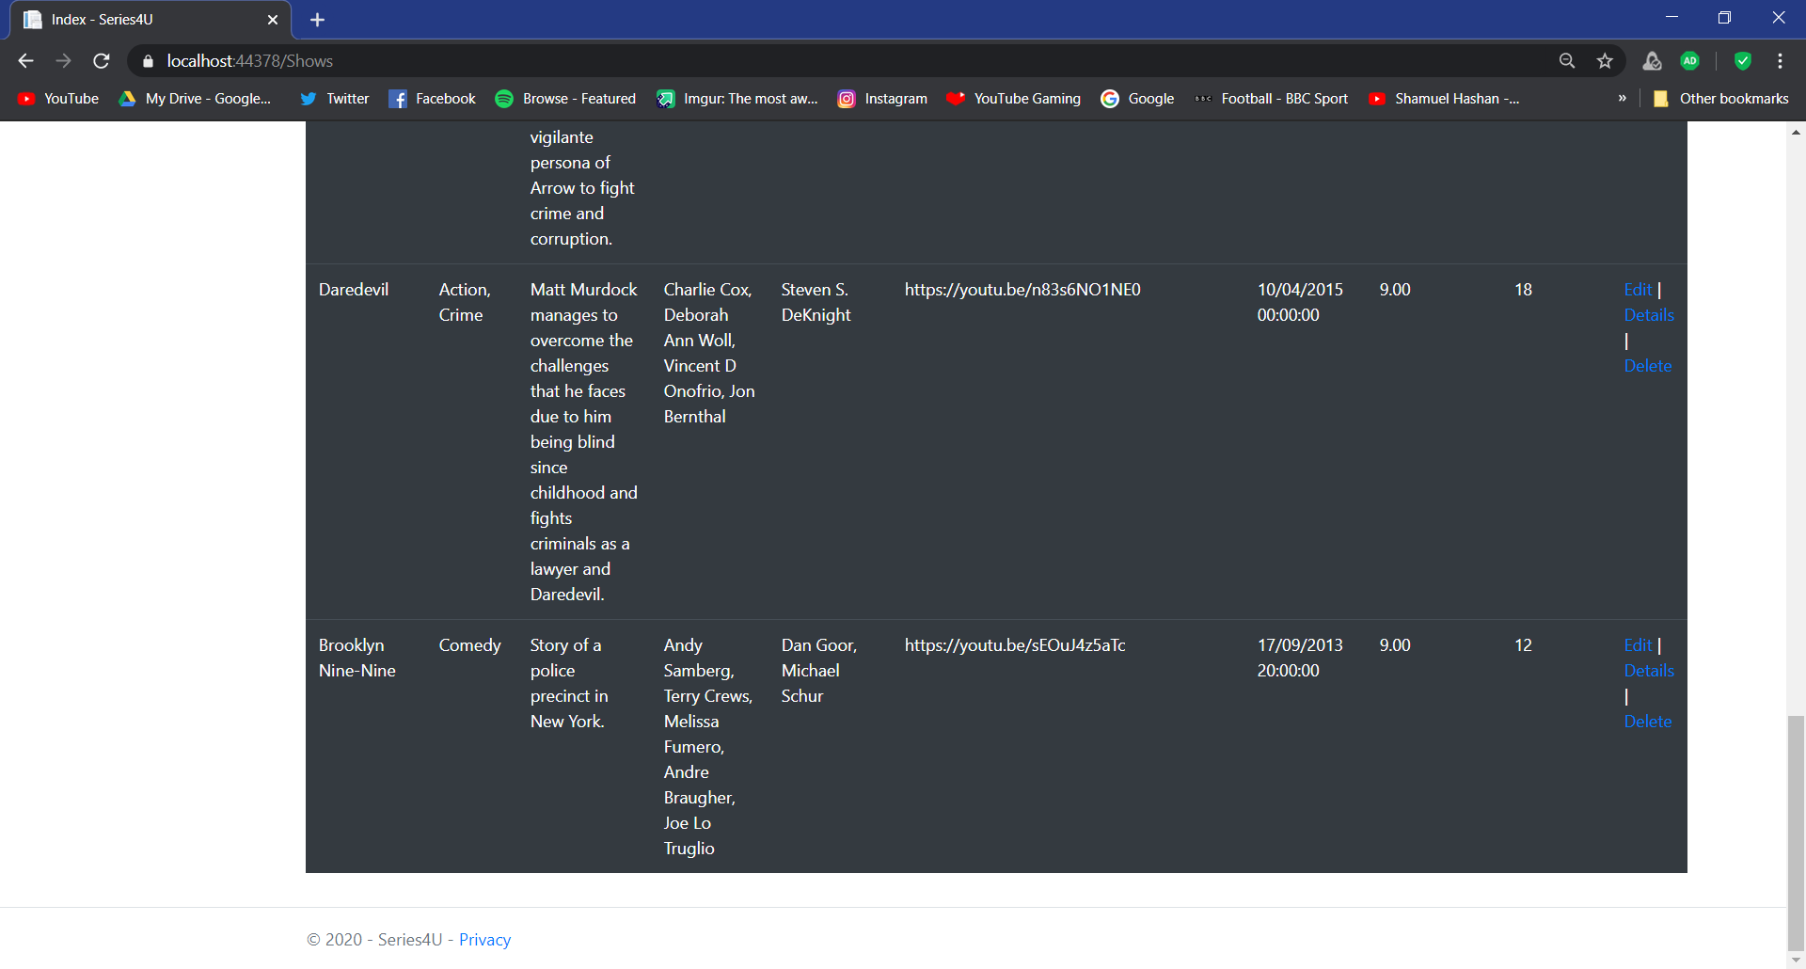
The test was a success as the flash is no longer on the database.

Displaying data.
This next test is to see if the data from a one of the shows will be displayed when you press the details link. To test this, I will click on the details link for the show called Stranger Things. After I click that link it should take me to a page that only shows the details for Stranger things.
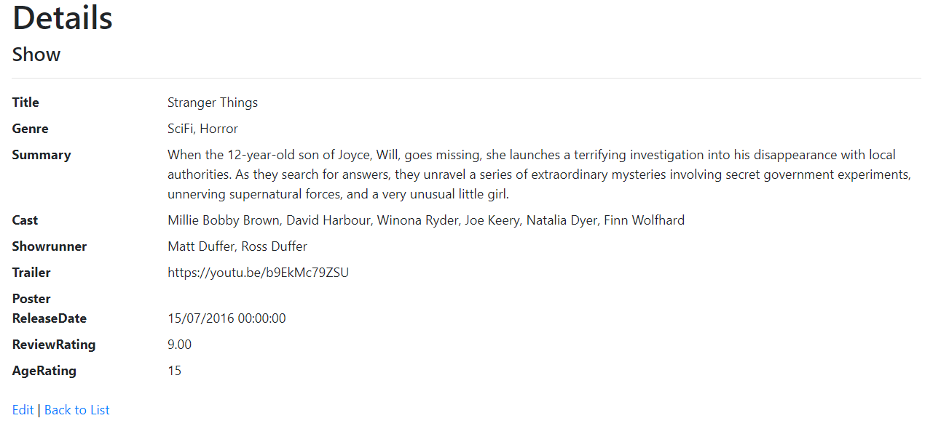
As shown in the screenshot it has taken me to a page that only shows details for stranger things. The test was a success. It has shown all the detail

Filters and Search
The purpose of this test is to see if the filters work. I will test this by searching for the title Daredevil and then I will press search. This should then only display the show Daredevil.
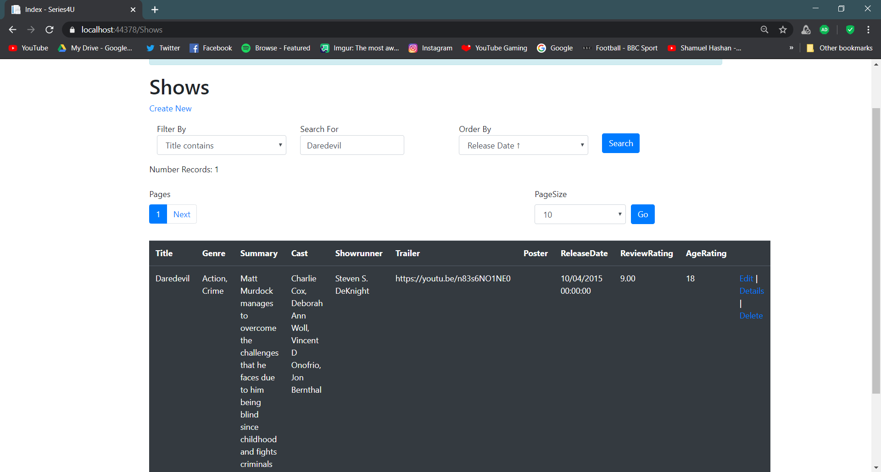
As shown in the screenshot. Daredevil was shown which means this test was a success.

Testing register
This test is to see if the website allows you to register as a user. To do this test, I will fill in the details with my email and a password so I can then register. This should then take you to the home page and a notification should pop up asking if you want to save your details.

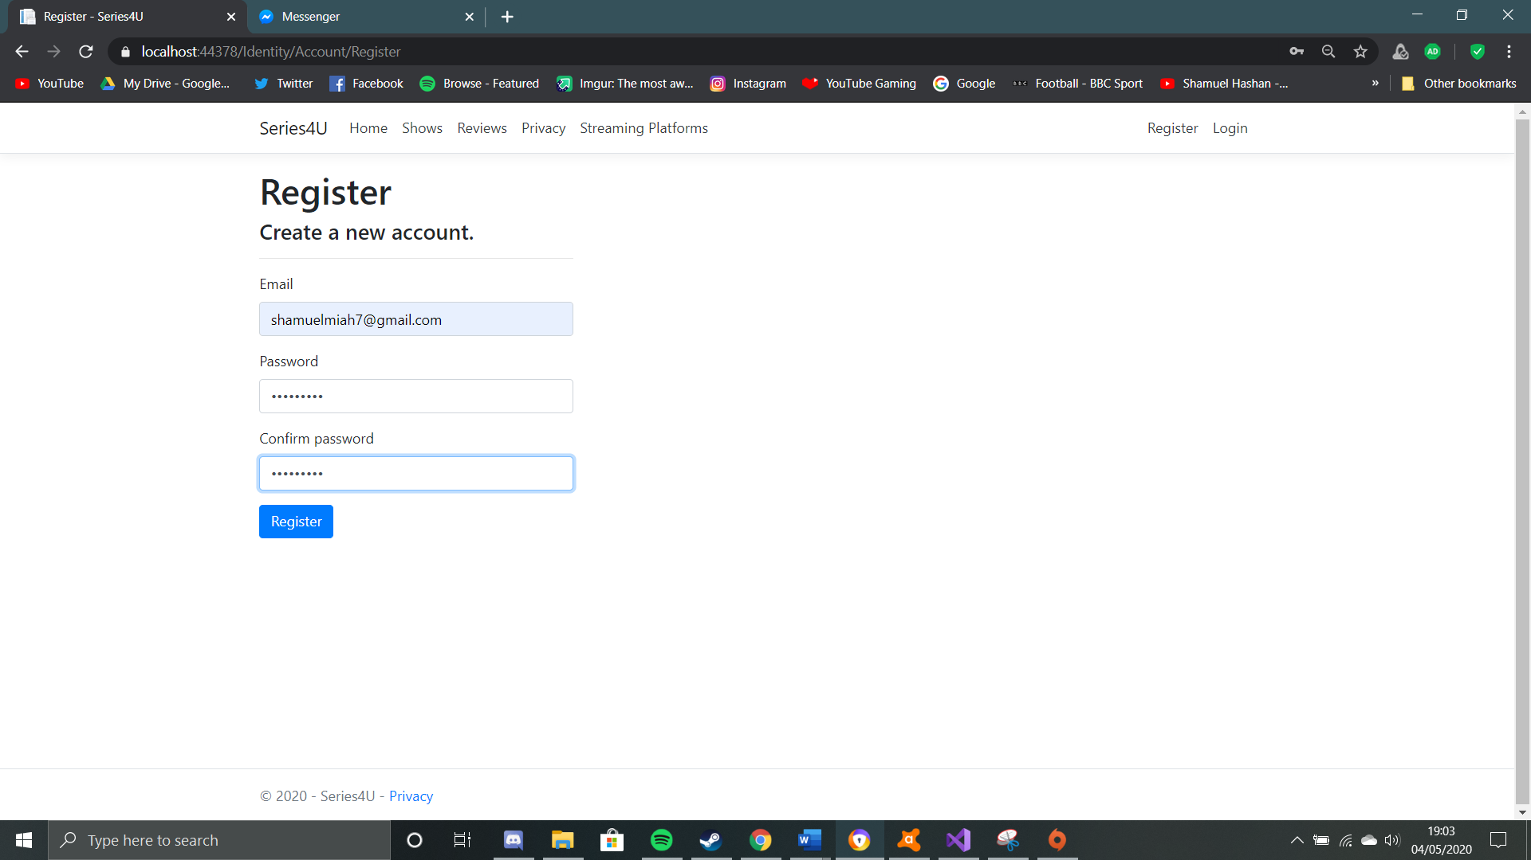
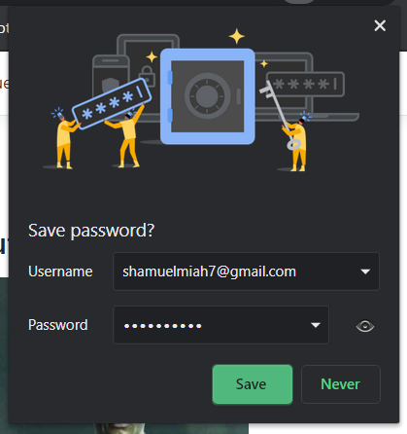

Logout
This test is to see if the logout function works on the webapp. To test this, I will click the logout button after I have logged in. After this is done it should display the login and register links on the navbar.
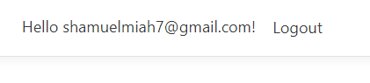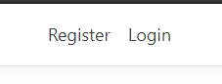
The test was a success as it did log the user out of the webapp and displated the register and login links on the navbar.

Login
The login fucntion will also need to be tested to see if the webapp allows the user to login. To do this test, I will be entering the email and password I used to register. It should take me to the homepage of the web app.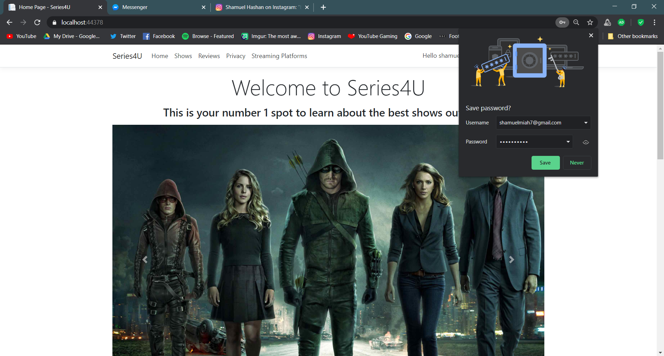

Login validation
One test that needs to be performed is the login validation. This test is to make sure that only people with the correct login details can login. To test this, the incorrect login details will be entered. It should say “invalid login attempt” after the login button is pressed.
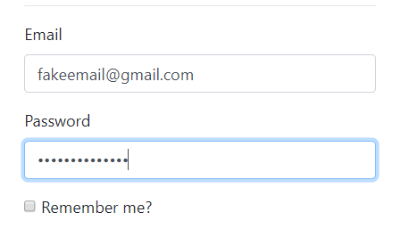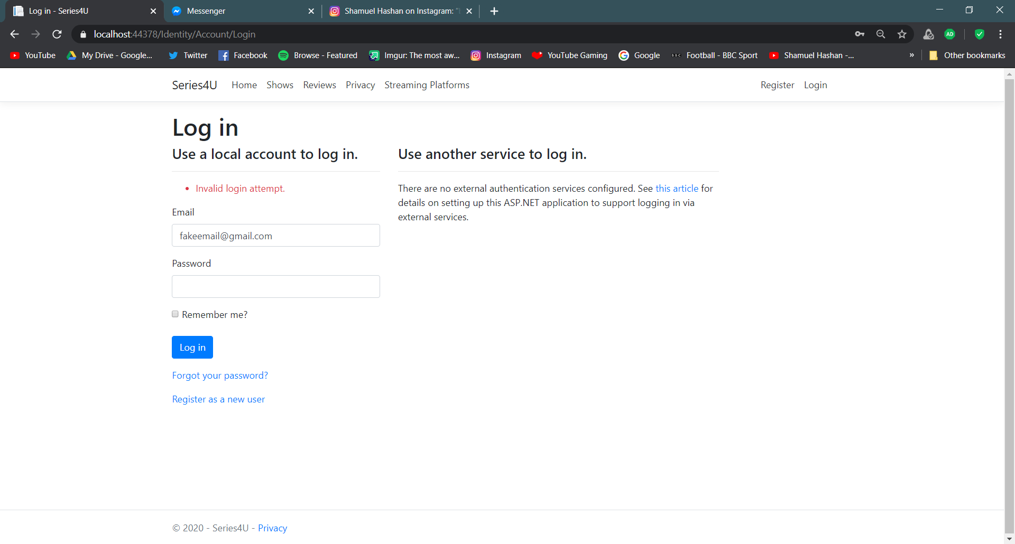
It displayed the “Invalid login attempt” text after which means this test was a success.

Conclusion

This report has discussed the requirements of the webapp. This report has also discussed how the webapp was designed and implemented. The functions of the webapp was also tested. The design of the webapp was very simple and it was easy to navigate however, if this was to be created again, I might use some more functions such as adding a renting system where users could rent tv shows.

References

[1] | imdb, “imdb home,” imdb, 04 05 2020. [Online]. Available: https://www.imdb.com/?ref_=nv_home. [Accessed 04 05 2020].

