HTML & CSS Web Development
Farley staines
2204098
Data and information systems
Introduction to web and database concepts
Contents
Introduction 3
Requirements 3
Implementation 3
Images 3
Index/ Home page 3
About page 4
Facts page 4
Points of interest page 5
Famous people page 5
Validation 5
Html 5
CSS 6
Evaluation 7
Part A 7
Usability 7
Accessibility 7
Search engine optimization (SEO) 7
Part B 8
Usefulness 8
Search Engine Optimisation 8
Accessibility 8
References 8
Appendices 10
CSS 10
HTML 10
Index Page 10
About Page 14
Facts Page 17
Points of interest page 20
Famous people page 23

Introduction
In the report it will cover the implementation of a website using multiple pages. It will then cover the usefulness, use of accessibility and search engine optimisation (SEO) within each page.

Requirements
The website displays information about Swansea likes its history and sports, as well as some facts about the place, it also shows some interesting places in and around Swansea to visit. The intended target is anyone above the age of 18 looking to visit Swansea.

Implementation

Images

Index/ Home page
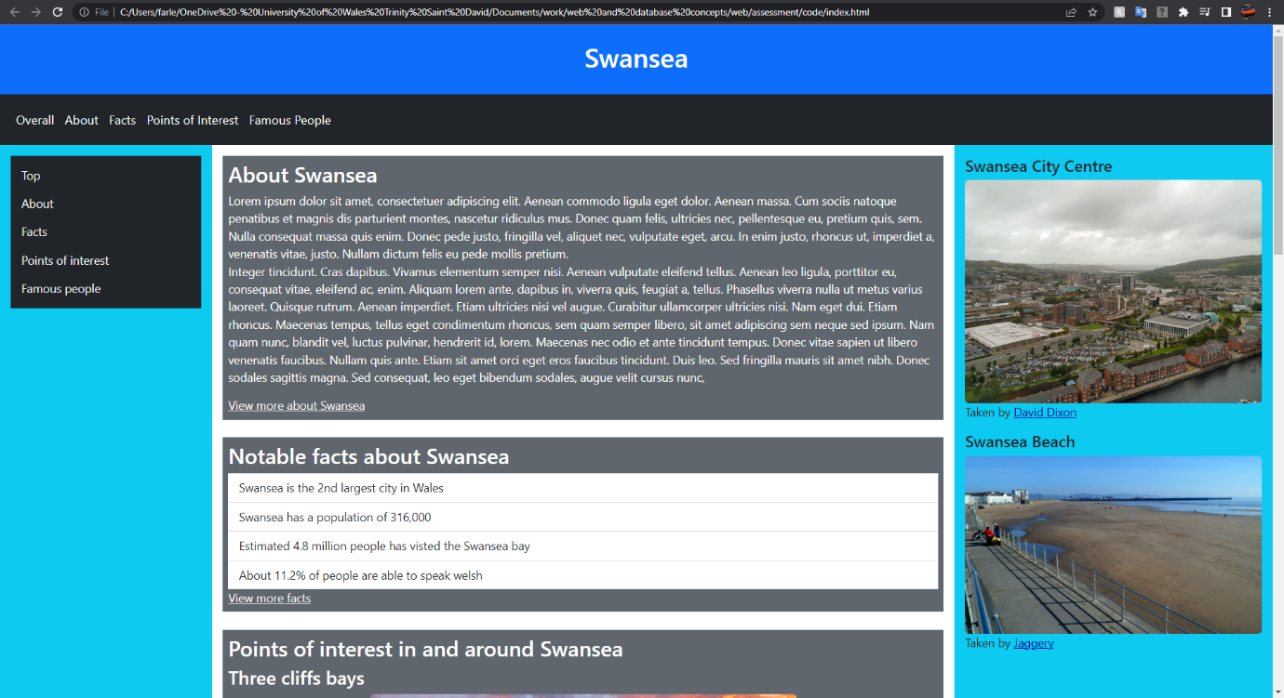

About page
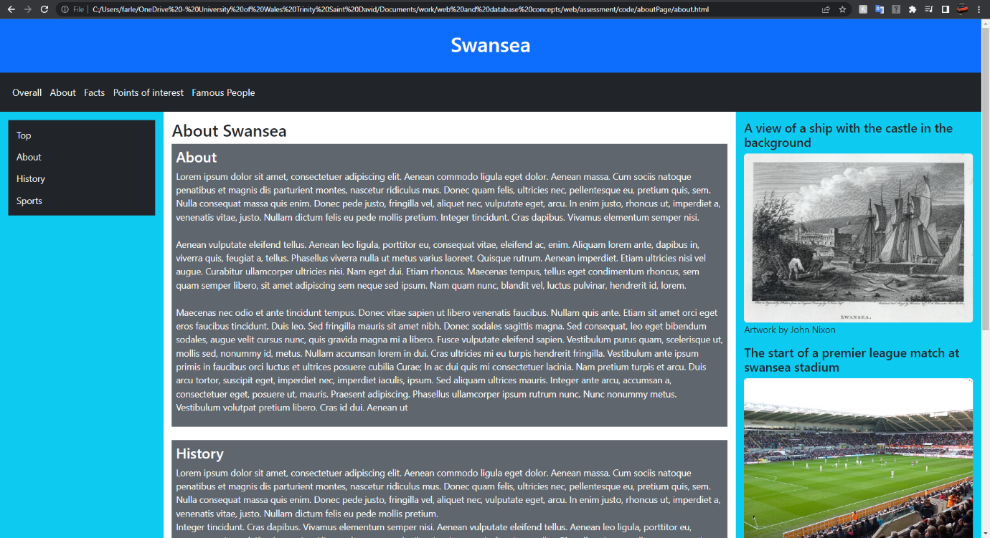

Facts page
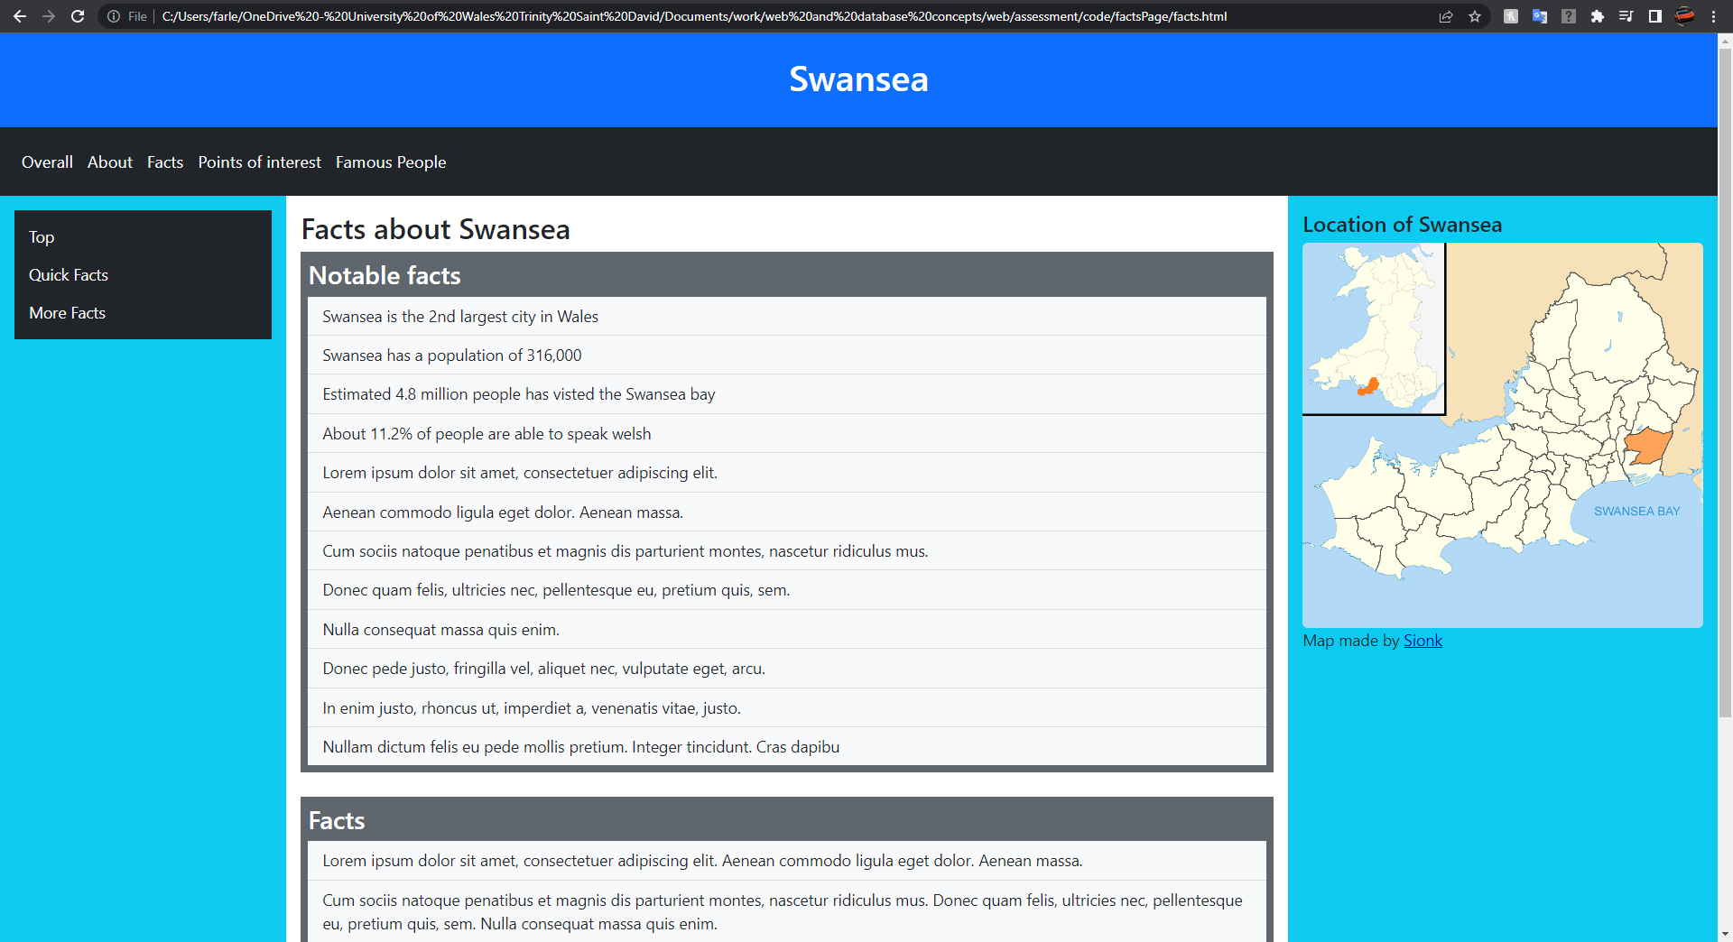

Points of interest page
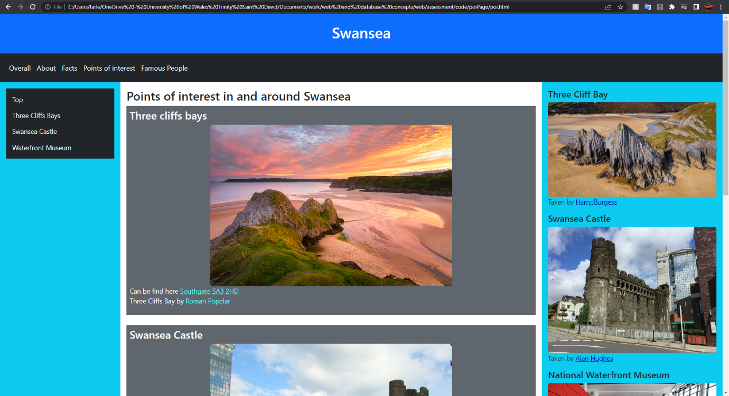

Famous people page
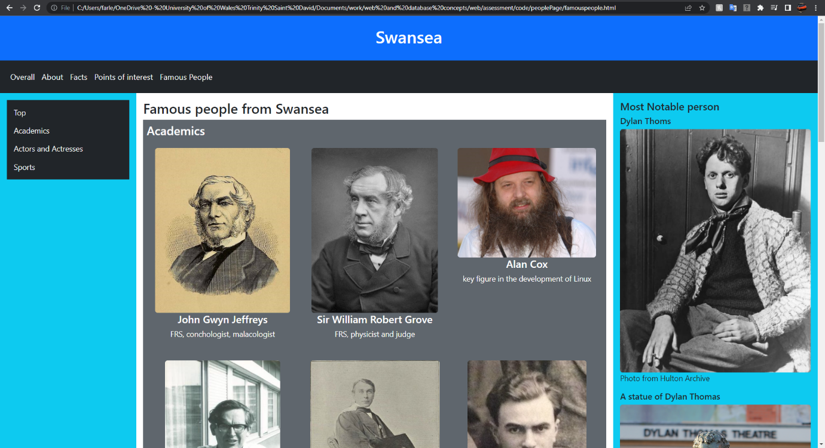

Validation

Html
Upon validating each page of my HTML website, the site says that there are no errors wrong any of them.
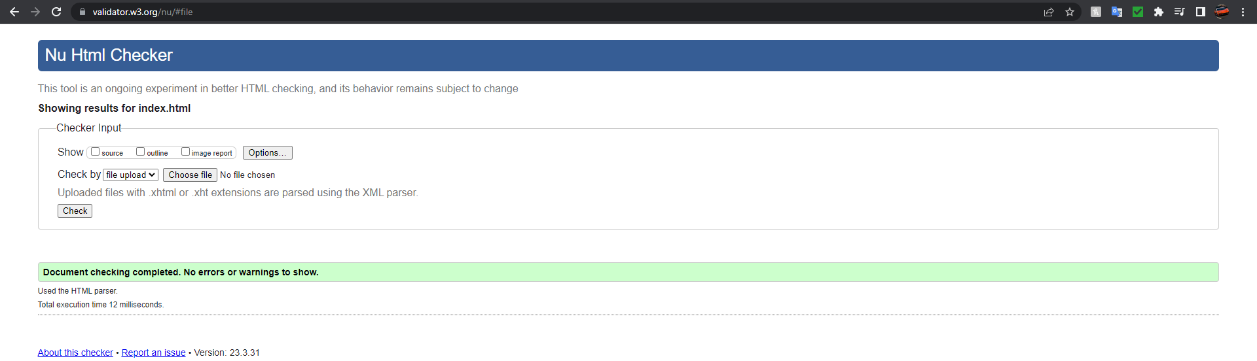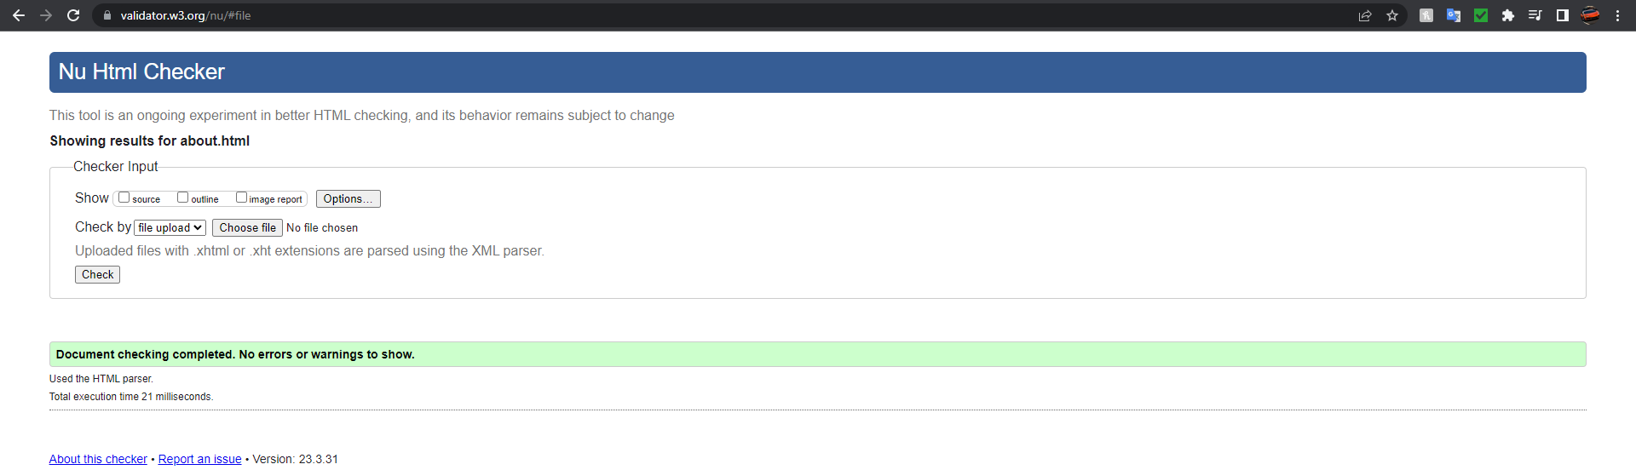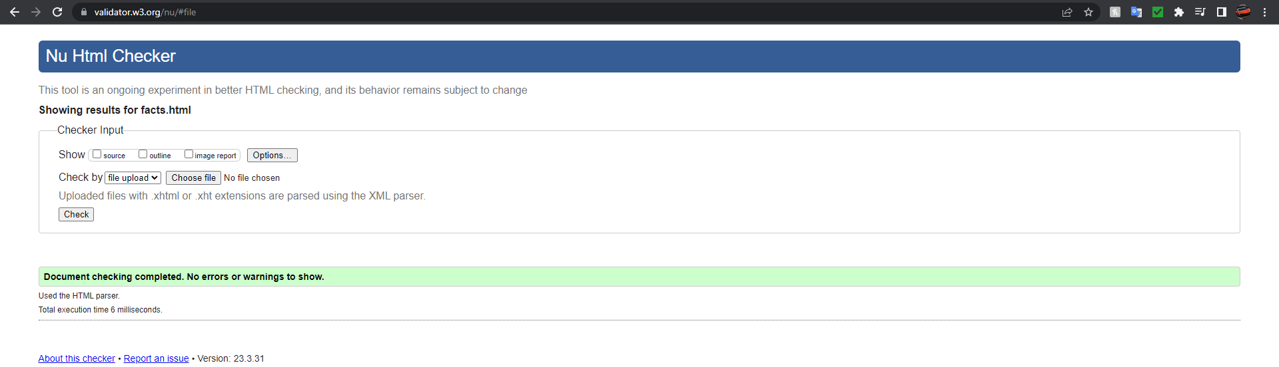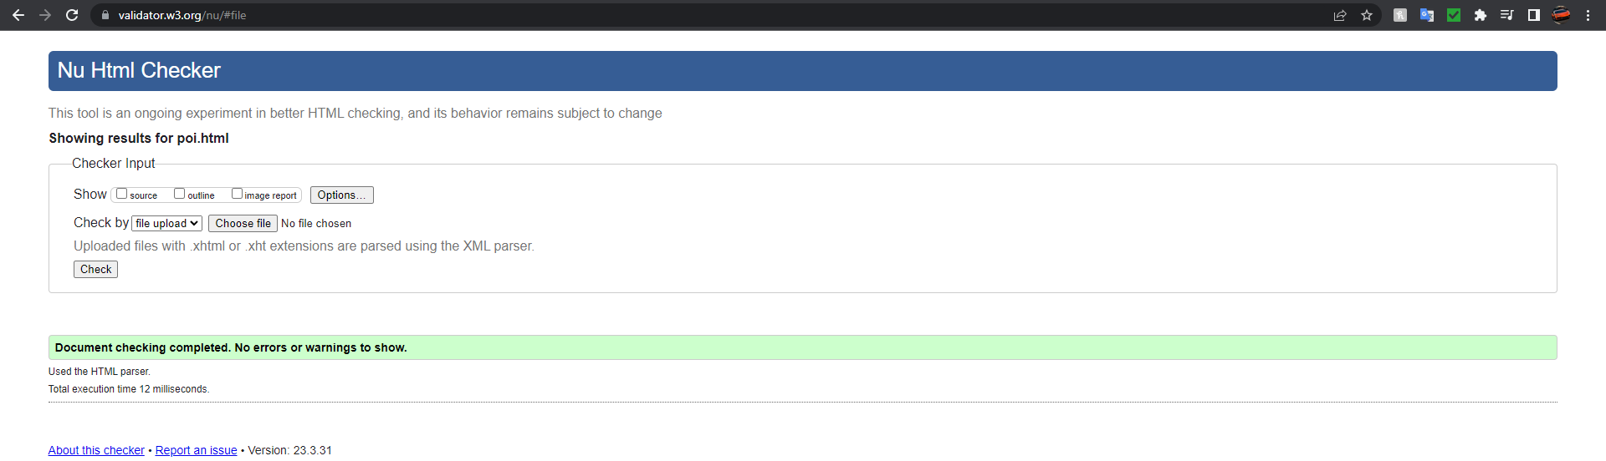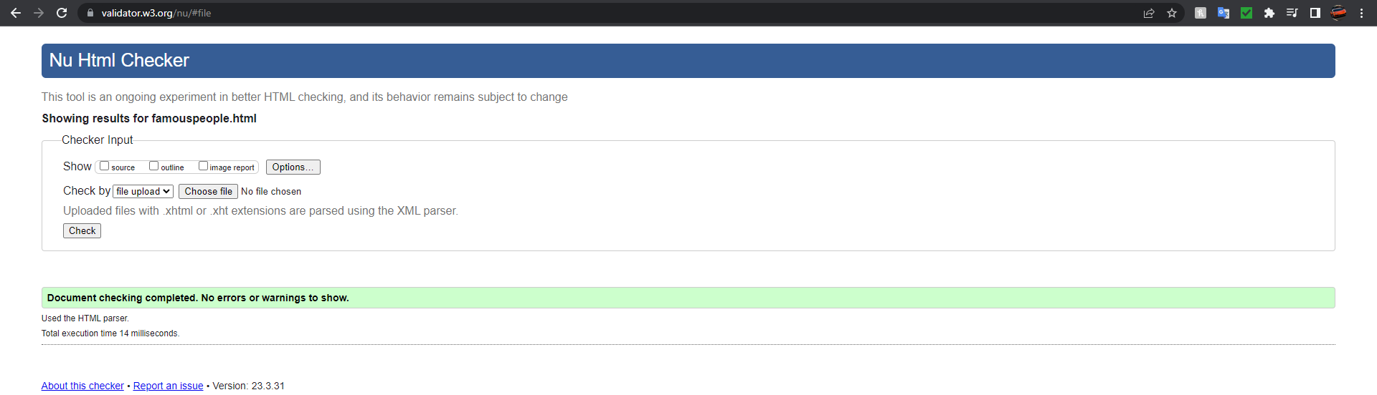

CSS
Upon validating my CSS, the site says that there are no errors wrong with it.
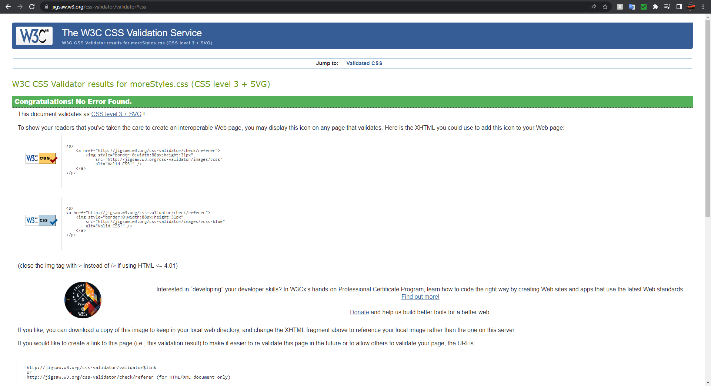

Evaluation

Part A

Usability
Website usability is the friendliness of a website and is determined by how well users can navigate and interact with it while still being able to achieve what they came here to do. It is a key component in web development as it gives a good impression to visitors. It is crucial to make it easy to navigate, allowing visitors to find what they are looking for quickly otherwise they might go to a different site to find what they are searching for. The main component of usability is to make sure your navigation system is as simple and easy to follow, so when you get new visitors who don’t know where anything is or where each heading goes to, they can easily navigate and get to what they need quickly. This is done by designing the website efficiently, with each link being informative and descriptive on where it takes you. Another method is to have a back button or breadcrumbs so the visitor doesn’t get lost and then can return to previous pages more easily. [1]. The use of breadcrumbs within a site helps the user complete task more efficiently and understand the hierarchy of the website. It also gets used a lot more if the breadcrumbs are underneath the title. [2]

Accessibility
Web accessibility is when a website is usable by as many people as possible. This is usually people with disability like, being deaf and blind, but this also will benefit other groups like those on mobile devices or with slow internet connections. Since developing a website requires a team and often is challenging, many of the staff lack awareness and motivation in training courses for accessibility training. Each team member has responsibilities for accessibility in developing a website and it is the project manager that needs to support them. Otherwise, there won’t be any changes to accessibility unless the government enforces it. Most web projects have the accessibility issue ignored or they pretend that it is done. [3]

Search engine optimization (SEO)
SEO or search engine optimization is a set of practices that determine the positioning and appearance of websites in the organic search results. Since the organic search is the main way for websites to attracted visitors, it is important that the website has a good strategy for SEO as it determines the quantity and quality of traffic that visits it [4]. Websites can also be affected in a negative way dropping it down the order. Some of those factors are hosting malware, viruses or trojans on the sites, the search engine will then act quickly to penalize these sites. Another factor is having paid links, search engines like google have a policy against these and will penalise them for it. [5]

Part B

Usefulness

Functionality, Look and feel and ease of use
The functionality and usability are very easy to use since the page headers are at the top, with the page content on the left side of the page. The page content will always stay on the side of the page even when scrolling down, this can be very useful when you want to jump to a particular point on the page. The page content also has a header for the top of the page so the user can jump back to the top with ease. Each link is noticeable with it being in a different colour to the text around it and being underlined to make it stand out.

Information
The website offers a wide range of information. It starts off with information about Swansea then is followed by its history and its sports. Following the about Swansea page it goes to the facts page. This offers some short facts that are easy to remember and some longer facts below which provide some more details. There is also a page of some interesting places in and around Swansea that could be visited on a day out.

Search Engine Optimisation
Each page has a title briefly describing what’s on the page and is about 60 characters long. There is also a meta description giving more information about what is currently on the page which is about 120 characters long. Each page also has about 5 meta tags keywords, although search engines give less importance to this, they can still be included. Below is an example of the title and description being used for SEO. [6]

Accessibility
Based on the aXe accessibility engine all my pages don’t have any issues that would need to be sorted out. With the first principle, perceivable. My website provides text alternatives for non-text-content, not using colour to distinguish something and still being able to read text clearing when zooming by 200% and 400%. With the second principle, operable. my website can be used by keyboard-only users and ease for what item they are currently on. There are no blinking or flashing content and uses useful title, headings, and labels. With the third principle, understandable. The website is clear what language the content is in, and features look and act as they should. With the fourth principle, robust. My website covers the use of HTML so assistive technologies can access and understand content. [7]

References

[1] | dreamkatcha, “The importance of website usability,” [Online]. Available: https://dreamkatcha.com/importance-website-usability/. [Accessed 5 may 2023].
[2] | S. C. Aery, “BREADCRUMB NAVIGATION DEPLOYMENT PATTERNS IN RETAIL WEB,” p. 21, July 2007.
[3] | M. Z. J. N. B. Hayfa Y Abuaddous, “Web Accessibility Challenges,” International Journal of Advanced Computer Science and Applications, vol. 7, no. 10, p. 175, 2016.
[4] | MOZ, “What is SEO,” [Online]. Available: https://moz.com/learn/seo/what-is-seo. [Accessed 6 may 2023].
[5] | N. Phadnis, “Website marketing using Search Engine Optimization,” International Conference On Emanations in Modern Technology and Engineering (ICEMTE-2017), vol. 5, no. 3, p. 3, 2017.
[6] | Google Search Central, “Search Engine Optimization (SEO) Starter Guide,” 21 March 2023. [Online]. Available: https://developers.google.com/search/docs/fundamentals/seo-starter-guide. [Accessed 8 May 2023].
[7] | GOV.UK, “Understanding WCAG 2.1,” 24 May 2022. [Online]. Available: https://www.gov.uk/service-manual/helping-people-to-use-your-service/understanding-wcag. [Accessed 9 May 2023].

Appendices

CSS
.profile img {
max-height: 24rem;
}
.textSize {
font-size: 1.1rem;
}
.navSize {
font-size: 1.15rem;
}
.mainBackground {
background-color:#5f666d;
}
.mainLink {
color:#56F8FF;
}
.mainReference {
color:#FBFBFB;
}
.sideLink {
color:#0300A3;
}

HTML

Index Page
<!DOCTYPE html>
<html lang="en">
<head>
<meta charset="utf-8">
<meta name="viewport" content="width=device-width, initial-scale=1.0">
<title>Overall look at Swansea - facts, history and points of interest</title>
<meta name="description" content="An overall guide about Swansea, containing information about the place, interesting facts and some points of interest nearby.">
<meta name="keywords" content="Swansea, swansea facts, swansea images, about swansea, swansea points of interest">
<meta name="author" content="Farley Staines">

<link rel="stylesheet" href="moreStyles.css">
<link href="https://cdn.jsdelivr.net/npm/bootstrap@5.2.3/dist/css/bootstrap.min.css" rel="stylesheet">
<script src="https://cdn.jsdelivr.net/npm/bootstrap@5.2.3/dist/js/bootstrap.bundle.min.js"></script>
</head>
<body>
<header id="top" class="container-fluid p-4 bg-primary text-white text-center">
<h1>
Swansea
</h1>
</header>
<nav class="container-fluid navbar navbar-expand-sm bg-dark navbar-dark p-3 navSize">
<ul class="navbar-nav">
<li class="nav-item">
<a title="The current page" class="nav-link text-white" href="index.html">Overall</a>
</li>
<li class="nav-item">
<a title="To information about swansea page" class="nav-link text-white" href="aboutPage/about.html">About</a>
</li>
<li class="nav-item">
<a title="To facts about swansea page" class="nav-link text-white" href="factsPage/facts.html">Facts</a>
</li>
<li class="nav-item">
<a title="To points of interest page" class="nav-link text-white" href="poiPage/poi.html">Points of Interest</a>
</li>
<li class="nav-item">
<a title="To famous poeple from Swansea page" class="nav-link text-white" href="peoplePage/famouspeople.html">Famous People</a>
</li>
</ul>
</nav>
<div class="row g-0">
<div class="col-sm-2 p-3 bg-info d-none d-sm-block textSize">
<nav class="container-fluid navbar sticky-top bg-dark navbar-dark px-3">
<ul class="navbar-nav">
<li class="nav-item">
<a title="To the top of the page" class="nav-link text-light" href="#top">Top</a>
</li>
<li class="nav-item">
<a title="To the about section" class="nav-link text-light" href="#about">About</a>
</li>
<li class="nav-item">
<a title="To the facts section" class="nav-link text-light" href="#facts">Facts</a>
</li>
<li class="nav-item">
<a title="To the points of interest section" class="nav-link text-light" href="#poi">Points of interest</a>
</li>
<li class="nav-item">
<a title="To the famous people section" class="nav-link text-light" href="#famous">Famous people</a>
</li>
</ul>
</nav>
</div>
<main class="col-sm-7 p-3 textSize">
<div id="about" class="container-fluid text-white p-2 mainBackground">
<h2>About Swansea</h2>
<p>
Lorem ipsum dolor sit amet, consectetuer adipiscing elit. Aenean commodo ligula eget dolor. Aenean massa. Cum sociis natoque penatibus et magnis dis parturient montes, nascetur ridiculus mus. Donec quam felis, ultricies nec, pellentesque eu, pretium quis, sem. Nulla consequat massa quis enim. Donec pede justo, fringilla vel, aliquet nec, vulputate eget, arcu. In enim justo, rhoncus ut, imperdiet a, venenatis vitae, justo. Nullam dictum felis eu pede mollis pretium.<br>
Integer tincidunt. Cras dapibus. Vivamus elementum semper nisi. Aenean vulputate eleifend tellus. Aenean leo ligula, porttitor eu, consequat vitae, eleifend ac, enim. Aliquam lorem ante, dapibus in, viverra quis, feugiat a, tellus. Phasellus viverra nulla ut metus varius laoreet. Quisque rutrum. Aenean imperdiet. Etiam ultricies nisi vel augue. Curabitur ullamcorper ultricies nisi. Nam eget dui. Etiam rhoncus. Maecenas tempus, tellus eget condimentum rhoncus, sem quam semper libero, sit amet adipiscing sem neque sed ipsum. Nam quam nunc, blandit vel, luctus pulvinar, hendrerit id, lorem. Maecenas nec odio et ante tincidunt tempus. Donec vitae sapien ut libero venenatis faucibus. Nullam quis ante. Etiam sit amet orci eget eros faucibus tincidunt. Duis leo. Sed fringilla mauris sit amet nibh. Donec sodales sagittis magna. Sed consequat, leo eget bibendum sodales, augue velit cursus nunc,
</p>
<a title="To information about swansea page" href="aboutPage/about.html" class="mainReference">View more about Swansea</a>
</div>
<br>
<div id="facts" class="container-fluid text-white p-2 mainBackground">
<h2>Notable facts about Swansea</h2>
<ul class="list-group list-group-flush">
<li class="list-group-item">Swansea is the 2nd largest city in Wales</li>
<li class="list-group-item">Swansea has a population of 316,000</li>
<li class="list-group-item">Estimated 4.8 million people has visted the Swansea bay</li>
<li class="list-group-item">About 11.2% of people are able to speak welsh</li>
</ul>
<a title="To facts about swansea" href="factsPage/facts.html" class="mainReference">View more facts</a>
</div>
<br>
<div id="poi" class="container-fluid text-white p-2 mainBackground">
<h2>Points of interest in and around Swansea</h2>
<h3>Three cliffs bays</h3>
<a title="To the image source" href="https://www.flickr.com/photos/romanpopelar/28694185595" target="_blank"><img title="A photo of three cliffs bay at sunset" src="poiPage/imgPOI/threecliffbay.jpg" style="width:60%" class="rounded img-fluid mx-auto d-block" alt="View of three cliffs bay at sunset"></a>
<p>
Can be find here <a title="To google maps for the location" href="https://www.google.com/maps/place/Three+Cliffs+Bay/@51.5726065,-4.1150939,1317m/data=!3m1!1e3!4m6!3m5!1s0x486e8d8262f3d1ab:0x83d779b0639d0085!8m2!3d51.5703546!4d-4.1137512!16s%2Fg%2F11c6vbc2zz" class="mainLink" target="_blank">Southgate SA3 2HD</a><br>
Three Cliffs Bay by <a title="To the profile of Roman Popelar" href="https://www.flickr.com/photos/romanpopelar/" class="mainLink" target="_blank">Roman Popelar</a>
</p>
<h3>Swansea Castle</h3>
<a title="To the image source" href="https://www.flickr.com/photos/16801915@N06/19119697572" target="_blank"><img title="A photo of swansea castle" src="poiPage/imgPOI/swanseacastle.jpg" style="width:60%" class="rounded img-fluid mx-auto d-block" alt="View of swansea castle"></a>
<p>
Can be find here <a title="To google maps for the location" href="https://www.google.com/maps/place/Swansea+Castle/@51.6203129,-3.9411575,98m/data=!3m1!1e3!4m6!3m5!1s0x486ef54a596c0279:0xaed41101fd434583!8m2!3d51.6203732!4d-3.9411404!16zL20vMDU4YnIx" class="mainLink" target="_blank">8 Castle St, Swansea SA1 1DW</a><br>
Swansea castle by <a title="To the profile of Reading Tom" href="https://www.flickr.com/photos/16801915@N06/" class="mainLink" target="_blank">Reading Tom</a>
</p>
<a title="To points of interest page" href="poiPage/poi.html" class="mainReference">View more points of interest</a>
</div>
<br>
<div id="famous" class="container-fluid text-white p-2 mainBackground">
<h2>Famous/ Notable people from Swansea</h2>
<h3>Dylan Thoms</h3>
<a title="To the image source" href="https://www.gettyimages.co.uk/detail/news-photo/welsh-poet-dylan-thomas-news-photo/2628745?" target="_blank"><img title="A photo of Dylan Thomas" src="peoplePage/imgPeople/dylant.jpg" class="rounded img-fluid mx-auto d-block" alt="A photo of Dylan Thomas"></a>
<p>Photo from Hulton Archive</p>
<a title="To fmaous people page" href="peoplePage/famouspeople.html" class="mainReference">View more famous people</a>
</div>
</main>
<div class="col-sm-3 p-3 bg-info textSize">
<div>
<h4>Swansea City Centre</h4>
<a title="To the image source" href="https://www.geograph.org.uk/photo/3133325" target="_blank"><img title="A photo overlooking swansea city centre" src="imgHome/swansea.jpg" class="rounded img-fluid" alt="a view overlooking swansea city centre"></a>
<p>Taken by <a title="To the profile of David Dixon" href="https://www.geograph.org.uk/profile/43729" target="_blank" class="sideLink">David Dixon</a></p>
</div>
<div>
<h4>Swansea Beach</h4>
<a title="To the image source" href="https://www.geograph.org.uk/photo/3673818" target="_blank"><img title="A photo of swansea beach" src="imgHome/beach.jpg" class="rounded img-fluid" alt="a view of swansea beach"></a>
<p>Taken by <a title="To the profile of Jaggery" href="https://www.geograph.org.uk/profile/39302" target="_blank" class="sideLink">Jaggery</a></p>
</div>
</div>
</div>
<footer class="bg-secondary text-center text-lg-start">
<div class="text-center p-3 text-white">
This website was made during 2023
</div>
</footer>
</body>
</html>

About Page
<!DOCTYPE html>
<html lang="en">
<head>
<meta charset="utf-8">
<meta name="viewport" content="width=device-width, initial-scale=1.0">
<title>About Swansea - General, History and Sports</title>
<meta name="description" content="Information about Swansea, including some general information, its history as well as its sports. Also includes some photos.">
<meta name="keywords" content="Swansea, swansea infomation, swansea images, about swansea, swansea history, swansea sports">
<meta name="author" content="Farley Staines">

<link rel="stylesheet" href="../moreStyles.css">
<link href="https://cdn.jsdelivr.net/npm/bootstrap@5.2.3/dist/css/bootstrap.min.css" rel="stylesheet">
<script src="https://cdn.jsdelivr.net/npm/bootstrap@5.2.3/dist/js/bootstrap.bundle.min.js"></script>
</head>
<body>
<header id="top" class="container-fluid p-4 bg-primary text-white text-center">
<h1>
Swansea
</h1>
</header>
<nav class="container-fluid navbar navbar-expand-sm bg-dark navbar-dark p-3 navSize">
<ul class="navbar-nav">
<li class="nav-item">
<a title="To the home page" class="nav-link text-white" href="../index.html">Overall</a>
</li>
<li class="nav-item">
<a title="The current page" class="nav-link text-white" href="about.html">About</a>
</li>
<li class="nav-item">
<a title="To facts about swansea page" class="nav-link text-white" href="../factsPage/facts.html">Facts</a>
</li>
<li class="nav-item">
<a title="To points of interest page" class="nav-link text-white" href="../poiPage/poi.html">Points of interest</a>
</li>
<li class="nav-item">
<a title="To famous poeple from Swansea page" class="nav-link text-white" href="../peoplePage/famouspeople.html">Famous People</a>
</li>
</ul>
</nav>
<div class="row g-0">
<div class="col-sm-2 p-3 bg-info d-none d-sm-block textSize">
<nav class="container-fluid navbar sticky-top bg-dark navbar-dark px-3">
<ul class="navbar-nav">
<li class="nav-item">
<a title="To the top of the page" class="nav-link text-light" href="#top">Top</a>
</li>
<li class="nav-item">
<a title="To the about section" class="nav-link text-light" href="#about">About</a>
</li>
<li class="nav-item">
<a title="To the history section" class="nav-link text-light" href="#history">History</a>
</li>
<li class="nav-item">
<a title="To the sports section" class="nav-link text-light" href="#sport">Sports</a>
</li>
</ul>
</nav>
</div>
<main class="col-sm-7 p-3 textSize">
<h2>About Swansea</h2>
<div id="about" class="container-fluid text-white p-2 mainBackground">
<h3>About</h3>
<p>
Lorem ipsum dolor sit amet, consectetuer adipiscing elit. Aenean commodo ligula eget dolor. Aenean massa. Cum sociis natoque penatibus et magnis dis parturient montes, nascetur ridiculus mus. Donec quam felis, ultricies nec, pellentesque eu, pretium quis, sem. Nulla consequat massa quis enim. Donec pede justo, fringilla vel, aliquet nec, vulputate eget, arcu. In enim justo, rhoncus ut, imperdiet a, venenatis vitae, justo. Nullam dictum felis eu pede mollis pretium. Integer tincidunt. Cras dapibus. Vivamus elementum semper nisi.<br><br>
Aenean vulputate eleifend tellus. Aenean leo ligula, porttitor eu, consequat vitae, eleifend ac, enim. Aliquam lorem ante, dapibus in, viverra quis, feugiat a, tellus. Phasellus viverra nulla ut metus varius laoreet. Quisque rutrum. Aenean imperdiet. Etiam ultricies nisi vel augue. Curabitur ullamcorper ultricies nisi. Nam eget dui. Etiam rhoncus. Maecenas tempus, tellus eget condimentum rhoncus, sem quam semper libero, sit amet adipiscing sem neque sed ipsum. Nam quam nunc, blandit vel, luctus pulvinar, hendrerit id, lorem.<br><br>
Maecenas nec odio et ante tincidunt tempus. Donec vitae sapien ut libero venenatis faucibus. Nullam quis ante. Etiam sit amet orci eget eros faucibus tincidunt. Duis leo. Sed fringilla mauris sit amet nibh. Donec sodales sagittis magna. Sed consequat, leo eget bibendum sodales, augue velit cursus nunc, quis gravida magna mi a libero. Fusce vulputate eleifend sapien. Vestibulum purus quam, scelerisque ut, mollis sed, nonummy id, metus. Nullam accumsan lorem in dui. Cras ultricies mi eu turpis hendrerit fringilla. Vestibulum ante ipsum primis in faucibus orci luctus et ultrices posuere cubilia Curae; In ac dui quis mi consectetuer lacinia. Nam pretium turpis et arcu. Duis arcu tortor, suscipit eget, imperdiet nec, imperdiet iaculis, ipsum. Sed aliquam ultrices mauris. Integer ante arcu, accumsan a, consectetuer eget, posuere ut, mauris. Praesent adipiscing. Phasellus ullamcorper ipsum rutrum nunc. Nunc nonummy metus. Vestibulum volutpat pretium libero. Cras id dui. Aenean ut<br>
</p>
</div>
<br>
<div id="history" class="container-fluid text-white p-2 mainBackground">
<h3>History</h3>
<p>
Lorem ipsum dolor sit amet, consectetuer adipiscing elit. Aenean commodo ligula eget dolor. Aenean massa. Cum sociis natoque penatibus et magnis dis parturient montes, nascetur ridiculus mus. Donec quam felis, ultricies nec, pellentesque eu, pretium quis, sem. Nulla consequat massa quis enim. Donec pede justo, fringilla vel, aliquet nec, vulputate eget, arcu. In enim justo, rhoncus ut, imperdiet a, venenatis vitae, justo. Nullam dictum felis eu pede mollis pretium.<br>
Integer tincidunt. Cras dapibus. Vivamus elementum semper nisi. Aenean vulputate eleifend tellus. Aenean leo ligula, porttitor eu, consequat vitae, eleifend ac, enim. Aliquam lorem ante, dapibus in, viverra quis, feugiat a, tellus. Phasellus viverra nulla ut metus varius laoreet. Quisque rutrum. Aenean imperdiet. Etiam ultricies nisi vel augue. Curabitur ullamcorper ultricies nisi. Nam eget dui. Etiam rhoncus. Maecenas tempus, tellus eget condimentum rhoncus, sem quam semper libero, sit amet adipiscing sem neque sed ipsum. Nam quam nunc, blandit vel, luctus pulvinar, hendrerit id, lorem. Maecenas nec odio et ante tincidunt tempus. Donec vitae sapien ut libero venenatis faucibus. Nullam quis ante. Etiam sit amet orci eget eros faucibus tincidunt. Duis leo. Sed fringilla mauris sit amet nibh. Donec sodales sagittis magna. Sed consequat, leo eget bibendum sodales, augue velit cursus nunc,
</p>
</div>
<br>
<div id="sport" class="container-fluid text-white p-2 mainBackground">
<h3>Sports</h3>
<p>
Lorem ipsum dolor sit amet, consectetuer adipiscing elit. Aenean commodo ligula eget dolor. Aenean massa. Cum sociis natoque penatibus et magnis dis parturient montes, nascetur ridiculus mus. Donec quam felis, ultricies nec, pellentesque eu, pretium quis, sem. Nulla consequat massa quis enim. Donec pede justo, fringilla vel, aliquet nec, vulputate eget, arcu. In enim justo, rhoncus ut, imperdiet a, venenatis vitae, justo. Nullam dictum felis eu pede mollis pretium.<br>
Integer tincidunt. Cras dapibus. Vivamus elementum semper nisi. Aenean vulputate eleifend tellus. Aenean leo ligula, porttitor eu, consequat vitae, eleifend ac, enim. Aliquam lorem ante, dapibus in, viverra quis, feugiat a, tellus. Phasellus viverra nulla ut metus varius laoreet. Quisque rutrum. Aenean imperdiet. Etiam ultricies nisi vel augue. Curabitur ullamcorper ultricies nisi. Nam eget dui. Etiam rhoncus. Maecenas tempus, tellus eget condimentum rhoncus, sem quam semper libero, sit amet adipiscing sem neque sed ipsum. Nam quam nunc, blandit vel, luctus pulvinar, hendrerit id, lorem. Maecenas nec odio et ante tincidunt tempus. Donec vitae sapien ut libero venenatis faucibus. Nullam quis ante. Etiam sit amet orci eget eros faucibus tincidunt. Duis leo. Sed fringilla mauris sit amet nibh. Donec sodales sagittis magna. Sed consequat, leo eget bibendum sodales, augue velit cursus nunc,
</p>
</div>
<br>
</main>
<div class="col-sm-3 p-3 bg-info textSize">
<div>
<h4>A view of a ship with the castle in the background</h4>
<a title="To the image source" href="https://commons.wikimedia.org/wiki/File:Swansea_%281129308%29.jpg" target="_blank"><img title="an artwork of a shipwrights near Swansea with the castle in the background" src="imgAbout/history.jpg" class="rounded img-fluid" alt="a view of shipwrights near swansea with the castle in the background"></a>
<p>Artwork by John Nixon</p>
</div>
<div>
<h4>The start of a premier league match at swansea stadium</h4>
<a title="To the image source" href="https://www.geograph.org.uk/photo/3279267" target="_blank"><img title="The start of a premier league match at Swansea stadium" src="imgAbout/sports.jpg" class="rounded img-fluid" alt="the start of a premier league match at swansea stadium"></a>
<p>Taken by <a title="To the profile of Robin Drayton" href="https://www.geograph.org.uk/profile/15303" target="_blank" class="sideLink">Robin Drayton</a></p>
</div>
</div>
</div>
<footer class="bg-secondary text-center text-lg-start">
<div class="text-center p-3 text-white">
This website was made during 2023
</div>
</footer>
</body>
</html>

Facts Page
<!DOCTYPE html>
<html lang="en">
<head>
<meta charset="utf-8">
<meta name="viewport" content="width=device-width, initial-scale=1.0">
<title>Facts about Swansea - Short quick facts and longer detailed facts</title>
<meta name="description" content="About 15 facts about Swansea. Including some short easy to remember facts, and some longer more detailed facts. Plus a map.">
<meta name="keywords" content="Swansea, swansea infomation, swansea images, about swansea, swansea facts">
<meta name="author" content="Farley Staines">

<link rel="stylesheet" href="../moreStyles.css">
<link href="https://cdn.jsdelivr.net/npm/bootstrap@5.2.3/dist/css/bootstrap.min.css" rel="stylesheet">
<script src="https://cdn.jsdelivr.net/npm/bootstrap@5.2.3/dist/js/bootstrap.bundle.min.js"></script>
</head>
<body>
<header id="top" class="container-fluid p-4 bg-primary text-white text-center">
<h1>
Swansea
</h1>
</header>
<nav class="container-fluid navbar navbar-expand-sm bg-dark navbar-dark p-3 navSize">
<ul class="navbar-nav">
<li class="nav-item">
<a title="To the home page" class="nav-link text-white" href="../index.html">Overall</a>
</li>
<li class="nav-item">
<a title="To information about swansea page" class="nav-link text-white" href="../aboutPage/about.html">About</a>
</li>
<li class="nav-item">
<a title="The current page" class="nav-link text-white" href="facts.html">Facts</a>
</li>
<li class="nav-item">
<a title="To points of interest page" class="nav-link text-white" href="../poiPage/poi.html">Points of interest</a>
</li>
<li class="nav-item">
<a title="To famous poeple from Swansea page" class="nav-link text-white" href="../peoplePage/famouspeople.html">Famous People</a>
</li>
</ul>
</nav>
<div class="row g-0">
<div class="col-sm-2 p-3 bg-info d-none d-sm-block textSize">
<nav class="container-fluid navbar sticky-top bg-dark navbar-dark px-3">
<ul class="navbar-nav">
<li class="nav-item">
<a title="To the top of the page" class="nav-link text-light" href="#top">Top</a>
</li>
<li class="nav-item">
<a title="To the quick facts section" class="nav-link text-light" href="#facts">Quick Facts</a>
</li>
<li class="nav-item">
<a title="To more facts section" class="nav-link text-light" href="#mfacts">More Facts</a>
</li>
</ul>
</nav>
</div>
<main class="col-sm-7 p-3 textSize">
<h2>Facts about Swansea</h2>
<div id="facts" class="container-fluid text-white p-2 mainBackground">
<h3>Notable facts</h3>
<ul class="list-group list-group-flush">
<li class="list-group-item bg-light">Swansea is the 2nd largest city in Wales</li>
<li class="list-group-item bg-light">Swansea has a population of 316,000</li>
<li class="list-group-item bg-light">Estimated 4.8 million people has visted the Swansea bay</li>
<li class="list-group-item bg-light">About 11.2% of people are able to speak welsh</li>
<li class="list-group-item bg-light">Lorem ipsum dolor sit amet, consectetuer adipiscing elit.</li>
<li class="list-group-item bg-light">Aenean commodo ligula eget dolor. Aenean massa.</li>
<li class="list-group-item bg-light">Cum sociis natoque penatibus et magnis dis parturient montes, nascetur ridiculus mus.</li>
<li class="list-group-item bg-light">Donec quam felis, ultricies nec, pellentesque eu, pretium quis, sem.</li>
<li class="list-group-item bg-light">Nulla consequat massa quis enim.</li>
<li class="list-group-item bg-light">Donec pede justo, fringilla vel, aliquet nec, vulputate eget, arcu.</li>
<li class="list-group-item bg-light">In enim justo, rhoncus ut, imperdiet a, venenatis vitae, justo.</li>
<li class="list-group-item bg-light">Nullam dictum felis eu pede mollis pretium. Integer tincidunt. Cras dapibu</li>
</ul>
</div>
<br>
<div id="mfacts" class="container-fluid text-white p-2 mainBackground">
<h3>Facts</h3>
<ul class="list-group list-group-flush">
<li class="list-group-item bg-light">Lorem ipsum dolor sit amet, consectetuer adipiscing elit. Aenean commodo ligula eget dolor. Aenean massa.</li>
<li class="list-group-item bg-light">Cum sociis natoque penatibus et magnis dis parturient montes, nascetur ridiculus mus. Donec quam felis, ultricies nec, pellentesque eu, pretium quis, sem. Nulla consequat massa quis enim.</li>
<li class="list-group-item bg-light">Donec pede justo, fringilla vel, aliquet nec, vulputate eget, arcu. In enim justo, rhoncus ut, imperdiet a, venenatis vitae, justo. Nullam dictum felis eu pede mollis pretium. Integer tincidunt.</li>
<li class="list-group-item bg-light">Cras dapibus. Vivamus elementum semper nisi. Aenean vulputate eleifend tellus. Aenean leo ligula, porttitor eu, consequat vitae, eleifend ac, enim. Aliquam lorem ante, dapibus in, viverra quis, feugiat a, tellus.</li>
<li class="list-group-item bg-light">Phasellus viverra nulla ut metus varius laoreet. Quisque rutrum. Aenean imperdiet. Etiam ultricies nisi vel augue. Curabitur ullamcorper ultricies nisi. Nam eget dui. Etiam rhoncus. Maecenas tempus, tellus eget condimentum rhoncus, sem quam semper libero, sit amet adipiscing sem neque sed ipsum. N</li>
</ul>
</div>
</main>
<div class="col-sm-3 p-3 bg-info textSize">
<div>
<h4>Location of Swansea</h4>
<a title="To the image source" href="https://commons.wikimedia.org/wiki/File:Swansea_Wales_communities_-_Bonymaen_locator.png" target="_blank"><img title="a map of swansea within wales" src="imgFact/swansealocation.png" class="rounded img-fluid" alt="a map of swansea within wales"></a>
<p>Map made by <a title="To the profile of Sionk" href="https://commons.wikimedia.org/wiki/User:Sionk" target="_blank" class="sideLink">Sionk</a></p>
</div>
</div>
</div>
<footer class="bg-secondary text-center text-lg-start">
<div class="text-center p-3 text-white">
This website was made during 2023
</div>
</footer>
</body>
</html>

Points of interest page
<!DOCTYPE html>
<html lang="en">
<head>
<meta charset="utf-8">
<meta name="viewport" content="width=device-width, initial-scale=1.0">
<title>Swansea points of interest - In and around swansea</title>
<meta name="description" content="Some interesting location in and around swansea. Range from natural structures, hisotoric buildings or ruins and museums.">
<meta name="keywords" content="Swansea, swansea infomation, swansea images, about swansea, swansea points of interest, swansea landmarks">
<meta name="author" content="Farley Staines">

<link rel="stylesheet" href="../moreStyles.css">
<link href="https://cdn.jsdelivr.net/npm/bootstrap@5.2.3/dist/css/bootstrap.min.css" rel="stylesheet">
<script src="https://cdn.jsdelivr.net/npm/bootstrap@5.2.3/dist/js/bootstrap.bundle.min.js"></script>
</head>
<body>
<header id="top" class="container-fluid p-4 bg-primary text-white text-center">
<h1>
Swansea
</h1>
</header>
<nav class="container-fluid navbar navbar-expand-sm bg-dark navbar-dark p-3 navSize">
<ul class="navbar-nav">
<li class="nav-item">
<a title="To the home page" class="nav-link text-white" href="../index.html">Overall</a>
</li>
<li class="nav-item">
<a title="To information about swansea page" class="nav-link text-white" href="../aboutPage/about.html">About</a>
</li>
<li class="nav-item">
<a title="To facts about swansea page" class="nav-link text-white" href="../factsPage/facts.html">Facts</a>
</li>
<li class="nav-item">
<a title="The current page" class="nav-link text-white" href="poi.html">Points of interest</a>
</li>
<li class="nav-item">
<a title="To famous poeple from Swansea page" class="nav-link text-white" href="../peoplePage/famouspeople.html">Famous People</a>
</li>
</ul>
</nav>
<div class="row g-0">
<div class="col-sm-2 p-3 bg-info d-none d-sm-block textSize">
<nav class="container-fluid navbar sticky-top bg-dark navbar-dark px-3">
<ul class="navbar-nav">
<li class="nav-item">
<a title="To the top of the page" class="nav-link text-light" href="#top">Top</a>
</li>
<li class="nav-item">
<a title="To the Three Cliffs Bays section" class="nav-link text-light" href="#threecliffsbay">Three Cliffs Bays</a>
</li>
<li class="nav-item">
<a title="To the Swansea Castle section" class="nav-link text-light" href="#swanseacastle">Swansea Castle</a>
</li>
<li class="nav-item">
<a title="To the Waterfront Museum section" class="nav-link text-light" href="#waterfrontmuseum">Waterfront Museum</a>
</li>
</ul>
</nav>
</div>
<main class="col-sm-7 p-3 textSize">
<h2>Points of interest in and around Swansea</h2>
<div id="threecliffsbay" class="container-fluid text-white p-2 mainBackground">
<h3>Three cliffs bays</h3>
<a title="To the image source" href="https://www.flickr.com/photos/romanpopelar/28694185595" target="_blank"><img title="A photo of Three Cliffs Bay at sunset" src="imgPOI/threecliffbay.jpg" style="width:60%" class="rounded img-fluid mx-auto d-block" alt="View of three cliffs bay at sunset"></a>
<p>
Can be find here <a title="To google maps for the location" href="https://www.google.com/maps/place/Three+Cliffs+Bay/@51.5726065,-4.1150939,1317m/data=!3m1!1e3!4m6!3m5!1s0x486e8d8262f3d1ab:0x83d779b0639d0085!8m2!3d51.5703546!4d-4.1137512!16s%2Fg%2F11c6vbc2zz" class="mainLink" target="_blank">Southgate SA3 2HD</a><br>
Three Cliffs Bay by <a title="To the profile of Roman Popelar" href="https://www.flickr.com/photos/romanpopelar/" class="mainLink" target="_blank">Roman Popelar</a>
</p>
</div>
<br>
<div id="swanseacastle" class="container-fluid text-white p-2 mainBackground">
<h3>Swansea Castle</h3>
<a title="To the image source" href="https://www.flickr.com/photos/16801915@N06/19119697572" target="_blank"><img title="A photo of Swansea Castle" src="imgPOI/swanseacastle.jpg" style="width:60%" class="rounded img-fluid mx-auto d-block" alt="View of swansea castle"></a>
<p>
Can be find here <a title="To google maps for the location" href="https://www.google.com/maps/place/Swansea+Castle/@51.6203129,-3.9411575,98m/data=!3m1!1e3!4m6!3m5!1s0x486ef54a596c0279:0xaed41101fd434583!8m2!3d51.6203732!4d-3.9411404!16zL20vMDU4YnIx" class="mainLink" target="_blank">8 Castle St, Swansea SA1 1DW</a><br>
Swansea castle by <a title="To the profile of Reading Tom" href="https://www.flickr.com/people/16801915@N06" class="mainLink" target="_blank">Reading Tom</a>
</p>
</div>
<br>
<div id="waterfrontmuseum" class="container-fluid text-white p-2 mainBackground">
<h3>National Waterfront Museum</h3>
<a title="To the image source" href="https://commons.wikimedia.org/wiki/File:National_Waterfront_Museum_%2819125415205%29.jpg" target="_blank"><img title="The front of the National Waterfront Museum" src="imgPOI/NationalWaterfrontMuseum.jpg" style="width:60%" class="rounded img-fluid mx-auto d-block" alt="a front view of the national waterfront museum"></a>
<p>
Can be find here <a title="To google maps for the location" href="https://www.google.com/maps/place/National+Waterfront+Museum,+Oystermouth+Rd,+Maritime+Quarter,+Swansea+SA1+3RD/@51.6170339,-3.9424454,16z/data=!4m6!3m5!1s0x486e8ab4c1618319:0x5eab29752c525c6d!8m2!3d51.6163955!4d-3.9385176!16s%2Fg%2F1vnrkg1x" class="mainLink" target="_blank">Oystermouth Rd, Maritime Quarter, Swansea SA1 3RD</a><br>
National Waterfront Museum by <a title="To the profile of Reading Tom" href="https://www.flickr.com/people/16801915@N06" class="mainLink" target="_blank">Reading Tom</a>
</p>
</div>
</main>
<div class="col-sm-3 p-3 bg-info textSize">
<div>
<h4>Three Cliff Bay</h4>
<a title="To the image source" href="https://pixabay.com/photos/gower-three-cliffs-bay-swansea-5994916/" target="_blank"><img title="A photo of Three Cliffs Bay" src="imgPOI/threecliffbay2.jpg" class="rounded img-fluid" alt="a different angle of three cliffs bay"></a>
<p>Taken by <a title="To the profile of HarryJBurgess" href="https://pixabay.com/users/harryjburgess-8767331/" target="_blank" class="sideLink">HarryJBurgess</a></p>
</div>
<div>
<h4>Swansea Castle</h4>
<a title="To the image source" href="https://www.geograph.org.uk/photo/5043561" target="_blank"><img title="A photo of Swansea castle" src="imgPOI/castle2.jpg" class="rounded img-fluid" alt="a different angle of swansea castle"></a>
<p>Taken by <a title="To the profile of Alan Hughes" href="https://www.geograph.org.uk/profile/121420" target="_blank" class="sideLink">Alan Hughes</a></p>
</div>
<div>
<h4>National Waterfront Museum</h4>
<a title="To the image source" href="https://www.geograph.org.uk/photo/1460400" target="_blank"><img title="an inside view of the National Waterfront Museum" src="imgPOI/museum2.jpg" class="rounded img-fluid" alt="an inside view of the national waterfront museum"></a>
<p>Taken by <a title="To the profile of Mick Lobb" href="https://www.geograph.org.uk/profile/26633" target="_blank" class="sideLink">Mick Lobb</a></p>
</div>
</div>
</div>
<footer class="bg-secondary text-center text-lg-start">
<div class="text-center p-3 text-white">
This website was made during 2023
</div>
</footer>
</body>
</html>

Famous people page
<!DOCTYPE html>
<html lang="en">
<head>
<meta charset="utf-8">
<meta name="viewport" content="width=device-width, initial-scale=1.0">
<title>Famous people from Swansea - Academics, Actor/Actresses, Sports</title>
<meta name="description" content="Famous people from Swansea, with categories including academics, actors and actrasses and sports. From past and present.">
<meta name="keywords" content="Swansea, swansea infomation, swansea images, about swansea, famous people from swansea, swansea famous people">
<meta name="author" content="Farley Staines">

<link rel="stylesheet" href="../moreStyles.css">
<link href="https://cdn.jsdelivr.net/npm/bootstrap@5.2.3/dist/css/bootstrap.min.css" rel="stylesheet">
<script src="https://cdn.jsdelivr.net/npm/bootstrap@5.2.3/dist/js/bootstrap.bundle.min.js"></script>
</head>
<body>
<header id="top" class="container-fluid p-4 bg-primary text-white text-center">
<h1>
Swansea
</h1>
</header>
<nav class="container-fluid navbar navbar-expand-sm bg-dark navbar-dark p-3 navSize">
<ul class="navbar-nav">
<li class="nav-item">
<a title="To the home page" class="nav-link text-white" href="../index.html">Overall</a>
</li>
<li class="nav-item">
<a title="To information about swansea page" class="nav-link text-white" href="../aboutPage/about.html">About</a>
</li>
<li class="nav-item">
<a title="To facts about swansea page" class="nav-link text-white" href="../factsPage/facts.html">Facts</a>
</li>
<li class="nav-item">
<a title="To points of interest page" class="nav-link text-white" href="../poiPage/poi.html">Points of interest</a>
</li>
<li class="nav-item">
<a title="The current page" class="nav-link text-white" href="famouspeople.html">Famous People</a>
</li>
</ul>
</nav>
<div class="row g-0">
<div class="col-sm-2 p-3 bg-info d-none d-sm-block textSize">
<nav class="container-fluid navbar sticky-top bg-dark navbar-dark px-3">
<ul class="navbar-nav">
<li class="nav-item">
<a title="To the top of the page" class="nav-link text-light" href="#top">Top</a>
</li>
<li class="nav-item">
<a title="To the academics section" class="nav-link text-light" href="#academics">Academics</a>
</li>
<li class="nav-item">
<a title="To the history section" class="nav-link text-light" href="#actor">Actors and Actresses</a>
</li>
<li class="nav-item">
<a title="To the sports section" class="nav-link text-light" href="#sports">Sports</a>
</li>
</ul>
</nav>
</div>
<main class="col-sm-7 p-3 textSize">
<h2>Famous people from Swansea</h2>
<div id="academics" class="container-fluid text-white p-2 mainBackground">
<h3>Academics</h3>
<div class="row g-0">
<div class="col-sm-4 p-3 text-center profile">
<a title="To the image source" href="https://www.alamy.com/portrait-of-john-gwyn-jeffreys-image414575340.html?imageid=F0A230DB-E014-4CAF-BC3F-E3868AFA2B05&p=1413351&pn=1&searchId=38d34484f70f5f027b73784da397e930&searchtype=0" target="_blank"><img title="A portrate of John Gwyn Jeffreys" src="imgPeople/academic/johnj.jpg" class="rounded img-fluid" alt="A portrate of John Gwyn Jeffreys"></a>
<h4>John Gwyn Jeffreys</h4>
<p>FRS, conchologist, malacologist</p>
</div>
<div class="col-sm-4 p-3 text-center profile">
<a title="To the image source" href="https://picryl.com/media/william-robert-grove-2-92d3b1" target="_blank"><img title="A portrate of Sir William Robert Grove" src="imgPeople/academic/williamg.jpg" class="rounded img-fluid" alt="A portrate of Sir William Robert Grove"></a>
<h4>Sir William Robert Grove</h4>
<p>FRS, physicist and judge</p>
</div>
<div class="col-sm-4 p-3 text-center profile">
<a title="To the image source" href="https://citaty.net/autori/alan-cox/" target="_blank"><img title="A photo of Alan Cox" src="imgPeople/academic/alanc.jpeg" class="rounded img-fluid" alt="A photo of Alan Cox"></a>
<h4>Alan Cox</h4>
<p>key figure in the development of Linux</p>
</div>
</div>
<div class="row g-0">
<div class="col-sm-4 p-3 text-center profile">
<a title="To the image source" href="https://commons.wikimedia.org/wiki/File:David_Williams_(mathematician).jpg" target="_blank"><img title="A photo of David Williams" src="imgPeople/academic/davidw.jpg" class="rounded img-fluid" alt="A photo of David Williams"></a>
<h4>David Williams</h4>
<p>FRS, mathematician</p>
</div>
<div class="col-sm-4 p-3 text-center profile">
<a title="To the image source" href="https://creazilla.com/nodes/7282142-y-prifathraw-j-viriamu-jones-m-a-bsc-f-r-s-5349001-illustration" target="_blank"><img title="A portrate of John Viriamu Jones" src="imgPeople/academic/johnv.jpeg" class="rounded img-fluid" alt="A portrate of John Viriamu Jones"></a>
<h4>John Viriamu Jones</h4>
<p>FRS, mathematician, physicist</p>
</div>
<div class="col-sm-4 p-3 text-center profile">
<a title="To the image source" href="https://commons.wikimedia.org/wiki/File:C_E_Wynn_Williams_1927.jpg" target="_blank"><img title="A photo of C. E. Wynn-Williams" src="imgPeople/academic/wynnwilliams.jpg" class="rounded img-fluid" alt="A photo of C. E. Wynn-Williamsx"></a>
<h4>C. E. Wynn-Williams</h4>
<p>physicist</p>
</div>
</div>
</div>
<br>
<div id="actor" class="container-fluid text-white p-2 mainBackground">
<h3>Actors and Actrasses</h3>
<div class="row g-0">
<div class="col-sm-4 p-3 text-center profile">
<a title="To the image source" href="https://commons.wikimedia.org/wiki/File:Catherine_Zeta-Jones_VF_2012_Shankbone.jpg" target="_blank"><img title="A photo of Catherine Zeta-Jones" src="imgPeople/actor/catherinez.jpg" class="rounded img-fluid" alt="A photo of Catherine Zeta-Jones"></a>
<h4>Catherine Zeta-Jones</h4>
<p>Years active: 1981–present</p>
</div>
<div class="col-sm-4 p-3 text-center profile">
<a title="To the image source" href="https://commons.wikimedia.org/wiki/File:Alexander_Vlahos_2013.jpg" target="_blank"><img title="A photo of Alexander Vlahos" src="imgPeople/actor/alexv.jpg" class="rounded img-fluid" alt="A photo of Alexander Vlahos"></a>
<h4>Alexander Vlahos</h4>
<p>Years active: 2008–present</p>
</div>
<div class="col-sm-4 p-3 text-center profile">
<a title="To the image source" href="https://commons.wikimedia.org/wiki/File:Matt_Ryan_At_Wales_Comic-Con_Homecoming_Wrexham_2022.jpg" target="_blank"><img title="A photo of Matt Ryan" src="imgPeople/actor/mattr.jpg" class="rounded img-fluid" alt="A photo of Matt Ryan"></a>
<h4>Matt Ryan</h4>
<p>Years active: 2001–present</p>
</div>
</div>
<div class="row g-0">
<div class="col-sm-4 p-3 text-center profile">
<a title="To the image source" href="https://www.alamy.com/ruth-madoc-at-the-itv-studios-london-england-200312-image62252754.html?imageid=D0C0AF41-8547-4729-9D2B-5397893BB4C9&p=215289&pn=1&searchId=73b2aab6b35d4315f3ed9c7c267b61a1&searchtype=0" target="_blank"><img title="A photo of Ruth Madoc" src="imgPeople/actor/ruthm.jpg" class="rounded img-fluid" alt="A photo of Ruth Madoc"></a>
<h4>Ruth Madoc</h4>
<p>Years active: 1959–2022</p>
</div>
<div class="col-sm-4 p-3 text-center profile">
<a title="To the image source" href="https://www.gettyimages.co.uk/detail/news-photo/actor-geraint-wyn-davies-attends-the-after-party-for-news-photo/3044454?" target="_blank"><img title="A photo of Geraint Wyn Davies" src="imgPeople/actor/geraintw.jpg" class="rounded img-fluid" alt="A photo of Geraint Wyn Davies"></a>
<h4>Geraint Wyn Davies</h4>
<p>Years active: 1976–present</p>
</div>
<div class="col-sm-4 p-3 text-center profile">
<a title="To the image source" href="https://www.gettyimages.co.uk/detail/news-photo/welsh-singer-and-comic-actor-harry-secombe-circa-1955-news-photo/74363306?" target="_blank"><img title="A photo of Harry Secombe" src="imgPeople/actor/harrys.jpg" class="rounded img-fluid" alt="A photo of Harry Secombe"></a>
<h4>Harry Secombe</h4>
<p>Years active: 1946–2001</p>
</div>
</div>
</div>
<br>
<div id="sports" class="container-fluid text-white p-2 mainBackground">
<h3>Sports</h3>
<div class="row g-0">
<div class="col-sm-4 p-3 text-center profile">
<a title="To the image source" href="https://www.alamy.com/stock-photo-nicole-cooke-womens-cycling-road-race-olympic-stadium-beijing-china-38113675.html?imageid=EB36E8E8-1A68-4ADC-8CF5-9E77EDB00153&p=1247536&pn=1&searchId=1a09d92c6479783076bf3b826bff3a81&searchtype=0" target="_blank"><img title="A photo of Nicole Cooke" src="imgPeople/sports/nicolec.jpg" class="rounded img-fluid" alt="A photo of Nicole Cooke"></a>
<h4>Nicole Cooke</h4>
<p>Cyclist</p>
</div>
<div class="col-sm-4 p-3 text-center profile">
<a title="To the image source" href="https://commons.wikimedia.org/wiki/File:Rob_Terry_July_2010.jpg" target="_blank"><img title="A photo of Rob Terry" src="imgPeople/sports/robt.jpg" class="rounded img-fluid" alt="A photo of Rob Terry"></a>
<h4>Rob Terry</h4>
<p>Wrestler</p>
</div>
<div class="col-sm-4 p-3 text-center profile">
<a title="To the image source" href="https://commons.wikimedia.org/wiki/File:2022-08-12_European_Championships_2022_%E2%80%93_Triathlon_Elite_Women_by_Sandro_Halank%E2%80%93291.jpg" target="_blank"><img title="A photo of Non Stanford" src="imgPeople/sports/nons.jpg" class="rounded img-fluid" alt="A photo of Non Stanford"></a>
<h4>Non Stanford</h4>
<p>2013 World Champion Triathlete</p>
</div>
</div>
<div class="row g-0">
<div class="col-sm-4 p-3 text-center profile">
<a title="To the image source" href="https://www.alamy.com/stock-photo-british-yachtswoman-tracy-edwards-sits-on-her-110ft-record-breaking-106957096.html?imageid=06D93A97-8508-4BA3-8335-1AD2F14860E2&p=312337&pn=1&searchId=9d7fcfc2dd7f10f36425986434c08178&searchtype=0" target="_blank"><img title="A photo of Tracy Edwards" src="imgPeople/sports/tracye.jpg" class="rounded img-fluid" alt="A photo of Tracy Edwards"></a>
<h4>Tracy Edwards</h4>
<p>Yachtswoman</p>
</div>
<div class="col-sm-4 p-3 text-center profile">
<a title="To the image source" href="https://commons.wikimedia.org/wiki/File:Simon_Jones.jpg" target="_blank"><img title="A photo of Simon Jones" src="imgPeople/sports/simonj.jpg" class="rounded img-fluid" alt="A photo of Simon Jones"></a>
<h4>Simon Jones</h4>
<p>Cricketer</p>
</div>
<div class="col-sm-4 p-3 text-center profile">
<a title="To the image source" href="https://www.gettyimages.co.uk/detail/news-photo/glamorgan-cricketer-don-shepherd-3rd-june-1968-news-photo/151184880?" target="_blank"><img title="A photo of Don Shepherd" src="imgPeople/sports/dons.jpg" class="rounded img-fluid" alt="A photo of Don Shepherd"></a>
<h4>Don Shepherd</h4>
<p>Cricketer</p>
</div>
</div>
</div>
<br>
</main>
<div class="col-sm-3 p-3 bg-info textSize">
<div>
<h4>Most Notable person</h4>
<h5>Dylan Thoms</h5>
<a title="To the image source" href="https://www.gettyimages.co.uk/detail/news-photo/welsh-poet-dylan-thomas-news-photo/2628745?" target="_blank"><img title="A photo of Dylan Thomas" src="imgPeople/dylant.jpg" class="rounded img-fluid" alt="A photo of Dylan Thomas"></a>
<p>Photo from Hulton Archive</p>
</div>
<div>
<h5>A statue of Dylan Thomas</h5>
<a title="To the image source" href="https://commons.wikimedia.org/wiki/File:Dylan_Thomas,_Maritime_Quarter,_Swansea.JPG" target="_blank"><img title="A photo of the Dylan Thomas Statue" src="imgPeople/dylantStatue.jpeg" class="rounded img-fluid" alt="A photo of the Dylan Thomas Statue"></a>
<p>Taken by <a title="To the profile of Stu's Images" href="https://commons.wikimedia.org/wiki/User:Stu%27s_Images" target="_blank" class="sideLink">Stu's Images</a></p>
</div>
</div>
</div>
<footer class="bg-secondary text-center text-lg-start">
<div class="text-center p-3 text-white">
This website was made during 2023
</div>
</footer>
</body>
</html>

