Introduction
The community project I am putting forward is to help people who have left schools with no qualifications, the aims of the project are to help people learn vital skills that could help them in a work based environment. With the information collected in my needs analysis I have seen there is a gap for adults without any qualifications, they slip under the radar and find it hard to get back on track, but with this community project I aim to help adults improve their skills in order to give them a better chance of getting jobs, and opportunities within the community. With the percent of people unemployed in Swansea being as high as 25% and the amount if people employed without qualifications being as low as 10% (Welsh Government, 2014) there is a real need for a place where adults can learn important skills that can benefit them in a work environment. The main reason for this project was the gap for people without any qualifications was huge, and there was not a lot of support out there for people after school, and when looking at my needs analysis, I realised I could help people in my local community.

The aims of my community project
There are four main aims of my community project, and all of them have been thought up in order to give adults without qualifications a helping hand with a career prospect, and help them get their lives back on track. I wanted to make a project that ensure all the people attending get the confidence and skills to help them when they join a workplace, or just give them the resources to help them find where they want to go with their career.
- To help people grow in confidence.
- To make people aware of the opportunities they have within their community.
- To help provide the resources for people to have a better opportunities.
- To get people engage with the thought of going back into education or trying to get a job within their community.
With these aims my project has the potential to help a lot of people who need the correct guidance/support, and resources to help them in anyway my project can. The way my community project has been created, the aims of the project are to guide those who are in need, and help them by giving them the correct guidance and encouragement in order to achieve their goals. The way my community project has been made means people can learn a lot if they want to, so there are no limits in what people can take from each session.

Target Group
The community project I am starting will be aimed at people aged 16 - 24 from Swansea who have left education without any qualifications, and are finding it hard to get a job. The growing number of children leaving education without any qualifications is growing which means there is a growing need for community projects just like the one I am putting forward. It will be open for people to turn up and receive help if they want it, they have the opportunities to learn things in order to give them a better chance of getting jobs or even helping them in their current job. People who leave education at sixteen without any qualifications often have not engaged with school, so I am creating this project in order to try and get those adults to come back and give learning new skills a chance in order to try and improve their lives. My target group is the most vulnerable group of people within the community, a group with very little support/help and encouragement, and this is why I have put forward my project, because I feel it could have a good impact on this group of people, and help them with the guidance they need. Many adults without qualifications find it hard to get jobs within modern society, this is because they do not have the skills that employers are looking for, and that is what my project is trying to help with. It will help these individuals to learn new skills but also help them realise what opportunities are within the community that could help them get a job or go back into education to get qualifications.

How it will benefit my target group?
My community project will affect my target group in a variety of different ways, it will help them learn new skills that could help them later on when they go for jobs, but also help them with their confidence and encourage them to take a different route with their life. My project will try to benefit the academic side of people, and with the encouragement of people within the project, the people attending will be encouraged and helped to achieve their goals. With a lot of people in a variety of different communities facing the same problems, I think this project will benefit many different people who are trying to find the support to get back into education or into work. My target group will be benefiting from this project in so many ways, the way in which it will help my target audience is, it will help those who have slipped under the radar get back on track with their education if they want that, or help them with any work based skills they may need to develop.
- It will help people learn new work based skills
- Help people know what opportunities are out there for them
- Show the participants how they could go back into education if they wanted to redo some of their qualifications.
- Help some of the individuals develop their communication and team building skills

When and where will my project be run?
My community project will be run once a week, for a six week period, and this will be done three times a year, meaning in total it will be run for eighteen weeks of the year. The project will run from 2 o'clock until 4 o’clock every saturday, in order to for people to have enough time to get to the project if they need a lift. The community project will be held in three different community halls, each will be run for the six weeks in this community hall. There is a process that needs to be followed in order to hire a community hall for my project, if you look at appendix A, this shows what the process is to hiring a community hall. The three community halls that will be hired are Townhill community hall/phoenix centre, Blaenymaes community centre and the Gendros community centre, and all of these are chosen because there are high rates of unemployment and poverty, this process means the community hall needs to be hired once a week for six weeks, I will have to apply for all three community halls for different times of the year, starting with townhill and ending in Gendros. By looking at my needs analysis, I realised there are so many different areas in Swansea in need of a community project like mine because of the growing numbers of unemployment, and children leaving school without any qualifications. My community project will be run for 30 people maximum to avoid overcrowding, and to ensure there are no health and safety risks. With all of these inplace the community project has a environment in which people can attend from the local area, and it is being run at an easy time on the weekend so that everyone has the best opportunity to attend if they want to.

What will be covered throughout the project?
In the community project there will be a range of things covered. There will be a variety of different things throughout the process, and throughout the process we will teach different things each week. I will also try to get different speakers/career advisors in voluntarily in order to help out the local community. With the process, I want to focus on skills that could help people when they get a job, and help them in the run up to finding a job, and, I also wanted to help people by providing resources to help them understand the opportunities available for them.
- Week 1 - Introduction session in order to understand the people attending.
- Week 2 - Encouragement and resource session, this is where the staff help and show people the opportunities out there that are available.
- Week 3 - Grammar and writing practice in order to help people writing applications or to help them when they get a job.
- Week 4 - This session will be based on interview training, help people when they get an interview, telling them what to wear, say and how to present themselves.
- Week 5 - This will be a team building session in order to prepare people to work as a team when they leave this process.
- Week 6 - this last session is making sure people know where they can go after the project and what different routes they can take in order to achieve their goals.

Who will run my community project?
My community project will be run by myself, and hopefully some volunteers from within the community. I will be in a coaching role within my project, and use encouragement as a tool to help people get involved within my project. I will hopefully get motivational speakers and interview experts to help in sessions two and four in order to give the participants the best opportunity to learn vital skills. The way my community project will be run by myself for four of the six sessions, I will use my experience in order to coach the participants in order to help them realise, and develop the skills they need in today's modern society. Whilst I will advertise my project looking for participants, I will also put an add for any volunteers that will be happy to help within my project, from helping the participants, to just giving out refreshments and getting equipment ready.

How will I advertise my Project?
My project will be advertised in a variety of different ways, this is so we have more of a chance to get more participants, and more volunteers that are willing to give back to their local community. I will create a poster that will be taken around places like job seekers, also places like community centres and local shops, I will also create an online poster that will be shared around social media in order to give more young people just out of education a chance of seeing the opportunity. If you look at appendix B that is what my posters and advertisement will look like, but with specific dates on them, so people know when and where the project will be run. With the internet being the main focus for most people in modern society, I think it is an obvious way to promote my local project and get the project spreading over social media.I will also be taking these posters and posting them, through doors within the three areas in which my project will be run in, this is so that if people do not have internet they still have the chance to come to my community project. So, I think the range of different ways of promoting my project are going to help me get the correct participants, because this way everyone will get the chance to see and come to the community project in their area.

Health and safety within my project?
Obviously with every social event there has to be health and safety in place in order to make the experience as safe as it can be for all the participants, and all the staff members. Health and safety is a serious thing that needs to be in place in any community project, ranging from safe equipment to making sure all exits are accessible for everyone, including anyone in a wheelchair. If you look at appendix C this gives everyone the basic platform for what should be inplace, and done so that everyone taking part is as safe as they can be. There are many rules that are put in place in order to protect the people within my project. If you look at appendix C it shows you what health and safety requirements are needed within a community project, these range from the equipment needing to be safe, to all the exits are clear incase of a fire. Health and safety is one of the most important things that needs ro be inplace in order to make the community project a success, the five main health and safety measures I will put in place will be:
- All fire exits are clear and clearly signed and all participants know the fire drill.
- Ensure all equipment and stationary are safe.
- Not to allow overcrowding within the sessions.
- Ensure there are no obstructions around the community halls that could cause harm.
- To ensure all participants are accounted for when they arrive and when they leave.
All these health and safety measures are put in place in order to make a safe and enjoyable environment for all the participants and staff.

Where will I get my funding for my project?
The main place I will try and get my funding for the community project from is Swansea council, they offer up to £25,000 as shown in appendix D. There are many ways in which the funding would ensure my project would be run to the highest standard possible. The way in which my funding will be spent will be equally managed:
- I will have to rent out the community halls.
- I will also have to buy equipment and resources that my project needs.
- The funds will also give me money to hire speakers if I cannot find any volunteers.
- The rest of the funds will help towards refreshments like tea/coffee.
- And I will also have to pay for poster and flyers to put through doors and in shops.
All these things listed above are the things I will need in order to create a good environment for people, and to ensure we can help them in any way possible.
I will also try to get donations to my community project, creating a social media page to ask for any help that people may want to give by donating. This way gives people of the community a chance to help with the local project even of they do not attend they can feel like they are giving back to the community. With all my projects being placed in deprived areas, and focused on people who are unemployed, the way I fund my projects would have to be different from if they were placed in other areas, for example, I cannot charge people to attend my project because people in my areas may not have the funds to attend, meaning I would not get my real target group to attend.

How I think my community project will work?
With the aims that have been put forward, the way I will see if my community project will work will be if the people attending take some encouragement and guidance and try to change the way they see employment. I want people to take some vital information from these sessions that could help them later on down the road when applying or getting a new job. My project does not have achievable goals like exams or rankings, but it will be there to ensure all people who attend get the correct guidance, and support in order to give my aimed group the tools to help them later down the road. After the sixth session of my project I will also ask people who have participated in my project what they felt about it, and if they thought it worked well, and if there was any room of improvements.

What obstacles could my project face?
Whilst creating my project I thought of what possible problems I could face, and how I could go about resolving these problems. One of the main obstacles I thought of, was what if we had someone turn up to one of my community centres and start being an obstruction to the other participants. I found that you cannot initially know someone will be an obstruction until they start to be one, and everyone deserves a chance in my community project, so nobody would be denied access to my project unless they had been told to leave before for obstructive behaviour. Another problem my project could face would be, with alcohol/drugs, and anybody who seemed under the influence of either would not be allowed into my community project. I feel these would be problems my community project could face in any area of Swansea, and that is why it is an obstacle we may have to face. Another obstacle that could be faced in my community project, could be if we have to many participants, this means people might have to book which ever session they would like to attend. Also, on the other end of the scale, if not a lot of people attend it could affect the way other people see the project. But that is why I am putting a big emphasis on the way I am advertising my project, because I feel it could really help the community if they get involved.

Have the objectives been achieved?
I think the objectives of my project have been achieved in the way I wanted to make my project, and what I want people to take from each session. I wanted to make the project something people could come to and learn new skills, and get advice in order to help them take the right path with their career. With the correct resources, some help and learning new skills they could decide if they wanted to go back and get qualifications, or just learn new skills to help them when trying to get a job. I feel all of the objectives my project has set out will, and have been achieved, and I think every participant would be happy within my sessions.

Conclusion
To conclude my project, I feel my project could have a real impact on the three communities it is set in if they all get behind it, and I feel it could benefit all the participants that get involved. It has been created in order to help those participants realise their potential, and help them understand the opportunities available to them in jobs and education. With every aspect of my community project being thoroughly thought out, I feel it could be a real success, and the ways it could help the individuals who feel left out and forgotten is what my project is all about. With so many of these young adults being forgotten about as soon as they leave school, I think it is crucial that more community projects like this are put forward in order to help my target group succeed in getting jobs or returning to education.

Appendices: A

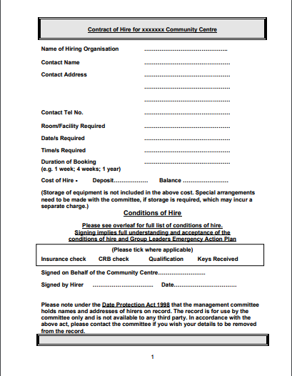
(Swansea Council, 2018).

Appendices: B
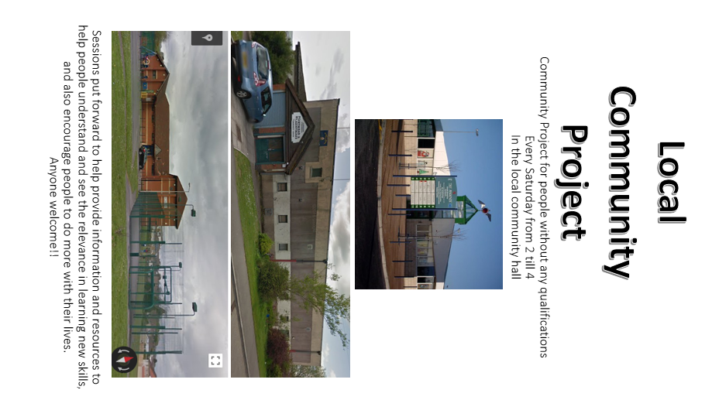

Appendices : C
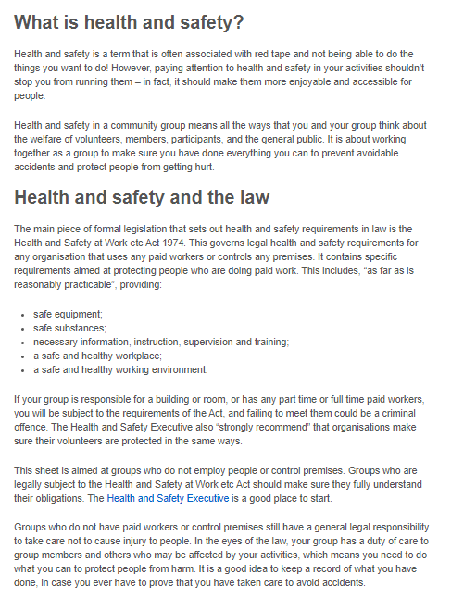(Resource centre, 2018).

Appendices: D
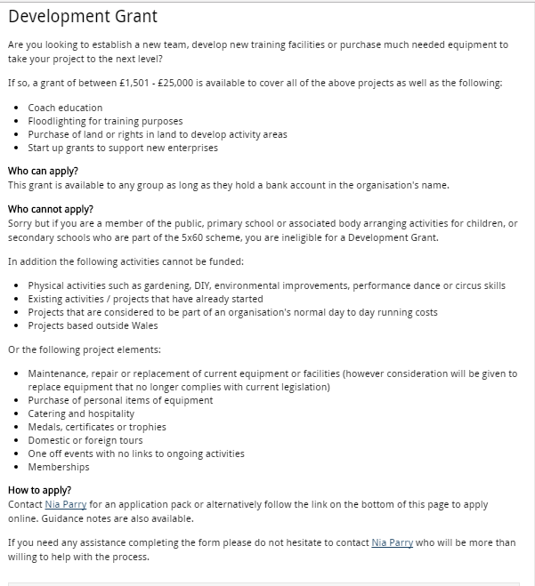
(Swansea Council, (2) 2018)

Reference list:
Resource centre. (2018). Health and Safety | Resource Centre. [online] Available at: https://www.resourcecentre.org.uk/information/health-and-safety/#practice [Accessed 17 Jan. 2018].

Swansea Council. (2018). Community centre. [online] Available at: http://file:///C:/Users/rebecca/Downloads/Community_Centre_Contract_of_Hire_2014.pdf [Accessed 15 Jan. 2018].

Swansea Council (2). (2018). Swansea - Development Grant. [online] Available at: http://www.swansea.gov.uk/article/5662/Development-Grant [Accessed 17th January. 2018].

Welsh government (2014). Local area summary statistics- Swansea. http://gov.wales/docs/statistics/2014/141218-local-area-summary-swansea-en.pdf. [Accessed 16th January 2018].

