Portfolio for ECEY4012
Content page
AI Acknowledgement – Page 1
Part 1 – Study Timetable - Pages 2-3
Part 2 – AI Activity – Pages 4-7
Part 3 - Poster and reference list – Page 8
Part 4 - Link to oral presentation – Page 9

AI Acknowledgement
I acknowledge the use of Microsoft 365 Copilot on 6.9.2026 to Explore Study Techniques. I used the
Prompt(s):
- ‘Ways to plan and organise your work and improve concentration and productivity’

- ‘I am a student in university doing early years and education and care. I would like to explore 2 study techniques. My chosen techniques are plan and organise my work and improve concentration and productivity’

- ‘Hi please give me information of where you got the information from’

I confirm that I have not presented any AI generated text as my own work. I confirm I have copies of my drafts, notes, and other resources I used before, and after the use of AI tools which I may be asked to provide in evidence.

I acknowledge the use of Microsoft 365 Copilot on 19.9.2026 to Create a diagram to add to my poster explaining my chosen two study techniques to students.
Prompt(s):
‘Hi, please provide me an image explaining the cycle of using the study skill planning and organising work using long and short term plans to meet the end goal breaking things down to manageable steps.’

I confirm that I have not presented any AI generated text as my own work. I confirm I have copies of my drafts, notes, and other resources I used before, and after the use of AI tools which I may be asked to provide in evidence.

Part 1 – Study Timetable
Amser /Time | Llun  Monday | Mawrth  Tuesday | Mercher  Wednesday | Iau  Thursday | Gwener  Friday | Sadwrn  Saturday | Sul  Sunday
00:00 - 00:59 | Rest | Rest | Rest | Rest | Rest | Rest | Rest
01:00 - 01:59 | Rest | Rest | Rest | Rest | Rest | Rest | Rest
02:00 - 02:59 | Rest | Rest | Rest | Rest | Rest | Rest | Rest
03:00 - 03:59 | Rest | Rest | Rest | Rest | Rest | Rest | Rest
04:00 - 04:59 | Rest | Rest | Rest | Rest | Rest | Rest | Rest
05:00 - 05:59 | Rest | Rest | Rest | Rest | Rest | Rest | Rest
06:00 - 06:59 |  |  |  |  |  | Rest | Rest
07:00 - 07:59 |  |  |  |  |  | Rest | Rest
08:00 - 08:59 | Work | Work | Work | Work | Work
09:00 - 09:59 | Work | Work | Work | Work | Work
10:00 - 10:59 | Work | Work | Work | Work | Work | Uni work – referencing and thorough checks
11:00 - 11:59 | Work | Work | Work | Work | Work | Uni work – reading and making notes for references
12:00 - 12:59 | Work | Work | Work | Work | Work | Uni work – reading and making notes for references
13:00 - 13:59 | Work | Work | Work | Work | Work | Shopping
14:00 - 14:59 | Work | Work | Work | Work | Work | Shopping
15:00 - 15:59 | Work | Work | Work | Work | Work | Shopping | Visit family
16:00 - 16:59 |  | Short term planning for 2 weeks | Late night in work |  |  | Spending time with loved ones | Visit family
17:00 - 17:59 | Uni on campus | Short term planning for 2 weeks | Uni work – plan and break down parts of assignment | Uni work – part two (personal plan) | Uni work – part three (personal plan) | Spending time with loved ones | Visit family
18:00 - 18:59 | Uni on campus | Short term planning for 2 weeks | Uni work - Part one (from personal plan) | Uni work – part two (personal plan) | Uni work – part three (personal plan) | Spending time with loved ones | Visit family
19:00 - 19:59 | Uni on campus | Short term planning for 2 weeks | Uni work – part one ( from personal plan) | Uni work – part two (personal plan) | Uni work – referencing and thorough checks | Spending time with loved ones
20:00 - 20:59 |  | Self care | Self care | Self care | Self care | Spending time with loved ones | Self care
21:00 - 21:59 | Watch TV | Watch TV | Watch TV | Watch TV | Watch TV | Self care | Watch TV
22:00 - 22:59 | Rest | Rest | Rest | Rest | Rest | Rest | Rest
23:00 - 23:59 | Rest | Rest | Rest | Rest | Rest | Rest | Rest

Part 2 – AI Activity
Initial Prompt from Microsoft Copilot 365
- ‘Ways to plan and organise your work and improve concentration and productivity’

Initial Prompt output
‘1. Plan Your Day
Use a To-Do List
- Write down all tasks you need to complete.
- Prioritise tasks
- Tick off completed tasks to maintain motivation.
Set Daily Goals
- Identify 3 to 5 key tasks you want to achieve each day.
- Break large projects into smaller, manageable steps.
- Allocate specific times for different tasks.
- Schedule challenging work during periods when you are most alert.
2. Improve Concentration
- Silence unnecessary notifications.
- Keep your workspace tidy.
- Work for 25 minutes.
- Take a 5-minute break.
- After four cycles, take a longer break of 15 to 30 minutes.
Focus on One Task at a Time
- Avoid multitasking where possible.
- Complete one activity before moving to the next.
3. Organise Your Workspace
- Store frequently used items within easy reach.
- Organise digital files into clearly labelled folders.
- Remove unnecessary paperwork and clutter.
- Keep only essential resources visible.
4. Manage Your Energy
Take Regular Breaks
- Short breaks help maintain focus and prevent fatigue.
- Stretch, walk around, or get some fresh air.
Look After Your Wellbeing
- Stay hydrated.
- Aim for sufficient sleep each night.
5. Review and Reflect
At the end of each day:
- Review what you completed.
- Identify any unfinished tasks.
- Plan priorities for the next day.
- Consider what worked well and what could be improved.’

Refined Prompts and Prompts used to Identify Resources
- ‘I am a student in university doing early years and education and care. I would like to explore 2 study techniques. My chosen techniques are plan and organise my work and improve concentration and productivity’

- ‘Hi please give me information of where you got the information from when prompt 1 was used’

Academic writing on 2 chosen Study techniques
The academic writing below discusses two study techniques that can support study success for students. These techniques are Planning and Organising Work and Improving Concentration and Productivity.
To start with, the planning and organising technique gives students manageable ways to keep on top of their work and breaks the work down into achievable steps. The way this works is creating a long-term plan which includes the end goal and a short-term plan that have daily tasks to ensure the students are working towards their goal(s) daily.
Prioritising tasks is important for students to start when planning. For example, listing the important tasks at the top with the closest due date down to least important tasks at the bottom with the due date furthest away. According to Cottrell (2021), students should look at this as ‘hot issues (red) to cold issues (blue)’ with red meaning top priority and blue meaning less of a priority. By following this technique, it allows students to have a healthy work and wellbeing balance and give them a sense of accomplishment when working their way through the list as well as achieving and meeting deadlines with limited stress.
Furthermore, McNicholas (2020) suggests working in a tidy workspace to avoid distractions can help when working on Concentration and Focus during study time. It is recommended to only keep your essentials within your workspace, however, when researching, it states you should ensure all of your resources are stored together to avoid procrastination (Moore et al 2010) mid study session as this may cause students to side track when looking for specific resources losing focus during study time.
To conclude, these two study techniques can improve students time management, organisational skills and maintain a healthy balance between work, learning and well being which is essential for students as these key lifestyle elements can be missed when studying. Students stress levels will be kept at a minimum when these study techniques are followed.

Reference list
- Cottrell, S. (2021). Skills for success: Personal Development and Employability (4th edn). Palgrave Macmillan.
- McNicholas, A.-M. (2020). The dyslexia, ADHD, and DCD-Friendly study skills guide. Jessica Kingsley Publishers.
- Moore, S., Neville, C., Murphy, M., & Connolly, C. (2010). The ultimate study skills handbook. Mcgraw-Hill/Open University Press.

Reflection on the use of AI
This reflection mirrors my background use of using Microsoft Copilot when exploring study techniques. This includes the effective uses, the obstacles I experienced and how AI can be used correctly and effectively in future studies ensuring critical thinking is used to compare the output to relevant books.
One thing that worked well was the app being easy to navigate, this is down to the use of it within my school and recent inset day training. To ensure I did not lose my research, I used the pinned option within the app so I could keep going back to find the research. It is an efficient tool to use when studying as the responses generate so quickly.
Though, getting the prompts right was a barrier I faced. My first prompt was very basic but using my knowledge from in school training and the useful tips within my first few lectures, it gave me an insight on the things that needed to be included, ensuring the prompts are very specific and include background information that at first, I did not even consider using as it didn’t appear to me how relevant background information was.
I found researching using other resources gave me confidence that the information I was using for my research from AI was relevant as it stated similar within the book I had used for research. However, I do acknowledge that this is not the case every time. I was very wary of using AI because it is a very new source and people do not know how reliable all the information it gives is. Using this tool made me quite nervy due to the fact I am new to referencing also new to university and their format of work I have not yet explored in detail.
I look forward to continuing to use AI tools in the future and I hope to use it more confidently as we move through the first year of this degree. I am intrigued to learn from other students within the lectures to include ideas and tips from the students who are using it for the same reasons, I know this will make me feel more comfortable when using AI. As a school we use it very differently to university. This does not mean both my experiences will not cross paths or even extend my knowledge and ability to use AI more effectively for both.

Part 3 – PowerPoint Poster and Reference List
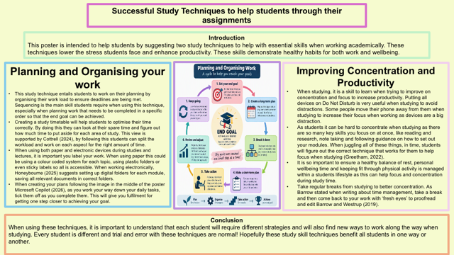

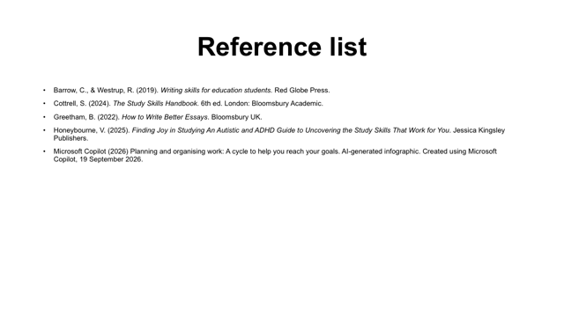

Part 4 – Link to Oral Presentation

Part 4 - Voice over.pptx

