UNIVERSITY OF WALES TRINITY SAINT DAVID - LONDON

  uwtsd logo - Bing images | Individual Reflective Report  On Group Presentation  Submitted by:  Yanislav Georgiev  Student ID: 2219323  Module: Introducing the Modern Workplace  Module code: LCBB4003  Lecturer: Dr Dudley Ofori

Table of Contents

Introduction: 3
Description: 4
Feelings: 4
Evaluation: 4,5
Analysis: 5
Conclusion: 6
Action Plan: 6
References: 7

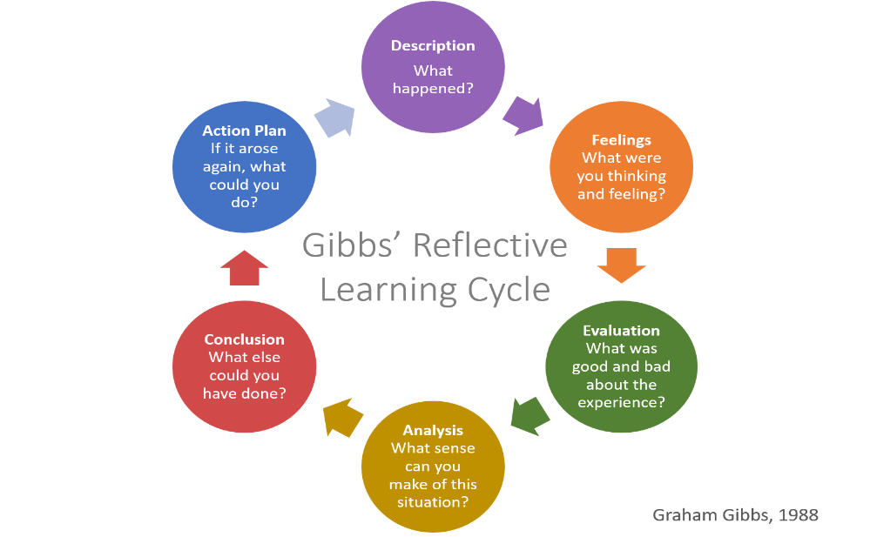

Introduction:
This reflective report critically scrutinises my experience participating in a group presentation as part of our academic assessment. Our team of five – my self Yanislav Georgiev, Valentin (the group leader), Yavor, Tsonyo, Linda - collaborated to manage tasks and deliver the group presentation. For dissecting and reflecting on my experiences, I have chosen Gibbs' Reflective Model. This model, featuring a six-stage cycle, encourages detailed reflection spanning experiences, feelings, evaluations, analysis, and plans for future actions. This model aptly aligns with our group dynamics and individual experiences, providing an effective framework for this reflective report (Gibbs, 1988).

Description:
Our group task was to deliver a group presentation on five predetermined topics. The group consisted of five members: Valentin, our team leader; Yavor, who presented second; Tsonyo, who presented fourth; Linda, who presented last; and myself, Yanislav Georgiev. I was responsible for the third presentation segment, titled "Discuss task and skills that a manager uses to run his organisation". Initially assigned the fifth topic, I switched roles with Linda to present the third segment, a process that required substantial preparation and coordination to ensure cohesive content delivery.

Feelings:
During the initial stages, I was away on holiday, and as a result, was chosen last to select my role. This led to mixed feelings of anticipation and apprehension; anticipation to contribute despite my late assignment, and apprehension about fulfilling my responsibilities effectively. When Valentin asked me to cut down my slides, I initially felt disappointed as I had invested substantial effort into creating them. The fact that he further reduced the content without prior consultation instigated feelings of frustration. Despite these challenges, I acknowledged his leadership role and respected his decision, understanding the necessity of maintaining time limits and coherence in the group presentation (Tuckman and Jensen, 1977).

Evaluation:
The overall group work process was a blend of diverse experiences, creating an environment of shared learning and constructive critique. The initial stages were challenging, especially being the last one to choose my role. This circumstance made me question the fairness of the group’s decision-making process. However, it also provided me with an opportunity to adapt to the situation and perform to the best of my ability, reflecting my resilience in unforeseen situations.
When Valentin asked me to cut down my slides, it made me realise the importance of brevity and precision in conveying complex ideas. Although it was initially disheartening to see my content being cut down, it ultimately led me to create a more concise and effective presentation. It is crucial to note that Valentin's further reduction of my slides without consultation led to feelings of disappointment and disregarded, highlighting potential areas for improvement in our team communication process. Despite this, I acknowledged the situation as part of a learning process that is inherent in teamwork (Bolton, 2010).

Analysis:
Reflecting on the group experience, I find that several situational aspects might be explained using relevant theoretical concepts. For instance, the circumstances that led to me being the last to select my role can be linked to the concept of "absence of groupthink", which advocates for collective decision-making. As I was away on holiday, this led to me accepting what was left, highlighting the significance of active participation in group discussions (Forsyth, 2018).
Similarly, when Valentin reduced my slide content without consulting me, it demonstrated an authoritative leadership style, which can sometimes lead to decreased team morale. Nevertheless, it also reflected the necessity to maintain a concise and coherent presentation, reinforcing the importance of effective communication within the team.
Despite these issues, our group worked effectively to overcome challenges, demonstrating problem-solving capabilities and adaptability. This is consistent with Tuckman's (1965) stages of group development, where we initially faced 'storming' but eventually moved to 'performing' by cooperating and accomplishing our task. This analysis reinforces the importance of reflective practice in understanding group dynamics and improving future performance.

Conclusion:
Reflecting upon the group experience has led me to crucial insights about teamwork, decision-making, communication, and leadership. The assignment presented an opportunity to explore my adaptability, particularly when I was the last one to choose my role. It reinforced the importance of active participation in group decisions and sparked growth in my ability to handle unforeseen situations.
Valentin's leadership style demonstrated a mixed approach. While his authoritative decisions concerning slide reduction were initially disheartening, they underscored the importance of concise communication and time management during presentations (Yukl, 2012). His approach promoted a focus on effectiveness over individual contributions, a valuable lesson for future team projects.
The experience significantly influenced my approach to group tasks, emphasising the need for open communication, mutual respect, and collective decision-making. It underscored the value of compromise and effective coordination in achieving group goals.
In conclusion, the experience provided an environment for practical learning beyond academic concepts, enhancing my skills in teamwork, communication, and adaptability. Reflecting on these experiences using Gibbs' model has been enlightening, illuminating areas of improvement and strengths that I will carry forward in my future team interactions and professional life.

Action Plan:
Given the lessons learned from this group work experience, I would certainly adopt some changes in future collaborative scenarios. Firstly, I would ensure active participation in decision-making processes, aiming to be more assertive with my inputs. Secondly, in the face of leadership decisions like the slide reduction, I would engage in constructive dialogue, articulating my viewpoints while respecting the team leader's perspective. Finally, I would strive for open, two-way communication within the team, fostering a collaborative environment that values every team member's contribution.

References:

Gibbs, G. (1988). Learning by doing: A guide to teaching and learning methods. Further Education Unit.
Tuckman, B. W., & Jensen, M. A. (1977). Stages of small-group development revisited. Group & Organization Studies, 2(4), 419-427.
Bolton, G. (2010). Reflective practice: Writing and professional development. Sage.
Forsyth, D. R. (2018). Group dynamics. Cengage Learning.
Yukl, G. (2012). Leadership in Organizations. Prentice Hall.

