

Development Across the Lifespan: Lucy Morris (2400095)
I confirm that I have not used any AI tools in the research and creation of this assignment. I confirm that I have not presented any AI generated materials as my own work. I confirm I have copies of my drafts, notes, and other resources I used, which I may be asked to provide in evidence.

Factors of Prenatal Growth That Can Impact Physical Development
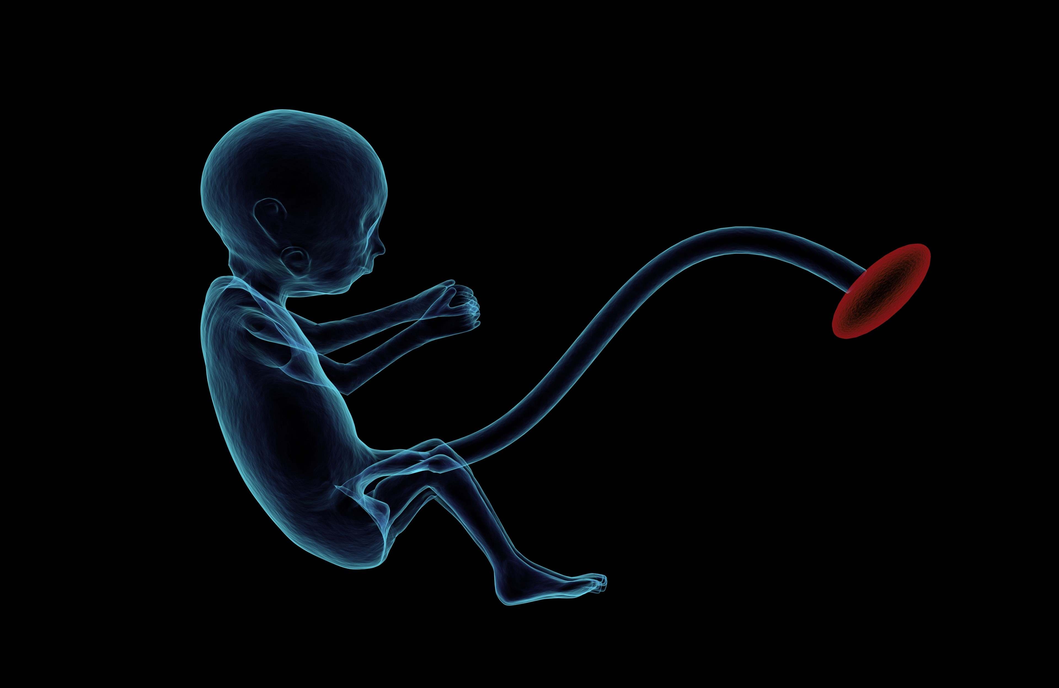

1 - This blog will discuss prenatal growth and the factors of it that are able to impact the physical development of a child. Prenatal development is a term that refers to the alteration/development of a baby before birth. There are several factors of prenatal development which can impact a child’s physical development after they have been born.

2 - It is well known that the stress experienced by a mother can affect her pregnancy. There is a connection between alterations of the fetus and the placenta (epigenetic changes). These changes can impact an individual during various developmental stages, both earlier and later points. Prenatal stress can also hold responsibility for damage caused to the psychomotor development of a child. (Buffa, Dahan, Sinclair, St-Pierre, Roofigan, Mutran, Rondeau and Dancause, 2018).
There are multiple factors of a pregnancy which can impact prenatal growth, including the mother’s lifestyle, for instance, whether she is consuming a balanced diet, how much exercise she participates in along with how often, the composition of her body and the amount of stress she experiences. These factors promote the fetus to make developmental plastic responses, which consist of processes which are epigenetic; because of this, a child’s phenotype may experience alteration. Prenatal growth and the size of individual at birth both have association with the development of health conditions during adulthood, for example, babies who did not have positive prenatal growth and were of a smaller size at birth are more likely to develop osteoporosis, cardiovascular disease and type 2 diabetes. However, babies who were of a larger size at birth also face being of a likelihood where they are at a higher risk of the development of diabetes (type 2) (Godfrey, Inskip and Hanson, 2011).

3 - Another factor that can affect a child’s physical development includes the vulnerability of their mother. The social status of which a child has does not have a direct connection/impact to/on their development; however, the experiences of which their mother has had does. American psychologist Urie Brofrenbrenner developed a theory which suggested how the development of an individual is affected/influenced by their environment. His approach implies how mothers who do not have access to a quality level of prenatal care can greatly impact the health of both her and the baby, concerning a proposal of health risks. Therefore, the mother being in a vulnerable position can affect the physical development of a child (Lindon, 2012, p. 238).
Research has proven that other factors of prenatal growth can impact upon how an individual develops physically, for example, the diet, emotions and health of the mother. The mother’s emotions can affect an infant during both the stages of pregnancy and birth. The process of birth can influence the early life and childhood of the infant. If a baby experiences trauma during birth, there is a likelihood that their development will be affected; for instance, if a baby does not receive enough oxygen during the labour process, they may be more at risk of having a condition such as cerebral palsy. What’s more, a problematic birth experience has been proven to cause a child to be more likely to develop disordered eating (Doherty and Hughes, 2014, p. 135 and 150).
References:
Boyd, D. G. and Bee, H. (2014) The developing child. London: Pearson Education
Buffa, G., Dahan, S., Sinclair, I., St-Pierre, M., Roofigari, N., Mutran, D., Rondeau, J. and Dancause, K. (2018) ‘Prenatal stress and child development: A scoping review of research in low-and middle-income countries’, PLoSONE, 13 (December) article 0207235. Available at: https://doi.org/ 10.1371/journal.pone.0207235
Davies, D. and Troy, M. F. (2020) Child development: a practitioner’s guide. New York: The Guilford Press
Doherty, J. and Hughes, M. (2014) Child development: theory and practice 0-11. 2nd edn. London: Pearson Education
Fox, N. L., Sexton, M. and Hebel, J. R. (1990) ‘Prenatal Exposure to Tobacco: I. Effects on Physical Growth at Age Three’, International Journal of Epidemiology, 19(1), pp. 66-71. Available at: https://academic.oup.com/ije/article-abstract/19/1/66/642732?login=false
Godfrey, K. M., Inskip, H. M., Hanson, M. A. (2011) ‘The long term effects of prenatal development on growth and metabolism’, Semin Reprod Med, 29(3), pp. 257-265. Available at: https://doi.10.1055/s-0031-1275518
Lindon, J. (2012) Understanding child development: 0-8 years. 3rd edn. London: Hodder Education
StudySmarter (2025) Neurotoxicity: Definition & Symptoms. Available at: Neurotoxicity: Definition & Symptoms | StudySmarter. (Accessed 12 February 2015)
UK Government (2012) Annual Report of the Chief Medical Officer 2012, Our Children Deserve Better: Prevention Pays. Available at: Chapter 5 – Healthcare (Accessed: 22 February 2025

The Impact of an Environment on Cognitive Development

4 - This blog will discuss how the environment of which a child is present in can impact their cognitive development, which can be described as development of their neurological and psychological development. It includes factors such as the child’s ability to understand concepts and articulate thoughts, as well as their thinking processes. It became increasingly apparent how the process of an individual’s development consists of a combination of both internal and external (environmental) factors (Davies and Troy, 2020, p. 4).
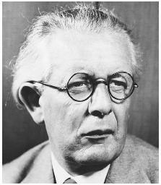
5 - An example of a way in which a child’s cognitive development can be impacted by their environment consists of the opportunities they may be presented with, which are able to influence the various ways in which development may take place. For instance, if a child is in attendance of a less-fortunate school which does not have access to materials/resources that can support learning transfers to a school which does have access to said resources and is therefore more able to deliver education of a higher quality, the child’s cognitive development may commence at a faster rate, demonstrating one environmental impact (Davies and Troy, 2020, p. 5).
Swiss psychologist Jean Piaget theorised that individuals are born with an innate plan regarding the process of cognitive development, however, the ways in which it unfolds is influenced by environmental factors. For example, despite his belief that the pattern by which the brain develops/matures is the same amongst everyone, he recognised and acknowledged that children’s cognitive abilities develop at varying rates. Piaget concluded that this was due to the environment of a child influencing the maturation of the brain (Boyd and Bee, 2014, p. 176).
Additionally, the environment of a child can impact their intelligence, as children who are fortunate enough to have positive environments at home, for example, those with a sense of security and care, have been associated with higher levels of intelligence, implying the effect of the environment of a child can have upon their cognitive abilities with regards to intelligence (Doherty and Hughes, 2014, p. 278).

6 - Relationships are a factor of a child’s environment that can impact cognitive development. These relationships include ones with a sense of stability, for example, ones with family members, as well as ones formed between the child and society. It is stated that the ways in which a child interacts with a range of different environments from an early point in their life can impact upon a child’s development. Furthermore, it has been concluded by research that there is a correlation between the environmental interactions of a child and their cognitive development, as these interactions can affect/influence it through several ways including social interaction, physical touch and the stimulation of senses (Davies and Troy, 2020, p. 4).
Piaget believed that there were 2 factors concerning the environment that were able to influence a child’s cognitive development; these consist of social transmission and the experiences of the child. Social transmission is a term used to describe individuals supporting their learning through providing them with new information. He stated that individuals a child may be reliant on for informational provision often include teachers, parents and other people in general. The information provided to the child to support their cognitive development can vary in complexity, from pieces of information such as the names of objects to models of cognitive development which are more sophisticated/mature. Piaget believed that experiences could support a child’s learning through them being presented with opportunities to take control of their own actions before observing the varying consequences of them, depending on the type of action (Boyd and Bee, 2014, p. 176).
What's more, according to UNICEF (2022), play is a factor that can influence a child’s cognitive development. Displayed to be favouring the ideology behind Piaget’s theory of cognitive development, it contains various elements of experiential learning. If a child engages in play with an adult, their brain is being presented with the chance to grow/develop as there are aspects of it which allow for the creation of neural connections which are then able to support other areas of the child’s development. Therefore, the development of a child’s cognitive abilities is likely to be supported if they are in an environment where they are presented with the opportunity to participate in activities consisting of play.

References:
Boyd, D. G. and Bee, H. (2014) The developing child. London: Pearson Education
Davies, D. and Troy, M. F (2020) Child development: a practitioner’s guide. New York: The Guilford Press
Doherty, J. and Hughes, M. (2014) Child development: theory and practice 0-11. 2nd edn. London: Pearson Education
Ferguson K. T., Cassells, R. C., MacAllister, J. W. and Evans, G. W. (2013) ‘The physical development and child development: An international review’, HHS Public Access, 48(4), pp. 437-468. Available at: https://doi:10.1080/00207594.2013.804190
McEwen, B. S. (2011) ‘Effects of stress on the developing brain’, Cerebrum: the Dana Forum on Brain Science, 14 (September) article 23447783. Available at: https://pmc.ncbi.nlm.nih.gov/articles/PMC3574783/
Tong, S., Baghurst, P., Vimpani, G. and McMichael, A. (2007) ‘Socioeconomic Position, Maternal IQ, Home Environment, and Cognitive Development’, The Journal of pediatrics, 151(3), pp. 284-288. Available at: doi:10.1016/j.jpeds.2007.03.020
United Nations Children’s Fund [UNICEF] (2022) The science of play. Available at: https://www.unicef.org/parenting/child-care/science-of-play (Accessed: 18 February 2025)

The Impact of ACEs on Emotional Development
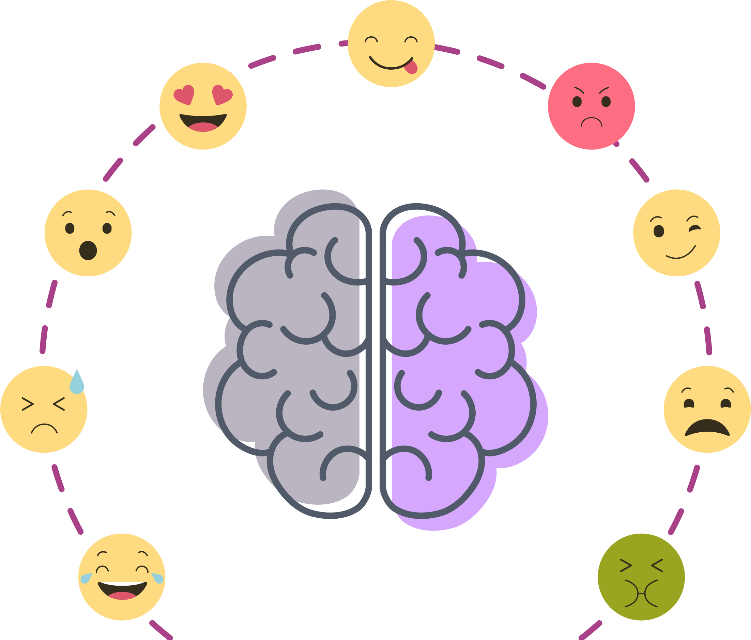

7 - This blog will discuss ACEs and the various ways they can have a profound impact on how individuals develop emotionally. According to the National Health Service [NHS] (2018), ACEs, also known as adverse childhood experiences, can impact emotional development significantly in several different ways. Firstly, what is an ACE? ACEs consists of a variety of experiences that are traumatic and have lasting impacts on the individual who experienced them later in life. Experiencing any form of abuse would be classed as an ACE. Emotional development is a term that refers to the acquisition of several skills/abilities, for example, expression, understanding, experiencing and regulation of emotions are all considered to be aspects of emotional development.
Trentacosta and Izard (2016) discuss how emotional development is a term that refers to the acquisition of several skills/abilities; for example, expression, understanding, experiencing and regulation of emotions are all considered to be aspects of emotional development.
Furthermore, the expression of emotion consists of reactions which are both physiological and physical. However, emotions are interpreted through thought processes and verbal communication. The ways in which a child reacts to the emotions they experience during the earliest points in their life are typical and do not differentiate much. However, they develop and begin to differentiate depending on the situation/reaction which has caused them over time (Hay, 2019, p. 1/10 and p. 2/11).

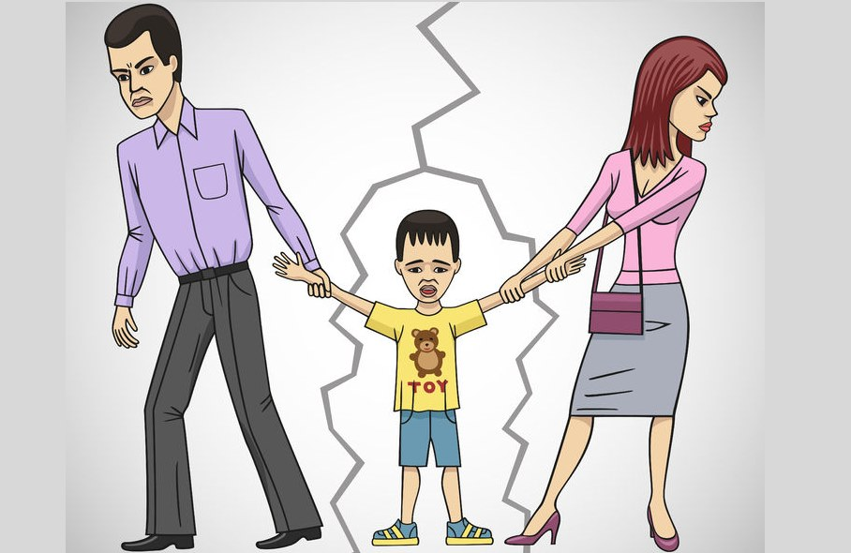
8 - Attachment issues is another way in which ACEs can impact emotional development. British psychiatrist John Bowlby developed the theory of attachment which suggests that solidified relationships are essential with regards to the prevention of the impacts of experiencing an ACE that can significantly affect an individual during childhood. It has been proven that stable, healthy relationships can lessen the impacts of experiencing an ACE, even for children who fell victim to experiencing as many as more than 4, highlighting the importance of the role relationships play in emotional development. Bowlby theorised that experiencing an ACE at an earlier stage of their life, for example, childhood, can damage/negatively affect an individual’s ability to attach to others later in life, demonstrating a way in which how experiencing an ACE can impact emotional development. The significance of said relationships is also displayed through its correlation with resilience. Resilience can be defined as having the ability to recover and continue living life in a healthy/positive way after experiencing a challenging moment/event/period. It is an incredibly valuable tool, especially when the challenge of attempting to recover from trauma experienced early in life is concerned, as it could potentially be beneficial when attempting to cope with the affects of ACEs. However, the impact of ACEs is evident through an individual’s damaged ability to display resilience due to the traumatic nature of what they may have experienced, causing the effects of it to become heightened and have a more profound impact. (Finch, Lawrence, Williams, Thompson and Hartwright, 2024).
What's more, the adversity of experiencing attachment insecurity is an experience that can impact greatly upon a child’s emotional development. For example, when they do not receive an appropriate/sufficient level of care, which can lead to their needs not being met, the process of development of their emotions can be interrupted (Doherty and Hughes, 2014, p. 345).

9 - Research has implied that experiencing harsh treatment with regards to emotions can alter the cortisol production of children, a hormone which is responsible for the regulation of the emotion of stress. The hormone plays an essential role in the functioning of the brain; however, it is possible for the production levels to exceed a healthy amount. As a result of this, children may experience a negative impact on their ability to engage/participate in healthy, positive learning processes. Another way in which they can be affected by this is through negative influence of their behaviour; for instance, a significant production of cortisol can lead to a child being more likely to display aggressive and anxious behaviour, therefore showcasing how experiencing an ACE can negatively concerning their ability to regulate emotions (Lindon, 2012, p. 86).
Experiencing adversity during childhood can hinder the development of an individual’s ability to display resilience and affect them throughout their adult life, also. The experience of adversity such as attachment insecurity can hinder the general development of a child, including emotional development, as young individuals are heavily reliant on their parent(s) to support the development of their brain through the creation/provision of experiences during appropriate moments of their life to allow their development to flourish. This is because children are unable to support their own development through the provision of stimulation. Therefore, a child’s development can face significant interruption due to experiencing the ACE of attachment insecurity (Davies and Troy, 2020, p. 139).
References:

Davies, D. and Troy, M. F. (2020) Child development: a practitioner’s guide. New York: The Guilford Press

Doherty, J. and Hughes, M. (2014) Child development: theory and practice 0-11. London: Pearson Education

Finch, K., Lawrence, D., Williams, M., Thompson, A. and Hartwright, C. (2024) ‘Relationship between adverse childhood experiences, attachment, resilience, psychological distress and trauma among forensic mental health populations’, The Journal of Forensic Psychiatry & Psychology, 35(5), pp. 660-684. Available at: https://www.tandfonline.com/doi/pdf/10.1080/14789949.2024.2365149?needAccess=true
Hay, D. (2019) Emotional Development from Infancy to Adolescence. London: Routledge

Kalia, V., Knauft, K. (2020) ‘Emotion regulation strategies modulate the effect of adverse childhood experiences on perceived chronic stress with implications for cognitive flexibility’, PLos ONE, 15(6), ?. Available at: https://research-ebsco-com.ezproxy.uwtsd.ac.uk/c/onvpsy/viewer/pdf/l3pnpw3p6j?route=details

Lindon, J. (2012) Understanding child development 0-8 years. 3rd edn. London: Hodder Education

National Health Service [NHS] (2018) Adverse childhood experiences and the lasting impact. Available at: Adverse childhood experiences and the lasting impact - NHS Safeguarding (Accessed: 22 February)

Trentacosta, C. and Izard, C. (2016) emotional development. Available at: https://www.britannica.com/science/emotional-development (Accessed: 6 February 2025)

Thompson, L., Filipp, S., Mack, J., Mercado, R. and Barnes, A. (2020) ‘Specific adverse childhood experiences and their association with other adverse childhood experiences, asthma, and emotional, developmental and behavioural problems in childhood’, Pediatric Research, 88(1), pp. 100-109. Available at: Specific adverse childhood experiences and their association with other adverse childhood experiences, asthma and emotional, developmental and behavioral problems in childhood - ProQuest

Whitters, G. (2020) Adverse Childhood Experiences, Attachment and the Early Years Learning Environment. London: Routledge
https://sway.cloud.microsoft/DM0HxM8I4VCRUyyo?ref=Link

