

Student name: Carmen Mosneagu
Student Id: 1714895
Module Title: Effective Team Working & Communication
Lecturer: Sylvia Hoffmann
Date: 13/05/2019

REAL LIFE EXPERIENCE

Introduction
Being a new student and studying for a Certificate in the Higher Education skills for the workplace I have been asked to write a report on what I have learned until now in this semester. The purpose of this report is to produce a report on communication and an effective teamwork which I have develop / acquired during this module, which is my first year of higher education. I will also focus on my daughter real life experience; I will discuss how well employers perform at communication. Using theory, performance, communication and findings of employers how can be improved. How we lean in the classroom at University many skills are required to work effectively and efficiently in an organization and communication is one of the vital skills among them. Workplace communication is defined as the process of exchanging different information and ideas in an organization. The forms of workplace communication are verbal, non-verbal and written communication. Workplace communication is essential for an organization’s ability to operate effectively and become productive. Effective workgroup and lateral communication result in improvement of individual as well as organization’s overall performance. Good communication also helps in improving employee engagement in terms of enhancement of relationships with co-workers and managers. The report will highlight on workplace communication and its significance. It will also include theories and models of communication. These have been discussed in the classroom when learning up about reflection, Gibbs model (1998).

Main body
I will write a life experience of my daughter who worked in the hotel during her college. One day in the evening when she was at work a colleague of hers wrote a wrong order and from that moment a confusion and a big problem were created because they were very busy with the orders. The order was supposed to be vegetarian sausages and he scored with pork sausage. From that moment the chef made the order that was written and when my daughter had to serve the menu at the table that family said she did not order the pig but ordered vegetarian sausages and they specified when they took the order that they were vegetarian and not I want meat of no kind.
They did not want to eat in the restaurant that it was very late because of the very poor service and they asked for money back on what they ordered, so that the manager of the restaurant hall had to talk to my girl and her colleague who took the order and only after discussing the problem with the head of the restaurant instead of returning the plate already made and giving them a drink from the house.
This was one of her happenings at work in the hotel, but she or she encountered certain problems for example: a man who paid the hotel room for 24 hours and arrived at the hotel for the morning of work was needed to wake him around eleven o'clock because he did not want to leave the hotel and he needed to pay for another 24 hours to rest and go to his house.
Another experience was when a couple was housed in the hotel and after consuming a lot of alcohol, they began to quarrel with each other and destroy the room. Then again, communication and teamwork were needed with the other colleagues and the hotel manager to solve the problem with hotel guests.
Another man who was staying at the hotel refused to leave the hotel because of health problems and was afraid of falling or making his way to his home. At that moment my girlfriend discussed with the hotel manager and decided that she had to call the police to remove him from the hotel, which happened within half an hour and panic was created around him.
The theory is that this experience is based on communication and teamwork, it is very important to be able to solve and at the same time to improve the way of communication and teamwork, to be as effective as possible, how to communicate verbally and nonverbal and to know communicating through body language.
In this report I will explain about the mathematical Shannon Weaver communication model in the following lines, I will also explain the communication between the sender and the recipient of the message, coding and decoding the intended information.
Workplace communication is highly important to different companies as it allows them to operate smoothly. Employees can experience a significant increase in productivity, commitment and morale if they are given opportunities to communicate up and down in organizational communication chain (Keyton et al., 2013). An effective communication is dependent on the professional and interpersonal relationships, which are developed through attentive listening, appropriate body language and active participation.

Team building: Building an effective team is all about the way in which team members collaborate and communicate with each other. It is essential to have one to one interaction to build a team. By using appropriate platforms of effective communication, members can exchange their thoughts and ideas (Wrench, 2013).
Employee job satisfaction: Employees feel empowered, when they are provided with opportunities to have upward communication. In this type of communication, employees provide their feedback related to workplace issues. When top managers and supervisors listen to their issue and respond to them actively, employees feel special and valued. This ultimately leads to significant increase in employee satisfaction (Zhang and Venkatesh, 2013).
Employee Turnover Rate: Flow of communication is important to employees in the workplace. They feel secure about their position if they receive updated and truthful information from management. They get the power to share concerns and thoughts within organizations. Therefore, excellent communication helps in retaining employees (Rajhans, 2012).
The Shannon- Weaver mathematical Model, 1949
This model is designed by mathematician Shannon in order to build up effective communication between the sender and receiver (Al-Fedaghi, 2012). The model is concerned with various concepts such as source, transmitter, channel, noise, receiver, message, encode, decode and information destination.

Figure 1: Shannon- Weaver mathematical Model
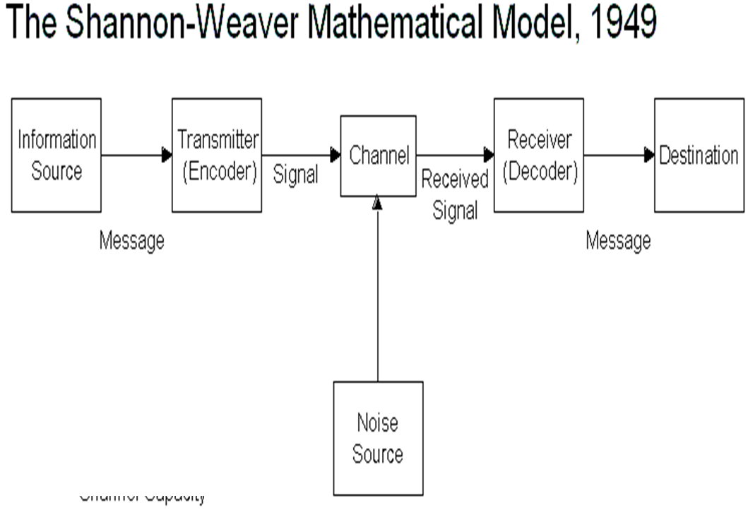 (Source: Al-Fedaghi, 2012)
Sender: Sender is the source of information and he or she develops the messages, chooses the right channel for the communication process and send the message for further activities.
Encoder: Encoder is the transmitter, who plays an important role in converting messages into signals. It can be directly referred to as machine.
Channel: It is the medium, which is used to send the messages.
Decoder: It is referred to as machine that converts signals into messages. Decoder can be the receiver who can translate the messages directly from signals.
Receiver: Receiver is the destination, where final message must reach. When the receiver gets the messages, he or she provides feedback as per the message.
Noise: Noise is referred to as physical disturbances prevent a successful communication process. It does not let the messages pass to the receiver. Noise can be environment, people and other factors.
The model explains that the sender encodes a message and sends that message to the receiver directly or through various channels. Sender converts that message into understandable codes to a machine. The message is sent through a suitable medium. The receiver performs the next step in the communication process. He or she decodes that message before interpreting it. The communication channel may have noise for which the receiver may not have the capacity to decode that message. The entire communication process may be hampered due to presence of noise in background (Al-Fedaghi, 2012).
This model can be used in the workplace both in upward and downward direction. In case of upward communication, employees of an organization are senders. They send the message through emails, telephones and direct communication mode. Top managers and supervisors are the receivers. They understand and interpret messages given by employees. They provide their opinions according to the messages. In case of downward communication in the workplace, management gives some order and covey some policies and procedures that an organization is going to implement. Managers may directly communicate with employees or use some channels such as telephone, emails and notices. When the message reaches at the employees, they try to give their viewpoint according to the messages.
Theory of communication
According to this theory, a communicator provides the thoughts to intended message and stimulates the receiver in a specific manner to achieve desirable result. The theory states that rhetorical communication is the simplest mode to win over the audiences (McCroskey, 2015).
Motivational speakers use rhetorical communication. This theory can be understood by analysing three appeals. These appeals are responsible for the success of communication process. These three appeals are called as the means of persuasion. The three appeals of Aristotle are as follows.
As per logical hypothesis of correspondence, three things should be considered before passing on any message. The sender must consider his or her information before speaking with others. The individual must decide the goal in the wake of imagining the information. The sender must determine the meaning that hoped to stimulate in mind of the receiver. Processes involved rhetorical communications are as follows.
Encoding process, this is the first stage of communication process, where the speaker should convert his or her ideas and thoughts into a manner that the receiver can easily understand. The concepts and words are chosen carefully according to the conceived ideas.
Decoding process, it is the final stage of communication process, where the receiver receives the message and perceives things. There are four elements involved in perceiving such as hearing, interpretation, evaluation and response.
According to the theory, some other elements also determine the success and failure. Noise is the major element that hinders the communication process. It refers to as the interference to the message provided by the sender. The receiver may perceive the intended message in a different way due to presence of background noise. Feedback channel also helps the sender to adapt as per the receiver’s feedback. This will ultimately help in increasing the chances of success of communication process. This theory can be implemented in an organization to the suitable appeal of a communication process. Employee and managers need to conceive an idea before sending a message to others. They should identify how the receiver will perceive the message that they are conveying. This theory can give a base for winning the audiences during communication process.
How to improve communication in the workplace and how can be improved
Communication is the key to the success of an organization. Good communication can bring everyone together towards organizational goal and breakdown obstacles. Effective communication helps in establishing clear expectations for managers and employees. It will convey how the performance will be improved. Loyalty and trust are keys to employee relationship and can be boosted by communication. Therefore, it is essential to improve workplace communication. It can be improved in the following manner.
Develop a communication-friendly Space: Managers encourage employees to express their thoughts and ideas by developing a communication friendly workplace. The employees must be shared with organizational goal. In addition to this, employees should be inspired to communicate with co-workers and build positive relationship among them (Hynes, 2012).
Conclusion
From this report, we can analyse how important communication is within the workplace. How one little mistake can cost and how it all comes down to the communication between a manager, an employer and a colleague. Communication is not just words spoken outload, it’s also actions which can be taken and body language when speaking to another.

Reference:
Maund, A. Schriek, M. and Tinkler, P. (2017). Certificate in Higher Education: Skills for the Workplace Student Yearbook. Sage Publications
Gibbs model (1998) - https://www.ed.ac.uk/reflection/reflectors-toolkit/reflecting-on-experience/gibbs-reflective-cycle
Morgan, P. (2016). The Business Student’s Guide to Study and Employability. Sage Publications
Al-Fedaghi, S., 2012. Codeless communication and the Shannon-Weaver model. In International Conference on Software and Computer Applications. Singapore: IACSIT Press,(str. 38-44).
Al-Fedaghi, S., 2012. A conceptual foundation for the Shannon-Weaver model of communication. International Journal of Soft Computing, 7(1), pp.12-19.
Hynes, G.E., 2012. Improving employees’ interpersonal communication competencies: A qualitative study. Business Communication Quarterly, 75(4), pp.466-475.
Keyton, J., Caputo, J.M., Ford, E.A., Fu, R., Leibowitz, S.A., Liu, T., Polasik, S.S., Ghosh, P. and Wu, C., 2013. Investigating verbal workplace communication behaviors. The Journal of Business Communication (1973), 50(2), pp.152-169.
Kobayashi, I., 2018. 20 Keys to workplace improvement. Routledge.
McCroskey, J.C., 2015. An introduction to rhetorical communication. Routledge.
Rajhans, K., 2012. Effective organizational communication: A key to employee motivation and performance. Interscience Management Review, 2(2), pp.81-85.
Wrench, J.S. ed., 2013. Workplace Communication for the 21st Century: Tools and Strategies that Impact the Bottom Line [2 volumes]: Tools and Strategies That Impact the Bottom Line (Vol. 1). ABC-CLIO.
Zhang, X. and Venkatesh, V., 2013. Explaining employee job performance: The role of online and offline workplace communication networks. Mis Quarterly, 37(3), pp.695-722.

