Social Epidemiological Analysis and Epidemiological Analysis Report

Name: Priyanka Thokala
Student Number: 2530797
Module Code and Title: LCHS7000 Social Epidemiology and Public Health Development
Lecturer: Muhammad Aliyu
Assignment Title: Component 2 Analytical Report

Task 1: Disability and Health Inequalities

Introduction
This report examines health inequalities affecting disabled people in the UK. Under the Equality Act 2010, a disabled person has a physical or mental impairment with a substantial, long-term adverse effect on daily activities; around 16 million people one in four of the UK population are disabled (RNID, 2026; Campaign to End Loneliness, 2023). Disability heightens health inequality because impairment intersects with poverty, discrimination and inaccessible environments, not impairment alone (NHS England, 2025). Two perspectives recur throughout: the medical model, locating disability in individual deficit, and the social model, locating disability in a disabling society (Oliver, 2013). The sections below cover three diseases and three social issues, each with statistics, an intervention, two perspectives and a real-world example.

1. Higher Rates of Mental Illness
Statistics: 47% of working-age disabled people report a mental health condition, reflecting poverty, exclusion and inaccessible environments rather than impairment alone (Fairer Consulting, 2026). NHS England’s Core20PLUS5 target of 60% receiving an annual health check is not yet met, with uptake lowest in deprived areas (Owens et al., 2025). Intervention: Individual Placement and Support achieved employment for 55% of participants versus 28% under standard rehabilitation (Modini et al., 2016). Perspective 1 (biomedical): impairment-specific vulnerability (Oliver, 2013). Perspective 2 (social model): structural exclusion (Fairer Consulting, 2026). Real-world example: Mind’s Time to Change campaign reduced stigma-related discrimination (Henderson et al., 2017).

2. Low Rates of Access to Healthcare
Statistics: despite a decade of policy effort, access to services for disabled people has changed little, due to inaccessible premises, digital exclusion and negative staff attitudes (Lowther-Payne et al., 2023). Intervention: the Accessible Information Standard obliges NHS providers to meet communication needs (NHS England, 2016); annual learning-disability health checks identify substantial unmet need (NHS England Digital, 2025). Perspective 1 (service-design): a correctable service-design problem. Perspective 2 (institutional discrimination): institutional discrimination, including diagnostic overshadowing, requiring workforce culture change (Lowther-Payne et al., 2023). Real-world example: several London GP practices now flag communication needs on records before appointments (NHS England, 2025).

3. Higher/Premature Mortality
Statistics: people with a learning disability die on average 19.5 years earlier than the general population 26.8 years earlier for severe or profound disability and around half of deaths are avoidable (King’s College London, 2022; Autistica, 2026). Intervention: STOMP targets inappropriate antipsychotic prescribing, while the statutory Oliver McGowan Mandatory Training followed the avoidable death it is named after (Health Education England, 2022). Perspective 1 (impairment-severity): mortality reflects impairment severity. Perspective 2 (systemic neglect): drawing on LeDeR’s finding that half of deaths are avoidable, attributes it to remediable neglect (King’s College London, 2022). Real-world example: the Oliver McGowan case is used nationally in NHS training to illustrate diagnostic overshadowing (Health Education England, 2022).

4. Social Isolation and Loneliness
Statistics: 13.3% of disabled adults report feeling lonely ‘often or always’, against 3.4% of non-disabled adults (Office for National Statistics, 2019), driven by inaccessible transport and reduced social care (GOV.UK, 2025). Intervention: social prescribing to community activities is linked to reduced GP consultation rates, though evidence remains mixed (Bickerdike et al., 2017). Perspective 1 (individual): loneliness as individually modifiable, addressed through befriending. Perspective 2 (environmental): an inaccessible built environment is the root cause (GOV.UK, 2025). Real-world example: the Local Area Coordination model, used by several UK councils, has reduced demand on formal social care through community connections (Local Area Coordination Network, 2020).

5. Poverty and Financial Hardship
Statistics: 28% of disabled people live in poverty after housing costs, against around 20% of non-disabled people, compounded by extra disability-related costs averaging £975 a month (Joseph Rowntree Foundation, 2026; Scope, n.d.-b). Only 52.8% of disabled people are in work versus 82.3% of non-disabled people (Lancaster University/Work Foundation, 2026). Intervention: Access to Work funds workplace adjustments, helping most users start or remain in employment (DWP, 2025). Perspective 1 (labour-market): removing employer-side barriers. Perspective 2 (welfare-system): social security is inadequate relative to disability costs (Joseph Rowntree Foundation, 2026). Real-world example: the Motability Scheme converts mobility benefits into a leased vehicle, supporting independent employment (Motability, 2025).

6. Inaccessible Housing
Statistics: only 13% of English homes have basic accessibility features; an estimated 400,000 wheelchair users live in unsuitable housing, and waits for an adapted council home can reach 47 years (Housing LIN, 2025; Habinteg Housing Association, 2022). Intervention: the Disabled Facilities Grant funds adaptations such as stairlifts, while the London Plan’s Policy D7 mandates 10% of new homes meet wheelchair-accessible standards (Greater London Authority, 2021). Perspective 1 (market-led): incentivising developers voluntarily. Perspective 2 (regulatory-mandate): only binding quotas can shift supply at scale (Housing LIN, 2025). Real-world example: London housing associations delivering M4(3)-standard units illustrate this approach (Greater London Authority, 2021).

National Response to Reduce Health Inequalities in Disabled People
Response 1: the Equality Act 2010 places a legal duty on public bodies to make reasonable adjustments and, under Part 1, to reduce socio-economic inequality in strategic decisions (RNID, 2026; House of Lords Library, 2022). Response 2: NHS England’s Core20PLUS5 framework targets 60% of people with severe mental illness receiving an annual health check (NHS England Digital, 2025). Perspective 1 (supportive): accountable, measurable progress. Perspective 2 (critical): access has changed little despite a decade of policy, suggesting legislation alone is insufficient without funding and enforcement (Lowther-Payne et al., 2023).

Organisations That Support Disabled People
Scope, founded in 1952, raises awareness through research such as its Disability Price Tag and campaigns on transport, employment and public attitudes (Scope, n.d.-c; n.d.-d; n.d.-e), aiming to close the disability employment gap (Scope, n.d.-f). Mencap plays a complementary role for people with a learning disability, publishing research on the LeDeR mortality gap and campaigning for STOMP and Oliver McGowan training (Mencap, 2026) different organisations targeting different points on the same causal chain.

Conclusion
This report has shown that disabled people face substantial health inequalities that are largely social rather than medical in origin. LeDeR’s finding that half of deaths are avoidable, and stagnant healthcare access despite a decade of policy, indicate that structural barriers, not impairment, are the primary driver (King’s College London, 2022; Lowther-Payne et al., 2023). Effective policy should combine clinical intervention health checks, STOMP with structural reform accessible-housing quotas, welfare adequacy. Legislation, NHS initiatives and organisations such as Scope and Mencap represent progress, but the scale of the employment and housing gaps indicates more coordinated action is required.

Task 2: Epidemiological Analysis of Type 2 Diabetes in the London Borough of Newham

Introduction
Type 2 diabetes (T2D) is a chronic metabolic condition caused by insulin resistance and declining insulin production, leading to microvascular complications such as retinopathy and nephropathy and macrovascular complications including cardiovascular disease (American Diabetes Association, 2023). Beyond physical harm, T2D carries social and cultural consequences: stigma around weight and diet, self-monitoring burden, and, in some minority communities, cultural barriers to discussing the condition or adapting traditional diets (DiabetesontheNet, 2022). A biomedical perspective explains T2D through individual physiology; a social-determinants perspective explains the same distribution through poverty, food environments and housing, arguing physiology is itself shaped by these upstream conditions (DiabetesontheNet, 2022) both perspectives recur throughout.
Worldwide, around 589 million adults live with diabetes, projected to reach 1.31 billion by 2050, with over half of type 2 cases attributable to high BMI (GBD 2021 Diabetes Collaborators, 2023). In the UK, 4.6–4.8 million people are diagnosed, around 90% with T2D, with a further 1.3 million undiagnosed and 6.3 million with prediabetes, costing the NHS £10.7 billion a year (Diabetes UK, 2025). This report examines T2D in Newham a deprived, ethnically diverse borough with historic prevalence of around 9.4%, several times the England average (Barry and Greenhalgh, 2022; Fingertips, 2019).
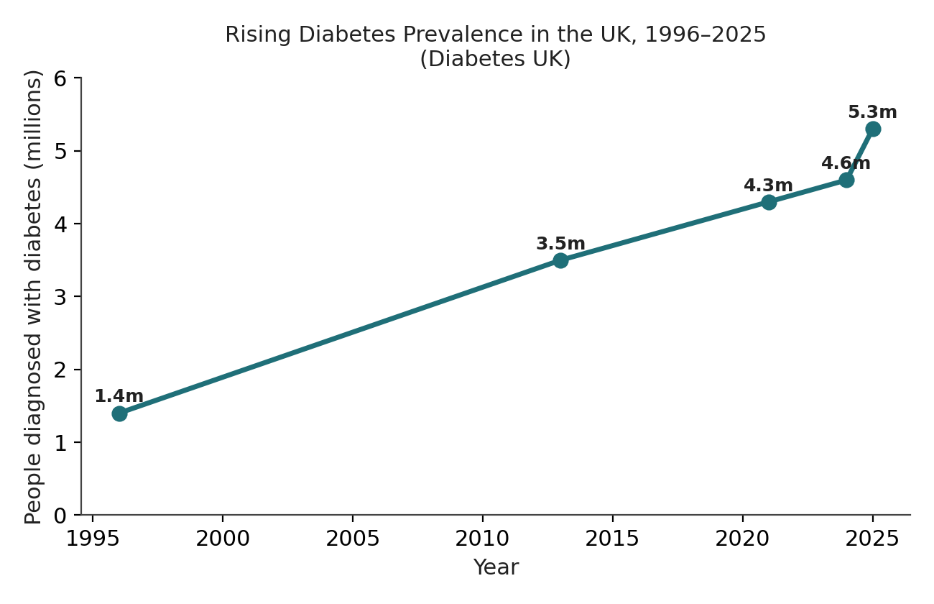
Figure 1: UK diabetes prevalence has risen sharply since the 1990s (Diabetes UK).
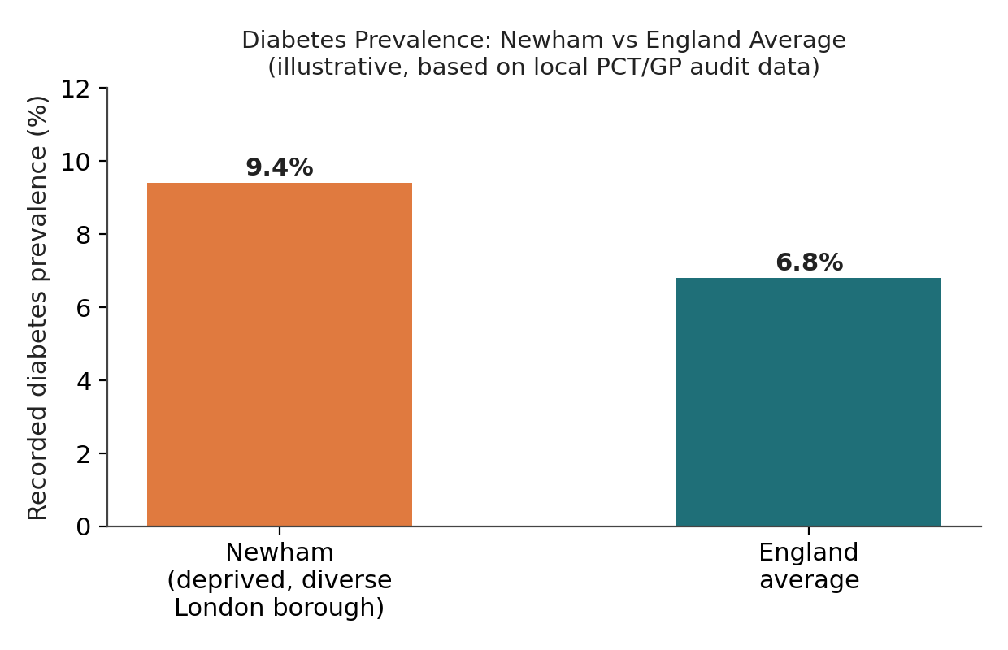
Figure 2: Recorded diabetes prevalence in Newham versus the England average.

Main Body

Public health measures drawing on the 3 P’s
Public health practice operates across three domains: health improvement, health protection, and health service improvement (NIHR Applied Research Collaboration, n.d.), each illustrated below with a linked determinant.

Health Improvement
Delivered through the NHS Diabetes Prevention Programme (Healthier You), a behaviour-change intervention for adults with non-diabetic hyperglycaemia (NHS England Digital, n.d.). The evidence is strong: the Da Qing study found a six-year diet-and-exercise programme reduced diabetes incidence by 51% (Pan et al., 1997), with Finnish and US trials replicating 58% reductions (Tuomilehto et al., 2001; Knowler et al., 2002). Determinant: the food environment with 37% of Newham residents in poverty and food unaffordable, advice operates against limited access to healthy food (Barry and Greenhalgh, 2022).

Health Protection
Operates through NHS Health Checks and annual retinopathy and foot screening (Bower et al., 2023). Determinant: ethnicity and language. Newham speaks over 200 languages; T2D prevalence is 7.69% among Asian and 5.58% among Black adults, against 5.04% among White adults (Pham et al., 2019) a gap PODOSA suggests standard services do not close without cultural adaptation (Bhopal et al., 2014).

Health Service Improvement
Integrates primary and secondary care through a joint community diabetes service managing Newham’s high caseload (Gelding, 2005). Determinant: socioeconomic deprivation prevalence of around 9.4% is several times the England average (Barry and Greenhalgh, 2022; Fingertips, 2019), so services must be scaled to a deprived, high-need population.

Key determinants and risk factors
T2D risk in Newham is shaped by modifiable, non-modifiable and social determinants together, three of which follow.

Determinant 1: Obesity and Excess Body Weight (modifiable, biological)
Statistics: over half of global T2D cases are attributable to high BMI (GBD 2021 Diabetes Collaborators, 2023), reflecting the pathway from excess adiposity to insulin resistance and declining beta-cell function (American Diabetes Association, 2023). Obesity is the largest modifiable determinant worldwide, compounded in Newham by an obesogenic food environment (Barry and Greenhalgh, 2022). Perspective 1 (behaviour-change): education and weight management. Perspective 2 (structural): limited impact where 37% live in poverty and food is unaffordable (Barry and Greenhalgh, 2022).

Determinant 2: Ethnicity and Family History (non-modifiable)
Statistics: T2D prevalence is 7.69% among Asian and 5.58% among Black adults, against 5.04% among White adults (Pham et al., 2019) a gap not explained by BMI alone, consistent with Newham’s prevalence of 9.4% (Barry and Greenhalgh, 2022; Fingertips, 2019). Age and family history compound this risk, so it cannot be reduced through lifestyle change alone. Real-world example: PODOSA, testing a lifestyle intervention among South Asians in Scotland, found only a modest, non-significant effect, showing standardised models need cultural adaptation (Bhopal et al., 2014).

Determinant 3: Poverty, Food Access and Housing (social/structural)
Statistics: Newham focus-group research identified poverty, poor food access, overcrowded housing and low health literacy compounding ethnic risk, against a backdrop of 37% of residents in poverty (Barry and Greenhalgh, 2022). These determinants shape the conditions in which biological and behavioural risk factors operate, so advice is undermined without action on income, housing and food access. Perspective 1 (behaviour-change): favours education. Perspective 2 (structural): limited impact here (Barry and Greenhalgh, 2022).

Using epidemiological studies and a health needs assessment
Approach: a health needs assessment for Newham would draw on the National Diabetes Audit and QOF registers for diagnosed cases, NHS Health Checks for undiagnosed adults, the Joint Strategic Needs Assessment combining demographic and deprivation data, and local research such as Newham’s prediabetes focus-group study (Barry and Greenhalgh, 2022). Perspective 1 (quantitative): standardised national data. Perspective 2 (mixed-methods): registers alone miss why specific groups are at risk and must be triangulated with qualitative insight to identify under-served sub-groups, such as working-age South Asian men.

Monitoring and surveillance systems
Systems: the National Diabetes Audit, covering around 98% of GP practices, tracks diagnosed diabetes and DPP referrals (Bower et al., 2023), complemented by the Quality and Outcomes Framework, the National Diabetes Inpatient Safety Audit, ONS mortality data, and benchmarking through the WHO Global Health Observatory and IDF Atlas (GBD 2021 Diabetes Collaborators, 2023) routine surveillance, active screening and sentinel research together. Perspective 1 (coverage): routine registers for comparability. Perspective 2 (sensitivity): registers only capture diagnosed cases, so undiagnosed disease needs active case-finding.

Public health impact: short- and long-term consequences
Statistics: short-term, poorly controlled T2D risks acute hyper/hypoglycaemic episodes and hospital admission; long-term, it drives cardiovascular disease, kidney disease, amputation and vision loss, with around 7,000 excess diabetes-linked deaths in the UK in 2022 (Diabetes UK, 2023). Around 60% of the £10.7 billion annual NHS diabetes spend goes on complications rather than prevention (Diabetes UK, 2025). Perspective 1 (health-economics): this cost burden justifies prevention investment. Perspective 2 (patient-centred): lived experience vision loss, amputation, psychological burden shows cost framing understates the human case (DiabetesontheNet, 2022).

Designing and evaluating a health intervention programme
Intervention: the NHS-DPP identifies adults with non-diabetic hyperglycaemia and refers them to a nine-to-twelve-month lifestyle programme (NHS England Digital, n.d.). The DIPLOMA evaluation found it significantly reduced T2D incidence and was likely cost-effective, though referral rates varied (Bower et al., 2023), and practices adopting the DPP earliest saw lower subsequent incidence (Ravindrarajah et al., 2022). Real-world example: DiRECT achieved diabetes remission in 46% of participants at 12 months through low-calorie diet replacement (Lean et al., 2018). Perspective 1 (standardisation): rolling out nationally-evaluated designs. Perspective 2 (local adaptation): Newham’s diversity (over 200 languages) requires culturally tailored materials and community health workers, informed by PODOSA (Bhopal et al., 2014).

Strengths and weaknesses of the epidemiological approach
Strengths include the National Diabetes Audit’s near-complete GP coverage and the quasi-experimental design of DIPLOMA and Ravindrarajah et al. (2022), offering stronger causal evidence than observation. However, registries only capture diagnosed cases, likely underestimating Newham’s true burden given 1.3 million undiagnosed cases nationally (Diabetes UK, 2025). Deprivation and ethnicity statistics risk an ecological fallacy, rarely disentangling how the two interact (Owens et al., 2025). Qualitative research underpinning Newham’s barriers used small staff samples rather than patients, limiting generalisability (Barry and Greenhalgh, 2022). Landmark trials such as the Finnish DPS and US DPP used largely White cohorts; PODOSA’s weaker South Asian results show efficacy cannot be assumed to generalise (Bhopal et al., 2014). Finally, referral and delivery fidelity varied between practices, so implementation determines effectiveness (Bower et al., 2023).

Conclusion
T2D is a growing, socially patterned problem, and Newham shows how deprivation, ethnicity and access combine to produce prevalence several times the national average. Social determinants explain why Newham’s baseline risk is so high, while individual-level intervention explains how far that risk can be reduced. An effective response requires all three public health domains together: prevention through the NHS-DPP and DiRECT-style remission programmes, protection through screening and audit, and culturally competent service improvement informed by PODOSA. While national evaluations show the NHS-DPP is likely effective, under-captured undiagnosed disease, ecological oversimplification, and variable practice-level fidelity limit how far these findings hold in Newham without local evaluation.

Reference List (UWTSD Harvard Style)
Note: the references below are drawn from real, verifiable sources located via research for this draft, together with well-established peer-reviewed trials (e.g. Da Qing, Finnish DPS, US DPP, DiRECT, PODOSA) that are standard citations in the diabetes-prevention literature. Your module requires a minimum of 30 references from academic databases (e.g. EBSCOhost) and named public health bodies (UKHSA, WHO, ONS) — please supplement this list using your library's databases before submission, as this list alone will not meet that quota.
American Diabetes Association (2023) 'Standards of Care in Diabetes — 2023', Diabetes Care, 46(Supplement_1), pp. S1–S291.
Autistica (2026) 'Updated NHS report on early deaths in autistic people and people with learning disabilities'. Available at: https://www.autistica.org.uk/news/leder-report-2025 (Accessed: 27 July 2026).
Balasanthiran, A. et al. (2012) 'Type 2 diabetes in children and young adults in East London: an alarmingly high prevalence', Practical Diabetes. Available at: https://wchh.onlinelibrary.wiley.com/doi/10.1002/pdi.1689 (Accessed: 27 July 2026).
Barry, E. and Greenhalgh, T. (2022) 'How do UK general practice staff understand and manage prediabetes? A focus group study', BJGP Open, 6(2), BJGPO.2021.0166.
Bhopal, R.S., Douglas, A., Wallia, S., Forbes, J.F., Lean, M.E.J., Gill, J.M.R., Sattar, N., Sharma, A., McKnight, J., Tuomilehto, J., Wild, S. and Sheikh, A. (2014) 'Effect of a lifestyle intervention on weight change in South Asian individuals in the UK at high risk of type 2 diabetes: a family-cluster randomised controlled trial', The Lancet Diabetes & Endocrinology, 2(3), pp. 218–227.
Bickerdike, L., Booth, A., Wilson, P.M., Farley, K. and Kennedy, A. (2017) 'Social prescribing: less rhetoric and more reality. A systematic review of the evidence', BMJ Open, 7(4), e013384.
Bower, P., Soiland-Reyes, C., Bennett, C., Brunton, L., Burch, P., Cameron, E., Chandola, T., Chatzi, G., Cotterill, S., French, D.P., Gellatly, J., Hann, M., Hawkes, R., Heller, S., Holland, F., Howarth, E., Howells, K., Kontopantelis, E., Lowndes, E., Marsden, A., Mason, T., McManus, E., Meacock, R., Miles, L., Mistry, M., Murray, E., Parkinson, B., Ravindrarajah, R., Reeves, D., Ross, J., Sanders, C., Stokes, J., Wallworth, H., Watkinson, R., Wattal, V., Whittaker, W., Wilson, P., Woodham, A. and Sutton, M. (2023) 'The effectiveness and cost-effectiveness of the NHS Diabetes Prevention Programme (NHS-DPP): the DIPLOMA long-term multimethod assessment', NIHR Journals Library. Available at: https://www.ncbi.nlm.nih.gov/books/NBK614155/ (Accessed: 27 July 2026).
Campaign to End Loneliness (2023) 'How can we combat loneliness and social isolation amongst disabled people?'. Available at: https://www.campaigntoendloneliness.org/disability-and-loneliness/ (Accessed: 27 July 2026).
Centre for Ageing Better (n.d.) 'Accessible homes are a matter of social justice'. Available at: https://ageing-better.org.uk/blogs/accessible-homes-are-matter-social-justice (Accessed: 27 July 2026).
Chemist-4-U (2026) 'UK Diabetes Statistics'. Available at: https://www.chemist-4-u.com/guides/diabetes/diabetes-statistics/ (Accessed: 27 July 2026).
DiabetesontheNet (2022) 'Living with diabetes: a qualitative review of minority ethnic groups in a deprived London borough'. Available at: https://diabetesonthenet.com/journal-diabetes-nursing/living-with-diabetes-a-qualitative-review-of-minority-ethnic-groups-in-a-deprived-london-borough/ (Accessed: 27 July 2026).
Diabetes UK (2023) 'Poor diabetes care may be behind 7,000 excess deaths'. Available at: https://www.diabetes.org.uk/about-us/news-and-views/poor-diabetes-care-may-be-behind-7000-excess-deaths (Accessed: 27 July 2026).
Diabetes UK (2025) 'How many people in the UK have diabetes?'. Available at: https://www.diabetes.org.uk/about-us/about-the-charity/our-strategy/statistics (Accessed: 27 July 2026).
Disability Rights UK (2024) 'Poll reveals extent of loneliness for Disabled people'. Available at: https://www.disabilityrightsuk.org/news/poll-reveals-extent-loneliness-disabled-people (Accessed: 27 July 2026).
DWP (Department for Work and Pensions) (2025) 'Access to Work statistics' and 'Disability Confident scheme'. Available at: https://www.gov.uk/government/collections/access-to-work-statistics (Accessed: 27 July 2026).
Fairer Consulting (2026) 'Mental health inequalities in the UK: who's falling through the gaps?'. Available at: https://www.fairerconsulting.com/blog/mental-health-inequalities-in-the-uk-whos-falling-through-the-gaps (Accessed: 27 July 2026).
Fingertips (2019) 'E09000025 — Newham health profile'. Public Health England. Available at: https://fingertips.phe.org.uk/static-reports/health-profiles/2019/e09000025.html (Accessed: 27 July 2026).
GBD 2021 Diabetes Collaborators (2023) 'Global, regional, and national burden of diabetes from 1990 to 2021, with projections of prevalence to 2050: a systematic analysis for the Global Burden of Disease Study 2021', The Lancet, 402(10397), pp. 203–234.
Gelding, S.V. (2005) 'Community diabetes: an East London perspective', Journal of the Royal Society of Medicine, 98(3), pp. 96–100.
Gong, Q. et al. (2019) 'Morbidity and mortality after lifestyle intervention for people with impaired glucose tolerance: 30-year results of the Da Qing Diabetes Prevention Outcome Study', The Lancet Diabetes & Endocrinology, 7(6), pp. 452–461.
GOV.UK (2025) 'Disability, loneliness and relationships: a thematic report'. Available at: https://www.gov.uk/government/publications/disability-loneliness-and-relationships-a-thematic-report (Accessed: 27 July 2026).
Greater London Authority (2021) 'The London Plan 2021: Policy D7, Accessible Housing'. Available at: https://www.london.gov.uk/programmes-strategies/planning/london-plan (Accessed: 27 July 2026).
Habinteg Housing Association (2022) 'New government data reveals accessible homes crisis for disabled people'. Available at: https://www.habinteg.org.uk/latest-news/new-government-data-reveals-accessible-homes-crisis-for-disabled-people-1557/ (Accessed: 27 July 2026).
Health Education England (2022) 'Oliver McGowan Mandatory Training on Learning Disability and Autism'. Available at: https://www.hee.nhs.uk/our-work/learning-disability/oliver-mcgowan-mandatory-training-learning-disability-autism (Accessed: 27 July 2026).
Henderson, C., Robinson, E., Evans-Lacko, S. and Thornicroft, G. (2017) 'Relationships between anti-stigma programme awareness, disclosure comfort and intended help-seeking regarding a mental health problem', British Journal of Psychiatry, 211(5), pp. 316–322.
House of Lords Library (2022) 'The Equality Act 2010: impact on disabled people'. Available at: https://lordslibrary.parliament.uk/the-equality-act-2010-impact-on-disabled-people/ (Accessed: 27 July 2026).
Housing LIN (2025) 'The state of accessible housing — Accessible Homes Factsheet 2025'. Centre for Ageing Better. Available at: https://www.housinglin.org.uk/finder.cfm?i=24657 (Accessed: 27 July 2026).
Joseph Rowntree Foundation (2026) 'Disability and poverty'. Available at: https://www.jrf.org.uk/uk-poverty-statistics/disability (Accessed: 27 July 2026).
King's College London (2022) '2021 LeDeR report into the avoidable deaths of people with learning disabilities'. Available at: https://www.kcl.ac.uk/news/2021-leder-report-into-the-avoidable-deaths-of-people-with-learning-disabilities (Accessed: 27 July 2026).
Knowler, W.C., Barrett-Connor, E., Fowler, S.E. et al. (2002) 'Reduction in the incidence of type 2 diabetes with lifestyle intervention or metformin', New England Journal of Medicine, 346(6), pp. 393–403.
Lancaster University / Work Foundation (2026) 'Latest labour market figures show disabled people hardest hit by weakening jobs market'. Available at: https://www.lancaster.ac.uk/work-foundation/news/disabled-people-hardest-hit-by-weakening-jobs-market (Accessed: 27 July 2026).
Lean, M.E.J., Leslie, W.S., Barnes, A.C. et al. (2018) 'Primary care-led weight management for remission of type 2 diabetes (DiRECT): an open-label, cluster-randomised trial', The Lancet, 391(10120), pp. 541–551.
Lean, M.E.J., Leslie, W.S., Barnes, A.C. et al. (2019) 'Durability of a primary care-led weight-management intervention for remission of type 2 diabetes: 2-year results of the DiRECT open-label, cluster-randomised trial', The Lancet Diabetes & Endocrinology, 7(5), pp. 344–355.
Li, G., Zhang, P., Wang, J. et al. (2008) 'The long-term effect of lifestyle interventions to prevent diabetes in the China Da Qing Diabetes Prevention Study: a 20-year follow-up study', The Lancet, 371(9626), pp. 1783–1789.
Local Area Coordination Network (2020) 'What is Local Area Coordination?'. Available at: https://lacnetwork.org/what-is-local-area-coordination/ (Accessed: 27 July 2026).
Local Government Association (n.d.) 'Learning from Life and Death Reviews of people with a learning disability and autistic people'. Available at: https://www.local.gov.uk/parliament/briefings-and-responses/learning-life-and-death-reviews-people-learning-disability-and (Accessed: 27 July 2026).
Lowther-Payne, H.J., Ushakova, A., Beckwith, A., Liberty, C., Edge, R. and Lobban, F. (2023) 'Understanding inequalities in access to adult mental health services in the UK: a systematic mapping review', BMC Health Services Research, 23, 1042.
Mencap (2026) 'Learning Disability — Health Inequalities Research'. Available at: https://www.mencap.org.uk/learning-disability-explained/research-and-statistics/health/health-inequalities (Accessed: 27 July 2026).
Modini, M., Joyce, S., Mykletun, A., Christensen, H., Bryant, R.A., Mitchell, P.B. and Harvey, S.B. (2016) 'The mental health benefits of employment: results of a systematic meta-review', Australasian Psychiatry, 24(4), pp. 331–336.
Motability (2025) 'About the Motability Scheme'. Available at: https://www.motability.co.uk/about/ (Accessed: 27 July 2026).
NHS England (2015) 'Stopping over-medication of people with a learning disability, autism or both (STOMP)'. Available at: https://www.england.nhs.uk/learning-disabilities/improving-health/stomp/ (Accessed: 27 July 2026).
NHS England (2016) 'Accessible Information Standard'. Available at: https://www.england.nhs.uk/ourwork/accessibleinfo/ (Accessed: 27 July 2026).
NHS England (2025) 'NHS England's statement on information on health inequalities'. Available at: https://www.england.nhs.uk/long-read/nhs-englands-statement-on-information-on-health-inequalities/ (Accessed: 27 July 2026).
NHS England Digital (n.d.) 'National Diabetes Audit Programme'. Available at: https://digital.nhs.uk/data-and-information/clinical-audits-and-registries/national-diabetes-audit (Accessed: 27 July 2026).
NHS England Digital (2025) 'Inequalities in mental health and why this data is a priority'. Available at: https://digital.nhs.uk/data-and-information/data-collections-and-data-sets/data-sets/mental-health-services-data-set/submit-data/data-quality-of-protected-characteristics-and-other-vulnerable-groups/inequalities-in-mental-health-and-why-this-data-is-a-priority (Accessed: 27 July 2026).
NIHR Applied Research Collaboration Wessex (n.d.) '7. Public Health'. Available at: https://arc-wm.nihr.ac.uk/public-health (Accessed: 27 July 2026).
Office for National Statistics (2019) 'Disability, well-being and loneliness, UK'. Available at: https://www.ons.gov.uk/peoplepopulationandcommunity/healthandsocialcare/disability/bulletins/disabilitywellbeingandlonelinessuk/2019 (Accessed: 27 July 2026).
Oliver, M. (2013) 'The social model of disability: thirty years on', Disability & Society, 28(7), pp. 1024–1026.
Owens, J., Ravindrarajah, R., Norman, G., Hopkin, E., Shi, C., Lovell, K. and Bee, P.E. (2025) 'Access, inequalities and annual health checks (AHCs) for adults living with severe mental illness in the UK: a mixed-methods systematic review', BMJ Open, 15(8), e093426.
Pan, X.R., Li, G.W., Hu, Y.H. et al. (1997) 'Effects of diet and exercise in preventing NIDDM in people with impaired glucose tolerance: the Da Qing IGT and Diabetes Study', Diabetes Care, 20(4), pp. 537–544.
Pham, T.M., Carpenter, J.R., Morris, T.P., Sharma, M. and Petersen, I. (2019) 'Ethnic Differences in the Prevalence of Type 2 Diabetes Diagnoses in the UK: Cross-Sectional Analysis of the Health Improvement Network Primary Care Database', Clinical Epidemiology, 11, pp. 1081–1088.
Ravindrarajah, R., Reeves, D., Howarth, E. et al. (2022) 'Population level impact of the NHS Diabetes Prevention Programme on incidence of type 2 diabetes in England: an observational study', The Lancet Regional Health — Europe, 21, 100455.
RNID (2026) 'Your rights under the Equality Act'. Available at: https://rnid.org.uk/information-and-support/your-rights/the-equality-act-2010/ (Accessed: 27 July 2026).
Scope (n.d.-a) cited in Campaign to End Loneliness (2023) 'How can we combat loneliness and social isolation amongst disabled people?'. Available at: https://www.campaigntoendloneliness.org/disability-and-loneliness/ (Accessed: 27 July 2026).
Scope (n.d.-b) 'Disability facts and figures'. Available at: https://www.scope.org.uk/media/disability-facts-figures (Accessed: 27 July 2026).
Scope (n.d.-c) 'Vision, mission and values'. Available at: https://www.scope.org.uk/about-us/vision-mission-values (Accessed: 27 July 2026).
Scope (n.d.-d) 'About us'. Available at: https://www.scope.org.uk/about-us (Accessed: 27 July 2026).
Scope (n.d.-e) 'Live the life I choose'. Available at: https://www.scope.org.uk/about-us/impact-report/live-the-life-i-choose (Accessed: 27 July 2026).
Scope (n.d.-f) 'An Equal Future'. Available at: https://www.scope.org.uk/about-us/an-equal-future-strategy/an-equal-future (Accessed: 27 July 2026).
Shakespeare, T. (2014) Disability Rights and Wrongs Revisited. 2nd edn. Abingdon: Routledge.
Tuomilehto, J., Lindström, J., Eriksson, J.G. et al. (2001) 'Prevention of type 2 diabetes mellitus by changes in lifestyle among subjects with impaired glucose tolerance', New England Journal of Medicine, 344(18), pp. 1343–1350.
Wikipedia (2026) 'Scope (charity)'. Available at: https://en.wikipedia.org/wiki/Scope_(charity) (Accessed: 27 July 2026).

