IWD
Assignment 2: Website design and development
16/12/2025
.

UNIVERSITY OF WALES TRINITY SAINT DAVIDLONDON CAMPUS
london campus
Module Name: Introduction to Web and Database Concepts

Module Code: ACCA4023

Student Name: Haytham Abubakar
Student ID: 2434465
Group: 3

Lecturer’s Name: Suneth Fernando

Table of Contents
Introduction to your case study which you choose 2
User Requirements 4
Website Implementation 5
Home page 5
Training page 5
Schedule page 6
Gallery page 6
Contact-us page 7
Validating my website 7
Self-evaluation of my website 9
Usefulness (usability and utility): 9
Search Engine Optimisation (SEO): 9
Website Accessibility: 9
Reference list 9
References 9

Introduction to your case study which you choose
Please explain what type of business which you have chosen and what type of business function which you are going to consider when you design and develop required website. Referents
Home page
presents, Sudan boxing cl cub’s premier training environment through striking visuals and compelling content. We showcase our professional boxing ring, modern training equipment, and dynamic class sessions with high-quality photographs. Visitors immediately see our certified coaches in action and red about our training philosophy emphasizing technology, discipline, and safety. Testimonials from accomplished fighter highlights our success in developing champions across various wight class. The page features recent tournaments victories and community achievements. Clean navigation directs users to detailed program information while maintaining visual appeal that captures boxing’s intensity and professionalism. Our goal is creating immediate engagement that motivates visitors to explore membership options and schedule their first training session.

Training-page
Our training page details comprehensive boxing programs structured for different skill levels and objectives. Beginner classes focus on fundamental techniques: proper stance, basic punches, defensive moves, and footwork essential. Intermediate programs incorporate combinations drills, pad work, controlled sparring, and strategic development. Advance training prepares competitive fight with intensive conditioning, tactical analysis, and competition simulation. Specialized offerings include youth programs (ages 8-17) teaching discipline through age-appropriate techniques, women’s boxing classes, and management. Each program specifies equipment requirements, skill prerequisites, and exerted outcomes. Certified coaches supervise all session ensuring correct from and progressive skill development, while maintaining a safe, supportive training environment.

Schedule-page
This schedule page provides our complete weekly training calendar with clearly organized class list. We display morning, afternoon, and evening sessions from Monday through Sunday with specific weekend training blocks. Each entry specifies exact timing, duration, class type, required skills level, and assigned instructor. The schedule accommodates divers commitments with early 6am fitness sessions, after-school youth programs, and evening technical workshops. We highlight peak training hours and recommend and advance registration for popular classes. Regular updates reflect holiday adjustments, special events, and weather-related change. Members can easily plan their weekly routine while identifying optimal training times that fit their personal schedules and progression goals with our structure program offering.

Gallery -page
Our gallery page presents an extensive visual collection of gym facilities, training sessions, and competitions events. Organized categories include facility tours showing our professional boxing ring, training equipment, and locker rooms action shots capture techniques demonstration , sparring sessions, bag work, and conditioning drills. Competition photo document local tournaments, regional matches, and award ceremonies community section feature charity events, youth programs, and teams-building activities each image includes descriptive captions with dates and context video clips showcase training methodologies and fighter testimonials. The gallery provides prospective members authentic insight into out training environment while our club’s history, transformative journey of our boxers through visual storytelling.

Contact us
The contact us page provides comprehensive access information for Sudan boxing club. We list our physical address in central Khartoum with embedded map direction and parking details. Multiple contact numbers include the main office line, emergency contact, and WhatsApp for international inquiries. Email addresses categorized for general information, membership questions, and private training requests. Detailed operating hours how daily schedules from 6am to 10pm weekday with adjusted weekend timing from collects name, email subject and massage for prompt response within 24 business hours additional sections cover public transportation routes, disability access information, and links to ongoing updates and community engagement.

User Requirements
List down user requirements. In other words, please identify what user is expecting from your website. This should include, type pages required, each page, what type of content which you need to include.
I used HTML and CSS to build the complete website structure and design. HTML_provided the foundation framework for all five page: the home welcoming visitors with compelling boxing imagery and introductory content, the training page detailing our specialized boxing programs and methodologies, the schedule page organizing weekly class availability, the gallery page showcasing visual documentation of our facilities and event, the contact us page containing location information and communications channels. Each page follows consistent structure organization with clear navigation elements, logical content hierarchy, and accessible information presentation that guides users intuitively through our boxing club’s offerings.

CSS handled all visual presentation aspects including the cohesive color scheme of black, red and white that reflects boxing’s traditional aesthetic. I implemented responsive design principles ensuring proper display across different devices, through without complex media queries for simplicity. Visual enhancements include subtle shadow effects on containers, consistent border treatments around element, and proper spacing between section for readability. The typographic system used clean, legible fronts from headers to body text. Layout techniques included flexbox for alignments, control and grid for gallery arrangements, creating, visual harmony while maintaining functional clarity. All design choice prioritize user experience and brand consistence throughout the website.

Website Implementation
Please explain what type of text editor (Visual studio code) used and what type of scripting languages use used to develop your website. Then provide screenshots of each page.

Home page
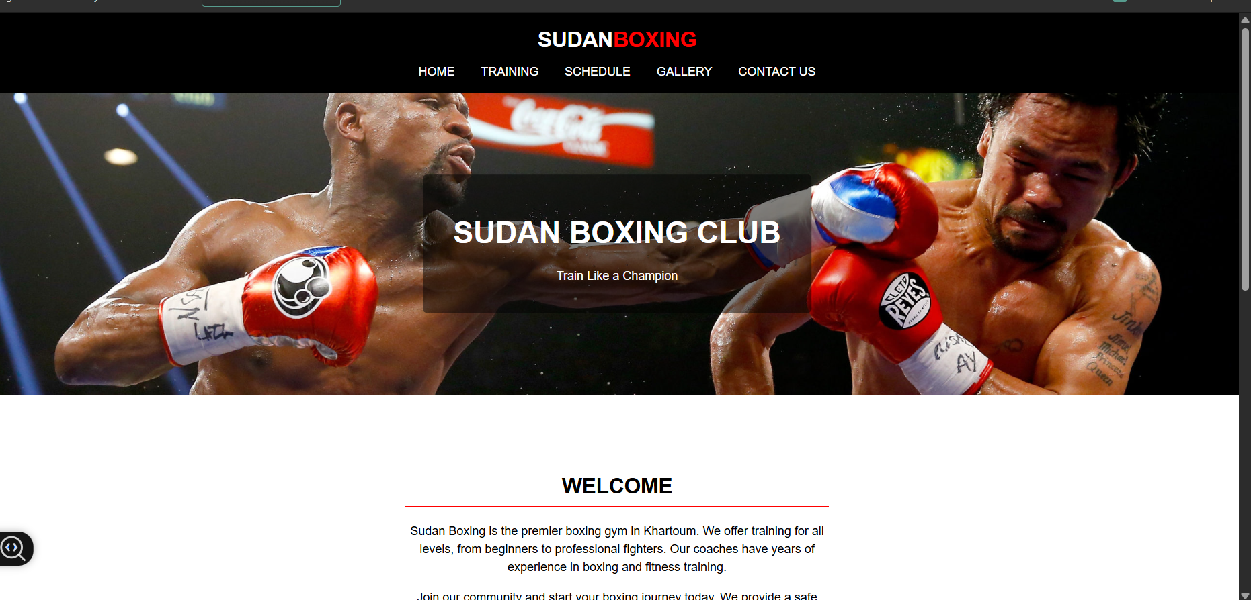

Training page
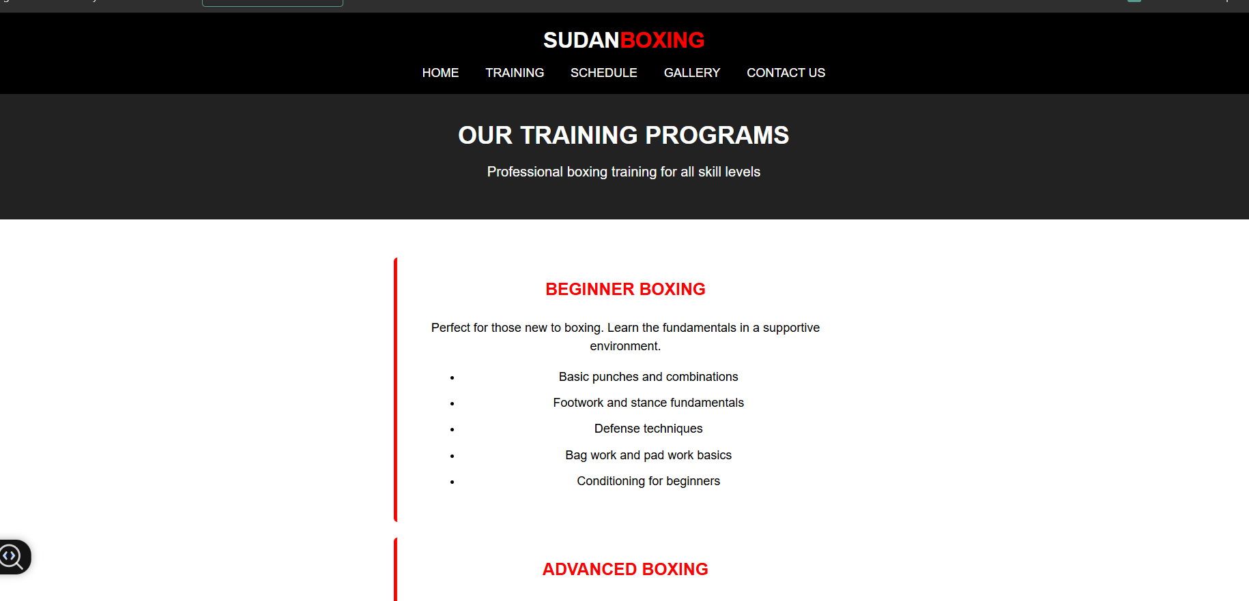

Schedule page
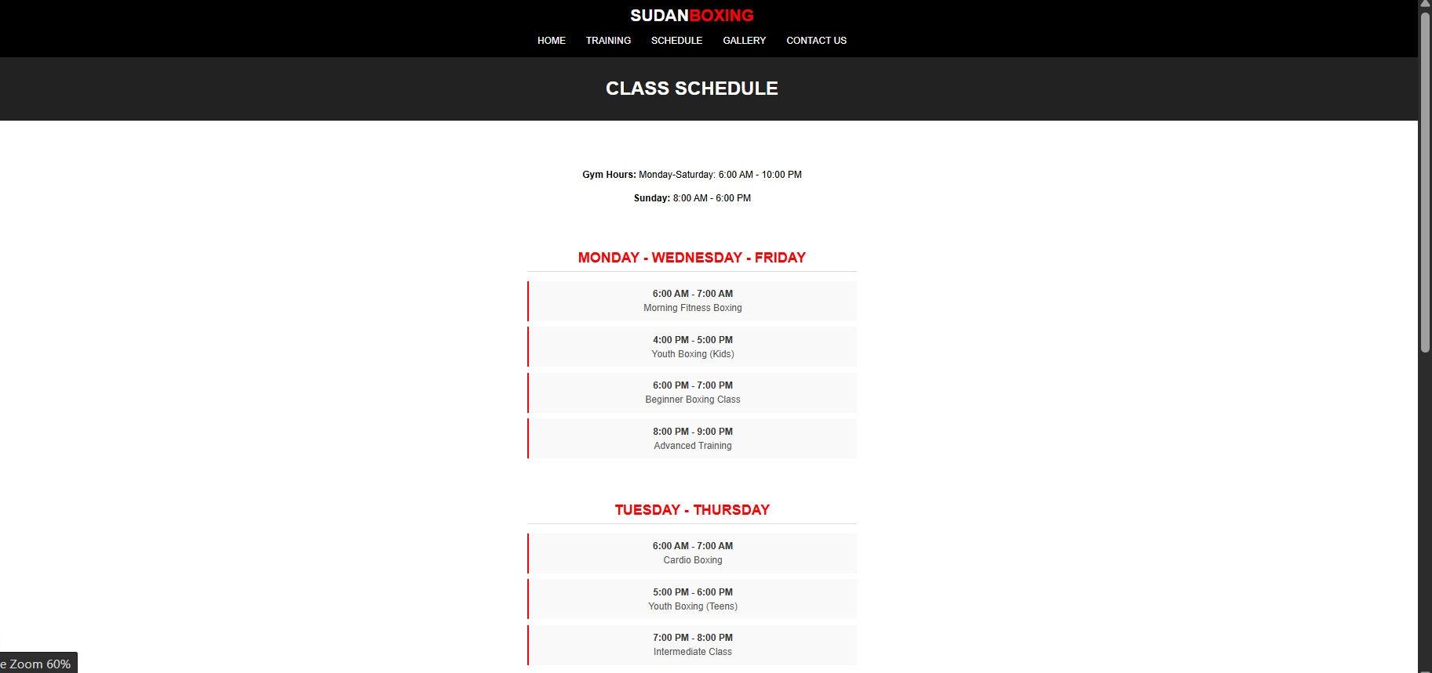

Gallery page
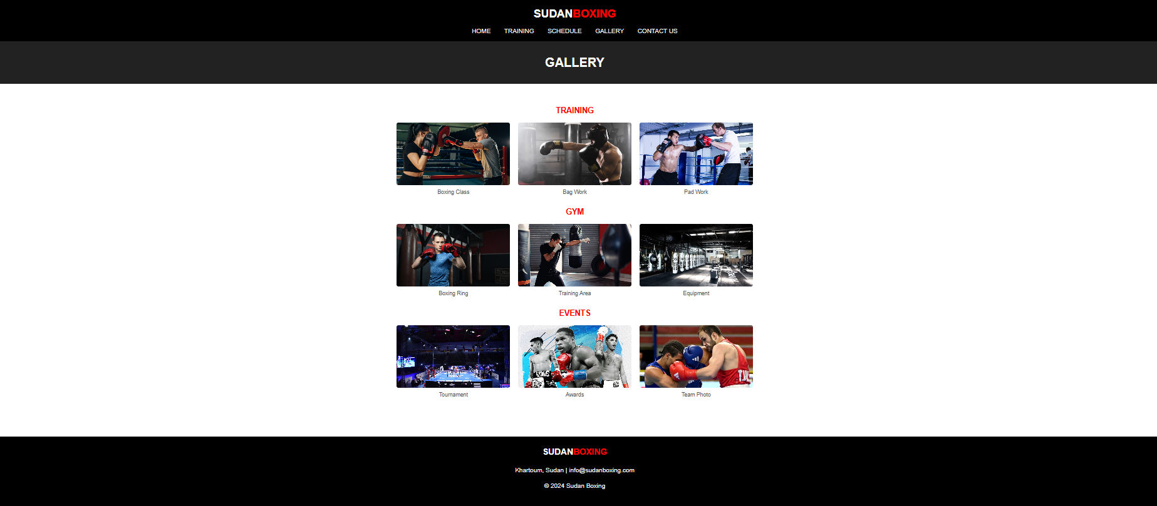

Contact-us page
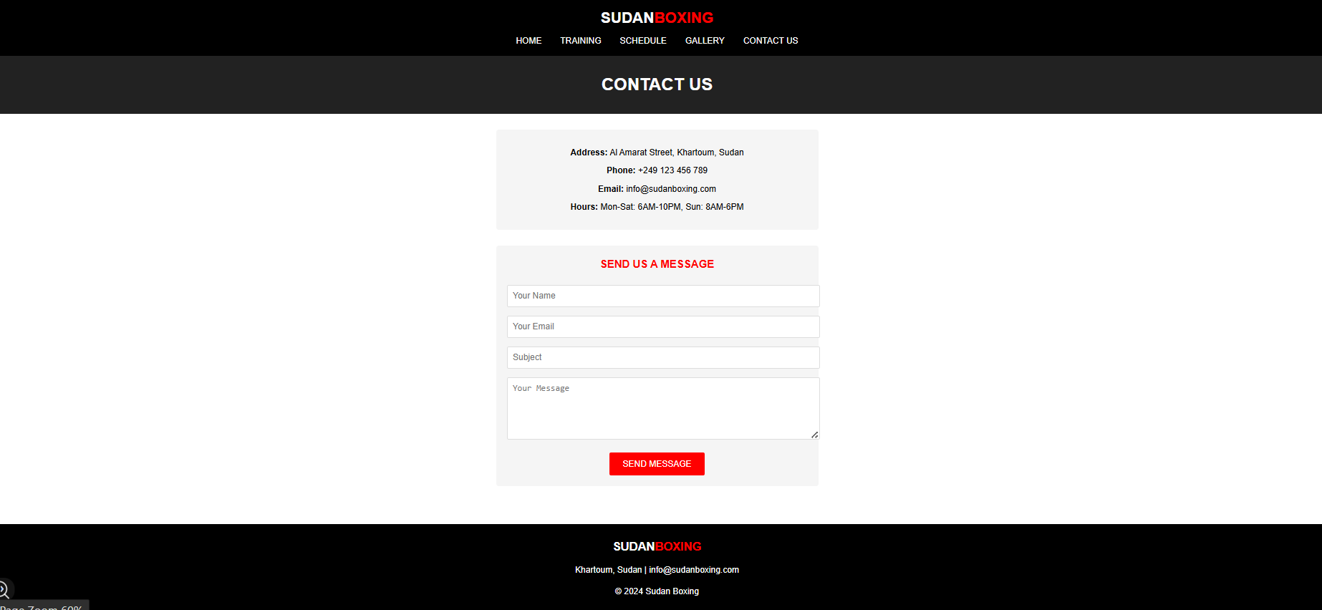

Validating my website
Please use the links provided in assignment brief to validate ONE HTML PAGE AND ONE CSS PAGE
HTML VALIDATION LINK: https://validator.w3.org/
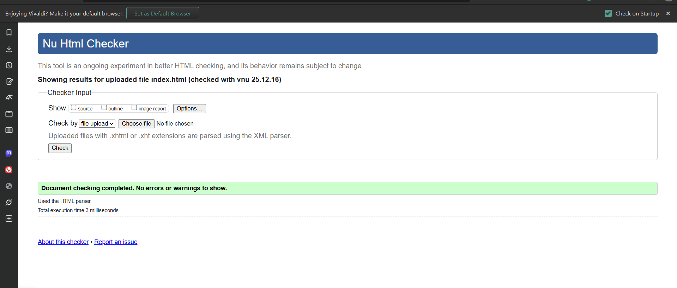
CSS VALIDATION LINK: https://jigsaw.w3.org/css-validator/
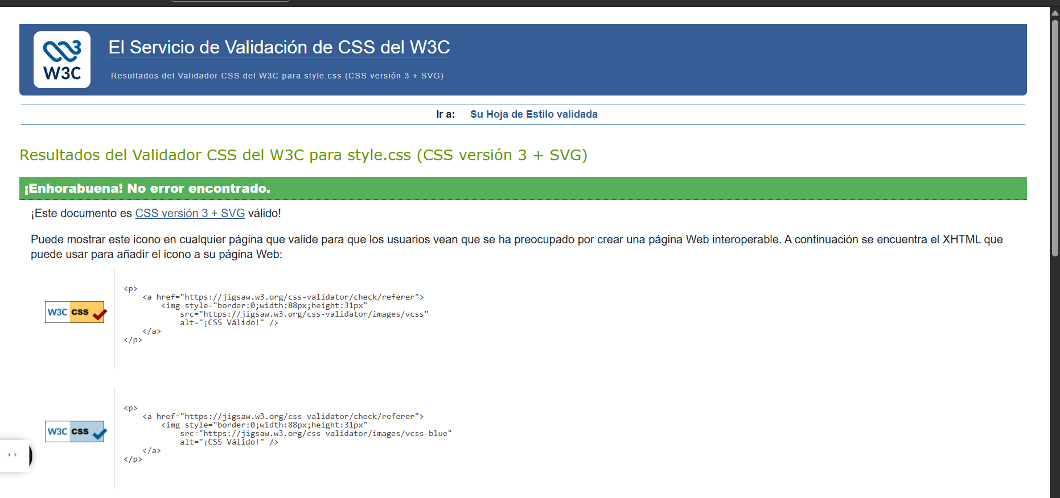

HTML
A validation tool, used experimentally at universities, to assess the compatibility of HTML documents with web standards; here, the result is error-free.
CSS
An official service of the W3C, used in university courses to validate a CSS stylesheet's syntax according to the current specifications; the example is valid.

Self-evaluation of my website
Usefulness (usability and utility): Referents
Use academic sources to identify what website usability means and compare your website with this criterion, whether you have met this criterion or not.

Search Engine Optimisation (SEO):
Helping a search engine index a webpage Webpages can be optimised (ie properly prepared) for visits from search engine spiders such as Googlebot. If this is done well, a spider will index it according to the desired keywords/phrases. To understand how to get a webpage properly indexed, however, one must learn to think like a spider thinks. This means ‘empathising’ with the job a spider must perform examining one webpage after another trying to figure out what each page is really about; rushing on to another website; repeating this task throughout the day, and the next day and the next, in an effort to examine the 8 billion plus webpages that are out there. If the spider were a person, one might even start to feel sorry for it and want to do whatever was possible to ‘ease the pain’. To accomplish this, webmasters need to provide spiders with clues written clearly in their webpages. (Wilson, 2006)
Website Accessibility:
Web Accessibility continues to hav e important social, legal and economic implications for ecommerce. Over 50 million Americans have disabilities and so do around 600 million world-wide (www.census.gov/ prod/2003pubs/c2kbr-17.pdf; www.usdoj.gov/crt/ ada/busstat.htm). Disabilities include a vast range of issues: cognition, vision, motor skills, and hearing. The disabled comprise 19.3% of the U.S. population, more than any other minority group, including the next largest group—Hispanics (14.9%). (Eleanor T. Loiacono, 2009)

Reference list

References
Eleanor T. Loiacono, N. C. (2009). The State of Corporate Website Accessibility.
Wilson, R. F. (2006). Search engine optimisation: A primer on keyword strategies. Basingstoke, UK.

