Sound and Moving Image
Dylan Hopkins
1702950
Computer Animation
Rob Jones
Word Count: 2329

Introduction
In this report I will construct an essay that will contain roughly 2500 words based on 1 of the 4 available questions that was tasked to us to answer. I will consider the primary theme of which every question I choose to answer, sate the writers involved, who they are, what they achieved etc. and to finish of I will write a conclusion based on the question that I have answered. The following questions are based on the subject of sound and moving images, the questions are as followed:
Question 1. Discuss how a critical awareness of acoustic ecologies can be used within the role of sound design for film, animation and video games
Question 2. Discuss the key concepts of Michel Chion's ‘audiovisual contract' and how it can be used to interpret the relationship between sound and image within moving image. Provide a short analysis of two or more film/animation/game scenes of your choice to help articulate your discussion.
Question 3. Provide an account of the function of silence in the sound-image relationship. Include at least two short analyses of film scenes of your choice to help articulate your discussion.
Question 4. From the SOUND & MOVING IMAGE research strand lectures, choose a theme, movement, or selection of artists or designers that relate to your practice or interests, and construct a 2,500-word essay. Consider primary themes, key writers, and relevant practitioners.

Chosen answer
The sound and moving image question that I have chosen to answer is the first question, this question is to discuss how a critical awareness of acoustic ecologies can be used within the role of sound design for film, animation and video games. I will answer the following subjects for this essay, what acoustic ecologies are, this is because I do not yet have a full understanding of the word. Who created such a concept, because it is important to understand where certain things come from, where it was created and why it was created, what purpose did it hold etc. I will answer why it is an effective relationship to have between both the sound designer and us the viewer and or player, I will have a slightly different answer for each section for film, animation and video games, this is because each subject is slightly different from one another.

What is an acoustic ecology?
In this report I will discuss how a critical awareness of acoustic ecologies can be used within the role of sound design for film, animation and video games and why it is an important and effective relationship, however before I can discuss such a subject, I must first understand exactly what acoustic ecologies are, including but not limited to, who the person behind the concept is, where and why the concept was created etc. I have to ask this question because I do not yet have a full understanding of what the word means, all I know at the present time is that it’s the relationship between us the listener and the environment.
Acoustic ecologies, which is also known as eacoacoustic or the term I’m more familiar with: soundscape, these terminologies in the realm of sound design for film, animation and video games are a variety of disciplines of studying or describing the unique relationship between us the viewer or player and the environment around us based entirely on sound. This concept was created in the late 1960s by a MR. Raymond Murray Schafer CC (CC being the second highest honour for merit in the system of orders, decorations, and medals of Canada.) and his team at the Simon Fraser University that Is located in Vancouver, British Columbia in Canada as part of the World Soundscape Project.
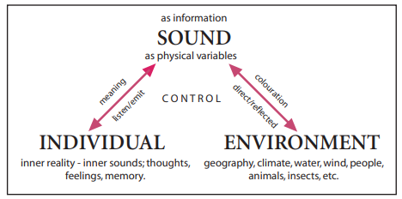

Figure 1: The mediating relationship of an individual to the environmental through sound (modifued from traoux 1984, 11)

The image above, depicts the innate relationship between sound, us as individuals and the environment, as you can see in the image above, there are three main sources for acoustic ecologies, sound, individuals and the environment.
The top centre of the image depicts sound as information and the medium to which we connect bot individuals and the environment with them being depicted as physical variables.
The left side of the image shows the individuals and their relationship to sound, this includes what may happen when we hear said sounds, how our inner reality reacts to sound, what we feel when certain sounds are heard, what we think in those moments, and does any memories surface when we hear these sounds e.g songs, loud bang sounds etc.
The right side of the image, shows the environmental side of this innate relationship, which includes all sounds that are natural, so in a movie, music does not count as part of this equation. The environmental part of acoustic ecologies include sounds such as, animals, insects, wind, water, people, any sound that is produced naturally, that we hear around us is part of the environmental side of acoustic ecologies.
The section at the top of the image, shows the medium to which we connect, the relationship, the sound if the information that both the individuals and environments receive, back and forth.
to summarise, acoustic ecologies are the innate and unique relationship that we as humans have with the environment, sound as information relayed to us, can change our perception of reality, what we think, what we feel, and memories attached to sound, we listen and we emit sound, whereas environmentally, it can only emit sound to us, it can be directed, in terms of two people having a conversation or it can be reflected, hearing sounds from a distance.

Why it is important to have this relationship in terms of film, animation and games
In this section of the repot I will now discuss how a critical awareness of acoustic ecologies can be used within the realm of film, animation and video games. Now that I have a more precise understanding about what acoustic ecologies are, it is now time to discuss why a critical awareness of acoustic ecologies is important to have in sound design for film, animation and video games, I will discuss this in 2 sections. The first section will cover the perspective of a sound designer, why it is important for a sound designer to have a critical awareness of acoustic ecologies, what sound designers will be able to achieve with this awareness etc. the second section will cover the perspective of the viewer or player.

Sound Designer
In this section of the repot I will explain why it is important for a sound designer to have an understanding of acoustic ecologies, explaining how sound designers can take the concept to create immersive sound effects for the environment. It is important for a sound designer to have a critical awareness of acoustic ecologies in order to give us the viewer and player better more immersive experience as to what we are seeing and or playing, after all sound is half the experience, and while silence in some areas can leave a deeper more meaningful impact, sound is still very important. The example that I am going to use in order to demonstrate an immersive experience, is through means of using sound to create an effective horror game, this is research that I have already done, due to another module which main theme centred around making a horror game.
There are various ways that a sound designer that has a critical awareness of acoustic ecologies can add to the experience of a horror game that are however not are not limited to:
Generating fear from sound, using this method, sound designers and music composers by using sound effects in conjunction with music can give the viewers and player a sense of dread, which increases our heat rate, which can give viewers and players an increase rush of adrenaline, which a good portion of people seem to enjoy at least artificially where real world stakes are low, others however do not like the experience, and perhaps that is the reason they play horror game, getting enjoyment out of something they hate, this is the main job of a sound designer. For example a sound designers that understand acoustic ecologies can create a very effective horror game from rapid onset and offset tempo’s that increase anxiety and creates a sense of urgency, that the player needs to get a move on, or something bad will happen to extreme frequency’s by creating high screeches or low rumbles that can indicate an unknown threat, e.g. creature screaming in the distance, machinery used in a way to give the player un uneasy experience to an immediate attack, by going from silence or low volume sounds and music to sudden high volume or loud music to create a jump scare or when the player gets attacked by a creature in the night etc.

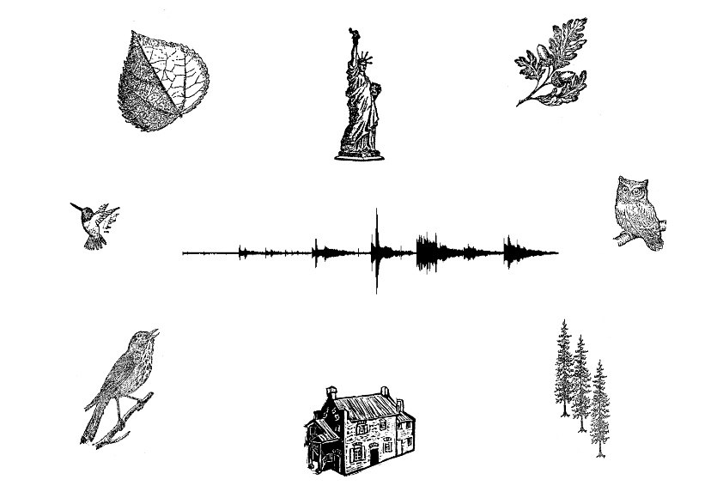

The image above shows examples of sounds that a sound designer might include but not limited to a horror game.
Sound designers that can understand such a thing, can make sure that we as a player or as a viewer can get the full immersive experience, this is why it is important for sound designers to have such a critical awareness for acoustic ecologies, it to fully immerse us into the experience, so that our full attention sole set on the visual and audios that we are seeing and listening to.
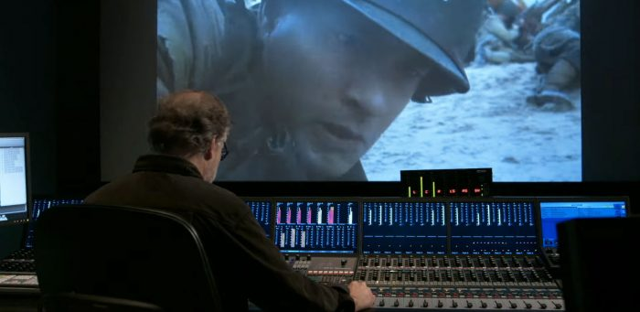
The image above shows a sound designer fine tuning which every project they are working on, it seems to be in the final stages, so this may just be mixing the audio together, making sure that each sound doesn’t interfere with each other.

Individuals
It is also important for us the viewer or player to have an awareness of acoustic ecologies, hearing certain sounds can evoke different things within us, it changes what we think, what we feel and can even bring forth certain memories, depending on the situation, we may not need to understand why a certain sound, sounds the way it does, like a sound designer needs to, however, having these sound within film, animation and video games, allowed us to fully immerse our selves into the film or animation what we are watching and video games that we are playing.

Acoustic Ecologies within film, animation and video games
In this section of the report, I will discuss how acoustic ecologies are used and how they are different within film, animation and video games, the differences between them, and why certain things are made the way they are.

Film
Sound within film are static meaning that every re-watch contains the exact same sound, at the exact same time at the exact same location, this differs to other form of media, like video games, however, film and animation alike are static. A sound designer has to consider many things in order for it to be immersive, the sounds that play have to sound to us at least realistic, even if those object don’t make those sounds, a sound designer has to make us believe that I the sound that the object in question makes.

Animation
Sound within animation compared to film contains a lot more leeway in what can be achieved as an animation assuming that I is more cartoony in nature can use sound effects and music in different ways for example, using sound effects to enhance humour, or using music to break tension. This also means that sound designers have more leeway to explore acoustic ecologies, for example, 80s anime usually incorporate synthesizes as the main source of sound effects, one person who was tasked with creating a punch sound effect, envisioned an electronic swoosh with a reverb and frequency shift, over the common meaty punches that we hear in video games and live action films.
Like film, sounds here, whether it be sound effects or music is static, each re-watch will repeat the same audio in the same locations and time.

Video Games
Sound within video games are completely different beast all together, as sound designers are required to create many different variation of the sound effects that they make, because, unlike the first who section where sound were static, sounds in video games, are dynamic meaning, that each replay of a mission or segment will be completely different sound wise.
To elaborate this, I will create a scenario to explain what I mean by this. In this scenario you are required to gain access to a building, I will replay this mission twice changing my playstyle each time. The first playthrough I decide to go in guns blazing, I’m inside the building shooting all enemies inside I will hear many things, people yelling, guns shooting etc. now on my second playthrough I decide to take the stealth option, now not only have the locations and timing changed I’ve decided not to go in the building at all, using a sniper I now hear a new set of sounds, the sniper shooting, wind, yelling from a distance etc. this is why video games are dynamic, no sound ever plays in the same order more than once, and its also why it is important for a sound designer to have an awareness of acoustic ecologies, because they have to understand the core concepts above.

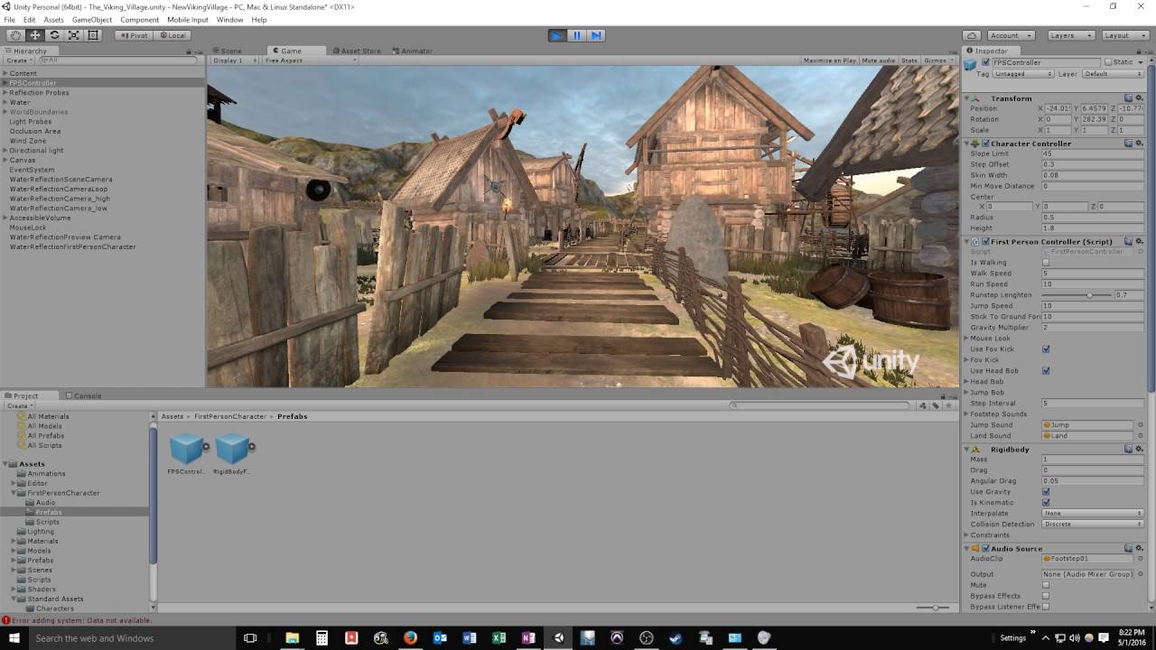

The image above is one such tool that sound designers may use when working with video games, the software above is called Wwise, and it is an audio tool to centralize all aspects of audio it allowed them to import audio, apply real time audio filters, mix, simulate audio environments, manage sound integration etc.

Conclusion
In conclusion it is important for a sound designer to have a critical awareness of acoustic ecologies, in order to give us the viewer and or player a fully immersive experience in the realm of film, animation and video games, this is because sounds make up half of the experience.

Bibliography
r. Schafer (No Date) https://musicalmrfox.co.uk/soundscape/page2/page12/files/stacks-image-5f2b619.jpg (Accessed 11.12.19)
sound ecologies (No Date) http://www.musicalecologies.net/wp-content/uploads/2015/03/ae3.jpg (Accessed 11/12/19)
Sound Mixing (No Date) http://www.filmmediaarts.com/wp-content/uploads/freshizer/713c8b1893f868b8e1c6136e8b9bb0d4_sound-design-800-320-c.jpg (Accessed 11.12.19)
Making Sound Design Saving Private Ryan (No Date) https://d13ezvd6yrslxm.cloudfront.net/wp/wp-content/images/makingwaves-sounddesign-savingprivateryan-700x341.jpg (Accessed 11.12.19)
Wwise (No Date) https://i.ytimg.com/vi/rK96gLoZMEY/maxresdefault.jpg (Accessed 11.12.19)
Matt Porter The Dos and Don’ts of making a horror video game 21st October 2014 https://www.vice.com/en_uk/article/gq83dm/the-dos-and-donts-of-horror-game-making-323 (Accessed 11.12.19)
Four developers of scary games explain how to make scary games very scary indeed (No Date) https://www.rockpapershotgun.com/2018/06/21/four-developers-of-scary-games-explain-how-to-make-scary-games-very-scary-indeed/ (Accessed 11.12.19)
What is acoustic ecologies (No Date) https://www.sciencedaily.com/terms/acoustics.htm (Accessed 11.12.19)
Introduction to acoustic ecology, Kendall Wrightson (No Date) https://web.archive.org/web/20140415001407/http://www.wfae.proscenia.net/library/articles/wrightson_intro.pdf (Accessed 11.12.19)
Word Forum for Acoustic Ecologies Liliane Karnouk (No Date) https://web.archive.org/web/20081211035644/http://interact.uoregon.edu/MediaLit/wfae/home/ (Accessed 11.12.19)

