
UNIVERSITY OF WALES TRINITY SAINT DAVID
MSc Cybersecurity and Digital Forensics
Module: Research Methods and Professional Development (ACFA7004)
Assessment Component 1: Research Proposal
Architectural Mitigations for Prompt Injection Attacks
in Agentic LLM Applications: A Composite Execution
Isolation and Data Symbolisation Framework
Student Name: Latchiarajan Parthasarathy
Student ID: 2531979
Supervisor: Dr Suresh Shanmugasundaram

Table of Contents
Table of Contents 2
List of Figures 4
List of Tables 4
Abstract 5
Section 1: Introduction 5
1.1 Context and Background 5
A) Overview of the Research Field 6
B) Current Developments 6
1.2 Research Problem 6
A) Problem Description 6
B) Current Challenges 7
Research Questions 8
1.3 Research Aim and Objectives 8
Research Aim: 8
SMART Objectives: 8
1.4 Significance of the Research 9
Academic significance: 9
Technical significance: 9
Practical significance: 10
Section 2: Literature Review 10
Search Strategy 10
Theme 1: The Agentic Attack Surface and Protocol Vulnerabilities 11
Theme 2: The Limits of Prompt-Based Filtering 11
Theme 3: Evaluation Metrics and the Security-Utility Trade-off 11
Theme 4: Architectural Mitigations via Isolation and Data Segregation 12
Literature Summary and Research Gap Justification 12
Section 3: Research Design and Methodology 13
3.1 Research Design 13
3.2 Research Methods and Materials 14
A) Research Methods 14
System Architecture and Workflow 14
Data Analysis and Evaluation 15
B) Research Materials 15
Ethical Considerations 16
Section 4: Expected Outcome 16
Expected Results 16
Implications 16
Limitations 17
Risk Register 17
Section 5: Timeline 17
Section 6: Presentation of the Proposal 18
Section 7: References 18

List of Figures
Figure 1.1: The Instruction-Data Conflation Problem
Figure 2.1: Stored IPI Attack Chain
Figure 3.1: Composite Defence Architecture
Figure 3.2: Design Science Research Process
Figure 5.1: Six-Month Gantt Chart

List of Tables
Table 1.1: SMART Compliance Check
Table 3.1: Software and Hardware Requirements
Table 3.2: Evaluation Metrics and Justification
Table 4.1: Risk Register and Contingency Plan
Table 5.1: Six-Month Project Timeline and Deliverables

Abstract
Recently, agentic large language model applications increasingly use tools, browse the internet, and control user files; however, the transformer architecture underpinning them treats trusted commands and untrusted third-party data as input within an indistinguishable channel [1]. This poses a structural flaw, which has the potential to hijack an agent's execution via an Indirect Prompt Injection, where harmful instructions within external content (such as a web page or an e-mail) can instruct the agent's actions without the user's knowledge or intervention [2]. Current attempts to prevent Indirect Prompt Injection through prompt engineering or multi-layered instructions are widely shown to be imperfect from a theoretical point of view, and are regularly bypassed by attacking agents [3].
This work proposes a layered architectural defense approach that consists of dual-LLM data symbolisation, which stops the compromised input channel from instructing the privileged model, and hub-and-spoke execution isolation, which severely restricts access to any particular tool call. We will use Design Science Research methodology to provide a functional prototype, which will then be attacked using the AgentDojo and AgentLAB benchmarks, measured by Targeted Attack Success Rate, Benign Utility, and latency overhead, to achieve a success rate of less than 10% with less than 8% utility loss on benchmark tasks.

Section 1: Introduction

1.1 Context and Background
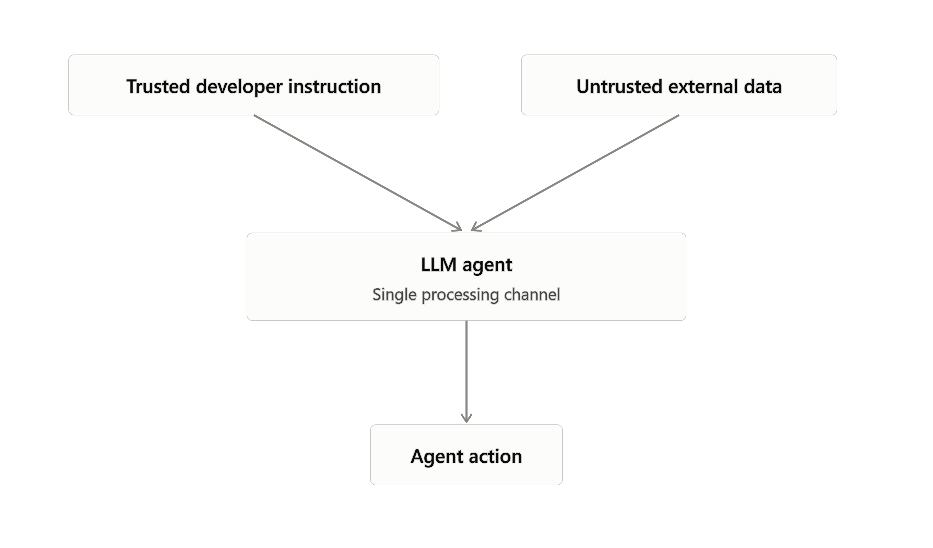
Figure 1.1: Diagram showing how trusted developer instructions and untrusted external data pass through the same neural pathway in a standard LLM agent, with no structural boundary between them. (Source: Author, 2026)

A) Overview of the Research Field
The intersection of cybersecurity and AI, more precisely the offensive/defensive interaction between tool-executing large language model agents acting autonomously. These systems are currently transitioning from what we know as chatbot-like systems to agentic systems, which can read files, access APIs, browse the web, and execute commands, deep on enterprise infrastructure that was absolutely not designed for such automated agents. There's a lot of tension in this area: the field is rapidly deployed in commercial use cases, but the underlying architecture is intrinsically susceptible to attacks, given that standard transformer-based models use the same “reading channel” for every input, from hardcoded developer prompts and actual user commands to any piece of text coming from a retrieved website or an incoming email [1].

B) Current Developments
Current work in the area focuses on formalizing AI security standards and recognizing that semantic filtering is insufficient. OWASP identified prompt injection as the #1 risk for both their LLM Applications Top 10 and their new Agentic Applications Top 10 lists, and government-level resources like NIST AI Risk Management Framework now recommend explicit threat modeling for agentic contexts [4]. By establishing the Model Context Protocol, a standards body managed to consolidate a large portion of the attack surface: Model Context Protocol allows any LLM application to programmatically describe, discover and call remote, or other “smart” or “tool-aware” services.
Analyses of Model Context Protocol's security properties report a lack of both required capability attestation and origin authentication, making any malicious (or compromised) tool server able to feed direct commands into the agent's reasoning [5].
As such, recent research has turned to issues of structural and architectural separation, including the development of dual-LLM patterns (one which processes user requests, the other handles untrusted inputs) and the concept of execution sandboxing [6], [7].

1.2 Research Problem

A) Problem Description
This shows a failure to retain control-flow integrity for agentic LLMs with external data retrievals, and the risk of Indirect Prompt Injection. Agentic LLMs blend trusted environmental system commands with untrusted input from external data, a weakness that, through a maliciously crafted surrounding environment—e.g. a malicious web document—can be exploited by an attacker. In a prompt injected through a data retrieval, an attacker can sneak—at time of execution—a dangerous sequence of commands into unharmful-looking and trusted input; the embedded commands can later disrupt the LLM's task goal, allowing for a zero-click data leak or unintentional system operations.

B) Current Challenges
Most of the current defenses are based on prompt engineering or on instructions/input filters; however, with these semantic solutions, structural limits are hit hard. Since the language is non-specified and a finite set of guardrails must be applied, it's impossible to cover every malicious input in a purely semantic way without contradiction. In a real scenario, active attackers that exploit their payloads against fixed filters recovered 64% accuracy success on unstructured questions, such that the instruction is hidden within passively processed text in the data [3].
While approaches exist that seek to isolate the architecture, they run into a genuine security-utility trade-off. Attempts at thorough execution isolation deprive the agent of data necessary for executing even an honest task, which appears as excessive benign-task failures. However, allowing an agent to have access to external data for an extended period opens the system up to Stored IPI, in which a malicious payload is written to the agent's persistent memory (disk) or otherwise into its long-term storage, sheds its untrusted origin label somewhere along the way, and is then trusted upon retrieval. The question of this trade-off is an open problem [6].
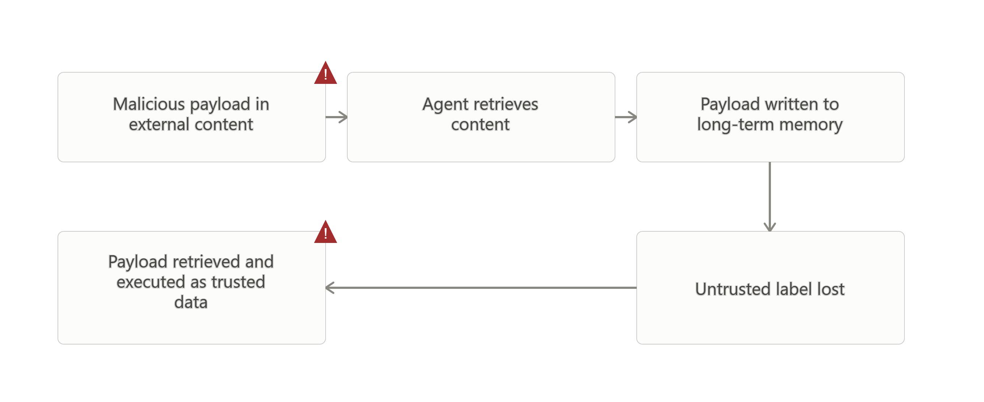
Figure 2.1: Step-by-step diagram showing how a malicious payload enters an agent's memory, loses its untrusted label, and is later retrieved and executed as trusted data. (Source: Author, 2026)
To date, most work focuses on only one of these two sides. Dual-LLM-style patterns overcome the immediately injected attack but are susceptible to Stored IPI, as they rely upon the agent tracking untrusted data within the agent's context, not the world [6]. Execution isolation mechanisms like IsolateGPT limit the scope of attacks in tool calls but suffer increased latency and loss of context for multi-step complex reasoning [7].
Defense work in AgentDojo proved that a security mechanism decreasing attack success had a corresponding decrease in ability on benign tasks.
This is formalized as a security-utility trade-off but one without an integrated architecture to overcome it [8]. The combination of data symbolization and execution isolation has not been demonstrated in a combined system that is robust against immediately injected and long-horizon attacks.

Research Questions
- RQ1: How does the standardisation of agent-tool communication via the Model Context Protocol amplify the efficacy of Indirect Prompt Injection attacks?
- RQ2: To what extent can a composite architecture using dual-LLM data symbolisation and hub-and-spoke execution isolation reduce Targeted Attack Success Rate in both static and long-horizon adversarial scenarios?
- RQ3: What is the quantifiable impact of this composite defensive architecture on Benign Utility and latency overhead?

1.3 Research Aim and Objectives

Research Aim:
In this paper, we demonstrate how to devise, build and test a composite framework of architectural mitigations, integrating the concept of hub-and-spoke execution isolation with the idea of dual LLM-based data symbolization, so as to prevent Direct Prompt Injection attacks from succeeding on tool-supported LLM agents with minimum penalty over benign task utilities.

SMART Objectives:
- 1. Critically evaluate the current landscape of Indirect Prompt Injection vulnerabilities within the Model Context Protocol ecosystem through a systematic literature review, by Month 2.
- 2. Design a composite defensive architecture combining execution sandboxing with persistent untrusted-data tracking, by Month 3.
- 3. Implement a functional Python-based prototype using open-weight language models and standard orchestration frameworks, by Month 4.
- 4. Measure Targeted Attack Success Rate and Benign Utility against the AgentDojo and AgentLAB benchmarks, targeting an ASR reduction below 10%, by Month 5.
- 5. Formulate architectural deployment guidelines for enterprise agentic systems aligned with the NIST AI RMF, by Month 6.
Table 1.1: SMART compliance check.
Objective | Specific | Measurable | Achievable | Relevant | Time-bound
1. Literature review | IPI vulnerabilities in MCP ecosystem | Completed literature synthesis | Public literature and standards accessible | Grounds later design decisions | Month 2
2. Architecture design | Sandboxing plus data-symbolisation design | Documented architecture diagrams | Prior art (IsolateGPT, DualView) available | Establishes the artefact to be built | Month 3
3. Prototype implementation | Python prototype, open-weight models | Working local prototype | vLLM, Llama-3.1/Mistral-7B accessible | Enables empirical testing | Month 4
4. Benchmark evaluation | ASR below 10% on AgentDojo/AgentLAB | ASR, BU, latency figures | Public benchmarks with reproducible seeds | Answers RQ2 and RQ3 | Month 5
5. Deployment guidelines | NIST AI RMF-aligned recommendations | Documented guideline framework | Builds directly on Objectives 1-4 | Delivers the research aim | Month 6

1.4 Significance of the Research

Academic significance:
In this research, we bridge a divide between two historic defense paradigms, execution isolation and semantic data symbolization, by analyzing their synergy on a long-horizon adversarial test case. The resulting work provides experimental evidence of the control-flow integrity of a stochastic natural language system at long distances [6, 7].

Technical significance:
Focusing on unique weaknesses to the Model Context Protocol integration layer, the ensuing framework creates a path toward defense against zero-click prompt injection and shifts the focus from statistical filtration toward concrete security from an architectural standpoint [5].

Practical significance:
High assurance guarantees are required by autonomous agents used in financial, healthcare and enterprise software applications, and tackling the security-utility trade-off is key to providing this. The goal of this research is to generate applicable and actionable guardrails enabling organizations to utilize agentic automation whilst satisfying relevant regulatory req

Section 2: Literature Review
This review covers prompt injection research in agentic LLM architectures from roughly January 2024 to mid-2026 and focuses on systemic, protocol-level, or structural approaches, excluding model-weight finetuning and direct prompting fixes to model outputs alone. This review examines four main topic clusters: the agentic attack surface expanded by the Model Context Protocol; the practical and formal limitations of prompting-based defenses; how secure agent designs can be measured; structural defense through isolation and partitioning; and the gap this work fills.

Search Strategy
Literature was systematically collected using PRISMA criteria, specifically searching IEEE Xplore, ACM Digital Library, arXiv, and industry authority disclosure sites such as OWASP, NIST, and the UK AI Safety Institute, limiting the time frame from January 2024 to mid-2026, to represent the era of increasing MCP and agentic LLM adoption. Boolean search terms were as follows: ('prompt injection' or 'indirect prompt injection') AND ('LLM agent' or 'agentic'); ('Model Context Protocol' or 'MCP') AND ('security' or 'vulnerability'); ('execution isolation' or 'sandboxing') AND ('LLM'); and ('AgentDojo' or 'AgentLAB' or 'benchmark') AND ('attack success rate'). Excluded were non-technical whitepapers from vendors without demonstrated research or experimental results, restricted to peer-reviewed conferences and empirically based arXiv papers.
The initial search returned about 47 potential sources after titles and abstracts were filtered.
After filtering and reading these potential sources, 25 remained, and then, after an additional filtering for the quality and availability of the research, 13 potential sources remained. These sources are cited below.

Theme 1: The Agentic Attack Surface and Protocol Vulnerabilities
The standardization of tool access through the MCP has created systemic risks beyond the individual security of any single model. MCP defines a common client-server architecture based on JSON-RPC through which LLMs may interact with their environment, but security analyses have demonstrated it lacks any requirement for capability attestation and mutual origin authentication, thereby enabling injection of any command into the agent context through a compromised or malicious tool server [5]. Since these vulnerabilities exist in the integration architecture layer and not the weights, counter measures must address protocol-level mediation and cannot solely lie at the model level.

Theme 2: The Limits of Prompt-Based Filtering
There has been a large amount of industry effort focused on prompt-based defenses and instruction hierarchy. One such example from OpenAI is the instruction hierarchy intended to instill models to favor developer prompt over outside data, as a defense mechanism against indirect prompt injections [9]. However, this type of defense has a structural limit: while the set of natural language inputs has infinitely large semantic variation, any deterministic guardrail-based set is bounded, ensuring the guardrail can't offer complete, non-contradictory detection for all possible adversarially worded prompts.
This is supported empirically.
Automatic optimizers used by adaptive attackers were able to defeat defenses, achieving attack success rates up to 64% in an open-ended setting [3]. This suggests the need for a structural control rather than continued attempts to parse the prompt's semantics.

Theme 3: Evaluation Metrics and the Security-Utility Trade-off
The tradeoffs between an LLM agent's vulnerability to adversarial attacks versus its functional usefulness. We formalise this concept in the AgentDojo benchmark, defining metrics for both targeted attack success rate and benign utility, across 97 realistically structured tasks and 629 security (malicious) test cases. We observe that reducing attack success by simply decreasing attack capability generally resulted in a decrease in the real capabilities of the agents.
More recent frameworks like AgentLAB go further, by studying longer-horizon adversarial attacks in the presence of which agents may be subject to the cumulative effects of multi-step interactions—specifically designed to introduce features such as memory injection and changes in the target objective of the agent (objective drifting).
They demonstrate that agents which appear immune to a single-step prompt injection are highly susceptible to even longer-term attacks of this nature, indicating that any solution should be evaluated against both transient and longer-form manipulation strategies.

Theme 4: Architectural Mitigations via Isolation and Data Segregation
In order to overcome the limitations of semantic filtering, other approaches, like new architectural patterns, have emerged that logically isolate instruction processing from the handling of untrusted data. One such pattern, called the Dual LLM, suggests a model being granted access to plan and execute tools, and a different model being put in a quarantine that only ever deals with untrusted data (without any tools). While it is effective against an in-band command injection, it may not be robust against a stored in-band attack (which involves injecting code into long-term storage that will later be read as trusted data).
That is due to the original design of the Dual LLM only considering the untrusted data contained within the scope of the agent alone.
The DualView pattern counters specifically against this vulnerability by widening the scope of untrusted data tracking into the user's global context, by keeping apart an AgentView only referencing symbols (and an unmodified HumanView), and reporting decreasing both immediately injected attacks and stored in-band attack success rates to 0%, whilst only increasing the utility by about 6 percentage points when compared to an unprotected version of the system. Other architectural patterns, like IsolateGPT, focusing on execution isolation architectures, rely on hub-and-spoke network configurations and OS-level sandboxing to limit the blast radius of third-party applications. However, these patterns come with other issues such as added latency and discontinuity of the context for complex planning tasks.

Literature Summary and Research Gap Justification
We observe from the literature a trend from measuring theoretical limits of prompt filtering toward real architectures that actually implement isolation. One missing piece is that DualView's method of data symbolisation covers Stored IPI in one mechanism, and IsolateGPT's sandbox method covers controlling tool execution in another mechanism, but there's no architecture that couples both methods together and measures against MCP-enabled, long-horizon attacks. We fill this gap by integrating DualView-style data symbolisation and IsolateGPT-style execution isolation into a composite architecture and measure it against AgentDojo and AgentLAB.

Section 3: Research Design and Methodology

3.1 Research Design
This research maintains an objectivist stance; Targeted Attack Success Rate, Benign Utility, and latency overhead are simply values of observed system behaviours for each run in each tested system instance—we assume our influence is negligible or is consistent and accounted for across runs. This corresponds appropriately with the research question investigating what quantifiable behavioural aspects of the system the proposed architecture is exhibiting, rather than anything constructed from social factors. The study also adopts a positivist epistemology; the only scientifically rigorous method for discovering the viability of the proposed architecture is controlled experimental investigation using standardized benchmarks and open models, results which are fully verifiable if reproduced by a fellow researcher under the same conditions.
On the topic of positionality, the reason for this research being interested in this aspect is the researcher's prior exposure to cybersecurity tooling (and some of the reasons why this proposal takes the practical question of feasibility of deployment, including latency overhead, and not just raw ASR reduction, seriously; grounding it in real deployment concerns, possibly risking over-reliance on practical feasibility at the expense of full theoretical coverage). Every design decision is therefore grounded with a citation, and all results, including those below the targeted ASR or utility value thresholds, are taken directly as measured. The overall approach can be identified as following Design Science Research.
Design Science Research is well-adapted to the field of computer science and cybersecurity research.
This is primarily because it involves developing and implementing an IT artifact, then critically evaluating the invention empirically, and then evaluating its utility and efficacy compared to existing techniques according to specified metrics [10].
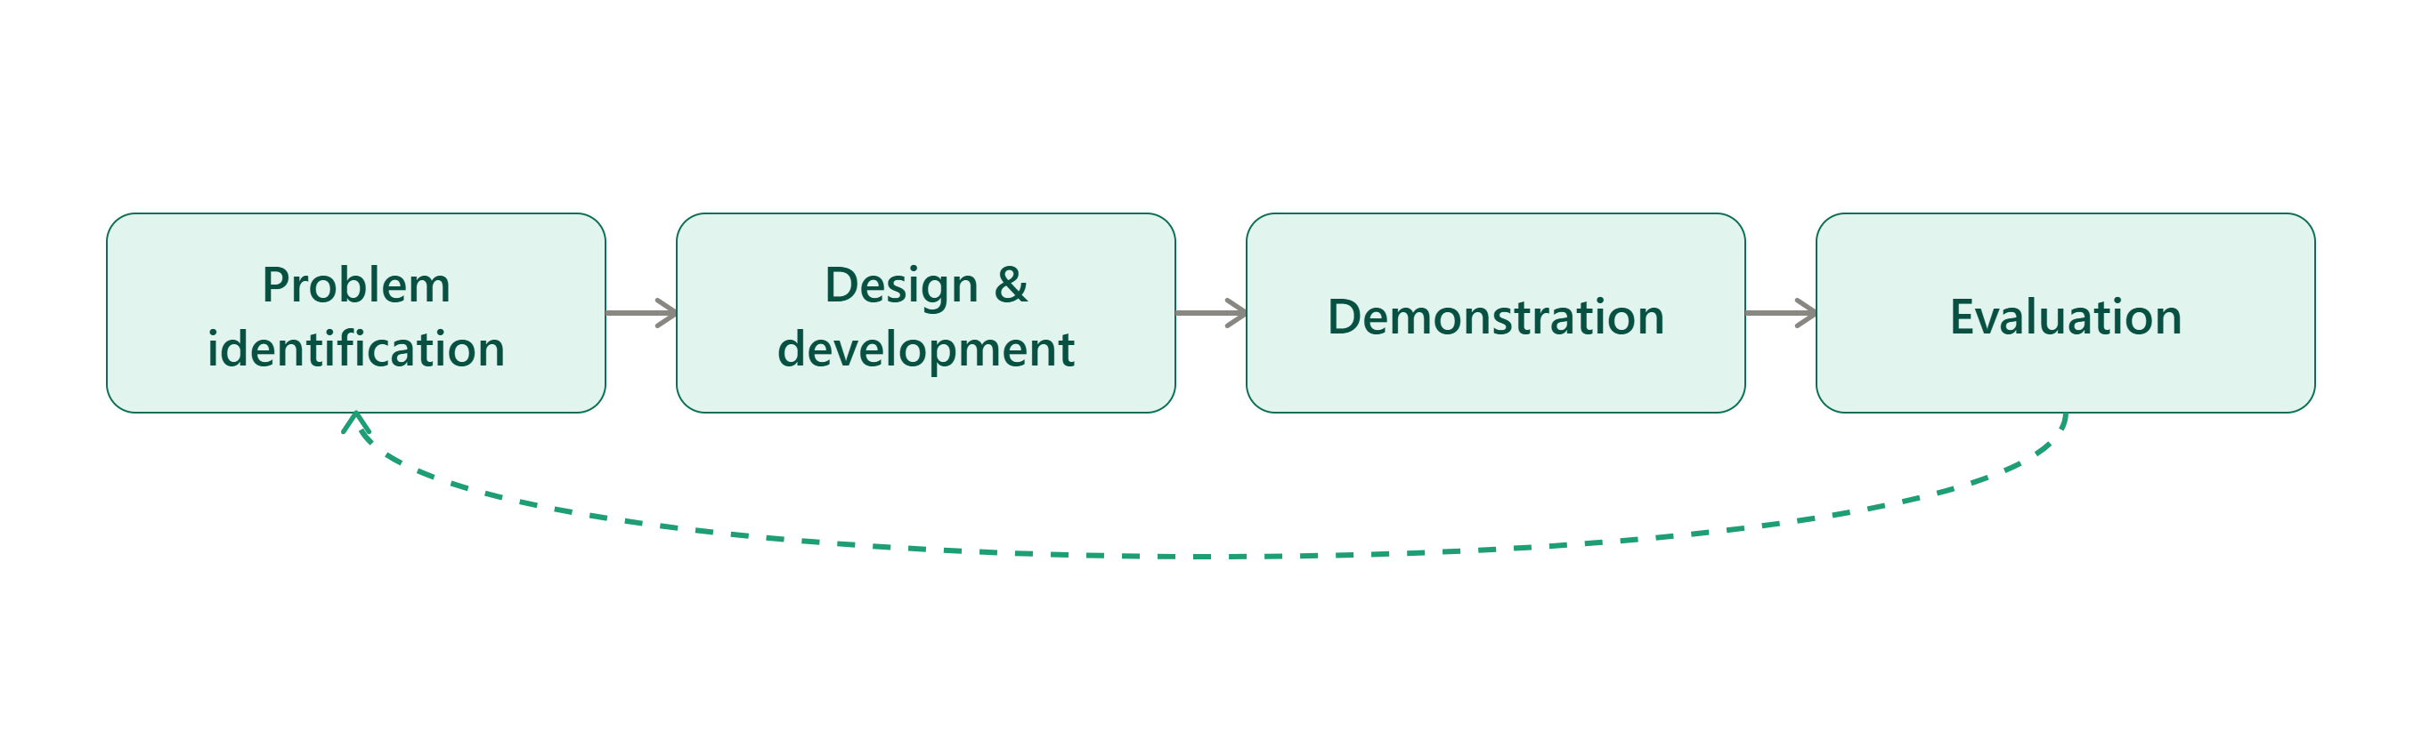
Figure 3.2: The iterative DSR cycle applied to this project, from problem identification through artefact evaluation. (Source: Author, 2026)

3.2 Research Methods and Materials

A) Research Methods
This work employs a quantitative, system-level evaluation methodology. A quantitative evaluation is required to accurately identify the statistical decrease in success rate relative to a control system, and to allow for accurate comparisons between system configurations on standardized benchmark test suites. A strategy is employed wherein a software prototype implementing the proposed architecture can be constructed and automatically subjected to adversarial testing. This produces empirical, repeatable data showing the location of the system in the security/utility trade space.

System Architecture and Workflow
There are three distinct parts of the designed artifact. The Hub's job is to deal with input and orchestration: it receives user prompts and environment inputs through the Model Context Protocol. The Quarantined Spoke's job is to deal with processing: we statically route untrusted external inputs to a quarantined version of the model stripped of all tool-calling abilities whose only function is to process the external input into opaque symbolic references.
The Privileged Spoke's job is to deal with analysis and output: it receives the user's directive and these opaque symbols; it then constructs a plan for how to execute the directive, and it never sees the raw untrusted text, which prevents malicious directives from controlling the program flow.
The orchestrator then translates opaque symbols to tool calls to highly constrained OS-level sandboxes. Table 3.1 details the hardware and software components needed.
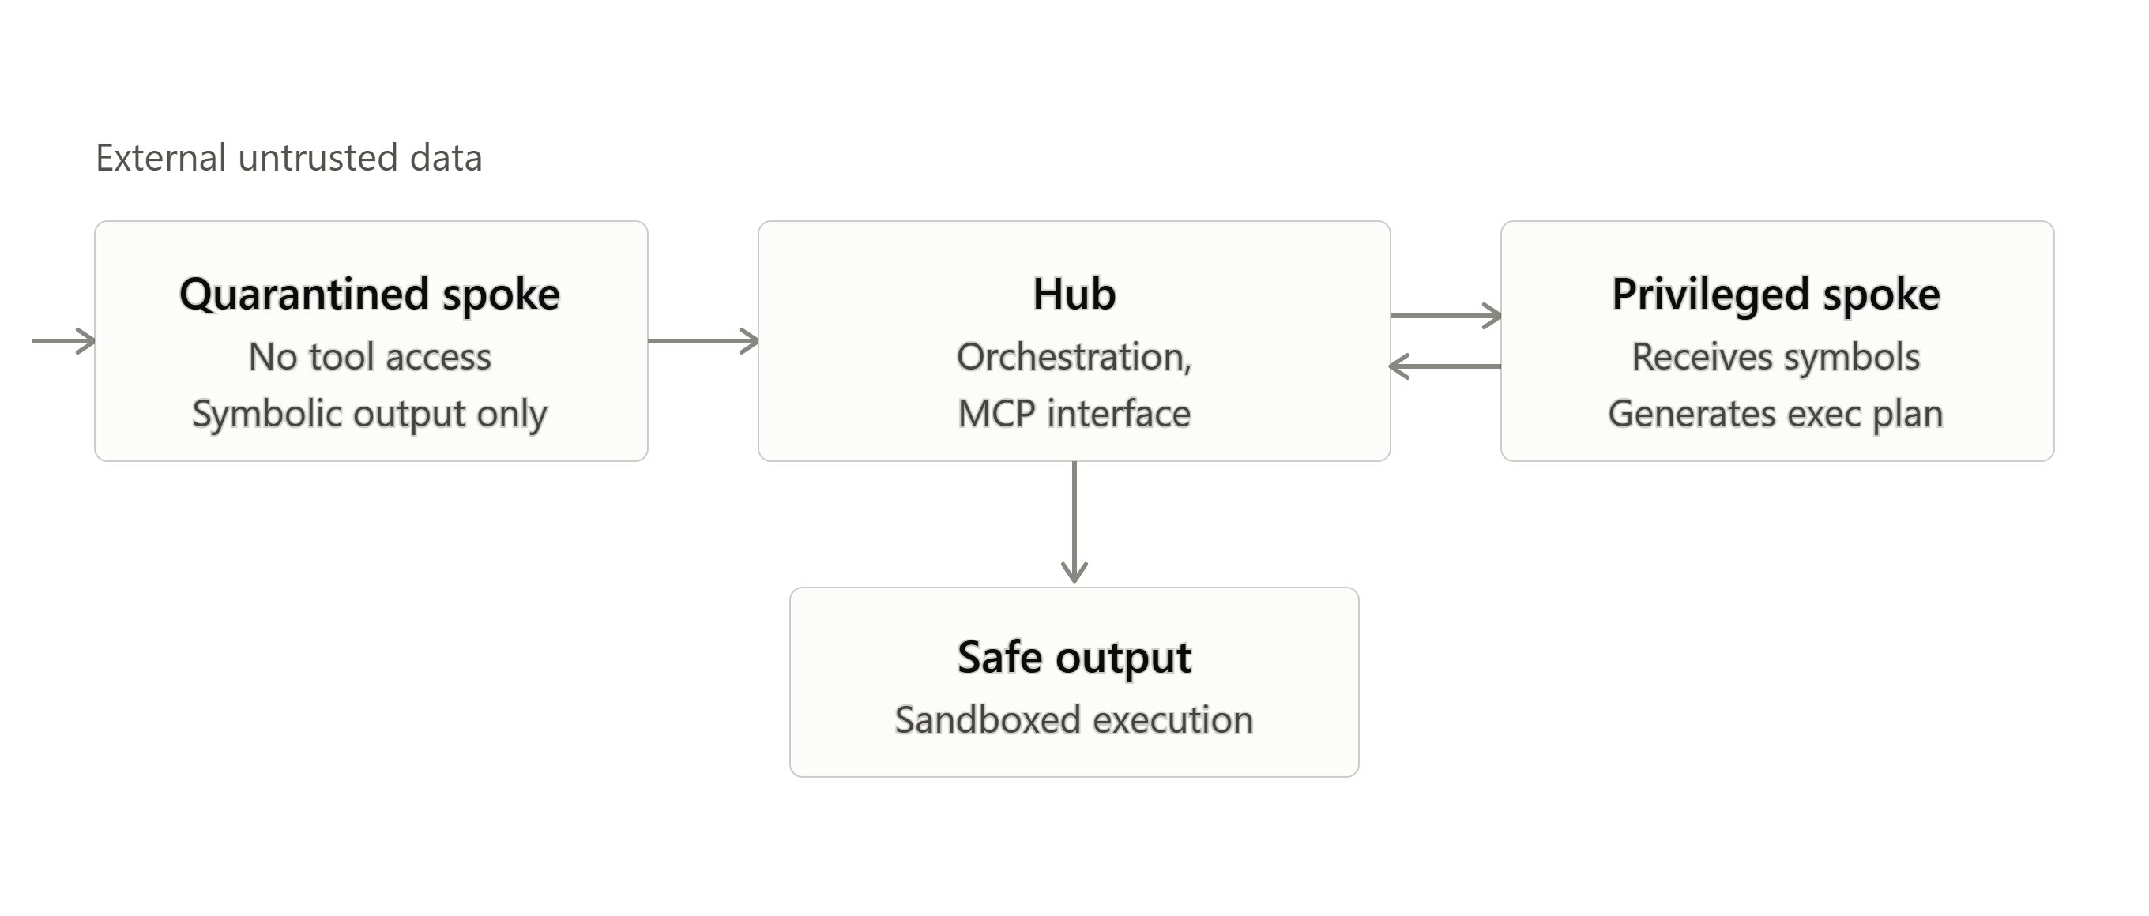
Figure 3.1: Diagram showing the Hub, Quarantined Spoke, and Privileged Spoke, with data symbolisation and sandboxed tool execution. (Source: Author, 2026)
Category | Requirement
Programming languages | Python 3.10 or later
Libraries and frameworks | LangChain (agent orchestration), MCP SDK (tool integration), Docker API (containerisation)
Evaluation tooling | AgentDojo and AgentLAB benchmark suites; UK AI Safety Institute's inspect_evals repository
Models | Local open-weight models (e.g., Llama-3.1-8B, Mistral-7B) executed via vLLM for full reproducibility
Hardware | Linux workstation with an NVIDIA RTX-series GPU (24GB VRAM) and fast NVMe storage for container sandboxing
Table 3.1: Software and hardware requirements.

Data Analysis and Evaluation
System performance will be evaluated against four metrics drawn from the AgentDojo and AgentLAB frameworks, summarised in Table 3.2.
Metric | Definition | Justification
Targeted Attack Success Rate (ASR) | Percentage of test instances where the injected payload achieves its objective | Measures primary security efficacy; lower is better
Benign Utility (BU) | Percentage of legitimate, unattacked tasks completed successfully | Measures functional penalty; higher is better
Turn to Success (T2S) | Average number of interaction turns required for a long-horizon attack to succeed | Evaluates resilience against sustained, multi-turn manipulation
Latency Overhead | Additional processing time, in milliseconds, from dual-LLM routing and isolation | Assesses deployment viability and computational cost
Table 3.2: Evaluation metrics and justification.

B) Research Materials
The evaluation is based on the AgentDojo test suite, composed of realistic static IPI cases (e.g., banking, travel, and workspace management applications), and the AgentLAB framework, which introduces long-horizon attacks (e.g., intent hijack, memory poison) [8]. AgentDojo and AgentLAB are open-sourced, community-maintained, and are the state of the art for evaluating agentic security, against which our approach is compared.

Ethical Considerations
For this project, only fabricated, open-source benchmarks that are designed with security testing in mind will be used. No human participant data, personally identifiable data, or live, in-house enterprise data will be used, and as such there will be no GDPR risk as far as data is concerned.
There is some offensive testing that must take place for this study, specifically indirect prompt injection and zero-click exploit testing. Such tests have the risk of creating usable exploit patterns. To counteract this, all adversarial testing will take place within a segregated, air-gapped Docker environment on local hardware; no live enterprises, public cloud environments, or unauthorized third-party APIs will be attacked or contacted at any point. If usable exploit patterns do develop, they will remain within the confines of the academic work, and will not be circulated as working exploits. The completed Ethics Form, which fully explains this containment method, is attached separately on Moodle before the physical development is started.

Section 4: Expected Outcome

Expected Results
We anticipate the ensemble configuration will yield a drop in the Targeted Attack Success Rate (TASR) to both adjacent/distant future direct and indirect prompt injection from around 30-40% in our original system, down to less than 10%. Meanwhile, the Benign Utility should drop by less than 8%, a beneficial region on the security–utility plane in terms of robustness compared to the state-of-the-art, single-mechanism defences described in the academic publications.

Implications
- Academic: empirical evidence validating that combining data symbolisation with execution isolation offers stronger defence against multi-turn adversarial strategies than semantic filtering alone.
- Technical: a reference architecture hardening the Model Context Protocol against zero-click exploits, with a verifiable method for tracking untrusted data across system states.
- Industry: an actionable, open deployment blueprint supporting the secure adoption of autonomous agents under frameworks such as the NIST AI RMF.

Limitations
Inherent added token count and inference latency: dual-LLM routing introduces token usage and inference latency, which might make the architecture prohibitive in resource-limited or latency-sensitive settings. The work is restricted to only the context of indirect prompt injection targeting tool-calling agents. It does not touch on the notion of model-weight poisoning, adversarial manipulation of the training data, or leaking sensitive information via hardware side channels.

Risk Register
Table 4.1 sets out the main risks to project delivery, with likelihood, impact, and mitigation.
Risk | Likelihood | Impact | Mitigation / contingency
Prototype fails to integrate cleanly with AgentDojo/AgentLAB APIs | Medium | High | Begin integration testing in Month 3 rather than Month 4; maintain a minimal-integration fallback
Open-weight models underperform relative to proprietary baselines | Medium | Medium | Report actual results with analysis; compare against published baselines rather than absolute targets
Sandboxing (seccomp/AppArmor) introduces excessive latency | Medium | Medium | Profile and optimise container configuration; relax isolation strictness only where justified by data
ASR reduction falls short of the 10% target | Medium | Medium | Report actual ASR with a shortfall analysis; compare against DualView and IsolateGPT baselines individually
GPU/hardware access delayed or insufficient | Low | High | Reserve cloud GPU instance as a fallback if local hardware provisioning is delayed
Six-month timeline slips due to prototype development delays | Medium | Medium | Build a buffer into Month 5 to absorb overruns from Months 3 and 4
Table 4.1: Risk register and contingency plan.

Section 5: Timeline
Table 5.1 sets out the six-month project timeline.
Month | Core activity | Milestone
1 | Finalise literature review; provision hardware; configure local LLM environment (vLLM) | Literature review chapter completed; environment operational
2 | Execute baseline testing of undefended agent architectures against AgentDojo and AgentLAB | Baseline ASR and BU metrics recorded
3 | Design and script the composite architectural prototype (Hub, Quarantined Spoke, Privileged Spoke, sandbox) | Alpha version of the defensive architecture deployed locally
4 | Integrate the prototype with testing frameworks; execute automated adversarial testing (static and long-horizon) | Experimental testing phase complete; raw data collected
5 | Conduct statistical data analysis; calculate latency overheads | Evaluation chapter drafted with finalised charts and tables
6 | Academic formatting, critical proofreading, and finalisation of the document | Final dissertation submitted
Table 5.1: Six-month project timeline and deliverables.
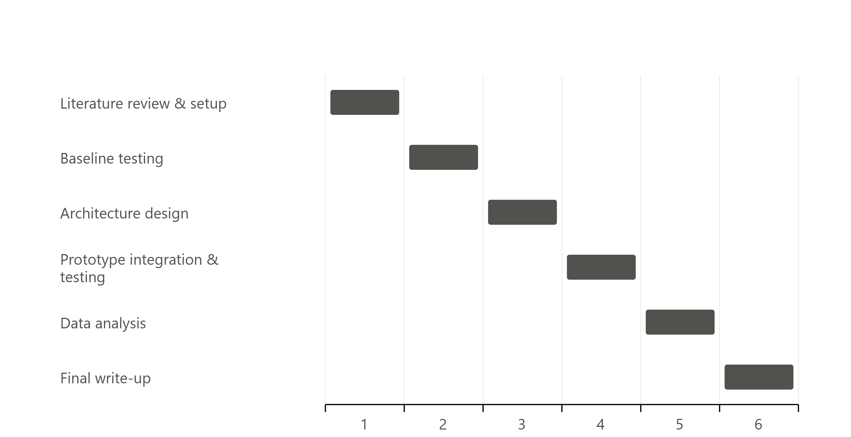
Figure 5.1: Visual Gantt chart showing the six project phases plotted across the timeline, corresponding to Table 5.1. (Source: Author, 2026)

Section 6: Presentation of the Proposal
The above proposal reflects the structure of headings as defined by the assessment and is written using a third-person academic tone throughout. Each paragraph will present a point with justification from referenced evidence, detail what this implies and proceed logically on to the next point, instead of sequentially quoting the references. Each point and statistic has an in-text IEEE numbered citation, referring to the numbered bibliography in Section 7.

Section 7: References
[1] S. Willison, "The Dual LLM Pattern for Building AI Assistants That Can Resist Prompt Injection," Apr. 2023. [Online]. Available: https://simonwillison.net/2023/Apr/25/dual-llm-pattern/
[2] K. Greshake, S. Abdelnabi, S. Mishra, C. Endres, T. Holz, and M. Fritz, "Not What You’ve Signed Up For: Compromising Real-World LLM-Integrated Applications with Indirect Prompt Injection," in Proc. 16th ACM Workshop on Artificial Intelligence and Security (AISec), Nov. 2023, pp. 79-90.
[3] Cloud Security Alliance, "NIST Proves Static AI Guardrails Are Mathematically Insufficient," Cloud Security Alliance, 2026. [Online]. Available: https://cloudsecurityalliance.org
[4] Open Worldwide Application Security Project, "OWASP Top 10 for LLM Applications," OWASP Foundation, 2025.
[5] "Security Analysis of the Model Context Protocol Specification and Prompt Injection Vulnerabilities in Tool-Integrated LLM Agents," arXiv preprint, 2025.
[6] J. Kim et al., "DualView: Preventing Indirect Prompt Injection in Personal AI Agents," arXiv:2607.03821, 2026.
[7] Y. Wu, F. Roesner, T. Kohno, N. Zhang, and U. Iqbal, "IsolateGPT: An Execution Isolation Architecture for LLM-Based Agentic Systems," in Proc. Network and Distributed System Security Symposium (NDSS), 2025.
[8] E. Debenedetti, J. Zhang, M. Balunović, L. Beurer-Kellner, M. Fischer, and F. Tramèr, "AgentDojo: A Dynamic Environment to Evaluate Prompt Injection Attacks and Defenses for LLM Agents," in Proc. Advances in Neural Information Processing Systems (NeurIPS), 2024.
[9] E. Wallace, K. Xiao, R. Leike, L. Weng, J. Heidecke, and A. Beutel, "The Instruction Hierarchy: Training LLMs to Prioritize Privileged Instructions," OpenAI, Apr. 2024.
[10] A. R. Hevner, S. T. March, J. Park, and S. Ram, "Design Science in Information Systems Research," MIS Quarterly, vol. 28, no. 1, pp. 75-105, Mar. 2004.
[11] "AgentLAB: Benchmarking LLM Agents against Long-Horizon Attacks," arXiv preprint, 2026.
[12] National Institute of Standards and Technology, "Artificial Intelligence Risk Management Framework (AI RMF 1.0)," NIST AI 100-1, Jan. 2023.
[13] British Computer Society, "BCS Code of Conduct for BCS Members," British Computer Society, 2022. [Online]. Available: https://www.bcs.org/membership-and-registrations/become-a-member/bcs-code-of-conduct/

