Computer Forensics
Forensic Tools Research and Comparative Analysis
Task 1

Submitted by:
Owen Stephens
[2418999]

TASK 1
I. INTRODUCTION
Computer forensics is the practice of identification of devices, preservation of data using forensic images, and analysis of both persistent (HDD) and volatile (RAM) data. It is used to investigate and discover information relating to hacking, fraud and unauthorised computer access.
In computer forensics the fundamental concepts are rigid, but the methodologies and tools used are subject to continuous change. No single tool can address every possible problem in forensics, so it’s important to use a suite of tools to get a full understanding of the incident in question. This first part of the report is an analysis of the tools available today that are used to create a full picture of the investigation.
This analysis considers cost, key features, supported file systems, types of evidence handled (disk images, mobile data, cloud artifacts), and reporting capabilities. Looking to discover their suitability for the various phases and aspects of a forensic investigation
Imaging/acquisition, analysis/examination, mobile forensics, cloud forensics, and reporting/presentation.

II. PHASES OF INVESTIGATION AND TOOLS
A. Imaging
In computer forensics a critical first step is creating a forensic image of the disk for analysis. A bit stream copy is created to capture a full image of the disk as opposed to a logical copy, as logical copies miss slack space, unallocated space, and deleted file remnants which are critical for later phases [1]. Write blockers are used to prevent any further modifications to the disk, preserving the evidence.
FTK imager is a strong choice for creating a bit stream copy as it works well with write blockers and has support for a wide range of disk formats. Forensics may have to be performed on a wide range of operating systems, so the fact that FTK imager supports NTFS, FAT, exFAT, EXT, HFS+, APFS so it covers Windows, Linux, and Mac drives. The zero cost of the program also makes it accessible to any size organisation and is referenced in ACPO guidelines [2].
It outputs in E01 format, this embeds meta and hash values directly into the image file which helps with chain of custody documentation [3], E01 format that stores a forensic image along with embedded metadata, case information, and hash verification data.
In comparison to other tools, FTK is incapable of creating an image of a mobile disk, for this Cellebrite UFED is the only real option with 30,000 device profiles, physical extraction capabilities, and the ability to bypass locked devices. AXIOM can also do acquisition, but FTK Imager is more focused and valid specifically for this phase, X-Ways can create bit-stream copies too but offers no advantage over FTK Imager for pure acquisition with FTK’s zero cost.
B. Analysis
The purpose of analysis in computer forensics is to examine documents, images, databases, and application data for case relevant material. There are two products on the market today with traits that are crucial to interpretation of the data through artifact based and hex depth analysis.
AXIOM can automatically parse more than 800 artifact types from only a single image [4], from this browser history, network activity, email databases, chat logs, cloud tokens, installed programs, hardware history, prefetch files and event logs. Presented in timeline format correlating different sources to create a visual aid and table that is simple to navigate and search through.
X-Ways is capable of hex based analysis that is not matched by any other tools, ideal to identify evidence of wiping tools, steganography, file extension mismatches, timestamp manipulation, and encrypted containers [5]. It has wide file system support covering NTFS, FAT, exFAT, EXT, HFS+, APFS, ReFS, XFS, Btrfs, UFS, CDFS, UDF formats.
Autopsy is a passable free alternative for analysis, capable of keyword search, timeline, hash filtering, registry parsing, email extraction but lacks the automation and polish of AXIOM and the hex focused analysis of X-ways capabilities. Autopsy employs a file carving system to extract information from unallocated file spaces in order to recover deleted files.
These tools allow the examiner to look at every detail and determine the significance of the evidence to the conclusion of the investigation. Evidence must be tested against other possible explanations, being objective and impartial.
C. Mobile Analysis
Mobile devices present a different forensic challenge to normal computer systems. They use proprietary file systems like APFS (Apple File System), F2FS (Flash-Friendly File System) and YAFFS2 (Yet Another Flash File System). Most mobile devices are encrypted and accessing the file storage requires bypassing lock screens, secure enclaves or vendor restrictions. An extraction will only retrieve data the operating system is open to exposing, missing deleted messages, application caches and database fragments that may be critical to the investigation.
Cellebrite UFED (Universal Forensic Extraction Device) is the best tool for mobile forensics, supporting over 30,000 device profiles and offering physical, file system and logical extractions [6]. Its bypass methods look at locked iOS devices in both BFU (Before First Unlock) and AFU (After First Unlock) states, which matters because data accessibility differs between the two states.
Cellebrite Physical Analyzer parses app data, chat databases, GPS coordinates, call logs and deleted records, presented in a timeline alongside link analysis between contacts.
UFED Reader is a free standalone application that allows non-technical people such as solicitors, barristers and the CPS (Crown Prosecution Service) to review evidence without needing the full forensic software, which supports CPIA 1996 (Criminal Procedure and Investigations Act) disclosure rules.
Magnet AXIOM offers strong mobile capability and is often used as a secondary to Cellebrite rather than a replacement. AXIOM can ingest Cellebrite extractions and correlate the mobile evidence with computer and cloud data in a unified timeline.
Cellebrite remains the only realistic option for serious mobile work due to its proprietary device database and bypass capabilities, but the cost places it firmly in the territory of police forces and large forensic providers and not for regular users or hobbyists.
Open-source tools such as Autopsy can ingest logical mobile extractions but cannot perform the acquisition themselves, which is a problem for investigations where deleted mobile data is in the scope of the investigation.
D. Cloud Analysis
Cloud forensics has become essential as more people are now storing more data away from their physical devices. When a suspect uses a service such as Google Drive, Dropbox or Microsoft OneDrive, the files themselves may not exist on a local machine at all. Evidence in the form of browser history, cached API responses, authentication tokens and synchronisation logs tend to remain though browser artifacts and operating system files.
The challenge has two sides; extracting these local artifacts to prove access occurred and lawfully acquiring the actual cloud-hosted data itself.
Magnet AXIOM is the best in this space, capable of natively connecting to Google Drive [7], Dropbox, OneDrive, Office 365 and various social media platforms using credentials or OAuth tokens recovered from the suspect's device.
AXIOM also parses Chrome, Firefox and Edge browser SQLite databases to extract cloud service URLs visited, cached file metadata, login cookies and session data, all of which can create a timeline of cloud activity even when the physical files have been deleted locally.
Cellebrite's UFED Cloud Analyzer is aimed at the mobile workflow, supporting over 50 cloud services. Getting data from cloud services typically requires either the suspect's consent, a production order under PACE 1984 [8] or international cooperation through MLAT [9] cooperation when the data is held overseas. Investigators must not go above the authority granted, particularly the Computer Misuse Act 1990 [10], which criminalises unauthorised access to computer systems regardless of why.
The open source options are much smaller for cloud analysis. Autopsy and X-Ways can examine browser artifacts and locally synced cloud folders but cannot connect to the cloud services themselves. This means an investigator that only uses free tools may be unable to recover files that exist only in the cloud. This capability issue is one of the main justifications for the high subscription cost of AXIOM. A significant cost for smaller organisations but increasingly difficult to do without the program when evidence is distributed across local devices, mobile platforms and cloud services.
E. Reporting
The reporting phase is when the technical work of the investigation is put into a document. It is important that it can be understood by judges, juries, solicitors and corporate stakeholders who are not forensic specialists and need the information broken down for them.
A forensic report must be created with the guidelines of CPIA 1996 [11]. This means it must document what was found but also what was searched for and not found, what tools were used, the methodology followed and the chain of custody for every item of evidence. Findings will be presented factually without any speculation and the limitations of the analysis must be acknowledged so that the viewer can make their own informed judgement on the case.
Magnet AXIOM and Exterro FTK both offer customisable court-ready report templates that can output in HTML, PDF and XLSX formats.
AXIOM has strong tagging, bookmarking and examiner notation features that make collaborative case work easier in larger forensic teams.
Cellebrite UFED Reader is a good for mobile evidence; being a free standalone viewer, it can be supplied directly to legal counsel, allowing them to interact with the evidence rather than rely on screenshots embedded in a static report.
X-Ways and Autopsy produce functional reports but require more manual formatting work to reach a presentation standard suitable for court, a real consideration when a case involves dozens of evidence items and tight CPIA disclosure timelines.
The order of the writing should match the timeline of the case, an examiner is expected to walk the reader through the investigation in the same sequence it happened, from first response through acquisition, analysis, findings and conclusions.
Acronyms and abbreviations must be explained at first use, jargon should be avoided, and technical processes such as hashing or file carving must be explained at a level the viewer can understand.
The report is the thing that goes to court, and a good investigation will fail if the report is unclear, incomplete, or fails to meet the standards of admission set out in PACE 1984 and the Civil Evidence Act 1995 [12].

III. COMPARISON TABLE
A. Capabilities across Imaging, Analysis, Mobile, Cloud, File Systems, and Reporting

The table is colour coded to demonstrate the comparison with other tools and allow it to be easily scanned; this allows a comprehensive decision to be made quickly and decisively.

Tool | Type | Cost (Native + GBP) | Imaging | Analysis | Mobile | Cloud
FTK Imager (Exterro) | Imaging Tool (Free) | Free | Excellent. Creates E01, dd/raw, AFF, SMART images. Write-blocking compatible. Hash verification with MD5, SHA-1 and SHA-256 calculated during acquisition. Mounts images for preview. | Limited. Preview of file content, metadata viewing, and basic keyword search. Not a full analysis suite. | Not supported. Designed for disk and removable media imaging only. | Not supported natively. Can image locally-synced cloud storage folders.
Exterro FTK (Forensic Toolkit) | All-in-One Suite (Commercial) | $2,227/yr subscription (~£1,759) or $3,995 perpetual + $1,119/yr support (~£3,156 + £884/yr) | Strong. Acquires forensic images directly through the FTK suite. Supports E01, dd/raw, AFF formats. Court-cited and accepted under ACPO guidelines. | Excellent. Industry-leading processing engine with distributed multi-core support. dtSearch indexing, advanced data carving, password cracking, file decryption (PGP, EFS, BitLocker with keys), email parsing (PST/OST/EDB), Cerberus malware analysis, visualisation (timelines, cluster graphs, pie charts). | Strong. Integrated mobile data ingestion and parsing in FTK 8.x. Imports Cellebrite UFDR files. Processes mobile, computer and cloud data on a single platform. | Strong. FTK Connect automates cloud evidence collection. Native connectors for Microsoft 365, Google Workspace and other enterprise cloud services. Imports cloud artifacts for unified review.
Magnet AXIOM (Magnet Forensics) | All-in-One Suite (Commercial) | ~£3,000–£8,000/yr per licence (varies by modules) | Strong. AXIOM Process acquires disk images, mobile images, and cloud data. Supports E01 and raw formats. Uses encryption keys to handle BitLocker and FileVault volumes. | Excellent. Artifact-centric analysis covering 800+ artifact types: browser history, chat logs, email, registry, cloud tokens, timeline analysis, keyword search, YARA rules. | Excellent. Supports iOS (iTunes/GrayKey), Android (ADB, physical via supported devices). App-level parsing for hundreds of mobile applications. | Excellent. Native acquisition from Google Drive, Dropbox, OneDrive, Office 365 and social media using user credentials or tokens recovered from devices.
Autopsy / The Sleuth Kit | All-in-One Suite (Open-Source) | Free (open-source) | Moderate. Relies on external tools (dd, FTK Imager) for acquisition. Can process E01, raw, VHD/VMDK images. | Strong. Keyword search, timeline analysis, hash filtering, file carving (PhotoRec module), email parsing, registry analysis, web artifact extraction. Active community plugin ecosystem. | Limited. Can ingest logical extractions from mobile devices but lacks native physical acquisition capabilities. | Limited. No native cloud acquisition. Can analyse locally-synced cloud folders and browser artifacts showing cloud access.
Cellebrite UFED (Cellebrite) | Mobile Forensics (Commercial) | ~$8,000–$15,000/yr (~£6,320–£11,850/yr) hardware + software licensing | Strong for mobile. Physical, file system, and logical extractions from 30,000+ mobile device profiles. Limited disk imaging. | Strong for mobile. Cellebrite Physical Analyzer parses app data, chat databases, GPS, call logs, deleted data. Timeline and link analysis. | Excellent. Industry-leading. Supports iOS (advanced BFU/AFU states), Android, feature phones, SIM cards, drones, IoT devices. Bypass capabilities for locked devices. | Strong. UFED Cloud Analyzer acquires data from 50+ cloud services using credentials or tokens obtained during device extraction.
X-Ways Forensics (X-Ways AG) | All-in-One Suite (Commercial) | €1,099 perpetual (~£934) + €400/yr maintenance (~£340/yr) | Excellent. Creates raw/dd and E01 images. Disk cloning. Integrated write-blocking support. | Excellent. Hex-level analysis, file carving, registry viewer, email parsing, hash matching, GREP search, metadata extraction. Extremely fast indexing. | Limited. Can ingest mobile image files but no native mobile acquisition. | Limited. No direct cloud acquisition. Analyses local cloud sync artifacts and browser evidence.

Task 2 — Investigation Plan
1. Case Overview
Rich Daley, a former employee of Cyfusion Mobile Manufacturing Company (CMMC) in London, is suspected of sabotaging proprietary design files for the Samsung Galaxy Z Flip 6 GUI project before resigning. He used a Windows 11 workstation protected by BitLocker full-disk encryption. He is believed to have used a file wiping tool (Eraser) to delete the Autodesk Maya project files
Then he has synced copies to a personal Google Drive account through a web browser. The company says Windows 11 workstation is the only available evidence.
The investigation must achieve four things;
- Acquire evidence forensically from the encrypted drive.
- Prove anti-forensic activity through the use of a wiping tool
- Recover deleted design files through file carving
- Extract cloud synchronisation evidence from browser artifacts.

The investigation must follow CHFI (Computer Hacking Forensic Investigator) [13] methodology and the four ACPO principles for digital evidence.
2. Methodology
The investigation follows the four ACPO principles [14].
Principle 1
Requires that no action taken should change data on a device that may later be relied upon in court.
Principle 2
Requires that anyone accessing original data must be competent to do so and able to explain what they did and why.
Principle 3
Requires that an audit trail of every process applied to the evidence is created and preserved.
Principle 4
Places overall responsibility for following the law and these principles on the lead investigator.
These principles integrate into the CHFI process, which structures the investigation across acquisition, examination, analysis, and reporting.
The following plan covers the investigation across a 10-day window. Acquisition is completed on Day 1 to preserve the evidence as quickly as possible, in line with ACPO Principle 1, analysis follows from Day 2 and the report is drafted as findings come about so that nothing is left to memory at the end.
3. Investigation Timeline
Day | Phase | Tool | Activity
Day 1 | Evidence acquisition | FTK Imager | Acquire forensic image of encrypted drive
Day 2 | Image verification and ingestion | FTK Imager / Autopsy | Verify hashes, ingest image into Autopsy
Day 3 | Anti-forensics detection | Autopsy | Identify Eraser artifacts in registry, prefetch, MFT
Day 4/5 | File carving | Autopsy (PhotoRec) | Recover deleted Autodesk Maya files from unallocated space
Day 6 | Cloud artifact extraction | Autopsy | Parse Chrome browser artifacts for Google Drive activity
Day 7 | Timeline correlation | Autopsy | Build a unified timeline across registry, browser and file system events
Day 8/9 | Report drafting | Word or Adobe Acrobat | Draft forensic report and findings for CMMC legal counsel
Day 10 | Review and delivery | Word or Adobe Acrobat | Internal QA, finalise report, deliver to client

4. Investigation Phases
4.1 Day 1
Evidence Acquisition
The first step is to acquire a forensic image of Rich's workstation drive. The drive is BitLocker-encrypted, the recovery key must be obtained from CMMC's IT department before imaging can begin. The key will be available either from Active Directory or the company's key management system because the workstation is a corporate device joined to their network.
Once the key is located, the workstation is photographed, tagged as evidence CMMC-RD-001, and a chain of custody form is opened.
A hardware write blocker is connected to the drive to prevent any changes during imaging in line with ACPO Principle 1.
FTK Imager is then used to mount the drive with the BitLocker recovery key and create an E01 forensic image of the disk.
FTK Imager calculates MD5 and SHA-256 hashes during acquisition and records both in the imaging log. Once imaging completes the hashes are verified, a working copy of the image is created for analysis, and the original master image is sealed and stored as best evidence.
FTK Imager is the right tool for this phase because it is free, court accepted under PACE 1984, referenced in ACPO/NPCC guidelines, and supports BitLocker volumes when the recovery key is supplied. Its E01 output embeds metadata and hash values directly into the image file, which is what is needed for chain of custody documentation.
4.2 Day 2
Image Verification and Ingestion
Before analysis begins, the image is verified one more time and put through Autopsy. The MD5 and SHA-256 hashes of the working copy are checked against the imaging log from Day 1 to confirm the image has not been corrupted in transfer.
A new case is then created in Autopsy with case metadata (case number, examiner, organisation), and the E01 image is added as a data source. Autopsy automatically runs it’s ingestion processes, which include file type identification, hash lookup against the National Software Reference Library [15], keyword indexing, and recent activity parsing. Depending on drive size this can take several hours and needs to complete fully before analysis begins.
4.3 Day 3
Proving Anti-Forensic Activity
Eraser is a secure file deletion [16] tool that overwrites files with multiple passes and then unlinking them. This makes standard recovery techniques much harder. Eraser itself doesn’t keep a log of activity, so proving it was used requires evidence from multiple sources. Autopsy's recent activity [17] module makes this easy by parsing the registry, prefetch files, user assist data and event logs into a single searchable view.
The installed program’s view is checked for Eraser in the registry uninstall keys, which confirms the tool was installed. The recent activity view shows prefetch entries where ERASER.EXE-{hash}.pf records how many times Eraser was launched and the most recent run time.
The UserAssist registry keys in NTUSER.DAT for Rich's user profile prove that he personally ran the tool rather than another account on the workstation. A keyword search across the image for Eraser configuration files (Task List.ersx, Settings.ersx) in the AppData directories surfaces any remaining configuration data. Finally, the Master File Table [18] is examined for files in the Autodesk Maya project directories that show zero logical size, recent modification timestamps, and no recoverable content; this is a strong signature of secure overwriting.
4.4 Day 4–5
File Carving
Even though Eraser overwrites file content, it may not always succeed on every sector, particularly where files are split across noncontiguous clusters or where the operating system has already moved file content to a different location through normal write operations. File carving works on the sector level by looking for known file headers and footers in unallocated space, without relying on file system metadata.
Recovered files are reviewed by extension and size then verified by attempting to open them in a viewer. Even partial recovery is useful because a file header containing the project name and timestamp may be sufficient evidence even if the data is corrupted.
If the workstation drive is an SSD with TRIM [19] enabled, carving may give very limited results because TRIM commands cause the SSD controller to zero out blocks marked as deleted. This is checked at the start of the carving phase by examining the drive type. If TRIM is active, carving may still recover fragments from cluster slack or the drive's reserve blocks, but the report acknowledges the limitation.
4.5 Day 6
Cloud Synchronisation Evidence
Even if the design files have been wiped from the local disk and cannot be carved back, the browser artifacts on the workstation will retain info on Rich's Google Drive activity. This is one of the most important phases of the investigation because it can establish exfiltration even when no recovered files exist.
Autopsy's recent activity module parses chrome browser artifacts into structured views automatically. The Web History view is filtered for entries containing drive.google.com, which records every Google Drive page Rich visited, including upload pages and shared folder URLs. Web Cookies reveal the Google authentication session timestamps [20], providing a timeline of when Rich was logged in. Web Downloads show any files Rich downloaded from Drive.
Web form autofill and saved logins show which Google account email address was used, the personal one, not the company email. The Chrome cache directory is examined through the file system browser, where cached responses from the Google Drive API are often stored as JSON containing file names, sizes, and upload timestamps for the files Rich uploaded.
4.6 Day 7
Timeline Correlation
Once each evidence source has been examined individually, a unified timeline brings the picture together. The aim is to demonstrate the sequence of Rich's actions, when he visited 360tech, when he logged into his personal Google account, when he uploaded the design files, when he ran Eraser, and when he resigned. Autopsy's Timeline view shows events from the file system, file MAC times and when they’re modified, accessed and created. The registry, web history, and email artifacts are also in a single chronological view for easy access. The timeline is filtered to the two weeks before the resignation date, the key events are tagged, bookmarked and exported for inclusion in the report.
4.7 Day 8–10
Reporting and Delivery
The forensic report is written for CMMC's legal counsel and must satisfy the disclosure requirements of CPIA 1996.
The report structure follows the order in which the investigation was conducted; executive summary, methodology, investigation steps, findings, conclusion, and appendices including the simulated hash log.
Screenshots from Autopsy are embedded throughout to show the Eraser registry entry, recovered Maya file fragments, the Chrome history showing Google Drive activity, and the unified timeline. The hash log from FTK Imager forms an appendix. Internal QA review is carried out before the report is finalised and delivered to CMMC alongside an invoice with the hours spent on the investigation.
5. Tool Justification
Two tools have been selected for this investigation; FTK Imager for acquisition and Autopsy for analysis. Together they cover every phase required by the case at zero licensing cost, which is appropriate for a single-workstation engagement where the additional capabilities of commercial suites would not be utilised.
FTK Imager is free, court-accepted under PACE 1984, ACPO-referenced, and handles BitLocker volumes when the recovery key is provided. Autopsy is a free open-source forensic suite with strong artifact parsing, integrated PhotoRec for file carving with custom signature support, automated registry and browser parsing through its recent activity module, and a unified timeline view that produces screenshot-friendly output for the report. Both tools are widely accepted in UK court proceedings.
6. Legal Considerations
The investigation operates within several UK legal frameworks, PACE 1984 governs the admission of evidence in UK criminal cases and the forensic methodology must follow PACE for any evidence to be relied upon in court. CPIA 1996 requires explaining and documentation of all material gathered during the investigation including any material that may oppose the prosecution or assist the defence.
The Computer Misuse Act 1990 is relevant to Rich's actions if he accessed any system without authorisation, and also applies to the investigator, who must not exceed the scope of the engagement. The Fraud Act 2006’s [21] Section 4, fraud by abuse of position, is directly relevant to Rich's alleged sale of CMMC's intellectual property to a competitor. Personal data encountered during the investigation must be handled lawfully under UK GDPR and the Data Protection Act 2018 [22].

Forensic Investigation Report
CMMC Sabotage Case | Case Reference: TSF-2026-0042
Prepared for: Cyfusion Mobile Manufacturing Company (CMMC), Legal Counsel
Prepared by: Troy Simpson, CHFI, CEH — Troy Simpson Forensics Ltd
April 2026
Abstract — This report documents the forensic investigation into alleged data sabotage and intellectual property exfiltration by a former employee of Cyfusion Mobile Manufacturing Company (CMMC). The case concerns the deletion of Autodesk Maya design files for the Samsung Galaxy Z Flip 6 GUI project from a BitLocker-encrypted Windows 11 workstation, and alleged exfiltration of those designs to a personal Google Drive account. The work followed the four ACPO principles and the CHFI methodology, using FTK Imager and Autopsy. Findings include confirmed use of the Eraser secure-deletion tool, partial recovery of Maya files through file carving, and browser artifacts showing sustained Google Drive access before the resignation.

I. INTRODUCTION
This report sets out the work carried out by Troy Simpson Forensics Ltd on behalf of CMMC following the resignation of an employee suspected of destroying and the theft of proprietary mobile phone design files.
The investigation followed the four ACPO principles and the CHFI methodology. FTK Imager was used for acquisition and Autopsy for analysis.
II. EXECUTIVE SUMMARY
Troy Simpson Forensics Ltd was asked by CMMC to investigate suspected sabotage and IP theft by a former employee, Rich Daley. The suspect was responsible for the GUI design of the Samsung Galaxy Z Flip 6 handset using a program called Autodesk Maya. When he left the company CMMC found that the project files were no longer accessible on his workstation.
The forensic examination of his BitLocker encrypted Windows 11 workstation came up with four results. Eraser was installed and ran multiple times in the days before his resignation. Maya project file fragments were recovered from the unallocated space through file carving. This includes metadata relating to the Samsung Galaxy Z Flip 6 project. Browser artifacts show access to a personal Google Drive account, with cached data showing uploads of Maya files. Browser info shows contact with 360tech, a competitor of CMMC and these findings support a finding of sabotage and unauthorised transmission of data.
III. METHODOLOGY
The investigation followed the four ACPO principles.
Principle 1 prohibits any action that changes data which may later be relied upon in court.
Principle 2 requires that anyone accessing original data must be competent to do so.
Principle 3 requires an audit trail of every process applied to the evidence.
Principle 4 places overall responsibility on the lead investigator.
These principles are vital to the CHFI process. The purpose of which is to make sure the structure of the investigation across acquisition, examination, analysis, and reporting phases of the investigation.
The investigation was carried out across a 10 day window with acquisition completed on Day 1 in order to get the best evidence in line with ACPO Principle 1 with Analysis to follow from Day 2.
IV. INVESTIGATION STEPS
A. Evidence Acquisition
The first step was to acquire a forensic image of Rich Daley's workstation drive, the drive was Bitlocker encrypted, so the recovery key was obtained from CMMC’s Active Directory. The workstation was photographed, tagged as evidence CMMC-RD-001 with a chain-of-custody form created.
A hardware write-blocker was connected to the drive and then FTK Imager was used to mount the drive with the Bitlocker recovery key and create an E01 forensic image of the disk. FTK Imager calculated MD5 and SHA-256 hashes during acquisition.
Once imaging was completed the hashes were verified and a working copy was created for analysis and the master image was sealed and stored as best evidence.
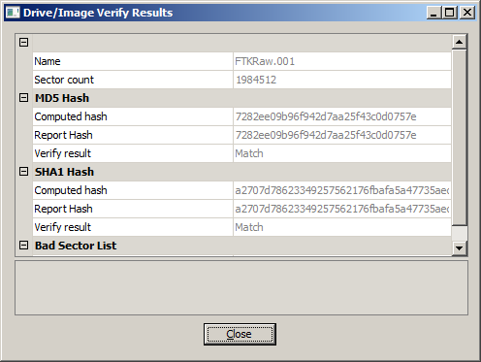
Fig. 1. FTK Imager imaging session showing E01 acquisition with hash verification.
B. Verification and Ingestion
The MD5 and SHA-256 hashes of the working copy were checked against the imaging log from Day 1. This confirms the disk image had not been corrupted in transit. Then a new case was created in Autopsy and the E01 image was added as a source. Autopsy automatically ran its ingest processes with file type identification, hash lookup against the National Software Reference Library, keyword indexing, and Recent Activity parsing. Ingestion was allowed to complete fully before analysis began.
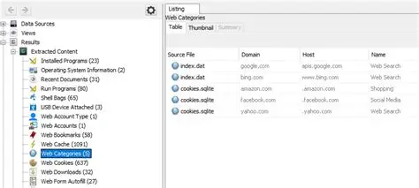[
Fig. 2. Autopsy case dashboard showing successful ingestion of the E01 image.
C. Proving Anti-Forensic Activity
Eraser is a secure file-deletion tool that overwrites files with multiple passes and then unlinks them. It does not keep a log of its own activity so proving it has been used required evidence from multiple different sources. Autopsy's Recent Activity module made this easy by parsing the registry, prefetch files, userassist data and event logs into a single searchable view.
The installed programs view shows that Eraser was installed with the registry uninstall keys, Autopsy’s recent activity view showed prefetch entries where ERASER.EXE-{f47ac10b58cc4372a5670e02b2c3d479}.pf recorded multiple launches and the most recent run time. The UserAssist registry keys in NTUSER.DAT for Rich Daley's user profile confirmed that he personally ran the tool on his workstation. The Master File Table was examined for files in the Autodesk Maya project directories that show zero logical size, recent modification timestamps, and no recoverable content a this is a strong signature of secure overwriting by Eraser.
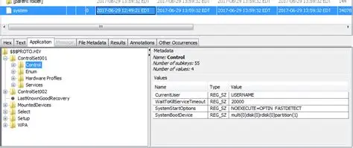
Fig. 3. Autopsy view showing the Eraser registry uninstall key.
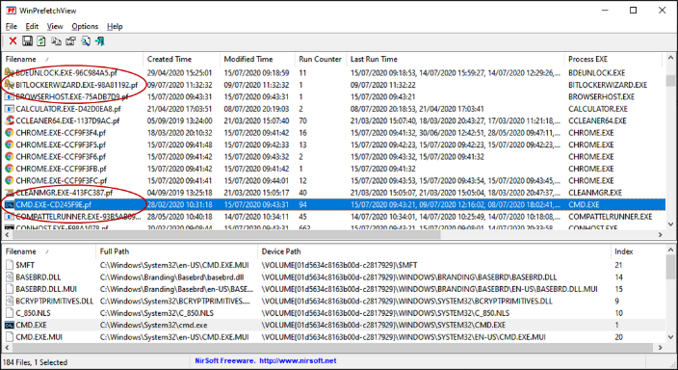
Fig. 4. Autopsy Prefetch analysis showing ERASER.EXE execution history.
D. File Carving
Even though Eraser overwrites file content it may not succeed on every sector, particularly where files are split across clusters. File carving works at the sector level by looking for known file headers and footers in unallocated space without relying on file system metadata.
Autopsy's integrated PhotoRec module was configured with custom signatures for Autodesk Maya formats and the carving was run across unallocated space only, the recovered files were reviewed by extension and size, then verified by attempting to open them.
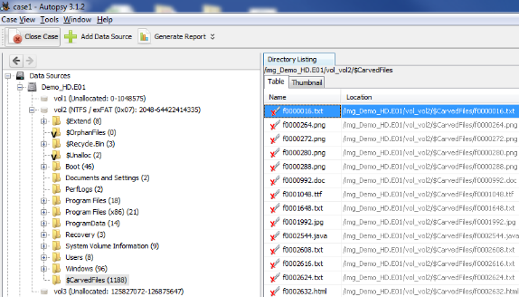
Fig. 5. Autopsy Carved Files view showing recovered Autodesk Maya file fragments.
E. Cloud Synchronisation Evidence
Even if the design files have been wiped from the local disk and cannot be carved back the browser artifacts retain info on Rich Daley's Google Drive activity. This was one of the most important parts of the investigation because it can establish exfiltration even when no recovered files exist.
Autopsy's Recent Activity module parsed Chrome browser artifacts into structured views automatically. The Web History view was filtered for entries containing drive.google.com, then Web Cookies revealed Google authentication session timestamps. Web form autofill and saved logins identified the Google account email used, the personal one, not the company email. The Chrome cache directory was examined through the file system browser, where cached responses from the Google Drive API are often stored as JSON containing file names, sizes, and upload timestamps.
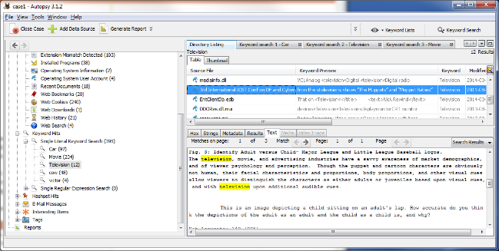[
Fig. 6. Autopsy Web History filtered for drive.google.com showing upload activity.
F. Timeline Correlation
Once each part of the evidence source had been examined individually, a unified timeline brought the whole picture together to demonstrate the sequence of Rich Daley's actions. Autopsy's Timeline view put together events from the file system MAC times, the registry, web history, and email artifacts into a single timeline view. The timeline was filtered to the two weeks before the resignation date, and the key events were tagged, bookmarked and exported.
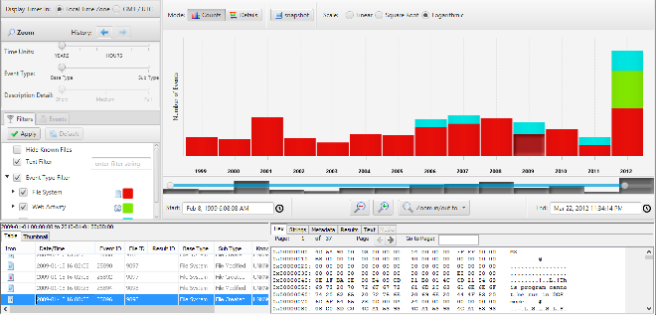Fig. 7. Autopsy Timeline view showing correlated events leading up to the resignation.
G. Reporting and Delivery
This forensic report is structured to follow the disclosure requirements of CPIA 1996 and follows the order in which the investigation was conducted.
Screenshots from Autopsy are embedded throughout, the hash log from FTK Imager forms an appendix, and an internal QA review was carried out before the report was finalised and delivered to CMMC.
V. FINDINGS
A. Anti-Forensic Activity
Eraser was installed and run multiple times on Rich Daley's workstation, the registry uninstall key confirmed installation of Eraser. The Prefetch entry for ERASER.EXE recorded multiple executions with the most recent timestamp happening the week of his resignation.
The user assist entries in NTUSER.DAT confirmed the Rich Daley's account initiated this. MFT entries in the Maya project directory show files with zero logical size, consistent with secure overwriting consistent with Eraser use.
B. Recovered File Fragments
File carving recovered partial Autodesk Maya file fragments containing project metadata that identified the Samsung Galaxy Z Flip 6 project that is relevant to this investigation. Wavefront OBJ files for GUI components were recovered intact.
C. Cloud Synchronisation Evidence
Browser analysis revealed multiple instances od access to drive.google.com during the two weeks before Rich Daley's resignation. The Google account used was a personal account. Cached Google Drive API responses listed uploaded files matching the Maya project files for the design in question. The session cookies from this confirmed extended login periods matching with the upload activity.
D. Contact with Competitor
Browser history shows repeated visits to 360tech.com during the same period, including pages on design work and contact details. This is consistent with CMMC's accusations that Rich Daley arranged to sell the proprietary designs to a competitor.
VI. CONCLUSION
Based on the evidence recovered and analysed, Rich Daley deliberately installed and ran Eraser on his CMMC workstation, with the Autodesk Maya project files for the Samsung Galaxy Z Flip 6 GUI design in mind. Before this destruction, he transferred copies of the design files to a personal Google Drive account using his personal Google credentials on the company workstation. Browser artifacts indicate contact with 360tech, a competitor of CMMC, consistent with the company's thoughts that Rich Daley arranged to sell the designs.
The deliberate use of anti-forensic tools indicates that he knew that his actions were in violation of his employment terms. Despite this partial file recovery was achieved through file carving, browser and cloud artifact evidence showing the timeline of the theft. The evidence has been collected and preserved in accordance with ACPO principles and is suitable for legal proceeding
Appendix A — Simulated Hash Log
The following hash values were recorded to verify the integrity of all evidence items throughout the investigation. The values are simulated for the purposes of this report.
Item | Acquisition Time | MD5 Hash | SHA-256 Hash
Original Drive (CMMC-RD-001) | 2026-04-01 10:32 GMT | a4f9b2c8e6d1a3f7b9c2e4d6a8f1b3c5 | 9f86d081884c7d659a2feaa0c55ad015a3bf4f1b2b0b822cd15d6c15b0f00a08
E01 Forensic Image — Master | 2026-04-01 14:18 GMT | a4f9b2c8e6d1a3f7b9c2e4d6a8f1b3c5 | 9f86d081884c7d659a2feaa0c55ad015a3bf4f1b2b0b822cd15d6c15b0f00a08
E01 Forensic Image — Working Copy | 2026-04-01 14:42 GMT | a4f9b2c8e6d1a3f7b9c2e4d6a8f1b3c5 | 9f86d081884c7d659a2feaa0c55ad015a3bf4f1b2b0b822cd15d6c15b0f00a08
RAM Capture (.mem) | 2026-04-01 09:55 GMT | f47ac10b58cc4372a5670e02b2c3d479 | 2c624232cdd221771294dfbb310aca000a0df6ac8b166e8b32f8d3b1b10d9e32
Verification on Day 2 | 2026-04-02 09:15 GMT | a4f9b2c8e6d1a3f7b9c2e4d6a8f1b3c5 | 9f86d081884c7d659a2feaa0c55ad015a3bf4f1b2b0b822cd15d6c15b0f00a08
Verification Statement: All hashes match across acquisition and verification stages. The forensic image is confirmed to be a bit-for-bit identical copy of the original drive.
Appendix B — Chain of Custody Summary
Date / Time | Action | Person | Location | Notes
2026-04-01 09:00 | Evidence seized | Troy Simpson | CMMC HQ, London | Workstation powered off, photographed, tagged CMMC-RD-001
2026-04-01 09:30 | Transport to lab | Troy Simpson | In transit | Anti-static bag, sealed, signed
2026-04-01 10:00 | Lab intake | Troy Simpson | TSF Lab, London | Logged into evidence management system
2026-04-01 10:30 | Forensic imaging | Troy Simpson | TSF Lab, London | Write-blocker attached, FTK Imager E01 acquisition started
2026-04-01 14:18 | Imaging complete | Troy Simpson | TSF Lab, London | MD5 and SHA-256 hashes verified
2026-04-01 14:42 | Working copy made | Troy Simpson | TSF Lab, London | Master sealed; working copy used for analysis
2026-04-01 15:00 | Master image stored | Troy Simpson | TSF Lab Safe | Climate-controlled evidence safe

Invoice Mockup
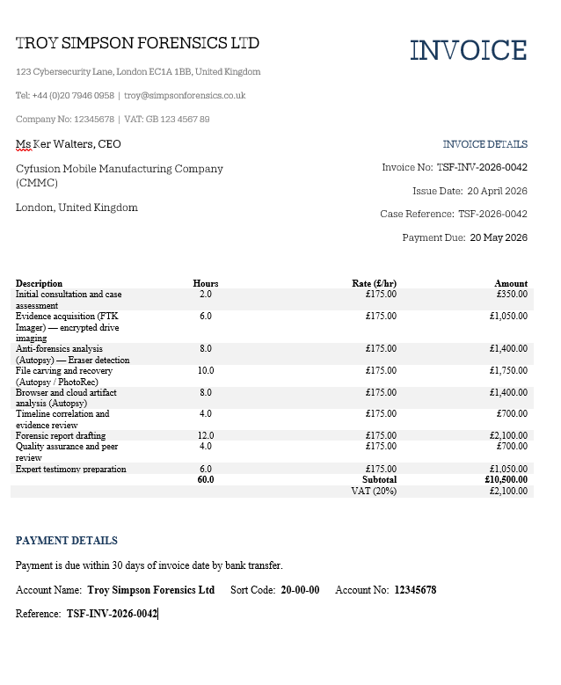

Bibliography
[1]
Z. Lei, “Forensic analysis of unallocated space,” Scholaris.ca, Jun. 2011. https://ontariotechu.scholaris.ca/items/c37779a5-6d59-4a30-9971-7dce1a5a2746 (accessed Apr. 28, 2026).
[2]
ACPO, “ACPO Good Practice Guide ACPO Good Practice Guide for Digital Evidence for Digital Evidence,” Mar. 2012. Available: https://www.digital-detective.net/digital-forensics-documents/ACPO_Good_Practice_Guide_for_Digital_Evidence_v5.pdf
[3]
M. Ali, A. Ismail, H. Elgohary, S. Darwish, and S. Mesbah, “A Procedure for Tracing Chain of Custody in Digital Image Forensics: A Paradigm Based on Grey Hash and Blockchain,” Symmetry, vol. 14, no. 2, p. 334, Feb. 2022, doi: https://doi.org/10.3390/sym14020334.
[4]
E. Daraghmi, Z. Qaroush, M. Hamdi, and O. Cheikhrouhou, “Forensic Operations for Recognizing SQLite Content (FORC): An Automated Forensic Tool for Efficient SQLite Evidence Extraction on Android Devices,” Applied Sciences, vol. 13, no. 19, p. 10736, Jan. 2023, doi: https://doi.org/10.3390/app131910736.
[5]
A. R. Javed, W. Ahmed, M. Alazab, Z. Jalil, K. Kifayat, and T. R. Gadekallu, “A comprehensive survey on computer forensics: State-of-the-Art, tools, techniques, challenges, and future directions,” IEEE Access, vol. 10, no. 1, pp. 11065–11089, Jan. 2022, doi: https://doi.org/10.1109/access.2022.3142508.
[6]
J. James, “FOUNDATIONS OF MOBILE FORENSICS: AN ACADEMIC APPROACH,” Issues In Information Systems, vol. 25, no. 3, 2024, doi: https://doi.org/10.48009/3_iis_2024_108.
[7]
J. Mehta, Yash Bhadania, P. Shah, and P. Prajapati, “Comparative Study of Mobile Forensics Tools: Autopsy, Belkasoft X and Magnet Axiom,” pp. 1257–1263, Aug. 2024, doi: https://doi.org/10.1109/icesc60852.2024.10689971.
[8]
“Police and Criminal Evidence Act 1984,” legislation.gov.uk, 1984. https://www.legislation.gov.uk/ukpga/1984/60/contents
[9]
“MUTUAL LEGAL ASSISTANCE TREATIES OF THE UNITED STATES.” Available: https://www.justice.gov/criminal/criminal-oia/file/1498806/dl
[10]
Computer Misuse Act, “Computer Misuse Act 1990,” Legislation.gov.uk, 1990. https://www.legislation.gov.uk/ukpga/1990/18/contents
[11]
“Criminal Procedure and Investigations Act 1996,” UK Legislation, 2019. https://uk-legislation.com/criminal-procedure-and-investigations-act-1996 (accessed Apr. 28, 2026).
[12]
“Civil Evidence Act 1995,” Legislation.gov.uk, 2019. https://www.legislation.gov.uk/ukpga/1995/38/contents
[13]
“CHFI Certification & Training | Computer Hacking Forensic Investigator,” EC-Council, Mar. 24, 2026. https://www.eccouncil.org/train-certify/computer-hacking-forensic-investigator-chfi-north-america/https://www.eccouncil.org/train-certify/computer-hacking-forensic-investigator-chfi-north-america/ (accessed Apr. 28, 2026).
[14]
College of Policing, “Forensics,” College of Policing, Feb. 21, 2022. https://www.college.police.uk/app/investigation/forensics
[15]
“National Software Reference Library (NSRL) | NIST,” NIST, Apr. 19, 2016. https://www.nist.gov/itl/csd/secure-systems-and-applications/national-software-reference-library-nsrl (accessed Apr. 28, 2026).
[16]
“Eraser – Secure Erase Files from Hard Drives,” Heidi.ie, May 13, 2015. https://eraser.heidi.ie/
[17]
“Autopsy User Documentation: Recent Activity Module,” Sleuthkit.org, 2024. https://www.sleuthkit.org/autopsy/docs/user-docs/4.21.0/recent_activity_page.html (accessed Apr. 28, 2026).
[18]
“The NTFS Master File Table (MFT): Advanced Forensic Analysis for Modern Investigators,” deaddisk, 2025. https://www.deaddisk.com/posts/ntfs-mft-advanced-forensic-analysis-guide/
[19]
“What is SSD Trim? The ‘Silent Killer’ of Deleted Data (and How to Tame It),” Isumsoft.com, 2025. https://www.isumsoft.com/windows-tips/what-is-ssd-trim-and-how-to-disable-it.html (accessed Apr. 29, 2026).
[20]
S. Englehardt et al., “Cookies That Give You Away,” Proceedings of the 24th International Conference on World Wide Web - WWW ’15, 2015, doi: https://doi.org/10.1145/2736277.2741679.
[21]
K. Campbell, “The Fraud Act 2006,” King’s Law Journal, vol. 18, no. 2, pp. 337–347, Jan. 2007, doi: https://doi.org/10.1080/09615768.2007.11427681.
[22]
E. Participation, “Data Protection Act 2018,” www.legislation.gov.uk, 2018. https://www.legislation.gov.uk/ukpga/2018/12/section/1

