

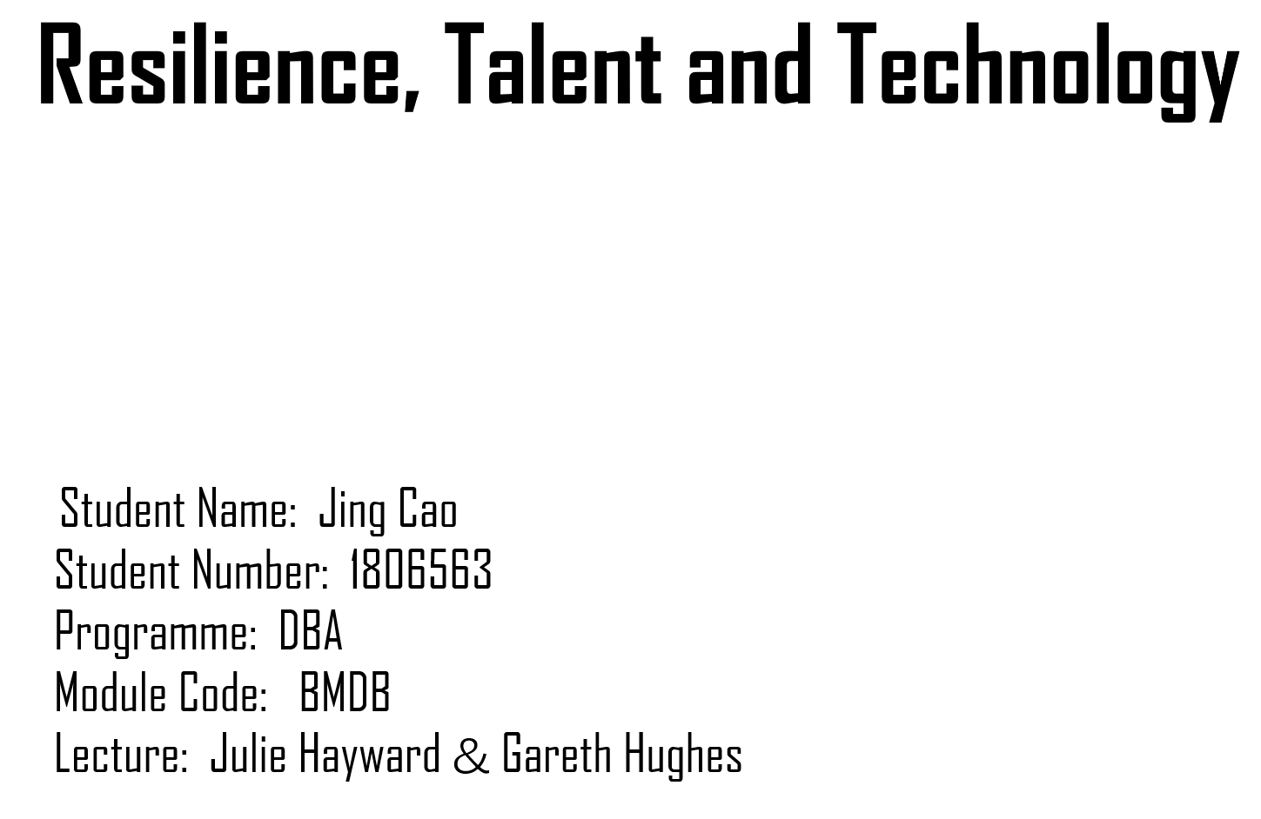

Contents
About the Chosen Organization: Google 1
1．PESTLE Analysis on Google Talent Attraction 5
2．The Influence of Labour Market on Google in the United States and Germany 12
3．Technology and Google Human Resource Planning 23
4．Executive Summary: Google Human Resource Policies in Germany and the United States 26
5．Human Resources Management in the Open Talent Economy 33
6．The Prevalence and Problems of Flexible Employment in High-tech Enterprises 37
7．The Influence of HR on Resilience and Performance, Based on AMO Model 44

About the Chosen Organization: Google

Google, a US multinational technology company, is a subsidiary of Alphabet Inc. It was founded in 1998 by Larry Page and Sergey Brin in a garage in Menlo Park, California. Google from the beginning of the search, after 21 years of development, almost become the synonym of search. The core of Google culture is “To organize the world's information and make it universally accessible and useful” (Google, 2019), and the informal slogan is “Don’t be evil” (Moses, 2008).
Google is involved in a wide range of businesses, from life sciences to smart homes. To better manage the company, Page and Brin restructured Google to make it a subsidiary of Alphabet Inc. In 2015. The new company's business includes seven parts: calico, Google x, fiber, Google ventures, Google capital, nest, Google (Figure 0-1).
Alphabet's business model is a typical umbrella structure, in which multiple powerful CEOs operate various businesses independently. Larry Page and Sergey Brin will provide internal resource assistance for all projects.
In the past 21 years, Google has continuously innovated and developed, and currently ranked 37th in the Fortune 500 (Fortune, 2019). In the second quarter of 2019, the revenue of Alphabet reached US $38.94 billion (Feiner, 2019), and the desktop market share of Google search, its leading business, reached 88.16% (Statcounter, 2019).
Figure 0-1 Alphabet's 7 subsidiaries
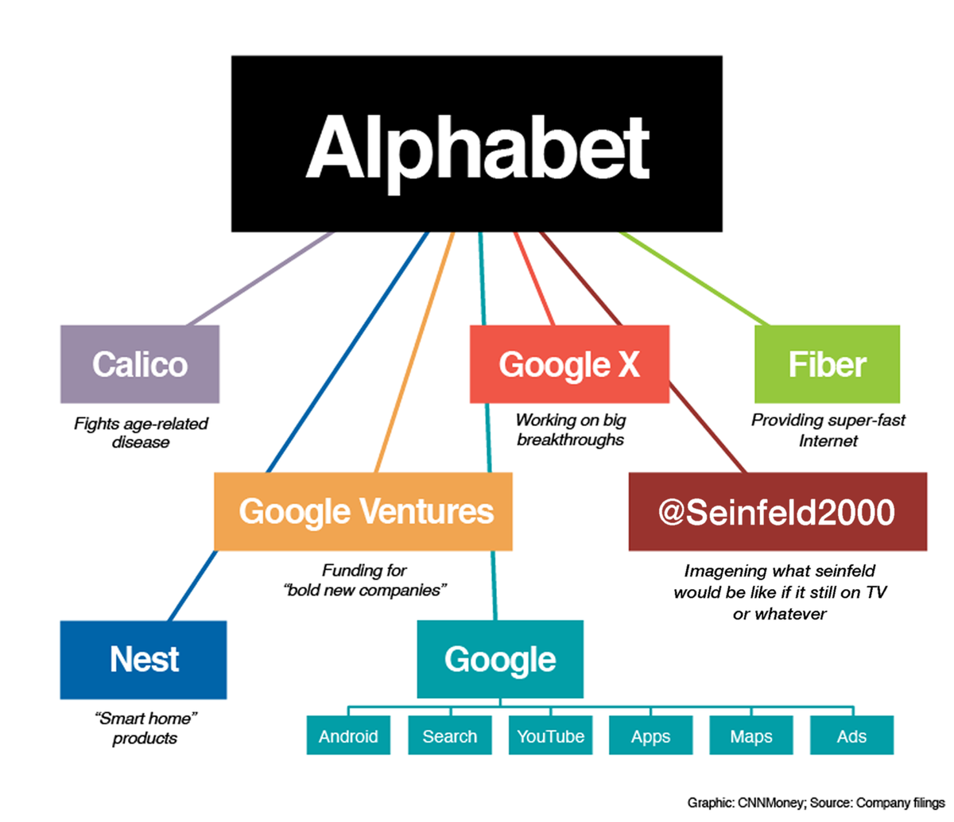

Reference
CNN (2019) What is Google’s New Alphabet? Available at:
https://money.cnn.com/interactive/technology/what-is-googles-new-alphabet/index.html
(Accessed: 18th October 2019)
Google (2019) About Google. Available at:
https://about.google/
(Accessed: 18th October 2019)
Feiner, L. (2019) ' Alphabet Rises after Earnings Beat, Announces $25 Billion Share Repurchase’, CNBC, 25nd, Jul. Available at:
https://www.cnbc.com/2019/07/25/alphabet-q2-2019-earnings.html
(Accessed: 14th October 2019)
Fortune (2019) Fortune Global 500. Available at:
https://fortune.com/global500/2019/search/
(Accessed: 14th October 2019)
Moses, A. (2018) ' Don’t Be Evil or Don’t Lose Value’, The Sydney Morning Herald, 16th, Apr. Available at:
https://www.smh.com.au/technology/dont-be-evil-or-dont-lose-value-20080416-gds9o9.html?page=3
(Accessed: 18th October 2019)
Statcounter (2019) Desktop Search Engine Market Share Worldwide. Available at:
https://gs.statcounter.com/search-engine-market-share/desktop/worldwide
(Accessed: 24th October 2019)

1．PESTLE Analysis on Google Talent Attraction

PESTLE is a tool for analyzing external factors that affect the development of an organization (Figure 1-1) and be used for strategic decisions in human resource management (CIPD, 2018). These six factors may contribute to an organization's bright future or be obstacles to its development. This article will analyze the factors that have an impact on the talent attraction of Google currently.
Figure 1-1 PESTLE framework
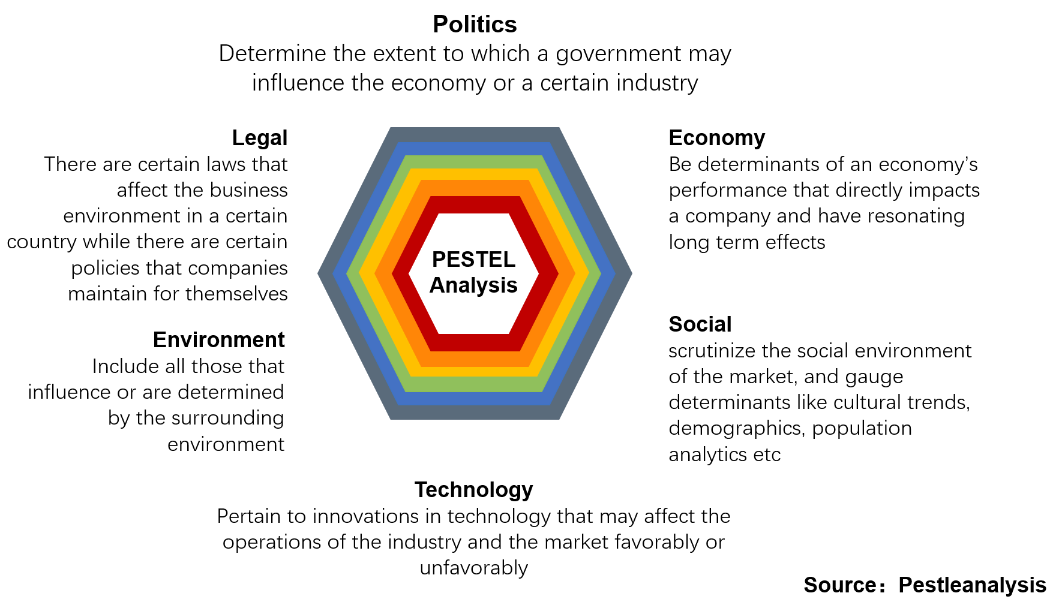
Political
The huge economic size of Google – ranking 37th in Fortune 500 (Fortune, 2019), and the extremely high market share of the search business have always been controversial. There have been anti-trust investigations against Google around the world. In 2017, the EU fined Google an unprecedented 2.4 billion euros. The argument was Google have violated European Union antirust rules by abusing search result with its absolute advantage and depriving other companies of the opportunity to compete. Fortunately, in the same period, the Federal Trade Commission (FTC) antitrust investigation found that Google did not violate U.S. Antitrust Law (Vincent, 2017).
But critics of Google have been lobbying the U.S. Department of Justice to do something, influenced by the success of the European antirust campaign. The U.S. Department of Justice and the FTC have agreed to launch an antitrust investigation into Google this year finally, focusing on the intersection of privacy and antitrust. On 9th September, the attorney-general of Texas, representing all 50 states, announced an investigation into “potential monopolistic behavior” by Google because of concerns about it impact on the competition of small firms in the marketplace (Lohr, 2019). If the investigation goes against Google, the worst outcome is the search could be forced to split into a separate company. That will cause Google to restructure again, including its talent structure. Some potential candidates may hold a wait-and-see attitude or prefer to choose similar high-tech companies with relatively stable status.
In addition, Google recently issued internal regulations to prevent political debate, because lost the U.S. military ‘s human-intelligence contract. It caused dissatisfaction among employees that sacrifices ethics for business interests (De Vynck, 2019). For engineers pursuing free spirit, that will greatly affect their value identification with Google, thus making it less attractive.
Social
The impact of social media is growing. However, in this segment of market, Google+ had always been unable to compete against Facebook. In April this year, Google+ was officially closed because of the low utilization rate (Welch, 2019).
However, Google has done a better job of using social media to appeal to younger people (18-24) than Facebook, which has two-thirds of the adult market. 94% of American teenagers prefer to Google’s YouTube (Perrin & Anderson, 2019). According to previous survey, social platform usage habits hardly change with age (Anderson & Jiang, 2019). Google can use YouTube to bond with teenagers, make itself a subconscious first choice for young people to work in the high-tech industry, preparing for the expansion of talent pool in the next 5-10 years.
Legal
Google and Oracle have been fighting JAVA infringement cases for a decade (Wolfe, 2019). If Google is restricted to JAVA technology, it will lose job seekers who are interested in the business.
Environment
Google uses cloud technology to work with the UN on environmental data tracking (UN Environment, 2018). This activity brought Google a good reputation in the high-quality labour market.
In addition, economic and technical factors have a great impact on Google’s capacity to attract talent. Due to the length of the article, they will be analyzed in task 2 and task 3.

Reference
Anderson, M. & Jiang, J. (2018) ' Teens, Social Media & Technology 2018’, Pew Research Center, 31^{h}, May. Available at:
https://www.pewinternet.org/2018/05/31/teens-social-media-technology-2018/
(Accessed: 20th October 2019)
De Vynck, G. (2019) ‘Google Doesn’t Want Staff Debating Politics at Work Anymore’, Bloomberg, 23th, August. Available at:
https://www.bloomberg.com/news/articles/2019-08-23/google-doesn-t-want-employees-debating-politics-at-work-anymore
(Accessed: 20th October 2019)
CIPD (2019) PESTLE Analysis. Available at:
https://www.cipd.co.uk/knowledge/strategy/organisational-development/pestle-analysis-factsheet#7992
(Accessed: 3th October 2019)
Hansen, s. (2019) ' The World’s Best Employers 2019: Alphabet Takes Top Spot Followed by Microsoft and Red Hat’, Forbes, 18th, October. Available at:
https://www.forbes.com/sites/sarahhansen/2019/10/18/the-worlds-best-employers-2019-alphabet-takes-top-spot-followed-by-microsoft-and-red-hat/#18aa72fb52ef
(Accessed: 22th October 2019)
Lohr, S. (2019) ' Google Antitrust Investigation Outlined by State Attorneys General’, The New York Time, 9th, September. Available at:
https://www.nytimes.com/2019/09/09/technology/google-antitrust-investigation.html
(Accessed: 12th October 2019)
Perrin, A. & Anderson, M. (2019) ' Share of U.S. adults using social media, including Facebook, is mostly Unchanged since 2018’, Pew Research Center, 10th, Apr. Available at:
https://www.Pew Research Center.org/fact-tank/2019/04/10/share-of-u-s-adults-using-social-media-including-facebook-is-mostly-unchanged-since-2018/
(Accessed: 20th October 2019)
UN Environment (2018) UN Environment and Google Announce Groundbreaking Partnership to Protect Our Planet. Available at:
https://www.unenvironment.org/news-and-stories/press-release/un-environment-and-google-announce-ground-breaking-partnership
(Accessed: 20th October 2019)
Vincent, J. (2017) ' Google fined a record €2.4 billion by the EU for manipulating search results’, The Verge, 27th, Jun. Available at:
https://www.theverge.com/2017/6/27/15872354/google-eu-fine-antitrust-shopping
(Accessed: 12th October 2019)
Welch, C. (2019) ' Google begins shutting down its failed Google+ social network’, The Verge, 2nd, Apr. Available at:
https://www.theverge.com/2019/4/2/18290637/google-plus-shutdown-consumer-personal-account-delete
(Accessed: 20th October 2019)
Wolfe, J. (2019) ‘Google Asks U.S. Supreme Court to End Oracle Copyright Case’, Reuters, 24th January. Available at:
https://www.reuters.com/article/us-oracle-google-court/google-asks-u-s-supreme-court-to-end-oracle-copyright-case-idUSKCN1PI2WC
(Accessed: 12th October 2019)

2．The Influence of Labour Market on Google in the United States and Germany

The performance of the labour market depends on the balance between supply and demand as well as many complex factors. This paper takes the U.S. and Germany as examples to discuss the impact of the labour market on Google.
From the perspective of supply and demand, both the U.S. and Germany have a low unemployment rate (3.5%, 3.1%) (Figure 2-1), and high retirement age (66, 65.7) (NASI, 2019; ETK, 2019). But labour force participation rate is not high (62.02%, 60.61%) (Figure 2-2).

Take into account the demographic factors. Since 1999, the population of the U.S. has been rising steadily, while that of Germany has barely budged (Figure 2-3). Moreover, consider the trends in birth rates (Figure 2-4) and the working-age population (Figure 2-5), is that even both markets are tight, the German future labour market will be tighter than America.

So far, the American unemployment rate is at the lowest point since 2008, but employment growth is not significant (Figure 2-6). The average American wage, despite increase, combined with inflation, is actually down 9.6% from 2006 (PayScale, 2019). Residents tend to choose free entertainment and cheaper goods. That is one reason why Google’s YouTube is so popular.
Nevertheless, as the main talent pool of Google, the labour participation rate of Americans with advanced degrees (25+) reached 73.9%, and the unemployment rate is only 2.0%, far lower than average (BLS, 2019a). San Francisco and Seattle, two cities with the highest wage growth in Q3 of 2019, are both high-tech bases (PayScale, 2019). Demand for highly skilled workers has led to severe labour shortages across the American economy. The U.S. Department of Labor predicts that information security analyst occupation will grow by 31.6% over the next 10 years (BLS, 2019b). With the decline of the proportion of the highly educated workforce in the U.S. over the past 20 years (Figure 2-7). Google has difficulties more and more in recruiting qualified employees in America.

Benefit by the dual-track system, Germany has a relatively bigger pool of highly skilled talent than America. The ratio of high to low skill wages is 1.73 (Tradingeconomics, 2019a) in Germany, and 2.32 in America (Tradingeconomics, 2019b). Take the most common senior software engineer among Google employees as an example, the average annual salary in Germany is $73,320 (Glassdoor, 2019a), that compares with $129,328 in America (Glassdoor, 2019b). American employers are increasingly focusing on the experience and efficiency of the employees, expand the talent pool with employment diversity. Like Ken Thompson, he was 63 when he started working for Google in 2006. However, that situation suppress young people’s opportunities. Youth unemployment is 8% in America (Tradingeconomics, 2019b), and 5.7% in Germany (Tradingeconomics, 2019a), is all above average. The situation, if continues, may exacerbate the mismatch between young workers’ skills and job requirements, leading to a labour skills gap in the next decade. More than 50% of adult employees in both countries attend training programs to improve their skills (Eurostat, 2019). Companies that offer learning opportunities are more likely than average to attract jobseekers.
Notably, Germany has a bigger open talent economy than America. Part-time employment as a share of total employment is twice that of America (Figure 2-8), and the gap continues to grow. That may be due to weak economic growth in Germany, which GDP grew by only 0.4%, compared with America’s 2.3% (Figure 2-9). The gig economy is likely to be an alternative. As the absolute hegemony of the global search engine, Google provides the matching service of labour supply and demand for the labour and organizations, improve the efficiency of labour skill.

With its welcoming attitude towards skilled migrants, Germany is becoming a magnet for international talent, especially for highly educated jobseekers under 30 (Deutschland, 2018). Highly skilled workers with relatively low wages, German labour market can supply Google with a large number of software scientists, data analysts. Especially, plenty of qualified industrial workers for self-driving cars. It also provides talent to Google in the U.S. through remote technology.

Reference
BLS, (2019a) Employment Status of the Civilian Population 25 Years and Over by Educational Attainment. Available at:
https://www.bls.gov/news.release/empsit.t04.htm
(Accessed: 17th October 2019)
BLS, (2019b) Fastest Growing Occupations. Available at:
https://www.bls.gov/emp/images/growing_occupations.png
(Accessed: 17th October 2019)
Deutschland, (2018) Germany Attractive for International Qualified Professionals. Available at:
https://www.deutschland.de/en/topic/business/jobs-in-germany-are-attractive-for-international-qualified-professionals
(Accessed: 19th October 2019)
ETK, (2019) Retirement Age in Different Countries. Available at:
https://www.etk.fi/en/the-pension-system/international-comparison/retirement-ages/ (Accessed: 14th October 2019)
Eurostat, (2019) Participation Rate in Education and Training (Last 4 Weeks – 2018 – and Last 12 Months – 2016) (% of Persons Aged 25-64). Available at:
https://ec.europa.eu/eurostat/statistics-explained/index.php?title=File:Participation_rate_in_education_and_training_(last_4_weeks_-_2018_-_and_last_12_months_-_2016)_(%25_of_persons_aged_25-64).png
(Accessed: 19th October 2019)
Glassdoor, (2019a) Senior Software Engineer Salaries in Germany. Available at:
https://www.glassdoor.co.uk/Salaries/germany-senior-software-engineer-salary-SRCH_IL.0,7_IN96_KO8,32.htm
(Accessed: 24th October 2019)
Glassdoor, (2019b) Senior Software Engineer Salaries in United States. Available at:
https://www.glassdoor.co.uk/Salaries/us-senior-software-engineer-salary-SRCH_IL.0,2_IN1_KO3,27.htm
(Accessed: 24th October 2019)
IBRD (2019) GDP Growth. Available at:
https://data.worldbank.org/indicator/NY.GDP.MKTP.KD.ZG?end=2018&locations=US-DE&start=2010
(Accessed: 24th September 2019)
IBRD (2019) Labour Force Participation Rate, Total. Available at:
https://data.worldbank.org/indicator/SL.TLF.CACT.ZS?end=2018&locations=US-DE&start=2009
(Accessed: 24th September 2019)
IBRD (2019) Labour Force with Advanced Education. Available at:
https://data.worldbank.org/indicator/SL.TLF.ADVN.ZS?locations=US-DE (Accessed: 24th September 2019)
IBRD (2019) Part-time Employment. Available at:
https://data.worldbank.org/indicator/SL.TLF.PART.ZS?end=2018&locations=US-DE&start=1999
(Accessed: 24th September 2019)
IBRD (2019) Population Ages 15-64. Available at:
https://data.worldbank.org/indicator/SP.POP.1564.TO.ZS?locations=US-DE
(Accessed: 24th September 2019)
ILOSTAT (2019) Country Profiles: The Latest Decent Work Statistics by Country. Available at:
https://ilostat.ilo.org/data/country-profiles/
(Accessed: 24th September 2019)
NASI, (2019) What is the Social Security Retirement Age? Available at:
https://www.nasi.org/learn/socialsecurity/retirement-age
(Accessed: 21th October 2019)
PayScale, (2019a) National (US) Pay Trends. Available at:
https://www.payscale.com/payscale-index/
(Accessed: 24th October 2019)
Tradingeconomics, (2019a) Germany Real Wages Growth. Available at
https://tradingeconomics.com/germany/wage-growth
(Accessed: 20th October 2019)
Tradingeconomics, (2019b) United States Wages and Salaries Growth. Available at:
https://tradingeconomics.com/united-states/wage-growth
(Accessed: 20th October 2019)
UN Population Division (1999-2018) World Population Prospects (1999-2018).

3．Technology and Google Human Resource Planning

URL: https://youtu.be/BWPRNBlprHw

Reference
Armin Trost (2013) Human Resource management Lecture Part 02 – HR Strategy and Planning [Video]. Available at:
https://www.youtube.com/watch?v=rVyJXnZEp2A
(Accessed: 10th October 2019)
Beardwell, J. (2017) Human Resource Management. 8th Ed. London: Pearson.
Gregg Learning (2018) HR Basics: Human Resource Planning [Video]. Available at:
https://www.youtube.com/watch?v=2fhXWlHubpA
(Accessed: 10th October 2019)
Google (2019) Introducing Anthos: An Entirely New Platform for Managing Applications in Today’s Multi-cloud World. Available at:
https://cloud.google.com/blog/topics/hybrid-cloud/new-platform-for-managing-applications-in-todays-multi-cloud-world
(Accessed: 15th September 2019)
Lombardo, J. (2017) Google’s HRM: HR Planning, Job Analysis & Design. Available at:
http://panmore.com/google-hrm-hr-planning-job-analysis-design
(Accessed: 25th September 2019)
Manyika, J. (2017) Technology, Jobs, and the Future of Work. Available at:
https://www.mckinsey.com/featured-insights/employment-and-growth/technology-jobs-and-the-future-of-work
(Accessed: 25th September 2019)
Meyer, D. (2018) How Cloud Computing Contributes to Autonomous Driving – A Thought Experiment. Available at:
https://mse238blog.stanford.edu/2018/07/davidmyr/how-cloud-computing-contributes-to-autonomous-driving-a-thought-experiment/
(Accessed: 15th September 2019)
Pratap, A. (2019) Google’s Human Resource Management Strategy. Available at:
https://notesmatic.com/2017/03/googles-human-resource-management-strategy/
(Accessed: 19th September 2019)
Taylor, S. (2018) Resourcing and Talent Management. 7th Ed. London: Kogan Page.
Torrington, D., et al. (2017) Human Resource Management. 10th Ed. London: Pearson.

4．Executive Summary: Google Human Resource Policies in Germany and the United States

As an American high-tech multinational enterprise, when Google conducts business in different countries, HRM will be affected by the economic system inevitably. The economic system is largely influenced by culture – group values, beliefs, attitudes (Inglehart, et al., 1998). According to Hofstede’s culture dimensions, there are big differences between American and German culture (Figure 4-1). On this basis, they form a liberal market economy and a coordinated market economy. The difference between systems is large enough to affect all aspects of corporate governance (Hopner, 2005) (Table 4-1). It is suggested that different HR policies should be adapt them to optimize corporate performance.
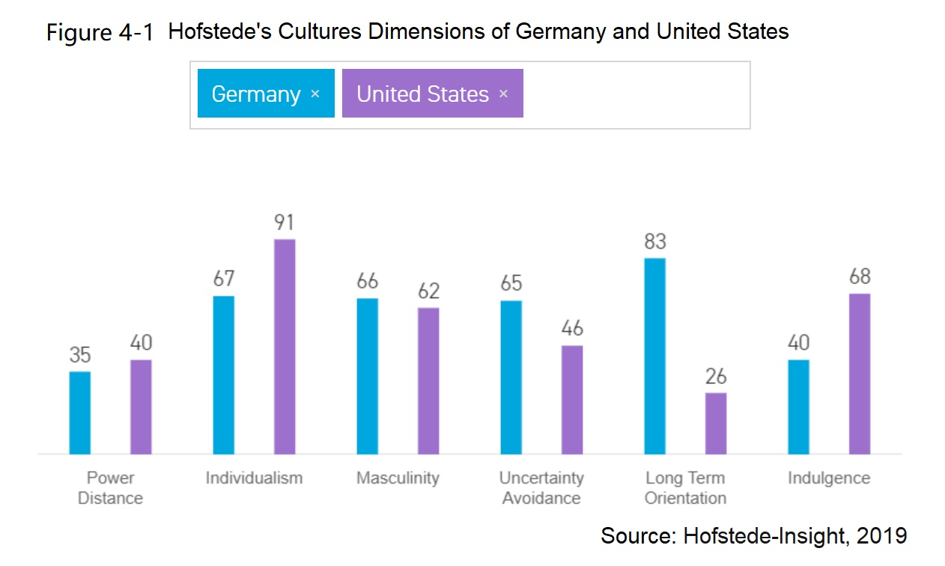
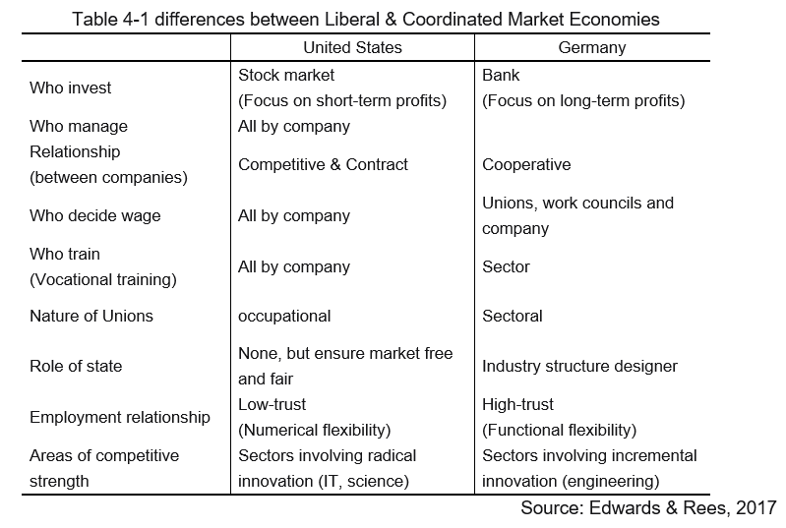
The recommendations are as follows.
- Labour Cost
US
Labor laws are less restrictive, with low firing costs (Bassen & Cole, 2019). But technologic talents mobility is high plus Google’s temporary contract rate of 50%, it is hard to obtain high commitment and team stability. Google should increase the proportion of long-term contracts. Although it will increase salary costs, it will reduce the cost of engaging and integration. That is more conducive to the construction of enterprise culture, improve productivity in the long run.
DE
Strict labour laws make firing expensive. Full-time and part-time employees are distinguished by working hours (Neighbour & Jpppich, 2019). Google can increase the proportion of non-traditional employees to ensure the numerical flexibility of employees to cut costs. Along with the new immigration laws, Germany has attracted a large number of skilled young migrants (Deutschland, 2018). They can be an important source of peripheral staff.
- Industrial Relations
US
Unions, with small clout, cannot act as a buffer between employees and firms. Google needs to set up a team to deal with a salary negotiation, make it clear to employees the reason for wage decision. Reprice wages every two years with effective evidence of performance. Avoid conflicts caused by income inequality. Even worse, strike.
DE
Unions are widely trusted, with collective bargaining reaching 56%, five-time of U.S. (ILO, 2019). The Unions limits the freedom of companies, but directly reduced labour conflicts by guaranteeing the basic rights and interests of workers. Google need to invest in the relationship with Unions, having their support, building good employment brands, to get appropriate of labour market.
- Training
US
The high-tech talent market is currently the tightest labour market in the U.S. (FRS, 2019), coupled with the lack of vocational education institutes (Spees, 2018) and the tightening of immigration policy (Re, 2019), the talent pool is shrinking. Google should increase the input expenditure of staff skill training, so that having a rational talent supply, even the training cost is high. Directly cooperate with universities and provide funds to universities to carry out some practical training according to the needs of Google.
DE
Having an excellent vocational education system, a huge number of specific skilled labour and the concentration of skilled immigrants. Germany has a large pool of young and high-tech talents with big employment intentions. Google’s overseas technology research and development center should be established in Germany. National Industry Strategy 2030 can be used to fight for tax cuts.
- Employee relations
US
Reward staff who improve technology and product, not just extreme innovation. Make each unique idea into a practical, mass-produced product.
DE
Encourage employees to be “ridiculous” to prompt innovation. Organize regular thematic activities to present ideas and offer a reward – financial or honor. Take a positional rotational system, one person works in one position for no more than 3 years, to avoid employees satisfied with the status quo, to maintain the possibility of innovation.

Reference
Bassen, N. and Cole, N.W. (2019) USA: Employment & Labour Law 2019. Available at:
https://iclg.com/practice-areas/employment-and-labour-laws-and-regulations/usa
(Accessed 23th October 2019)
BMWI (2019) National Industry Strategy 2030. Available at:
https://www.bmwi.de/Redaktion/EN/Artikel/Industry/nationale-industriestrategie-2030.html
(Accessed 19th October 2019)
DOL (2019) Seasonal Employment / Part-Time Information. Available at:
https://www.dol.gov/general/topic/workhours/seasonalemployment
(Accessed 23th October 2019)
Edwards, T. and Rees, C., (2017) International Human Resource Management: Globalization, National Systems and Multinational Companies. 3rd Ed. Harlow: Pearson Education.
Farndale, E., Brewster, C., & Poutsma, E. (2014) ‘Coordinated vs. Liberal Market HRM: The Impact of Institutionalization on Multinational Firms’, International human resource management, pp. 20-39.
DOI: 10.1080/09585190802404247
Francis, X., & Hezel, S.J. (2009) ‘The Role of Culture in Economic Development’, Micronesian Counselor, (77).
Greif, A. (2006) Institutions and The Path to The Modern Economy: Lessons from Medieval Trade. Cambridge University Press.
FRS (2019) Beige Book, January. Available at:
https://www.federalreserve.gov/monetarypolicy/files/BeigeBook_20190116.pdf
(Accessed 13th October 2019)
Inglehart, R.F., Basanez, M. & Moreno, A. (1998) Human Values and Beliefs: A Cross-Cultural Sourcebook. 1st Ed. Ann Arbor: University of Michigan Press.
Hofstede-Insight (2019) Compare Countries. Available at:
https://www.hofstede-insights.com/product/compare-countries/
(Accessed 25th October 2019)
Höpner, M. (2005) ‘What connects industrial relations and corporate governance? Explaining institutional complementarity’, Socio-Economic Review, 3(2), pp.331-358.
ILO (2019) The Latest Decent Work Statistics by Country. Available at:
https://ilostat.ilo.org/data/country-profiles/
(Accessed 25th September 2019)
Mazur, J. (2019) Even Silicon Valley Giants Struggle Keeping Tech Talent. Here’s How to Do Better. Available at:
https://www.entrepreneur.com/article/339437
(Accessed 23th October 2019)
Neighbor, K. and Joppich, T.G. (2019) Germany: Employment & Labour Law 2019. Available at:
https://iclg.com/practice-areas/employment-and-labour-laws-and-regulations/germany
(Accessed 23th October 2019)
Pryor, F. (2007) ‘Culture and Economic System’, The American Journal of Economics and Sociology, 66(4), pp.817-855.
Znaniecki, F. (1952) Cultural sciences: Their Origin and Development (Vol. 2). Urbana: University of Illinois Press.
Re, G. (2019) ‘Trump Administration Tightens Rules for Immigration Work Permits’, Fox News, 19th August. Available at:
https://www.foxnews.com/politics/trump-admin-tightens-rules-for-immigrant-work-permits
(Accessed 23th October 2019)

5．Human Resources Management in the Open Talent Economy

Slide: https://uowtsd-my.sharepoint.com/:p:/g/personal/1806563_student_uwtsd_ac_uk/Ea2tatEvI3BPoe53LPxbjwoB0JvBrudfOu59oDbKoGEYfQ?e=nPEkK8

Reference
Ritson, N. (2013) Strategic Management. Available at:
https://my.uopeople.edu/pluginfile.php/57436/mod_book/chapter/121631/BUS5116.Ritson.Strat.Mgmt.pdf
(Accessed: 7th September 2019).
Businessballs (2019) Flexible-Firm Model. Available at:
https://www.businessballs.com/organisational-culture/flexible-firm-model/
(Accessed: 7th September 2019).
Chaudhary, R. (2017) ‘Technology and Digitization. A highly wired, agile and mobile workforce. The emergence of the millennial generation. These three are all rapidly changing the rules of the employment game’, Human Capital Leadership Institute, 9th October. Available at:
https://www.hcli.org/articles/tectonic-shift-house-demand-talent-transforming-consulting-world
(Accessed: 5th September 2019).
Deloitte. (2013) The Open Talent Economy: People and Work in a Borderless Workplace. Available at:
http://www.deloitteblog.co.za/the-open-talent-economy-people-and-work-in-a-borderless-workplace/
(Accessed: 3rd September 2019).
Deloitte (2016) 2016 Global human capital trends. Available at:
https://www2.deloitte.com/us/en/insights/focus/human-capital-trends/2016.html
(Accessed: 3rd September 2019).
Deloitte (2017) 2017 Global human capital trends. Available at:
https://www2.deloitte.com/us/en/insights/focus/human-capital-trends/2017.html
(Accessed: 3rd September 2019).
Deloitte. (2018) 2018 Global human capital trends. Available at:
https://www2.deloitte.com/us/en/insights/focus/human-capital-trends/2018.html
(Accessed: 3rd September 2019).
Deloitte. (2019) 2019 Global human capital trends. Available at:
https://www2.deloitte.com/us/en/insights/focus/human-capital-trends.html
(Accessed: 3rd September 2019).
Juneja, (2015) Employer Branding and Talent Attraction in Open Talent Economy. Available at:
https://www.managementstudyguide.com/employer-branding-and-talent-attraction-in-open-talent-economy.htm
(Accessed: 4th September 2019).
Lepak, D. P. & Snell, S. A. (2002). Examining the human resource architecture: The relationships among human capital, employment, and human resource configurations. Journal of management, 28(4), 517-543.
Lombardi (2017) Harnessing the power of the open talent economy. Available at:
https://www.marginalia.online/harnessing-the-power-of-the-open-talent-economy/
(Accessed: 6th September 2019).
Nayak, D. (2019) Managing Human Resources within ‘The Open Talent Economy’. Available at:
https://blog.mettl.com/talent-hub/managing-human-resources-within-the-open-talent-economy
(Accessed: 5th September 2019).

6．The Prevalence and Problems of Flexible Employment in High-tech Enterprises

Over the past 30 years, with the development of technology and smart connect product, the boundaries of industries are blurring. Change has upended all common organizational model. Companies need to continuously improve flexibility to adapt to, or even transcend, changes in the environment. There are two features in the development of organizations: expanding the scale to ensure their influence in the market and bring the economies of scale. Meanwhile, the core teams remain small and respond quickly to the external dynamic.
Luckily, Atkinson contributed a theory for this trend as early as 1984. He believed that employees should be divided into core and peripheral groups according to their importance to the organization (Figure 6-1), to optimize the use of human resources and prepare for market fluctuations. Core employees are hard to be replaced because of their skills, knowledge or experience. The peripheral groups are recruited according to the number and type of specific tasks (Table 6-1).
For organizations, functional flexibility removes the boundary of jobs and tasks. Core teams can be easily deployed in different positions (Erasums & Schenk, 2009). Peripheral employees, which are out of phase with the essence of the core group, value to the organization in terms of numerical change (Walsh & Deery, 1997). The key of flexible firm model is using talent flexibly rather than having it.
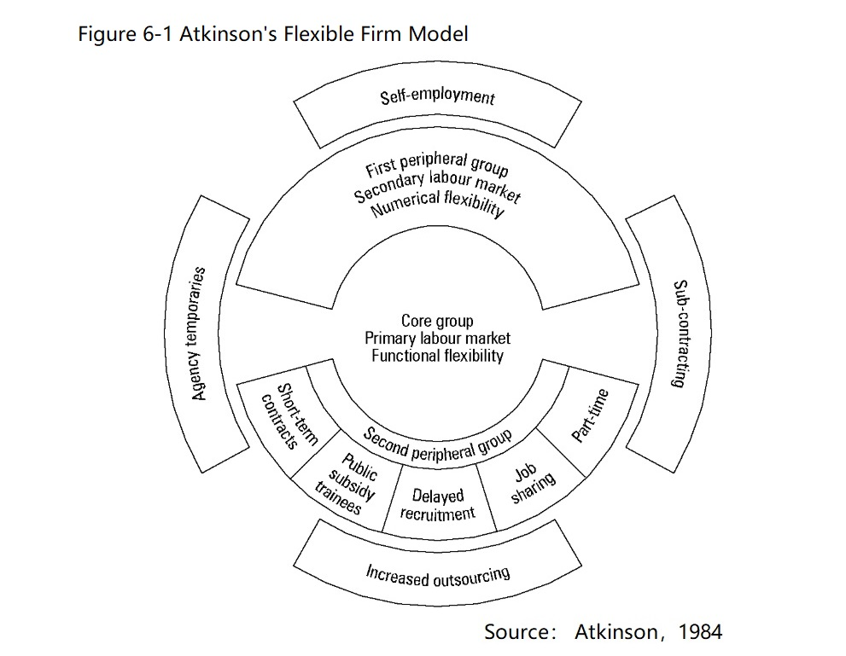
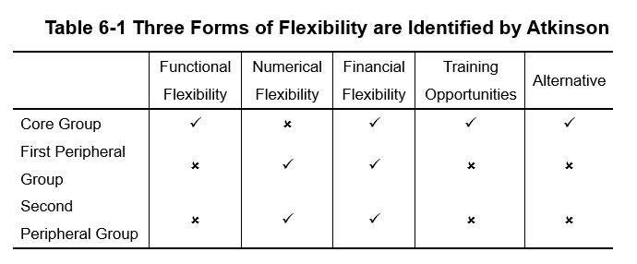
Especially in the high-tech industry, the unstructured, combinatorial and changeable work is very suitable for open talent economy, a cooperative, transparent and technology-feasible business model with a fast cycle (Deloitte, 2013). Independent professionals can enter the workplace based on their skills and expertise, create new opportunities for themselves. Employers fill the skills gap from a world-class talent pool. Work is also transformed from position-oriented to collaboration-oriented. Talent is growing into a mix of employees, contractor, and freelancers (Deloitte, 2013). Human resource flexibility allows employers to scale up or down their business and minimize the cost of the process quickly. In 2017, more than 43% of labour under 35 in the U.S. worked outside of traditional jobs (Chaudhary, 2019).
However, the model is not without side effects.
One important reason organization welcome flexible employment form is cost. Traditional employment costs are too high due to labour laws. Open talent is not on the balance sheet of the company (Deloitte, 2013) and can be hired or fired at any time in line with business needs. American tech companies save $100 thousand per year per position by using contractors compared with long-term contract employment (Moreno, 2019). For high value-added professionals, who are less dependent on any organization, the form brings more freedom. But for others, it means a precarious income and no pension or health insurance. Within an enterprise, flexibility is largely the ability to respond rapidly and cheaply to the labour market (Price, 2007). Surveys revealed that almost all employment growth in the U.S. between 2005 and 2015 came from the work arrangements of open talent (Passy, 2019). Google insiders acknowledge that non-traditional employment has exceeded 50% this year (Wakabayashi 2019). Many jobs are assumed by default by contractors. Even with experience, it is hard for them to get a full-time job, but a contract of up to two years. Various actions of Google imply that they have no employment relationship with Google (Passy 2019), excluding them from the protection of labour law. They call themselves TVC (temporary, Vendor, contractual), endure the inequality in pay and opportunities, restricted company information and the risk of being thrown out at any time (Wong, 2019). Following the outcry, Google issued a statement in April calling on U.S. companies to offer $15 an hour and other basic benefits by 2020 (D’Onfro, 2019).
On the other hand, flexible employment will increase management costs. The unstable employee relationship will lead to the lack of communication between employees to form a unified vision. Organization has difficult to get employee’s commitment, even the willingness to innovate. The cost of resolving the complexity created by inconsistencies in goal identification and motivation may be greater than the savings from using short-term employees. Google stipulates that everyone, whether core employees or not, should have a desk in the company (Boersma, 2016).
To make better use of employment activities to enhance the flexibility of enterprises, perfect laws and regulations are needed to ensure a fair working environment. In addition, HR also needs to adjust the management mode to adapt to the network labour relationship formed by the cooperative teamwork.

Reference
Atkinson, J. (1984) ‘Manpower Strategies for Flexible Organizations’. Personnel Management, 16(8), pp. 28-31
Boersma, M. (2016) ‘Flexible Working – the Backlash’, Financial Times, 23th May. Available at:
https://www.ft.com/content/9897d768-b3ed-11e2-b5a5-00144feabdc0
(Accessed: 8th October 2019)
Chaudhary, M. (2019) ‘Stoke Raised $4.5M Seed to Bring the Open Talent Economy to Businesses’, HR Technologist, 4th September. Available at:
https://www.hrtechnologist.com/news/mobile-workforce/stoke-raises-45m-seed-to-bring-the-open-talent-economy-to-businesses/
(Accessed: 8th September 2019)
D’Onfro, J. (2019) ‘Google to Require its U.S. Shadow Workforce’ to Receive Healthcare and a 15 Minimum Wage’, Forbes, 2nd Apr. Available at:
https://www.forbes.com/sites/jilliandonfro/2019/04/02/google-to-require-temp-and-contract-workers-to-receive-healthcare-and-parental-leave/#3ca04e05615e
(Accessed: 18th October 2019)
Deloitte (2013) The Open Talent Economy: People and Work in a Borderless Workplace. Available at:
http://sa.deloitteblog.co.za/wp-content/uploads/2013/08/The-open-talent-economy.pdf
(Accessed: 5th September 2019)
Erasmus, B., and Schenk, H. (2008) South African Human Resource Management: Theory & Practice. 8th Ed. Juta Company
Handy, C. (1989) The age of unreason. Boston: Harvard Business School Press.
Kalleberg, A.L. (2001) ‘Organizing Flexibility: The Flexible Firm in a New Century’. British Journal of Industrial Relations, 39(4), 479-594.
Moreno, J., (2019) Google Follows a Growing Workplace Trend: ‘Hiring More Contractors than Employees’, Forbes, 31th May. Available at:
https://www.forbes.com/sites/johanmoreno/2019/05/31/google-follows-a-growing-workplace-trend-hiring-more-contractors-than-employees/#c2f3566447fe
(Accessed: 22th October 2019)
Passy, Jacob (2019) ‘Google Has More Temp and Contract Workers than Actual Employees – But They Have Far Fewer Rights’, MarketWatch, 30th May. Available at:
https://www.marketwatch.com/story/google-has-more-temp-and-contract-workers-than-actual-employees-but-they-have-far-fewer-rights-2019-05-30
(Accessed: 17th October 2019)
Wakabayashi, D. (2019) ‘Google’s Shadow Work Force: Temps Who Outnumber Full-Time Employees’, The New York Time, 28th May. Available at:
https://www.nytimes.com/2019/05/28/technology/google-temp-workers.html?partner=IFTTT
(Accessed: 17th September 2019)
Walsh, J. & Deery, S. (1997) Understanding the peripheral workforce: an examination of employee diversity in the service sector. Department of Management & Industrial Relations, University of Melbourne.
Wong, J.C. (2019) ‘Google Staff Condemn Treatment of Temp Workers in Historic Show of Solidarity’, The Guardian, 2nd Apr. Available at:
https://www.theguardian.com/technology/2019/apr/02/google-workers-sign-letter-temp-contractors-protest
(Accessed: 17th October 2019)

7．The Influence of HR on Resilience and Performance, Based on AMO Model

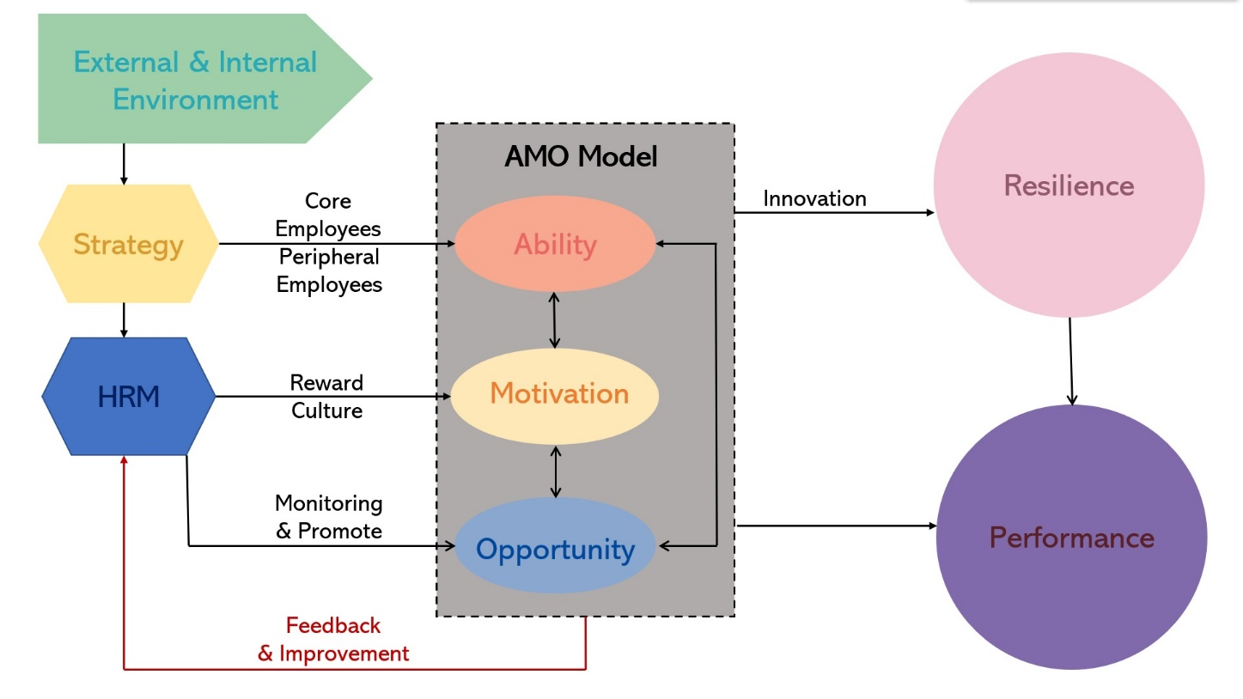

Reference
Armstrong, M. and Taylor, S. (2017) Armstrong’s Handbook of Human Resource Management Practice 14th Ed. London: Kogan Page.
Atkinson, J. (1984) ‘Manpower Strategies for Flexible Organizations’. Personnel Management, 16(8), pp. 28-31
Blyton, P. and Morris, J. (2017) A flexible Future?: Prospects for Employment and Organization. Berlin: De Gruyter.
Cooper, C.L., Liu, Y., and Tarba, S.Y. (2014) ‘Resilience, HRM Practices and Impact on Organizational Performance and Employee Well-being’, International Journal of Human Resource Management 2015 Special Issue.
Coutu, D.L. (2002). How resilience works. Harvard business review, 80(5), pp.46-56.
Lengnick-Hall, C.A., Beck, T. E., and Lengnick-Hall, M. L. (2011) ‘Developing a capacity for organizational resilience through strategic human resource management’, Human Resource Management Review, 21(3), pp.243-255.
Pink, D.H. (2011) Drive: The surprising truth about what motivates us. Edinburgh: Canongate Books Ltd.
Ritson, N. (2013) Strategic Management. Available at:
https://my.uopeople.edu/pluginfile.php/57436/mod_book/chapter/121631/BUS5116.Ritson.Strat.Mgmt.pdf
(Accessed: 7th September 2019).
Taylor, S. (2018) Resourcing and Talent Management 7th Ed. London: Kogan Page.
Van Der Vegt, G. et al. (2015) ‘Managing Risk and Resilience’, Academy of Management, 58(4), pp.971-980.

