Built Environment Programmes -Level 5. BSc (Hons) Construction Management (Hons) Civil engineering and HND pathways

Module Code: ACBA5001
Title: Programmes
Name: Cerith Owen Davies
Student Number: 2115743

Contents
Introduction 3
Work Structure 4
Method statement 3 major activities 4
Excavation 4
Material storage for take-off or re-use 5
Ground Make-Up 6
Surface Finishing 6
Site Reports 7
Cost 7
Time 8
Hours worked. 8
Resources 8
References 11

Introduction
The purpose of this report is to give information on the 3 main activities undertaken throughout the project, and detail on the project itself. The report will also include cost breakdowns and material breakdowns. The project is located in Hendrefoilan, Swansea. The purpose of the project is to create a highway access with the section 38 agreement for the development of a housing estate produced after.
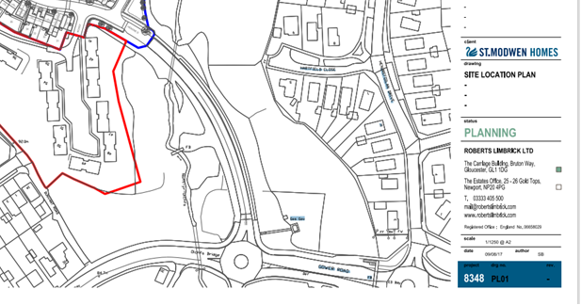
The Image above is a overhead view of the building outline of the project in its existing form.

Work Structure
A step-by-step layout will be produced in a gantt chart with the use of Microsoft project, giving all works needed from start to finish to complete the job in hand.

Method statement 3 major activities

Excavation

- Before any excavation works start, the site engineer will mark the area of works to ready for cutting or filling the area giving a foot (300mm) extension either way in order for later works when building the ground back up and kerbing boundary, this will be done with profile and travellers due to being a larger area and to avoid having to re check depths using a dumpy level after cutting.
- Once the area is marked, the engineer will then gather any information on existing services and drainage in that are from given drawings, as well as secondary checks with a CAT and genny in case of any additional or unexpected services. As well as any overhead services to be goal post present to give warning of the hazard. If any work is to happen beneath the overhead cables a separate permit will need to written by authorised personnel and discussed with the team.
- The final process before physical works begin is signing the permit of digs and discussing what services are nearby and other considerations while excavating, as well as the process and machinery that will be used. This permit of dig will be filled and issued by an authorized personal as well as signed by themselves and the groundworkers involved.
- If any hedgerows or vegetation is being ripped up/destroyed an environmental permit will need to be issued and an environmental expert present. As well as archaeologists if believed to be any historic relevance to the land.
- Soil stripping works begins, any topsoil and vegetation will be stored separately on site where they must be sealed and covered to avoid cross contamination and re used in the green areas on site. A small sample will be taken to a recycling/ commercial waste disposal area to be tested if happy all material not needed will be taken from site will be taken to disposal location unless stated otherwise by management. Material will be taken by 6-wheel lorries which can hold around 16tonne at a time.
- Plant segregation must be maintained during excavation operations, and designated pedestrian paths must be established to prevent pedestrian collisions with workers. Additionally, all excess personnel must be removed from the area. Plant crossing points will also be used as precaution to avoid collisions between workers or civilians.
- Only a skilled, qualified banksman will be present in the work area if complete plant segregation is not possible.
- Excavation operations will be continuously observed by the engineer and supervisor to ensure the necessary profile & level is attained. They will always be visible to the plant operator and control plant movements via a pre-arranged communication process.
- Once excavations are complete and engineer is happy with levels, CBR testing will need to be complete to see whether the ground is suitable. Anywhere with less than 5% will require terram before backfilling with the specified materials. Soils are logged in accordance with British Standard BS5930:2015
- With carting of material off-site other access roads will get dirty, to avoid any conflict from the community a road sweeper will be used at the end of every shift to clean surrounding roads.

Material storage for take-off or re-use
- All stockpiles must be agreed with site management team, the location must not be covering any services, drainage and have a chance of escaping into watercourses and polluting the area as well as any ground will poor load bearing capacity as it can cause subsidence or collapsing to any ground.
- Stockpiles must be segregated and marked out for workers understanding as well as machine operators and lorries who are taking away unneeded material. This will also prevent dumper operatives from offloading into wrong piles.
- Stockpiles must not exceed the height of 3m from hard standing ground, supervisors must inspect stockpiles daily and be aware of any sliding, cracking. Any problems must be noted to site management immediately and action must be taken.
- In this scenario stockpiling of waste material will be very minimal due to lorries taking away throughout the excavation process.
- The excavator operator will make sure that stockpiles are filled uniformly while loading to prevent overly steep faces and potentially unstable slopes that could result in slope failure and cause the excavator to slide or topple over.
- When arranging materials to form a stockpile, they should be "tracked in" gently and not steeper than their angle of repose. Usually, no steeper than 30 degrees for the material used. If in question, this should be verified by consulting the engineer.
- Dumpers must be used when practical to so whether rear tipping or forward tipping dumpers. Forward tipping dumpers must refrain from climbing existing stockpiles.

Ground Make-Up
- Once confirmed and engineer is happy with dig levels, the engineer will create a new traveller that’s altered in height, dependant on the ground make-up stated by the designers’ drawings e.g. 300mm of type 3 clean stone.
- All areas that were not within the CBR testing tolerance will require terram to be a laid over the surface.
- 6-wheel lorries will then deliver the desired quantities of the correct stone to begin the make-up process, the stone will be laid beyond the kerb line which is already counted for in the dig process and by the engineers marking out. When tipping from the lorry it must be overseen by the banksman to avoid any collisions with overhead cables, if not possible a designated drop off point will be already made with signage and fenced off.
- Any transportation of stone will be done by a 3Tonne forward tipping dumper and loaded by a 6Tonne machine, reasoning for these size machines is still efficient in terms of loading and transporting material as well as a good size to manoeuvre and avoid any collisions.
- Any gullies and drainage will be positioned and placed within the build-up process, the site engineer will determine the locations, heights, and falls. If any connection is needed to be made to a main, an S106 agreement is needed to be made with Welsh water and needs to be visually inspected by a member that all complies with Welsh water standards.
- After all drainage is complete, the stone will be brought up to level with the use of a 6 tonne machines grading to the correct height, while thoroughly checked over with the use of the profiles.
- Following on from that, the kerb line will then be marked out. The reason for laying the kerbs onto the stone is to save on costs to avoid overspending on concrete to lay the kerbs. Kerb must have a minimum of 150mm of concrete beneath. Dependant on the over all make-up, it might require some scratching of the newly placed stone to gain that amount of concrete beneath.
- Concrete wagon will then deliver concrete to site and offloaded. To avoid accidents handheld two-man kerb lifter or kerb lifter attachment for the machine will be used to transport and place kerbs.
- Kerbs complete, all remainder concrete will be used to ‘haunch’ the back of the kerbs for extra support.
- Continuation of build-up using correct materials as well as building up gullies with the use of a class-b engineering brick (2 courses minimum) as well as a lid, this would have been accounted for when placing the gully pot resulting in lid sitting 20mm below watermark on kerbs. Levels of stone will be brought up to level ready for tarmac finishing. Crownlines in centre of road will also be built up with stone for cost reasons.
- Note- Local council highways clerk of works will call out at each stage to see if complying to standards.
- All stone is brought up to level and compacted in layers of 150mm with the use of a 3tonne roller. Once all is complete site management will liaise with tarmac company giving details of square meterage as well as designed specification of tarmac thicknesses and tarmac grade.

Surface Finishing
- Tarmac company will come to site on date requested, once on site all employees of the company must attend to site office to be inducted and read through their RAMS, this will give them all the relevant information about the site itself and the rules they must follow as well as a guide on the sequence of their works.
- After reading the RAMS they must sign to show they understand what is asked of them, they will then prepare for surfacing the tarmac by getting into all the appropriate PPE.
- The tarmac company will arrange their own transportation of the asphalt material and work out the tonnage needed based off the square meterage that was given, tarmac is then delivered to site in lorries with small opening points on the back which are operated by a lever to allow the desired amount of asphalt out.
- The tarmac will be laid in two courses, binder course and the surface/wearing course to specifications thicknesses. The binder course will be laid first and will be left time to harden before doing the surface course.
- The asphalt will be laid by hand in any tight areas with the use of a wheelbarrow to transport the asphalt and then a rake and shovel to level off. Any large area will be done with the use of a barber greene, a load will be tipped directly into the barber greene from the lorry. The barber greene can be set to correct heigh required meaning little to no levelling off will needed to be made.
- Once all binder course is laid, a roller will be used to compact the asphalt and a whacker plate in any tight spaces or near any edging material to avoid damage to kerbs.
- The binder course will be left for a couple of days to allow the asphalt to settle and harden. Once hardened the tarmac company will return and repeat the process for the surface course. Before laying the course, they will clean any dirt or debris (if any) of the binder course to avoid any separation between the two courses. When laying the finishing course, they will need to make sure its sitting flush with all manhole covers and gully gratings, this will be done with shovel and rake to get the best chance and making the level more accurate.
- After tarmac is finished and hardened, white lining boys will be given drawings to show where any road markings are located, this will allow the company to quantify the materials needed.
- Once on site, they will attend the site office to be inducted and to read through their RAMS, they will then sign to show they understand and agree with everything.
- They will also be required a hot works permit, as the use of blowtorch is required to heat up the paint and dry the surface area for laying the road markings.
- Firstly, they will use the drawings to mark out all road markings. Once that is complete they will then heat the paint and lay following the specifications.

Site Reports
The use of Microsoft project allows us to analyse the cost, time and resources put into specific tasks or the overall job, creating Gantt charts with multiple different figures relating to time cost and resources.

Cost

Figure 1-Task cost overview
On Microsoft project a ‘resource sheet’ can be made which has a breakdown of costs of labour, materials. This can then be calculated to preform charts like the one above to give the overall budget of the job.

Time
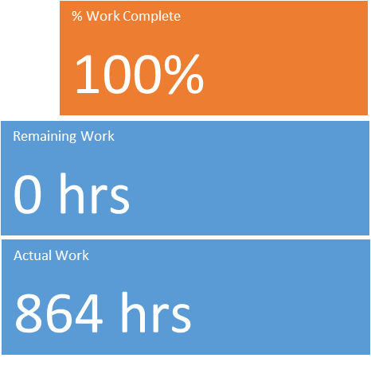
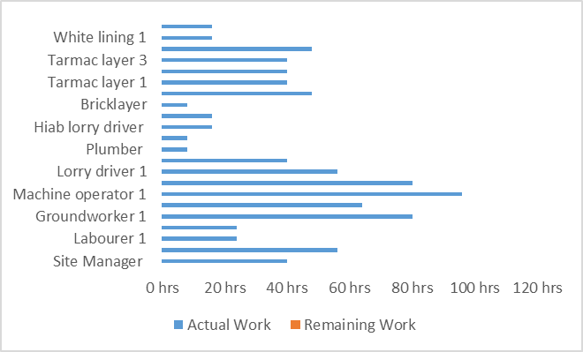

Figure 2- Work Overview Figure 3- Resource stats

Hours worked.
Microsoft project also gives detail the number of hours should be allocated to the project, this can also be broken down into individual tasks. This feature will also prove beneficial for understanding timeframes and whether we will exceed budget due to not meeting the remaining hours that can be sourced from these charts.

Resources

Below will be charts created within the software showing the amount of hours each worker has carried out, this can also show the remaining hours of each worker. This will give a better understanding on how much work is left for each person. In the graph it shows that the the workers who put the most hours in is the groundworks team as well as the site manager and engineer.
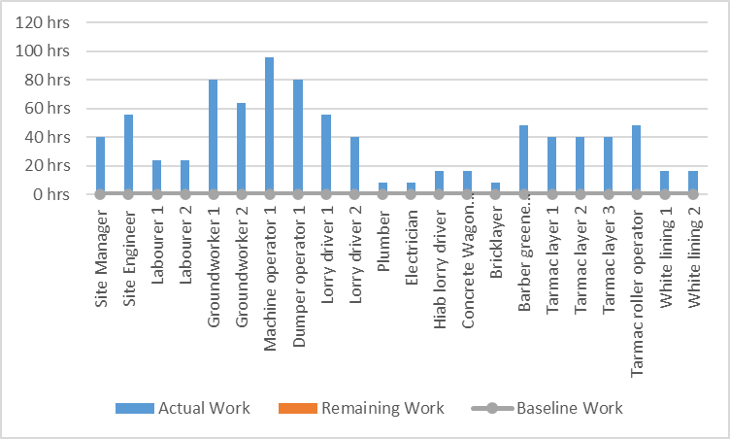

Figure 4- Resource overview
Another figure that goes in hand with the one above is the cost status graph which shows the amount of money each individual cost throughout the lifespan of the project, this tool will help with profit margins on future jobs as it will allow you to understand how to delegate workers and the amount of workers needed in order to complete tasks as efficiently as possible.
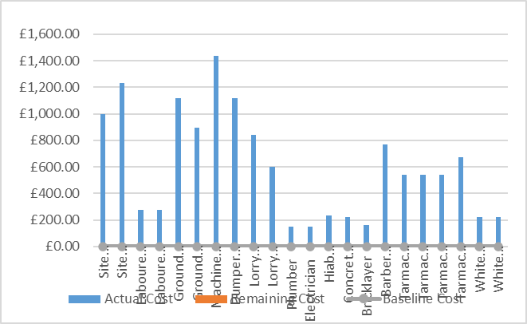
Figure 5- Cost status
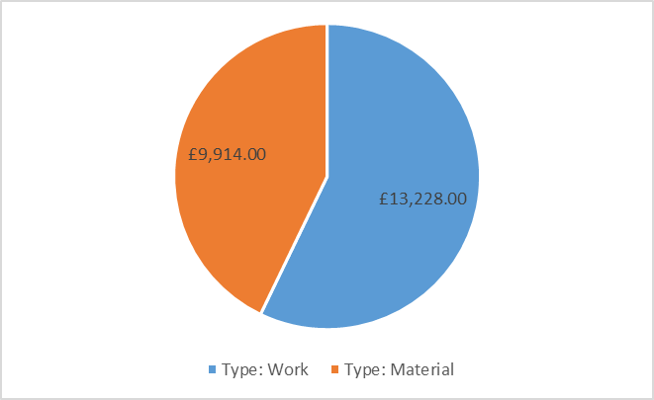
Figure 6- Cost Distribution

Another resource cost overview is the pie chart above which shows the cost breakdown between material cost and labour cost, this job shows that the labour cost was higher than the material cost being around 60% of the overall cost of the project.

References
EMSGeotech (2024) Phase 2: Site and ground investigation. Available at: https://www.ems-geotech.co.uk/phase-2-site-ground-investigations
(Accessed 1st April 2024)
EPAVictoria (2020) Managing stockpiles publication 1985. (Accessed 1st April 2024)
DwrCymru(2024) New Sewer Connections-S106. Available at: https://developers.dwrcymru.com/en/applications/waste-connections/new-sewer-connections
(Accessed 2nd April 2024)
That Builder (2023) How to lay Tarmac driveways. Available at : https://www.thatbuilder.co.uk/how-to-lay-a-tarmac-driveway/
(Accessed 3rd April 2024)

