Victoria Greene
P142884
Automotive Engineering BSc
27th November 2017
Feasibility Study of Electric Vehicles to Reduce Carbon Impact

Table of Contents
Introduction 3
Research 4
Types of Emissions Created by the Internal Combustion Engine 4
Regulations and the increasing popularity of the E.V 4
Electric vehicle Performance: - Mention Hybrids and instant torque 5
Infrastructure 6
Chicken or the egg on infrastructure; 7
Range and Charge Time 7
Vehicles with extended range and performance 10
Up and Coming Battery Technology 10
Maintenance 11
Emission Regulations 12
Companies Pledge to go Electric: 13
NEDC compared to the WLTP and RDE 14
Electric Vehicle Complications in Rural Areas 14
Electric Vehicle Complication in Urban Areas 14
Costs Involved with owning and buying an electric vehicle 15
Disbelief of the efficiency and true emissions of E.Vs 15
Methodology 16
Analysis 17
Types of Emissions Created by the Internal Combustion Engine 17
Electric vehicle performance 17
Regulations 17
Popularity of the E.V 17
Infrastructure 17
Chicken or the egg on infrastructure: 17
Range and Charge Time: 17
Vehicles with extended range and performance, this should have a short term positive affect on industry 18
Maintenance 18
Companies Pledge to go Electric 18
NEDC compared to the WLTP and RDE short to medium 18
Discussion 19
Conclusion 19
Evaluation 19
Bibliography 20

Introduction

It surprises some to hear that the electric vehicle came into existence before the internal combustion engine, while the use of ice powered vehicles have flourished and become a staple part of the transport industry in today’s society, the electric vehicle or ‘E.V’ has developed at a much slower rate, struggling to become as established as vehicles powered by gasoline or diesel. (Husain, 2011)

This paper will explore the reasons why the electric vehicle may or may not have the elements needed to develop into an accepted alternative to ice powered vehicles by looking at the short, medium and long term effects on the automotive industry and also the effects on different communities, such as rural and urban.

Research

Types of Emissions Created by the Internal Combustion Engine

There are several different emissions that are produced as a result of burning a fossil fuel in order to release energy, such as, carbon monoxide, Unburnt Hydrocarbons, Particulate Matter, Nitrogen Oxides, Sulphur Oxides and Carbon Dioxide. Emission laws for vehicles are in place to try and drastically reduce the output of these gases. (Union of Concerned Scientists , 2014)

Regulations and the increasing popularity of the E.V

In 2015, the Transportation industry was responsible for approximately 27% of greenhouse gas emissions with industry responsible for a further 21% (Edenhofer, 2014), with these types of high readings, regulations have been put in place to try and drastically decrease the amount of emissions that the transport industry is responsible for. One particular effective regulation, is the limitation on the average amount of emissions that a fleet of vehicles is responsible for, prompting manufacturers to consider reducing engine size and to also consider electric and hybrid electric vehicles as a solution to the increasing emissions produced by internal combustion engines. (European Commision , 2017)

It is important to note that is not just the regulations that are spurring change in the automotive and transport industries, companies are taking the initiative to supply lower emission vehicles such as electric and hybrid, because they recognise that society as a whole are gradually looking toward a greener future. (Husain, 2011)

Numerous companies have already successfully produced E.Vs, with the market demand continually growing. This can be proved by considering at the number of E.Vs registered in 2013 which was 3,500, then comparing it to the number of E.Vs registered by the end of September 2017, which was approximately 126,000. (NGC, 2017)

Electric vehicle Performance: - Mention Hybrids and instant torque

A feature that is often overshadowed by concerns of range and battery charge time, are the performance aspects of electric vehicles.

Below is an example of the instant torque that can be generated by an electric motor, (used in the lotus 414E) compared to the torque produced by an internal combustion engine alone (used in the Evora S)

(Lotusproactive, 2012)

Infrastructure

With the increase in sales in electric cars, there is also an increase in the charging stations available for E.Vs. There are currently, 4,917 different areas within the UK to charge an E.V, with some of these locations offering numerous charging points, equating to 14,061 connectors in total. (Zap Map, 2017). In comparison, there are 8,459 regular fuel stations that provide petrol and diesel.

Moreover, with lots of vehicle owners without guaranteed parking outside their residences, there are issues with connecting their electric vehicle to a power source overnight.

As long as individuals still experience even a minor struggle in finding or using a charging station nearby or en-route, this will stay a prominent problem acting against the acceptance of the electric vehicle. (The Times, 2017).

Chicken or the egg on infrastructure;

In order to produce a mass of electric vehicle charging points to match petrol and diesel station frequencies, the numbers of electric vehicles must increase to a point in which mass charging points are necessary, however, are customers willing to invest in an electric vehicle when the infrastructure is not absolute, therefore creating a chicken or the egg effect on electric infrastructure. (Forbes, 2016)

Range and Charge Time
Below are some of the most popular electric cars as stated by the telegraph, arranged in a table to easily assess performance in range and charge time. (The Telegraph , 2017)

Model | Range | Charge Time
Renault Zoe | 250 Miles (NEDC) (Renault, 2017) | 7-8 Hours (Home)  (Renault, 2017)
Tesla Model S | 409 Miles (EPA – 5) (Tesla, 2017) | 12 -13 Hours (Home)  (Tesla, 2017)
Nissan Leaf | 124 (NEDC) (Nissan, 2017) | 12-15 Hours (Home)  (Nissan, 2017)
Volkswagen e - Golf | 186 (NEDC) (Volkswagen, 2017) | 12-15 Hours (Home)  (pod-point, 2017)
Tesla Model X | 351 (EPA – 5) (Tesla, 2017) | 12 Hours (Home)
Volkswagen e - Up | 99 (NEDC) (Volkswagen, 2017) | 10-12 Hours (Home)  (pod-point, 2017)
BMW i3 | 124 (NEDC) (BMW, 2017) | 9-10 Hours (Home) (pod-point, 2017)
Hyundai Ioniq | 174 (NEDC) (Hyundai, 2017) | 12 Hours (Home)  (Hyundai, 2017)
(V.Greene)

(The Telegraph , 2017)

There are some fast charging points in the UK that are capable of charging an E.Vs to 80% capacity in thirty minutes, but with this comes complications. In an academic journal named energy policy, discussing the economics of fast charging, there is a mention of the implications of fast charging on battery life. (Andreas Schroeder, 2012).

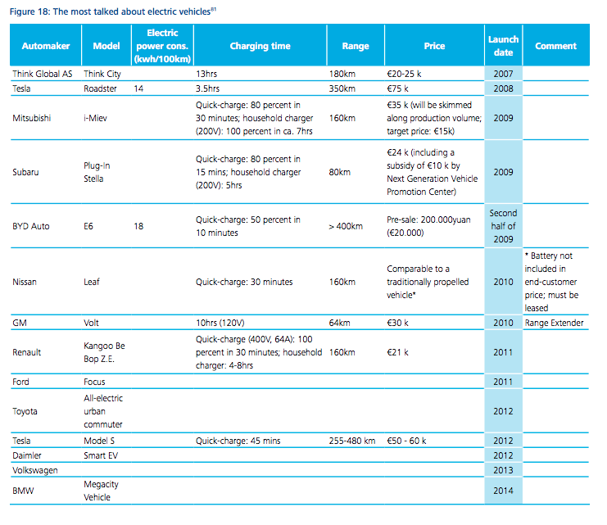
Here is a more expansive table taken from a report outlining change in the automotive industry, highlighting some of the quick charging capabilities of some Vehicles:

(Deloitte, 2009)

Vehicles with extended range and performance

Currently, the fully electric vehicle with the most impressive range is the Tesla Roadster, with a quoted range of 620 miles, which is truly impressive, if you are willing to pay the £200,000 price tag. (Tesla, 2017) (This is due to the substantial amount of lithium ion cells used)

The highest electric range of a vehicle that has a substantial range without a substantial price tag is the Chevrolet Bolt with an apparent 238 miles of range costing approximately £28,000-£29,000 pounds. (Chevrolet, 2017)

Up and Coming Battery Technology

The first lead acid battery was invented in the mid 1800’s by Gaston Planté (Godfrey Boyle, 2003), since then, there has been significant development in battery technology.

The lithium ion battery industry has grown exponentially in the last few years, dominating the battery markets for gadgets and are being used in electric vehicles, (Energy Storage , 2017) as the name suggests, lithium ion is used to store electrical energy chemically. Although these types of batteries have greater energy density, are lightweight and often have lower maintenance than their equivalents, there are still some major disadvantages. (Godfrey Boyle, 2003) Lithium Ion batteries discharge by themselves through time, they also suffer greatly with age and use, but predominantly, the major concern with these batteries, is the source of lithium ion itself. Lithium ion is a natural source and is depleting a fearsome rate, the cost of mining this material is often expensive and even dangerous at times, due to the location of the sources. (The Ohio State University , 2017)

The alternatives to a lithium ion battery are as follows;

Nickel-cadmium - These batteries share much of the advantages of lithium ion batteries, such as prolonged life, but cadmium is very toxic, therefore difficult to dispose of. (Godfrey Boyle, 2003)

Nickel iron – With advantages involving durability and long life, nickel iron can be a likeable alternative, but they have a low energy density and discharge easily over time. (Mpoweruk, 2005)

Nickel-metal hybrid – Rapid charging capabilities, as well as similar disadvantages and disadvantages from above. (Mpoweruk, 2005)

Sodium Sulphur – A battery configuration that operated at a temperature of 300-350 degrees, more suitable for stationary energy storage. (European Assosiation for Storage of Energy, 2016)

Maintenance

An Article by the independent newspaper written in 2016 stated that there is a massive risk to individuals who are working on electric vehicles without the appropriate training. It also stated that out of the 45,000 electric cars in the UK at that time, there were only 100 trained mechanics officially able to work on electric vehicles. (The Independant, 2016)

As well as concerns with servicing and mechanical work issues, there are also concerns toward the life of batteries i.e. how often will the battery need replacing in the vehicle after long term use? Below are some examples from the ‘fleetcarma.com’ website of how some manufacturers are providing support to customers;

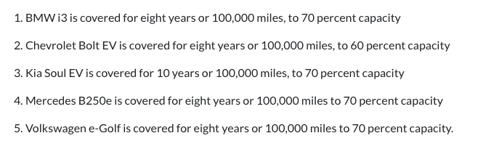

(Fleetcarma, 2017)

Emission Regulations

As emission regulations continue to increase in stringency, the automotive industry is being forced to come to terms with creating a portfolio of vehicles with improved emission control and carbon output.

One of the most fundamental regulations that have spurred great change has been stated by the Copenhagen accord created in 2009 that the maximum temperature of the globe should not surpass two Degrees Celsius. (United Nations Framework Convention on Climate Change, 2009) Which in turn, effects the amount of allowed emission’s produced by vehicles.

Below is a table demonstrating the deployment of the Euro Emission Laws:
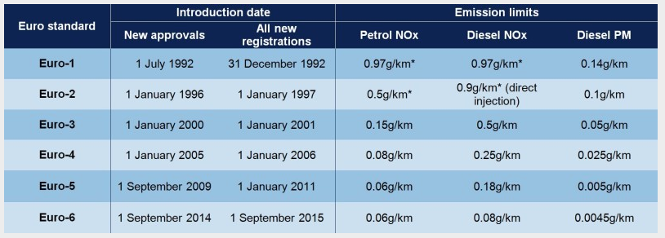

(The Society of Motor Manufacturers and Traders, 2017)

The Euro Emission standards above do not describe the whole story of the increase in stringency of regulations. As reported by the guardian, Britain are looking to phase out the sale of petrol and diesel cars altogether by 2040, by which point there will be a ban of sale of these vehicles. (The Gaurdian, 2017)

Some manufactures, have already had substantial positive reaction to this, by looking toward the future and planning major changes to their production of petrol and diesel engines, take Volvo for example, they have claimed that from 2019, they will only be producing hybrid or fully electric vehicles, this has been described as a ‘significant move’. (The Independant , 2017)

Companies Pledge to go Electric:

Daimler, BMW and Volkswagen | These German car makers have pledged to cut diesel emissions of their vehicles further by ‘updating software’ on current vehicles.  They have also stated that they will provide incentives for customers with older diesel vehicles to trade in their vehicle for a new, less polluting one. (The Times, 2017)
Volvo | Have stated they will only produce hybrid and electric vehicles from 2019. (The Independant , 2017)
Jaguar Land Rover | Jaguar land rover has promised to produce an electric version of all of their vehicles by 2020. (Financial Times, 2017)
Aston Martin | Aston martin have promised a hybrid version of all their vehicles within a decade (Financial Times, 2017)
GM | GM plans to ‘phase out’ diesel and petrol vehicles, and plan to have 20 fully electric vehicles by 2023 (Williams, 2017)
Ford | Ford have now set up a team dedicated to electric vehicles and plan to spend a large sum of money on development of new E.Vs (Williams, 2017)
VW group | Plan to have 300 Electric and hybrid versions of their vehicles by 2030 (Williams, 2017)

NEDC compared to the WLTP and RDE
The New European driving cycle is used regularly to validate the ‘well to wheel’ efficiency of a vehicle. But over the recent years it has come under major criticism for not being an effective representative of ‘real world’ driving. (Joachim Demuynck, 2012)

As of September 2018, vehicles will have to adhere to new legislative testing called the WLTP (worldwide harmonized light vehicle test procedure), which is said to be much more demonstrative of actual driving. Cars will also soon be made to demonstrate WLTP information such as the fuel consumption and CO2 output on legislative stickers on the forecourt so that buyers can consider these aspects before purchasing. (WLTPfacts, 2017)

(Greene, 2017)

Electric Vehicle Complications in Rural Areas
There is a prominent safety concern with the quietness of electric vehicles, some of the public and some organisations argue that because of the lack of noise of the vehicle, they are prone to be involved in more accidents. An Article from the telegraph states that even ‘taking into account the number of vehicles on the road, it is more likely to be hit by an electric vehicle.
(The Telegraph , 2012).

On the other hand, people who live in the countryside often really value the clean and fresh air that they breathe, therefore may value the option of having a vehicle that produces low or no emissions. (Denis Bouchard, 2016)

Electric Vehicle Complication in Urban Areas

E.Vs could be the answer to lowering the pollution in built up areas, but as mentioned in the research section, there are complications for electric vehicles in built up areas, such as plugging in your electric vehicle overnight. (Hull, 2017)

Costs Involved with owning and buying an electric vehicle

There are grants available from the government to act as an incentive to purchase an electric vehicle. The amount of grant varies depending on which electric car is purchased, a greater grant will be awarded to cars with the smallest amount of emissions.

There are three categories of cars that are eligible for the grant, the first category is for electric vehicles that do not produce any emissions over a 70 mile journey, allowing the full allocation of grant of (‘35% of the vehicle cost up to 45000’) (GOV UK , n.d.). The second and third category are of a similar layout, but allowing small emissions to be produced, with smaller amounts of grant available.

Disbelief of the efficiency and true emissions of E.Vs

As well as the fundamental issues around the mass acceptance of electric vehicles, there are also concerns toward whether E.Vs are actually sustainable. With the predominant argument being that in order to produce electricity in the first place, some fossil fuels will have to be burnt, which in turn, create emissions, whether it creates more or less emissions than burning fuel in an internal combustion engine is being argued frequently. (Scientific America, 2016)

Methodology

One important aspect of the method of investigating into the impact of electric vehicles, is to consider lots of current article and papers, as this industry is progressing quickly, basing research on older references would prove inaccurate.

Another issue, is because electric vehicle can be a hot topic, which much of the public having their own strong opinions on such matters (some of which can vary in fact and accuracy), it is essential that every reference for information is a credible and viable source.

There are vast amounts of information regarding this topic out there, even credible sources have varied arguments regarding the subject matter, therefore it was important to mention varied positive and negative views from credible sources on electric vehicles, in order to provide a fair and impartial collaboration of information.

Analysis

In this section, the topics covered in the research section will be analysed to see whether they have short, medium or long term effects on the automotive industry.

Types of Emissions Created by the Internal Combustion Engine is a prominent reason why manufacturers are looking toward electric vehicles, it could be argued that if internal combustion engines did not create emissions, there would be little interest in electric vehicles, the existence of these emissions will affect the industry long term, pushing them closer to the electric vehicle market for the foreseeable future. (The independant , 2009)

Electric vehicle performance will affect the industry short term, as companies are producing electric vehicles, they are confronted with the issue of range, which is a commonly off-putting for vehicle owners, however, if battery technology continues to develop exponentially, then manufacturers will soon be able to provide batteries with more impressive range, at eventually cheaper prices. (Science Daily , 2017)

Regulations have been affecting the automotive industry since their existence, as companies have no option but to adhere to them, they will continue to effect the industry long term. (The Society of Motor Manufacturers and Traders, 2016)

Popularity of the E.V directly affects industry, as popularity of a vehicle is linked to the amount of vehicles sold. Therefore, companies are required to make electric vehicles a tempting option, which can often mean substantial investing. (Business Insider , 2016)

Infrastructure: The issue of infrastructure will inevitably have to change in order for a mass acceptance of E.Vs short term. Despite the number of vehicle charging stated in the research section, there are still complaints about instances when electric vehicle owners have struggled to find a suitable place nearby to charge their vehicle. (The Times, 2017). It has been suggested that this is due to sporadic and uneven placement of charging stations. (Transport For London, 2016).

Chicken or the egg on infrastructure: Major fuel station such as shell are now considering E.Vs as part of the future, shell are going to introduce its first wave of charging points, with more to come in the future. (The Gaurdian , 2017) If major fuel providers follow suite; they may be able to overcome the chicken or the egg effect.

Range and Charge Time: The term ‘range anxiety’ is frequently used in describing the negative opinions toward electric vehicles. Despite there being electric vehicles out there with impressive electric ranges, they do come at a cost, which can be enough to dissuade a vehicle owner from considering E.Vs. (Clark, 2017) However, Battery materials and designs are changing positively, but arguably, not enough to support an easy transition to using electric vehicles in the same fashion as fuel based vehicles; meaning despite the progress of modern battery technology, there are still concerns with range, charge time and durability, therefore it is likely that this issue will affect the industry for a medium term.

Vehicles with extended range and performance, this should have a short term positive affect on industry

Maintenance - As discussed, electric vehicles are increasing in popularity, but when it comes to maintaining an electric vehicle, are there enough qualified garages out there to appropriately maintain electric vehicles, especially if their numbers keep increasing. There needs to be a drastic increase in trained mechanics with the knowledge to maintain E.Vs, to train this will come at a substantial cost to automotive companies, but when achieved, it should provide electric vehicle owners with the confidence that they can have their E.V maintained effectively.

Companies Pledge to go Electric: with these well-known car companies publicly pledging to move towards electric and hybrid vehicles, this could prompt other companies to move toward these future vehicles.

NEDC compared to the WLTP and RDE short to medium
The WLTP and NEDC are compared regularly as the WLTP is referred to as the improved replacement. There are a few major differences of how the NEDC and WTLP differ, the table below highlights some of the changes that make the WTLP an ‘improved’ test procedure:
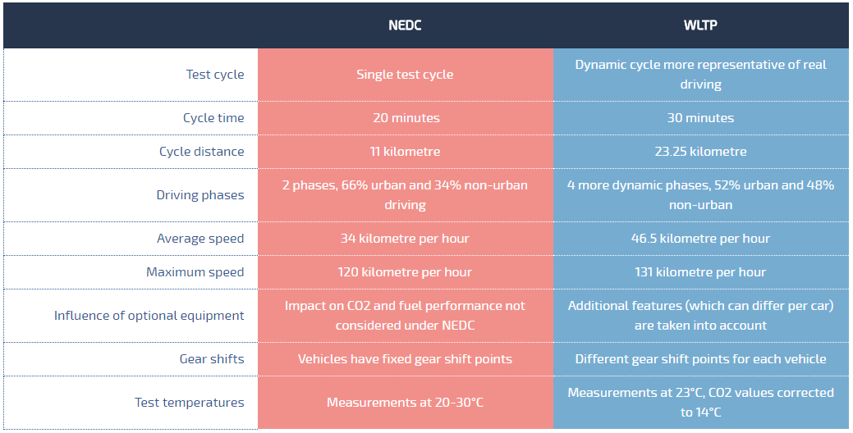

(WLTPfacts, 2017)

Comparative tests have shown that NEDC and WLTP have seen differences in CO2 readings of up to eleven percent and also discrepancies of energy usage of up to 44% (Jelica Pavlovic, 2016).

(Greene, 2017)

Discussion

The discussion within academia and the media is a very mixed bag, since electric vehicles are such a controversial subject, there are opinions and discussions that vary widely, often depending on the personal opinion of the author, which appears often however much they are attempting to be impartial.

Conclusion

The main points gathered from this paper outline the practical complications of electric vehicles and what needs to be improved to make electric vehicles a more feasible option for everyone, such as infrastructure, battery technology, cost and overall efficiency. Once these improvements are successfully achieved through time, there could be little practical reasoning for the resistance against the mass use of electric vehicles.

On the other hand, the admiration for the internal combustion engine will be difficult for some to overcome, no matter how practical and efficient E.V’s become. (The Telegraph - Lifestyle, 2017)

Unfortunately, by looking at the current and planned regulations, there soon will be no choice for even the most committed internal combustion fan to own an electric or hybrid vehicle, as long as regulations continue to increase in stringency and manufacturers respond by introducing E.Vs. (BBC News, 2017)

Evaluation

Looking back at the methodology, this report has effectively outlined the impact on the automotive industry, by looking at recent and relevant reliable sources. Both sides of the argument have been included throughout the compilation of this report.

Bibliography
Andreas Schroeder, T. T., 2012. The economics of fast charging infrastructure for electric vehicles. Energy Policy , p. 1.
BBC News, 2017. New diesel and petrol vehicles to be banned from 2040 in UK. [Online]
Available at: http://www.bbc.co.uk/news/uk-40723581
[Accessed 27 November 2017].
BMW, 2017. Range and Charging. [Online]
Available at: http://www.bmw.co.uk/en_GB/new-vehicles/bmw-i/i3/2017/range-charging-efficiency.html
[Accessed 22 November 2017].
Business Insider , 2016. Automakers could be making a big mistake with their big bets on electric cars. [Online]
Available at: http://uk.businessinsider.com/why-automakers-are-investing-in-electric-cars-2016-10
[Accessed 27 November 2017].
Chevrolet, 2017. Bolt EV. [Online]
Available at: http://www.chevrolet.com/bolt-ev-electric-vehicle
Clark, R., 2017. Electric cars are on a road to nowhere. The Spectator, 5 August, p. 1.
Deloitte, 2009. https://www2.deloitte.com/content/dam/Deloitte/in/Documents/manufacturing/a-new-era-auto-transformation-report-online.pdf, Sweden : https://www2.deloitte.com/content/dam/Deloitte/in/Documents/manufacturing/a-new-era-auto-transformation-report-online.pdf.
Denis Bouchard, J. T., 2016. Can an electric vehicle work in the countryside?. [Online]
Available at: http://infohemmingford.org/english/can-an-electric-vehicle-work-in-the-countryside/
[Accessed 27 November 2017].
Department of Transport, 2015. National Travel Survey. [Online]
Available at: https://www.gov.uk/government/uploads/system/uploads/attachment_data/file/457752/nts2014-01.pdf
Edenhofer, O. R. P.-M. Y. S. E. F. S. K. K., 2014. United States Environmental Protection Agency. [Online]
Available at: https://www.epa.gov/ghgemissions/global-greenhouse-gas-emissions-data#Sector
[Accessed 10 October 2017].
Energy Storage , 2017. Lithium-ion predicted to dominate even in ‘longer duration’ global market. [Online]
Available at: https://www.energy-storage.news/news/lithium-ion-to-dominate-even-in-longer-duration-global-market-says-i.h.s-ma
[Accessed 27 November 2017].
European Assosiation for Storage of Energy, 2016. Sodium Sulphur Battery, s.l.: European Assosiation for Storage of Energy.
European Commision , 2017. Reducing CO2 emissions from passenger cars. [Online]
Available at: https://ec.europa.eu/clima/policies/transport/vehicles/cars_en
[Accessed 27 November 2017].
Financial Times, 2017. Jaguar revs up electric car race with pledge to customers. 7 September, p. 1.
Fleetcarma, 2017. fleetcarma. [Online]
Available at: https://www.fleetcarma.com/todays-electric-car-batteries/
[Accessed 22 November 2017].
Forbes, 2016. The Electric Car Market Has A 'Chicken Or Egg' Problem. [Online]
Available at: https://www.forbes.com/sites/jackperkowski/2016/09/26/china-electric-car-charging-station/#458954d8123c
[Accessed 27 Novmber 2017].
GaBi, Database, 2013. Projection of Elecricity Mix - United Kingdom , United Kingdom: GaBi.
Godfrey Boyle, B. E. J. R., 2003. Energy Systems and Sustainability. Oxford: Oxford University Press .
GOV UK , n.d. GOV UK. [Online]
Available at: https://www.gov.uk/plug-in-car-van-grants
[Accessed 23 November 2017].
Greene, V., 2017. A technical comparison of the energy losses and emissions produced via different energy sources used to power an electric vehicle, in comparison to a vehicle powered by an internal combustion engine, Swansea: UWTSD.
Hull, R., 2017. Want an electric car charge point on the street outside your house? There's a £2.5m pot, but the catch is you have to apply though your council. This is Money , 23 February , p. 1.
Husain, I., 2011. Design Fundalmentals of Electric and Hyrbrid Vehicles. 2nd ed. Florida: Taylor and Francis Group LLC.
Hyundai, 2017. Ioniq. [Online]
Available at: http://www.hyundai.co.uk/new-cars/ioniq
[Accessed 22 November 2017].
International Energy Agency, 2011. CO2 Emissions by Sector, 1973 to 2010, Paris: IEA.
Jelica Pavlovic, A. M. B. C., 2016. CO2 emissions and energy demands of vehicles tested under the NEDC. Applied Energy, Volume 177, p. 1.
Joachim Demuynck, D. B. D. P. c. F. M. V., 2012. Recommendations for the new WLTP cycle based on an analysis of vehicle. Energy Policy 49, 17 July, 49(0301- 4215), p. 1.
Lotusproactive, 2012. Evora 414E. [Online]
Available at: https://lotusproactive.wordpress.com/2012/10/04/full-acceleration/
[Accessed 22 November 2017].
Mike Berners-Lee, D. C., 2013. The Burning Question. 1st ed. London: Profile Books Ltd.
Mpoweruk, 2005. Nickel Iron (NiFe) Batteries Characteristics. [Online]
Available at: http://www.mpoweruk.com/nickel_iron.htm
[Accessed 22 November 2017].
NGC, 2017. Electric car market statistics. [Online]
Available at: http://www.nextgreencar.com/electric-cars/statistics/
[Accessed 6 November 2017].
Nissan, 2017. Nissan Leaf. [Online]
Available at: https://www.nissan.co.uk/vehicles/new-vehicles/leaf/charging-range.html
[Accessed 22 November 2017].
pod-point, 2017. pod-point. [Online]
Available at: https://pod-point.com/landing-pages/bmw-i3-charging
[Accessed 22 November 2017].
Renault, 2017. Revolutionary range. [Online]
Available at: https://www.renault.co.uk/vehicles/new-vehicles/zoe-250/driving%20range.html
[Accessed 22 November 2017].
Science Daily , 2017. Better rechargeable batteries coming soon?. [Online]
Available at: https://www.sciencedaily.com/releases/2017/09/170921101754.htm
[Accessed 27 November 2017].
Scientific America, 2016. Electric Cars Are Not Necessarily Clean. [Online]
Available at: https://www.scientificamerican.com/article/electric-cars-are-not-necessarily-clean/
[Accessed 27 November 2017].
Tesla, 2017. Model S. [Online]
Available at: https://www.tesla.com/en_GB/models
[Accessed 22 November 2017].
Tesla, 2017. Tesla. [Online]
Available at: https://www.tesla.com/en_GB/modelx?redirect=no
[Accessed 22 November 2017].
Tesla, 2017. Tesla Roadster. [Online]
Available at: https://www.tesla.com/roadster/
The Gaurdian , 2017. Battery Technology Fundamentals. [Online]
Available at: https://u.osu.edu/2367group3/environmental-concerns/effects-of-mining-lithium/
[Accessed Ni 2017].
The Gaurdian , 2017. Shell to open electric vehicle charging points at UK petrol stations. [Online]
Available at: https://www.theguardian.com/business/2017/oct/18/shell-to-open-electric-vehicle-charging-points-at-uk-petrol-stations
[Accessed 27 November 2017].
The Gaurdian, 2017. Britain to ban sale of all diesel and petrol cars and vans from 2040. The Gaurdian , 25 July, p. 1.
The independant , 2009. The Big Question: Are electric cars the answer to Britain's environmental problems?. [Online]
Available at: http://www.independent.co.uk/extras/big-question/the-big-question-are-electric-cars-the-answer-to-britains-environmental-problems-1666749.html
[Accessed 27 November 2017].
The Independant , 2017. All of Volvo's cars from 2019 will be powered by electric motors, the company has announced.. The Independant, 22 November.
The Independant, 2016. Motor industry says the Government must take action to prevent unqualified cowboys from servicing the new vehicles. [Online]
Available at: http://www.independent.co.uk/life-style/motoring/motoring-news/electric-cars-mechanics-with-no-specialist-training-risk-death-when-tinkering-with-the-vehicles-a6816786.html
The Ohio State University , 2017. Effects of Mining Lithium. [Online]
Available at: https://u.osu.edu/2367group3/environmental-concerns/effects-of-mining-lithium/
[Accessed 27 November 2017].
The Society of Motor Manufacturers and Traders, 2016. Public Policy and Vehicle Legislation. [Online]
Available at: https://www.smmt.co.uk/about/structure/ppvl-department/
[Accessed 27 November 2017].
The Society of Motor Manufacturers and Traders, 2017. UK Car Emissions Testing. [Online]
Available at: https://www.smmt.co.uk/industry-topics/emissions/testing/
[Accessed 22 November 2017].
The Telegraph - Lifestyle, 2017. A ban on petrol and diesel cars by 2040? Why don't you ban the compact disc while you're at it. [Online]
Available at: http://www.telegraph.co.uk/cars/comment/ban-petrol-diesel-cars-2040-dont-ban-compact-disc/
[Accessed 27 November 2017].
The Telegraph , 2012. Plan to tackle 'silent killer' electric cars. [Online]
Available at: http://www.telegraph.co.uk/motoring/news/9688619/Plan-to-tackle-silent-killer-electric-cars.html
[Accessed 23 November 2017].
The Telegraph , 2017. The UK's best electric cars. [Online]
Available at: http://www.telegraph.co.uk/cars/advice/best-electric-cars/best-electric-cars3/
[Accessed 22 November 2017].
The Times, 2017. Business. [Online]
Available at: http://www.telegraph.co.uk/business/2017/08/02/germany-strikes-deal-car-giants-vw-bmw-daimler-reduce-diesel/
[Accessed 23 November 2017].
The Times, 2017. Electric dreams thwarted by shortage of car-charging points. The Times, 6 July.
Transport For London, 2016. Electric vehicle charging infrastructure, London: Transport For London .
United Nations Framework Convention on Climate Change, 2009. Copenhagen Climate Change Conference - December 2009. [Online]
Available at: http://unfccc.int/meetings/copenhagen_dec_2009/meeting/6295.php
[Accessed 22 November 2017].
Volkswagen, 2017. Volkswagen. [Online]
Available at: http://www.volkswagen.co.uk/new/up-pa/which-model-compare/details/2800#!#tech-spec
[Accessed 22 November 2017].
Volkswagen, 2017. Volkswagen e - golf. [Online]
Available at: http://www.volkswagen.co.uk/new/golf-vii-pa/which-model-compare/details/3183#!#tech-spec
[Accessed 22 November 2017].
Williams, B., 2017. Mashable. [Online]
Available at: http://mashable.com/2017/10/03/electric-car-development-plans-ford-gm/#hLfntO.X8iqz
[Accessed 23 November 2017].
WLTPfacts, 2017. wltpfacts. [Online]
Available at: http://wltpfacts.eu/from-nedc-to-wltp-change/
[Accessed 1 11 2017].
Zap Map, 2017. Stats. [Online]
Available at: https://www.zap-map.com

