Name: Valentin Scriosteanu

Student Id: 2122219

Module code: BMSW4003_LON

Module title: Digital Skills and Research Methods

Lecturer name: Amitave Banik

Assignment title: DSR Assessment 2 Individual Report

Word Count: 2000

Table of Contents
1.0 Introduction............................................................................................................ 3
2.0 Background.............................................................................................................4
3.0 Aim..........................................................................................................................6
4.0 Objectives...............................................................................................................6
5.0 Method…….............................................................................................................6
6.0 Results....................................................................................................................7
7.0 Disscusion...............................................................................................................8
8.0 Conclusion...............................................................................................................12
9.0 References..............................................................................................................13
10.0 Appendix................................................................................................................14

1.0 INTRODUCTION
Recent technological advancements in education, such as the development of multiple applications on a platform provided by virtual learning environments (VLEs) and a variety of different software that supports both face-to-face and online learning, have led to a growth in demand for blended and online courses in Higher Education Institutions (HEI). VLE is defined as a collection of elements that enable students and lecturers to engage in a variety of online activities, particularly online learning (JISC, 2014).

HEI understood the potential of technology and introduced it into their classrooms to improve learning. VLE is an example of technological advancement. VLE gives learners the opportunity to study at their own speed and independently, while at the same time being supported by their tutors and classmates. The University of Wales Trinity Saint David (UWTSD) is providing the VLE opportunity to its students in order to ensure that they have an efficient learning experience, adapted to modern technology. However, a debate emerges as to whether the employment of VLE is useful to pupils. The aim of this report is to analyse the impact of VLE-Moodle on the learning experience of students at the UWTSD London Campus.

2.0 BACKGROUND
The literature emerged form secondary data in this chapter will be compared and contrasted against primary data obtained from UWTSD students.
Nwabude (2012) defines VLE as a kind of virtual environment that is often used to support instructional materials, upload assessments and grades, and facilitate contact between tutors and students via the use of a messaging system.
According to Puzhevich (2020), VLE-Moodle based learning usage is not a recent practice in the system of education. Many educational institutions had previously used VLE software prior to the epidemic. However, they were not prioritised. They have only acquired popularity and recognition in recent years. Moreover, Sumpter and Gribble (2020) argue that, like with so many other aspects of education, the COVID-19 epidemic has underlined their critical nature, thereby causing their tremendous popularity. During the pandemic, universities abandoned traditional and hybrid learning paradigms in favour of purely virtual course delivery. Regardless of its usage during the lockdown, according to Cesco et al. (2021) research, the learning experience of students is heavily reliant on the resources and approaches of learning, and the VLE has introduced a new and distinctive method of learning that is assisting students in achieving their institutional objectives extremely well.
One of the reasons for its pre-pandemic usage is the need for distance learning. According to Price and Kirkwood, (2013), the demand for distant education was highlighted mostly for students desiring to pursue higher education at institutions located in other countries. Due to the economic impossibility of living in a foreign nation for educational purposes, Moodle-based learning was launched to alleviate the dilemma. Tyriana et al. (2019) described Moodle-based learning as the procedure of studying or educating through the internet via the creation of a virtual learning environment (VLE) that enables the creation of courses, tutorials, and a fully functional classroom setting. Also, Tyriana et al. (2019) argued that a VLE is a means to integrate technology into education in a manner that is more beneficial than conventional learning.
Another for using VLEs in higher education is that they may be easily adapted. Ng'ambi and Lombe (2012) found that flexibility was the most important feature of VLEs. A virtual learning environment (VLE) made education more flexible, especially when it came to time management. In Moodle-based learning, students could study at their own pace since material is always available. However, Manoj (2019) said that Moodle-based learning is mostly accessible. Anyone with an online connection could access learning materials anytime and from anywhere they are, according to Manoj (2019). Additionally, it demonstrates another benefit of VLEs: their cost.
When compared to traditional university programmes, the use of Moodle-based learning makes education more inexpensive. According to Miao, Mishra, and McGreal (2016), individuals may now access overseas education without incurring additional costs for housing and transportation. Despite these benefits of VLEs or Moodle-based learning, the study highlighted a variety of downsides that must be considered. In a Virtual institution or course, students' learning experiences are vastly different from those of students in traditional classrooms. Learners' aversion to change precludes them from accepting an online learning environment, and it also takes time for them to get used to a computer-based education.
According to Lynch (2017), the high-speed broadband connection required to study or download online courses is not available to all students. It is not uncommon for students to have trouble communicating with their online professors and peers. This method makes it difficult for pupils to adhere to the VLE, resulting in a troublesome learning experience. Also, according to Abdullah Omaish et al., (2022) students might have difficulty resolving fundamental computer difficulties due to their lack of understanding in this area. However, technical ability is required for students to handle their online projects and lectures effectively and without encountering difficulties.
Additionally, according to Schoology's (2020) survey, the majority of expatriate students in London reside outside universities amenities, making it challenging for them to keep connected with the technological requirements of their chosen degree. Certain international students lack access to computers and seek technical aid from learning resource centres. Additionally, the Schoology research demonstrates that online provision needs significant preparation and requires information technology (IT) infrastructure, platforms, administrative procedures, and, most significantly, online lecturers to be in place.

3.0 AIM
The aim of this report is to analyse the impact of VLE-Moodle on the learning experience of students at the UWTSD London Campus.

4.0 OBJECTIVES
- To assess the use of the Virtual Learning Environment (VLE) at the University of Wales Trinity Saint David's London campus
- To find the relation between the Virtual Learning Environment (VLE) and the students' learning experiences
- To conduct an analysis of the difficulties encountered by students in a virtual learning environment
- To provide recommendations for resolving student issues in the VLE

4.0 METHOD
The term "data collection" refers to the act of collecting sufficient information on various factors related to a certain topic of research (Kabir, 2016). Primary and secondary data were the two main types of data gathered. Primary data is the data gathered for the first time, often by the researchers themselves, and have never been utilised before. Original data are gathered from primary sources, often via the use of a questionnaire or an interview. Secondary data, on the other hand, may be characterised as information gathered from secondary sources such as publications, reports, and government resources. Secondary data is often acquired and utilised previously by a third-party entity.
This study used both primary and secondary data. Primary data was obtained via a survey at the University of Wales Trinity Saint David's London campus on students. The study was done by designing a questionnaire with five closed-ended questions representative of the study's entire field. Conversely, secondary data was obtained from websites and published literature on virtual learning environments (VLEs).
Secondary data are gathered and analysed focusing on their accuracy, validity, utility, and relevance to the field of study. Utilizing both sources benefited the study in enhancing the report's credibility.

5.0 RESULTS
In the primary research it was discovered that VLE and Moodle might impact positively the effectiveness of the studies at UTWSD London Campus. Because of the VLE students might learn more on Moodle than they do on a regular basis. Thus, VLEs are a fantastic resource that assists students in improving their learning quality. Primary data results are relevant and suitable since actual individuals engaged in the survey.
Following primary data analysis, it is clear that the majority of students benefit from the UWTSD London Campus's Virtual Learning Environment, a Moodle-based online platform. According to primary research, the majority of pupils prefer virtual learning environments over conventional education systems. Their motivations vary. The first factor is the web platform's flexibility. Following that, the fact that the studies are affordable. Certain students assume that by reducing their travel expenses, housing payments, and food and beverage expenses, they can finance their university course. Technology is also significant to some students, they claim that using a computer daily to access VLE materials improves their computer abilities. However, the majority of students questioned believed that the primary disadvantage of VLE is communication. Due to the VLE platform, communication between peers and instructors decreases

6.0 DISCUSSION
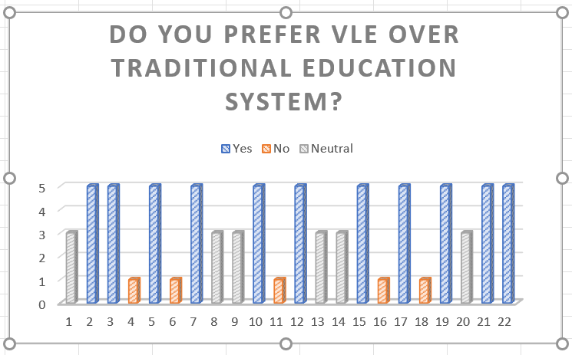
Figure 1

According to the evidence from above, more than half of respondents agree with the statement, believing that VLEs are superior to conventional learning. However, four students out of 22 respondents favoured conventional learning over VLE because they believe it is ineffective. Thus, it is apparent that a VLE is more beneficial for students' learning. According to the study findings of Sumpter and Gribble (2020), adopting VLE as a new mode of instruction is challenging. Due to the school system's primary concentration on classroom performance, many students and instructors are adaptable to change. His research established a clear positive correlation between a preference for VLE-based education and IT expertise. To ascertain students' attitudes on the use of VLE in education, they were prompted to answer to the following question as seen in the next figure.

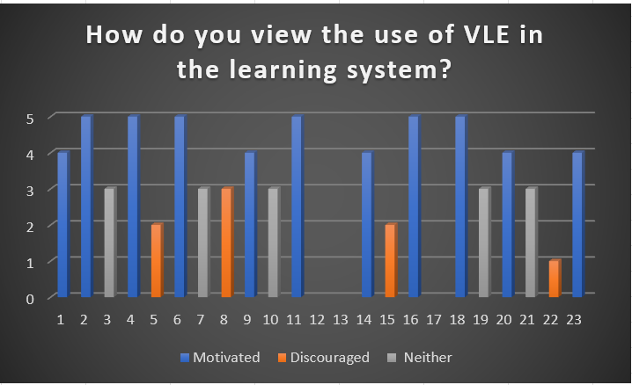
Figure 2
Among 22 students, 11 said that they were inspired to implement Moodle-based learning or a virtual learning environment (VLE) in their educational system. Though four of them expressed discouragement, seven were neutral about the implementation of VLE in education. The results are consistent with those of Ntshwarang, Malinga, and Losike-Sedimo (2021) indicated that implementing a VLE or adopting Moodle-based learning is among the most successful strategies to motivate people to learn more in this age of technological advancement. The modern student likes to be constantly engaged with technology. As a consequence, students who dislike technology are more inclined to feel challenged, which discourages and frustrates them as they attempt to adjust to the virtual learning environment.

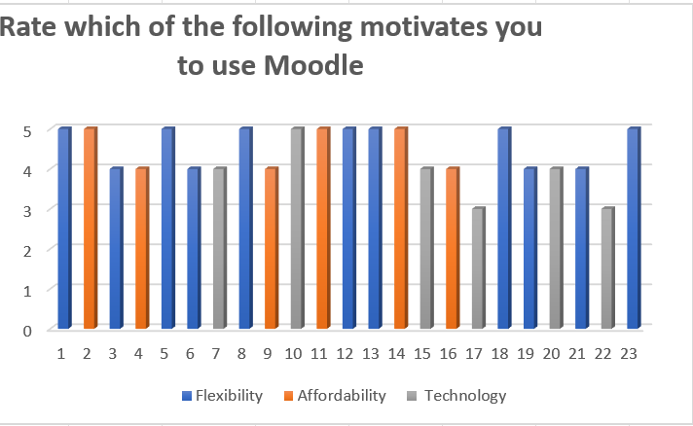
Figure 3
The flexibility of Moodle-based education was cited as the most important advantage by 50 percent of participants. It is consistent with Casper's (2019) results that students prefer Moodle-based learning because of its cost, space and time flexibility. Alternately, 25% favoured the current technology on the VLE platform, while 25% favoured the affordability element. While attitudes clearly favour flexibility, further study is necessary to determine if affordability and technology play an equal role in people's rationales.

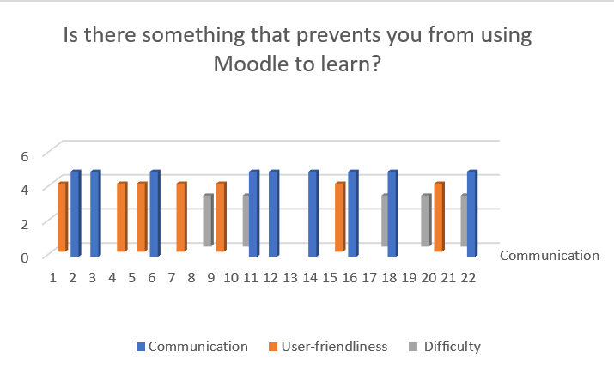
Figure 4
Approximately at 41% of respondents said that the primary barrier to adopting a VLE is communication. According to Barrot, Llenares, and del Rosario (2021), the primary barrier to student success in Moodle-based learning is an absence of contact between students and lecturers. On the other side, 32% of respondents believe VLEs are not user-friendly, and 23% believe they are a very tough method for acquiring instruction. According to Schoology (2020), efficient VLE usage is closely tied to students' IT knowledge. Pupils with advanced IT skills find the VLE to be more participatory, however the remainder of the students consider it difficult to utilise. While introducing VLE into school for the first time, emphasising various traits or areas will assist in reducing students' unfavourable perceptions
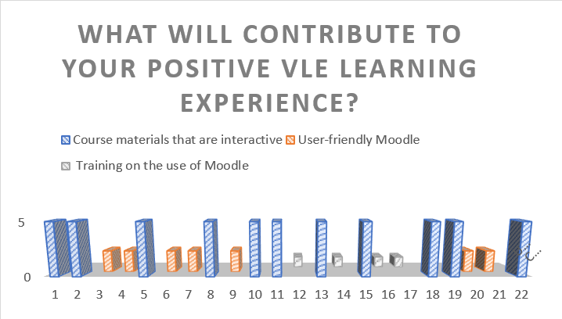
Figure 5
For this reason, 50% of the students believe that Moodle's interactive course materials or overview will spur them to use it for their education. The user-friendly virtual learning environment was deemed effective by 32% of the respondents. While 18% said that they needed VLE training in order to begin with VLE-based education.

7.0 CONCLUSION
This study looked at how students at the UWTSD London Campus responded with regards to their virtual learning environment. The virtual learning environment (VLE) has provided students with a wide range of communication capabilities, including instant messaging and video conferencing. However, students believe that the communication between their peers and academic staff has suffered because of the imposed distance. Thus, interaction could be improved. On the other hand, learners ability to focus in class has increased as a result of the use of innovative teaching strategies including VLE, internet, and video lectures.

9.0 References
Abdullah Omaish, H., Sennuo, A., Alymany, G., Abdullah, M.U., AlNakib, S., Divan, A. and Dionigi, F. (2022). Knowledge gaps amongst students entering higher education in the non-regime North of Syria: Causes and possible solutions. International Journal of Educational Research Open, [online] 3, p.100129. doi:10.1016/j.ijedro.2022.100129.
Al-Ajlan, A.S. (2012). A Comparative Study Between E-Learning Features. [online] www.intechopen.com. IntechOpen. Available at: https://www.intechopen.com/chapters/27926 [Accessed 3 May 2022].
Anggraeni, A. (2015). USING E-LEARNING TO SUPPORT LEARNING AND TEACHING LANGUAGE: The Importance of Virtual Learning Environments (VlE) to Improve Students` Sepaking Ability. www.academia.edu. [online] Available at: https://www.academia.edu/77599643/USING_E_LEARNING_TO_SUPPORT_LEARNING_AND_TEACHING_LANGUAGE_The_Importance_of_Virtual_Learning_Environments_VlE_to_Improve_Students_Sepaking_Ability [Accessed 3 Apr. 2022].
Barrot, J.S., Llenares, I.I. and del Rosario, L.S. (2021). Students’ online learning challenges during the pandemic and how they cope with them: The case of the Philippines. Education and Information Technologies, [online] 26(7321–7338). doi:10.1007/s10639-021-10589-x.
Casper, A. (2019). 5 Reasons Your School Needs Flexible Learning Spaces. [online] www.schoology.com. Available at: https://www.schoology.com/blog/5-reasons-your-school-needs-flexible-learning-spaces [Accessed 3 Apr. 2022].
Cesco, S., Zara, V., Toni, A.F.D., Lugli, P., Betta, G., Evans, A.C.O. and Orzes, G. (2021). Higher Education in the First Year of COVID-19: Thoughts and Perspectives for the Future. International Journal of Higher Education, 10(3), p.285. doi:10.5430/ijhe.v10n3p285.
Gallacher, C. (2015). What is a VLE (Virtual Learning Environment?). [online] EPALE - European Commission. Available at: https://epale.ec.europa.eu/en/blog/what-vle-virtual-learning-environment [Accessed 2 Apr. 2022].
JISC (2014). Archived version of http://www.jisc.ac.uk/whatwedo/programmes/buildmlehefe/lifelonglearning/mlebriefingpack.aspx from 2014. [online] www.webarchive.org.uk. Available at: https://www.webarchive.org.uk/wayback/archive/20140616050141/http://www.jisc.ac.uk/whatwedo/programmes/buildmlehefe/lifelonglearning/mlebriefingpack.aspx [Accessed 2 Apr. 2022].
Kabir, S.M.S. (2016). Methods Of Data Collection. [online] ResearchGate. Available at: https://www.researchgate.net/publication/325846997_METHODS_OF_DATA_COLLECTION [Accessed 3 Apr. 2022].
Lynch, M. (2017). The Absence of Internet at Home is a Problem for Some Students - The Edvocate. [online] The Edvocate. Available at: https://www.theedadvocate.org/the-absence-of-internet-at-home-is-a-problem-for-some-students/ [Accessed 3 Apr. 2022].
Manoj, K. (2019). Online learning is education that takes place over Internet. [online] Zoomtute. Available at: https://www.zoomtute.com/content/blogs/18/online-learning-is-education-that-takes-place-over-internet-dot [Accessed 3 Apr. 2022].
Miao, F., Mishra, S. and McGreal, R. (2016). Open Educational Resources: Policy, Costs and Transformation. [online] oasis.col.org. Commonwealth of Learning (COL); Available at: http://oasis.col.org/handle/11599/2306 [Accessed 3 May 2022].
Ng’ambi, D. and Lombe, A. (2012). Using Podcasting to Facilitate Student Learning: A Constructivist Perspective. Journal of Educational Technology & Society, [online] 15(4), pp.181–192. Available at: https://www.jstor.org/stable/jeductechsoci.15.4.181 [Accessed 8 Apr. 2022].
Ntshwarang, P.N., Malinga, T. and Losike-Sedimo, N. (2021). eLearning Tools at the University of Botswana: Relevance and Use Under COVID-19 Crisis. Higher Education for the Future, p.234763112098628. doi:10.1177/2347631120986281.
Nwabude, A. (2012). Part 5: Learning and Teaching Styles 410 HOW WOULD VIRTUAL LEARNING ENVIRONMENT (VLE) ENHANCE ASSESSMENT FOR LEARNING MATHEMATICS BY THE SPECIAL EDUCATION NEEDS STUDENTS (SENS) IN SECONDARY EDUCATION SECTOR. [online] Available at: https://files.eric.ed.gov/fulltext/ED567061.pdf [Accessed 2 Apr. 2022].
Price, L. and Kirkwood, A. (2013). Using technology for teaching and learning in higher education: a critical review of the role of evidence in informing practice. Higher Education Research & Development, 33(3), pp.549–564. doi:10.1080/07294360.2013.841643.
Puzhevich, V. (2020). The Use Of Virtual Learning Environment In Education | SCAND Blog. [online] SCAND. Available at: https://scand.com/company/blog/the-use-of-virtual-learning-environment-in-education/#:~:text=A%20virtual%20learning%20environment%20%28VLE%29%20is%20not%20a [Accessed 2 Apr. 2022].
Sumpter and Gribble (2020). ‘VLE success is not about tech, it’s about practice and people’. [online] Jisc. Available at: https://www.jisc.ac.uk/blog/vle-success-is-not-about-tech-its-about-practice-and-people-17-nov-2020 [Accessed 2 Apr. 2022].
Triyana, I.G.N., Sri Ratmini, N.K., Mandra, I.W. and Ruscitadewi, N.W. (2019). The Use Of Moodle-Based E-Learning In Evaluating Students’ Learning. Jurnal Penjaminan Mutu, 5(2), p.165. doi:10.25078/jpm.v5i2.1089.

10.0 Appendix

