Moodle: Changemakers: Creativity and Value Creation

Moodle code: BMHP5014

MOVE & CONNECT
Social Exercise Groups for Older Adults (65+) POSTER & PITCH

Name: Edmilza Veloso
Student I.D.: 2028154
Lecture Name: Laila Surani
Timeline Phase 1: Community consultation and pilot delivery. Phase 2: Expansion through local authority partnerships. Phase 3: Evaluation and long-term integration into community health services.
Dissemination MOVE & CONNECT would be promoted through GP practices, social prescribers, local councils, voluntary organisations and community networks. Word of mouth and peer ambassadors would support engagement among older adults.
Stakeholder engagement
In addition to community-based promotion, MOVE & CONNECT would engage stakeholders through local authority partnerships, NHS primary care networks and voluntary sector organisations. Digital platforms, newsletters and community noticeboards would raise awareness, while collaboration with older adult champions would strengthen trust and programme uptake.

Conclusion MOVE & CONNECT offers an innovative, preventative approach to healthy ageing by integrating physical activity and social connection. The programme addresses key gaps in older adult wellbeing, reduces isolation, and supports sustainable value creation within UK health and social care. By combining physical activity, social connection, and preventive care, MOVE & CONNECT demonstrates how creative, community-led innovation can generate meaningful value in health and social care. The programme not only enhances individual wellbeing but also contributes to more sustainable, inclusive and resilient community health systems across the UK.

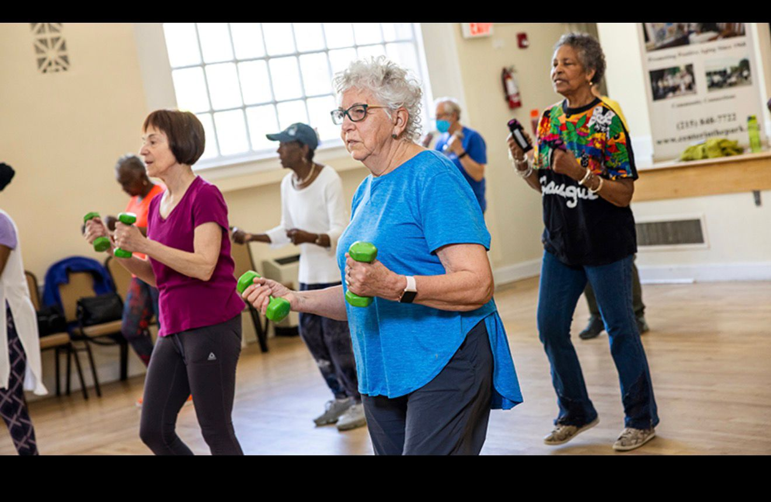
Innovation Overview MOVE & CONNECT is a community-based health and social care initiative designed to improve physical activity, mental well-being and social connection among older adults aged 65 and over in the UK. The programme combines low-impact group exercise with structured social interaction, creating safe and inclusive spaces that promote healthy ageing and reduce social isolation. The innovation supports preventative care by encouraging regular movement, peer support and community engagement.

Additional Value and Innovation
MOVE &CONNECT is innovative because it integrates physical activity with structured social engagement, aligning with the NHS social prescribing agenda. Unlike traditional exercise programmes, this initiative places equal emphasis on social connection, peer support and community belonging, addressing both physical and psychosocial determinants of health. By embedding the programme within existing community settings, MOVE & CONNECT promotes preventative care, early intervention and sustainable wellbeing, contributing to long-term value creation within UK health and social care systems.

The issue Older adults are at increased risk of physical inactivity, loneliness and mental health difficulties, including depression and anxiety. Social isolation has been linked to poorer health outcomes and higher demand on health and social care services. Many older people encounter barriers to accessing physical activity opportunities due to mobility issues, lack of confidence, cost, or the absence of local provision, emphasising the need for accessible community-based solutions.
Evidence Base Evidence indicates that over 1.4 million older people in the UK experience chronic loneliness, with increased risks of depression, anxiety, cardiovascular disease and reduced quality of life (Age UK, 2023). Physical inactivity among older adults also contributes significantly to falls, loss of independence and increased hospital admissions (NHS England, 2022). Addressing these interconnected issues through accessible, community-based interventions is essential to reducing pressure on overstretched health and social care services.
Target Group & Impact The programme targets adults aged 65+, particularly those living alone or with long-term conditions. Expected outcomes include improved mobility, balance, and strength; reduced loneliness; enhanced mental well-being; and reduced pressure on NHS and social care services.

Wider social impact
MOVE & CONNECT supports the common good by reducing health inequalities experienced by older adults who may be socially isolated, economically disadvantaged or living with long-term conditions. Improved physical strength, balance and confidence can reduce fall-related injuries, while enhanced social connections, resilience and wellbeing. Collectively. These outcomes have the potential to reduce GP appointments, emergency admissions and reliance on formal care services, generating both social and economic value.
Implementation MOVE & CONNECT would be delivered in community centres, leisure facilities, faith venues and sheltered housing schemes. Sessions would be led by trained exercise instructors and supported by community health workers, volunteers, and social prescribers. The programme complements NHS services by offering preventative, non-clinical support through social prescribing pathways.

Technology integration Technology supports the effectiveness and accessibility of MOVE & CONNECT through digital referral pathways from GP practices and social prescribers. Attendance and progress tracking systems enable monitoring of engagement and outcomes, while simple digital tools such as SMS or WhatsApp reminders help maintain participation. Secure data management systems ensure compliance with GDPR, supporting evaluation and continuous improvement of the programme.
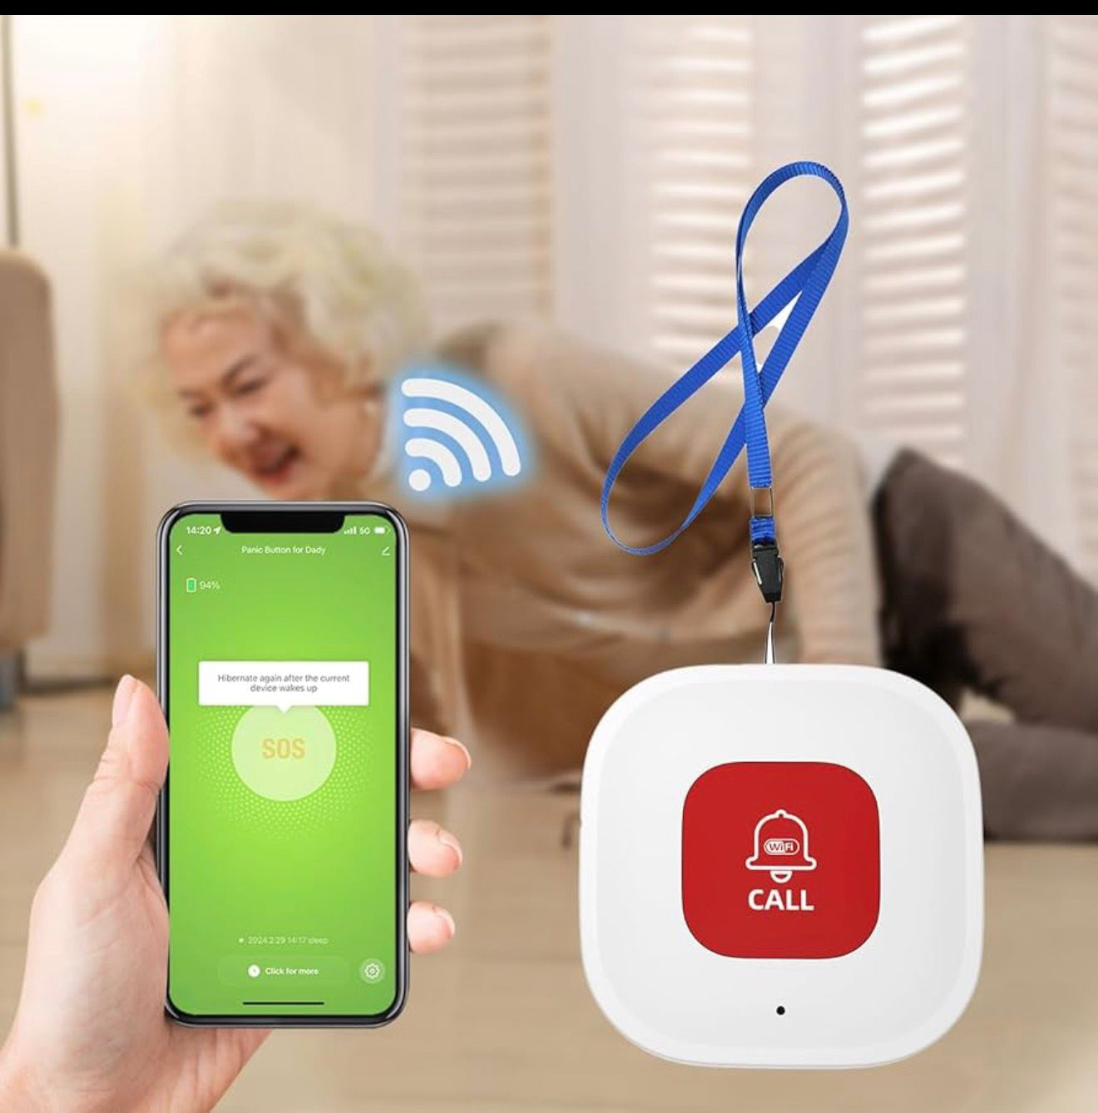
Programme Design Sessions include chair-based or low-impact exercises, stretching, and balance activities combined with guided social time, such as group discussions or refreshments. Activities are tailored to individual abilities, fostering inclusivity and confidence while encouraging peer support and ongoing engagement.

Theoretical rationale
The programme is informed by active ageing principles and social support theory, which emphasise the importance of maintaining physical, social and psychological engagement in later life. Group-based activities encourage motivation, accountability and peer encouragement, increasing long-term adherence. Sessions are adaptable to cultural needs, language differences and varying physical abilities, ensuring inclusivity and sustained participation.

Regulation & safety The programme aligns with NHS social prescribing guidance, safeguarding policies, health and safety standards and inclusive practice guidelines. Risk assessments and instructor training ensure participant safety.

Policy and Legal Framework
MOVE & CONNECT complies with key UK legislation and guidance, including NHS England social prescribing frameworks, safeguarding adult’s policies, the Equality Act 2010, and Health and Safety at Work regulations. All facilitators will receive appropriate training in risk assessment, first aid, and inclusive practice. Data collected through the programme will comply with GDPR requirements, ensuring the confidentiality and ethical handling of participant information.

MOVE & CONNECT
Social Exercise Groups for Older Adults (65+)

PITCH: MOVE & CONNECT
Social Exercise Groups for Older Adults (65+)
Introduction
MOVE & CONNECT is an innovative, community-based health and social care initiative designed to address key physical, mental and social challenges experienced by older adults aged 65 and over in the UK. The programme aligns with national priorities for preventative care, active ageing and social prescribing by integrating low-impact physical activity with structured social interaction. This pitch builds directly on the accompanying poster. It provides a more detailed explanation of the programme’s rationale, implementation, policy relevance and value creation, demonstrating its potential to enhance individual wellbeing and contribute to sustainable health and social care systems.
Rationale for the Innovation
Older adults face an increased risk of physical inactivity, loneliness and declining mental health, all of which poorer health outcomes and increased demand on NHS and social care services. Chronic loneliness affects a significant proportion of older people in the UK and has been linked to depression, anxiety, cardiovascular disease and reduced quality of life (Age UK, 2023). In addition, physical inactivity contributes to falls, loss of independence and avoidable hospital admissions (NHS England, 2022). MOVE & CONNECT to these interconnected challenges by offering an accessible, community-based solution that addresses both physical and psychosocial determinants of health. Unlike traditional exercise programmes that focus primarily on physical outcomes, this initiative recognises social connections as a care component of wellbeing. By combining movement with peer support and community engagement, MOVE & CONNECT represents a creative and person-centred approach to healthy ageing and prevention.
Target Group and Contribution to the Common Good
The programme targets adults aged 65 and over, particularly those living alone, experiencing social isolation or managing long-term conditions. These individuals often face barriers to accessing physical activity opportunities, including mobility limitations, low confidence, financial constraints and limited local provision. By improving mobility, balance, and strength, MOVE & CONNECT supports participants in maintaining independence and confidence in daily life. Structured social interaction reduces loneliness and enhances emotional well-being, promoting resilience and social inclusion. These outcomes extend beyond individual participants, contributing to the common good by reducing health inequalities, easing pressure on GP services and supporting more efficient use of health and social care resources. As a preventative intervention, MOVE & CONNECT has the potential to reduce long-term costs associated with falls, hospital admissions and reliance on formal care.
Implementation and Programme Design
MOVE & CONNECT would be delivered in accessible community settings, including community centres, leisure facilities, faith venues and sheltered housing schemes. Sessions would be led by trained exercise instructors and supported by community health workers, volunteers and social prescribers. This multidisciplinary delivery model ensures professional oversight while maintaining strong community involvement. Programme sessions combine chair-based or low-impact exercises, stretching and balance activities with guided social time, such as group discussions or refreshments. Activities are adapted to individual abilities, promoting inclusivity and ensuring participants feel safe and supported. This flexibility is essential for sustaining engagement and encouraging long-term participation. The programme is informed by active ageing principles and social support theory, which emphasise the importance of maintaining physical, social and psychological engagement in later life. Group-based activities foster motivation, accountability and peer encouragement, increasing adherence and promoting a sense of belonging within the community.
Policy, Regulation and Professional Practice
MOVE & CONNECT aligns closely with UK health and social care policy, particularly the NHS social prescribing agenda, which promotes non-clinical, community-based interventions to support wellbeing. The programme complements existing NHS services by offering preventative support that addresses wider determinants of health and reduces demand on clinical care. In terms of regulation and safety, MOVE & CONNECT complies with key legislation and guidance, including safeguarding adults’ policies, the Equality Act 2010 and Health and Safety at Work regulations. All facilitators would receive appropriate training in risk assessment, first aid and inclusive practice, ensuring participant safety and dignity. Data collected through the programme would be managed in accordance with the GDPR and the Data Protection Act 2018, providing the confidentiality and ethical handling of participant information.
Technology Integration and Innovation
Although MOVE & CONNECT is primarily community-based, technology plays a supportive role in enhancing accessibility and effectiveness. Digital referral pathways from GP practices and social prescribers enable efficient identification and engagement of suitable participants. Attendance and engagement tracking systems support monitoring and evaluation, ensuring the programme can demonstrate measurable impact. Simple digital tools, such as SMS or WhatsApp reminders, help maintain, particularly for individuals who may forget sessions or lack confidence. Notably, the programme adopts a proportionate and inclusive approach to technology, ensuring digital elements enhance rather than replace face-to-face interaction.
Dissemination and Stakeholder Engagement
Effective dissemination is central to the success of MOVE & CONNECT. The programme would be promoted through GP practices, social prescribers, local authorities, voluntary organisations and community networks. Word of mouth and peer ambassadors play a key role in building trust and encouraging engagement among older adults. Additional promotion through community noticeboards, newsletters and digital platforms supports broader awareness while maintaining a local, person-centred focus. Collaboration with stakeholders across health, social care and the voluntary sector strengthens programme credibility, sustainability and potential for long-term integration into community health strategies.
Value Creation and Sustainability
MOVE & CONNECT demonstrates how creativity and innovation can generate meaningful value within health and social care. By integrating physical activity, social connection, and preventive care, the programme delivers individual, social, and economic benefits. Improved well-being among participants contributes to reduced demand on NHS and social care services, supporting long-term system sustainability. Community-based design enables scalability and adaptation across diverse local contexts. Partnership with local authorities, primary care network and voluntary organisations support expansion while maintaining quality, inclusivity and alignment with policy priorities.
Conclusion
In conclusion, MOVE & CONNECT offers an innovative, evidence-based and person-centred approach to healthy ageing in the UK. By addressing physical inactivity and social isolation together, the programme fills a critical gap in current provision and aligns strongly with national health and social care policy. MOVE & CONNECT not only enhances individual wellbeing but also contributes to the common good by supporting more resilient, inclusive and sustainable health and social care systems, making it a compelling initiative worthy of adoption and support.

POSTER References:

Age UK (2023) Later life in the United Kingdom. London: Age UK.

NHS England (2022) Social prescribing. Available at: https://www.england.nhs.uk/personalisedcare/social-prescribing/ (Accessed: 10 December 2025).

World Health Organization (2021) Active ageing: A policy framework. Geneva: WHO.

UK Government (2010) Equality Act 2010. London: The Stationery Office.

UK Government (2018) Data Protection Act 2018. London: The Stationery Office.

NHS England (2023) Personalised care and community-based support. Available at: https://www.england.nhs.uk/personalisedcare/
(Accessed: 10 December 2025).

PITCH References:

Age UK (2023) Later life in the United Kingdom. London: Age UK.

Barton, J. and Pretty, J. (2010) ‘What is the best dose of nature and green exercise for improving mental health?’, Environmental Science & Technology, 44(10), pp. 3947–3955.

NHS England (2022) Social prescribing. Available at: https://www.england.nhs.uk/personalisedcare/social-prescribing/(Accessed: 10 December 2025).

NHS England (2023) Universal personalised care: Implementing the comprehensive model. Available at: https://www.england.nhs.uk/personalisedcare/ (Accessed: 10 December 2025).

Public Health England (2020). Improving social connectedness. London: PHE.

UK Government (2010) Equality Act 2010. London: The Stationery Office.

UK Government (2018) Data Protection Act 2018. London: The Stationery Office.

World Health Organization (2021) Active ageing: A policy framework. Geneva: WHO.

