Research on pyrotechnic detection based on CG-yolo
Xu Yingjian
Abstract:In view of the high cost of the detection of mountain fire smoke, a lightweight identification network based on YOLOv5 is proposed inspired by the edge computing thinking.Aiming at the excessive defects of the YOLOv5 model, this method proposes a modified convolutional neural network CG-yolo recognition network by modifying the network structure.The experimental results show that the speed of CG-yolo is increased by 9.5%, the recall rate increases by 1.8%, and the accuracy rate loss is only 1.7%. When deployed on NVIDIA Jetson Nano edge computing platform, the running speed can reach 13fps, which better meets the actual engineering requirements of hidden danger monitoring.
1 Introduction
If mountain fire smoke cannot be detected and taken in time, large smoke will pollute the transmission lines, and even burn the power transmission and transformation facilities when the fire is large, resulting in large-scale power failure.Due to the characteristics of unfixed time and place of fireworks, the low efficiency of manual monitoring mode and the high cost of server-side image recognition can not meet the needs at this stage.Therefore, a pyrotechnic early warning and detection network that can automatically perform image processing on the edge computing platform is urgently needed to relieve the pressure of manual monitoring and reduce the monitoring cost.
The present convolutional neural network includes two categories: single-stage (one stage) algorithm and two-stage (two stage) algorithm. The typical single-stage algorithm mainly includes YOLO series [10~15] and SSD [16] series, and these algorithms have fast detection speed and high detection accuracy.Reconstruction of the SSD algorithm by adding convolutional and pooling layers in VGG16 networks in literature [1] improves the detection accuracy of pyrotechnics.Gaussian parameters were used in literature [2] to achieve the new YOLOv3 pyrotechnic detection model, which is 5.5% more accurate compared to the original model.The successful application of these two algorithms in pyrotechnic detection proves that the single-stage algorithm meets the accuracy requirements of actual pyrotechnic detection.Literature [17~19] uses the YOLOv5[10] algorithm in different scenarios to prove that the single-stage algorithm, YOLOv5, works while maintaining high accuracy,Fast running speed, and a wide range of engineering applications.However, the above methods have excessive computation, inconvenient deployment or high cost problems.
In order to facilitate the deployment of intelligent detection algorithms on low computing power devices, the industry has proposed lightweight networks such as MobileNets [3~4] and SqueezeNet[5], and in 2020, Huawei Noah's Ark Laboratory proposed GhostNet[6] with faster detection speed.Although these algorithms reduce a large number of convolution and floating point operations, their accuracy is insufficient to meet the accuracy requirements of pyrotechnic detection in actual engineering.Literature [7] proposes a DH-MobileNet network structure instead of the VGG16 network in the SSD structure to simplify the model and reduce the operation amount.Literature [8] improved the yo lov4-tiny with the residual structure constructed by GhostNet to obtain YOLO-GhostNet, which improved the detection speed by 24% compared with the original network and accelerated the inference speed.Literature [9] proposes a Ghost convolutional module for the original convolution, and introduces three SPP modules to form the target recognition lightweight algorithm GS-YO LO, in which the prediction speed is significantly improved.Such algorithms generally integrate lightweight network modules with deep convolutional network, improving the operation speed, but the recall and accuracy rate decreased significantly.
In order to solve the above problems of high computing volume and low accuracy of the lightweight network, this paper selects the YOLOv5s[10] algorithm with high detection accuracy and fast speed, adds the attention mechanism of the algorithm to the lightweight module, forms the CG module, and replaces the CSP1_X module in the YOLOv5s backbone network to form the CG-yolo.Finally, the network was deployed to the Jetson Nano platform through model transformation, which met the performance and efficiency requirements of fireworks monitoring based on edge computing mode.
2 The YOLOv5 Framework
The specific structure of the network YOLOv5 with the minimal YOLOv5s structure is shown in Figure 1.
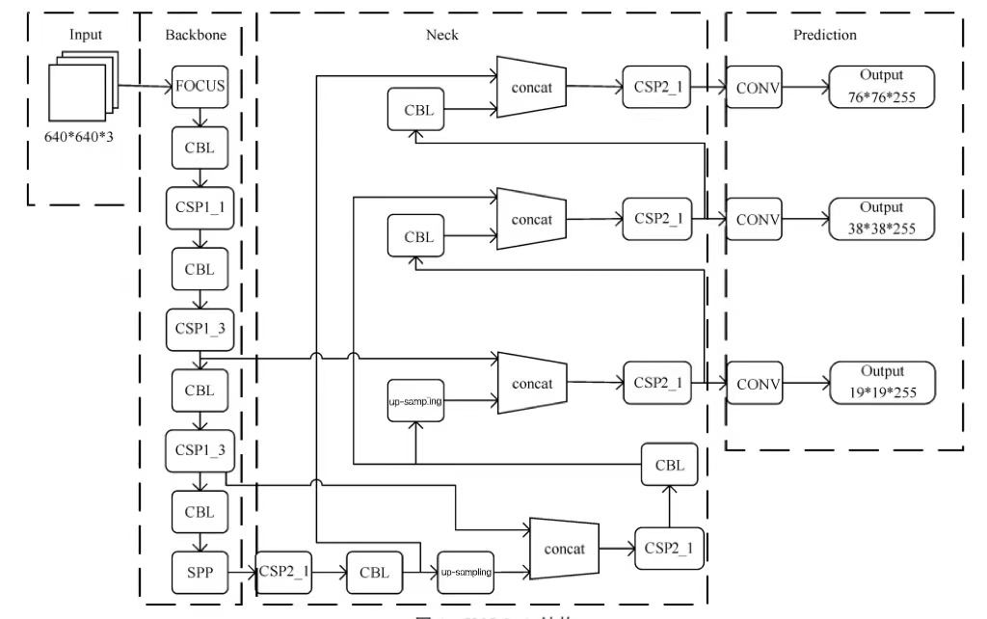
Figure 1 The YOLOv5s Structure
The network structure of YOLOv5s is divided into four parts: input, Backbone, Neck, and prediction layer (Prediction), each of which some new technologies are applied.The input end adopts mosaic data enhancement and adaptive anchor box calculation, which not only enriches the diversity of data, but also further improves the detection speed. Focus structure and csp1 are used in backbone network_ X structure, where X represents the residual components used in CSP structure, and each residual component uses two CBL (conv + BN + leakyrelu) structures. The neck part of the network adopts the same FPN + pan structure as yolov4, and uses csp2_ X structure to strengthen network feature fusion. Yolov5s runs directly on the edge computing platform, and its detection speed is only 4fps. Therefore, CG Yolo lightweight algorithm is proposed in this paper.
3 CG-yolo lightweight object detection algorithm
Due to the complex structure of CSP1_X in bottleneck, this paper first replaces it with the simple structure and small calculation of Ghostbottleneck 207 Volume 50 module.
3.1 Lightweight module Ghostbottleneck
Literature [6] found that the output feature maps of convolutional layers usually contain many redundancies and some of them may be similar to each other, thus proposing a new Ghost module that reduces the computation by obtaining similar features in the feature map through simple filtering and linear transformation.
The Ghostbottleneck consists of two stacked Ghost modules.The first Ghost module was used as an extension layer, increasing the number of channels.The second Ghost module reduces the number of channels, to match the number of shortcut channels.Then, shortcut is used to connect the input and output of these two Ghost modules.The second Ghost module does not use ReLU, while the other layers apply batch normalization (BN) and ReLU activation functions after each layer.The structure of stride=2 is between two Ghost module s, connected by a deep convolution of stride=2 (DWConv).The Ghostbottleneck structure is shown in Figure 2.
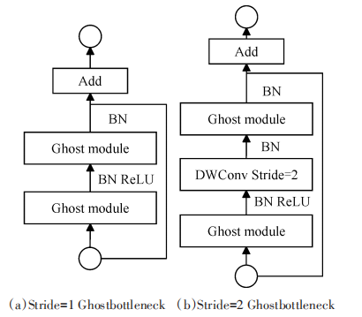
Figure 2. Ghostbottleneck structure diagram
In this paper, stride=1 Ghostbottleneck module is used to replace the more complex CSP1_X module in the original network to reduce the network operation amount and improve the detection speed.To ensure that the mAP index does not fall seriously, the attention mechanism CoordAttention needs to be added to the Ghostbottleneck.
3.2 Attention mechanism, CoordAttention
Literature [20] proposes a novel attention mechanism designed specifically for lightweight networks, called CoordAttention, or CA.To enable the lightweight network to have attention over larger regions while reducing computational overhead, the attention mechanism beds location information in the channel attention.The implementation process of this method is divided into two steps: coordinate information embedding (coordinate information embedding) and coordinate attention generation (coordinate attention generation). The specific structure of CA attention mechanism is shown in Figure 3.
The CA module decomposes the global pooling into two one-dimensional feature encoding operations, enabling feature aggregation along two spatial directions.This allows remote dependencies to be captured in one spatial direction, while preserving exact positional information along the other spatial direction.Specifically, for input X, each channel is encoded along the horizontal and vertical coordinate directions using the size (H, 1) and (1, W) pooling cores.The resulting feature maps were then encoded as a pair of orientation-aware and location-sensitive attention map, respectively, and applied to the input feature maps to enhance the representation of the object of interest.The operation that embed the coordinate information corresponds to two parts X AvgPool and Y AvgPool in the graph.When designing the coordinate attention generation operation, the two feature maps generated by the first cascade module are then transformed using a shared 11 convolution to generate the intermediate feature map.Next, f is cut into two separate tensors along the spatial dimension, and two 11 convolutional Fh and Fw are used to transform the feature graph to the same number of channels and input X.The final output of the CA module can be described in the following equation.
At this point, the CA module completes both horizontal and vertical direction attention, and it is also a kind of channel attention.The attention mechanism is better than the traditional SE Attention, improving the accuracy and flexible lightweight under the premise of ensuring the number of parameters.The Ghostbottleneck module is too simple, which makes the feature extraction insufficient. Therefore, the CA attention mechanism is selected to be inserted into the Ghostbottleneck module to improve the detection accuracy of the network.
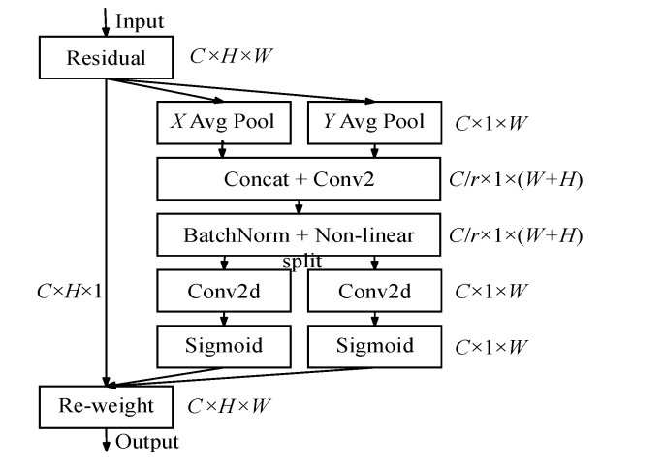
Figure 3. CoordAttention structure diagram
3.3CG-Yolo
The YOLOv5s backbone network has Focus modules for slicing the images, which aims to reduce the computation and replace it with ordinary downsampling.The floating-point operation number FLOPs is introduced here to compare the two modules.FLOPs is often used to measure the complexity of the model in algorithms, and FLOPs are inversely proportional to the running speed of the algorithm.Usually, only the number of multiplication operations is considered, and only the calculation amount of parameter layers such as Conv and FC is considered, and BN and activation functions are generally ignored.The calculation method is the feature map of the current layer filter output,The specific formula is as follows.
Ordinary down sampling is to take a 640 × six hundred and forty × 3 picture input 3 × In the convolution of 3,Step size is 2, output channel 64, after the subsampling of 32032064 feature diagram, then the calculation amount of ordinary convolution subsampling theory is 88473600. Focus performed the slice operation, and changed the original three input channels to 12 input channels, while other parameters are the same as Conv. It can be seen that the calculation amount of Focus is four times that of ordinary convolution, but there is no information loss when downsampling.To reduce the computation, we replaced the original Focus functional module with the ordinary Conv convolutional module.
Due to the structural complexity of the YOLOv5 networks, the large redundancy results in a slower detection speed.In order to improve the detection speed of networks with constant detection performance, a CG (CA + Ghostbottleneck) module is proposed to lightweight the YOLOv5 network.The CG module not only realizes the extraction of the redundant feature map in the YOLOv5 network, but also reflects the importance of the feature channel. The structure of the CG module is shown in Figure 4.
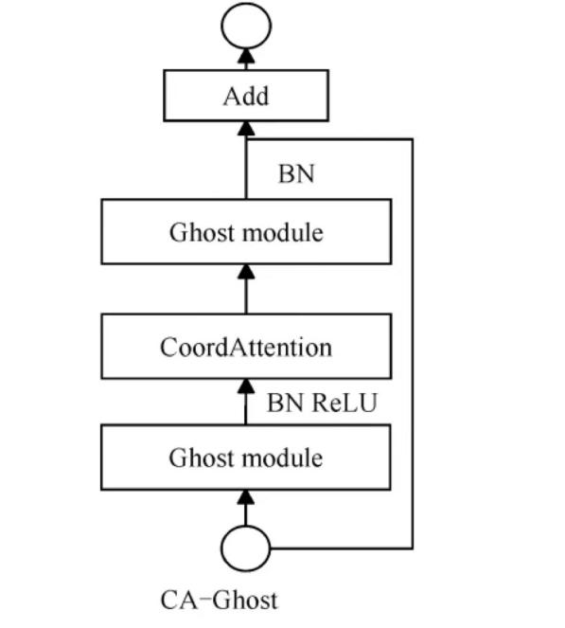
Figure 4. C G module structure diagram
This research proposes that the CA attention mechanism is integrated into the Ghostbottleneck module of stride to 1, which ensures the recall and accuracy rate while reducing the operation amount.After the first Ghost convolution operation, the Ghost convolutional expression capability needs to normalize the input to the BN layer, followed by the ReLU activation function.The CA attention mechanism is added after the ReLU activation function, which solves the effect of the offset and increase of the input data, and the invariance of the CA module on the input and output channel can continue with the second Ghost convolution operation thereafter.Replace the new CG module with the CSP1_X module in the original network Bottleneck.Thus, for the complete improvement of the YOLOv5s, the modified YOLOv5 network was named CG-yolo.
- Build an edge computing platform
The existing transmission channel pyrotechnic detection methods mainly capture pictures from the pictures captured by the camera, then conduct long-distance transmission through the network cable, and finally use the high-performance graphical server for detection.The high-performance graphics server required by this method is expensive, and the delay of network transmission efficiency makes the detection not real-time.Therefore, this paper proposes a line hidden danger detection method based on the edge computing platform, which can realize the delay-free detection at the monitoring point, and then pass the hidden danger information to the host machine.
  - Edge calculation
Edge computing refers to the use of data source measurement, cheap and computing, storage and other capabilities of the platform, nearby services.As far as pyrotechnics detection is concerned, terminal computing needs to transfer a large number of pictures to high-performance servers through the network, and then use deep convolutional neural network for detection, which has the short board of high running cost and insufficient graphics card utilization.Edge computing uses the computing platform to directly detect multiple nearby monitoring points, and finally only transmit the test results back to the terminal or network platform.
  - Edge computing platform Jetson Nano
In this research, we use the CG-yolo algorithm to train the pyrotechnic samples, and then the resulting model is deployed on the Jetson Nano platform provided by NVIDIA Company to verify the engineering utility of the algorithm.To achieve faster detection, TensorRT developed by NVIDIA.However, since the model obtained after the training of the CG-yolo algorithm is a pt format file, the model transformation is required.First, the pt was changed to wts format, the model was visualized, the model integrity was verified, and the C + + version of YOLOv5 was changed according to the visualized structure. Finally, the wts file was converted to a engine file, from which the model transformation was completed and deployed.
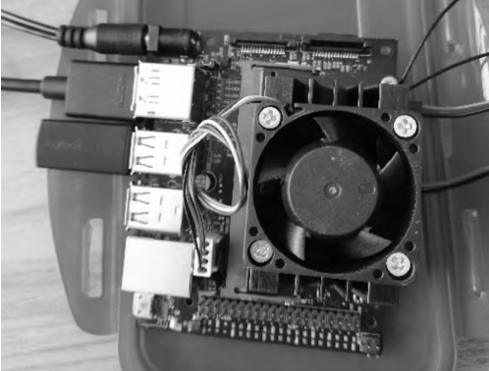
Figure 5. Edge platform Jetson Nano
5 Test analysis
In order to verify the effective 209 Volume 50 of the CG-yolo-based fireworks detection algorithm, this experiment was carried out under the Pytorch deep learning framework. The training process used a high-performance server, whose CPU is Intel (R) Xeon (R) Gold 5118, both graphics cards are GTX2080ti, and the video memory of a single graphics card is 12GB.The edge computing platform is Jetson Nano 4GB, 64-bit quad-core ARM A57 for CPU and 128-core NVIDIA Maxwell for GPU.
5.1 Dataset preparation
To ensure the applicability of the algorithm, the pyrotechnic data set used in this paper is mainly provided by the State Grid Nanjing Branch.The data set was first expanded by the mirror method, and then the annotation software labelImg was used to label the smoke and the wildfire separately. The annotation process is shown in Figure 6.
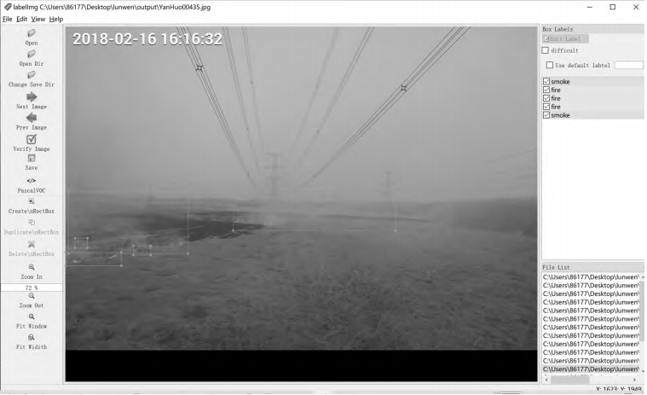
Figure 6 The labelImg annotation example diagram
When annotation, an xml file is generated to convert the xml file to a x l file with picture information txt and saved to the same folder as the image.In this paper, the training set, verification set and test set are randomly generated in the ratio of 8:1 ∶ 1:1, with a total of 1608 pictures, including 401 mountain fire pictures and 1207 smoke pictures.
5.2 Evaluation indicators
In order to compare the differences between the selected methods and other deep convolution detection and identification algorithms, this paper mainly uses four indexes: recall Recall, precision Precision, mAP and FPS.The FPS represents the number of identified frames per second.The mAP is the mean of all categories.The formula of Recall and Precision is calculated as follows:
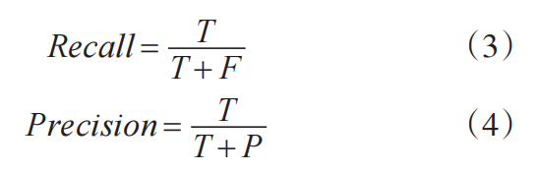
T means that it detects the target hidden danger as the corresponding target.F indicates that the target hidden danger is detected as a non-corresponding target.P indicates that the detected target is no hidden target.By calculating the recall and accuracy of the transmission channel hazard, the accuracy-accuracy (PR) curve is drawn, and mAP is the area under the curve.In practical engineering applications, in order to prevent accidents, regulators pay more attention to recall and detection of speed FPS.
5.3 Experimental results
This research mainly improves the YOLOv5s algorithm, get CG-yolo algorithm, and finally run on the Jetson Nano platform to realize the detection and identification of wildfire smoke.To ensure the reliability of the experiment, all our training tests were conducted on the same device, and the training process was consistent.During training, using YOLOv5's automatic clustering method, the number of iterations of the whole training set was set to 400 rounds, the number of single input images batch-size to 32, and the input image size img-size was uniformly scaled to 640640. The image size entered during the test was set to 640 and the confidence IOU was 0.6. The training set was trained using the CG-yolo algorithm on the GPU for about 7h to obtain the final pyrotechnic detection model weights.
In the comparison experiment, this paper mainly analyzes the two aspects of the detection data and the actual test results, supplemented by the real-time map on the accuracy rate of the two networks.
On the one hand, under the same computing environment, the traditional lightweight deep learning algorithm YOLOv4-Tiny, the traditional single-stage algorithm SSD, and the original network YOLOv5s are compared and analyzed with this paper.Through comparative experiments, the present algorithm is better than the other three algorithms.Compared with the original network, the mAP only decreased by 0.2%, the detection speed of the algorithm increased by 9.5%, and the recall rate improved by 1.8%. CG-yolo is more suitable for practical engineering applications.Moreover, by comparison with YOLOv4-tiny, the present algorithm is slightly slower than tiny, but the mAP is far better than ti ny.The CG-yolo indicators outperformed the SSD algorithm.It can be seen that the algorithm and architecture proposed in this paper have more advantages in practical engineering applications.The pairs of the three algorithms are shown in Table 3.
Table 3 Comparison of several deep learning networks
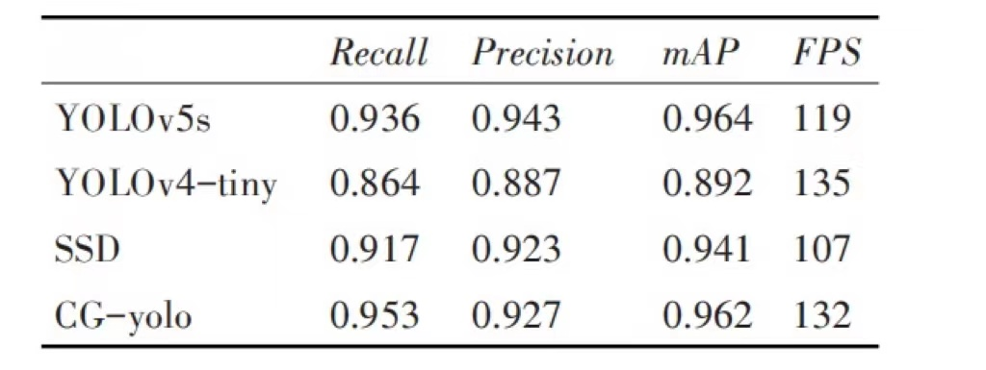
On the other hand, to verify the effectiveness of the proposed algorithm in practical scenarios, the actual effect diagram is shown in Figure 7.
The first column is the test results of CG-yolo, and the second column is the test results of YOLOv5s. By comparing the two randomly selected test results, it is clear that under the premise of speed improvement, the two algorithms have the same recognition effect on flame and smoke.In order to illustrate the general trend that the recall and precision of CG Yolo is similar to that of the original network, this paper analyzes Fig. 8 and Fig. 9.
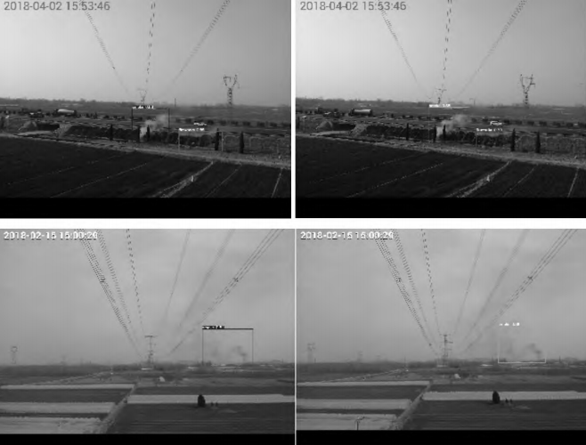
Figure 7 CG-yolo and YOLOv5 test results
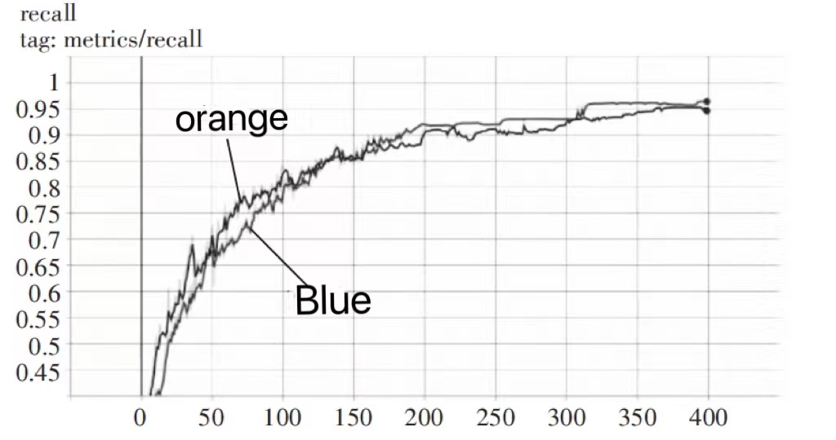
Figure 8. recall
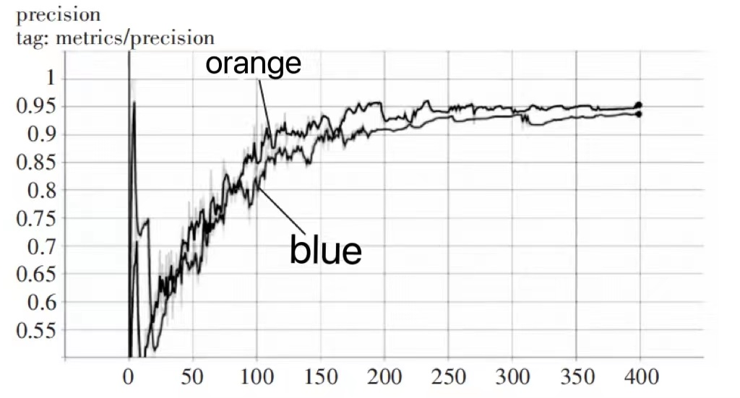
Figure 9. precision
Figures 8 and 9 are the models after each round of training to test the test set, calculate the recall accuracy rate, and draw the final curve diagram.The blue line is the modified version of CG-yolo, the orange line is the YOLOv5s network, the abscissa is the training times, and the ordinate is the decimal form of recall and accuracy.From the figure, we can analyze that at the end of round 400, CG-yolo increased by 1.8% compared with the original network and recall decreased by 1.7%.From the growth trend from the overall graph, we can find that the recall is higher than the original network, while the accuracy is slightly lower.
In this paper, a convolutional neural network capable of real-time detection is deployed on the edge computing platform, so, the transformed model is put into the edge computing device nano and tested using the test set.It is found that in the edge devices, our algorithm still performs very well, the running speed reaches 13fps, and the detection effect is the same as on the server side, meeting the requirements of fireworks detection deployment in the edge computing platform.The operating effect of the edge equipment is shown in Figure 10.
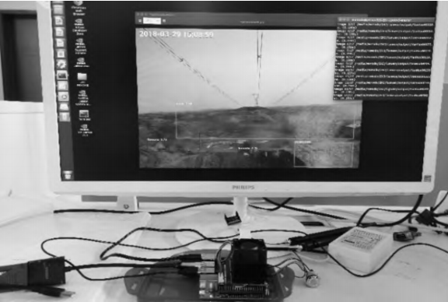
Figure 10 Detection effect in Jetson Nano
6 Conclusion
This paper presents a compression algorithm of YOLO target recognition model based on CA-Ghostbottleneck module, CG-YOLO, which cannot be deployed on the edge computing platform.The original CSP1_X module was replaced with the efficient lightweight module Ghostbot tleneck, and the CA attention mechanism was added to the Ghostbot tleneck module, which improved the detection speed of the algorithm on the basis of ensuring accuracy.In this paper, the algorithm improves the detection speed by 9.5% compared to YOLOv5s, but this paper only considers the use of more lightweight modules, but does not consider the effective methods of mitigation models such as pruning, quantification and distillation.The experimental results show that the method proposed in this paper effectively optimizes the YOLOv5s structure. Compared with the smaller volume and faster prediction speed of the traditional YOLOv5 model, it is very friendly to the embedded platform with low computing power and low memory. It is successfully deployed on the edge computing device Jetson Nano, obtaining a detection speed of 13fps.In addition, the proposed scheme in this paper can not only efficiently compress and accelerate the YOLOv5 model, but also other convolutional neural network models can replace the operational modules according to this scheme, so as to provide a method reference for other deep learning algorithms deployed on resource-limited embedded platforms.

Reference
- ZHANG Dexin，SHI Yukun. A firework recognition algo⁃ rithm based on SSD framework：CN109165575A［P］. 2019-01-08.
- CHEN Jinpeng，SUN Hao，DONG Hui，et al. Fireworks intelligent recognition algorithm based on convolutional211neural network［J］. Journal of Fuzhou University（Natural Science Edition），2021：1-7.
- Andrew G. Howard，Menglong Zhu，Bo Chen，et al. Mo⁃ bileNets：Efficient Convolutional Neural Networks for Mo⁃ bile Vision Applications［J］. Computer Vision and Pattern Recognition，2017.
- A. Howard，et al. Searching for MobileNetV3［C］//IEEE In⁃ ternational Conference on Computer Vision （ICCV）， 2019：1314-1324.
- IANDOLA F N，HAN S，MOSKEWICZ M W，et al. SqueezeNet：AlexNet-level accuracy with 50x fewer pa⁃ rameters and <0.5MB model size［J］. ICLR 2017 Confer⁃ ence Official Review，2016，11（1）：112-120.
- K. Han，Y. Wang，Q. Tian，et al. GhostNet：More Fea⁃ tures From Cheap Operations［C］// IEEE Conference on Computer Vision and Pattern Recognition（CVPR），2020： 1577-1586.
- Li LAN, Xi Shushu, Zhang Caibao, et al. Workpiece surface defect recognition algorithm based on an improved SSD model [J]. Computer Engineering and Science, 2020,42 (09): 1608-1615.
- CAO Yuanjie，GAO Yuxiang. Lightweight beverage recog⁃ nition network based on GhostNet residual structure ［J］. Computer Engineering，2021，1-7.
- FU Huitong，WANG Peng，LI Xiaoyan，et al. Lightweight network model for mobile target recognition［J］. Journal of Xi'an Jiaotong University，2021：1-9.
- ZHU L L，GENG X，LI Z，et al. Improving YOLOv5 with Attention Mechanism for Detecting Boulders from Plane⁃ tary Images ［J］. RemoteSensing，2021，13 （18） ： 152-161.
- HUANG Wenbin， CHEN Renwen， YUAN Tingting. Compression scheme of UAV target detection model based on improved yolov3-spp［J］. Computer Engineer⁃ ing and Application，2021：1-12.
- Redmon J，Divvala S，Girshick R，et al. You Only Look Once：Unified，Real-Time Object Detection［C］// IEEE Conference on Computer Vision and Pattern Recognition， 2016：6517-6525.
- Redmon J，Farhadi A. YOL09000：Better，Faster，Stron⁃ ger［C］//IEEE Conference on Computer Vision and Pat⁃ tern Recognition，2017：6517-6525.
- Redmon J，Farhadi A. Yolov3：An incremental improve⁃ ment［C］//IEEE Conference on Computer Vision and Pat⁃ tern Recognition，2018.
- Bochkovskiy A，Wang C Y，Liao H Y M. YOLOv4：Op⁃ timal Speed and Accuracy of Object Detection［C］//IEEE conference on Computer Vision and Pattern Recognition， 2020.
- Liu W，Anguelov D，Erhan D，et a1. SSD：Single shot multibox detector［C］//Proceedings of European Confer⁃ ence on Commuter Vision，2016：21-37.
- WANG Li，HE Mutian，XU Shuo，et al. Garbage classi⁃ fication and detection based on yolov5s network ［J］. Packaging Engineering，2021，42（08）：50-56.
- TAN Shilei，BIE Xiongbo，LU Gonglin，et al. Real time detection of human mask wearing based on yolov5 net⁃ work model ［J］. Laser Magazine，2021，42 （02）： 147-150.
- XIE Haoyuan，HUANG Qunxing，LIN Xiaoqing，et al. Prediction of garbage calorific value based on image deep learning ［J］. Acta Chemica Sinica，2021，72 （05）：2773-2782.
- Q. Hou，D. Zhou，J. Feng. Coordinate Attention for Effi⁃ cient Mobile Network Design［EB/OL］. 2021.https：//arx⁃ iv.org/abs/2103.02907.

APPLICATION FOR ETHICAL APPROVAL

In order for research to result in benefit and minimise risk of harm, it must be conducted ethically. A researcher may not be covered by the University’s insurance if ethical approval has not been obtained prior to commencement.

The University follows the OECD Frascati manual definition of research activity: “creative work undertaken on a systematic basis in order to increase the stock of knowledge, including knowledge of man, culture and society, and the use of this stock of knowledge to devise new applications”. As such this covers activities undertaken by members of staff, postgraduate research students, and both taught postgraduate and undergraduate students working on dissertations/projects.

The individual undertaking the research activity is known as the “principal researcher”.

Ethical approval is not required for routine audits, performance reviews, quality assurance studies, testing within normal educational requirements, and literary or artistic criticism.

Please read the notes for guidance before completing ALL sections of the form.

This form must be completed and approved prior to undertaking any research activity. Please see Checklist for details of process for different categories of application.

Delete the Guidance Notes at the end of the form BEFORE submitting your application

SECTION A: About You (Principal Researcher)
1 | Full Name: |  | Xu Yingjian
2 | Tick all boxes which apply: |  | Member of staff: | ☐ | Honorary research fellow: | ☐
3 | Undergraduate Student | ☐ | Taught Postgraduate Student | ☐ | Postgraduate Research Student | ☒

4 | Institute/Academic Discipline/Centre:
5 | Campus: | University of Wales Trinity Saint David
6 | E-mail address: | 2106319@student.uwtsd.ac.uk
7 | Contact Telephone Number: | 17631792217
 | For students:
8 | Student Number: | 2106319
9 | Programme of Study: | Research on pyrotechnic detection based on CG-yolo
10 | Director of Studies/Supervisor: | Kapilan Radhakrishnan

SECTION B: Approval for Research Activity
1 | Has the research activity received approval in principle?  (please check the Guidance Notes as to the appropriate approval process for different levels of research by different categories of individual) |  | YES | ☒ | NO | ☐
 |  |  |  |  | Date
2 | If Yes, please indicate source of approval (and date where known): Approval in principle must be obtained from the relevant source prior to seeking ethical approval | Research Degrees Committee |  | ☒ | 2022.3.28
3 |  | Institute Research Committee |  | ☒ | 2022.3.28
4 |  | Other (write in) |  | ☒ | 2022.3.28

SECTION C: Internal and External Ethical Guidance Materials
 | Please list the core ethical guidance documents that have been referred to during the completion of this form (including any discipline-specific codes of research ethics, and also any specific ethical guidance relating to the proposed methodology). Please tick to confirm that your research proposal adheres to these codes and guidelines.
1 | UWTSD Research Ethics & Integrity Code of Practice | ☒
2 | UWTSD Research Data Management Policy | ☒
3 |  | ☐

SECTION D: External Collaborative Research Activity
1 | Does the research activity involve collaborators outside of the University? |  | YES | ☐ | NO | ☒
2 | If Yes, please provide the name of the external organisation and name and contact details for the main contact person and confirmation this person has consented to their personal data being shared.as part of this collaboration.
3 | Institution
4 | Contact person name
5 | Contact person e-mail address
6 | Has this individual consented to sharing their details on this form? |  | YES | ☐ | NO |  |  | ☐
7 | Are you in receipt of a KESS scholarship? |  | YES | ☐ | NO |  |  | ☐
8 | Is your research externally funded |  | YES | ☐ | NO |  |  | ☐
9 | Are you specifically employed to undertake this research in either a paid or voluntary capacity? | Voluntary | YES | ☐ | NO |  | ☐
10 |  | Employed | YES | ☐ | NO |  | ☐
11 | Is the research being undertaken within an existing UWTSD Athrofa Professional Learning Partnership (APLP) | If YES then the permission question below does not need to be answered. | YES | ☐ | NO |  |  | ☐
12 | Permission to undertake the research has been provided by the partner organisation | (If YES attach copy)  If NO the application cannot continue | YES | ☐ | NO |  |  | ☐

Where research activity is carried out in collaboration with an external organisation
13 | Does this organisation have its own ethics approval system? | YES | ☐ | NO | ☒
14 | If Yes, please attach a copy of any final approval (or interim approval) from the organisation

SECTION E: Details of Research Activity
1 | Indicative title: | Research on pyrotechnic detection based on CG-yolo
2 | Proposed start date: | 2022.1.1 | Proposed end date: | 2022.3.28
3 | Introduction to the Research (maximum 300 words)  Ensure that you write for a Non-Specialist Audience when outlining your response to the three points below:  - Purpose of Research Activity  - Proposed Research Question  - Aims of Research Activity  - Objectives of Research Activity  Demonstrate, briefly, how Existing Research has informed the proposed activity and explain  - What the research activity will add to the body of knowledge  - How it addresses an area of importance.
4 | Purpose of Research Activity  (this box should expand as you type)
5 | Research Question  (this box should expand as you type)
6 | Aims of Research Activity  (this box should expand as you type)
7 | Objectives of Research Activity  (this box should expand as you type)
8 | Proposed methods (maximum 600 words)  Provide a brief summary of all the methods that may be used in the research activity, making it clear what specific techniques may be used. If methods other than those listed in this section are deemed appropriate later, additional ethical approval for those methods will be needed.
9 | (this box should expand as you type)

10 | Location of research activity  Identify all locations where research activity will take place.
11 | (this box should expand as you type)
12 | Research activity outside of the UK  If research activity will take place overseas, you are responsible for ensuring that local ethical considerations are complied with and that the relevant permissions are sought. Specify any local guidelines (e.g. from local professional associations/learned societies/universities) that exist and whether these involve any ethical stipulations beyond those usual in the UK (provide details of any licenses or permissions required). Also specify whether there are any specific ethical issues raised by the local context in which the research activity is taking place, for example, particular cultural and/or legal sensitivities or vulnerabilities of participants.
13 | (this box should expand as you type)

14 | Use of documentation not in the public domain: Are any documents NOT publicly available? | NO | ☐
14 |  | YES | ☒
15 | If Yes, please provide details here of how you will gain access to specific documentation that is not in the public domain and that this is in accordance with prevailing data protection law of the country in question and England and Wales.  (this box should expand as you type)

SECTION F: Scope of Research Activity
1 | Will the research activity include: | YES | NO
2 | Use of a questionnaire or similar research instrument? | ☐ | ☒
3 | Use of interviews? | ☐ | ☒
4 | Use of diaries? | ☐ | ☒
5 | Participant observation with their knowledge? | ☐ | ☒
6 | Participant observation without their knowledge? | ☐ | ☒
7 | Use of video or audio recording? | ☐ | ☒
8 | Access to personal or confidential information without the participants’ specific consent? | ☐ | ☒
9 | Administration of any questions, test stimuli, presentation that may be experienced as physically, mentally or emotionally harmful / offensive? | ☐ | ☒
10 | Performance of any acts which may cause embarrassment or affect self-esteem? | ☐ | ☒
11 | Investigation of participants involved in illegal activities? | ☐ | ☒
12 | Use of procedures that involve deception? | ☐ | ☒
13 | Administration of any substance, agent or placebo? | ☐ | ☒
14 | Working with live vertebrate animals? | ☐ | ☒
15 | Other primary data collection methods, please explain in this box  For example, ‘focus groups’. Please indicate the type of data collection method(s) in this box and tick the accompany box. | ☒ | ☐
16 | Details of any other primary data collection method:  (this box should expand as you type) | ☒ | ☐
If NO to every question, then the research activity is (ethically) low risk and may be exempt from some of the following sections (please refer to Guidance Notes).

If YES to any question, then no research activity should be undertaken until full ethical approval has been obtained.

SECTION G: Intended Participants
1 | Who are the intended participants: | YES | NO
2 | Students or staff at the University? | ☒ | ☐
3 | Adults (over the age of 18 and competent to give consent)? | ☒ | ☐
4 | Vulnerable adults? | ☒ | ☐
5 | Children and Young People under the age of 18? (Consent from Parent, Carer or Guardian will be required) | ☒ | ☐
6 | Prisoners? | ☒ | ☐
7 | Young offenders? | ☒ | ☐
8 | Those who could be considered to have a particularly dependent relationship with the investigator or a gatekeeper? | ☒ | ☐
9 | People engaged in illegal activities? | ☒ | ☐
10 | Others (please identify specifically any group who may be unable to give consent) please indicate here and tick the appropriate box. | ☐ | ☐
11 | Other – please indicate here:  (this box should expand as you type) | ☐ | ☐

12 | Participant numbers and source  Provide an estimate of the expected number of participants. How will you identify participants and how will they be recruited?
13 | How many participants are expected? | (this box should expand as you type)
14 | Who will the participants be? | (this box should expand as you type)
15 | How will you identify the participants? | (this box should expand as you type)

16 | Information for participants: | YES | NO | N/A
17 | Will you describe the main research procedures to participants in advance, so that they are informed about what to expect? | ☒ | ☐ | ☐
18 | Will you tell participants that their participation is voluntary? | ☒ | ☐ | ☐
19 | Will you obtain written consent for participation? | ☒ | ☐ | ☐
20 | Will you explain to participants that refusal to participate in the research will not affect their treatment or education (if relevant)? | ☒ | ☐ | ☐
21 | If the research is observational, will you ask participants for their consent to being observed? | ☒ | ☐ | ☐
22 | Will you tell participants that they may withdraw from the research at any time and for any reason? | ☒ | ☐ | ☐
23 | With questionnaires, will you give participants the option of omitting questions they do not want to answer? | ☒ | ☐ | ☐
24 | Will you tell participants that their data will be treated with full confidentiality and that, if published, it will not be identifiable as theirs? | ☒ | ☐ | ☐
25 | Will you debrief participants at the end of their participation, in a way appropriate to the type of research undertaken? | ☒ | ☐ | ☐
26 | If NO to any of above questions, please give an explanation
27 | (this box should expand as you type)

28 | Information for participants: | YES | NO | N/A
29 | Will participants be paid? | ☒ | ☐ | ☐
30 | Is specialist electrical or other equipment to be used with participants? | ☒ | ☐ | ☐
31 | Are there any financial or other interests to the investigator or University arising from this study? | ☒ | ☐ | ☐
32 | Will the research activity involve deliberately misleading participants in any way, or the partial or full concealment of the specific study aims? | ☒ | ☐ | ☐
33 | If YES to any question, please provide full details
34 | (this box should expand as you type)

SECTION H: Anticipated Risks
1 | Outline any anticipated risks that may adversely affect any of the participants, the researchers and/or the University, and the steps that will be taken to address them.  If you have completed a full risk assessment (for example as required by a laboratory, or external research collaborator) you may append that to this form.
2 | Full risk assessment completed and appended? |  | Yes | ☐
2 |  |  | No | ☒
3 | Risks to participants  For example: emotional distress, financial disclosure, physical harm, transfer of personal data, sensitive organisational information
4 | Risk to Participant:  (this box should expand as you type) | How will you mitigate the Risk to Participant  (this box should expand as you type)
5 | If research activity may include sensitive, embarrassing or upsetting topics (e.g. sexual activity, drug use) or issues likely to disclose information requiring further action (e.g. criminal activity), give details of the procedures to deal with these issues, including any support/advice (e.g. helpline numbers) to be offered to participants. Note that where applicable, consent procedures should make it clear that if something potentially or actually illegal is discovered in the course of a project, it may need to be disclosed to the proper authorities
 | (this box should expand as you type)
6 | Risks to investigator  For example: personal safety, physical harm, emotional distress, risk of accusation of harm/impropriety, conflict of interest
 | Risk to Investigator:  (this box should expand as you type) | How will you mitigate the Risk to Investigator:  (this box should expand as you type)
7 | University/institutional risks  For example: adverse publicity, financial loss, data protection
 | Risk to University:  (this box should expand as you type) | How will you mitigate the Risk to University:  (this box should expand as you type)

8 | Disclosure and Barring Service
9 | If the research activity involves children or vulnerable adults, a Disclosure and Barring Service (DBS) certificate must be obtained before any contact with such participants. | YES | NO | N/A
10 | Does your research require you to hold a current DBS Certificate? | ☐ | ☒ | ☐

SECTION I: Feedback, Consent and Confidentiality
1 | Feedback  What de-briefing and feedback will be provided to participants, how will this be done and when?
 | (this box should expand as you type)
2 | Informed consent  Describe the arrangements to inform potential participants, before providing consent, of what is involved in participating. Describe the arrangements for participants to provide full consent before data collection begins. If gaining consent in this way is inappropriate, explain how consent will be obtained and recorded in accordance with prevailing data protection legislation.
 | (this box should expand as you type)
3 | Confidentiality / Anonymity  Set out how anonymity of participants and confidentiality will be ensured in any outputs. If anonymity is not being offered, explain why this is the case.
 | (this box should expand as you type)

SECTION J: Data Protection and Storage
In completing this section refer to the University’s Research Data Management Policy and the extensive resources on the University’s Research Data Management web pages (http://uwtsd.ac.uk/library/research-data-management/).
1 | Does the research activity involve personal data (as defined by the General Data Protection Regulation 2016 “GDPR” and the Data Protection Act 2018 “DPA”)? | YES | NO
 | “Personal data” means any information relating to an identified or identifiable natural person (‘data subject’). An identifiable natural person is one who can be identified, directly or indirectly, in particular by reference to an identifier such as a name, an identification number, location data, an online identifier or to one or more factors specific to the physical, physiological, genetic, mental, economic, cultural or social identity of that natural person. | ☐ | ☐
2 | If YES, provide a description of the data and explain why this data needs to be collected:
 | (this box should expand as you type)
3 | Does it involve special category data (as defined by the GDPR)? | YES | NO
 | “Special category data” means sensitive personal data consisting of information as to the data subjects’ –  (a) racial or ethnic origin,  (b) political opinions,  (c ) religious beliefs or other beliefs of a similar nature,  (d) membership of a trade union (within the meaning of the Trade Union and Labour Relations (Consolidation) Act 1992),  (e) physical or mental health or condition,  (f) sexual life,  (g) genetics,  (h) biometric data (as used for ID purposes), | ☐ | ☐
4 | If YES, provide a description of the special category data and explain why this data needs to be collected:
 | (this box should expand as you type)

5 | Will the research activity involve storing personal data and/or special category data on one of the following: | YES | NO
6 | Manual files (i.e. in paper form)? | ☐ | ☒
7 | University computers? | ☒ | ☐
8 | Private company computers? | ☒ | ☐
9 | Home or other personal computers? | ☐ | ☒
10 | Laptop computers/ CDs/ Portable disk-drives/ memory sticks? | ☐ | ☒
11 | “Cloud” storage or websites? | ☐ | ☒
12 | Other – specify: | ☐ | ☒
13 | For all stored data, explain the measures in place to ensure the security of the data collected, data confidentiality, including details of password protection, encryption, anonymisation and pseudonymisation:
 | (this box should expand as you type)
14 | All Data Storage
15 | Will the research activity involve any of the following activities: | YES | NO
16 | Electronic transfer of data in any form? | ☐ | ☒
17 | Sharing of data with others at the University? | ☐ | ☒
18 | Sharing of data with other organisations? | ☐ | ☒
19 | Export of data outside the European Union or importing of data from outside the UK? | ☐ | ☒
20 | Use of personal addresses, postcodes, faxes, emails or telephone numbers? | ☐ | ☒
21 | Publication of data that might allow identification of individuals? | ☐ | ☒
22 | Use of data management system? | ☐ | ☒
23 | Data archiving? | ☐ | ☒
24 | If YES to any question, please provide full details, explaining how this will be conducted in accordance with the GDPR and DPA (and/or any international equivalent):
 | (this box should expand as you type)
25 | List all who will have access to the data generated by the research activity:
 | (this box should expand as you type)
26 | List who will have control of, and act as custodian(s) for, data generated by the research activity:
 | (this box should expand as you type)
27 | Give details of data storage arrangements, including security measures in place to protect the data, where data will be stored, how long for, and in what form. Will data be archived – if so how and if not why not.
 | (this box should expand as you type)
28 | Please indicate if your data will be stored in the UWTSD Research Data Repository (see https://researchdata.uwtsd.ac.uk/ ). If so please explain. (Most relevant to academic staff)
 | (this box should expand as you type)
29 | Confirm that you have read the UWTSD guidance on data management (see https://www.uwtsd.ac.uk/library/research-data-management/) | YES | ☒
29 |  | NO | ☐
30 | Confirm that you are aware that you need to keep all data until after your research has completed or the end of your funding | YES | ☒
30 |  | NO | ☐

SECTION K: Declaration
31 | The information which I have provided is correct and complete to the best of my knowledge. I have attempted to identify any risks and issues related to the research activity and acknowledge my obligations and the rights of the participants.  In submitting this application I hereby confirm that I undertake to ensure that the above named research activity will meet the University’s Research Ethics and Integrity Code of Practice which is published on the website: https://www.uwtsd.ac.uk/research/research-ethics/
 | Signature of applicant: |  | Date:

For STUDENT Submissions:
32 | Director of Studies/Supervisor: |  | Date:
33 | Signature: |  | Date:

For STAFF Submissions:
34 | Academic Director/ Assistant Dean: |  | Date:
35 | Signature: |  | Date:

Checklist: Please complete the checklist below to ensure that you have completed the form according to the guidelines and attached any required documentation:
☒ | I have read the guidance notes supplied before completing the form.
☒ | I have completed ALL RELEVANT sections of the form in full.
☒ | I confirm that the research activity has received approval in principle
☒ | I have attached a copy of final/interim approval from external organisation (where appropriate)
☒ | I have attached a full risk assessment (and have NOT completed Section H of this form) (where appropriate) ONLY TICK IF YOU HAVE ATTACHED A FULL RISK ASSESSMENT
☒ | I understand that it is my responsibility to ensure that the above named research activity will meet the University’s Research Ethics and Integrity Code of Practice.
☒ | I understand that before commencing data collection all documents aimed at respondents (including information sheets, consent forms, questionnaires, interview schedules etc.) must be confirmed by the DoS/Supervisor, module tutor or Academic Director.
☒ | I have deleted the guidance notes before submitting the PG2 for consideration

RESEARCH STUDENTS AND STAFF ONLY
All communications relating to this application during its processing must be in writing and emailed to pgresearch@uwtsd.ac.uk , with the title ‘Ethical Approval’ followed by your name.
You will be informed of the outcome of your claim by email; therefore it is important that you check your University and personal email accounts regularly.
STUDENTS ON UNDERGRADUATE OR TAUGHT MASTERS PROGRAMMES should submit this form (and receive the outcome) via systems explained to you by the supervisor/module leader.

