


Computer Forensics (CF)

Lab 8

Wales Institute of Science and Art
Applied Computing
I.Q Building, Room 205
Swansea
SA1 8EW

Lecturer: Assoc. Professor Carlene Campbell
Email: carlene.campbell@uwtsd.ac.uk
Website: https://www.knowledgewithprofit.com

Exercise 01: Extract Password Hashes from the Target System using pwdump
Lab Scenario
Smith, a forensic investigator, was working on a case wherein a disgruntled employee, Martin, has encrypted important data of the organization on his PC and left the organization. Now, to gather the crucial data that was kept in the suspect's system, Smith needs to crack the perpetrator’s account. In order to crack the password of the perpetrator’s account, Smith needs to first gather the LM and NTLM password hashes from the system and find the hash for James’ account.
As an expert forensic investigator, you must know how to gather the LM and NTLM password hashes from the system to crack the system passwords.
Lab Objectives
NTLM hash is used to verify the user's password in the Windows Operating System. NTLM hashes can be used to crack user passwords when combined with various other tools such as Mimikatz, John the Ripper, and Hashcat.
Overview of the Lab
This lab familiarizes you with the pwdump7 tool and helps you understand how to gather the LM/NTLM password hashes from the system.
Lab Tasks
Note: In this lab, we are considering that the footprint of the investigation is not a major issue
- Import the given OVA file in VirtualBox (LAB07-08.ova) and turn on the VM.
- Once the Windows Server logon screen loads, login with the following credentials:
Username: Administrator
Password: Str0ngPa$$w0rd
- In the Windows Server VM in your VirtualBox, open either Mozilla Firefox or Google Chrome and go to https://github.com/Seabreg/pwdump. Click on the Code button and select the Download ZIP option.
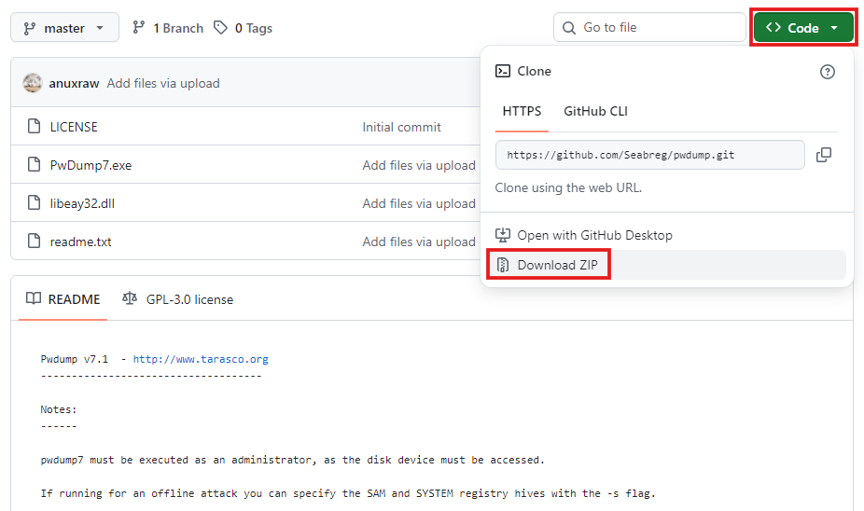
- In the Downloads folder, open the pwdump-master.zip file and copy the pwdump-master folder to the Desktop.
- In the Start menu of your Windows Server VM, type cmd and click on Run as Administrator to open Command Prompt with administrator privileges.
Note: If a User Account Control pop-up appears, click Yes.
- In the Command Prompt window, type cd C:\Users\Administrator\Desktop\pwdump-master to navigate to the pwdump-master folder on the Desktop.
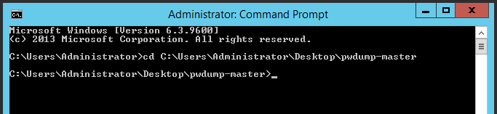
- Now, type PwDump.exe and press Enter to dump the Hashes of the user accounts on the Windows virtual machine in the Command Prompt window.
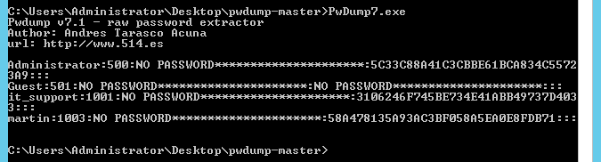
- The output format for pwdump is:
username : RID : LM_hash : NTLM_hash :::
In this example, the LM Hash is not stored as it is disabled for security reasons on modern Windows systems.
- Create a New Text Document on the Desktop named hashes.txt and copy the NTLM hashes of the users Administrator, it_support, and martin into the file, each on a new line. Save the file.
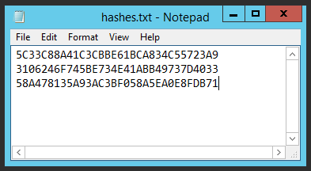
- As a forensic investigator, you can further use these hashes along with password cracking tools such as hashcat or mimikatz to recover the system passwords.
- Close all open windows.

Lab Analysis
Analyse and document the results of this lab exercise.
Exercise 02: Detect Steganography
Lab Scenario
Attackers occasionally attempt to deceive users and system security by hiding a malicious program within an apparently useful image or file. By doing this, they can avert security checks and lure victims into downloading and running malware, as well as prevent forensic identification.
As an expert forensic investigator, you must be able to detect and analyze steganography files.
Lab Objectives
Steganography is the process of hiding information or a file within another file. In other words, it is the process of disguising a harmful file as a safe file.
The objective of this lab is to help you analyze files hidden using steganography and find their impact on a system or network.
Overview of the Lab
This lab familiarizes you with tools such as StegSpy, Image Steganography, OpenStego, and DeepSound, and it helps you understand how to identify messages or files with hidden content using these tools.
Lab Tasks
Note: In this lab, we are considering that the footprint of the investigation is not a major issue.
- In the Windows Server VM, open either Mozilla Firefox or Google Chrome and go to Forensics tools. Open the Defeating Anti-forensics Technique folder and download the Steganography Detection Tools folder.
- In the Downloads folder, open the OneDrive_yyyy-mm-dd.zip file and copy the Steganography Detection Tools folder to the Desktop.
Part A - StegSpy
- Now go back to Forensics tools on the browser. Navigate to Evidence Files → Evidence Files → Image Files and download the suspicious file Model.png onto the Server.
- Navigate to Desktop → Steganography Detection Tools → StegSpy and double-click StegSpy2.1.exe to launch the tool.
Note: If an Open File - Security Warning pop-up appears, click Run.
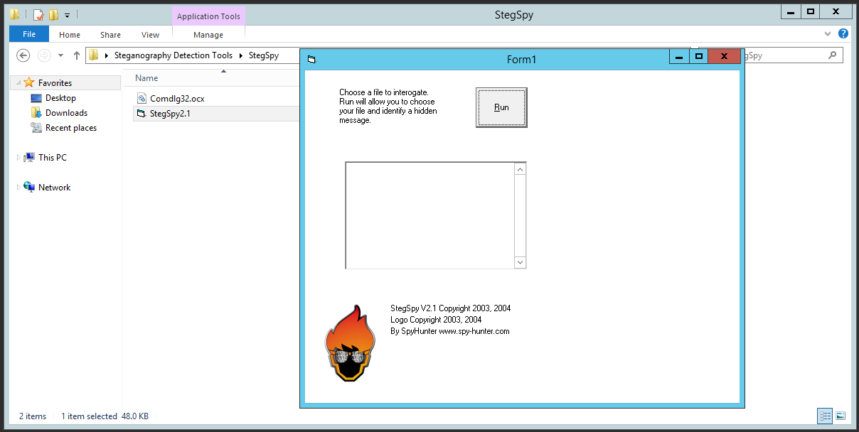
- Click the Run button from the tool’s main page to add the suspicious file.
- An Open window appears. Navigate to the location of the suspicious file. Select the file Model.png and click the Open button.
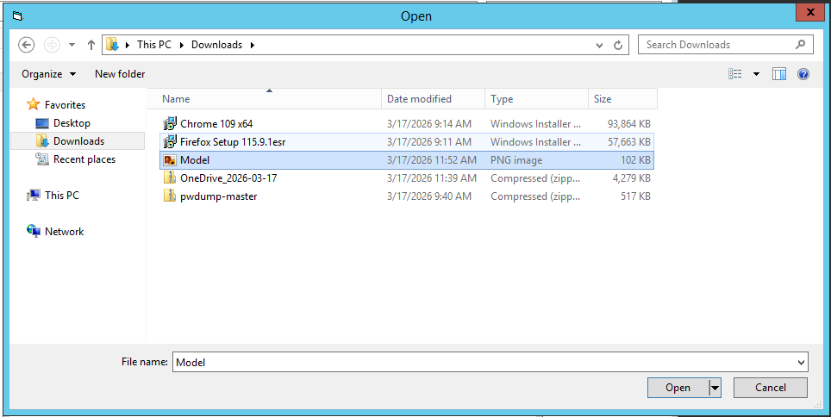
- The tool will scan the file and display the type of steganography technique used to hide another file within it.
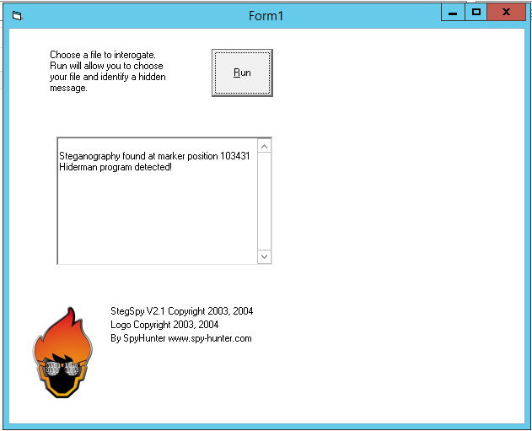
- Close all application windows.
Part B - OpenStego
- You shall now attempt to extract the hidden file from another suspicious image (Sample.png) using the OpenStego tool.
- Go back to Forensics tools on the browser. Navigate to Evidence Files → Evidence Files → Image Files and download the suspicious file Sample.png onto the Server.
- To install OpenStego, navigate to Desktop → Steganography Detection Tools → OpenStego and double-click the Setup-OpenStego-v0.8.6.exe file.
Note: If an Open File - Security Warning pop-up appears, click Run.
Note: In the Select Setup Install Mode window, click on Install for me only.
- The OpenStego setup wizard appears. Accept the license agreement and follow the wizard-driven installation steps to install the application.
- OpenStego requires Java to be installed. Download the required Java packages from https://download.java.net/java/GA/jdk17/0d483333a00540d886896bac774ff48b/35/GPL/openjdk-17_windows-x64_bin.zip.
- Navigate to C:\ and create a new folder named Java. In the Downloads folder, open the openjdk-17_windows-x64_bin.zip file and copy the jdk-17 folder to the C:\Java\ folder.
- From the Desktop, right-click This PC → Properties → Advanced system settings. Click Environment Variables. Under System variables, click New… Enter the below values and click OK
Variable name: JAVA_HOME
Variable value: C:\Java\jdk-17
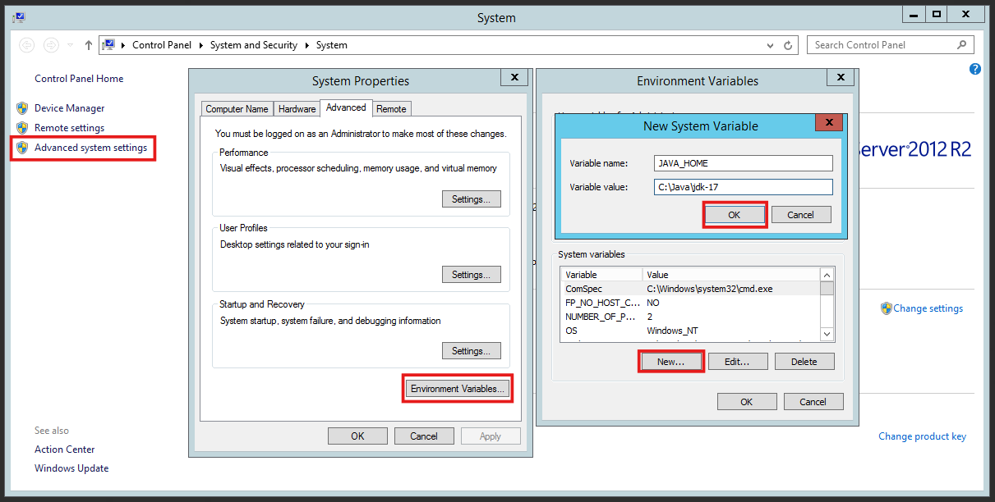
- Again, under System variables, find the Path variable, select it and click Edit… Add ;%JAVA_HOME%\bin in the Variable value field at the end of the list and click OK.
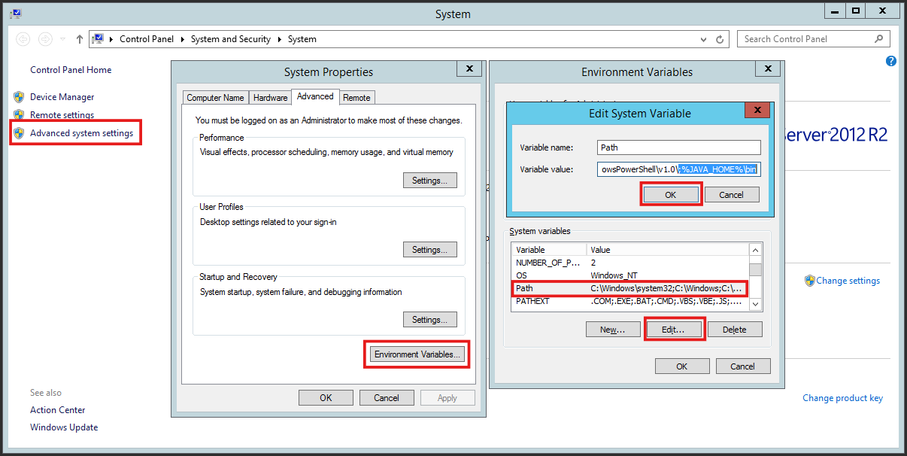
- Click OK on the remaining windows.
- To verify if Java is installed correctly, open a new command prompt window (Refer Step 5 in Exercise 01) type java -version and press Enter. The output should look like this:
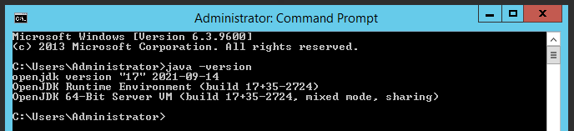
- To check if the JAVA_HOME variable is configured correctly, in the same command prompt window, type echo %JAVA_HOME% and press Enter. The output should look like this:
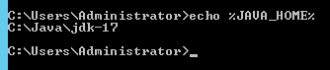
- Navigate to the Start menu, search for OpenStego, and click on the icon to start the application.
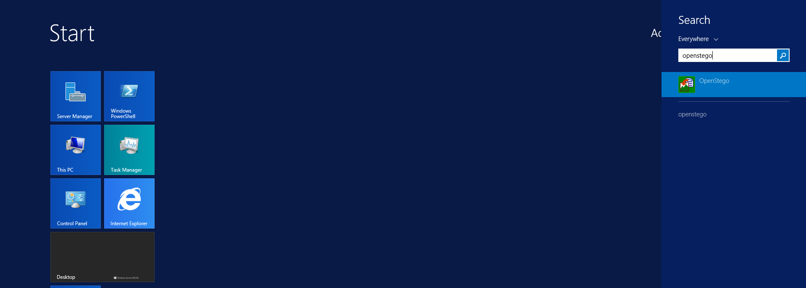
- The OpenStego GUI appears. Click the Extract Data button under the Data Hiding section to input the file containing steganography and extract the hidden data.
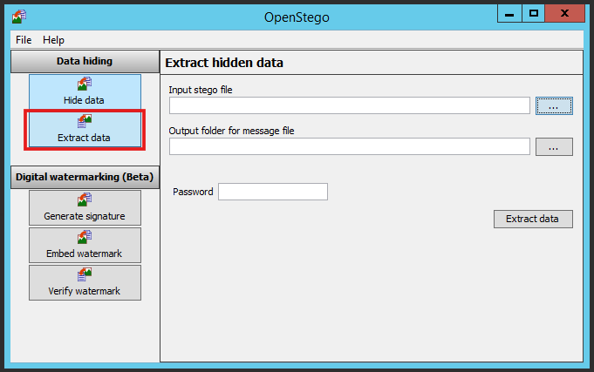
- Provide the path of the file containing steganography in the Input stego file field. The suspicious file (Sample.png) containing steganography will be in the Downloads folder. Also, specify a folder as an output directory in the Output folder for message file field. In this lab, we are setting the output folder as Desktop.
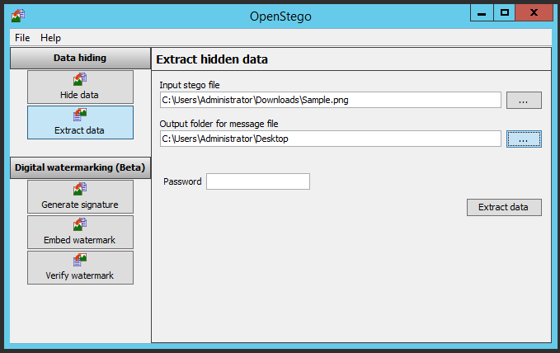
- Click the Extract Data button. The tool will analyze the file and extract the hidden data successfully. It saves the extracted data to Desktop. Click OK.
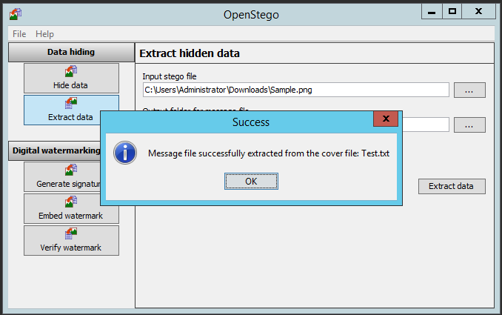
- The hidden file will be extracted to Desktop as Test.txt, which contains the text as shown in the following screenshot:
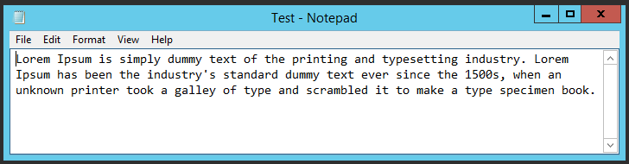
- In this manner, you can extract hidden data from an image file. Close the text file and OpenStego application.
Part C - DeepSound
- During investigations, you might also come across audio files that contain hidden data. In this section, you will learn the process of extracting hidden data from an audio file using DeepSound.
- Go back to Forensics tools on the browser. Navigate to Evidence Files → Evidence Files → Audio Files and download the suspicious file Dangerous.wav onto the Server.
- To install DeepSound, navigate to Desktop → Steganography Detection Tools → DeepSound and double-click the DeepSoundSetup.msi file. Accept the license agreement and follow the wizard-driven instructions to install the application.
Note: If an Open File - Security Warning pop-up appears, click Run.
- Upon completing the installation, either a dialog box will appear asking you to choose a browser and select OK, or a web browser will open automatically, displaying a webpage associated with the DeepSound software. Close the browser window and click Finish on the installation window.
- Double-click the DeepSound icon located on the Desktop to launch the application. The DeepSound GUI appears. Click the Open carrier files button to add the file containing steganography.
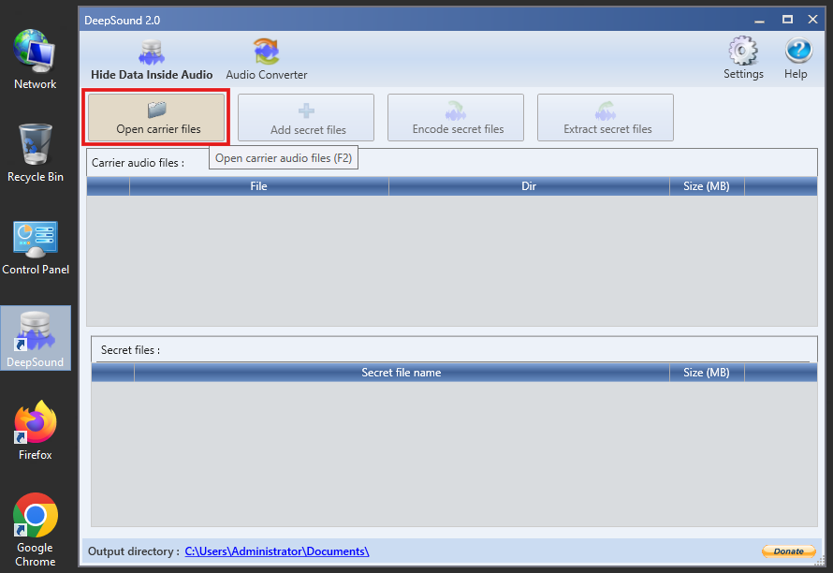
- Provide the path of the file containing steganography and click the Open button. The suspicious file (Dangerous.wav) containing steganography will be in the Downloads folder. Then click the Extract secret files button to start extracting the hidden files or data.
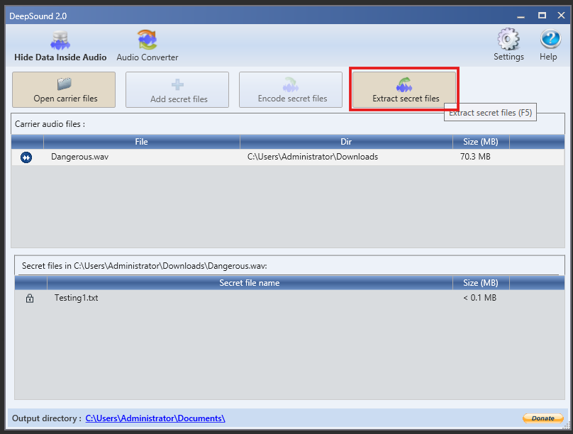
- After extraction, the tool will generate a message displaying the location of the extracted file. Click OK.
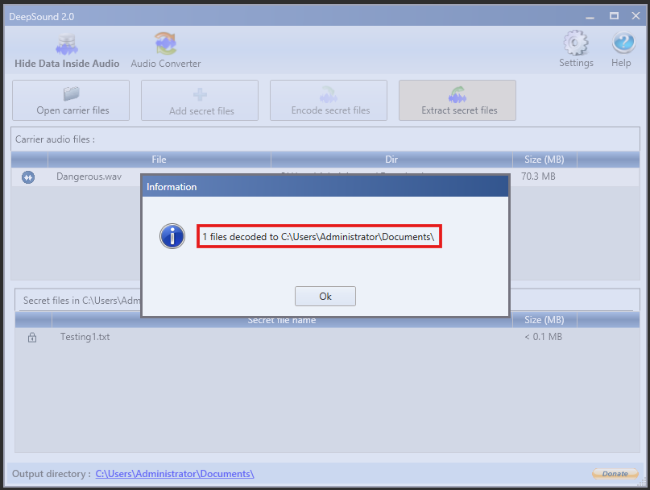
- To view the contents of the hidden file that was extracted in the previous step, navigate to the location displayed in the screenshot above, i.e., C:\Users\Administrator\Documents\ and open the file named Testing1.txt, which contains the text as shown in the following screenshot:
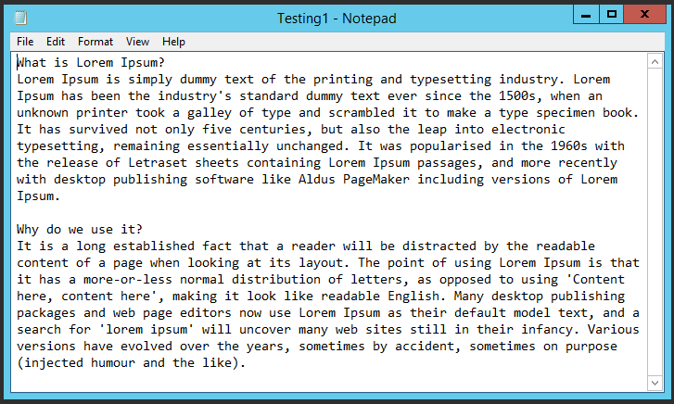
- In this manner, you can detect and analyze data hidden in files of various formats using steganography tools.
- Close all open windows and power off the Windows Server VM.
Part D - zsteg
- Now you will analyze and view the data embedded in an image (cat.png) by using zsteg tool.
- Power on and login to the Ubuntu Forensics virtual machine.
- To enable Internet access, open a new Terminal window and run
sudo nmcli networking on
- Open a new Mozilla Firefox window and go to Forensics tools on the browser. Navigate to Evidence Files → Evidence Files → Image Files and download the suspicious file cat.png onto the VM.
- Now switch back to the terminal window. To install zsteg, we need to install ruby. Type the command sudo apt install ruby and press Enter.
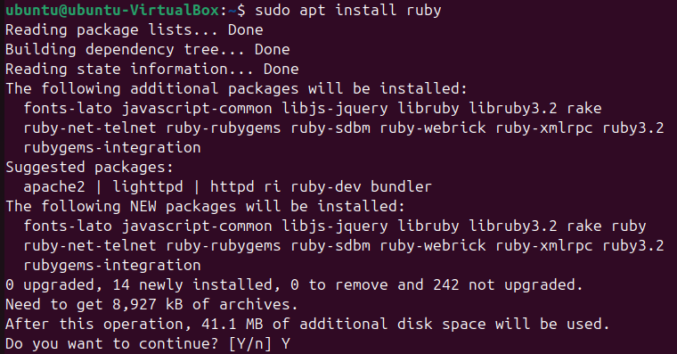
- Now, type the command sudo gem install zsteg and press Enter.
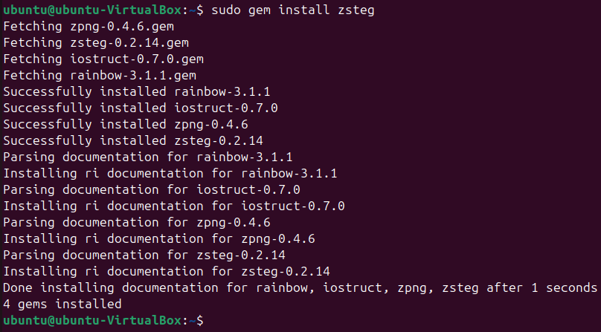
- In the terminal type, zsteg Downloads/cat.png and press Enter. The information that is encrypted in the PNG image file will be displayed.
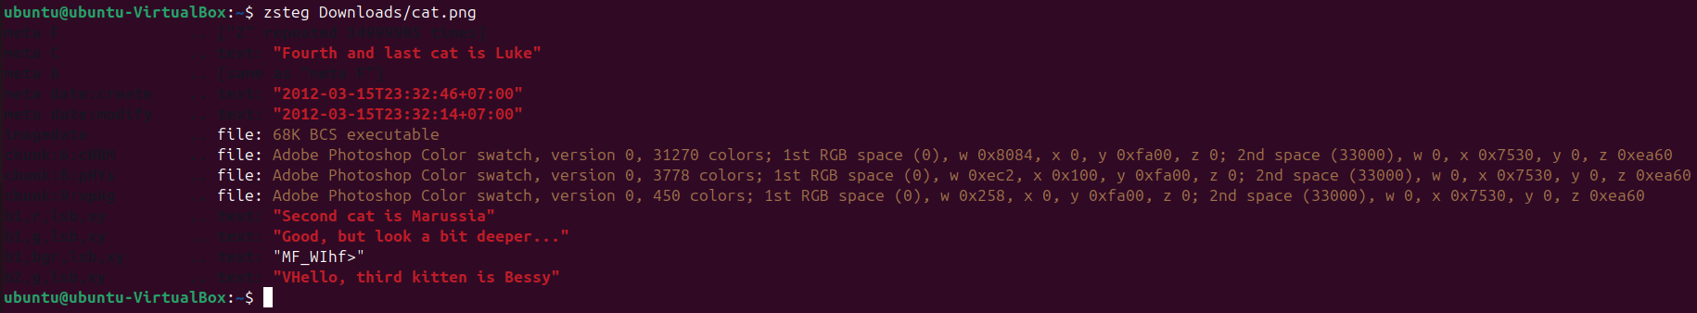
- In this manner, you can extract hidden data from an image file. Turn off the Ubuntu Forensics virtual machine.

Lab Analysis
Analyse and document the results of these lab exercises.

Task: Using https://tryhackme.com/ website

- Once you have signup go to learn and do one of the Forensics free lab

- Choosing any of the Hands-on activities by going into the Learn menu and search for a Forensics lab of your choice.

- To select a free walk through task, select
  - Go to Walkthroughs as shown below

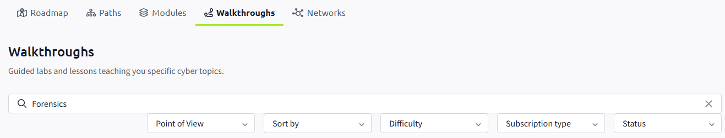
  - Type Forensics
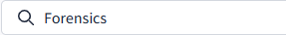
  - In the drop-down menus below the search, select the following in red circle:

  - Choose any of the free walkthrough exercises and give it a go. If you have not done the “Intro to Digital Forensics”, start with that one.
  - Now try to find a lab on how to convert an E01 image file to a dd image file and vice versa.
  - Or choose a forensics lab of your choice.

There are many other similar sites. If you are using a different one, please share it with the class. Do any of the free walkthrough exercise but the option is yours if you want to subscribe (pay).

