Object Analysis – el-Moghraqa ‘funerary cones’
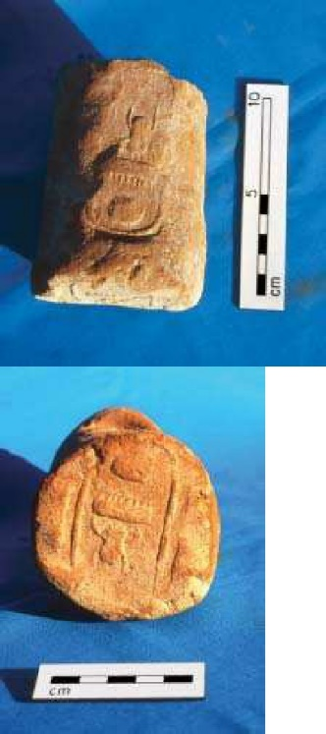
The ‘funerary cones’ were found in the el-Moghraqa archaeological excavation site at Gaza, Israel, in 1996 and 2000 (Steel et al, 2004: 323, 326). There were fifteen larger cone fragments found in 1996, with two more in 2000, alongside many small fragments; the cones were dated from Middle to Late Bronze Age (Steel et al, 2004: 326). They are entitled ‘funerary cones’ due to their similarity in construction and design to those found in funerary sites in the Theban area of Egypt (see figures 1 and 2). Trade occurred between Egypt and the Levant (Ownby, 2010: 1; see Map 1), so cultural hybridity is likely, and therefore could have been adapted by people from Gaza for their own purposes. Trade could have equally brought these objects into the area ready-made or travelling craftsmen could have made them in situ.
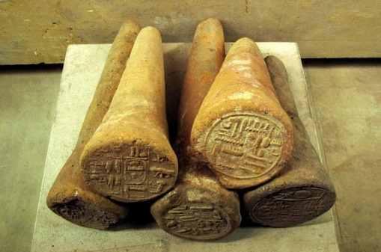
Figure 1 (left): Egyptian funerary cones. (Ancient Origins, 2016)

Figure 2 (right): Cone fragments from el-Moghraqa stamped with the prenomen of Thutmose
III (Clarke in Steel et al, 2004: 323)

The clay was groggy, unrefined, and assumed to be local; this was unconfirmed due to political situations in the area at the time. They were badly fired, and naively executed (Steel et al, 2004: 326), suggesting either a lack of knowledge and experience with using clay effectively or they were not important enough to warrant a proper firing.

The cones are embossed with hieroglyphs, depicting the throne names of Egyptian Pharaohs, which were pressed onto them from carved stamps, possibly made of wood. The hieroglyphs on the cones were not as good as the ones in Egypt, suggesting a copycat design, or created by an inexperienced scribe, and they may have lost something in translation (see figures 3 and 4 for comparison).
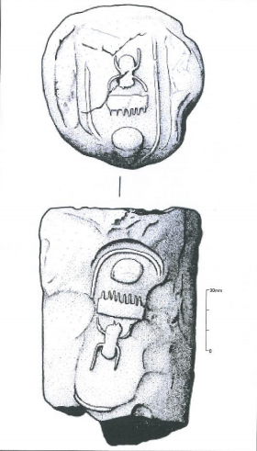
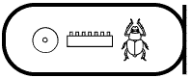
Figure 3 (left): Hieroglyphs for Thutmose III, mn-ḫpr-rꜤ, note the scarab has six legs (above), and Hatshepsut, mꜢꜤt-kꜢ-rꜤ (below). (Fleury, 2001)

Figure 4 (right): Gazan funerary cone showing positions of both stamps, and the hieroglyphs. Note the scarab sign has four legs instead of six. (Steel et al, 2004: 322)

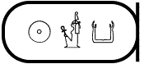

One of the suggestions for the purpose of these cones is architectural, forming part of a building structure (Steel, 2016: 5), with the cartouches protruding (Steel et al, 2004: 329), however, their structural weakness makes this unlikely; this is doubly implausible due to the lack of any bonding materials, or supportive structures being found.

The cones, in antiquity, were consistently broken off at 100mm (Steel et al, 2004: 329), keeping the cartouche intact, suggesting known importance of the hieroglyphs, or at the very least the cartouche. This could disregard suggestions that they simply copied without any understanding. Despite this, the breaks could have been coincidental; if the cones were protruding a building by 10cm, an event, such as its collapse, could have broken them all at that length.

In Egypt, cones have both regent’s and deceased individual’s symbols, whereas these cones only indicate the Egyptian Regent. Egyptian cones are also only embossed on the front, whereas Gaza’s are on the side too. With evidence of trade, there may have been an Egyptian death in Gaza, making it impossible to return the body to Egypt for burial; consequently, a burial took place, attempting to recreate Egyptian process.

Two of the larger fragments bear the name Hatshepsut, whilst the rest bear Thutmose III (Steel et al, 2004: 323, 327, 329); these were co-regents in Egypt at a time which was probably contemporary to the production of the cones. With the implied historic destruction of most evidence for Hatshepsut (Roth, 2006: 277), this could explain why there are so few in comparison to Thutmose III. If they were made for an individual funeral, this would explain the lack of any other cones in the area, and also the lack of knowledge regarding their correct execution. In addition, this could also explain why evidence for Hatshepsut had survived, and why there were so few cones with her stamp could merely be that her stamp broke during the making process, and it was not worth creating another for this single incidence.

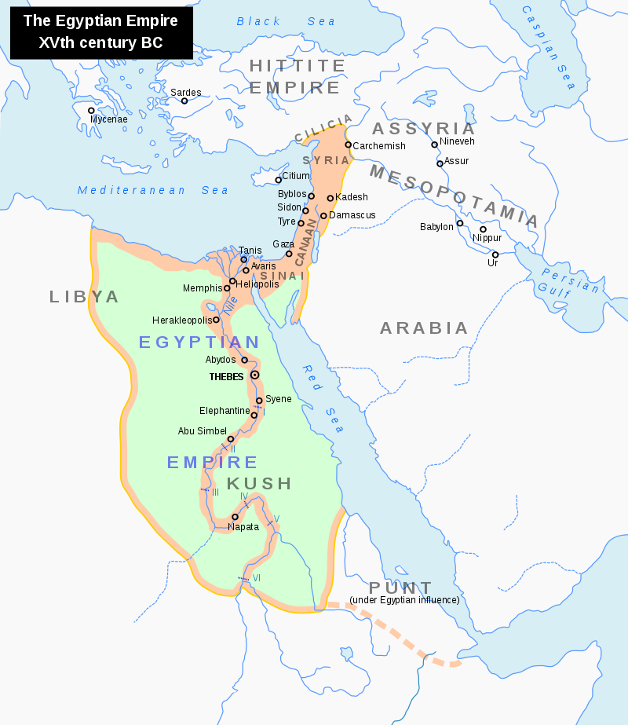
Map 1: Map marking Thebes, Egypt and Gaza, Israel. (Nacu, 2008)

Reference List
Ownby, M. 2010. Canaanite jars from Memphis as evidence for trade and political relationships in the Middle Bronze Age (doctoral thesis). [Available at: https://doi.org/10.17863/CAM.15961] (Accessed: 28th February 2018)

Roth, A.M. 2006. ‘Erasing a Reign’, in C.H. Roehrig (eds), Hatshepsut: From Queen to Pharaoh. New York: Metropolitan Museum of Art.

Steel, L., Manley, W.P., Clarke, J., and Sadeq, M. 2004. ‘Egyptian ‘Funerary Cones’ from el-Moghraqa, Gaza’. The Antiquities Journal. Vol. 84, pp. 319-33.

Steel, L. 2016. ‘Shifting Relations in Bronze Age Gaza’, in T. Clack (edited), Archaeology, Syncretism and Creolisation. Oxford: Oxbow. (in press)

Figure References
Ancient Origins. 2016. ‘Examining Cryptic Grave Goods: What Are the Ancient Egyptian Funerary Cones?’, in Ancient Origins. [Available at: http://www.ancient-origins.net/artifacts-other-artifacts/examining-cryptic-grave-goods-what-are-ancient-egyptian-funerary-cones-020736] (Accessed: 28th February 2018)

Fleury, K. 2001. ‘The Pharaohs’ in Neferchichi’s Tomb. [Available at: https://www.neferchichi.com/the-pharaohs-tuthmosis-iii and https://www.neferchichi.com/the-pharaohs-hatshepsut ] (Accessed: 24th February 2018)

Nacu, A. 2008 ‘Egypt 1450 BC.svg’ in Wikipedia. [Available at:
https://en.wikipedia.org/wiki/File:Egypt_1450_BC.svg] (Accessed: 25th February 2018)

