Changemakers: Building your personal Brand for Sustainable Employment
(BMTP5014/C)

By Jasmine Roberts

Part 1
Skills Audit
Skill | Rating of skill  (1-10) | Improvements for the future
Customer service | 8/10 | Going on customer service courses to help improve on it more and going to different events to gain more customer service experience. I will also volunteer with my brother in law business to improve my customer skills when dealing with the customers questions and inquires on what going on.
Time management | 6/10 | Focus on work more, understanding that goals need to be great in order for the work to be completed in a short amount of time. I will also set myself time schedule when to complete my work each day after university to maintain on time with assignments.
Leadership | 7/10 | Being able to lead a group of people. Understanding who they are, listening to their concerns and answering any questions that they may have.  Understand their values and beliefs so that if I have set a task that they have a problem with I know to set them on a different task that is more suitable for them.
Problem solving | 8/10 | Becoming more aware of any problems that occur and try to solve them as quickly as possible. Thinking outside the box on how to become better at problem solving and think of problems before they happen to have a solution in hand. I will also have more than one back plan to fall back onto if a plan that has been set doesn’t go smoothly as hoped to.
Helpful | 8/10 | Looking after the customers and understand them as well as their needs. Making sure that the customers know that they will always get the help that they need. Maintaining to ask customers if they need anything and to continue to be there for them if they have gone quiet or do not understand.

Experiences:
- Volunteered in University e.g. helping out in Ffos Las racecourse
- Restaurant ( fine dinning) any Marriott Hotel
- Volunteered in college in a range of events
- Part time work in Parc-Y-Scarlets
- Helping my brother in law with his business
- Volunteered when in college and taken part in events (Skill Cymru)
- Bag packing when taking part in sports
- Organised an party for a family member- helped me with managing with a budget and aiming to achieve their like within their party
- Organising a stand at Skills Cymru for travel and tourism course to gain more interests from students leaving schools
- Volunteered and helped out in Twickenham
- Attended the world travel market twice
- Advertised an product/service for my brother in laws business
- Working at Winter Wonderland for the last 2 years (Christmas job -November to January)

Qualifications and training:
- GCSE Maths & English ( grade C in both)
- GCSE Welsh (grade B)
- GCSE Leisure and Tourism (grade B)
- First Aid
- ABTA training

Jobs available:
- Working in a restaurant which will great better customer service from being around the customers a lot more.
- PGL- creating better leadership skills, learning from new people.
- Working in hotels which will help me better confidence in speaking to customers and helping them with inquires they may have.
- Travel agents- allow myself to understand how the booking system works and allow to find holidays for customers that they want to go on for while.
- Camp America- By doing this it will give me the chance to not only traveller to a different country but will also help to understand the country and their values and beliefs.
- Tour guide- help with my confidence in speaking in front of a group, maintain a better knowledge of routes, increase my knowledge of the area and be able to deal with questions under pressure.

Part 2
Personal development plan

Having developments and achievements that are achievable is important so you know what they are good and what they need to improve on. Another positive on a development plan is that it will highlight the areas that are not going as smoothly as other will will understand that those areas will need more improvement to more forward within life and the career,

For the future and professing into becoming a better version of who you can be. Having a development plan that shows long term as well as short term goals can help to develop what should be a main focus in life and what needs to be done over a long period of time. Another plan is making sure that the goals that have been set are useful and achievable to become and gain better knowledge of the situation.

My short terms goals will be to improve on my academic skills and how to improve on my Harvard references. In order to become more professional with my work and to get greater marks when handing in assignments.

The Gibbs reflective cycle and SMART goals will help to put into perspective on how to make sure that my goals are specific, measurable, achievable, relevant and time bound to when it’s going to be done by in order to make it happen. Undertaking the Gibbs reflective cycle and understanding the 6 layers to go through it will help gain better knowledge of a goal set, understand the emotion when going through it, how to deal with it better and how to change it so it doesn’t happen again if the goal wasn’t achievable.

One of my SMART goals

Specific – Making sure to arrive on time before lectures starts
Measurable- I will measure arrive before lectures start by catching a train earlier and making sure I have time to walk to the campus.
Attainable – I will check trains time the night before and make sure that when I wake up to make sure if there is a delay to catch the earlier train so that I have time spare instead of arriving late to class.
Relevant – This is relevant to the course as making sure I arrive in on time for lecture session it’s important to be early to ain’t the attendance and take notes of the session that are being help.
Time-based – By the end of the January’s I will know exactly what trains to catch to arrive in university earlier and to make sure that I have spare time to walk there as well.

What do I want/need to learn? (Specific & Relevant) | What will I do to achieve this? (Specific) | What resources or support will I need? (Achievable) | What will my success criteria be? (Measurable) | Target dates for review and completion (Timebound)
Harvard referencing | To achieve improving Harvard defending I will book a session with the library colleagues to gain better knowledge. Another way to chive this is that I will use the library resources book on defences and highlights area I need to improve on and read a few times and practise until I get hang of it. | The resources that will support this will be the Libra ray resources and a session which will be held with the library to over it in greater detail to make sure I understand it . | This will be measured as I will make sure to read over the book a handful of time and practise until I am formalise with this. It will also be measured by lesions set before hand to attend | I will review this after every 2 weeks to see if I have improvement. Another way I will review this will be after every assignment and read through the feedback to see if the referencing style has been improved.
Organising my work better. | To organise my myself and my work better I will make sure that I use different books of different units to make sure that all the notes are together. I will also do this my planing my assignment before started to type up my assignments. | Resources that will be used within this section will be different notepads for different lectures. I will also download a mind-map app on my laptop/iPad to make sure I plan my work before starting. | Organising working will be measured by reading through the notes that I have taken notes off and highlighting the point that caught my eye to know to include writhing my work. | The time based for this will be every end of the week I will are sure that all notes are in a good condition and making sure to update before next lecture for that unit.

Part 3
Reflections on clear path

“When making early career decisions, I did not seek out mentors”.Garewel .. Kevin. R(September 2019). By having said this, it shows that by having mentors within your career path, they can help to not only boost you to become better but they can also help you with any problems that you get. My mentors throughout my life has been my family and friends. In college my mentors grew to not only my friends and family but to my lectures as well. The same thing happened in university. By having mentors, they help to reflect on yourself and they also help you to network better with new people which creates new career paths for a person.

“Career- oriented employees will not stay around long in a business that does not have a clear path leading to more responsibility, satisfaction, compensation and benefits. ( Detmer. (2007)).
By not having a clear pathway in an business environment can often lead to people wanting more from a company and if they aren’t getting the correct career path that they need in order to progress in their future.

Gaining new experiences throughout a clear path is a main goal that people set for themselves. Becoming more and more reflective on who you are as a person and what you become is an important role while focusing on your future career. “We change as we go through a course of study and gain new experiences, so reflection needs to be a continual process rather than a one-off event” ( Cottrell.(2015)).

From the experiences that I’ve gained in my life so far, I’ve learned that in order to be successful in a career or get more out of a career that I would like, I need to take on new experiences as well as the old ones. Having said this, being focused on what is important and how I can create a clear path to reflect on the past and the future.

From gaining experiences of volunteering in college and university, I have learned that in order to get better networking skills and meet new people who can create job opportunities for people, and get somewhere in their future.

Reflecting back on my career path, I believe that I have experienced a few things but I would like to experience more for the future so that I can get a better knowledge of how to become better in customer service, how to become a better leader and to experience more things in life.

Setting SMART goals for myself can help to to reflect on what I’ve needed to improve in the past, how I’ve said I’m gonna do it and how I’ve actually done it. This can help to achieve something for my future and it can also help me to become more reflective on how far I’ve come from what I was and what I’ve become.

Overall, having a reflective clear path can help anyone to face their fears and be a better version of themselves. It can also help people to decide what career path they want to take and what roads they need to take in order for the career to become successful.

Appendix
Guide line for skills audit

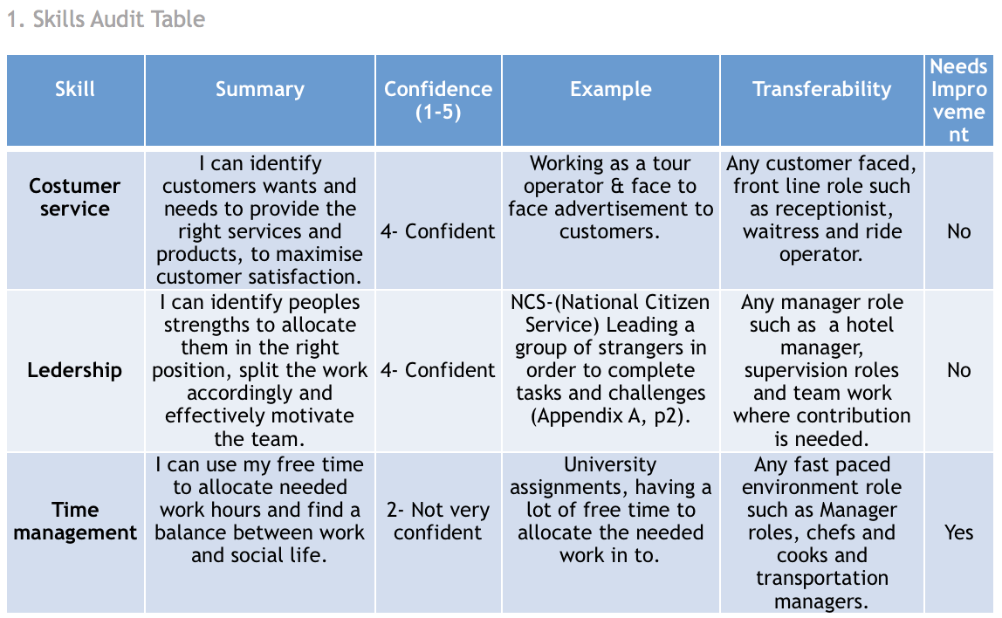
Gibbs reflective cycle
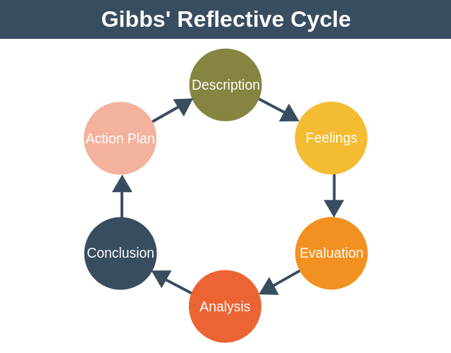

Bibliography

Cottrell. (2015). Skills for success : personal development and employability (3rd ed.). Palgrave Macmillan

Detmer. (2007). Creating clear career paths. Rental Product News (1992), 29(4), 70–.

EPM(2011) Gibbs reflective cycle. Image. Available at:
https://expertprogrammanagement.com/2019/05/gibbs-reflective-cycle/ Accessed on:20 January 2023

Garewal. (2019). I wish I had been told that: Reflections on career paths. The Journal of Academic Librarianship, 45(5), 102005–. https://doi.org/10.1016/j.acalib.2019.02.008

