Student Name: Calin Andrei Buica
Student number:2112409
Module: Effective Teamwork and Communication
Module code: BMSW4002
Lecturer name: Soban Sadiq

EFFECTIVE TEAMWORK AND COMMUNICATION
Executive Summary
The impact of the communication skills on organizations has been identified through the use of models based on effective communication. A vivid discussion on the communication skills has been done with specific examples and the pros and cons of technology in the aspect of communication has been done. The use of models such as Linear model of communication and theories such as Leader-Member Exchange Theory has been done and the examples includes various companies and recommendations has been given.
Table of Contents
Introduction 4
3 Models of communication 4
Communication skills 6
Advantages and disadvantages of technology in communication 7
Examples of poor communication in your organization 9
Recommendations (theory) 10
Conclusion 10
References 11

Introduction
Communication is playing a critical role in generating efficiency within the team that allows individual team members to share knowledge in order to make effective decisions. This report intends to analyse the effectiveness of communication in achieving the common goals of an organisation. Different models of communication such as the “Linear model of communication”, “Transactional Model of Communication” and “Interactive model of communication” are going to be analysed in this report. It will be followed by discussions on the effectiveness of different communication skills. Active listening and verbal and non-verbal communications will be discussed in this report to understand the implication of communication approaches. Both the disadvantages and advantages of using effective technologies within the communication process will be illustrated in this report. The impact of poor communication and recommendations for improving communication skills will be analysed at the end of the report.

3 Models of communication
Linear model of communication
One of my friends is working in a renowned supermarket chain in the UK, ASDA and as per his statement that this organisation is committed to enhancing the team communication process. This company introduces a new communication technology named VoCoVo, which allows the controlling of multiple operations at a time (Retail Technology News, 2022). This technological implementation helps in improving the quality of communication during the decision-making process in which two-way communication is allowed by the organisation. Hence, effective team communication helps the company to enhance the overall customers’ in-store experience. As opined by Song et al. (2018), the implementation of a linear model of communication is effective for maintaining a header-free communication, which further considers the application of effective technologies such as the Internet of Things (IoT). This theoretical framework indicates the one-way direction of communication, which has different negative consequences. As the linear communication model does not allow the sharing of feedback from the receiver end, which may lead to the development of miscommunication or misinterpretation. By taking the reference to ASDA, two-way communication is more effective in comparison to linear communication during the development of an effective decision within a team project.
Transactional Model of Communication
While I am working as an intern at Nike, one of the leading sports retail organisations in the UK, I was experiencing a poor workplace culture. Team members felt excluded from the management due to poor communication and management structure of the company (CNBC, 2018). Employees of Nike felt unfit within the organisational culture due to the poor team communication and lack of information-sharing opportunities. As illustrated by Bragg et al. (2021), the transactional model of communication involves different phases of communication such as receiving the message, interpreting, informing and influencing. In the beginning, the speaker shares knowledge with the listener, which is further interpreted by the listener after receiving the message. This communication model is effective for keeping the listener informed about the situation along with the influence on the decision-making of the listener. Hence, the application of the transactional model can be effective for Nike to maintain an effective work culture by allowing the participation of team members along with the leaders during the decision-making process.
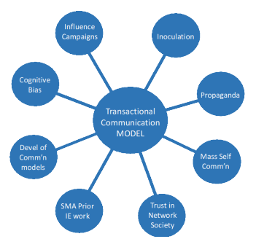
Figure 1: Transactional communication model
(Source: CNBC, 2018)
Interactive model of communication
During the pandemic situation, one of my friends resigned from British Airways due to the poor management style of the company. During the crisis period, this organisation failed to keep its employees motivated and conflicts were generated among the employees due to the lack of a transparent communication process (BBC, 2020). Unresolved conflicts for a longer time period generated a feeling of demotivation among the employees. Poor communication can be identified as the reason behind the generation of conflicts. In this context, consideration of employees’ perspectives is highly required to mitigate the issue of poor communication. Wilbur Schramm proposed an Interactive communication model in which the collection of feedback from listeners is allowed within the linear operational channels (Inspired2learn, 2022). The opinion or knowledge of the speṁthe listener, which developed either desired or undesired impact on the listener’s mind. Therefore, the application of this model can be effective for British Airways to consider the employees’ opinions during the conflict management or decision-making process.
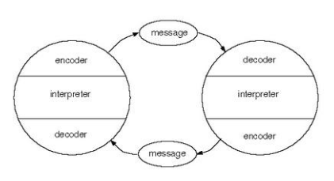
Figure 2: Interactive communication model
(Source: Inspired2learn, 2022)

Communication skills
Active listening skills
Listening skills are highly required for understanding the point of view of the speaker during the decision-making process. In order to communicate properly, active listening skills enable an individual to make effective decisions by considering diversified knowledge. In a group work, active listening skill is important for giving quick responses in an appropriate manner (BBC, 2022a). In my professional career, I have worked within a team many times and it helps me to recognise my poor listening skill. As I am lacking listening skills, I failed to understand the instruction of my leader during one of my group projects in my professional career. In this context, I have to be more patient and attentive to the speech of the speaker to understand his or her point of view. It will be beneficial for me to make effective decisions by considering others' perspectives.
Non-verbal communication skills
During my professional period, I experienced an issue in which my audience miss interpreted my opinion and gave negative feedback. I was not feeling confident during the delivery of the speech, which further created a negative image of my personality. After discussion with the audience, I got to know that I failed to maintain a positive body language which led to the development of a negative impression about myself in their mind. Non-verbal communication includes different uses that help in developing a positive mindset of audiences (British Council, 2022). In that situation, I have to maintain a confident and positive approach to make an effective interaction with the audience which may beneficial for avoiding the risk of annoying interpretation of the knowledge sharing process. This issue can be sustained by practising more communication and taking part in seminars to understand the other’ communication styles.

Advantages and disadvantages of technology in communication
Advantages
In the modern era of the digital world, technology is massively used in various means of communication purposes in different business organisations and in personal communication as well. Technology, for communication purposes, is used in various modes such as mobile technology as portable devices that are used for communicating with other people such as smartphones, laptops, GPS (Global positioning systems) devices etc. that enables carrying devices and communicating with people from anytime and anywhere. The global pandemic has led the whole communication system to transform into a more digital one as direct interaction was restricted to avoid social gatherings in offices for which business ventures had to shift their working system into a remote working format. There are various methods of digital communication such as emails, video conferences, text messages and many more, which are widely getting used for sustaining the effective consistency of communication in workplace. It tends to help in communicating among team members while working in a work from home system. Microsoft has developed its personal communication platform “Microsoft Teams” for communicating with its employees in a remote working system (Microsoft, 2022a). Communication technologies such as Wireless Fidelity, Bluetooth or data networking services technology in business make communication faster and easier. The use of these communication technologies in a business ensures higher productivity and efficiency of employees a business by enabling flexibility of working that brings a better quality of work (Ni Business Info, 2022). In addition to that communication technologies also help in cloud computing, maintaining stock availabilities, ordering systems as well in manufacturing or retail industries (BBC, 2022). Various social media platforms such as LinkedIn, Monster, Indeed, Twitter, Facebook etc have become the best ways that are used by business firms for communicating with consumers (Statista, 2021). Studies reveal that LinkedIn is the most used social media platform that is used by both business firms and employees for business interactions regarding selection, recruitment, reviewing a business in terms of working experience etc. This communication helps both employees and employers in developing an efficient workforce and getting an understanding of a specific workplace by considering reviews and ratings on these platforms.
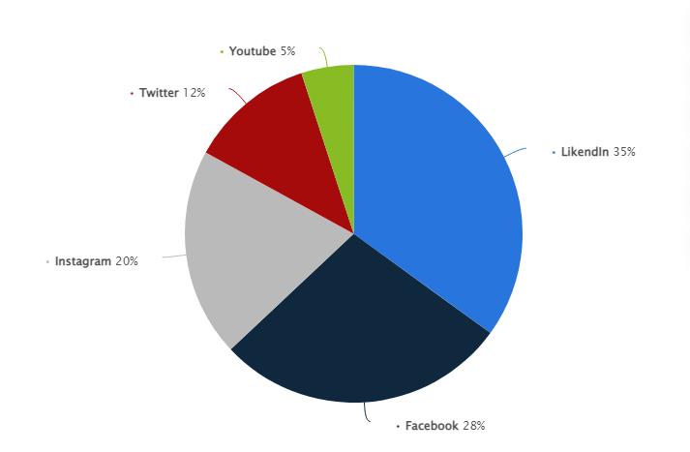
Figure 1: Social media platforms used for business communication
(Source: Statista, 2021)
Disadvantages
The use of technology in communication comes with various drawbacks as well as there is always a scope for data security while using online modes of communication. Microsoft has incorporated technologies in its VPN strategy to ensure data security by preventing unauthorised access, controlling authorised user access, enabling network protection such as IDS/IPS and preventing data loss while working in a remote working system (Microsoft, 2022b). Other major disadvantages of technology can be mentioned as it increases the dependency on technology, requires additional training for the employees and it is an expensive approach as the development and maintenance of digital infrastructure adds additional cost to business organisations (Ni Business Info, 2022). Another repercussion of using technology for communication can be mentioned as social media platforms create a huge job opportunity for employees which in turn leads to random switching to other companies that lead to business firms facing issues in employee retention. On the other hand, it affects the employees as well in terms of the “hire and fire” approach of the employers and increases the risk of job cuts (BBC, 2022b).

Examples of poor communication in your organization
Communication plays a major role in the engagement between the employees and also to evaluate the factor of motivation and satisfaction (Ter Hoeven and Van Zoonen, 2020). In the organization, I am working on which is Tesco Plc, there has been some problem regarding communication, and also it has affected the productivity of the workplace. The issues in communication mainly include the factor in verbal communication, problems in motivation, and also cultural differences. The issues will be described in a more detailed way by me that I have faced in Tesco Plc. The first problem that I have been facing is in the verbal communication where the communication with the employees has been a major issue. There have been times when I have seen that some of the employees have no participation in teamwork resulting in issues in the workplace. As a result, the company Tesco Plc has to face problems regarding its operations in the company.
The factor of motivation is another issue that has been faced by me due to the decrease in the productivity of the company Tesco Plc. The productivity during the Covid-19 has badly affected the company leading to a lack of motivation among the employees to perform better. As a result, there has a been a lack of engagement among us which has led to the issue of leaving the organization by the employees. Cultural differences are one of the biggest problems that have been faced by me Tesco Plc as it is a big company where there is a diverse workforce. Communication with international clients has been a major challenge that has been faced by me and many other employees.

Recommendations (theory)
The recommendations have to be provided in accordance with the issues that have been identified. The theory of Leader-Member Exchange Theory mainly focuses on the relationship between the employees and the managers and also there is a factor of trust (Zhou et al. 2021). The same method can be applied by the company Tesco Plc so that the employees can communicate with the managers and share their problems leading to better verbal communication between the staff. The theory for the issue of motivation is Alderfer's ERG theory where the factor of existence, growth, and relatedness is present (Acquah et al. 2021). The issue is the motivation that has been faced by the employees of Tesco Plc can be rectified as the application of the theory will help the employees to adjust to the issues and it will help them to have effective communication.
The cultural differences can be rectified by the theory of the Cognitive Diversity Hypothesis through which the diversity in the workplace is focused as the performance is evaluated by situations leading to creativity (Men et al. 2019). The employees of Tesco Plc through the implication of the theory can identify the problem such as language barriers and accordingly work in order to rectify the issue through continuous engagement or use of any technology. These are some of the theories that can rectify the issues in Tesco Plc and also for future innovation.

Conclusion
The conclusion that has been identified here is that the aspect of communication is a major factor in the development of an organization. The use of models has been put forward which includes a linear model of communication, a transactional model, and also the interactive model. The examples have been used for making the study more informative and detailed and also to understand its effect. The two communication skills have been identified and the impact and issues related to the use of technology have been evaluated. The reflective study involves the poor communication skills in the company and the recommendations have been provided with models.

References
Acquah, A., Nsiah, T.K., Antie, E.N.A. and Otoo, B., 2021. Literature review on theories of motivation. EPRA International Journal of Economic and Business Review (JEBR), 9(5), pp.1-6.
BBC, 2020. British Airways: A breakdown in trust?. [online] BBC. Available at: <https://www.bbc.com/news/business-53023563> [Accessed 29 April 2022].
BBC, 2022a. Advantages and disadvantages of using new technology for businesses - Technological influence on business activity - Eduqas - GCSE Business Revision - Eduqas - BBC Bitesize. [online] BBC Bitesize. Available at: <https://www.bbc.co.uk/bitesize/guides/z4bjjhv/revision/6> [Accessed 26 April 2022].
BBC, 2022b. Listening skills and responding to others. [online] BBC. Available at: <https://www.bbc.co.uk/bitesize/guides/z3ydv4j/revision/3#:~:text=losing%20valuable%20marks.-,Remember,in%20the%20most%20appropriate%20manner.
Bragg, B., Cooley, S., Cooley, A., Hinck, R. and Kitsch, S., 2021. Transactional Communication Model: Quick Look. The Media Ecology and Strategic Analysis Group.
British Council, 2022. Non-verbal communication. [online] British Council. Available at: <https://www.teachingenglish.org.uk/article/non-verbal-communication> [Accessed 30 April 2022].
CNBC, 2018. Nike CEO apologizes to employees for workplace culture after months of turmoil. [online] CNBC. Available at: <https://www.cnbc.com/2018/05/04/nike-ceo-apologizes-to-employees-for-workplace-culture-after-months-of-turmoil.html/> [Accessed 29 April 2022].
Inspired2learn, 2022. Communication Models - A-Z of Coaching & Mentori. [online] Inspired2learn.co.uk. Available at: <https://www.inspired2learn.co.uk/article/51/AZofCoachingandMentoring/> [Accessed 30 April 2022].
Men, C., Fong, P.S., Luo, J., Zhong, J. and Huo, W., 2019. When and how knowledge sharing benefits team creativity: The importance of cognitive team diversity. Journal of Management & Organization, 25(6), pp.807-824.
Microsoft, 2022a. Responding to COVID-19 together. [online] News.microsoft.com. Available at: <https://news.microsoft.com/covid-19-response/> [Accessed 23 April 2022].
Microsoft, 2022b. Alternative ways for security professionals and IT to achieve modern security controls in today’s unique remote work scenarios. [online] Microsoft Security Blog. Available at: <https://www.microsoft.com/security/blog/2020/03/26/alternative-security-professionals-it-achieve-modern-security-controls-todays-unique-remote-work-scenarios/> [Accessed 22 April 2022].
Ni Business Info, 2022. Advantages and disadvantages of mobile technology | nibusinessinfo.co.uk. [online] Nibusinessinfo.co.uk. Available at: <https://www.nibusinessinfo.co.uk/content/advantages-and-disadvantages-mobile-technology> [Accessed 25 April 2022].
Retail Technology News, 2022. Retail Technology | Asda enhances team communication. [online] Retail Technology News. Available at: <https://www.retailtechnology.co.uk/news/7220/asda-enhances-team-communication/> [Accessed 30 April 2022].
Song, X., Choi, H. and Shi, Y., 2018, June. Permuted linear model for header-free communication via symmetric polynomials. In 2018 IEEE International Symposium on Information Theory (ISIT) (pp. 661-665). IEEE.
Statista, 2021. Most important social media in communications strategies U.S. 2020 | Statista. [online] Statista. Available at: <https://www.statista.com/statistics/1196237/important-social-media-i-communications-strategies-usa/> [Accessed 27 April 2022].
Ter Hoeven, C.L. and Van Zoonen, W., 2020. Helping others and feeling engaged in the context of workplace flexibility: The importance of communication control. International journal of business communication, p.2329488419898799.
Zhou, X., Rasool, S.F., Yang, J. and Asghar, M.Z., 2021. Exploring the relationship between despotic leadership and job satisfaction: the role of self efficacy and leader–member exchange. International journal of environmental research and public health, 18(10), p.5307.

