Serial positioning effect report:
ABSTRACT:
The study was conducted to investigate the serial Positioning effect, which examines if people recall more words at the beginning of the list (as that is in your long-term memory) and at the end (as that is in your short-term memory) more than the middle. A study was made with a list of words and at the end the participants were expected to write all the words they could remember. The findings supported the hypothesis as in fact people did remember the end and beginning more.
INTRODUCTION:
Serial positioning effect is the idea that the position of words in a list affect an individual's recall. Thus, the idea is that people tend to recall words more at the beginning (primary effect) and at the end of a list (recency effect). Murdock's research into this phenomenon in 1960 acknowledged that this does occur. He did a study with many people and different lists of words, the results supported the serial positional effect for example, the 40-1 list shows an almost flat middle section and the beginning and end on the lists showing higher recall (Murdock, 1960). This supports the idea people find that they can successfully recall words at the beginning and end of a list as the words presented in the middle do not have enough time for maintenance rehearsal to occur and transfer to the long-term memory and new information at the end removed it from the short-term memory.
Atkinson and Shiffrin's Multi-store memory model in 1968 explains the possible reasoning behind the occurrence of the serial positioning effect. The multi store model is based on the belief that our memory is divided into three components the sensory register, the short-term memory and long-term memory. This is used to explain the reason behind serial position effect as the long-term memory is where information is retained permanently, and this occurs when information is processed for a longer period. So, it can be transferred from short-term memory to long-term memory this could even occur unconsciously such as looking at a series of words. Therefore, this explains why there tends to be higher amounts of recall at the beginning of the list as the words at the beginning had enough time to move to long-term memory. Short-term memory is where information is retained for short, limited period after it is received but it is retained for a longer time than the sensory register which can explain why people tend to recall more words at the end of the list as it is just entered the short-term memory (Atkinson and Shiffrin, 1968).
METHOD:
Ten participants, five females and three males. Two participants did not provide a sex.
They were students from university.
Design:
The 14 words created and presented are the independent variables and the Dependent variables is the amount the participant could recall correctly as that is what is being measured.
Word order:
1: Behave 2: Direct 3: Defend 4: Calmly 5: Deadly 6: Locate 7: Gentle 8: Advice 9: Expose 10: Unlikely 11: Honest 12: Forget 13: Obtain 14: Stupid
Materials:
- Paper and pen
- Laptop
- Paper cup
- Super lab where there was 16 words presented for 1500 Ms.
- Toronto word pool chart
- A consent form and information sheet were provided to the participant prior to the start of the study (a link will be provided in the appendices).
- A debrief form was provided to the participant after completed the study (a link will be provided in the appendices).
- A protocol document that reminded researcher what to do.
Procedure:
First, a consent form was created and named 22 nov-memory recall consent form and added to a folder named memory recall. A debrief form was then created and named 22 nov- debrief form memory recall and added to the same folder.
A block, trial and event were created and named instructions then the block was linked to the trial and trial to the event. In the event the settings were changed so the participant could only continue if they press the space bar. (The instructions are in the appendices)
Next, a block, trial and event were created named ISI and one named cross both were placed between each word. The ISI was presented first for 500 Ms and then the cross straight after for another 500 Ms so the participant would be fixated on the centre of the screen.
An event for all 14 words was created. These were all chosen with a similar concreteness between 3.2-3.8 and 6 letters. Each word and number were written in a piece of paper. The words were taken out of a cup and allocated to the numbers taken from the other pieces of paper. Once that was done 14 event names were created in that order, this was shown in the screen for 1500ms. Each event was connected to a trial that was numbered according to the numbers picked for the words. A block was then created which was named words and connected to the trials from 1-14. These trials were also connected to the ISI and Cross.
A second instructions trial, block and event were created that provided the participant with the next part of the studies instructions. A correct response was created for this part which was pressing the space bar.
After that was completed an End event that thanked the participants for taking part in the study and asked them to let the researcher know they finished was created. A trial was created called end that connected these which then also connected to a block named end.
A protocol document was created and named 29nov- protocol which was then saved to the memory recall folder.
Lastly, this super lab study was put in our memory recall folder.
Once the study was complete, each participant was welcomed into a lab one at a time. A consent form and pen to recall the words at the end was provided. Each researcher was given a protocol sheet to follow. Once done, data from each participant was collected and separated from the consent form.
RESULTS:
Overall number of words recalled correctly were 47 so the Mean number of words recalled is 4.7.
The number of accurate words recalled on average in the beginning were 20 and the number recalled at the end were 24 however in the middle only 3.
Females 19 words recalled, and Males 13 words recalled.
The findings suggested More words were recalled in the end and beginning of the list.
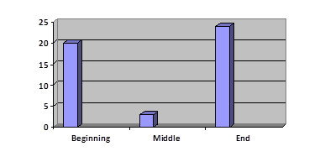
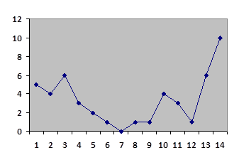
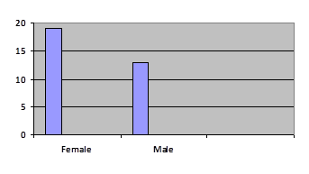
DISCUSSION:
The hypothesis is supported as the graphs in the results section suggests that more words were recalled in the beginning and end of the list which supports the primary and recency effect.
This means that due to short-term memory and long-term memory people really do tend to recall words at the end of the list more because it is still in the short-term memory and recall words at the beginning of a list more because they have had time to transfer into their long-term memory however towards the middle It has not had enough time to move to the long-term memory and have taken too long in which it has left the short-term memory.
These findings also do indicate that besides the occurrence of the serial positioning effect females correctly recalled words more than men this can be clearly shown in the bar graph in the results section.
From the line graph presented in the results section we can see that there is a clear decline in the number of words recalled in the middle of the list with almost a flat line but an increase with a peak of number of words recalled near the end of the list. There is also a noticeable increase in the number of words recalled at the beginning of the list.
However, flaws could be identified in this report for example, more work should have been done to look further into the reason behind the gender differences in word recall. Also, using more participants would have allowed me to get more results from several types of people.
These findings mirror the findings found in Murdock theory and can be understood using Atkinson and Shiffrin's multi store model. Murdock found the same results that the study conducted found as in all the data collected and all the graphs made the words in the middle of the list are less accurately recalled compared to the beginning and end of a list and this is explained through the belief that at the end of the list it is still in your short term memory and in the beginning it has had enough time to move into your long term memory.
REFERENCES:
- Toronto word pool chart
- Murdock. (1962). The serial position effect of free recall. Journal of Experimental Psychology.
- Atkinson, R. C., & Shiffrin, R. M. (1968). Human memory: A proposed system and its control processes. In Psychology of learning and motivation (Vol. 2, pp. 89-195). Academic Press.
APPENDICES:
Instructions1: ‘In this study you will be shown a series of words, one after the other. Your task is to pay attention to the words presented on the screen. Please make sure you have read and consented to taking part in the study. Press the space bar when you are ready to start.’
Instructions2: ‘For the next part of the study please write down any words that you remember on the piece of paper provided to you. Press the Spacebar when you have completed this task’



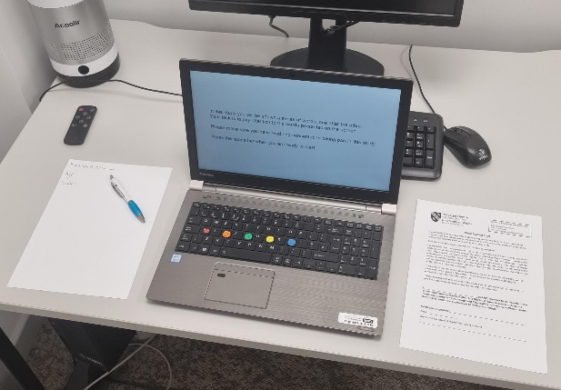
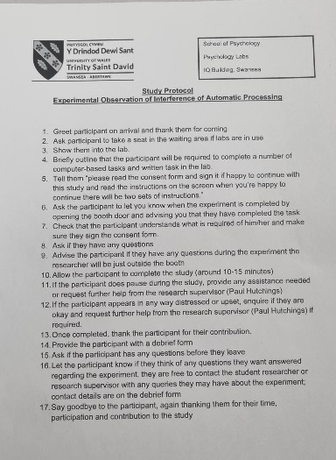
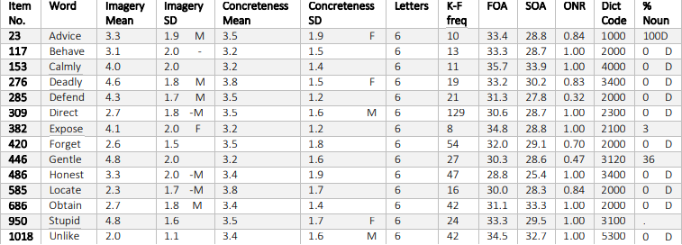

Word | P1 | P2 | P3 | P4 | P5 | P6 | P7 | P8 | P9 | P10
Behave | P |  |  | P | P |  | P | P
Direct |  | P |  |  | P | P |  |  |  | P
Defend |  | P | P | P |  | P |  | P | P
Calmly | P |  | P |  |  | P
Deadly | P |  |  |  |  |  |  |  |  | P
Locate | P
Gentle
Advice | P
Expose | P
Unlikely | P |  |  | P |  |  | P | P
Honest | P |  | P |  |  |  |  |  | P
Forget |  |  |  |  | P
Obtain | P |  | P | P |  | P | P |  |  | P
Stupid | P | P | P | P | P | P | P | P | P | P
Age |  | 20 | 23 |  | 19 | 22 | 25 | 20 | 31 | 26
Gender |  | F | F |  | F | M | M | F | F | M

