

Digital Skills and Research Methods
Lecturer: | Ze Zook
Student Name: | Sherin Ahmed
Student Number: | 1712386
Module No: | BMSK4003_LON
Module Title: | Digital Skills and Research Methods

By the act of making this submission, the student declares that this is the work of the student named above. The work has not, in whole or in part, been knowingly presented elsewhere for assessment, or where assessment has been built on a previous assessment. This has been identified. Where materials have been used from other sources it has been property acknowledged. ¡f this statement is untrue, the student acknowledges that an assessment offence has been committed. Attention is drawn to the plagiarism and unfair practice policies of both the University and of ILM.

Executive Summary
This report sheds light on the impact of modern technologies and social media as marketing and communication tool of an organization. Hence the report had selected Talent Plus, UK as the organization for analysis. Thus the study had examined the available literatures on evaluating the impact of digitization on organizational performance. Then the report had selected tablets, smart phones and web-based emails as the change implantation tools for Talent Plus. Then the study had focused on social media as an effective tools for the social media as a tool for marketing, information gathering and communication within the workplace. Analysis will evaluate the existing marketing and communication system in Talent Plus. In practical application and Deployment section the report had presented the implanted digital practices of several organizations. Lastly few recommendations were listed for Talent Plus before concluding this study.
Table of Contents
Introduction 4
Digital technology in an organization 4
Tablets and Smartphone 4
Web-based email 4
Usefulness of the above mentioned tools 5
Social network and some renowned social networking sites 6
Social networking sites and the way its help getting better jobs 8
Uses of social networking sites in workplace 9
The implications with regard to personal and professional security 9
Social network prefer for getting jobs 10
Conclusion 10
Reference List 11
Appendices 14

Introduction
In this age of continuous development in technology and advent of the World Wide Web had created the requirement to review the conventional business communication and marketing strategies. This report will critically evaluate the impact of digital transformation within Talent Plus. Thereafter the report will elaborate the use of social media
.

Digital technology in an organization

Tablets and Smartphone
Tablets and Smart phones had gained the potential to influence any business activity. It can be observed that most of the organizations are providing tablets to collect and conduct market research and surveys before launching a service or product. Arkorful et al. (2017, p.23) illustrated that these smart phones are also essential for sending and checking emails. Moreover smart phones also enables employees to access their company website from the client location. Hence it can be analysed that tablets and smart phones can be used by the representatives of Talent Plus while visiting their client location. Tablets will enable to store the details with resumes of every employee from the client organization. Smart phones will allow recording the structured interviews of each employee from client organization. This will enable Talent Plus representatives to analyse these records at a later date to produce an appropriate report.

Web-based email
Web-based emails can also be used for effective business communication. Most of the organization considers email as a formal communication. However the web-based email has the additional feature of mass mailers. This enables business to communicate their latest offers and discounts to their customers instantly and in a cost effective way. Another effective function of these web-based emails is their efficient contact management system. This system is responsible for creating a contact book by default. Hence it also saves the time required to create a contact list for customers. Hence it can be analysed that these web based email system will enable Talent Plus to reach a vast number of clients within UK at free of cost. It will also enable the Talent Plus employees to address the customer service issues of their existing clients easily. However Baumeier et al, (2017, p.110) stated that several customers still prefers to collect the hard copy of each document to save their sensitive data from fraudulent activities. Thus business

Usefulness of the above mentioned tools
It can be observed that the apart from the usage of tablets, smart phones and web based emails to implement digital technology, there are several practices that can be incorporated by Talent Plus. These practices will enable to create a unique brand image of Talent Plus among its customers. It was reported that the social marketing strategy incorporated by John Lewis was appropriate to address the market demands of the generation C customers (Bianchi et al, 2018). On the contrary it can be observed from the web designing of LEGO, that its uniqueness lies within that design (Charlton, 2014). Thus being a talent management group it is essential for Talent Plus to develop a formal website which will list the interview videos of the client organization. Thus the new clients are able to assess these videos and develop their brand awareness of Talent Plus. The “About US” page needs to incorporate the basic theory behind the vision and mission of Talent Plus. This website also needs to ensure that includes the details of their client organization and search engine optimization. (Refer to appendix 1)
The main impacts of implementing the digital technology within any organization can be measured through the enhanced level of interpersonal skills within employees, rate of innovation within the workplace performance. Boyce, J.M., (2016) depicted that digital technology has enhanced the creativity and innovation power of each and every employee of an workplace. It was reported that the Financial Technology sector was able to contribute around £6.6 billion in 2016 with the implementation of Digital transformation. On the contrary Dixon et al. (2015, p.100) stated that digital transformation has its negative impact also in terms of invading data security. It was reported that the MongoDB database Hacking incident of the Ai-Type company’s database had developed a crucial question on several organizations digital transformation process. There are several advantages of social media as a marketing or communication toll for any business. Social media allows the businesses to address a vast range of audience base at free of cost. It also helps to address the customer service issues instantly and leads to incorporate applicable strategies based on the data analysis (Charlton, G., 2014)

The web-based emails and social media application can be influenced from the application of Manchester City (Davis, 2016). Manchester City is active in social media to create the trust base within its customers. Hence Talent Plus can also create a face book blog where the grooming experts can share their knowledge of success.
The first step in change implementation within Talent Plus is to distribute tablets and smart phones to all its representatives. Thereafter an effective website can be developed where the interview videos can be shared with all the customers. These websites also requires enlisting the reviews of the existing clients of Talent Plus. This will allow the new clients to access the service of Talent Plus (Charlton, G., 2014).

Social network and some renowned social networking sites
Social networking sites are the different kind of social and virtual connectivity and socializing platforms where people come to get along with each other, know and communicate with each other. In these kind of places, people communicate and share similar interests, music, knowledge, career interests or other things. Facebook, Twitter and LinkedIn can be said to be the most popular social networking sites and platforms among many of the other existing ones (Dai et al. 2017). These are used by billions of people worldwide to learn something, to communicate with each other, to share news, music interests, films, poetry, literature and other form of artworks. These social networking sites are also used to raise different kind of social awareness and carry on with events such as child care, women empowerment, propagating religious indoctrination and other kind of healthcare needs and awareness.
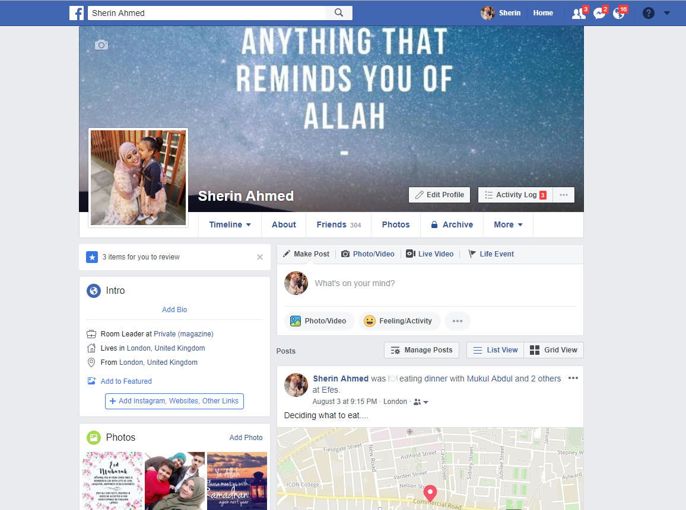
https://www.facebook.com/sherin.ahmed.940

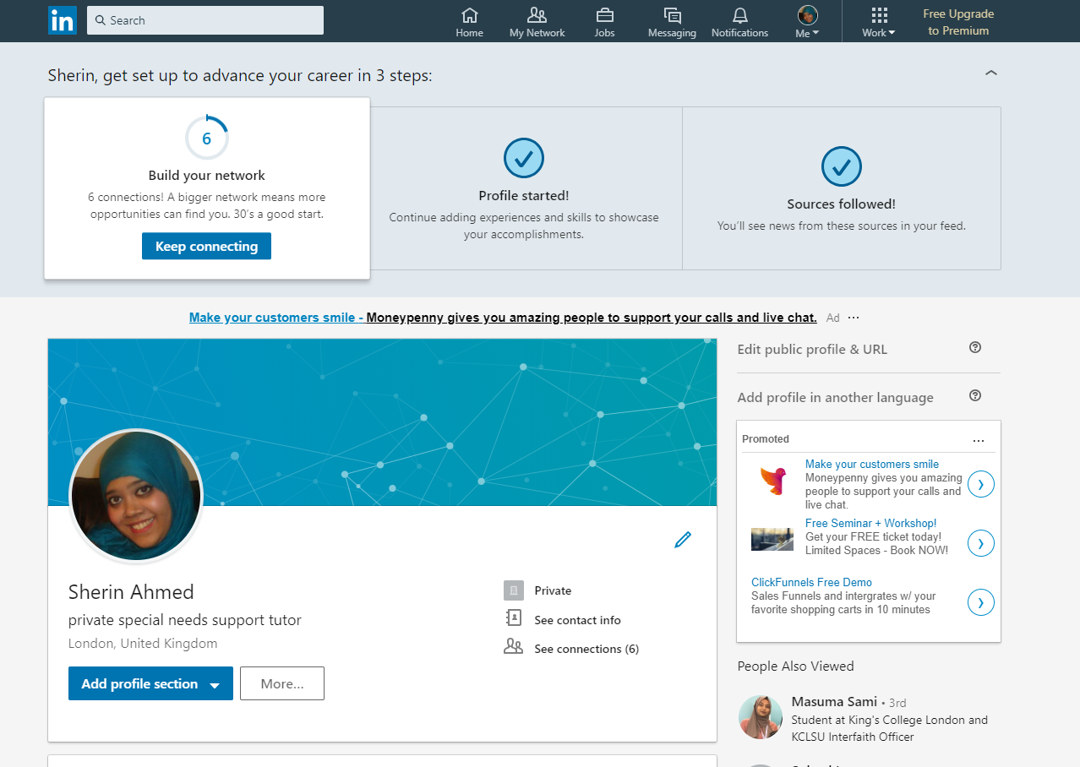
https://www.linkedin.com/in/sherin-ahmed-546a16114/

Social networking sites and the way its help getting better jobs
The most helpful for the plot of the social networking sites that helps in finding different kind of jobs can be said to be networking sites such as Facebook and LinkedIn. LinkedIn has thousands of job offering and offers different advertisement and seeking of jobs. It helps in directly establishing contacts between the job seekers and the job providing concerns or the organization who want to hire staffs for the vacated positions. The skills have to be listed and profile has to be kept updates and great stories have to updated (Davis, B., 2016). 87% of the jobs are found by people with the help of LinkedIn while 55% of the people find their job opportunities with the help of Facebook. On the other hand, in Facebook different kind of groups operate which helps in collecting and broadcasting different kind of jobs related data and information to the people following them. Thus, if such kind of groups can have followed, many of the job news can be gathered. Further, many of the times it is seen that the jobs providing companies can be directly contacted through messages and other things.

Uses of social networking sites in workplace
It very well may be said that Facebook and Twitter as a reliable sort of wide range informal and formal communication stage, which helps in interfacing and simple exchange of data and information starting with one individual then onto the next. It is served through individual messages or done by communicating in which, the work environment furnishes with various sort of notice and things that need to be conveyed within no time over Facebook and Twitter (Van Devecken, S., 2016). The LinkedIn site likewise helps in making others know about various sort of things that the business needs to pass on to his representatives or individual individuals in the working environment with the aid of data and broadcasting the information on at diverse stages which are mainly, bolstered over LinkedIn.
Advantages and disadvantages of using social networks in the workplace
The networking sites such as Twitter, Facebook and LinkedIn gives numerous kind of advantages:
- They help in quick delivery of data and information and establishes smooth communication in the workplace
- It helps to send different kind of data files such as images, videos, sounds, texts, pictures, money and other things.
- Where face to face or physical contact cannot be established, these kind of social networking sites helps in establishing smooth and hassle free real time communication between the members or broadcasting some important information.
The disadvantages posed by Twitter, Facebook and LinkedIn are:
- There are a huge chances of spreading of rumors and as these mediums have a kind of informal and vast approach, the source of such rumors is hard to trace for the organization (Verhoeven and Vliegenthart, 2017).
- Wrong information may be spread and as these mediums are very fast, it may not be possible for the organization to check and rectify the information. This delay may bring upon various negative consequences for the organization.

The implications with regard to personal and professional security
The individual and expert security is especially required in these sort of social networking mediums. Personal identification and different confidential things may come to a stake of being vulnerable and numerous times, instances of misrepresentation and phony can be believed to occur over these communications platforms (Dixon et al. 2016). Further, spillage of information because of poor encryption can likewise be seen numerous times which additionally brings down entire monetary and other kinds of social and reputational devastation on the users of these social networking mediums. Thus while making use of the social networking sites, strong passwords have to be used and inking of phones number and necessary things have to be accomplished. The user has to be careful not to use unsecured data connection and wise choice of the search engine that is being used also have to be made by the user concerned.

Social network prefer for getting jobs
The best preferred network can be said to be LinkedIn. it can be said that LinkedIn is the best networking site to get the best kind of jobs, as per the choice and within a short range of time. It also helps in choosing from different kind of job organization, and ion this networking site, the organization directly established contact with the job seeker. Thus it can be termed to be the best job seeking and providing social networking platform. In addition, it can also be used by the users to establish smooth communication with all the other sugars and other people from all over the world. Thus, it can be termed to be the best of all the other social networking sites.

Conclusion
The study had first examined the literatures available on the impact of modern technologies and social media within any business process. Thereafter the study had selected the implementation tools which can be used by the selected organization to implement the change. Theoretical aspect had determined the basic three drivers of digitization. Then the analysis will elaborate about the business process before implementing change. Lastly the study had determined the change implementation process to enhance the quality of business processes. Thus it can be concluded that Digitization can guide organization to manage time and resource effectively while being cost effective.

Reference List
Arkorful, V. and Abaidoo, N., (2015). The role of e-learning, advantages and disadvantages of its adoption in higher education. International Journal of Instructional Technology and Distance Learning, 12(1), pp.29-42.
Baumeier, B., Rohlfing, M. and Andrienko, D., (2014). Electronic Excitations in Push–Pull Oligomers and Their Complexes with Fullerene from Many-Body Green’s Functions Theory with Polarizable Embedding. Journal of chemical theory and computation, 10(8), pp.3104-3110.
Bianchi, C. and Andrews, L., (2015). Investigating marketing managers' perspectives on social media in Chile. Journal of Business Research, 68(12), pp.2552-2559.
Boyce, J.M., (2016). Modern technologies for improving cleaning and disinfection of environmental surfaces in hospitals. Antimicrobial Resistance & Infection Control, 5(1), p.10.
Charlton, G., (2014). 13 ecommerce best practice lessons from AO.com. Econsultancy [online]. Available at: https://econsultancy.com/blog/64902-13-ecommerce-best-practice-lessons-from-ao-com [Accessed 02/08/2018]
Dai, W., Qiu, M., Qiu, L., Chen, L. and Wu, A., (2017). Who moved my data? privacy protection in smartphones. IEEE Communications Magazine, 55(1), pp.20-25.
Davis, B., (2014). 18 companies with brilliant digital strategies. Econsultancy [online]. Available at: https://econsultancy.com/blog/65620-18-companies-with-brilliant-digital-strategies [Accessed 02/08/2018]
Devecken, S., (2016). Effects Of Digital Transformation On Businesses: Helpful Use Cases. Digitalist [online]. Available at: https://www.digitalistmag.com/digital-supply-networks/2016/10/24/effects-of-digital-transformation-businesses-use-cases-04593153 [Accessed 01/08/2018]
Dixon, A.W., Martinez, J.M. and Martin, C.L., (2015). Employing social media as a marketing strategy in college sport: an examination of perceived effectiveness in accomplishing organizational objectives. International Review on Public and Nonprofit Marketing, 12(2), pp.97-113.

Appendices
Appendix 1


Website Design of John Lewis


Website Design of LEGO

