

School of Applied Computing

Student Name: | Peter Davies |  | Student P number: | P079868
Programme: | BSc Web Development
Module: | Responsive Web Design & Development | Lecturer: |  | Kemi Ademoye
Assignment Title: | Responsive Web Design Portfolio
Hand Out Date: | October 2017 |  | Submission deadline: | 08/12/2017



Disclosure: | I declare that this assignment is all my own work and that I have acknowledged all materials used from the published or unpublished works of other people. All references have been duly cited.
Student’s Signature: |  | Date:

Contents

- Abstract…………………………………………………………………………………………………………1

- Implementation……………………………………………………………………………………………..2

  - Website Description…………………………………………………………………………………2
  - Responsive Design Explained……………………………………………………………………2
    - Breakpoints………………………………………………………………………………….2
    - Content Display Strategy………………………………………………………………3
      - Viewports………………………………………………………………………………3

    - Frameworks, Libraries, Tools & Referenced Code………………………….3
    - Screenshots…………………………………………………………………………………5
      - Mobile View (max-width: 600px)……………………………………………5
      - Mobile View (max-width: 900px)…………………………………………..12
      - Mobile View (max-width: 1200px)…………………………..……………30
      - Mobile View (max-width: 1800px)………………………………………..47

- Evaluation ………………………………………………………………………………………………….59

  - Errors & Challenges Encountered………………………………………………………….59
  - Evaluation of JP Surfboards Responsive Website……………………………………60
  - Reflection & Recommendations…………………………………………………………….60

- References…………………………………………………………………………………………………61

- Bibliography……………………………………………………………………………………………...64

- Appendix……………………………………………………………………………………………..……66

Abstract

The Responsive Web Design & Development module requires the design of a responsive website, implemented using the mobile-first approach. The hand coded website accompanies this report.

The website is based on surfboard manufactures, JP Surfboards who produce hand crafted custom water equipment.

The report aims to outline any research which has been conducted whilst producing the website, as well as including screenshots of the completed site, explanations of breakpoints used and the content display strategy. An evaluation section follows, documenting the challenges faced, the overall evaluation of the site and reflective recommendations. A reference list, bibliography and appendix follow the report

Implementation

2.1 Website Description

JP Surfboards, a Swansea based manufacturer, established in 1992, and family run. The business produces custom water craft, mainly surfboards and SUP’s, from their Penclawdd factory [1].

73% of activity online is related to local content [2]–[4], with this in mind the purpose of is to give JP Surfboards a web presence and advertise products to a locally and worldwide.. A contact page is provided with embedded Google map to locate the business. A contact form allows visitors to e-mail JP Surfboards directly and provides links to the business’ social media pages. A specially designed form has been included to allow customers to order directly. This form was based on the form, which, can be found in the appendix. The footer includes contact information, with a telephone link from mobile devices.

Targeting water sports men, women and children of all ages wishing to contact the business, find out where they are based, or learn about the products JP Surfboards offers.

Relevance is held in 3 areas. With 81% of customers using the web to research products and businesses [5], it is important that JP has a website to capture this massive percentage of customers. Secondly, the website offers a world-wide advertisement for JP. Finally, a web presence offers credibility to a business.

2.2 Responsive Design Explained

2.1.1 Breakpoints

Breakpoints were chosen after research into breakpoints. An article on the subject by David Gilbertson informs that the correct breakpoints are 600px, 900px, 1200px and 1800px for extra-large monitors [6]. Research into the most popular devices used supports this.

The smallest breakpoint was chosen based on the most popular mobile-phone devices used in Europe. A 2016 article from Device Atlas states the iPhone 5 is most popular, then iPhone 6, Galaxy S5, S6 and iPhone 4 [7]. All offer screen widths and viewports of <600 pixels, both in portrait and landscape orientation, inclusive of browsers [8], [9], making 600px an ideal breakpoint to larger devices. However, upon testing, it was found that up to a screen size of 355px the company logo and hamburger menu displayed incorrectly. To compensate for this a break point was added for a max-width of 355px.

600px to 900px is the next breakpoint range, to accommodate viewers using tablets with portrait screen widths between 600px and 900px. Popular tablet devices; iPads and Galaxy Notes, the market leaders [10] have portrait screen widths of <900px [9], [11].

Third breakpoint set at 1200 pixels. Accommodating devices with screen width between 900 to 1200 pixels. Tablets are inclusive in this range in landscape orientation, apart from the iPad Pro with a width of 1366 pixels in landscape orietation [9], [11],

Fourth breakpoint range is 1200px to 1800px for the most popular desktop and laptop screen sizes. Data from w3schools informs that 44% of traffic to their website, as of January 2017, fell between these breakpoints [12], however, this website is a learning environment for developers; it could be argued users will have a larger screen size. Nevertheless, Lardinois of TechCrunch, states that ‘since early 2012, 1366x768 desktop screens are the most popular’, surpassing 1024x768 [13] enforcing the 1200px breakpoints validity.

Finally, a breakpoint of 1800px was chosen for users of extra-large screens, however, given the max-width of the grid is 1200px this breakpoint was unused.

2.1.2 Content Display Strategy

2.2.2.1 Viewports

When designing from a mobile-first approach, it is important to display the most relevant content [14]. Content displayed on the home page, <=600px, was limited to images linking to boards, social media images, and the footer. Hover styles for the board images were removed, and positioning of the link button was changed to the top left corner to allow full view of the products. Content on remaining pages was centred and padding applied to buttons and text to ensure readability. Headings were also added to board pages inform user location on site. Navigation is now in the form of a hamburger menu and the company logo is changed to a better design incorporating the company name. It was discovered when viewing on screens up to 355px, extra padding on the logo and hamburger menu was required to position these elements, therefore a 5th breakpoint was introduced to apply these styles.

From 600px to 1200px all content is displayed on the home page, the main image slider and text slider are introduced with links on board images with no hover state. Navigation is still provided by the hamburger menu, which has been re-positioned higher to keep in line with the logo which is now centred. Buttons on the board images have also been repositioned to ensure they stay in the corner of the image as the viewport gets larger.

At 1200px the site is now in desktop mode with all features available. Navigation is now offered through dropdown links on hover and the logo has changed. Positioning of elements on the page is now changed to display more content without scrolling, the boards gallery, contact and about pages images and content are now displayed side by side using col-span classes. Link buttons on slideshow and board images are now displayed on hover and headings on the individual board pages are now removed as model name is clearly displayed.

2.2.3 Frameworks, Libraries & Referenced Code

Frameworks

CSS Frameworks such as Bootstrap [15] and Zurb [16] have not been implemented. Instead, using SASS [17], a framework has been created using functions and mixins learnt from lectures.

Libraries

JQuery [18] – The jQuery library is used to support functions for the slideshow. The library has been included in the by downloading and linking the minified jQuery file using the <script> tag.

Google Fonts [19] – Google Fonts library utilised to provide embedded font into the site. ‘Raleway’ is not widely installed on most devices, needing to be embedded to ensure correct font was displayed on every device. Achieved by linking to the Google Application Programming Interfaces, or API’s [20], in the head of each page of the site.

Google Maps [21] – A Map is embedded in the contact page allowing visitors to quickly view and get directions from their location. Achieved by placing Googles generated code in the <iframe> tag.

Tools & Referenced Code

SlickSlider [22] – The image slider, and text slider. This slider was used for its versatility, with many settings available, the required settings being chosen in the jQuery code.

Dropdown Menu – Code used for the CSS dropdown menus is modified code from W3 Schools [23], [24].

Hover Effects on Images – CSS overlay effects for the images [25].

Hamburger Menu – Erik Terwan’s code, modified from CodePen [26] to provide mobile navigation.

To Top – Function allowing user to click to return to the top of the page
was learnt and modified from W3 Schools [27][28][29].

Heading Border – A 1px border applied to the header when scrolling down the page was implemented from W3 Schools on scroll event page [28], however, the JS code itself was written from knowledge gained in the ‘Introduction to JavaScript’ module with Gaynor Thomas [30]. The function originally called in the <main> tag, this was later moved to the scrollFunction.js file in the project to streamline the code.

Favicon – To display the favicon of JP’s logo in the browser an online favicon tool was used [31] and then the icon linked in the website head on all pages.

2.2.4 Screenshots

2.2.4.1 Mobile View (max-width: 600px;)

Home Page
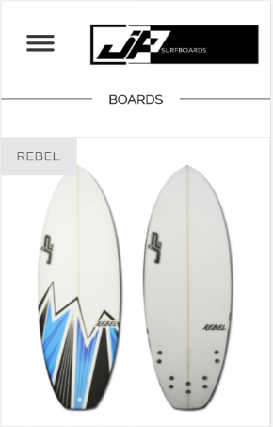
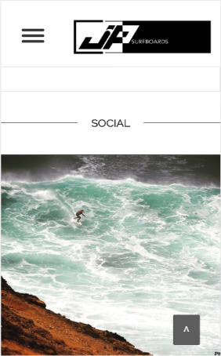

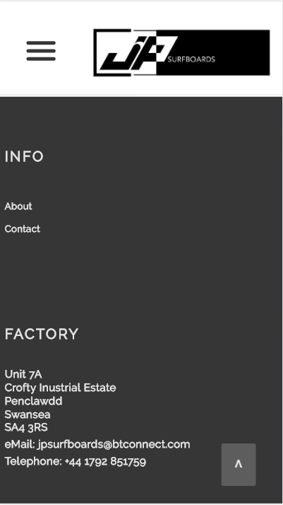
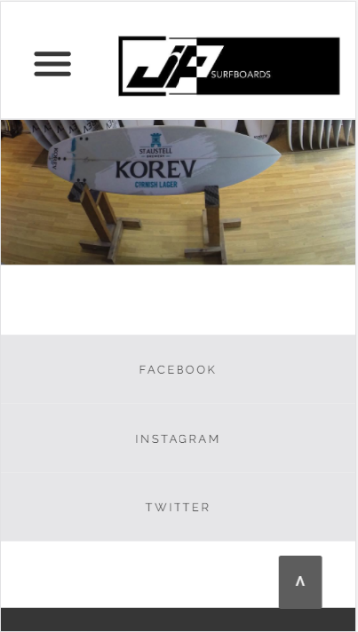

Surfboards

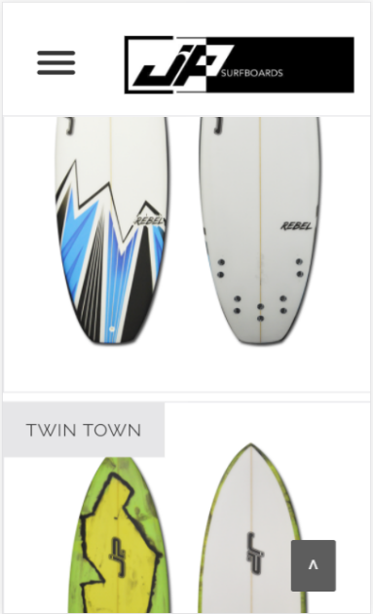
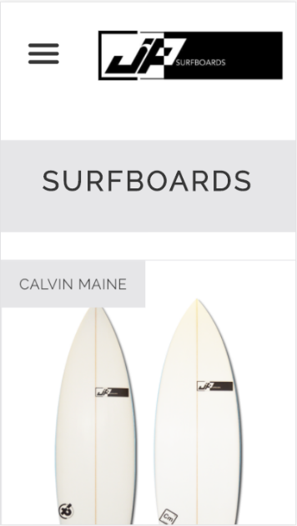

Custom
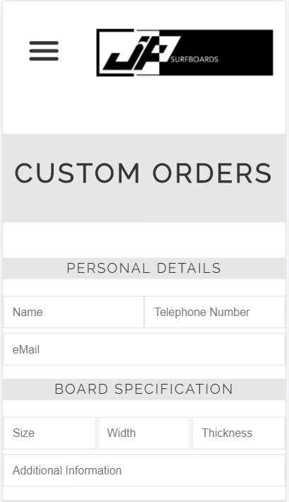
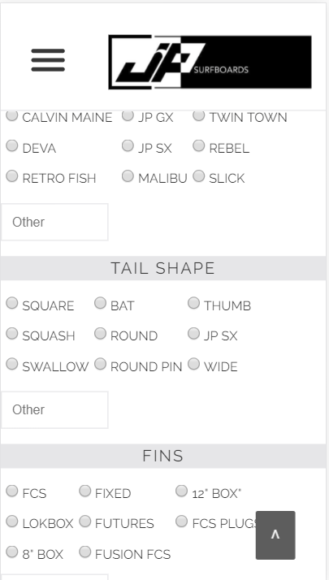

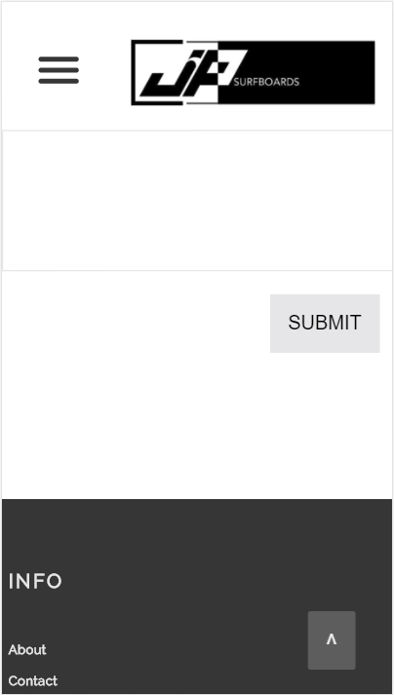
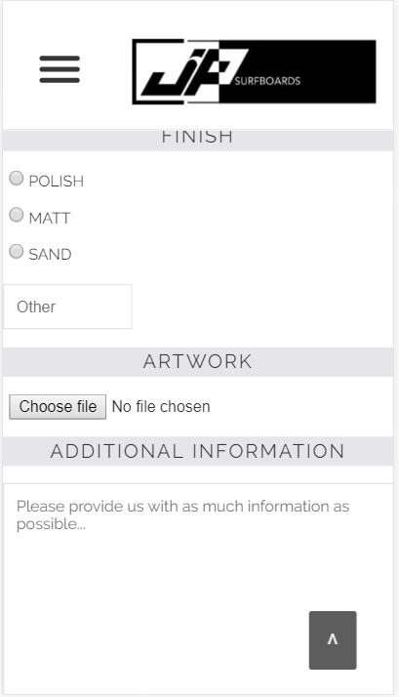

About
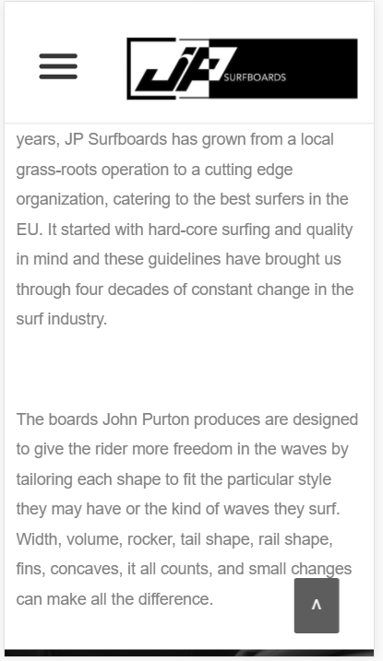
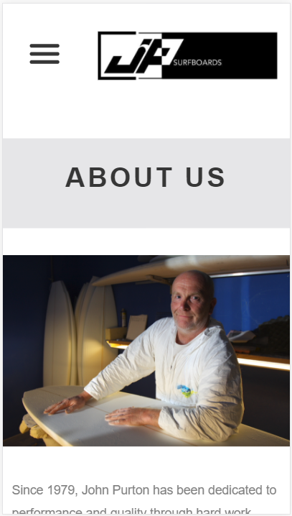
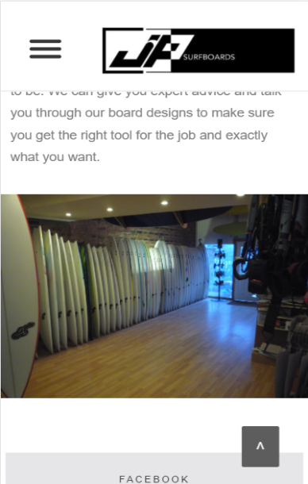
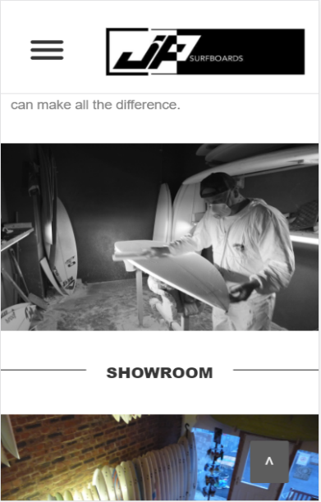
Contact
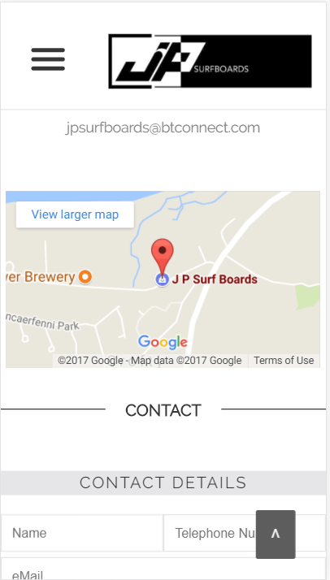
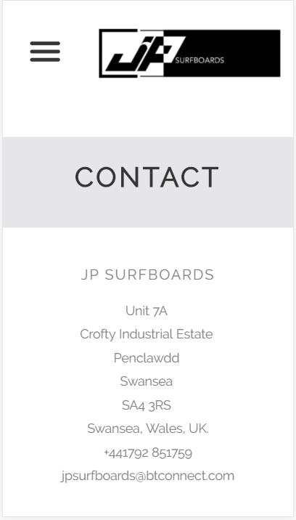

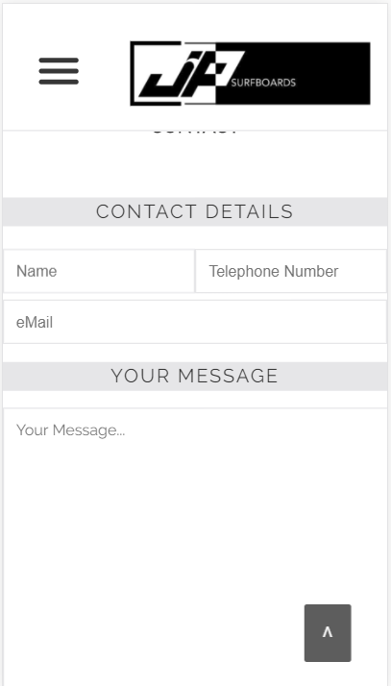
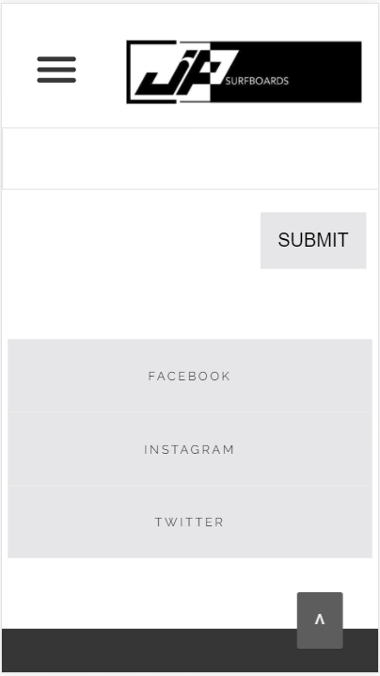

Board Page
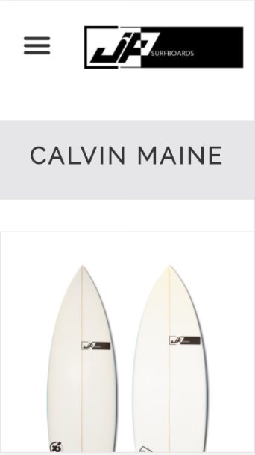
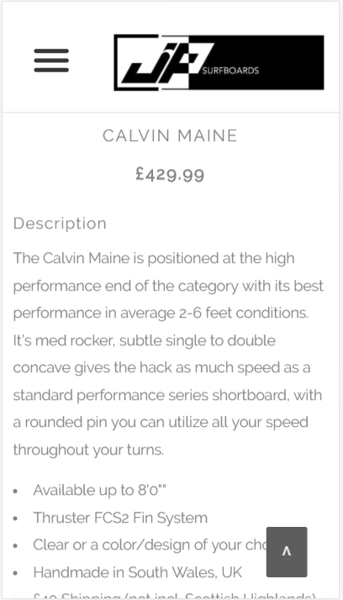

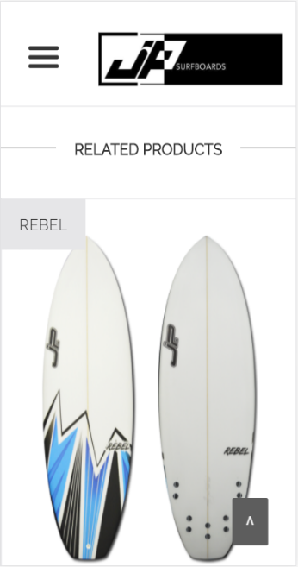
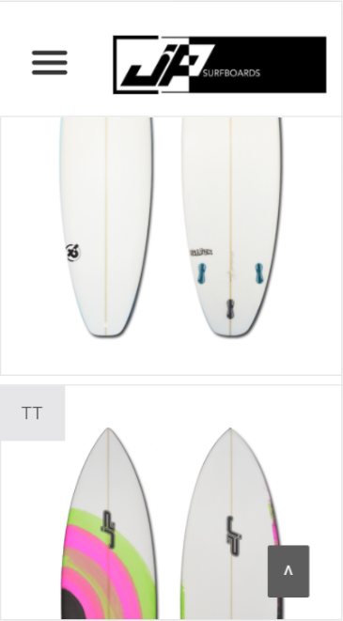

Hamburger Menu

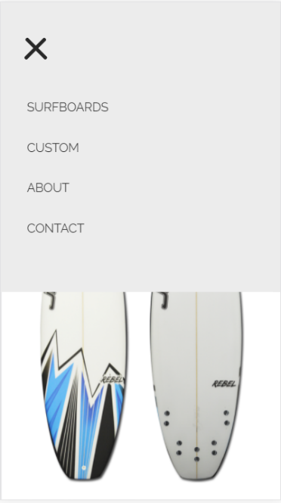

2.2.4.2 Screenshots (max-width: 900px;)

Home page

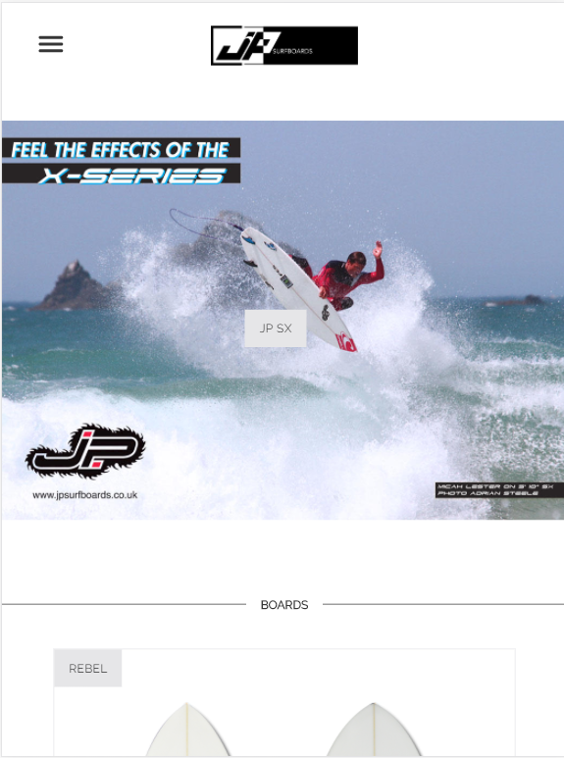

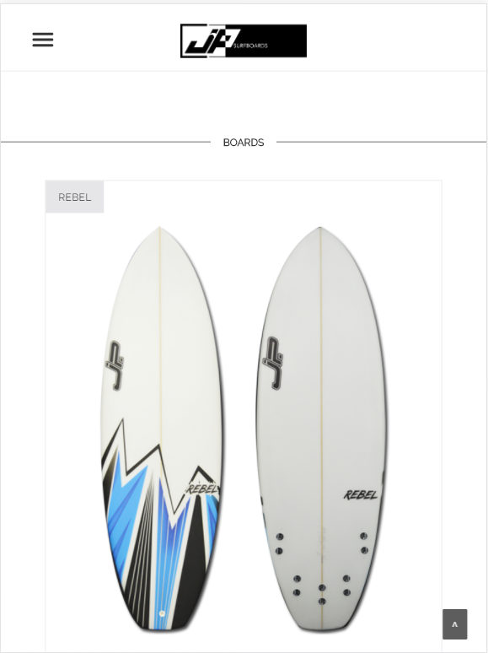

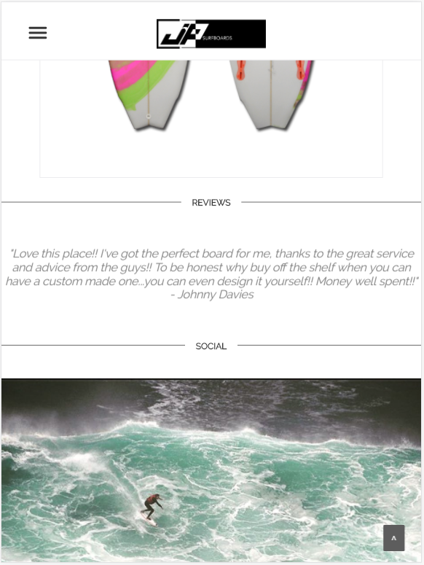

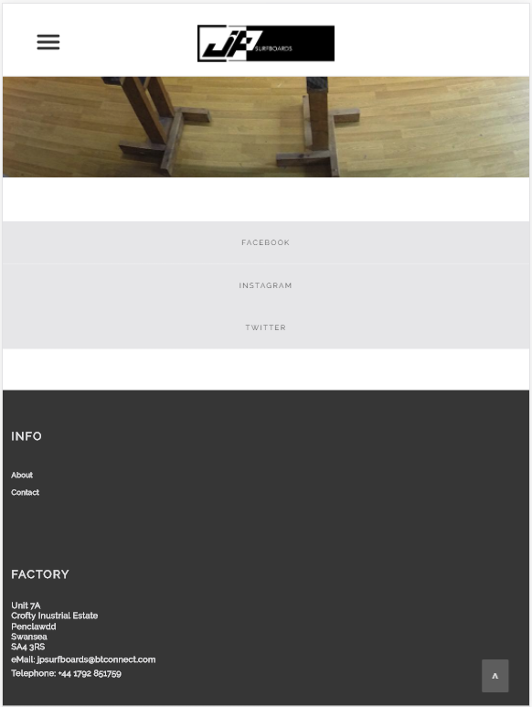

Surfboards

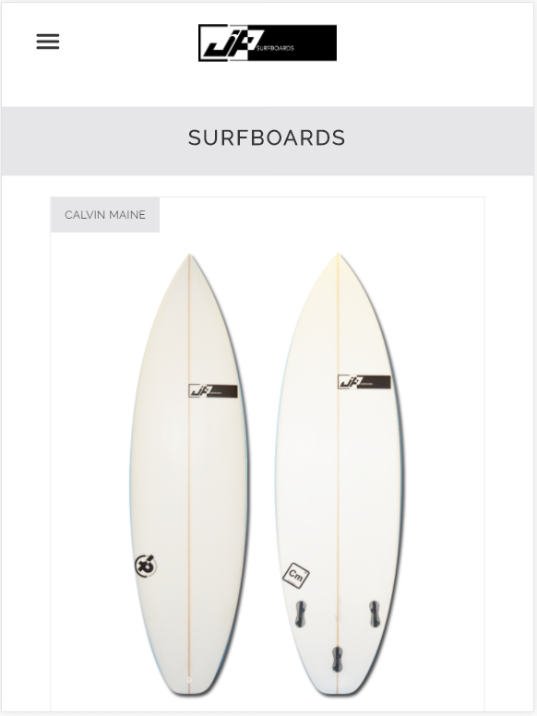

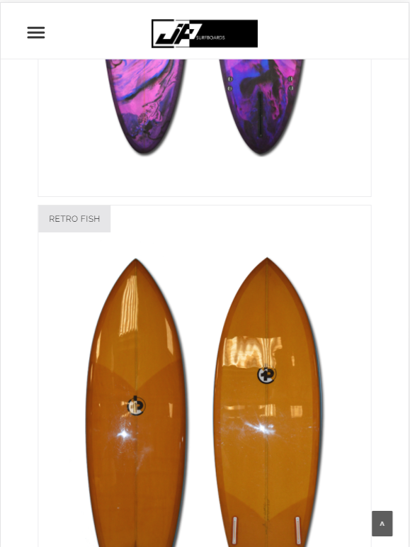

Custom

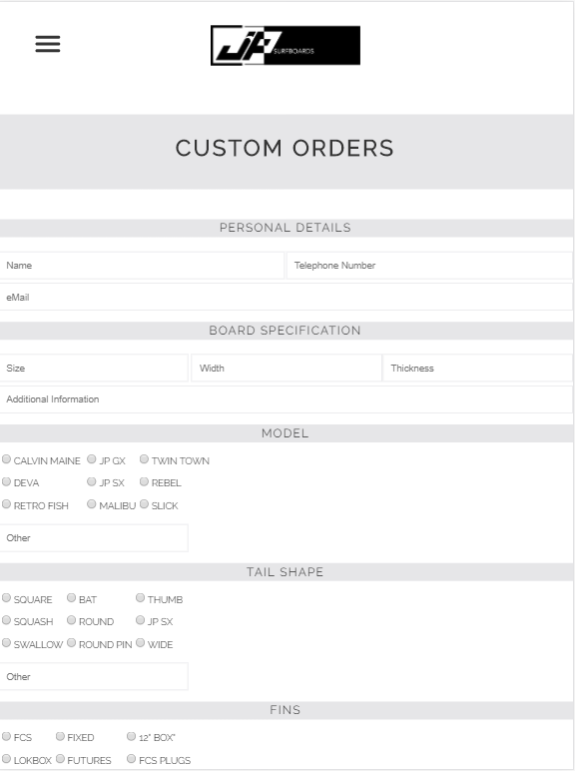

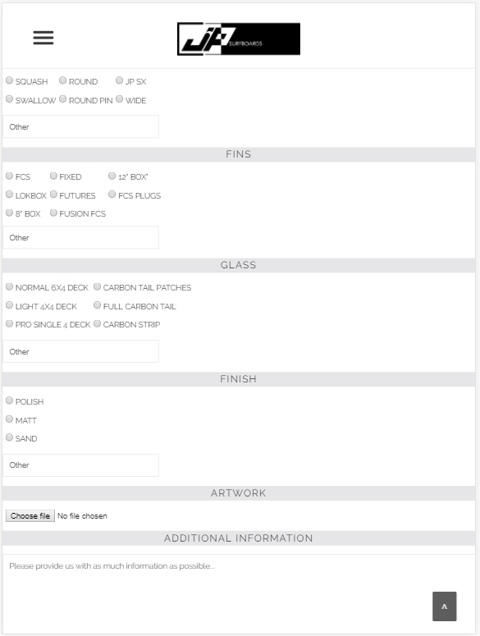

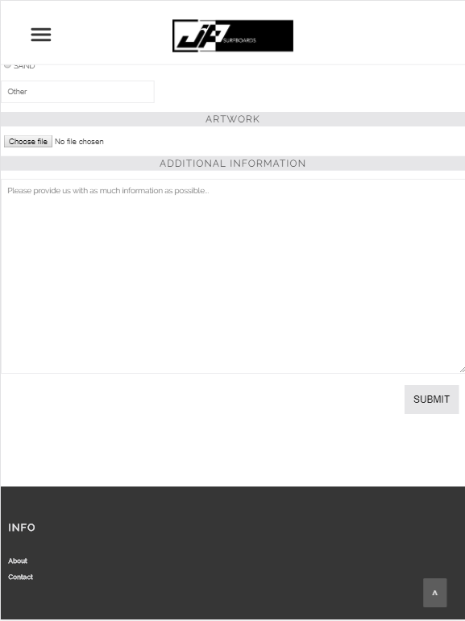

About

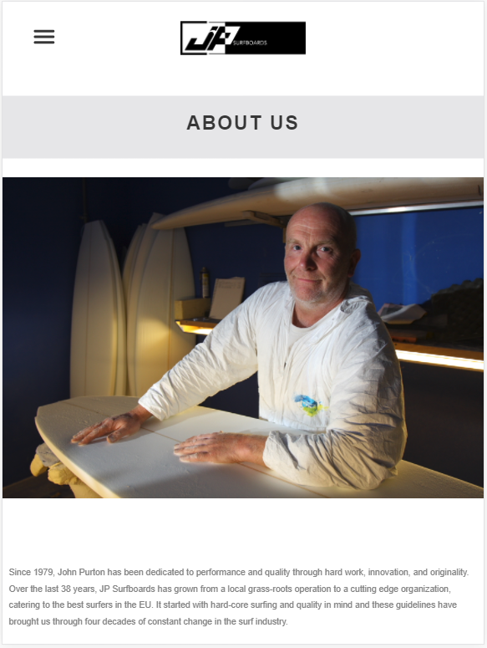

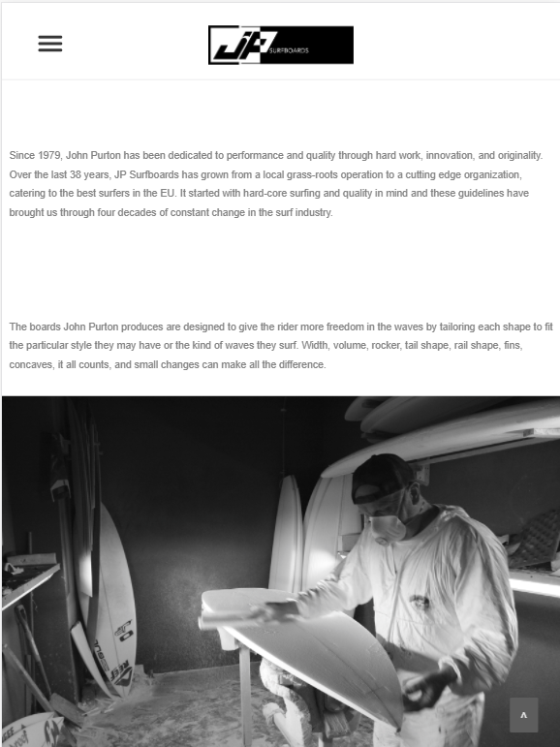

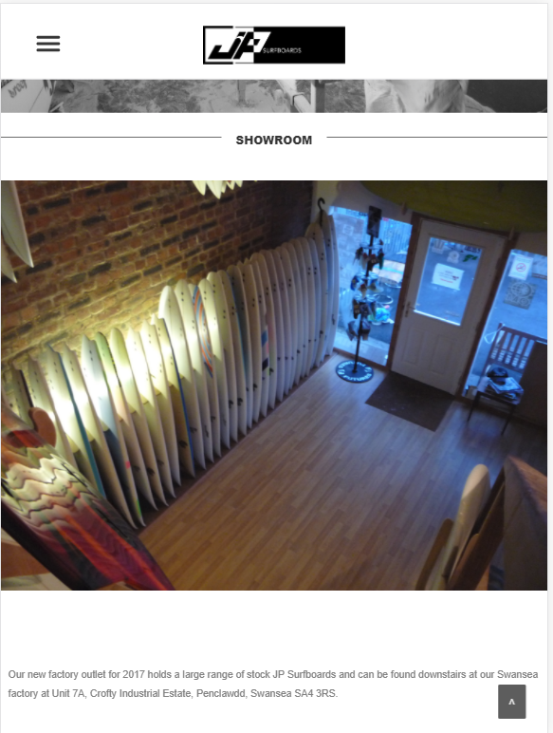

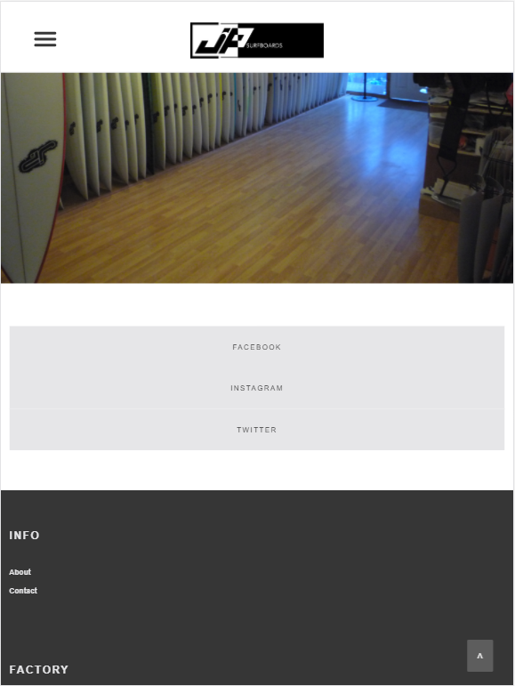

Contact

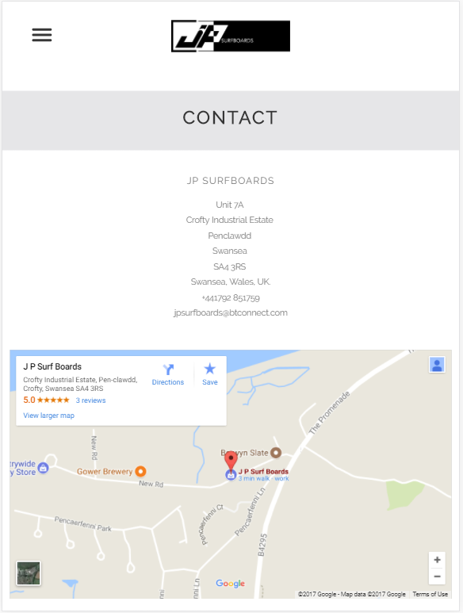

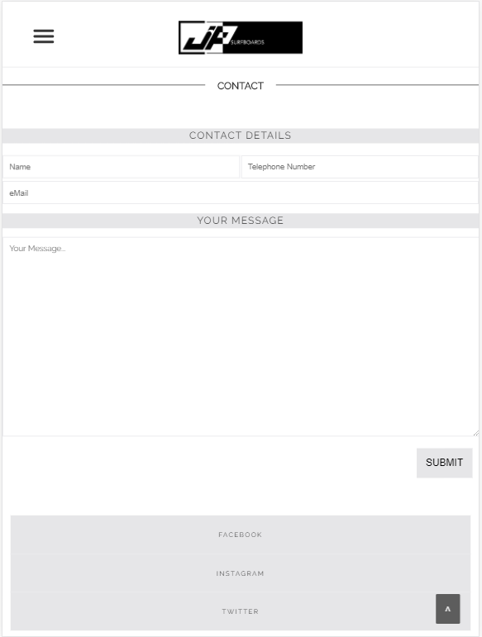

Board Page

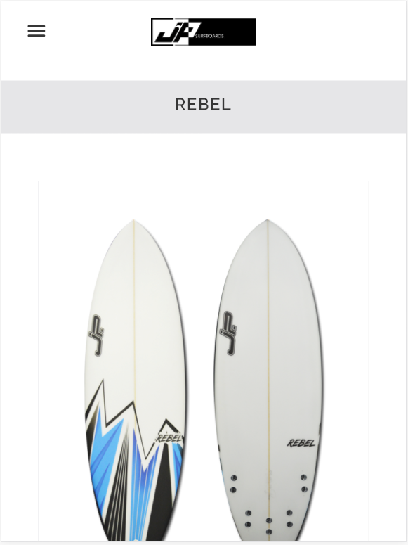

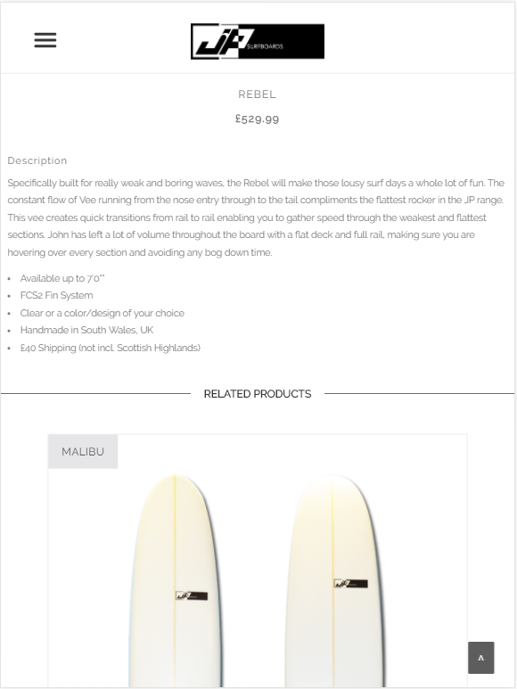

Hamburger

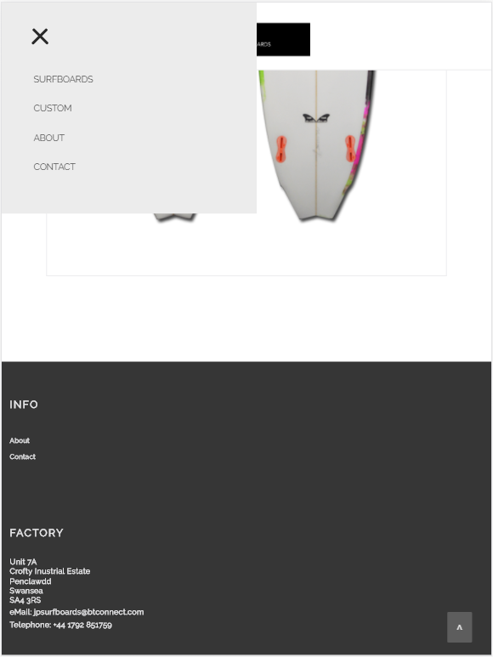

2.2.4.3 Screenshots (max-width: 1200px;)

Home Page

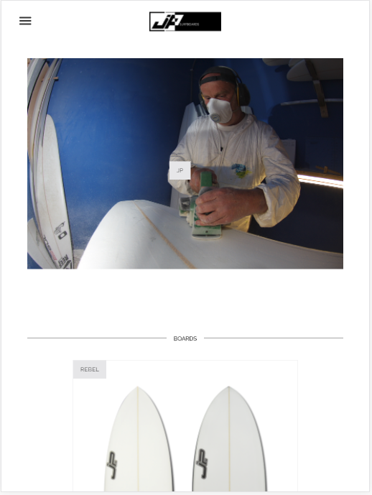

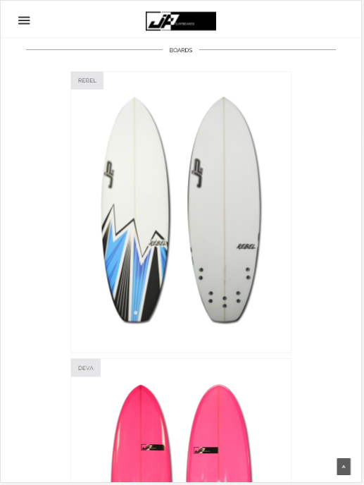

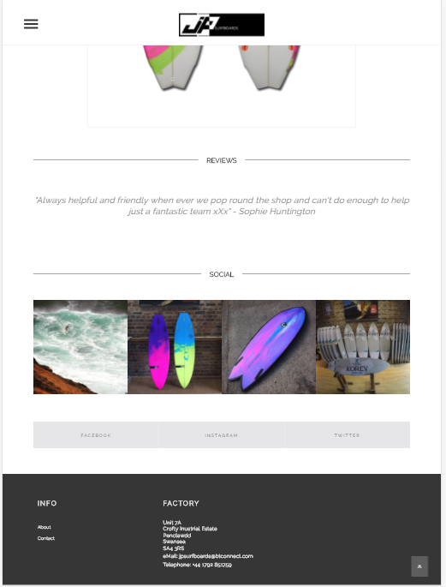

Surfboards

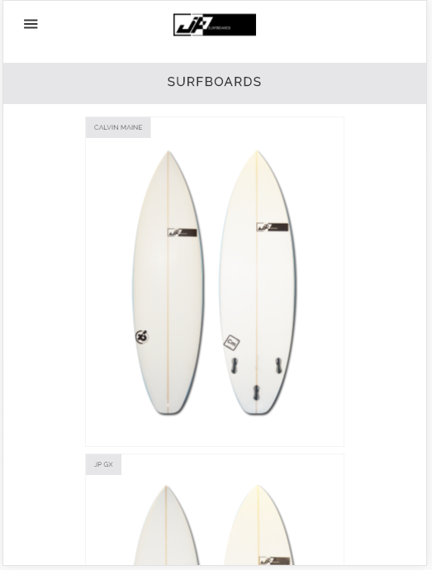

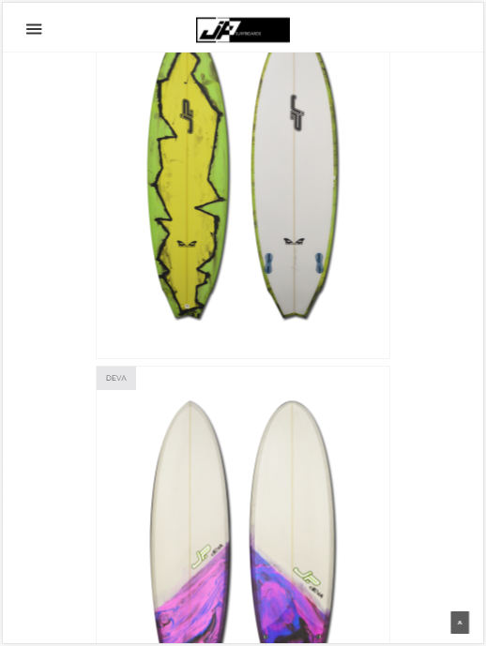

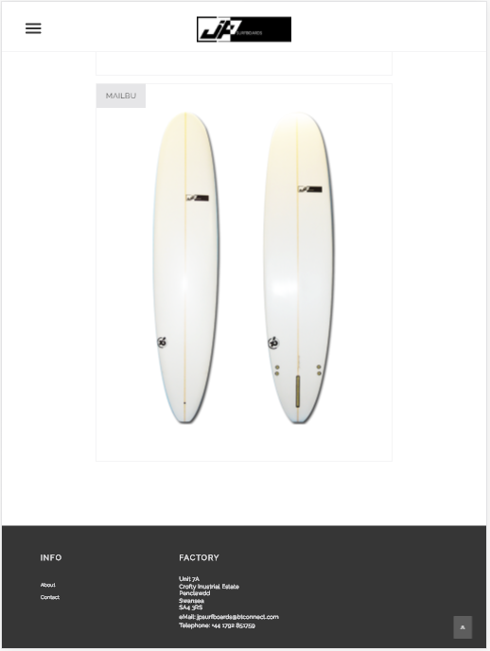

Custom

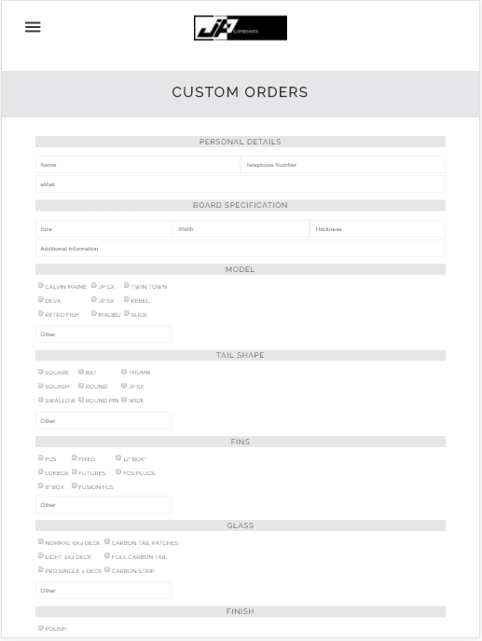

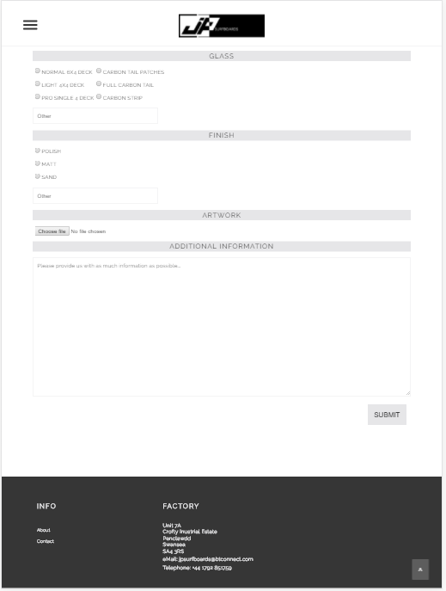

About

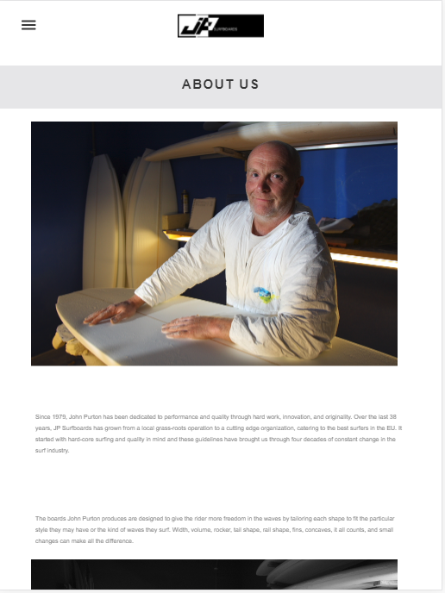

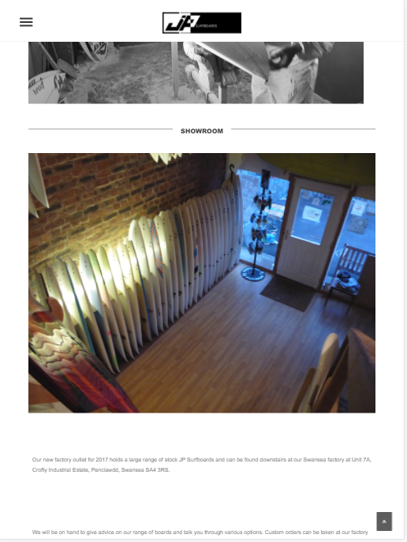

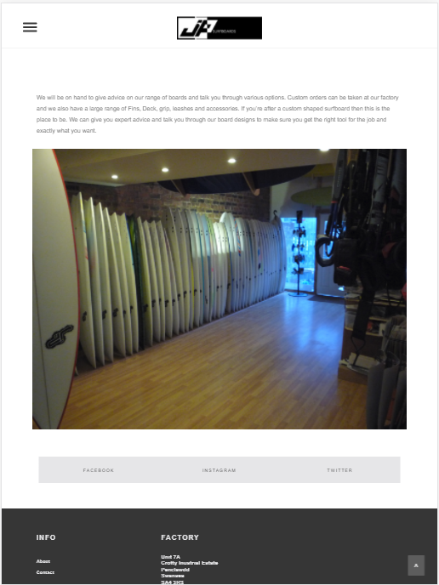

Contact

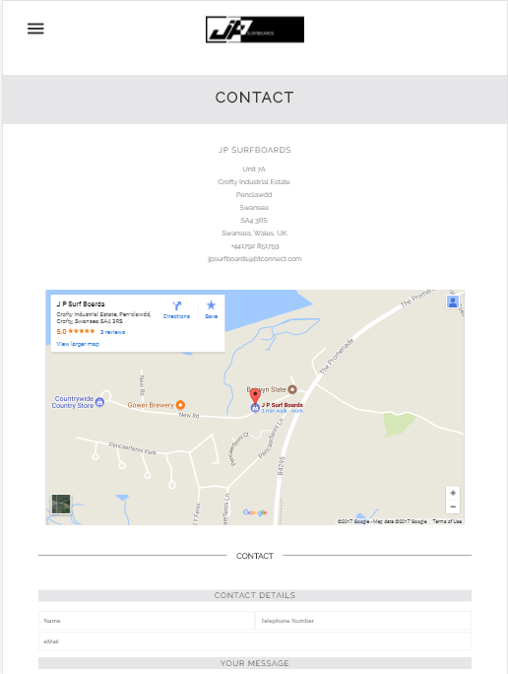

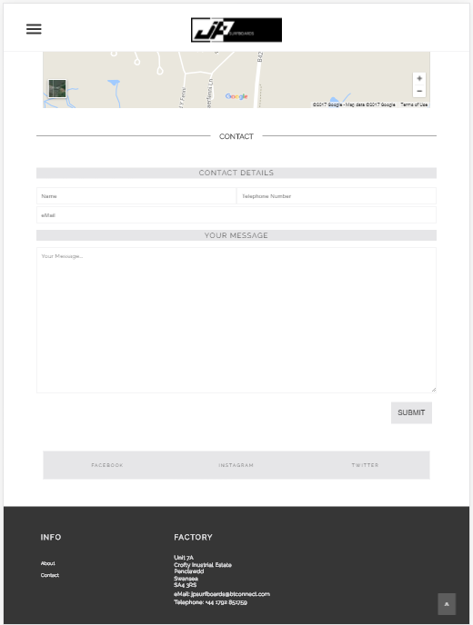

Board Page

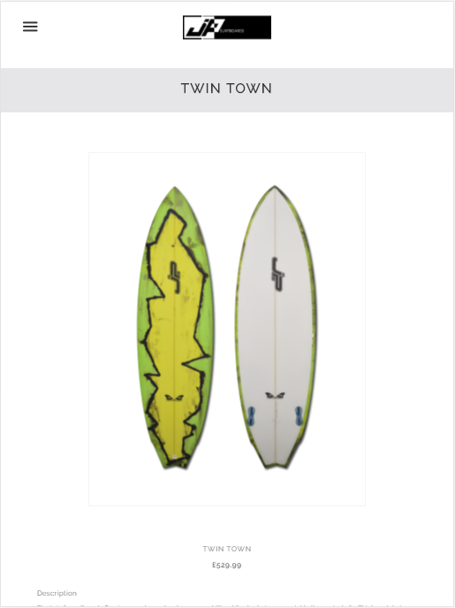

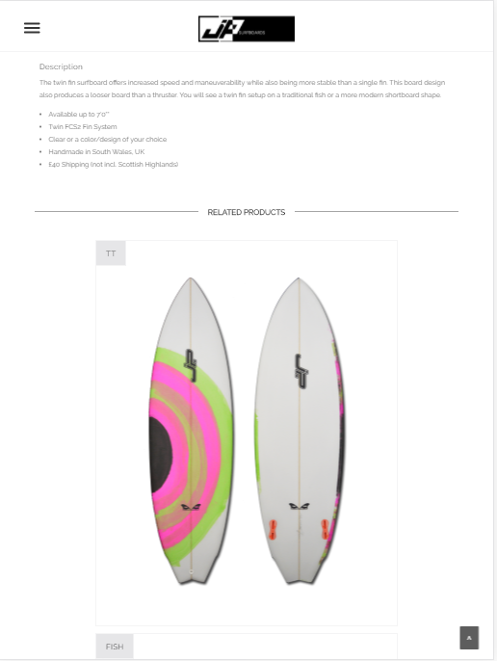

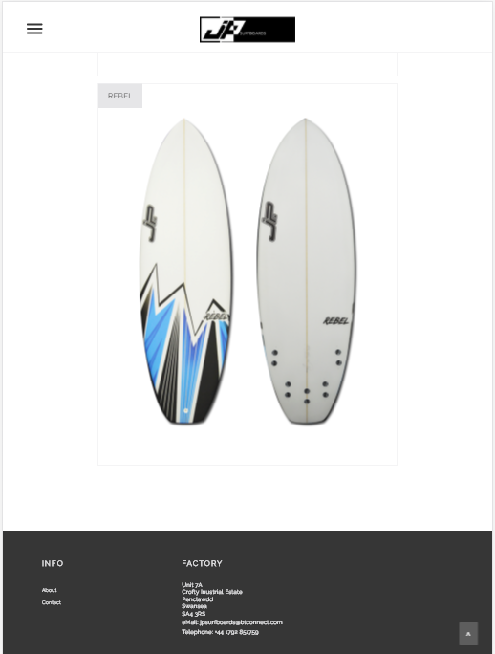

Hamburger Menu

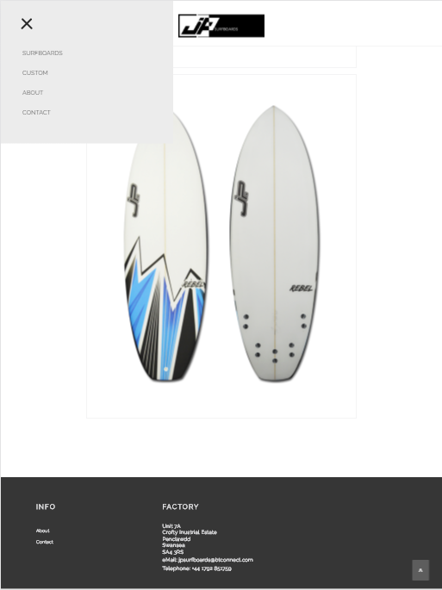

2.2.2.4 Screenshots (max-width: 1800px;)

Home Page

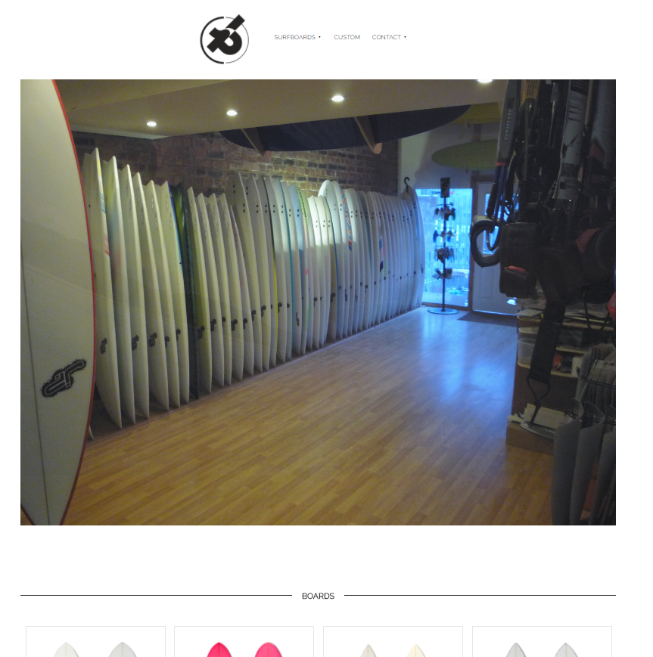

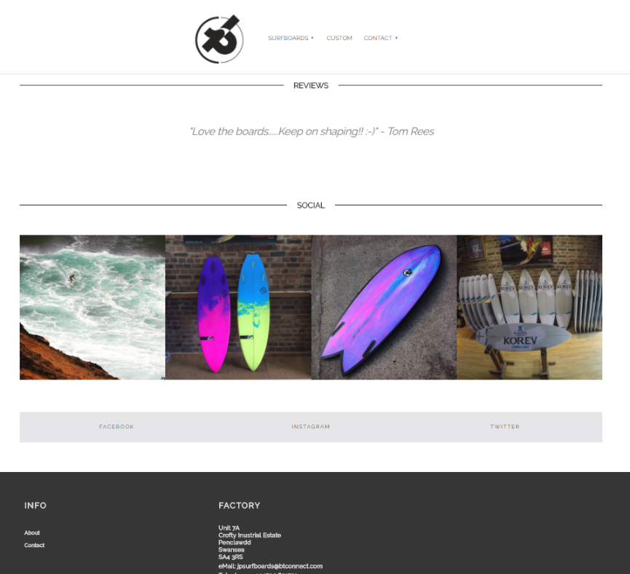

Surfboards

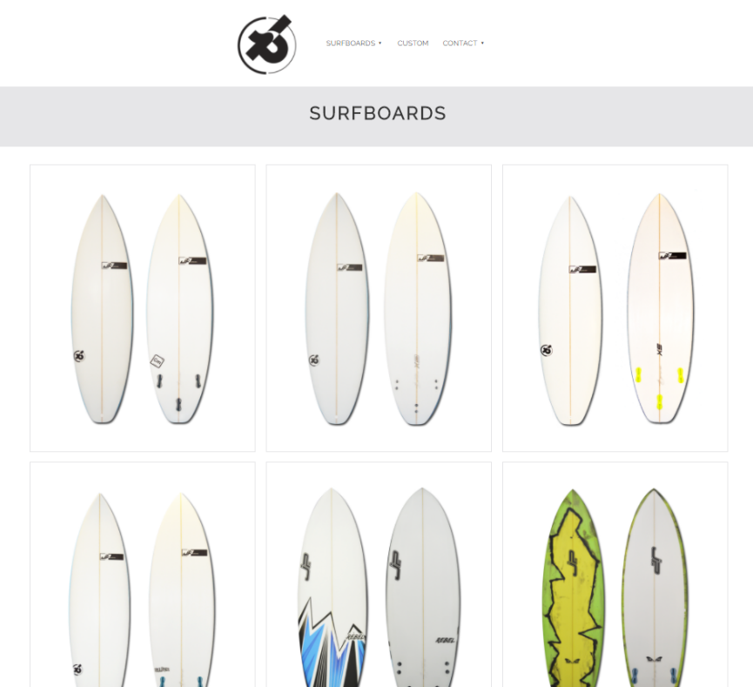

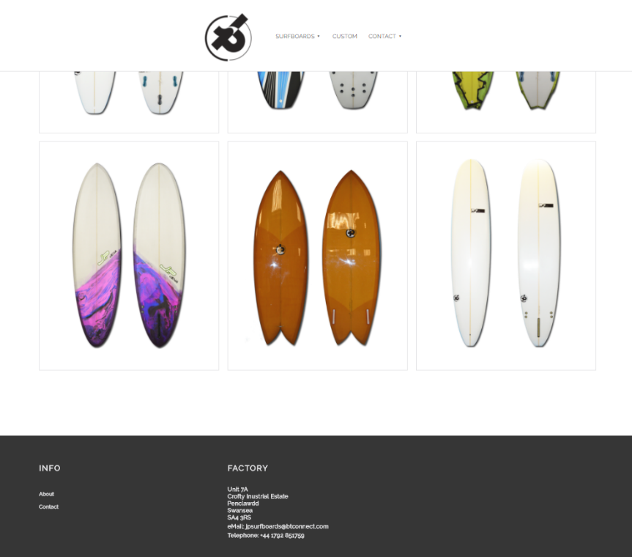

Custom

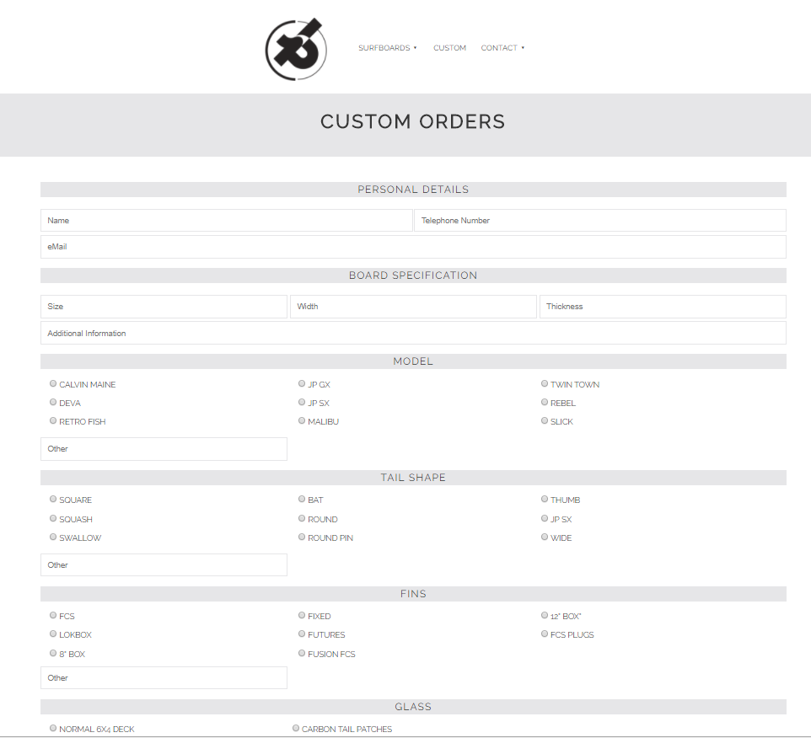

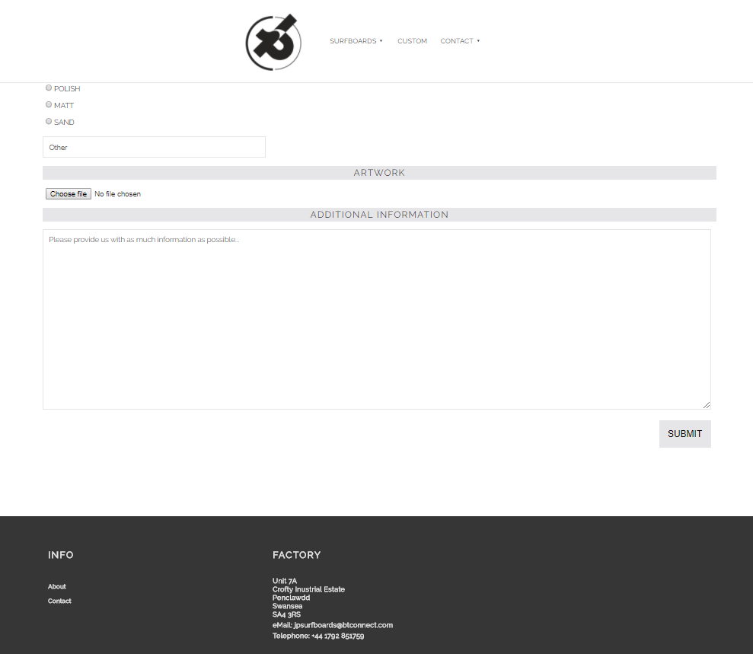

About

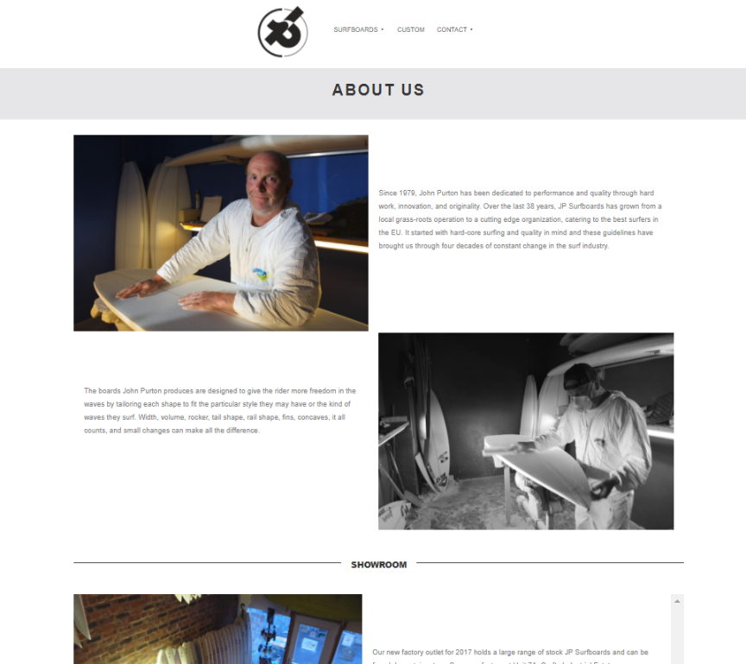

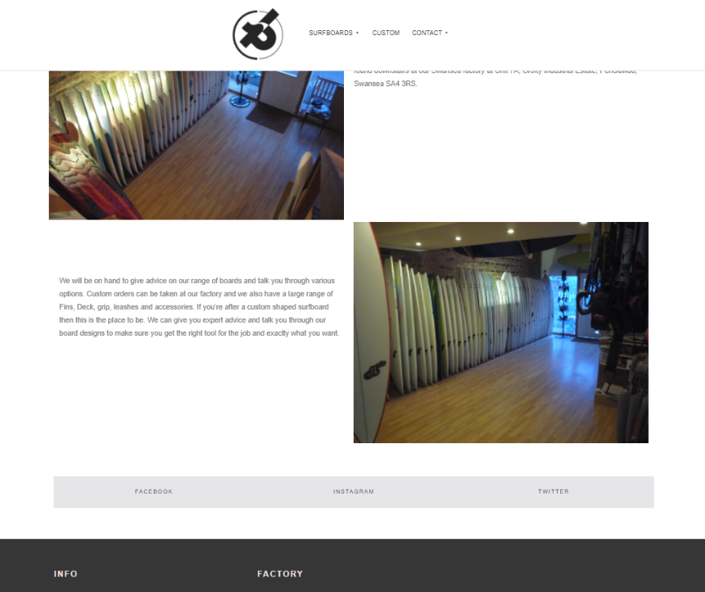

Contact

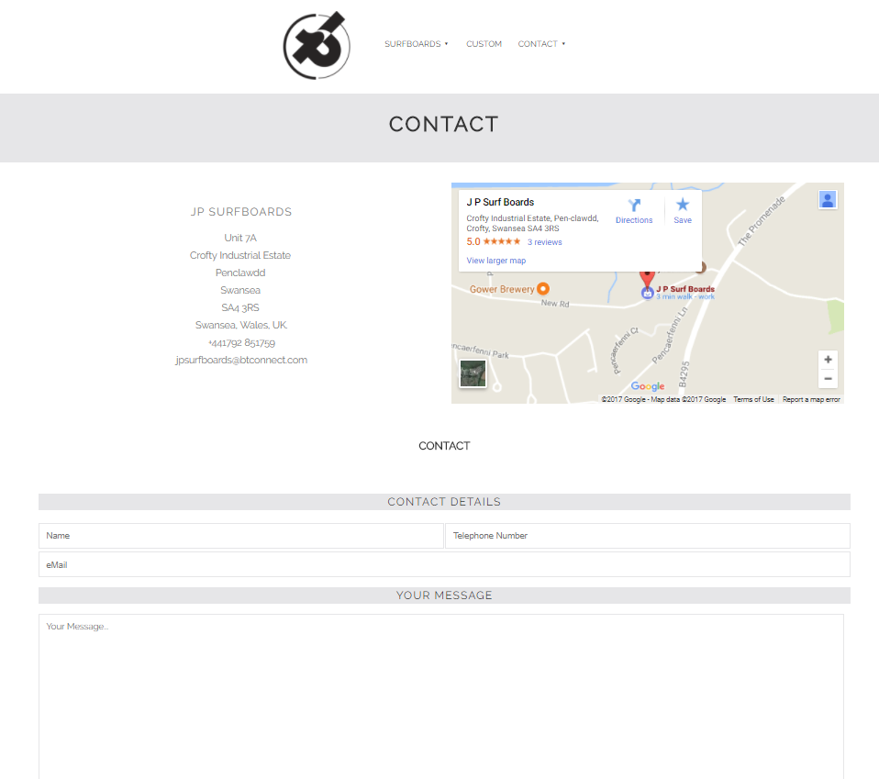
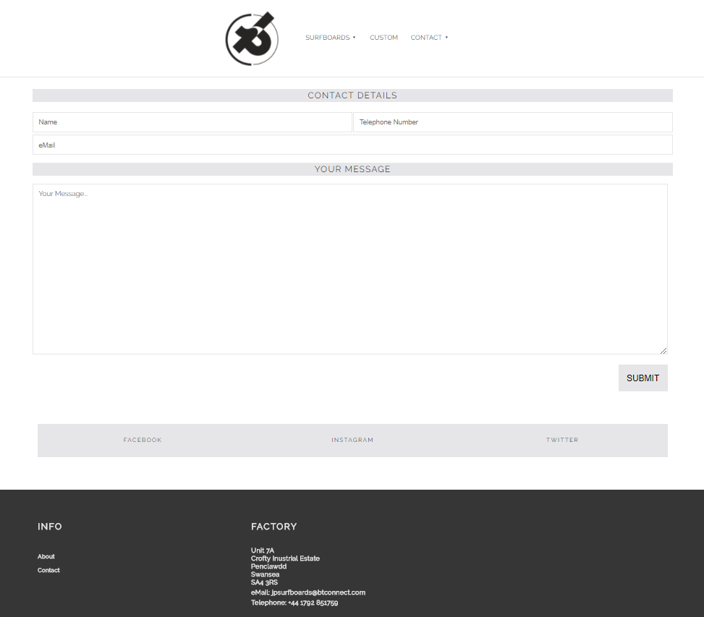

Board Page
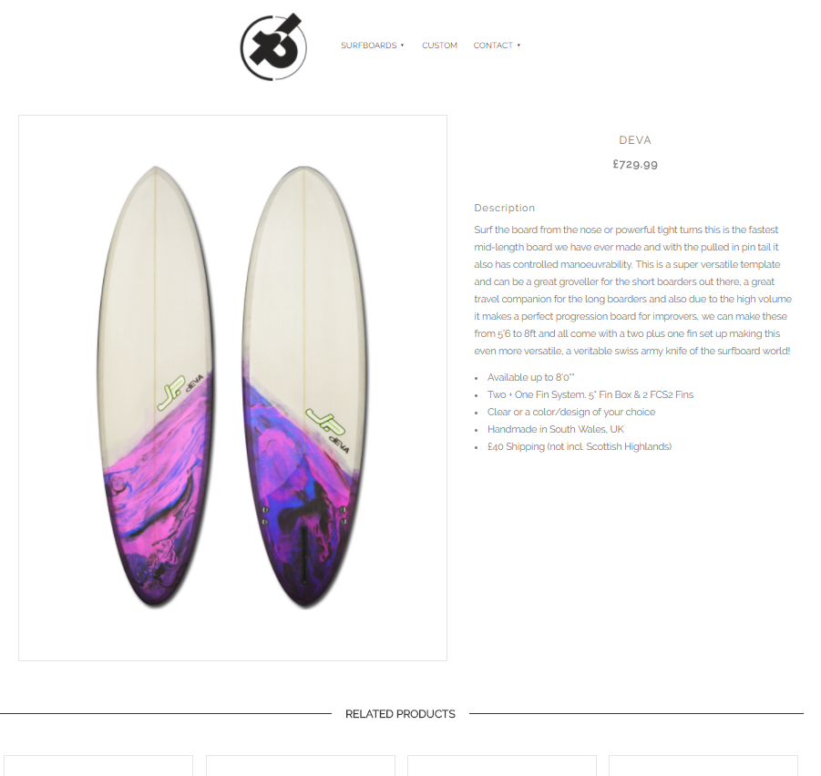

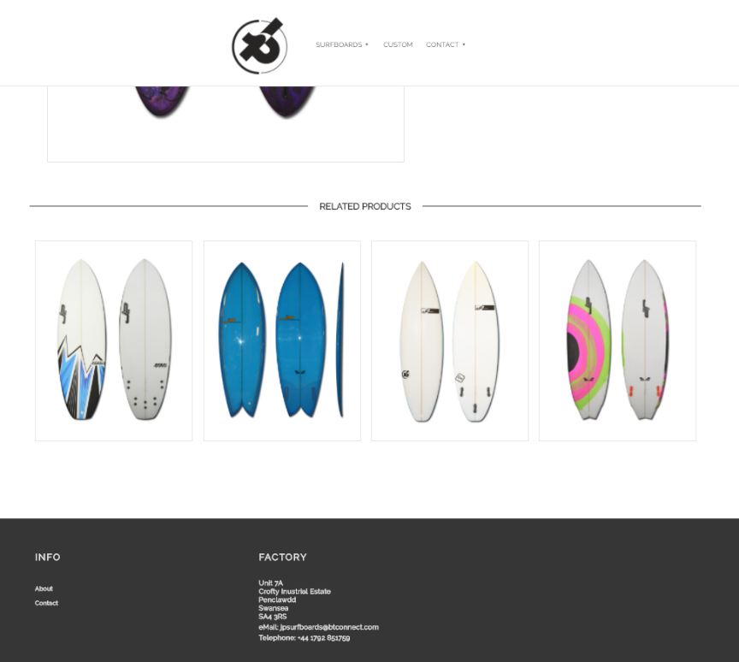

Evaluation

3.1 Errors & Challenges Encountered

- The header uses the CSS position ‘fixed’ property to allow it to stay at the top of the page, creating a problem for the content on the page. The ‘fixed’ style takes the element out of the flow of the document [32] meaning all other elements will start from the top and therefore be hidden behind the header. To solve this, a ‘spacer’ <div> element was added with a height of 120px, the height of the header, to allow content to clear the header. Empty <div> elements are not semantic, as stated on the W3 website ‘elements whose content model allows any flow content or phrasing content should have at least one node in its contents that is palpable content and that does not have the hidden attribute specified’ [33]. Better solutions should be researched and implemented.

- To reset the style of the page the * selector was used to select all elements, and box-sizing was set to ‘border-box’, creating a centring problem with content as border-box was added to all elements. Solution; box-sizing specification was moved to the <html> and <body> tags.

- The dropdown menu was not clearing the fixed header. The reason; position property was set ‘absolute’, setting it ‘fixed’ took the content out of the flow of the document and the dropdown cleared the header rather than forcing the header to re-size.

- The position property was also modified for the CSS Hamburger menu. It was not clearing the header, the <ul> hiding behind. Solution; the position was set to ‘absolute’ from ‘relative’ and the z-index property was set to a higher value on all child elements of the menu to allow the elements to stack [34].

- The slideshow used comes with pre-built in arrows to allow user to move the slides manually. This setting is default and it has been manually activated in the jQuery file, however, the arrows do not display. Looking through Google’s developer tools the elements are being displayed, however, even by defining different styles to the arrows element container, the arrows do not show. Investigation into the arrows on this element is needed, it was desired to use Font Awesome chevrons [35] as icons to navigate.

- Social media links at the bottom of the page should display a gap between the grey or a border right and left <li>. When a border is added, the last <li> element pushes below the <li>’s. Setting box sizing to ‘border-box’ on parent element solves the problem but the browser now displays space at the end of the last <li> element. Remaining un-fixed.

- A small amount of SASS [17] is implemented. It’s use sitewide is limited due to time constraints. Benefits of the SASS pre-processor are vast, practice is required to utilise it. Code remains untidy.

- Mobile-first developing proved a steep learning curve. This approach, even on a small website, like the one produced has proved to be tasking. It’s a skill that will improve with experience as nearly all websites developed today use a mobile-first approach [36].

- Logo will not display in Firefox or MS Edge browsers. Using CSS ‘content’, ‘background’ or ‘background-image’. Setting sizes on the container element and the class did not work. Pseudo classes ‘:before’ and ’:after’ displayed logo across all browsers, however, size styles would not apply.

3.2 Evaluation of JP Surfboards

The JP Surfboards website is relevant to the subject matter, providing an aesthetically pleasing, fresh, simple effective design. Navigation is simplistic, owing to three displayed links, utilising a drop-down menu on hover state linking other sections of the site. The logo is modern, and links to the home page. In mobile-view, the simplistic approach is continued with a simple hamburger menu offering four links. The logo is changed to a more explanatory one, whilst innkeeping with the theme. On screens larger than 600px, the slideshow impresses, spanning the full width of page.

Colours site wide are fresh, and consistent, passing most contrast tests. Text colour used (#828282) on some pages fails three guidelines on WCAG’s contrast checker [37], however, it was decided to keep the theme across all pages. ‘Raleway’ font is modern and reflects the business image well, it is concise and clear. Bold headings, provide the visitor with a location on the website. Images have been carefully selected, are all relevant and enhance the website’s look and feel. The contact page offers an informative location for customers to find contact information, location and e-mail the business. The purpose-built order form is simple, clear and effective.

3.3 Reflection & Recommendations

The navigation provided could improve as a ‘clickable’ one, over, a hovering one, improving the usability when viewed through large mobile devices in landscape orientation.

Display of surfboards in the individual surfboard page would profit from a thumbnail gallery at the foot of the main image. Users click the thumbnail to display a larger image in the main image frame, allowing more images of the board.

Colours used compliment well, are uniform, but, from an accessibility perspective, the colours could be improved to meet every guidelines outlined by W3C [38] to ensure the website is accessible to all.

Finally, the content at present is limited. More information on each surfboard could be added, with more models available to view online, too. The website would benefit from more media; an image gallery and embedded videos of professionals riding the products, and biographies of the surfers who use John’s boards. A more in-depth history of John, his son and the company would also offer a more personal touch.

References

[1] “J P Surf Boards - Google Maps.” [Online]. Available: https://www.google.co.uk/maps/place/J+P+Surf+Boards/@51.6383517,-4.1278922,15z/data=!4m5!3m4!1s0x0:0x98f08ddabb9be802!8m2!3d51.6383517!4d-4.1278922. [Accessed: 08-Dec-2017].

[2] M. Jones, “The importance of web presence for small businesses,” Simply Business, 2013. [Online]. Available: https://www.simplybusiness.co.uk/knowledge/articles/2013/05/why-web-presence-is-important/. [Accessed: 08-Dec-2017].

[3] A. Shotland, “7 Local Web Marketing Infographics To Overload Your Brain,” Search Engine Land, 2011. [Online]. Available: https://searchengineland.com/7-local-web-marketing-infographics-to-overload-your-brain-68444. [Accessed: 08-Dec-2017].

[4] S. Spears, “Local Business Stats | Spears Marketing,” Spears Marketing, 2012. [Online]. Available: https://spearsmarketing.com/3049/local-business-stats/. [Accessed: 08-Dec-2017].

[5] K. Morrison, “81% of Shoppers Conduct Online Research Before Buying [Infographic] – Adweek,” AdWeek, 2014. [Online]. Available: http://www.adweek.com/digital/81-shoppers-conduct-online-research-making-purchase-infographic/. [Accessed: 08-Dec-2017].

[6] “The 100% correct way to do CSS breakpoints – freeCodeCamp.” [Online]. Available: https://medium.freecodecamp.org/the-100-correct-way-to-do-css-breakpoints-88d6a5ba1862. [Accessed: 29-Nov-2017].

[7] P. Piejko, “Top 5 most popular smartphones across the globe,” Device Atlas, 2016. [Online]. Available: https://deviceatlas.com/blog/most-popular-smartphones-2016. [Accessed: 08-Dec-2017].

[8] K. Larson, “iPhone 6 Screen Size and Mobile Design Tips - Updated for iPhone 8 &amp; X!,” Kyle J Larson. [Online]. Available: http://www.kylejlarson.com/blog/iphone-6-screen-size-web-design-tips/. [Accessed: 08-Dec-2017].

[9] “mydevice.io know your mobile device (pixel-ratio, CSS width, features),” My Device. [Online]. Available: https://mydevice.io/devices/. [Accessed: 08-Dec-2017].

[10] R. Fingas, “Conflicting statistics still put Apple’s iPad at top of tablet market in Dec. quarter,” Apple Insider, 2017. [Online]. Available: http://appleinsider.com/articles/17/02/02/conflicting-statistics-still-put-apples-ipad-at-top-of-tablet-market-in-dec-quarter. [Accessed: 08-Dec-2017].

[11] “Viewport Sizes.” [Online]. Available: http://viewportsizes.com/?filter=. [Accessed: 08-Dec-2017].

[12] “Browser Display Statistics,” W3Schools, 2017. [Online]. Available: https://www.w3schools.com/browsers/browsers_display.asp. [Accessed: 10-Dec-2017].

[13] F. Lardinois, “Move Over 1024×768: The Most Popular Screen Resolution On The Web Is Now 1366×768 | TechCrunch,” TechCrunch, 2012. [Online]. Available: https://techcrunch.com/2012/04/11/move-over-1024x768-the-most-popular-screen-resolution-on-the-web-is-now-1366x768/. [Accessed: 10-Dec-2017].

[14] “Defining Breakpoints | Responsive Web Design.” [Online]. Available: https://responsivedesign.is/strategy/page-layout/defining-breakpoints/. [Accessed: 10-Dec-2017].

[15] “Bootstrap · The most popular HTML, CSS, and JS library in the world.” [Online]. Available: https://getbootstrap.com/. [Accessed: 10-Dec-2017].

[16] “The most advanced responsive front-end framework in the world. | Foundation.” [Online]. Available: https://foundation.zurb.com/. [Accessed: 10-Dec-2017].

[17] “Sass: Syntactically Awesome Style Sheets.” [Online]. Available: http://sass-lang.com/. [Accessed: 10-Dec-2017].

[18] “jQuery.” [Online]. Available: https://jquery.com/. [Accessed: 10-Dec-2017].

[19] “Google Fonts.” [Online]. Available: https://fonts.google.com/. [Accessed: 10-Dec-2017].

[20] “API Client Libraries | Google Developers.” [Online]. Available: https://developers.google.com/api-client-library/. [Accessed: 10-Dec-2017].

[21] “Google Maps Embed API | Google Developers.” [Online]. Available: https://developers.google.com/maps/documentation/embed/. [Accessed: 10-Dec-2017].

[22] K. Wheeler, “Slick - the Last Carousel You’Ll Ever Need.” [Online]. Available: http://kenwheeler.github.io/slick/. [Accessed: 10-Dec-2017].

[23] “CSS Dropdowns.” [Online]. Available: https://www.w3schools.com/css/css_dropdowns.asp. [Accessed: 27-Nov-2017].

[24] “How To Create a Hoverable Dropdown Menu.” [Online]. Available: https://www.w3schools.com/howto/howto_css_dropdown.asp. [Accessed: 27-Nov-2017].

[25] “How To Create Image Hover Overlay Effects.” [Online]. Available: https://www.w3schools.com/howto/howto_css_image_overlay.asp. [Accessed: 05-Dec-2017].

[26] “Pure CSS Hamburger fold-out menu.” [Online]. Available: https://codepen.io/erikterwan/pen/EVzeRP. [Accessed: 07-Dec-2017].

[27] “How To Create a Scroll Back To Top Button.” [Online]. Available: https://www.w3schools.com/howto/howto_js_scroll_to_top.asp. [Accessed: 03-Dec-2017].

[28] “W3 Schools - onscroll Event.” [Online]. Available: https://www.w3schools.com/jsref/event_onscroll.asp. [Accessed: 27-Nov-2017].

[29] “12.15. Changing the Element’s CSS Style Properties - JavaScript Cookbook [Book].” [Online]. Available: https://www.safaribooksonline.com/library/view/javascript-cookbook/9781449390211/ch12s16.html. [Accessed: 27-Nov-2017].

[30] “Gaynor Thomas - University of Wales Trinity Saint David.” [Online]. Available: http://www.uwtsd.ac.uk/staff/gaynor-thomas/. [Accessed: 10-Dec-2017].

[31] “Favicon Generator for all platforms: iOS, Android, PC/Mac...” [Online]. Available: https://realfavicongenerator.net/. [Accessed: 10-Dec-2017].

[32] C. Coyier, “position | CSS-Tricks,” CSS-Tricks, 2017. [Online]. Available: https://css-tricks.com/almanac/properties/p/position/. [Accessed: 10-Dec-2017].

[33] “HTML 5.1 2nd Edition: 3. Semantics, structure, and APIs of HTML documents.” [Online]. Available: https://www.w3.org/TR/html5/dom.html#sec-palpable-content. [Accessed: 10-Dec-2017].

[34] “CSS z-index property.” [Online]. Available: https://www.w3schools.com/cssref/pr_pos_z-index.asp. [Accessed: 10-Dec-2017].

[35] “fa-chevron-left: Font Awesome Icons.” [Online]. Available: http://fontawesome.io/icon/chevron-left/. [Accessed: 10-Dec-2017].

[36] J. Knutila, “What is Mobile First Design, and Why Should I Care? | Moboom,” Moboom, 2013. [Online]. Available: http://moboom.com/blog-post/what-is-mobile-first-design-and-why-should-i-care/e14c121f-f539-aa88-23a1-5217e7b71283. [Accessed: 10-Dec-2017].

[37] “WCAG - Contrast Checker.” [Online]. Available: https://contrastchecker.com/. [Accessed: 10-Dec-2017].

[38] “Web Content Accessibility Guidelines (WCAG) 2.0.” [Online]. Available: https://www.w3.org/TR/WCAG20/. [Accessed: 10-Dec-2017].

Bibliography

[1] “Handling Scroll Events - Sencha Touch Cookbook [Book].” [Online]. Available: https://www.safaribooksonline.com/library/view/sencha-touch-cookbook/9781849515443/ch09s03.html. [Accessed: 10-Dec-2017].
[2] “How to Embed Google Maps in Responsive Websites.” [Online]. Available: https://www.labnol.org/internet/embed-responsive-google-maps/28333/. [Accessed: 10-Dec-2017].
[3] “How To Create Image Hover Overlay Effects.” [Online]. Available: https://www.w3schools.com/howto/howto_css_image_overlay.asp. [Accessed: 05-Dec-2017].
[4] “Deep Get/Set in Maps | CSS-Tricks.” [Online]. Available: https://css-tricks.com/snippets/sass/deep-getset-maps/. [Accessed: 30-Nov-2017].
[5] “CSS - box-sizing.” [Online]. Available: http://learnlayout.com/box-sizing.html. [Accessed: 28-Nov-2017].
[6] “How to build a responsive grid system | Zell Liew.” [Online]. Available: https://zellwk.com/blog/responsive-grid-system/. [Accessed: 28-Nov-2017].
[7] “A Simple Responsive Grid, Made Even Better With Sass.” [Online]. Available: https://webdesign.tutsplus.com/tutorials/a-simple-responsive-grid-made-even-better-with-sass--cms-21540. [Accessed: 28-Nov-2017].
[8] “Designing grids | Zell Liew.” [Online]. Available: https://zellwk.com/blog/designing-grids/. [Accessed: 28-Nov-2017].
[9] “10 SASS (SCSS) mixins you should be using in your projects.” [Online]. Available: https://engageinteractive.co.uk/blog/top-10-scss-mixins. [Accessed: 28-Nov-2017].

[10] “CSS Slideshow text.” [Online]. Available: https://codepen.io/nucliweb/pen/ymedj. [Accessed: 02-Dec-2017].

[11] “CSS Dropdowns.” [Online]. Available: https://www.w3schools.com/css/css_dropdowns.asp. [Accessed: 27-Nov-2017].
[12] “How To Create a Fixed Menu.” [Online]. Available: https://www.w3schools.com/howto/howto_css_fixed_menu.asp. [Accessed: 27-Nov-2017].
[13] “JavaScript: automatic slideshow.” [Online]. Available: https://codepen.io/gabrieleromanato/pen/dImly. [Accessed: 01-Dec-2017].
[14] “W3.CSS Slideshow.” [Online]. Available: https://www.w3schools.com/w3css/w3css_slideshow.asp. [Accessed: 27-Nov-2017].
[15] “12.15. Changing the Element’s CSS Style Properties - JavaScript Cookbook [Book].” [Online]. Available: https://www.safaribooksonline.com/library/view/javascript-cookbook/9781449390211/ch12s16.html. [Accessed: 27-Nov-2017].
[16] “Popular Screen Resolutions: Designing for All » Media Genesis.” [Online]. Available: http://mediag.com/news/popular-screen-resolutions-designing-for-all/. [Accessed: 10-Dec-2017].
[17] “W3Counter: Global Web Stats.” [Online]. Available: https://www.w3counter.com/globalstats.php. [Accessed: 10-Dec-2017].

Appendix



