
Module Name: Analysing and Solving Problems
Module Code: ACCA 4019
Student Name: Dimitar Ivanov
Student ID: 2504573
Lecturer Name: Semih Yumusak
Submission Date:26/03/26
Deconstructing the Problem 3
Overview of the Problem 3
MoSCoW Analysis and Constraints 3
Must Have Requirements 3
Should Have Requirements 3
Could Have Requirements 3
Constraints 3
Key Variables 4
Propose a Solution 4
Overview of the Solution 4
Flowchart 5
Explanation of the Flowchart 5
Key Decisions and Assumptions 6
How the Solution Solves the Problem 6
Reflect and Justify 6
References 8

Deconstructing the Problem

Overview of the Problem
The reason we deconstruct the problem into small problems is to solve the small problem first and to make the problem easier to solve which also gives us a better understanding of the problem[1]

The problem consists of classrooms and their inefficiency since the room are full and overcrowded while other are not used effectively. The imbalance of the classrooms leads to timetables not fitting and staff having to move in-between classrooms which makes time wasting a big issue which also impacts the learning environment and experience.

The root of the problem can be interpreted as problem with resource allocation where the limited classroom space should be assigned based on the class and staff requirements and staff capabilities. This demands for further analysis of how rooms and time slots along with class sizes interact and how we can make them work in the most efficient way possible.

MoSCoW Analysis and Constraints

Must Have Requirements
Classrooms must be assigned based on class sized to prevent overcrowding. The timetable management needs to be better so that same rooms isn't booked twice for two different classes at the same time, which therefore brings us to the last issue which is assigning all classes with a specific room for that specific hour.

Should Have Requirements
The rooms could be used more efficiently to reduce the space that’s not available as well as the allocation should minimize movement time so that students and staff optimize their time better.

Could Have Requirements
The preference for allocating classes could be given to nearby buildings or location to further minimize the timewasting as well as flexibility for time periods could also help with timetable adjustments[2]

Constraints
- Every classroom has certain capacity that cannot be surpassed to prevent overcrowding
- Time slots are predetermined and restricted.
- The number of rooms available also restricted.
- Schedules need to be fixed for better organisation

Key Variables
The key variables in the certain scenario are room capacity which determines the capacity of people including staff in the room as well as time slots to specify when classes are take place and must never overlap, which links to the room availability and whether a certain room is available at a given time, and lastly the location sequence and the importance of staff and students travel time between classes.

Propose a Solution

Overview of the Solution
The solution that I am proposing is designed to improve the use of the classrooms availability by assigning rooms based on sizes, location and time accessibility. The solution ensures overcrowding being reduced, as well as timetables clashing and movement between classes that’s not needed. This certain approach follows an operation shown through the created flowchart which showcases each decision is based on constraints. The approach of step-by-step allocation method guarantees that all the classes are set efficiently while keeping a balanced use of the resources.

Flowchart
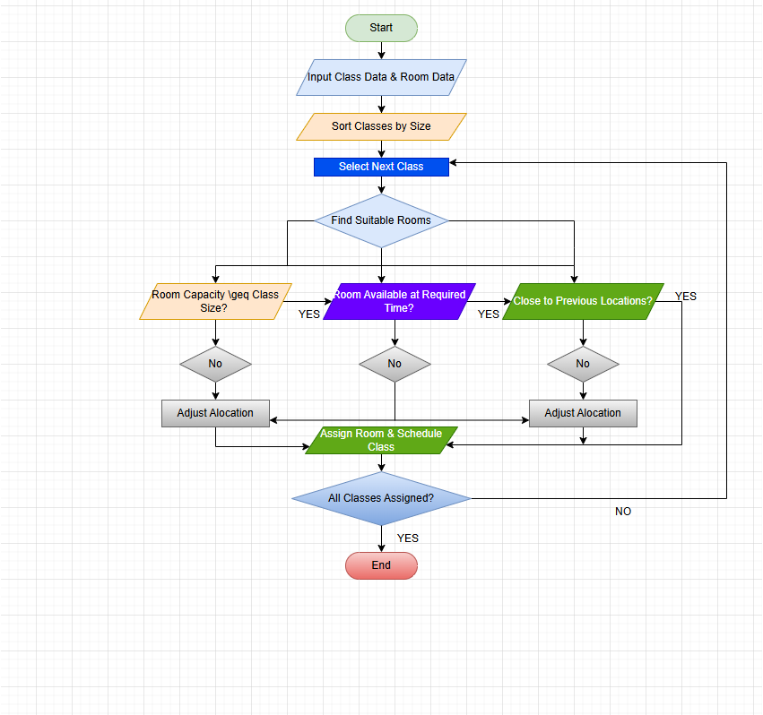

Explanation of the Flowchart
As you can see illustrated on the flowchart, process starts with the two inputs that are class data and room data. The flowchart contains important information like class sizes, different time slots, capacity and availability of the room. The shown inputs are the core of the process. The following step involves sorting out the classes by size descending sequence which ensures larger classes are being prioritized which reduces the chances of overcrowding which also ensures rooms with higher capacity are used correctly. The following process selects the next class and starts it by locating a suitable room which is only considered suitable when it satisfies the given conditions shown in the flowchart. The conditions check if the room capacity is sufficient for the available room and evaluate whether the room is free at a specific time, which therefore helps with the prevention of multiple classes assigned for one room at the same time. The third and final condition considers if the next room is located close to the previous room. The final step helps decrease the movement of the students and the staff as well as reducing wasting time between the classes. If all criteria are, the system continues with allocating a suitable room and updates the schedule according to the new allocation. If the criteria aren’t met, the process is repeated and the system continues to find a new alternative room that fits the class. Once all the classes have been assigned correctly, the system checks whether all the classes have a selected room and if there’s a class without a suitable room, the process repeats itself until it finds all class are booked. At the end when all the classes are assigned with a room with a time slot, the timetable is complete and the system ends.

Key Decisions and Assumptions
The key decisions included during creation of the flowchart was the use of sub-dividing the problems and taking care of them one at a time[3]. Various important decisions supported the solution which prioritized bigger classes using high-capacity rooms which reduced overcrowding and helped with efficiency. As well as the integration of multiple checks such as capacity and availability to guarantee the process being more realistic and effective. The solution is based on several presumptions which require all data like class sizes and availability which must be accurate beforehand to make the allocation effective. The time slots are fixed to the schedules and can’t be changed during the scheduling process.

How the Solution Solves the Problem
The given flowchart addresses all the problems and addresses the core issues which were overcrowding, timewasting between periods and timetable clashes. The solution prevents situations like overcrowding and overfilled rooms. In addition, the consideration of rooms helps reducing movement which increases the efficiency of the students and staff moving smoother and wasting less time. In conclusion the structured solution provides efficient utilisation of classrooms, balanced allocation with better learning environments.

Reflect and Justify
The proposed solution included numerous problem-solving techniques, such as decomposition, abstraction and logical thinking. The used techniques help with the complex problem of allocating classrooms to be split into small and easier manageable tasks, which helped analysing and addressing it effectively[4].
Decomposition was to divide the bigger problem which therefore helped addressing the components individually so all the issues can be solved and easily managed. The approach helped with clarity and reducing the complexity of the problem. The abstraction was crucial important to focus on the important variables like class size, capacity, availability, proximity while neglecting unnecessary details. This made the solution more efficient and generalisable, rather than overly analytical and complex. Abstraction helped with the flowchart representation by making it clearer and simpler rather than more complicated versions[5]. Logical Thinking was the main role of creating the flowchart representation and designing the step-by-step allocation process. The use of decision-making points throughout the flowchart showcased how the conditions are calculated systematically, making sure each classroom assignment has met the constraint. This structured approach made the process simple and well grounded.
This approach was appropriate since it addressed the core issues shown in the problem. By focusing on larger classes and using constraint checks, the flowchart solution was efficient by preventing overcrowding and using the available space. Additionally, the integration of available space eliminated the scheduling conflict and reduced movement between classes.
However, the solution has its limitations like assuming that all the input data such as class sizes and availability is correct and free to use in advance. In real scenarios, there could be factors like last minute changes like cancelations of classes and certain rooms unavailable due to other factors, which could potentially affect the created system. Additionally, the approach doesn’t take into consideration more complex factors such as equipment and preferences from lecturers. Another limiting factor is not using an advanced optimisation approach and techniques. The flowchart is easier to understand and execute; it will not always produce the best allocation in a complex situation.
In conclusion, whilst the solutions have its own limitations dues to highly complex scenarios, the use of techniques such as abstraction and decomposition provides practical method for an improved allocation of classes and showcases the use of analytical thinking in real life scenarios.

References
[1] "S. Pfohl, “Toward a Sociological Deconstruction of Social Problems,” Social Problems, vol. 32, no. 3, pp. 228–232, Feb. 1985, doi: https://doi.org/10.2307/800681."
[2] "T. Kravchenko, T. Bogdanova, and T. Shevgunov, “Ranking Requirements Using MoSCoW Methodology in Practice,” Cybernetics Perspectives in Systems, vol. 503, pp. 188–199, 2022, doi: https://doi.org/10.1007/978-3-031-09073-8_18."
[3] "M. Vali, “Sub-Dividing Genetic Method for Optimization Problems,” arXiv.org, 2026. https://arxiv.org/abs/1307.5679 (accessed Mar. 24, 2026)."
[4] "E. Kant and A. Newell, “Problem solving techniques for the design of algorithms,” Information Processing & Management, vol. 20, no. 1–2, pp. 97–118, Jan. 1984, doi: https://doi.org/10.1016/0306-4573(84)90042-6."
[5] "K. McMaster, B. Rague, and N. D. Anderson, “Integrating Mathematical Thinking, Abstract Thinking, and Computational Thinking,” Oct. 2010, doi: https://doi.org/10.1109/fie.2010.5673139,

