HTML & CSS Web Development Assignment
Author: Kes Sumner (2015409)
L4 - Introduction to Web and Database Concepts (ACCA4023_G)
School of Applied Computing
Wales Institute of Science and Art
Date and Time of submission: 31/10/2021 2100 (due to EC)
Contents
1 Introduction 3
2 Requirements 3
3 Implementation 3
3.1 Screen shots 4
3.2 Validation 6
3.2.1 HTML code errors and warnings 7
3.2.2 CSS code errors and warnings 7
4 Evaluation 7
4.1 Usability 8
4.1.1 Usability Research 8
4.1.2 Usability Evaluation 9
4.2 Search Engine Optimisation 9
4.2.1 Search Engine Optimisation Research 10
4.2.2 Search Engine Optimisation Evaluation 11
4.3 Accessibility 11
4.3.1 Accessibility Research 12
4.3.2 Accessibility Evaluation 12
5 References 13
6 Appendices 14
6.1 HTML 14
6.1.1 Main Page 14
6.1.2 Italy Page 17
6.1.3 Ireland Page 19
6.1.4 Switzerland Page 22
6.1.5 Hints and Tips Page 24
6.2 CSS 27
6.2.1 Grid Code 27
6.2.2 Display Code 28

Introduction

The purpose of this report is to review the website that was designed and created as a separate component of this assignment. The contents of this report consist of the following components:
- Requirements: A description of the purpose of the website and it’s subject matter, the audience that are targeted or maybe interested in the subject matter and the relevance of the content to the target audience.
- Implementation: The implementation section contains two topic areas of the build process undertaken for the website:
  - The look and feel of the site are captured and displayed in this first subsection in the form of screenshots of each of the five pages of the website.
  - The other topic area is about validation of the code constructed for the website and a description of key issues/errors that were found by using code validation.
- Evaluation: this final section of the report based on research of three core areas of evaluating a website:
  - Usability.
  - Accessibility.
  - Search Engine Optimisation (SEO).

Requirements

The website that was created is about motorcycle touring in Europe, with relevance to specific countries that I have visited, and have experience of, as part of previous motorbike tours, specifically Italy, Switzerland and Ireland.
The purpose of the site is to demonstrate the enjoyment and excitement from such an experience and the variety of places that can be visited, which in turn have a wide range of languages and cultures.
The target audience for the site are fellow experienced tourers looking for ideas or places to visit such as some of the few that I have included within the website, but also for motorbike riders who may be interested in trying bike tours and are looking for hints and tips and ideas suitable places to visit.
The site also has a hints and tips page for some of the key things that I have learnt from my experiences on bike tours, as well as some links to relevant external websites for those interested in further investigating in more depth or even trying motorbike touring themselves.

Implementation

The first part of this section of the report demonstrates the view and layout of the various pages of the website. For continuity, the web pages are structured using the same grid-based layout with the content being different for each geographical area or topic.
The second part of this section describes the process of and outcome from performing validation of the HTML and CSS code used to construct the site. The recommended validator sites were used to test both the HTML and CSS code. These were http://validator.w3.org/ for the HTML code and http://jigsaw.w3.org/css-validator/ for the CSS code. The output of both validation runs were reviewed for errors which are discussed in more detail later in this section, all errors were quite minor and easy to rectify.

Screen shots

Each of the five pages of the web sites are shown as screenshots below, along with a brief description of each of the page’s contents.

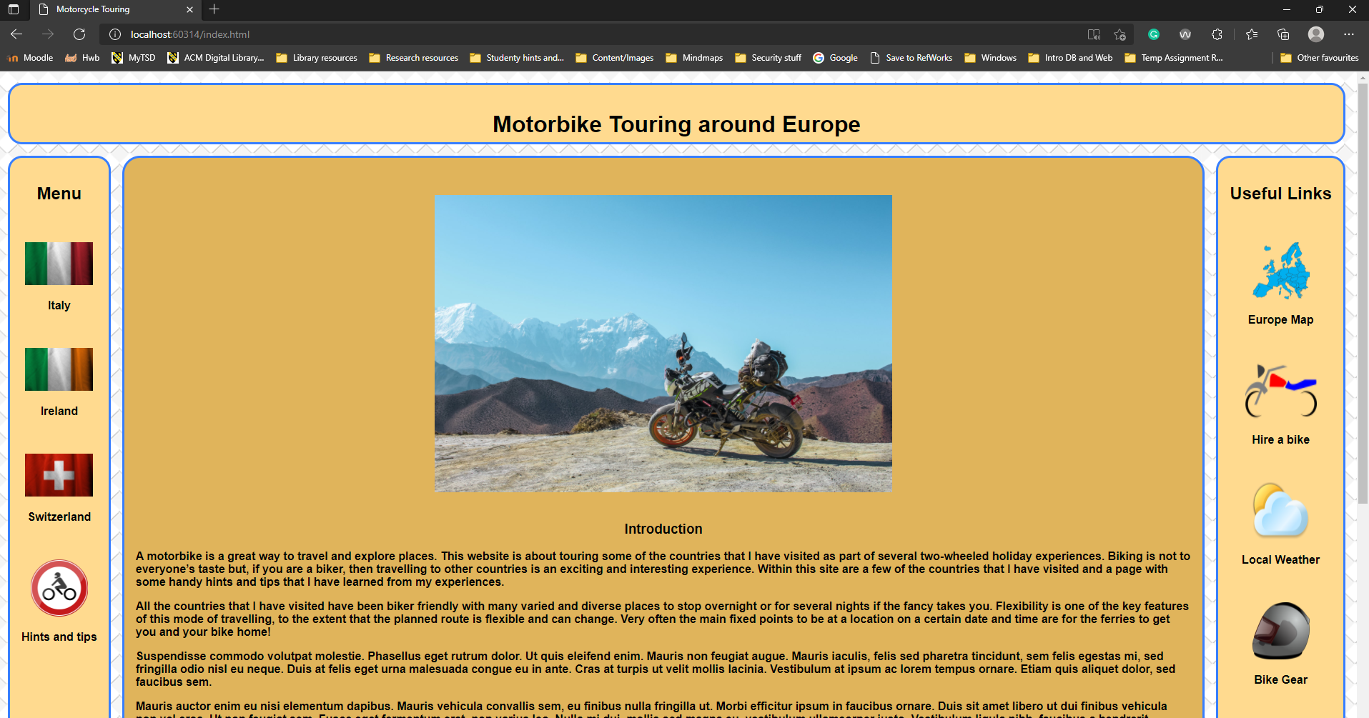
Figure 1: Home page.
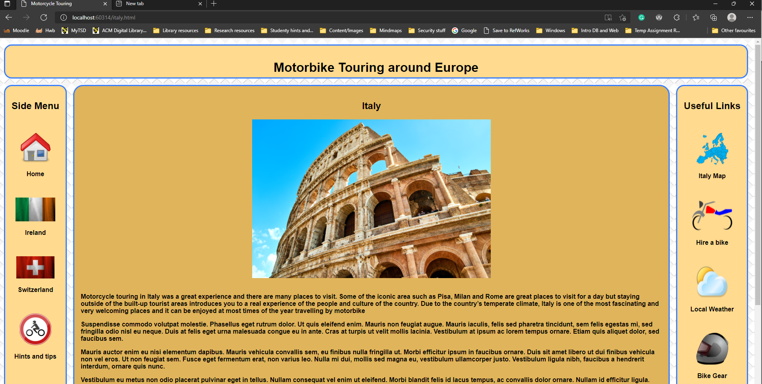
Figure 2: Italy page.

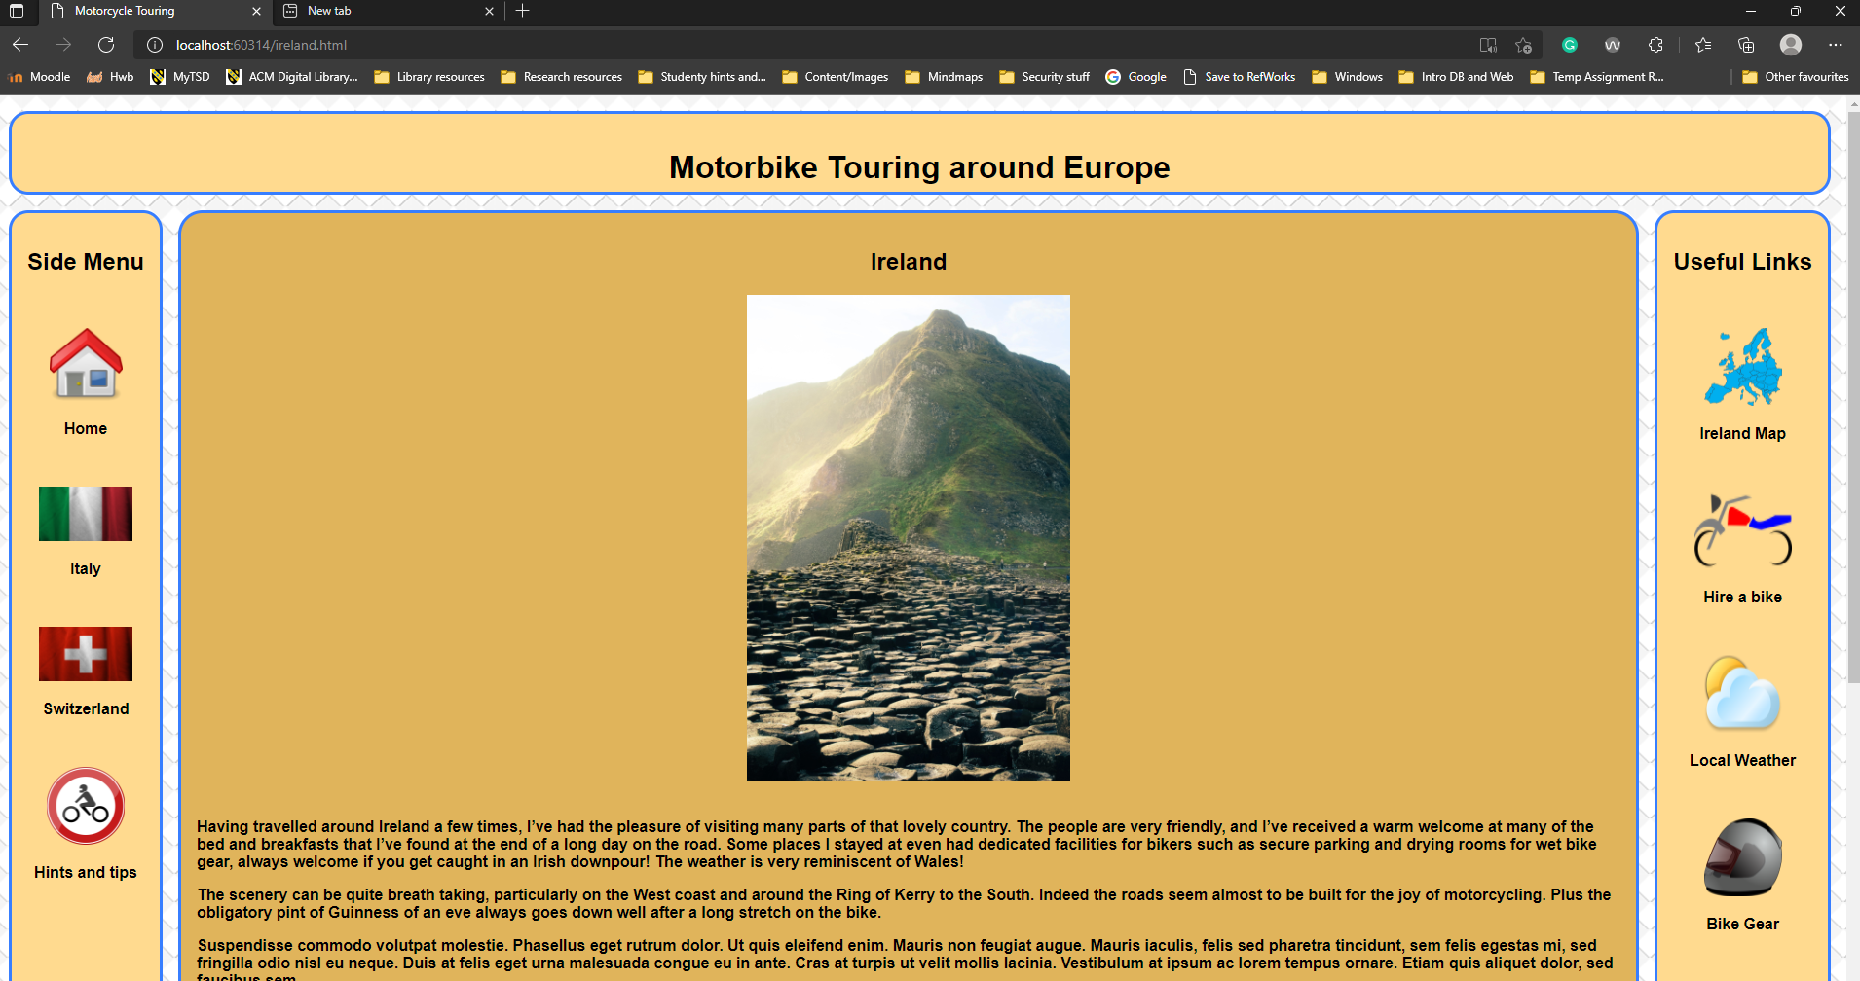
Figure 3: Ireland page.
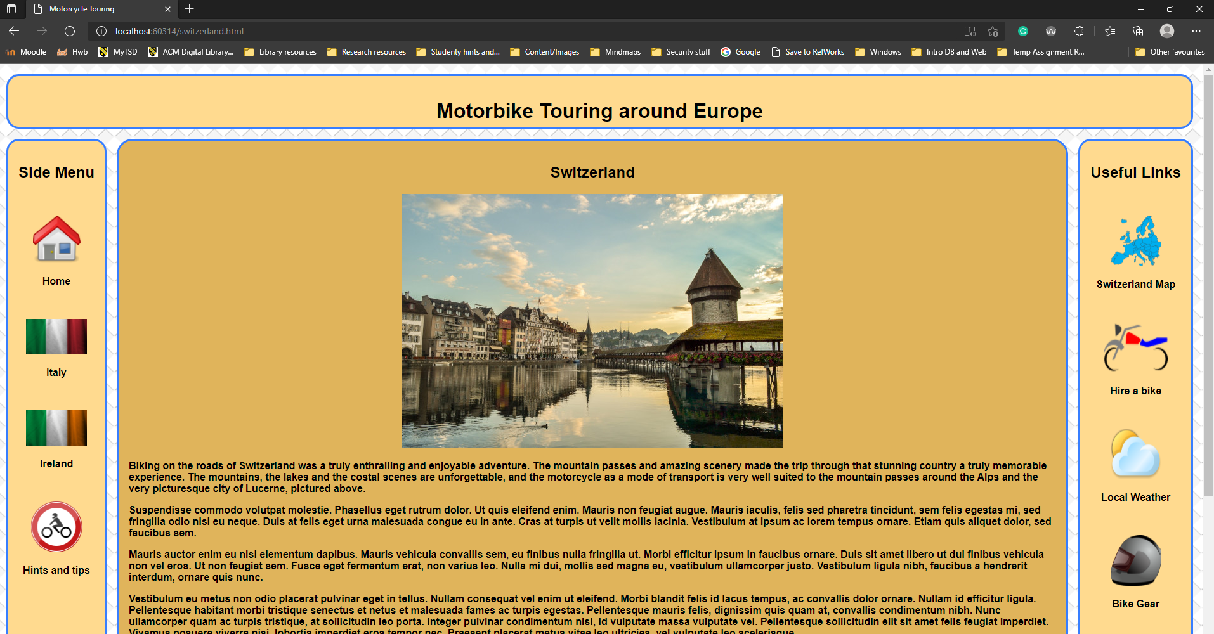
Figure 4: Switzerland page.

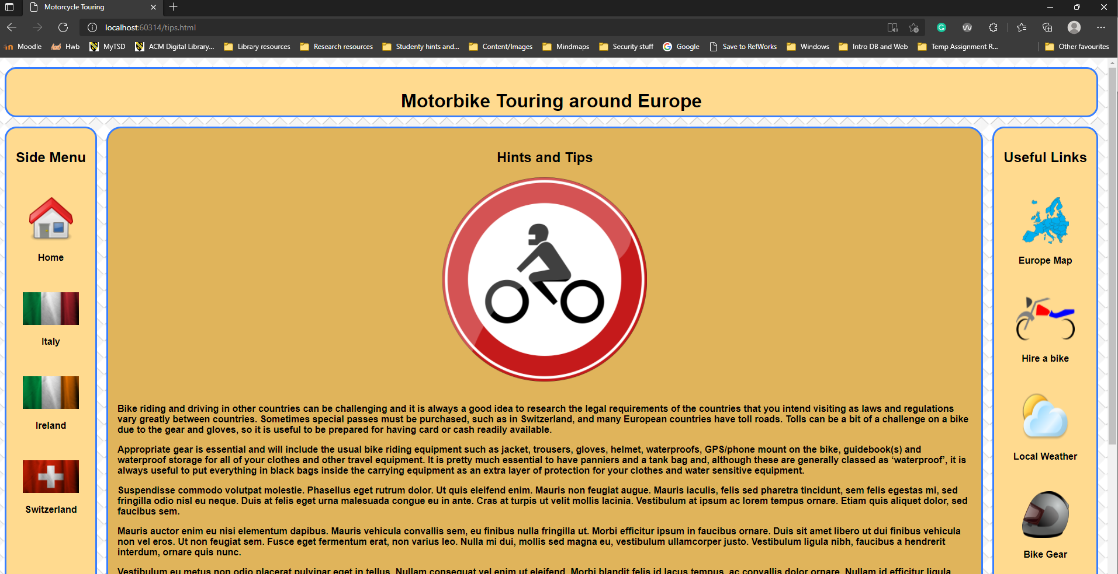
Figure 5: Hints and Tips page.

Validation

The recommended code validation sites were used to check the HTML home page and CSS coding, there were http://validator.w3.org/ for the HTML code and http://jigsaw.w3.org/css-validator/ for the CSS code.

HTML code errors and warnings

A few common errors/ warnings were found in the HTML home page coding, these were simple errors and warnings that were easy to rectify. These are shown below:
- Error 1: ‘Consider adding a lang attribute to the html start tag to declare the language of this document.’
This error was resolved by adding the lang attribute and the appropriate ISO code to the HTML tag on each HTML page like this:
<html lang="en">

- Error 2: ‘Bad value images ”/ktm mountains pic.jpg” for attribute src on element img: Illegal character in path segment: space is not allowed.’
Changing the space to a hyphen in the filename and the html code resolved this error:
“<img src="images/ktm-mountains.jpg"

- Error3:’An img element must have an alt attribute, except under certain conditions.’
Several of the image (img) statements didn’t have alternative options for if the image was not found. Resolved this error by adding alt to the code line, e.g.:
“<img src="images/ktm-mountains.jpg" alt="Swiss mountains picture" style="width:40em;height:26em;" />”

Some of the errors, such as the ‘lang’ attribute error were also corrected in the other website pages within the site.

CSS code errors and warnings

No errors were encountered as part of the CSS validation testing using the recommended validation website tool. I think that this is mainly due to the ability of Visual Studio to flag some errors within the CSS coding whilst the code is being written.
There were a couple of times that errors were flagged within Visual Studio for typing and/or spelling errors which were easily corrected and another error that was encountered was missing the semi-colon from the end of an attribute statement resulting in some strange formatting of pages. These types of errors were quickly traced to the omitted semi-colon and quickly rectified.

Evaluation

This section of the report focusses on the evaluating the overall quality of the website by reviewing three key areas listed below:
  - Usability or usefulness.
  - Search Engine Optimisation (SEO).
  - Accessibility.

Usability

Usability of a website is the simple sounding design feature of a website that makes it attractive and appealing to users that visit the site. It is defined in more formal terms by the International Standard Organisation (ISO), under ISO 9241 as “the effectiveness, efficiency and satisfaction with which specified users achieve specific goals in particular environments or context of use” [1].
Although this sounds relatively simple it is quite a complex criterion to meet, as the variety, diversity and needs of users that visit the site can potentially be extensive. For example, a website needs to appeal to a wide range of users. One common factor that features in designing a website for a good user and usability experience is age. Younger users generally have more experience and familiarity with technology and can be more able to navigate complex technical constructs with ease, whereas older users may prefer a simpler interface and some accessibility features such as larger fonts. [2]

Usability Research

The importance of website usability is emphasised in the paper “Understanding of website usability: Specifying and measuring constructs and their relationships”
Within the study paper, effort was devoted to creating useful website usability guidelines, introduce ways and mechanisms to measure different site suability structures and measure customer’s feelings on usability such as levels of satisfaction and their intent to revisit the site.
The study had two goals, first being to help identify common factors or features of website usability and, secondly to investigate the rules of reasoning about website usability constructs.
Theoretical ideas and concepts of website usability are explored and conclude that additional investigation is warranted. Some discussion about being able to identify the constructs of website usability and a variety of usability factors.
There is an extensive review of other supporting literature from a wide range of sources and a detailed investigation into the relationship between usability constructs and subsequent online purchasing.
A comprehensive in-depth investigation of research methods and results is detailed covering the two key goals identified previously using a variety of analyses and matrices to demonstrate output and results.
The ensuing discussion and findings included factors such as interactivity and social networking features embedded within a site contribute significantly to the likelihood of purchase on an e-commerce site, also simplicity was not conducive to site visitors being immersed in an online shopping experience.
The key findings of the study were mechanisms that could be utilised for measuring the usability quality of websites. The findings could potentially be used to aid construction of a theoretical model of website usability.[3]

Usability Evaluation

Evaluating the design of the website created as part of this assignment, the following areas were reviewed:
- Functionality
The website is quite straight forward in its functionality to present some insight into the subject matter of motorcycle touring. The site uses a 12-column grid split into an accepted five section standard layout consisting of a header, footer, side menu (links to other pages of the site), main and right side (external links) sections to external related websites.
- Usability
The look and feel of the website are quite simple to aid usage. Complementary colours have been selected, using an online palette selector tool (https://paletton.com/), to assist with presenting a pleasant visual experience. The layout makes navigation of the site simple using the menu system on the left side of the page and uses national flags to emphasise menu options. Each page has links to all other pages within the site, except the current page that the user is on, to maintain simplicity.

- Content
The website presents the subject matter over several pages, from the home page with introductory text and selection of images to each of the other pages for each country and the hints and tips page. In addition to the descriptive text on each page, some Lorem Ipsum was used to give a view of a reasonable amount of text for each page.
On reflection and considering the key points in the discussed paper, there are several areas that could be improved in the future:
- The layout could be improved to include a more polished presentation to the user. The current layout is quite simplistic but could potentially be improved to provide a slicker, more professional view for the website users.
- The content could be expanded to include more destinations with fuller, more complete information on each country/destination such as have some standard subjects such as local/national events, local/national holidays, languages (e.g., Switzerland is a multi-language country, depending on where you are in the country, different languages are prevalent).

Search Engine Optimisation

Search engine optimisation (SEO) is the practice of integrating aspects into the design of a website that will potentially increase the visibility and ranking of the website when a user performs a search of the Web using a search engine such as Google or Bing.
There are two types of optimisations that can be used to aid the elevation of a website in the rankings of web search engines:
- On-page optimisation
This is where part of the design process includes steps to optimise the website search ranking by incorporating measures within the website itself. These measures include, but are not limited to [4]:
  - Use of keywords in the within the website but not overuse of keywords else this is penalised by the search engine ranking system. The recommendation is 1-1.5% of the textual content.
  - Placement of keywords is also a factor, when placing keywords within the text of the website, place them as the start or end of sentences/paragraphs.
  - Use of some of the tags of a website, such as the heading tags (<H1>, <H2> etc, ‘alt’ attribute of image statements, the meta and title tags.
  - The URL itself will also be part of the ranking so inclusion of keywords in it should be part of the design.
  - Internal and external links can/should also include keywords with them if possible.
  - Images relative to the subject matter can use the image titles and as mentions previously, use the ‘alt’ tag for keyword and variations of the keyword.
  - Have multiple keywords rather than just using one, use variants.

- Off-page optimisation
Off page optimisation is where links are built with other websites, external to the website concerned. This is a longer-term method that increases keyword rankings that includes some of the below [4] [5]:
  - A presence on social networking sites will increase the rankings of the main website.
  - Using social media bookmarking sites such as Reddit, Tumbler and StumbleUpon.
  - Use a blog to promote your website.
  - Document and photo sharing using sites such as Google documents, Flickr etc can help direct people to the target website.

Search Engine Optimisation Research

Search Engine Optimisation is a process of optimising web pages to attain higher ranking from online search using search engines such as Google, Bing, Yahoo etc. Due to sheer size of the web, search engines cannot index the whole web which requires website designers and maintainers to incorporate mechanisms to enhance a website’s potential ranking score in the result of a user search.
Algorithms are used by search engines to rank websites during searches. Generally, these algorithms use variables such as site popularity the quality of the content, keyword density and location, social media exposure as well as many other factors to calculate the rank of a site in a search engine results page (SERP).
Multiple tools are available to help with developing a website’s SEO profile, such as Google Analytics, SEOQuake, Firebug and so on.
Many other studies have been carried out and published about SEO from many aspects of the web, such as e-commerce sites, bank sites, government bodies sites, blogs etc. The results of these studies have tailored and focussed SEO mechanism and processes to benefit the user by optimising sites for relevant content and speed.
A framework is proposed comprising of the following elements:
- Site audit
Prior to performing before carrying out SEO activities for a website, perform an audit of the website to capture issues and measures such as broken web links, website speed, tags and meta-tags.
- On-site optimisation
Suggested guidelines for on-site optimisation include deciding on keywords to use, good structure of the website, include keywords in appropriate parts of the site such as tags, content and pay attention to location of those keywords and relevant images.
A case study was carried out on several SEO projects with pre-optimisation statistics of search results being recorded for each project. The developed framework was applied to all the project sites and subsequent statistics recorded. The results showed a marked difference with some project sites achieving top ten placings in Google searches after the optimisation framework was applied.
The conclusion highlights the criticality of SEO to businesses and the importance of applying a good SEO framework, such as described in the paper, to attract more site visitors and subsequently increase business. [6]

Search Engine Optimisation Evaluation

Following researching SEO the below techniques were applied to the website in order to improve the search ranking capability of the site.
  - Use of keywords in the within the website. Placement was also considered in this technique.
Keywords/phrases used included motorcycle tour, bike touring, travelling, holiday, Europe, the country names. The words/phrases were used in the meta, title, image alt and higher-level headings tags. Where used in the body text the words/phrases were placed at the start or end of sentences/paragraphs.
  - The URL itself also contains keywords.
  - Internal and external links include keywords with them where possible.
  - Images relative to the subject matter can use the image titles and as mentions previously, use the ‘alt’ tag for keyword and variations of the keyword.
  - Have multiple keywords rather than just using one, use variants.
  - Some measures were used to optimise speed of the website such as resizing the image raw files displayed using image manipulation software such as GIMP.

Accessibility

The four principles of web accessibility about the W3C WCAG 2.1 guidelines are:
- perceivable.
- operable.
- understandable.
- Robust

Each of the principles plays a key role, if adhered to, in helping to ensure that websites are accessible and useable to all potential users accessing a particular website. This should include web sites being able to cater for a wide range of alternatives to text and graphics, depending on the abilities/disabilities of the person accessing the website.
Requirements that need to be met should include areas such as catering for text readers, alternatives for multimedia and use of semantic HTML, ensuring the code is structure to allow for alternative methods of accessing a website’s content and information. [7] [8]

Accessibility Research

Web accessibility must cater for a wide range of disabilities identified by the Centre for Disease Control, namely visual, auditory, cognitive, and motor disabilities. The four categories have different requirements when it comes to web accessibility.
Several instances of legal action against corporations and government bodies are cited for violating various national and regional legislation relating to disability acts and accessibility, including web accessibility.
Studies have found that many sites had severe barriers to accessibility. Simple low-level barriers such as failing to use alternate tags for images and relative sizing and positioning of the site structure.
Comparison of W3C international consortium Web Content Accessibility Guidelines (WCAG) version 1.0 and version 2, including the four key principles introduced in version 2 which are that content must be perceivable, operable, understandable and robust.
Steps of developing web accessibility in an organisational website are Planning, Analysis, Design, Implementation and Support.
Ethical implications are utilitarianism, pluralism, and contractarianism.
To conclude, the different ethical stances have different implications and outcomes with regards to accessibility and the reasoning for implementing good accessibility measure. [9]

Accessibility Evaluation

The accessibility of the implemented website against the four key principles of the WCAG 2.1 guidelines fell short in a few areas. The Web Accessibility Evaluation Tool (WAVE) was used to check the website for accessibility issues and a few failures were found which are listed below:

- Fully justified text content.
Issue: The text content of all pages was fully justified which WAVE raised as an alert for use of justification with passages of over 500 words.
Resolution: The text format was changed to left justified.
- Skipped heading level.
Issue: One of the pages had a level 2 heading with a level 1 heading lower down the page
Resolution: Reorganised the heading fields to maintain a top-down flow of header numbering.
- Missing ‘alt’ values in some ‘img ‘ attributes.
Issue: Several img statements were missing alt text values.
Resolution: Added appropriate text to the problematic fields and retested.

References

IEEE format references are used for this report.
[1] World Wide Web Consortium, “Usability - ISO 9241 definition”, W3C, 2021. [Online]. Available: https://www.w3.org/2002/Talks/0104-usabilityprocess/slide3-0.html [Accessed Oct. 20, 2021].
[2] K. Kous, M. Pušnik, M. Heričko, and G. Polančič, “Usability evaluation of a library website with different end user groups,” Journal of librarianship and information science, vol. 52, no. 1, pp. 75–90, 2020, doi: 10.1177/0961000618773133.
[3] ]Y. Lee and K. A. Kozar, “Understanding of website usability: Specifying and measuring constructs and their relationships,” Decision Support Systems, vol. 52, no. 2, pp. 450–463, 2012, doi: 10.1016/j.dss.2011.10.004.
[4] Skew Infotech PVT Ltd, “SEO techniques for better ranking”, 2017. [Online]. Available: Important Aspects of Web Designing – Skew InfoTech [Accessed Oct. 22, 2021].
[5] Wiki-How, “On Page Search Engine Optimization Factors & Techniques”, 2021. [Online]. Available: https://www.wiki-how.in/on-page-search-engine-optimization/ [Accessed Oct. 20, 2021].
[6] M. N. A. Khan and A. Mahmood, “A distinctive approach to obtain higher page rank through search engine optimization,” Sadhana (Bangalore), vol. 43, no. 3, pp. 1–12, 2018, doi: 10.1007/s12046-018-0812-3.
[7] World Wide Web Consortium, “Introduction to Web Accessibility”, WAI, 2021. [Online]. Available: https://www.w3.org/WAI/fundamentals/accessibility-intro/ [Accessed Oct. 23, 2021].
[8] World Wide Web Consortium, “Web Content Accessibility Guidelines (WCAG) 2.1”, W3C, 2018. [Online]. Available: https://www.w3.org/TR/WCAG21/ [Accessed Oct. 26, 2021].
[9] C. Peters and D. A. Bradbard, "Web accessibility: an introduction and ethical implications," Journal of Information, Communication & Ethics in Society, vol. 8, (2), pp. 206-232, 2010. Available: https://www.proquest.com/scholarly-journals/web-accessibility-introduction-ethical/docview/1011912539/se-2?accountid=130472. DOI: http://dx.doi.org/10.1108/14779961011041757.

Appendices

Below are the code listings for each of the web pages and the CSS code.

HTML

Main Page

<!DOCTYPE html>
<html lang="en">
<head>
<meta charset="utf-8" />
<meta name="viewport" content="width=device-width, initial-scale=1">
<meta name="description" content="Touring Europe on a Motorcycle">
<meta name="keywords" content="motorcycle,motorbike,biker,tour,touring,biker,travel,travelling,europe, ">
<title>Motorcycle Touring</title>
<link rel="stylesheet" href="styles/display.css">
<link rel="stylesheet" href="styles/grid.css">
</head>

<body>
<header-item>
<h1>Motorbike Touring around Europe</h1>
</header-item>
<menu-item>
<h2>Menu</h2>
<br />
<div id="menu-item">
<ul>
<li>
<a href="italy.html">
<p><img src="images/italy-flag.jpg" alt="Italian flag" style="width:95px;height:60px;" /></p>
<p>Italy</p>
<br />
</a>
</li>
<li>
<a href="ireland.html">
<p><img src="images/ireland-flag.jpg" alt="Irish flag" style="width:95px;height:60px;" /></p>
<p>Ireland</p>
<br />
</a>
</li>
<li>
<a href="switzerland.html">
<p><img src="images/switzerland-flag.jpg" alt="Swiss flag" style="width:95px;height:60px;" /></p>
<p>Switzerland</p>
<br />
</a>
</li>
<li>
<a href="tips.html">
<p><img src="images/road-sign.png" alt="Picture of motorcycle road sign" style="width:80px;height:80px;" /></p>
<p>Hints and tips</p>
<br />
</a>
</li>
</ul>
</div>
</menu-item>
<main-item>
<div id="main-title">
<br/> <br/>
<img src="images/ktm-mountains.jpg" alt="Swiss mountains picture" style="width:40em;height:26em;" />
<br/> <br/>
<h3>Introduction</h3>
</div>
<p>
A motorbike is a great way to travel and explore places. This website is about touring some of the countries that I have visited as part of several two-wheeled holiday experiences. Biking is not to everyone’s taste but, if you are a biker, then travelling to other countries is an exciting and interesting experience. Within this site are a few of the countries that I have visited and a page with some handy hints and tips that I have learned from my experiences.
</p>
<p>
All the countries that I have visited have been biker friendly with many varied and diverse places to stop overnight or for several nights if the fancy takes you. Flexibility is one of the key features of this mode of travelling, to the extent that the planned route is flexible and can change. Very often the main fixed points to be at a location on a certain date and time are for the ferries to get you and your bike home!
</p>
<p>Suspendisse commodo volutpat molestie. Phasellus eget rutrum dolor. Ut quis eleifend enim. Mauris non feugiat augue. Mauris iaculis, felis sed pharetra tincidunt, sem felis egestas mi, sed fringilla odio nisl eu neque. Duis at felis eget urna malesuada congue eu in ante. Cras at turpis ut velit mollis lacinia. Vestibulum at ipsum ac lorem tempus ornare. Etiam quis aliquet dolor, sed faucibus sem.</p>
<p>Mauris auctor enim eu nisi elementum dapibus. Mauris vehicula convallis sem, eu finibus nulla fringilla ut. Morbi efficitur ipsum in faucibus ornare. Duis sit amet libero ut dui finibus vehicula non vel eros. Ut non feugiat sem. Fusce eget fermentum erat, non varius leo. Nulla mi dui, mollis sed magna eu, vestibulum ullamcorper justo. Vestibulum ligula nibh, faucibus a hendrerit interdum, ornare quis nunc.</p>
<p>Vestibulum eu metus non odio placerat pulvinar eget in tellus. Nullam consequat vel enim ut eleifend. Morbi blandit felis id lacus tempus, ac convallis dolor ornare. Nullam id efficitur ligula. Pellentesque habitant morbi tristique senectus et netus et malesuada fames ac turpis egestas. Pellentesque mauris felis, dignissim quis quam at, convallis condimentum nibh. Nunc ullamcorper quam ac turpis tristique, at sollicitudin leo porta. Integer pulvinar condimentum nisi, id vulputate massa vulputate vel. Pellentesque sollicitudin elit sit amet felis feugiat imperdiet. Vivamus posuere viverra nisi, lobortis imperdiet eros tempor nec. Praesent placerat metus vitae leo ultricies, vel vulputate leo scelerisque.</p>
<p>Mauris auctor enim eu nisi elementum dapibus. Mauris vehicula convallis sem, eu finibus nulla fringilla ut. Morbi efficitur ipsum in faucibus ornare. Duis sit amet libero ut dui finibus vehicula non vel eros. Ut non feugiat sem. Fusce eget fermentum erat, non varius leo. Nulla mi dui, mollis sed magna eu, vestibulum ullamcorper justo. Vestibulum ligula nibh, faucibus a hendrerit interdum, ornare quis nunc.</p>
<p>Lorem ipsum dolor sit amet, consectetur adipiscing elit. Morbi semper sed sem ac bibendum. Mauris elementum urna at nibh ornare, egestas volutpat ante varius. Vivamus velit velit, feugiat nec mauris vel, sodales posuere ipsum. Praesent nisl ipsum, tempus quis viverra quis, ullamcorper vel ex. Aliquam quis scelerisque tellus, in sodales leo. Nunc fermentum pharetra hendrerit. Pellentesque porta consectetur metus ac dictum. In pharetra arcu elit, sit amet congue odio aliquam sit amet. Donec pretium metus quis varius sagittis. Vivamus et enim non lacus lobortis lacinia. Nam cursus ex turpis, sed accumsan erat faucibus efficitur. In hac habitasse platea dictumst. Sed dapibus, dolor sed convallis facilisis, velit metus laoreet lorem, quis aliquam justo nisi ac diam.
<p>In nec volutpat odio. Sed bibendum neque mauris, id dapibus velit sodales et. Nulla ac libero augue. Suspendisse venenatis rhoncus nisi a porta. Sed porta est mattis dolor sodales pharetra. Praesent nec lobortis risus. Aenean id velit quis ligula venenatis laoreet eget non magna.</p>
<p>In nec volutpat odio. Sed bibendum neque mauris, id dapibus velit sodales et. Nulla ac libero augue. Suspendisse venenatis rhoncus nisi a porta. Sed porta est mattis dolor sodales pharetra. Praesent nec lobortis risus. Aenean id velit quis ligula venenatis laoreet eget non magna.</p>

</main-item>
<aside-item>
<h2>Useful Links</h2>
<br />
<a href="https://www.google.com/maps/place/Europe" target="_blank">
<p><img src="images/europe-map.png" alt="Touring map of Europe" style="width:80px;height:80px;" /></p>
<p>Europe Map</p>
<br />
</a>
<a href="https://www.superbikerental.co.uk/adventure-touring-motorbike-rental.php" target="_blank">
<p><img src="images/hire-a-bike.png" alt="Picture of a motorbike" style="width:100px;height:80px;" /></p>
<p>Hire a bike</p>
<br />
</a>
<a href="https://www.climatestotravel.com/continents/europe" target="_blank">
<p><img src="images/weather.png" alt="Weather icon" style="width:80px;height:80px;" /></p>
<p>Local Weather</p>
<br />
</a>
<a href="https://www.bikestop.co.uk/ride-style/touring" target="_blank">
<p><img src="images/bike-helmet.png" alt="Bike helmet icon" style="width:80px;height:80px;" /></p>
<p>Bike Gear</p>
</a>
</aside-item>

<footer-item>
<p>
<a href="http://jigsaw.w3.org/css-validator/check/referer">
<img style="border:0;width:88px;height:31px"
src="http://jigsaw.w3.org/css-validator/images/vcss"
alt="Valid CSS!" />
</a>
</p>
</footer-item>

</body>
</html>

Italy Page

<!DOCTYPE html>
<html lang="en">
<head>
<meta charset="utf-8" />
<meta name="viewport" content="width=device-width, initial-scale=1">
<title>Motorcycle Touring</title>
<link rel="stylesheet" href="styles/display.css">
<link rel="stylesheet" href="styles/grid.css">
</head>

<body>
<header-item>
<h1>Motorbike Touring around Europe</h1>
</header-item>
<menu-item>
<h2>Side Menu</h2>
<br />
<div id="menu-item">
<ul>
<li>
<a href="index.html">
<p><img src="images/home.png" alt="Home icon" style="width:75px;height:75px;" /></p>
<p>Home</p>
<br />
</a>
</li>
<li>
<a href="ireland.html">
<p><img src="images/ireland-flag.jpg" alt="Irish flag" style="width:100px;height:60px;" /></p>
<p>Ireland</p>
<br />
</a>
</li>
<li>
<a href="switzerland.html">
<p><img src="images/switzerland-flag.jpg" alt="Swiss flag" style="width:6em;height:3.5em;" /></p>
<p>Switzerland</p>
<br />
</a>
</li>
<li>
<a href="tips.html">
<p><img src="images/road-sign.png" alt="Picture of biker road sign" style="width:5em;height:5em;" /></p>
<p>Hints and tips</p>
<br />
</a>
</li>

</ul>
</div>
</menu-item>
<main-item>
<section>
<div id="main-title">
<h1>Italy</h1>
<img src="images/colusseum.jpg" alt="Picture of the Colusseum" style="width:600px;height:400px;" />
</div>
<br/>
<p>
Motorcycle touring in Italy was a great experience and there are many places to visit. Some of the iconic area such as Pisa, Milan and Rome are great places to visit for a day but staying outside of the built-up tourist areas introduces you to a real experience of the people and culture of the country.
Due to the country’s temperate climate, Italy is one of the most fascinating and very welcoming places and it can be enjoyed at most times of the year travelling by motorbike
</p>
<p>Suspendisse commodo volutpat molestie. Phasellus eget rutrum dolor. Ut quis eleifend enim. Mauris non feugiat augue. Mauris iaculis, felis sed pharetra tincidunt, sem felis egestas mi, sed fringilla odio nisl eu neque. Duis at felis eget urna malesuada congue eu in ante. Cras at turpis ut velit mollis lacinia. Vestibulum at ipsum ac lorem tempus ornare. Etiam quis aliquet dolor, sed faucibus sem.</p>
<p>Mauris auctor enim eu nisi elementum dapibus. Mauris vehicula convallis sem, eu finibus nulla fringilla ut. Morbi efficitur ipsum in faucibus ornare. Duis sit amet libero ut dui finibus vehicula non vel eros. Ut non feugiat sem. Fusce eget fermentum erat, non varius leo. Nulla mi dui, mollis sed magna eu, vestibulum ullamcorper justo. Vestibulum ligula nibh, faucibus a hendrerit interdum, ornare quis nunc.</p>
<p>Vestibulum eu metus non odio placerat pulvinar eget in tellus. Nullam consequat vel enim ut eleifend. Morbi blandit felis id lacus tempus, ac convallis dolor ornare. Nullam id efficitur ligula. Pellentesque habitant morbi tristique senectus et netus et malesuada fames ac turpis egestas. Pellentesque mauris felis, dignissim quis quam at, convallis condimentum nibh. Nunc ullamcorper quam ac turpis tristique, at sollicitudin leo porta. Integer pulvinar condimentum nisi, id vulputate massa vulputate vel. Pellentesque sollicitudin elit sit amet felis feugiat imperdiet. Vivamus posuere viverra nisi, lobortis imperdiet eros tempor nec. Praesent placerat metus vitae leo ultricies, vel vulputate leo scelerisque.</p>
</section>
<p>Mauris auctor enim eu nisi elementum dapibus. Mauris vehicula convallis sem, eu finibus nulla fringilla ut. Morbi efficitur ipsum in faucibus ornare. Duis sit amet libero ut dui finibus vehicula non vel eros. Ut non feugiat sem. Fusce eget fermentum erat, non varius leo. Nulla mi dui, mollis sed magna eu, vestibulum ullamcorper justo. Vestibulum ligula nibh, faucibus a hendrerit interdum, ornare quis nunc.</p>
<p>Lorem ipsum dolor sit amet, consectetur adipiscing elit. Morbi semper sed sem ac bibendum. Mauris elementum urna at nibh ornare, egestas volutpat ante varius. Vivamus velit velit, feugiat nec mauris vel, sodales posuere ipsum. Praesent nisl ipsum, tempus quis viverra quis, ullamcorper vel ex. Aliquam quis scelerisque tellus, in sodales leo. Nunc fermentum pharetra hendrerit. Pellentesque porta consectetur metus ac dictum. In pharetra arcu elit, sit amet congue odio aliquam sit amet. Donec pretium metus quis varius sagittis. Vivamus et enim non lacus lobortis lacinia. Nam cursus ex turpis, sed accumsan erat faucibus efficitur. In hac habitasse platea dictumst. Sed dapibus, dolor sed convallis facilisis, velit metus laoreet lorem, quis aliquam justo nisi ac diam.
<p>In nec volutpat odio. Sed bibendum neque mauris, id dapibus velit sodales et. Nulla ac libero augue. Suspendisse venenatis rhoncus nisi a porta. Sed porta est mattis dolor sodales pharetra. Praesent nec lobortis risus. Aenean id velit quis ligula venenatis laoreet eget non magna.</p>
</main-item>
<aside-item>
<h2>Useful Links</h2>
<br />
<a href="https://www.google.com/maps/place/Italy" target="_blank">
<p><img src="images/europe-map.png" alt="Touring map of Europe" style="width:80px;height:80px;" /></p>
<p>Italy Map</p>
<br />
</a>
<a href="https://www.superbikerental.co.uk/adventure-touring-motorbike-rental.php" target="_blank">
<p><img src="images/hire-a-bike.png" alt="Picture of a motorbike" style="width:100px;height:80px;" /></p>
<p>Hire a bike</p>
<br />
</a>
<a href="https://www.climatestotravel.com/climate/italy" target="_blank">
<p><img src="images/weather.png" alt="Weather icon" style="width:80px;height:80px;" /></p>
<p>Local Weather</p>
<br />
</a>
<a href="https://www.bikestop.co.uk/ride-style/touring" target="_blank">
<p><img src="images/bike-helmet.png" alt="Bike helmet icon" style="width:80px;height:80px;" /></p>
<p>Bike Gear</p>
</a>
</aside-item>
<footer-item>
<p>
<a href="http://jigsaw.w3.org/css-validator/check/referer">
<img style="border:0;width:88px;height:31px"
src="http://jigsaw.w3.org/css-validator/images/vcss"
alt="Valid CSS!" />
</a>
</p>
</footer-item>
</body>
</html>

Ireland Page

<!DOCTYPE html>
<html lang="en">
<head>
<meta charset="utf-8" />
<meta name="viewport" content="width=device-width, initial-scale=1">
<title>Motorcycle Touring</title>
<link rel="stylesheet" href="styles/display.css">
<link rel="stylesheet" href="styles/grid.css">
</head>

<body>
<header-item>
<h1>Motorbike Touring around Europe</h1>
</header-item>
<menu-item>
<h2>Side Menu</h2>
<br />
<div id="menu-item">
<ul>
<li>
<a href="index.html">
<p><img src="images/home.png" alt="Home icon" style="width:75px;height:75px;" /></p>
<p>Home</p>
<br />
</a>
</li>
<li>
<a href="italy.html">
<p><img src="images/italy-flag.jpg" alt="Italian flag" style="width:6em;height:3.5em;" /></p>
<p>Italy</p>
<br />
</a>
</li>
<li>
<a href="switzerland.html">
<p><img src="images/switzerland-flag.jpg" alt="Swiss flag" style="width:6em;height:3.5em;" /></p>
<p>Switzerland</p>
<br />
</a>
</li>
<li>
<a href="tips.html">
<p><img src="images/road-sign.png" alt="Picture of biker road sign" style="width:5em;height:5em;" /></p>
<p>Hints and tips</p>
<br />
</a>
</li>
</ul>
</div>
</menu-item>
<main-item>
<section>
<div id="main-title">
<h1>Ireland</h1>
<img src="images/giants-causeway.jpg" alt="Picture of Giant's Causeway, Ireland" style="width:332px;height:500px;" />
</div>
<br />
<p>Having travelled around Ireland a few times, I’ve had the pleasure of visiting many parts of that lovely country. The people are very friendly, and I’ve received a warm welcome at many of the bed and breakfasts that I’ve found at the end of a long day on the road. Some places I stayed at even had dedicated facilities for bikers such as secure parking and drying rooms for wet bike gear, always welcome if you get caught in an Irish downpour! The weather is very reminiscent of Wales!</p>
<p>The scenery can be quite breath taking, particularly on the West coast and around the Ring of Kerry to the South. Indeed the roads seem almost to be built for the joy of motorcycling. Plus the obligatory pint of Guinness of an eve always goes down well after a long stretch on the bike.</p>
<p>Suspendisse commodo volutpat molestie. Phasellus eget rutrum dolor. Ut quis eleifend enim. Mauris non feugiat augue. Mauris iaculis, felis sed pharetra tincidunt, sem felis egestas mi, sed fringilla odio nisl eu neque. Duis at felis eget urna malesuada congue eu in ante. Cras at turpis ut velit mollis lacinia. Vestibulum at ipsum ac lorem tempus ornare. Etiam quis aliquet dolor, sed faucibus sem.</p>
<p>Mauris auctor enim eu nisi elementum dapibus. Mauris vehicula convallis sem, eu finibus nulla fringilla ut. Morbi efficitur ipsum in faucibus ornare. Duis sit amet libero ut dui finibus vehicula non vel eros. Ut non feugiat sem. Fusce eget fermentum erat, non varius leo. Nulla mi dui, mollis sed magna eu, vestibulum ullamcorper justo. Vestibulum ligula nibh, faucibus a hendrerit interdum, ornare quis nunc.</p>
<p>Vestibulum eu metus non odio placerat pulvinar eget in tellus. Nullam consequat vel enim ut eleifend. Morbi blandit felis id lacus tempus, ac convallis dolor ornare. Nullam id efficitur ligula. Pellentesque habitant morbi tristique senectus et netus et malesuada fames ac turpis egestas. Pellentesque mauris felis, dignissim quis quam at, convallis condimentum nibh. Nunc ullamcorper quam ac turpis tristique, at sollicitudin leo porta. Integer pulvinar condimentum nisi, id vulputate massa vulputate vel. Pellentesque sollicitudin elit sit amet felis feugiat imperdiet. Vivamus posuere viverra nisi, lobortis imperdiet eros tempor nec. Praesent placerat metus vitae leo ultricies, vel vulputate leo scelerisque.</p>
</section>
<p>Mauris auctor enim eu nisi elementum dapibus. Mauris vehicula convallis sem, eu finibus nulla fringilla ut. Morbi efficitur ipsum in faucibus ornare. Duis sit amet libero ut dui finibus vehicula non vel eros. Ut non feugiat sem. Fusce eget fermentum erat, non varius leo. Nulla mi dui, mollis sed magna eu, vestibulum ullamcorper justo. Vestibulum ligula nibh, faucibus a hendrerit interdum, ornare quis nunc.</p>
<p>Lorem ipsum dolor sit amet, consectetur adipiscing elit. Morbi semper sed sem ac bibendum. Mauris elementum urna at nibh ornare, egestas volutpat ante varius. Vivamus velit velit, feugiat nec mauris vel, sodales posuere ipsum. Praesent nisl ipsum, tempus quis viverra quis, ullamcorper vel ex. Aliquam quis scelerisque tellus, in sodales leo. Nunc fermentum pharetra hendrerit. Pellentesque porta consectetur metus ac dictum. In pharetra arcu elit, sit amet congue odio aliquam sit amet. Donec pretium metus quis varius sagittis. Vivamus et enim non lacus lobortis lacinia. Nam cursus ex turpis, sed accumsan erat faucibus efficitur. In hac habitasse platea dictumst. Sed dapibus, dolor sed convallis facilisis, velit metus laoreet lorem, quis aliquam justo nisi ac diam.
<p>In nec volutpat odio. Sed bibendum neque mauris, id dapibus velit sodales et. Nulla ac libero augue. Suspendisse venenatis rhoncus nisi a porta. Sed porta est mattis dolor sodales pharetra. Praesent nec lobortis risus. Aenean id velit quis ligula venenatis laoreet eget non magna.</p>
</main-item>
<aside-item>
<h2>Useful Links</h2>
<br />
<a href="https://www.google.com/maps/place/Ireland" target="_blank">
<p><img src="images/europe-map.png" alt="Touring map of Europe" style="width:80px;height:80px;" /></p>
<p>Ireland Map</p>
<br />
</a>
<a href="https://www.superbikerental.co.uk/adventure-touring-motorbike-rental.php" target="_blank">
<p><img src="images/hire-a-bike.png" alt="Picture of a motorbike" style="width:100px;height:80px;" /></p>
<p>Hire a bike</p>
<br />
</a>
<a href="https://www.climatestotravel.com/climate/ireland" target="_blank">
<p><img src="images/weather.png" alt="Weather icon" style="width:80px;height:80px;" /></p>
<p>Local Weather</p>
<br />
</a>
<a href="https://www.bikestop.co.uk/ride-style/touring" target="_blank">
<p><img src="images/bike-helmet.png" alt="Bike helmet icon" style="width:80px;height:80px;" /></p>
<p>Bike Gear</p>
</a>
</aside-item>
<footer-item>
<p>
<a href="http://jigsaw.w3.org/css-validator/check/referer">
<img style="border:0;width:88px;height:31px"
src="http://jigsaw.w3.org/css-validator/images/vcss"
alt="Valid CSS!" />
</a>
</p>
</footer-item>
</body>
</html>

Switzerland Page

<!DOCTYPE html>
<html lang="en">
<head>
<meta charset="utf-8" />
<meta name="viewport" content="width=device-width, initial-scale=1">
<title>Motorcycle Touring</title>
<link rel="stylesheet" href="styles/display.css">
<link rel="stylesheet" href="styles/grid.css">
</head>

<body>
<header-item>
<h1>Motorbike Touring around Europe</h1>
</header-item>
<menu-item>
<h2>Side Menu</h2>
<br />
<div id="menu-item">
<ul>
<li>
<a href="index.html">
<p><img src="images/home.png" alt="Home icon" style="width:75px;height:75px;" /></p>
<p>Home</p>
<br />
</a>
</li>
<li>
<a href="italy.html">
<p><img src="images/italy-flag.jpg" alt="Italian flag" style="width:6em;height:3.5em;" /></p>
<p>Italy</p>
<br />
</a>
</li>
<li>
<a href="ireland.html">
<p><img src="images/ireland-flag.jpg" alt="Irish flag" style="width:6em;height:3.5em;" /></p>
<p>Ireland</p>
<br />
</a>
</li>
<li>
<a href="tips.html">
<p><img src="images/road-sign.png" alt="Picture of biker road sign" style="width:5em;height:5em;" /></p>
<p>Hints and tips</p>
<br />
</a>
</li>
</ul>
</div>
</menu-item>
<main-item>
<section>
<div id="main-title">
<h1>Switzerland</h1>
<img src="images/lucerne.jpg" alt="Picture of Lucerne, Switzerland" style="width:600px;height:400px;" />
</div>
<br/>
<p>Biking on the roads of Switzerland was a truly enthralling and enjoyable adventure. The mountain passes and amazing scenery made the trip through that stunning country a truly memorable experience. The mountains, the lakes and the costal scenes are unforgettable, and the motorcycle as a mode of transport is very well suited to the mountain passes around the Alps and the very picturesque city of Lucerne, pictured above.</p>
<p>Suspendisse commodo volutpat molestie. Phasellus eget rutrum dolor. Ut quis eleifend enim. Mauris non feugiat augue. Mauris iaculis, felis sed pharetra tincidunt, sem felis egestas mi, sed fringilla odio nisl eu neque. Duis at felis eget urna malesuada congue eu in ante. Cras at turpis ut velit mollis lacinia. Vestibulum at ipsum ac lorem tempus ornare. Etiam quis aliquet dolor, sed faucibus sem.</p>
<p>Mauris auctor enim eu nisi elementum dapibus. Mauris vehicula convallis sem, eu finibus nulla fringilla ut. Morbi efficitur ipsum in faucibus ornare. Duis sit amet libero ut dui finibus vehicula non vel eros. Ut non feugiat sem. Fusce eget fermentum erat, non varius leo. Nulla mi dui, mollis sed magna eu, vestibulum ullamcorper justo. Vestibulum ligula nibh, faucibus a hendrerit interdum, ornare quis nunc.</p>
<p>Vestibulum eu metus non odio placerat pulvinar eget in tellus. Nullam consequat vel enim ut eleifend. Morbi blandit felis id lacus tempus, ac convallis dolor ornare. Nullam id efficitur ligula. Pellentesque habitant morbi tristique senectus et netus et malesuada fames ac turpis egestas. Pellentesque mauris felis, dignissim quis quam at, convallis condimentum nibh. Nunc ullamcorper quam ac turpis tristique, at sollicitudin leo porta. Integer pulvinar condimentum nisi, id vulputate massa vulputate vel. Pellentesque sollicitudin elit sit amet felis feugiat imperdiet. Vivamus posuere viverra nisi, lobortis imperdiet eros tempor nec. Praesent placerat metus vitae leo ultricies, vel vulputate leo scelerisque.</p>
</section>
<p>Mauris auctor enim eu nisi elementum dapibus. Mauris vehicula convallis sem, eu finibus nulla fringilla ut. Morbi efficitur ipsum in faucibus ornare. Duis sit amet libero ut dui finibus vehicula non vel eros. Ut non feugiat sem. Fusce eget fermentum erat, non varius leo. Nulla mi dui, mollis sed magna eu, vestibulum ullamcorper justo. Vestibulum ligula nibh, faucibus a hendrerit interdum, ornare quis nunc.</p>
<p>Lorem ipsum dolor sit amet, consectetur adipiscing elit. Morbi semper sed sem ac bibendum. Mauris elementum urna at nibh ornare, egestas volutpat ante varius. Vivamus velit velit, feugiat nec mauris vel, sodales posuere ipsum. Praesent nisl ipsum, tempus quis viverra quis, ullamcorper vel ex. Aliquam quis scelerisque tellus, in sodales leo. Nunc fermentum pharetra hendrerit. Pellentesque porta consectetur metus ac dictum. In pharetra arcu elit, sit amet congue odio aliquam sit amet. Donec pretium metus quis varius sagittis. Vivamus et enim non lacus lobortis lacinia. Nam cursus ex turpis, sed accumsan erat faucibus efficitur. In hac habitasse platea dictumst. Sed dapibus, dolor sed convallis facilisis, velit metus laoreet lorem, quis aliquam justo nisi ac diam.
<p>In nec volutpat odio. Sed bibendum neque mauris, id dapibus velit sodales et. Nulla ac libero augue. Suspendisse venenatis rhoncus nisi a porta. Sed porta est mattis dolor sodales pharetra. Praesent nec lobortis risus. Aenean id velit quis ligula venenatis laoreet eget non magna.</p>
</main-item>
<aside-item>
<h2>Useful Links</h2>
<br />
<a href="https://www.google.com/maps/place/Switzerland" target="_blank">
<p><img src="images/europe-map.png" alt="Touring map of Europe" style="width:80px;height:80px;" /></p>
<p>Switzerland Map</p>
<br />
</a>
<a href="https://www.superbikerental.co.uk/adventure-touring-motorbike-rental.php" target="_blank">
<p><img src="images/hire-a-bike.png" alt="Picture of a motorbike" style="width:100px;height:80px;" /></p>
<p>Hire a bike</p>
<br />
</a>
<a href="https://www.climatestotravel.com/climate/Switzerland" target="_blank">
<p><img src="images/weather.png" alt="Weather icon" style="width:80px;height:80px;" /></p>
<p>Local Weather</p>
<br />
</a>
<a href="https://www.bikestop.co.uk/ride-style/touring" target="_blank">
<p><img src="images/bike-helmet.png" alt="Bike helmet icon" style="width:80px;height:80px;" /></p>
<p>Bike Gear</p>
</a>
</aside-item>
<footer-item>
<p>
<a href="http://jigsaw.w3.org/css-validator/check/referer">
<img style="border:0;width:88px;height:31px"
src="http://jigsaw.w3.org/css-validator/images/vcss"
alt="Valid CSS!" />
</a>
</p>
</footer-item>
</body>
</html>

Hints and Tips Page

<!DOCTYPE html>
<html lang="en">
<head>
<meta charset="utf-8" />
<meta name="viewport" content="width=device-width, initial-scale=1">
<title>Motorcycle Touring</title>
<link rel="stylesheet" href="styles/display.css">
<link rel="stylesheet" href="styles/grid.css">
</head>

<body>
<header-item>
<h1>Motorbike Touring around Europe</h1>
</header-item>
<menu-item>
<h2>Side Menu</h2>
<br />
<div id="menu-item">
<ul>
<li>
<a href="index.html">
<p><img src="images/home.png" alt="Home icon" style="width:75px;height:75px;" /></p>
<p>Home</p>
<br />
</a>
</li>
<li>
<a href="italy.html">
<p><img src="images/italy-flag.jpg" alt="Italian flag" style="width:6em;height:3.5em;" /></p>
<p>Italy</p>
<br />
</a>
</li>
<li>
<a href="ireland.html">
<p><img src="images/ireland-flag.jpg" alt="Irish flag" style="width:6em;height:3.5em;" /></p>
<p>Ireland</p>
<br />
</a>
</li>
<li>
<a href="switzerland.html">
<p><img src="images/switzerland-flag.jpg" alt="Swiss flag" style="width:6em;height:3.5em;" /></p>
<p>Switzerland</p>
<br />
</a>
</li>
<li>
</ul>
</div>
</menu-item>
<main-item>

<section>
<div id="main-title">
<h1>Hints and Tips</h1>
<img src="images/road-sign.png" alt="Picture of biker road sign'" style="width:350px;height:350px;" />
</div>
<br />
<p>Bike riding and driving in other countries can be challenging and it is always a good idea to research the legal requirements of the countries that you intend visiting as laws and regulations vary greatly between countries. Sometimes special passes must be purchased, such as in Switzerland, and many European countries have toll roads. Tolls can be a bit of a challenge on a bike due to the gear and gloves, so it is useful to be prepared for having card or cash readily available.</p>
<p>Appropriate gear is essential and will include the usual bike riding equipment such as jacket, trousers, gloves, helmet, waterproofs, GPS/phone mount on the bike, guidebook(s) and waterproof storage for all of your clothes and other travel equipment. It is pretty much essential to have panniers and a tank bag and, although these are generally classed as ‘waterproof’, it is always useful to put everything in black bags inside the carrying equipment as an extra layer of protection for your clothes and water sensitive equipment.</p> <p>Suspendisse commodo volutpat molestie. Phasellus eget rutrum dolor. Ut quis eleifend enim. Mauris non feugiat augue. Mauris iaculis, felis sed pharetra tincidunt, sem felis egestas mi, sed fringilla odio nisl eu neque. Duis at felis eget urna malesuada congue eu in ante. Cras at turpis ut velit mollis lacinia. Vestibulum at ipsum ac lorem tempus ornare. Etiam quis aliquet dolor, sed faucibus sem.</p>
<p>Mauris auctor enim eu nisi elementum dapibus. Mauris vehicula convallis sem, eu finibus nulla fringilla ut. Morbi efficitur ipsum in faucibus ornare. Duis sit amet libero ut dui finibus vehicula non vel eros. Ut non feugiat sem. Fusce eget fermentum erat, non varius leo. Nulla mi dui, mollis sed magna eu, vestibulum ullamcorper justo. Vestibulum ligula nibh, faucibus a hendrerit interdum, ornare quis nunc.</p>
<p>Vestibulum eu metus non odio placerat pulvinar eget in tellus. Nullam consequat vel enim ut eleifend. Morbi blandit felis id lacus tempus, ac convallis dolor ornare. Nullam id efficitur ligula. Pellentesque habitant morbi tristique senectus et netus et malesuada fames ac turpis egestas. Pellentesque mauris felis, dignissim quis quam at, convallis condimentum nibh. Nunc ullamcorper quam ac turpis tristique, at sollicitudin leo porta. Integer pulvinar condimentum nisi, id vulputate massa vulputate vel. Pellentesque sollicitudin elit sit amet felis feugiat imperdiet. Vivamus posuere viverra nisi, lobortis imperdiet eros tempor nec. Praesent placerat metus vitae leo ultricies, vel vulputate leo scelerisque.</p>
</section>
<p>Mauris auctor enim eu nisi elementum dapibus. Mauris vehicula convallis sem, eu finibus nulla fringilla ut. Morbi efficitur ipsum in faucibus ornare. Duis sit amet libero ut dui finibus vehicula non vel eros. Ut non feugiat sem. Fusce eget fermentum erat, non varius leo. Nulla mi dui, mollis sed magna eu, vestibulum ullamcorper justo. Vestibulum ligula nibh, faucibus a hendrerit interdum, ornare quis nunc.</p>
<p>Lorem ipsum dolor sit amet, consectetur adipiscing elit. Morbi semper sed sem ac bibendum. Mauris elementum urna at nibh ornare, egestas volutpat ante varius. Vivamus velit velit, feugiat nec mauris vel, sodales posuere ipsum. Praesent nisl ipsum, tempus quis viverra quis, ullamcorper vel ex. Aliquam quis scelerisque tellus, in sodales leo. Nunc fermentum pharetra hendrerit. Pellentesque porta consectetur metus ac dictum. In pharetra arcu elit, sit amet congue odio aliquam sit amet. Donec pretium metus quis varius sagittis. Vivamus et enim non lacus lobortis lacinia. Nam cursus ex turpis, sed accumsan erat faucibus efficitur. In hac habitasse platea dictumst. Sed dapibus, dolor sed convallis facilisis, velit metus laoreet lorem, quis aliquam justo nisi ac diam.
<p>In nec volutpat odio. Sed bibendum neque mauris, id dapibus velit sodales et. Nulla ac libero augue. Suspendisse venenatis rhoncus nisi a porta. Sed porta est mattis dolor sodales pharetra. Praesent nec lobortis risus. Aenean id velit quis ligula venenatis laoreet eget non magna.</p>
</main-item>
<aside-item>
<h2>Useful Links</h2>
<br />
<a href="https://www.google.com/maps/place/Europe" target="_blank">
<p><img src="images/europe-map.png" alt="Touring map of Europe" style="width:80px;height:80px;" /></p>
<p>Europe Map</p>
<br />
</a>
<a href="https://www.superbikerental.co.uk/adventure-touring-motorbike-rental.php" target="_blank">
<p><img src="images/hire-a-bike.png" alt="Picture of a motorbike" style="width:100px;height:80px;" /></p>
<p>Hire a bike</p>
<br />
</a>
<a href="https://www.climatestotravel.com/continents/europe" target="_blank">
<p><img src="images/weather.png" alt="Weather icon" style="width:80px;height:80px;" /></p>
<p>Local Weather</p>
<br />
</a>
<a href="https://www.bikestop.co.uk/ride-style/touring" target="_blank">
<p><img src="images/bike-helmet.png" alt="Bike helmet icon" style="width:80px;height:80px;" /></p>
<p>Bike Gear</p>
</a>
</aside-item>
<footer-item>
<p>
<a href="http://jigsaw.w3.org/css-validator/check/referer">
<img style="border:0;width:88px;height:31px"
src="http://jigsaw.w3.org/css-validator/images/vcss"
alt="Valid CSS!" />
</a>
</p>
</footer-item>
</body>
</html>

CSS

Grid Code

html {
height: 100%;
}

#header-item {
grid-area: header;
}
#menu-item {
grid-area: nav;
}
#main-item {
grid-area: main;
}
#aside-item {
grid-area: aside;
}
#footer-item {
grid-area: footer;
}

body {
display: grid;
grid-template-columns: auto / repeat(12, 1fr); /* Create 12 column grid */
grid-template-rows: auto min-content; /* Set row characteristics */
/* rather than set fixed height for the header and footer rows, 'min-content' makes it minimum size to fits it's content. */
grid-gap: 1em 1em;
margin: 1em;
}

main-item {
grid-column-start: 2;
grid-column-end: 12;
}

header-item, footer-item {
height: 3em;
grid-column-start: 1; /* sets the start of the column at grid line 1 - there are four grid lines in the example (the lines between the columns, NOT the column number! */
grid-column-end: 13; /* sets the start of the column at grid line 4 - the last grid line so the header column spans the full width of the page */
}

menu-item {
grid-column-start: 1;
grid-column-end: 2;
}

aside-item {
grid-column-start: 12;
grid-column-end: 13;
}

Display Code

html {
font-family: 'Helvetica Neue', 'Helvetica', 'Arial', sans-serif;
font-weight: 600;
box-sizing: border-box;
}

body {
background-image: url("../images/embossed-diamond.png");
/* background: #028140; */
font-family: Arial, Helvetica, san-serif;
font-size: 16px;
margin: 0;
}

header-item, menu-item, aside-item, footer-item {
background: #FFDA8F;
text-align: center;
color: #000000;
border: 3px solid #377EFF;
border-radius: 20px;
padding: 1em;
}

main-item {
background: #E0B45B;
font-size: 16px;

color: black;
border-radius: 25px;
border: 3px solid #377EFF;
padding: 1em;
}

#main-title {
text-align: center;
}

a {
color: #000000;
text-decoration: none;
}

a:hover {
color: #aa1717;
}
menu-item ul {
padding: 0;
list-style: none;
}

