Student Name:- Radadiya Rajnik Pravinbhai
Student Id:-2433479
Module Title:Enterprice Network Security
Module Code:- ACCA7032

Table of Contents
Introduction 3
Section 1 - Management and Licensing (A-SMS, A-GW, A-GUI) 3
Checkpoint Smart Console Install 3
A-SMS Install 12
A-GW install 25
Section 2 - Firewall Policy and Threat Prevention 41
2.1 Design of the access control rule-base 42
2.2 Threat Prevention: IPS, Anti-Virus and Anti-Bot 52
2.3 Identity‑based and user‑aware controls 54
2.4 Monitoring, logging and the justification of regulations 54
Section 3 - Additional Security Features 55
3.1 The hardening of GAIA as well as admin access 57
Conclusion 59

Introduction
This document outlines the installation of a Check Point GAIA-based security product to secure security for the Swansea corporate network. This work is a follow-up to Part One of the Part One deployment and focuses on the introduction of an exclusive Security Management Server (A-SMS) as well as the Security Gateway (A-GW), and a workstation for management (A-GUI) that provide central control of policies, monitoring as well as secure connectivity between the network's external and internal segment.
With these GAIA appliances that are layered, the security architecture can be designed and set up to implement real-world corporate policies which include firewall rules with granularity to control outbound and inbound traffic, security features such as IPS or anti-malware as well as user- and group-based access control. Screenshots of the installations and configuration of A-SMS as well as Smart Console, A-GW policy management, licensing and validation tests are used in order to prove that the software meets prerequisites of the module, and also improves the overall security capabilities of the network.

Section 1 - Management and Licensing (A-SMS, A-GW, A-GUI)
This chapter explains how Check Point Security Management Server (A-SMS), Security Gateway (A-GW) as well as the Management Workstation (A-GUI) were put in place and merged to offer centralized security administration for The Swansea corporate network. Gaia R81.20 was chosen as the OS unified for A-SMS as well as A-GW since it is compatible with Check Point's complete selection of software blades, as well as a consistent, online management interface that can be used for the system, network as well as security settings. This stage was to establish a reliable management plane, to assign the proper IP address as well as establish trust between Gateway and management, and confirm that all necessary licenses are in good order and working.

Checkpoint Smart Console Install

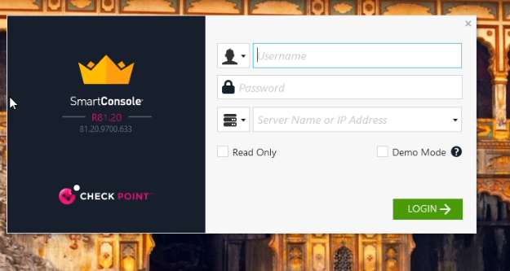
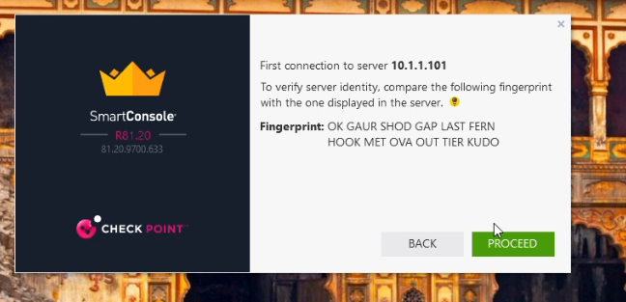
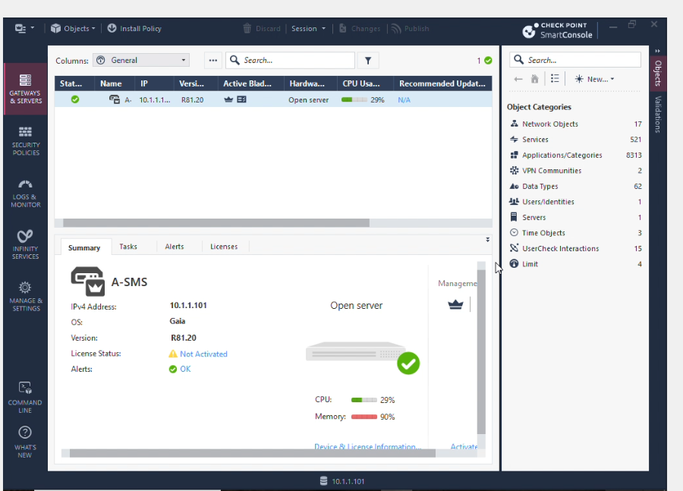
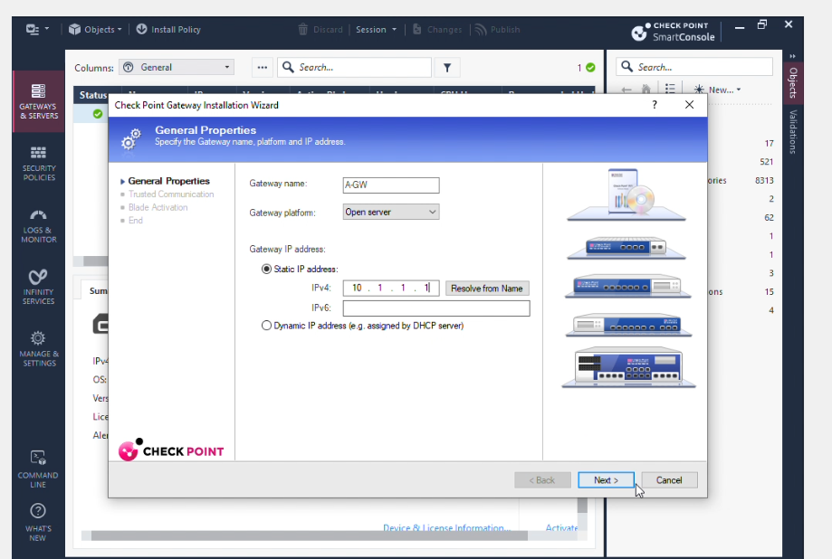
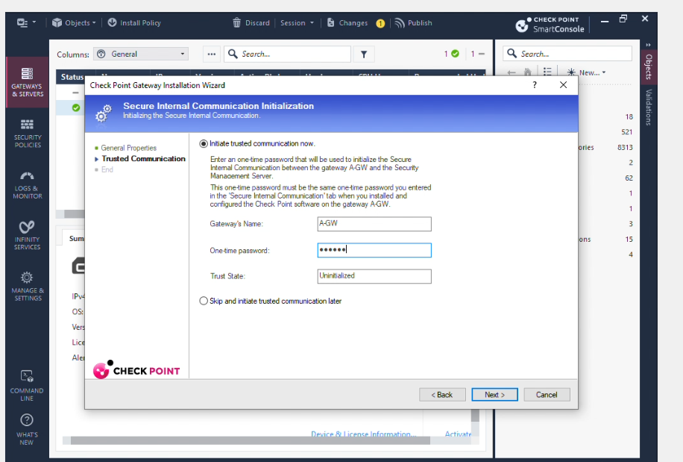
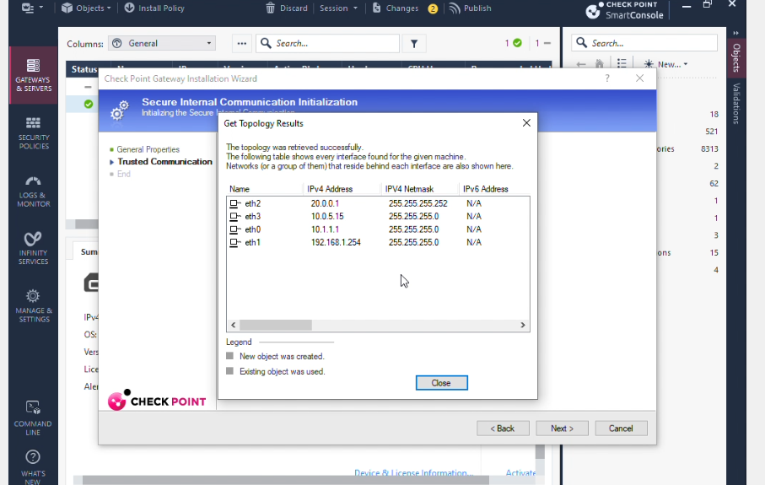

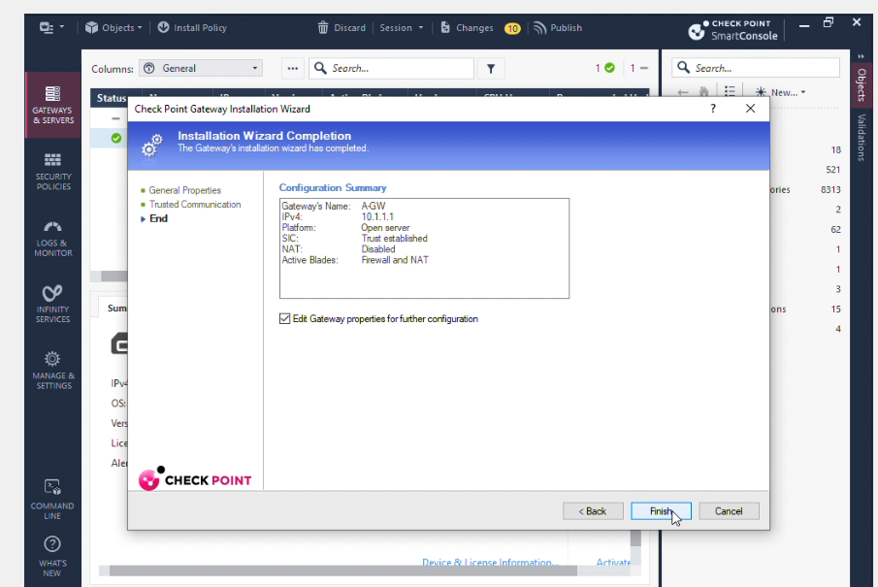

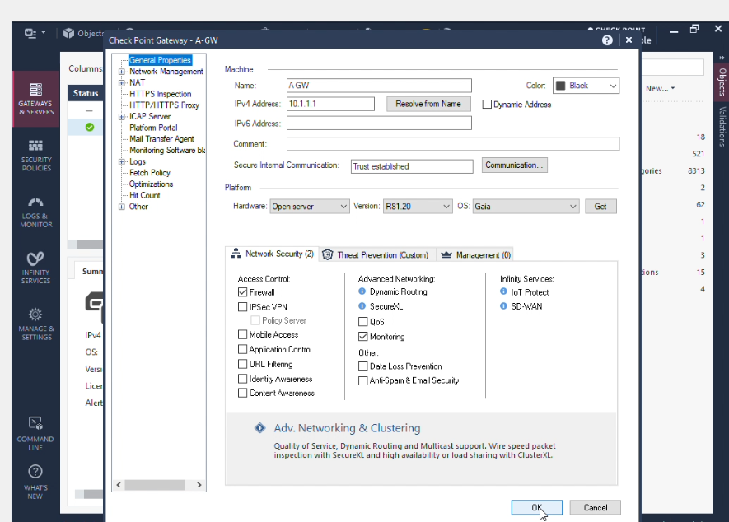

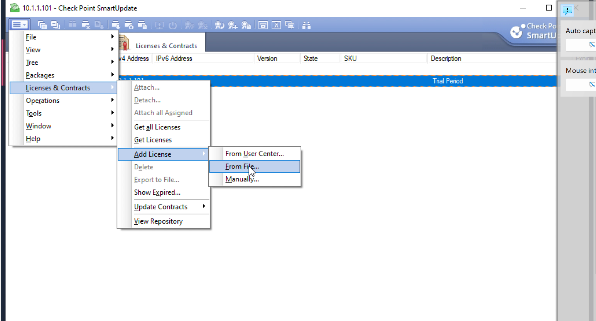

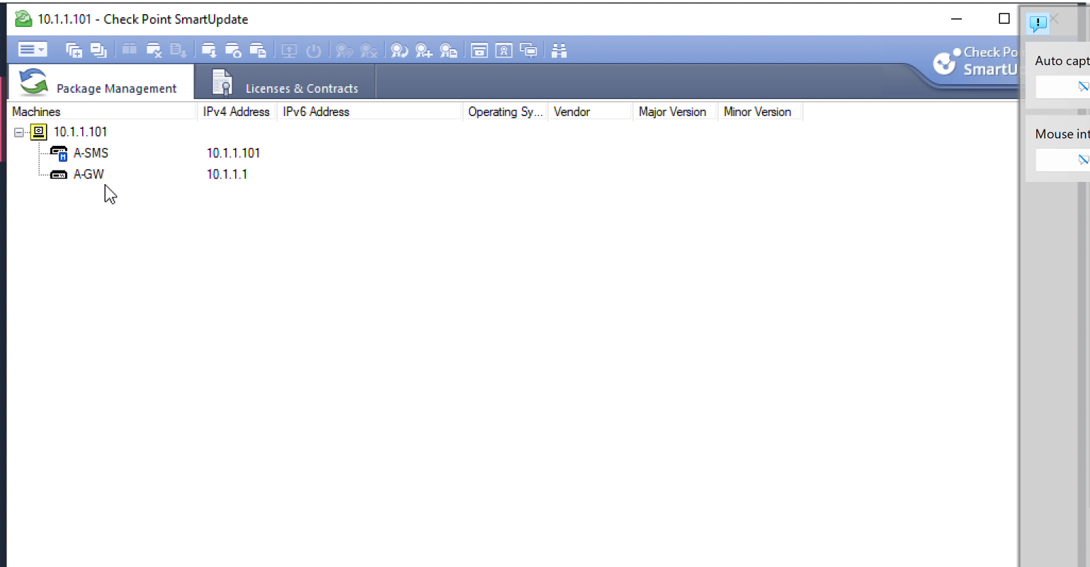

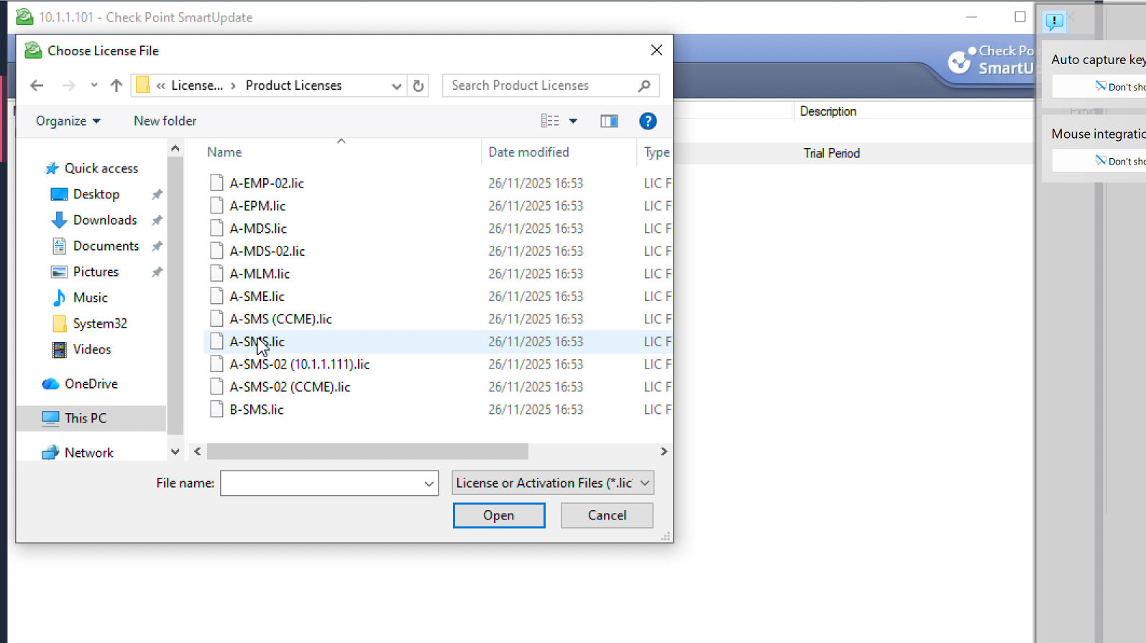

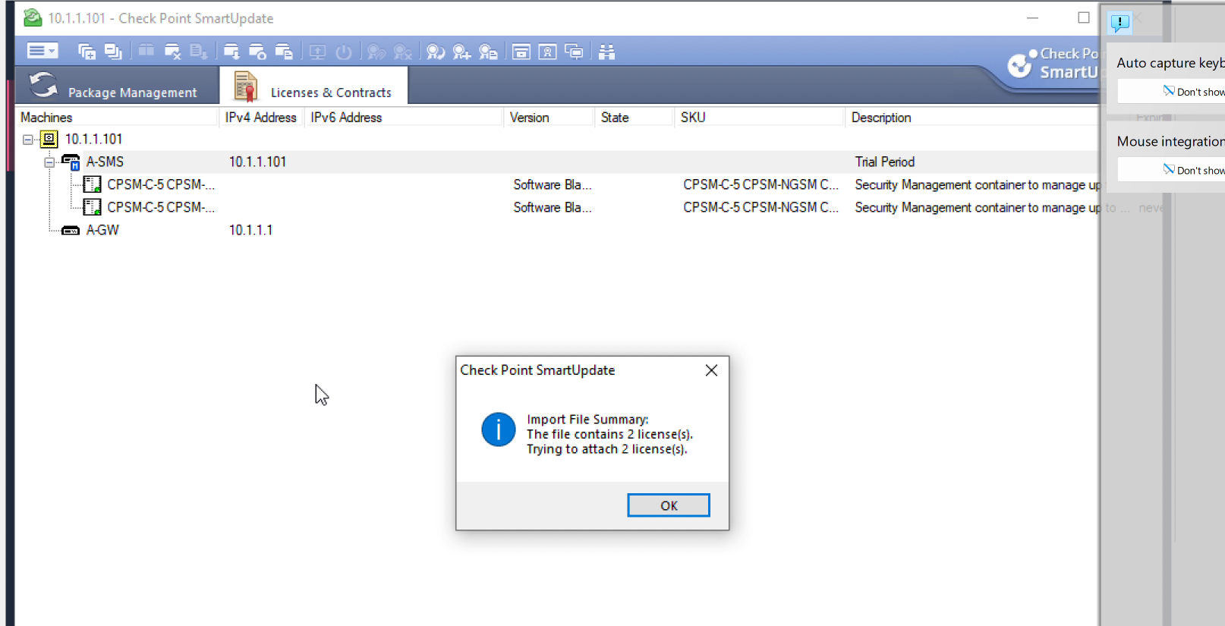
The virtual machine running A-SMS was set up using Oracle VirtualBox using the R81.20 Gaia ISO image using the normal fresh-install process as outlined by the Check Point documentation. The disk was partitioned in order to provide the space needed for logs, system as well as backup and system volumes as well as a separate maintenance password to users on the locally-based "admin" user was configured to enable console recovery if the interface on the web goes down. Once the system had began to boot, the First-Time Configuration Wizard was utilized to assign the management interface on an internal "Swansea" network, assigning A-SMS with the static IP address of 10.1.1.101/24 and the default gateway being A-GW at 10.1.1.1. DNS servers (192.168.1.1, 8.8.8.8, 4.2.2.2) as well as NTP servers (time1.google.com and time2.google.com) were specified in order to make sure that certificates, logs and policies utilize synchronized and resolvable times as well as naming data, which is an important check Point recommended procedure.

A-SMS Install
In the same wizard, A-SMS was identified as designated as a Security Management Server rather than an interface, which allowed the Security Management software blades to be responsible for the storage of policies, logging as well as administration. An administrator account for the Gaia administrator's account was established and for security reasons the strict password was used (combining length and complex) to limit the possibility of gaining access via brute force into the Management plane. When the wizard had finished, the system was rebooted with the Gaia Portal was accessed from the workstation of A-GUI Windows via HTTPS with the company's internal management IP. The privacy alert for the browser was accepted since it was self-signed certificates, which is common in testing settings. Within the portal there was a System Overview page confirmed that A-SMS had been running Gaia R81.20 with 64-bit Open Server profile with all administration processes running, and provided an image of the baseline to the report.

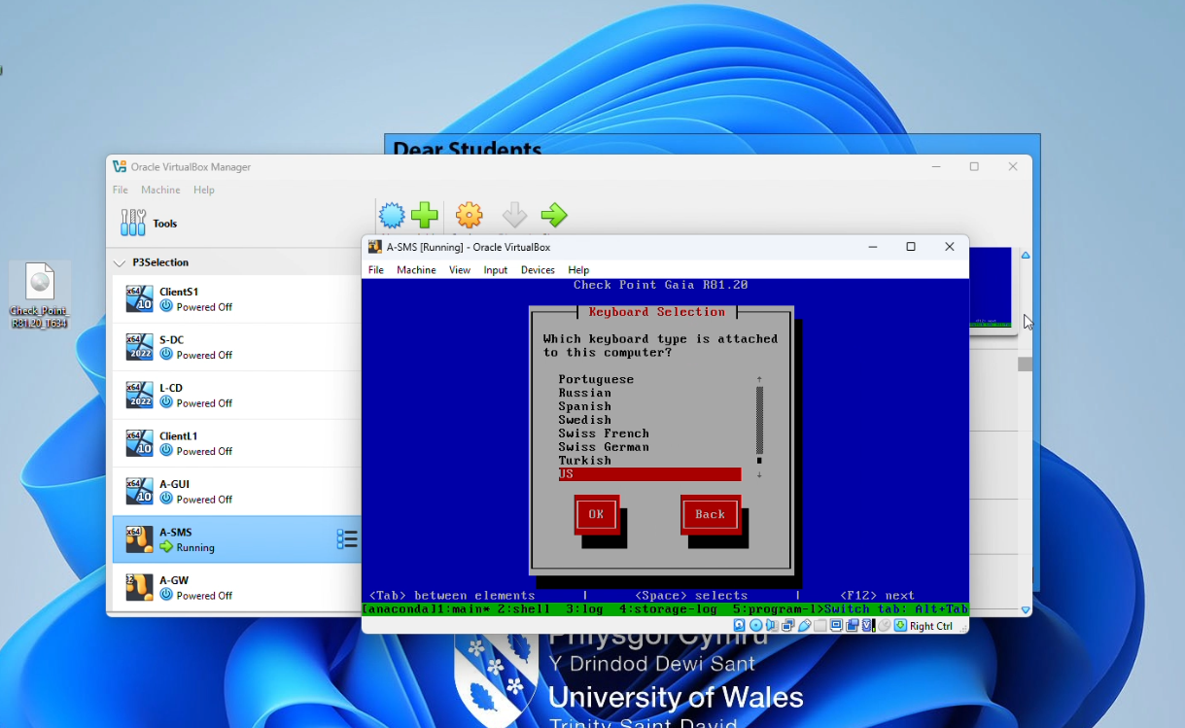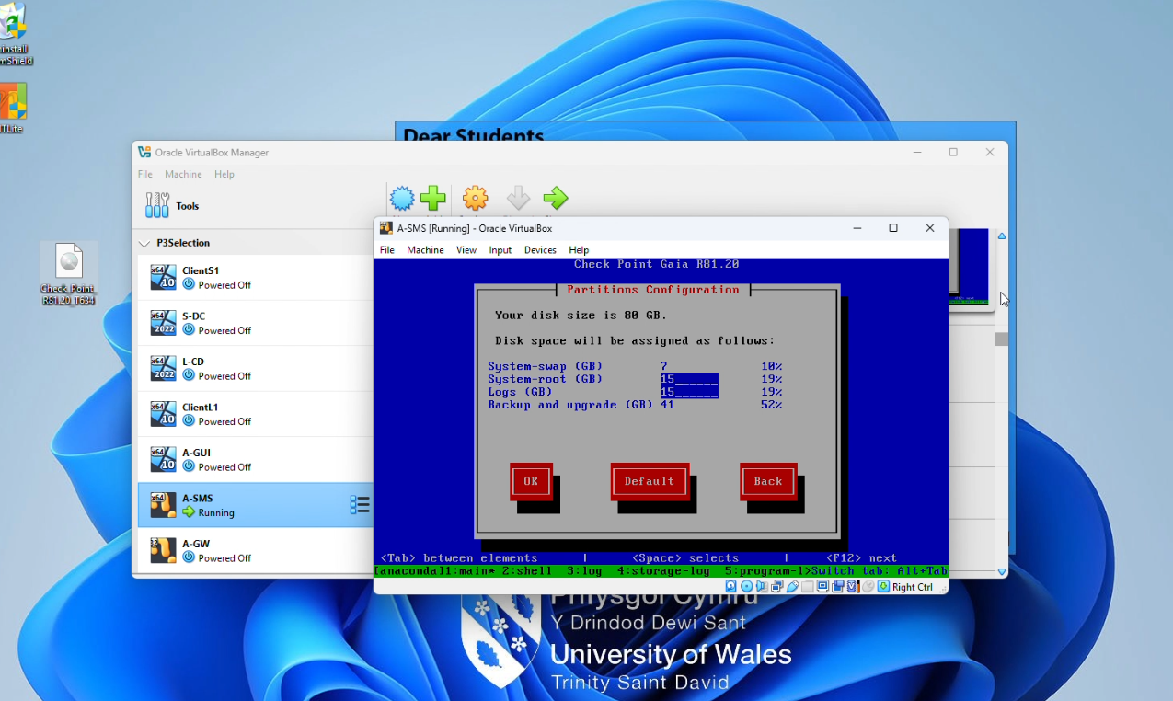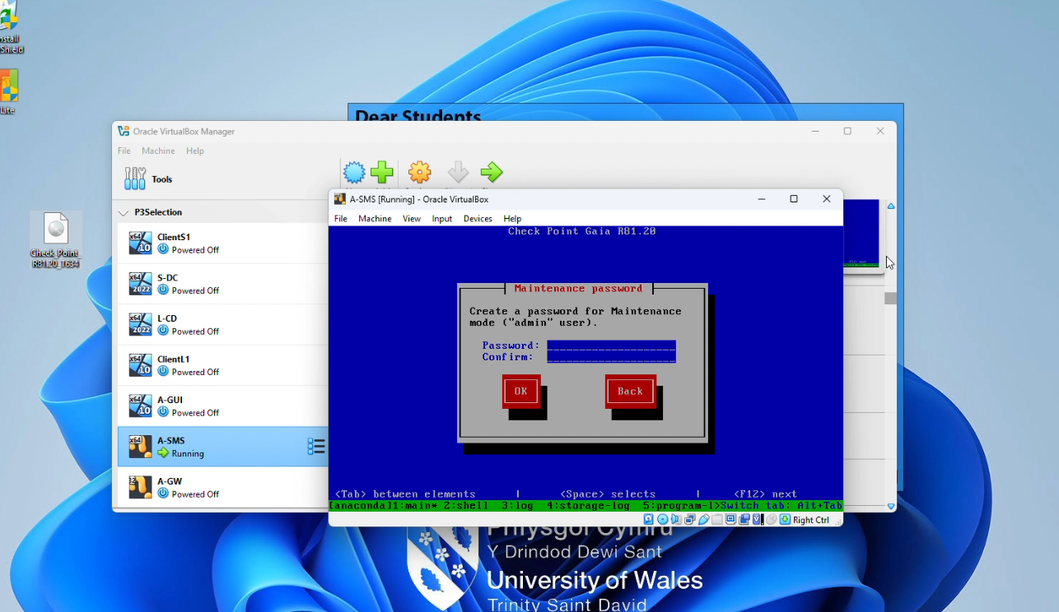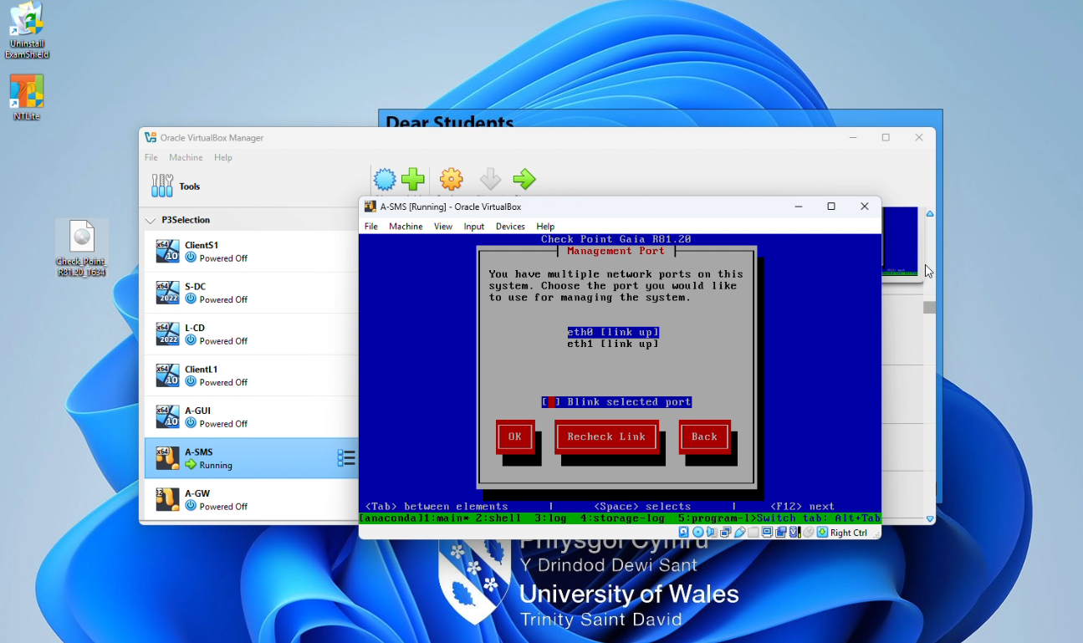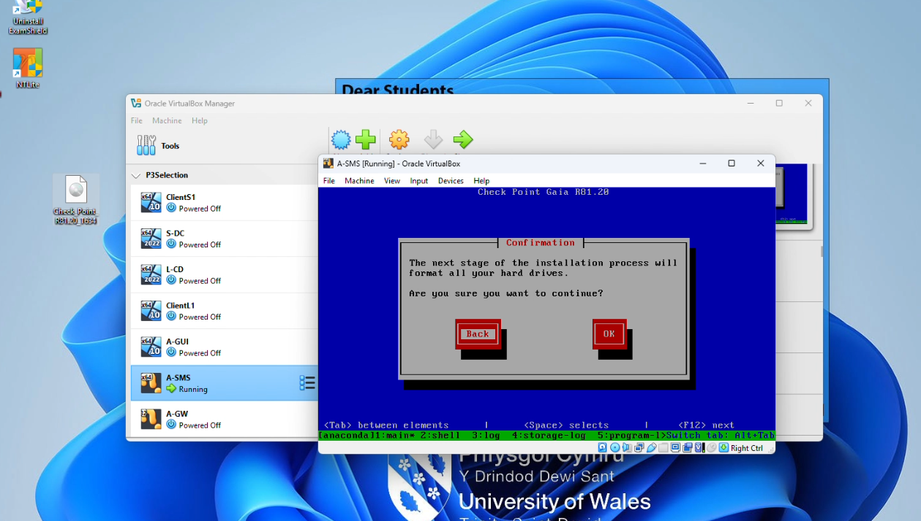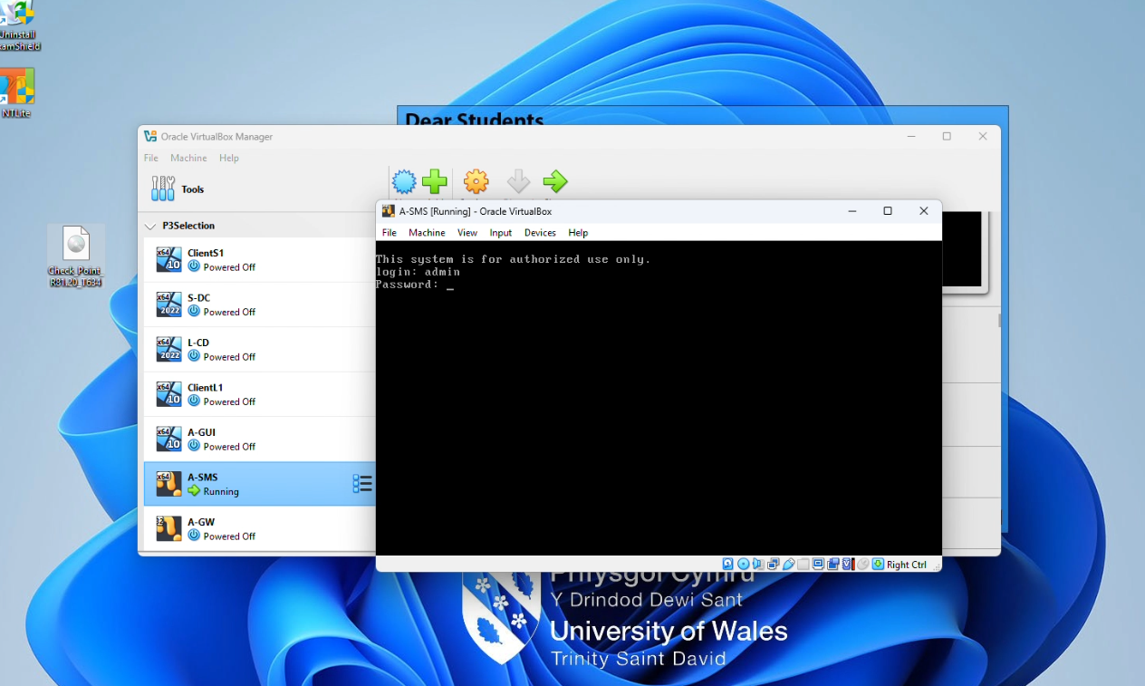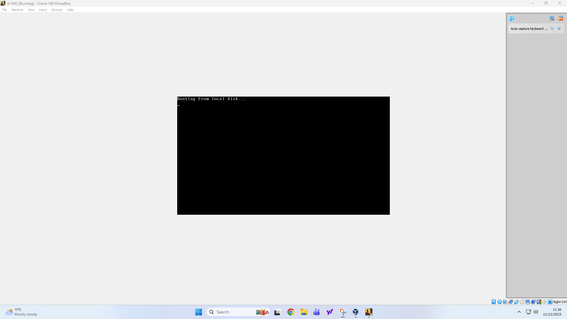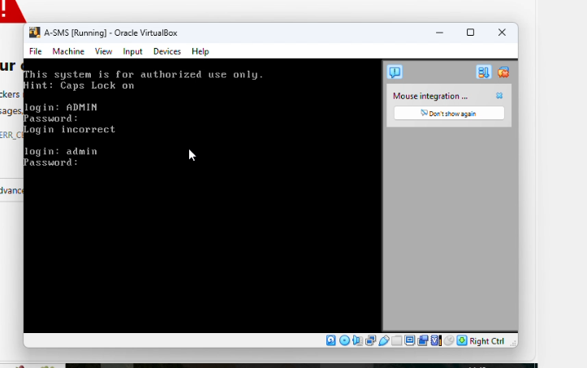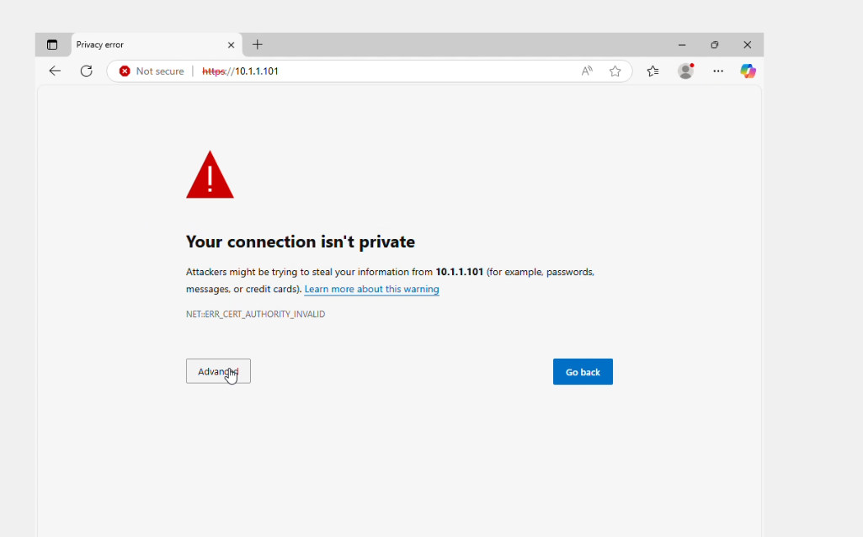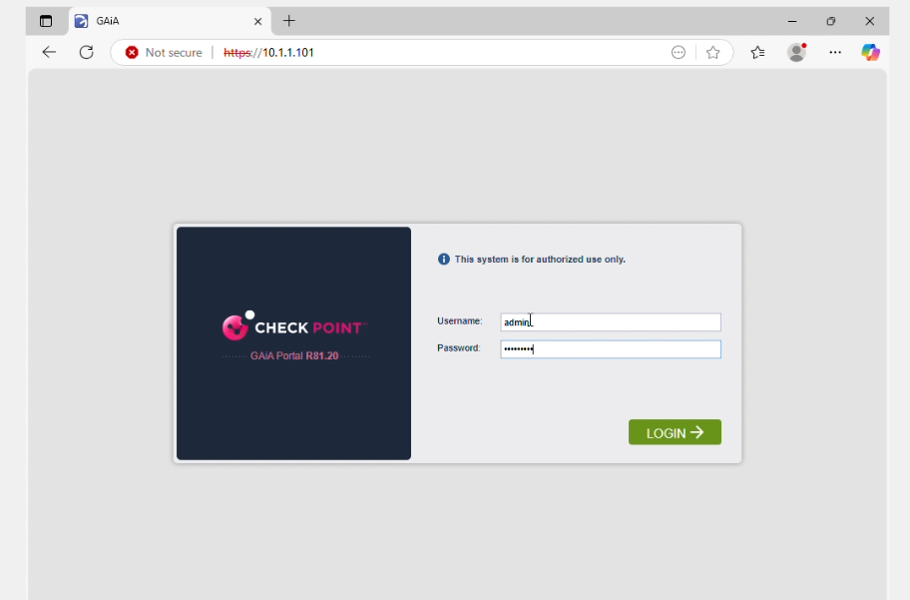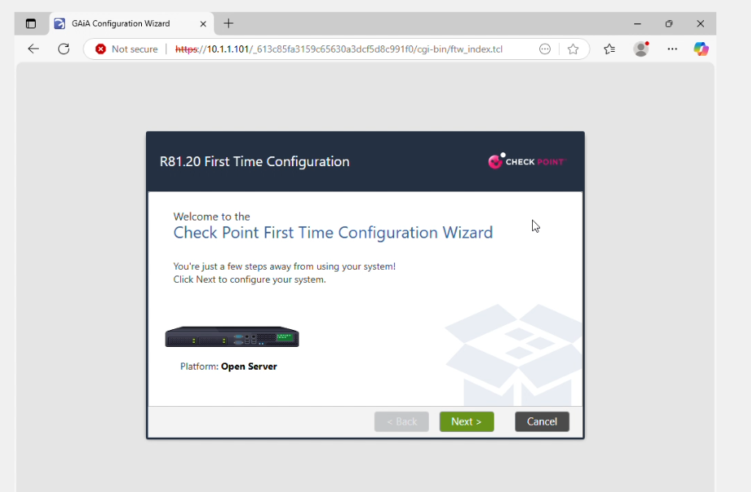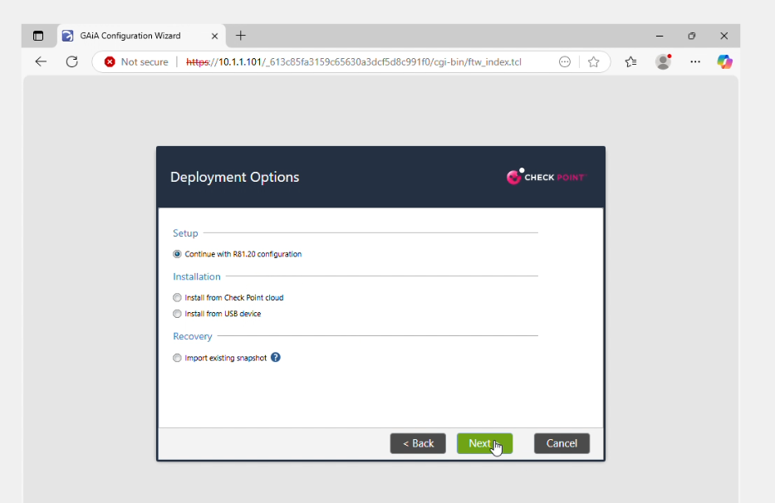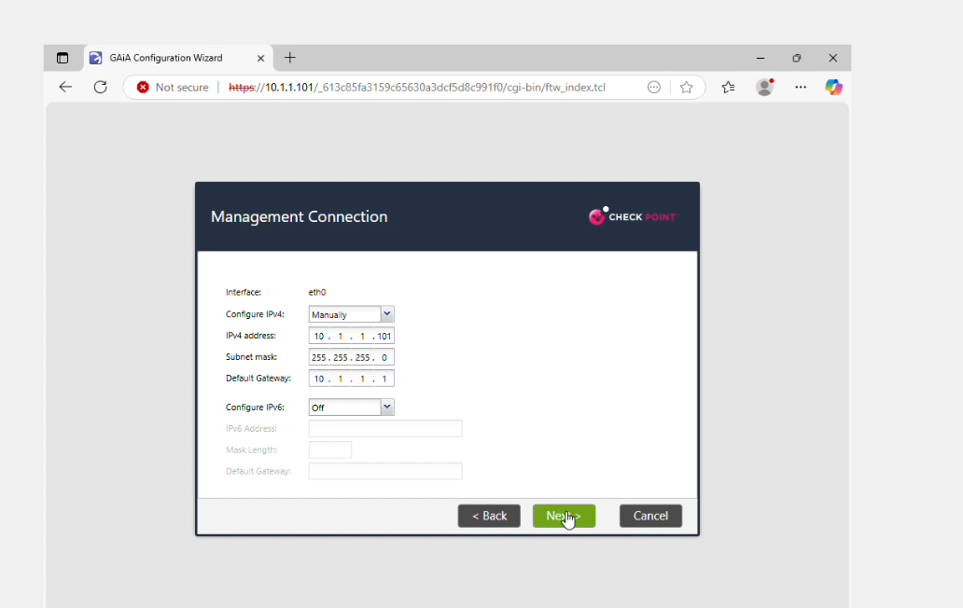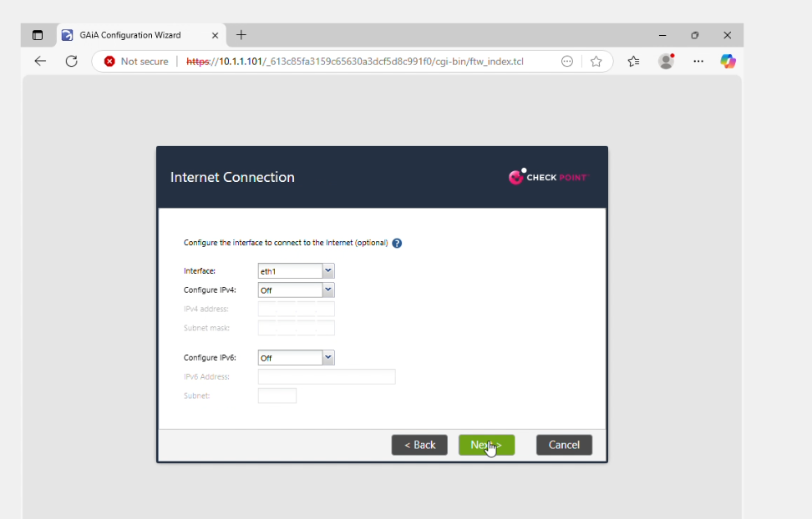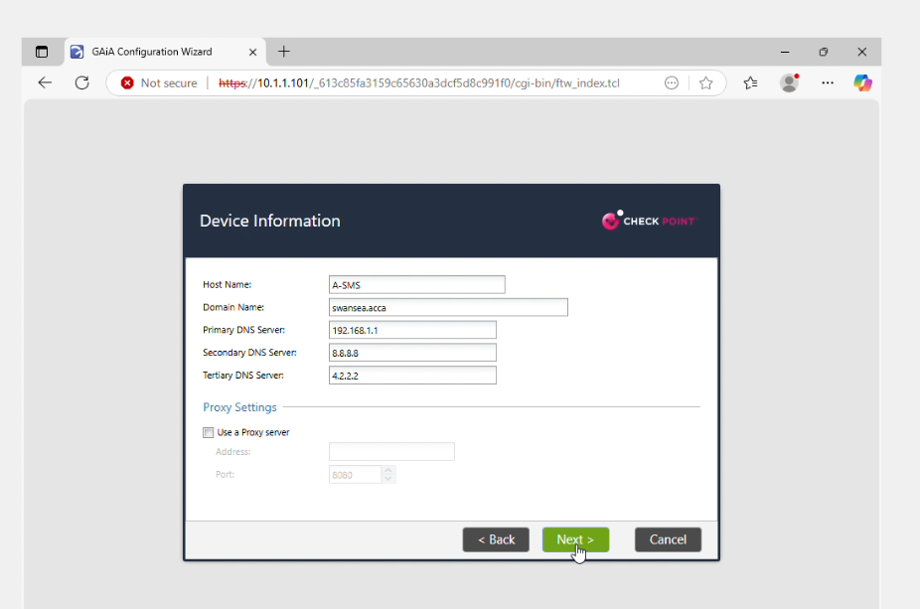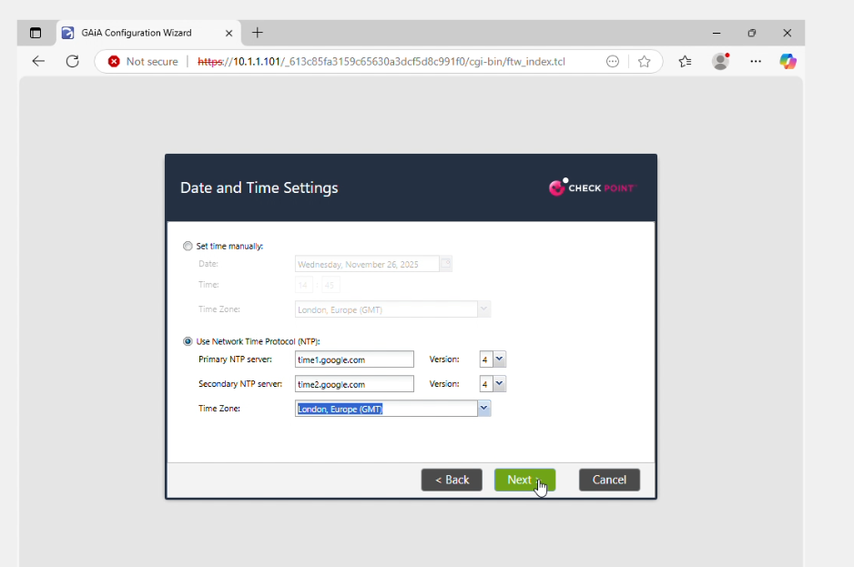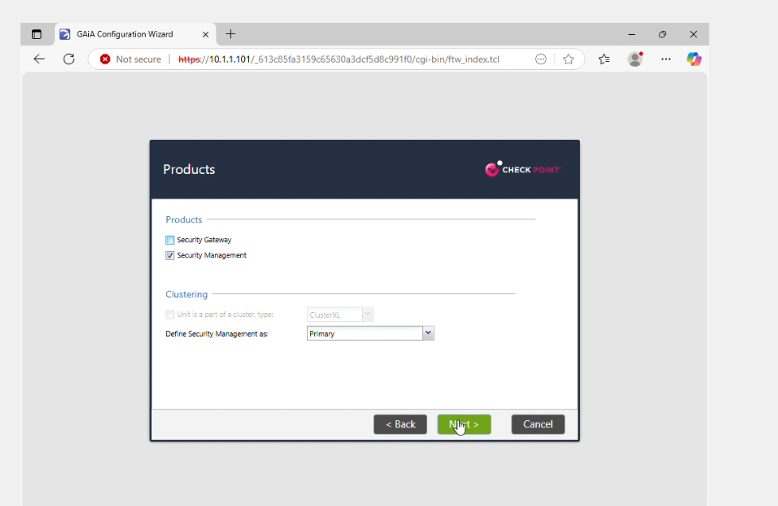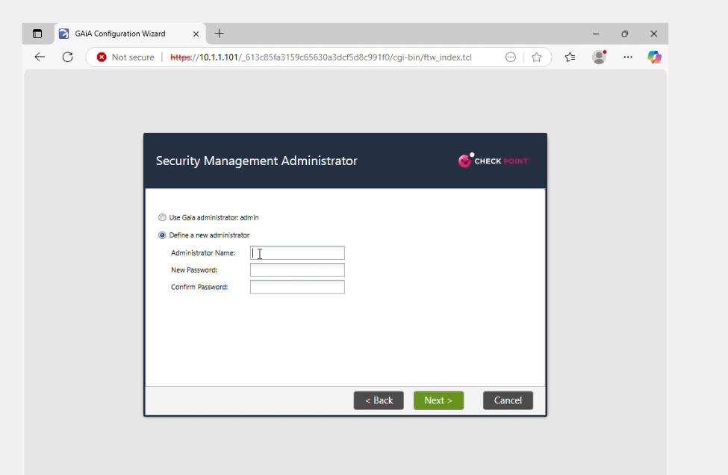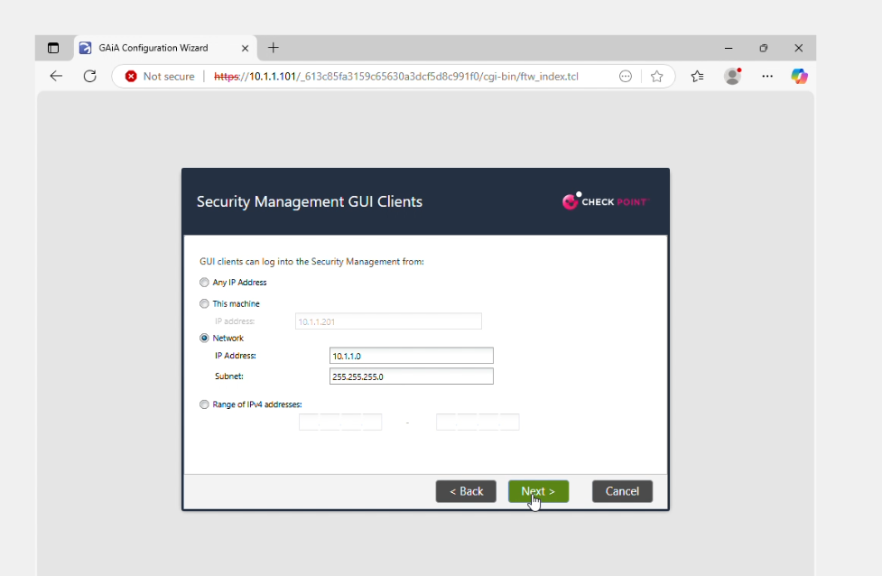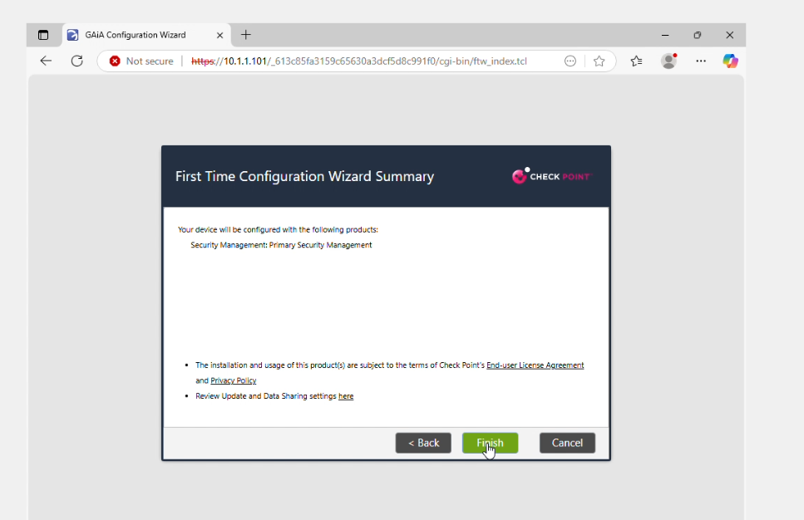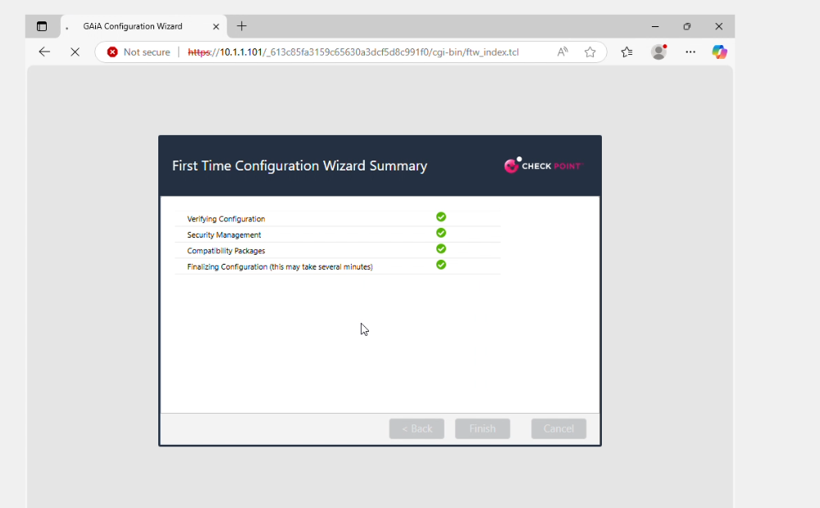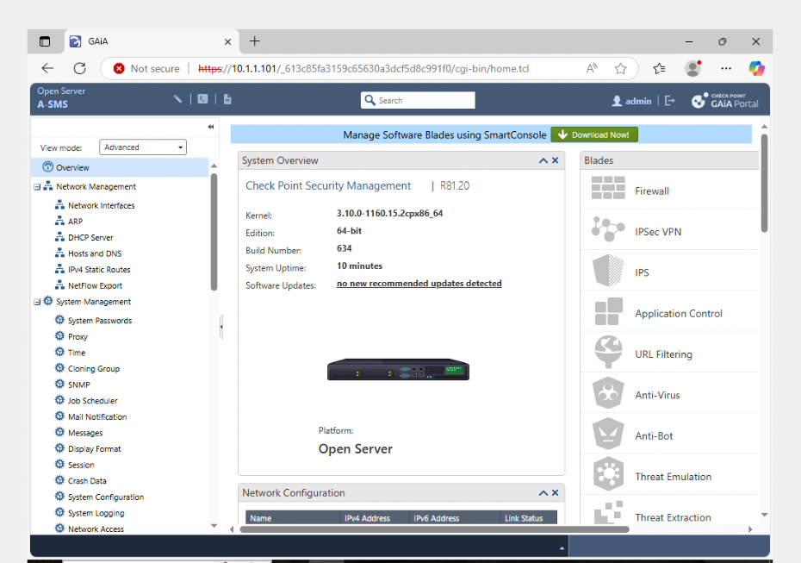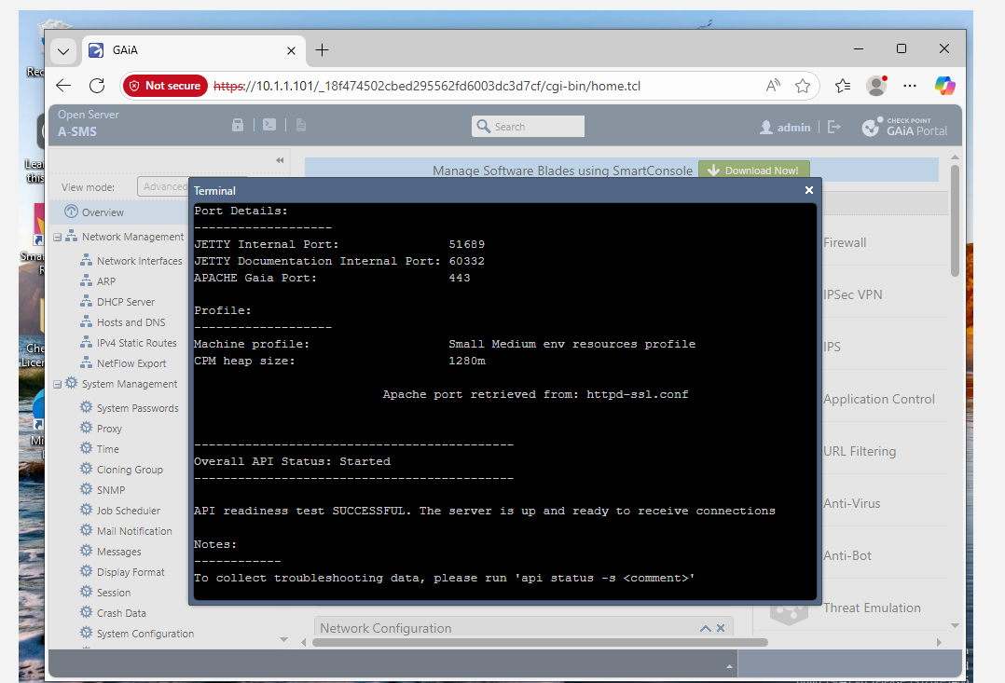

A-GW install

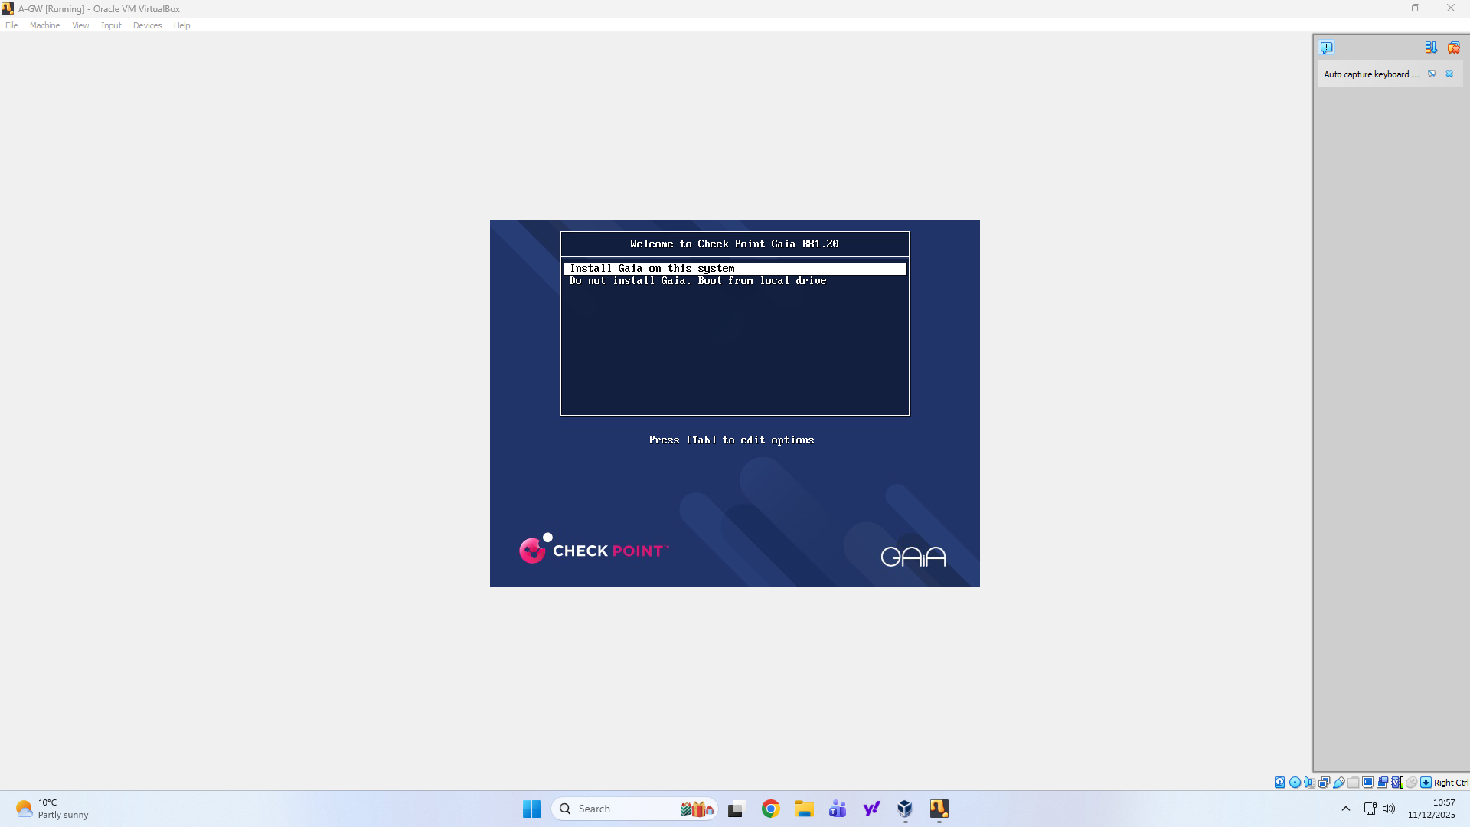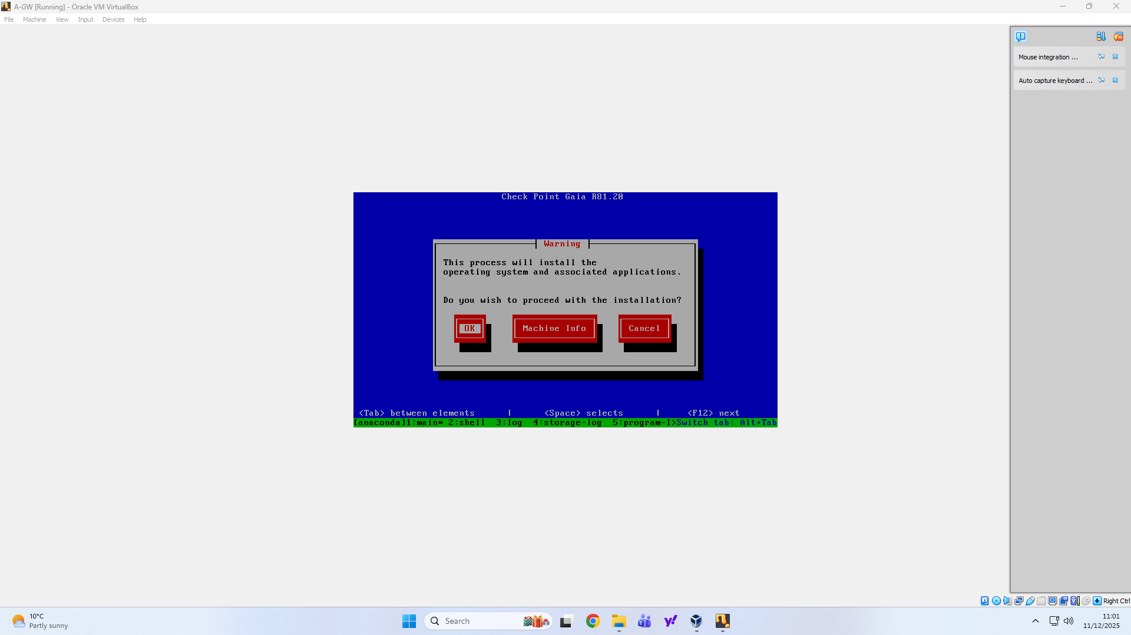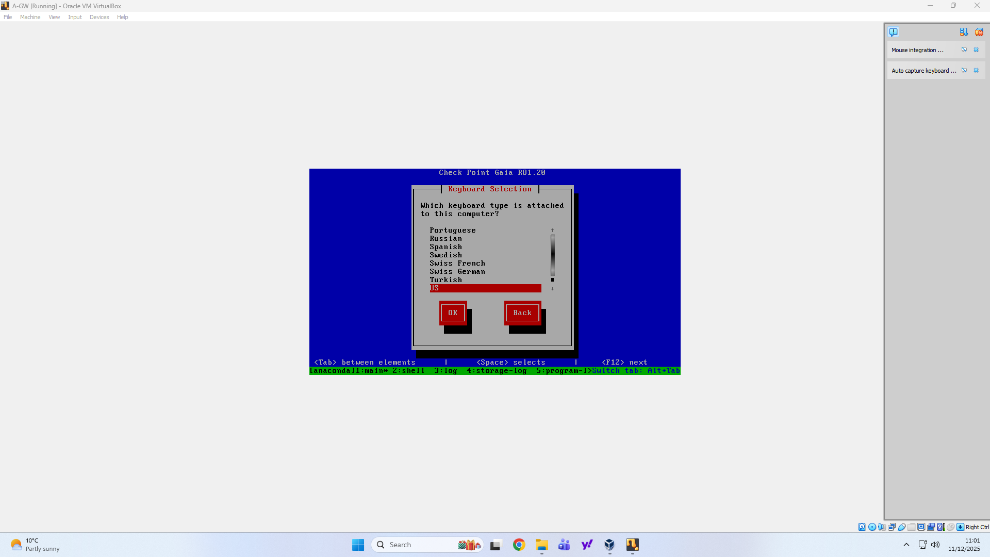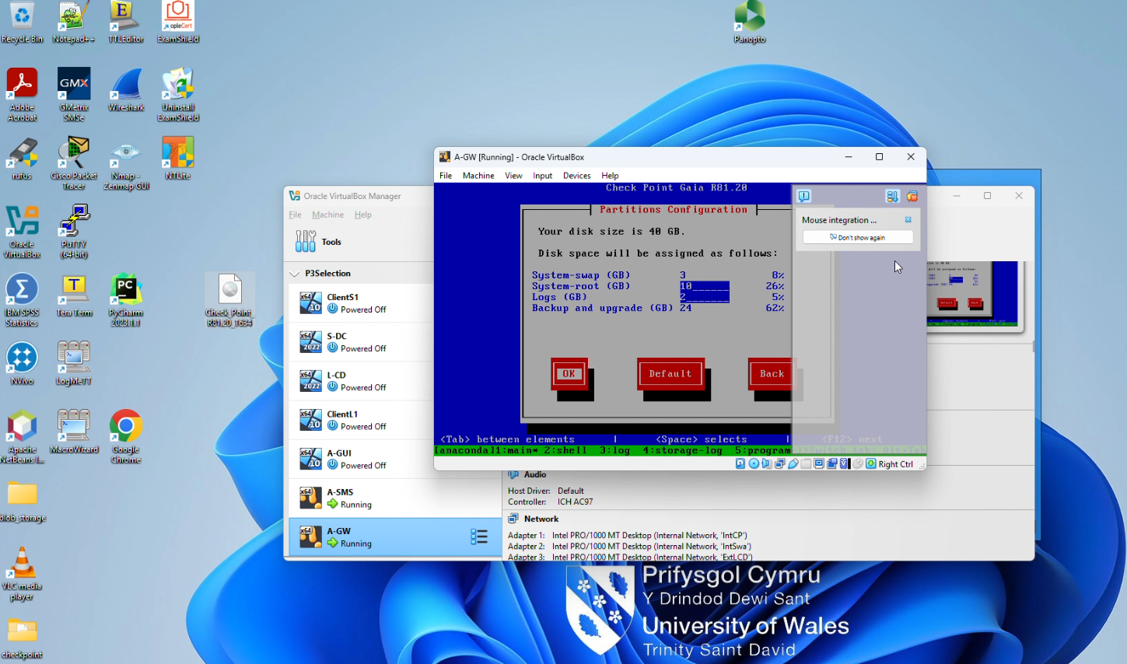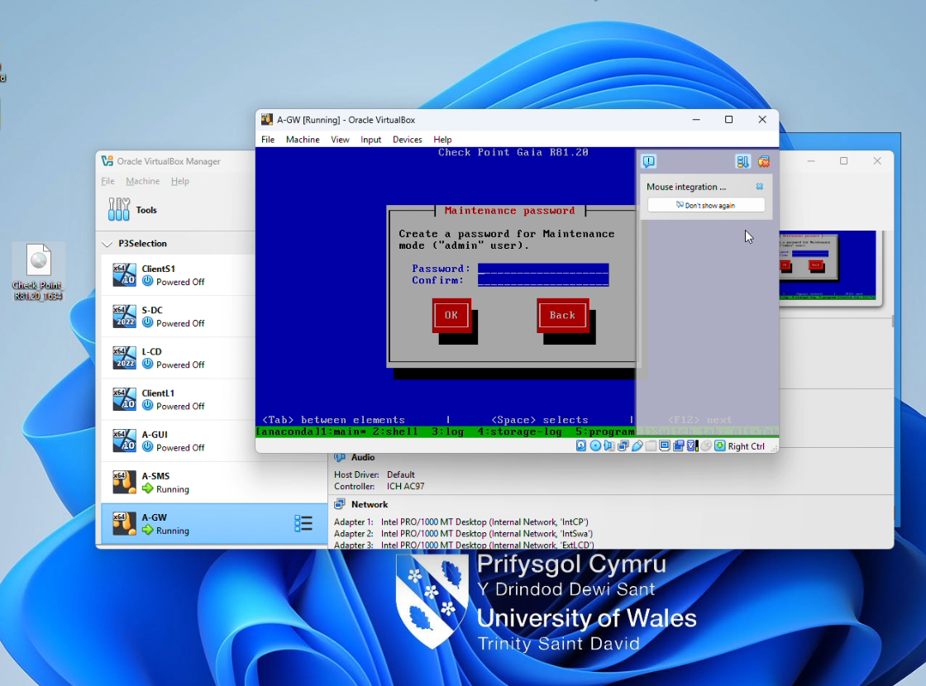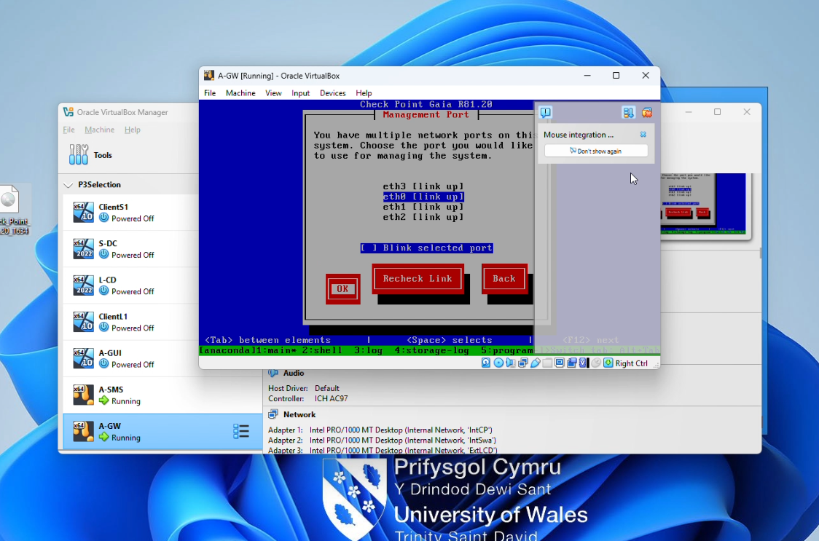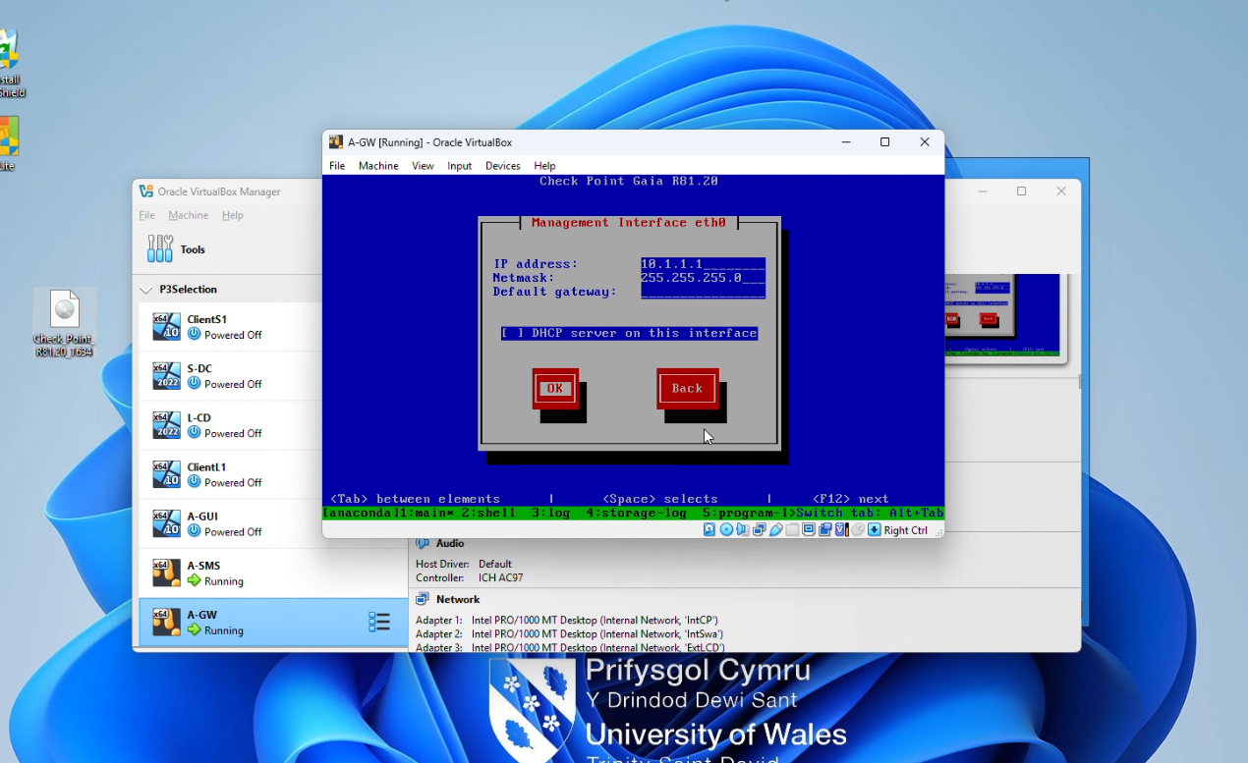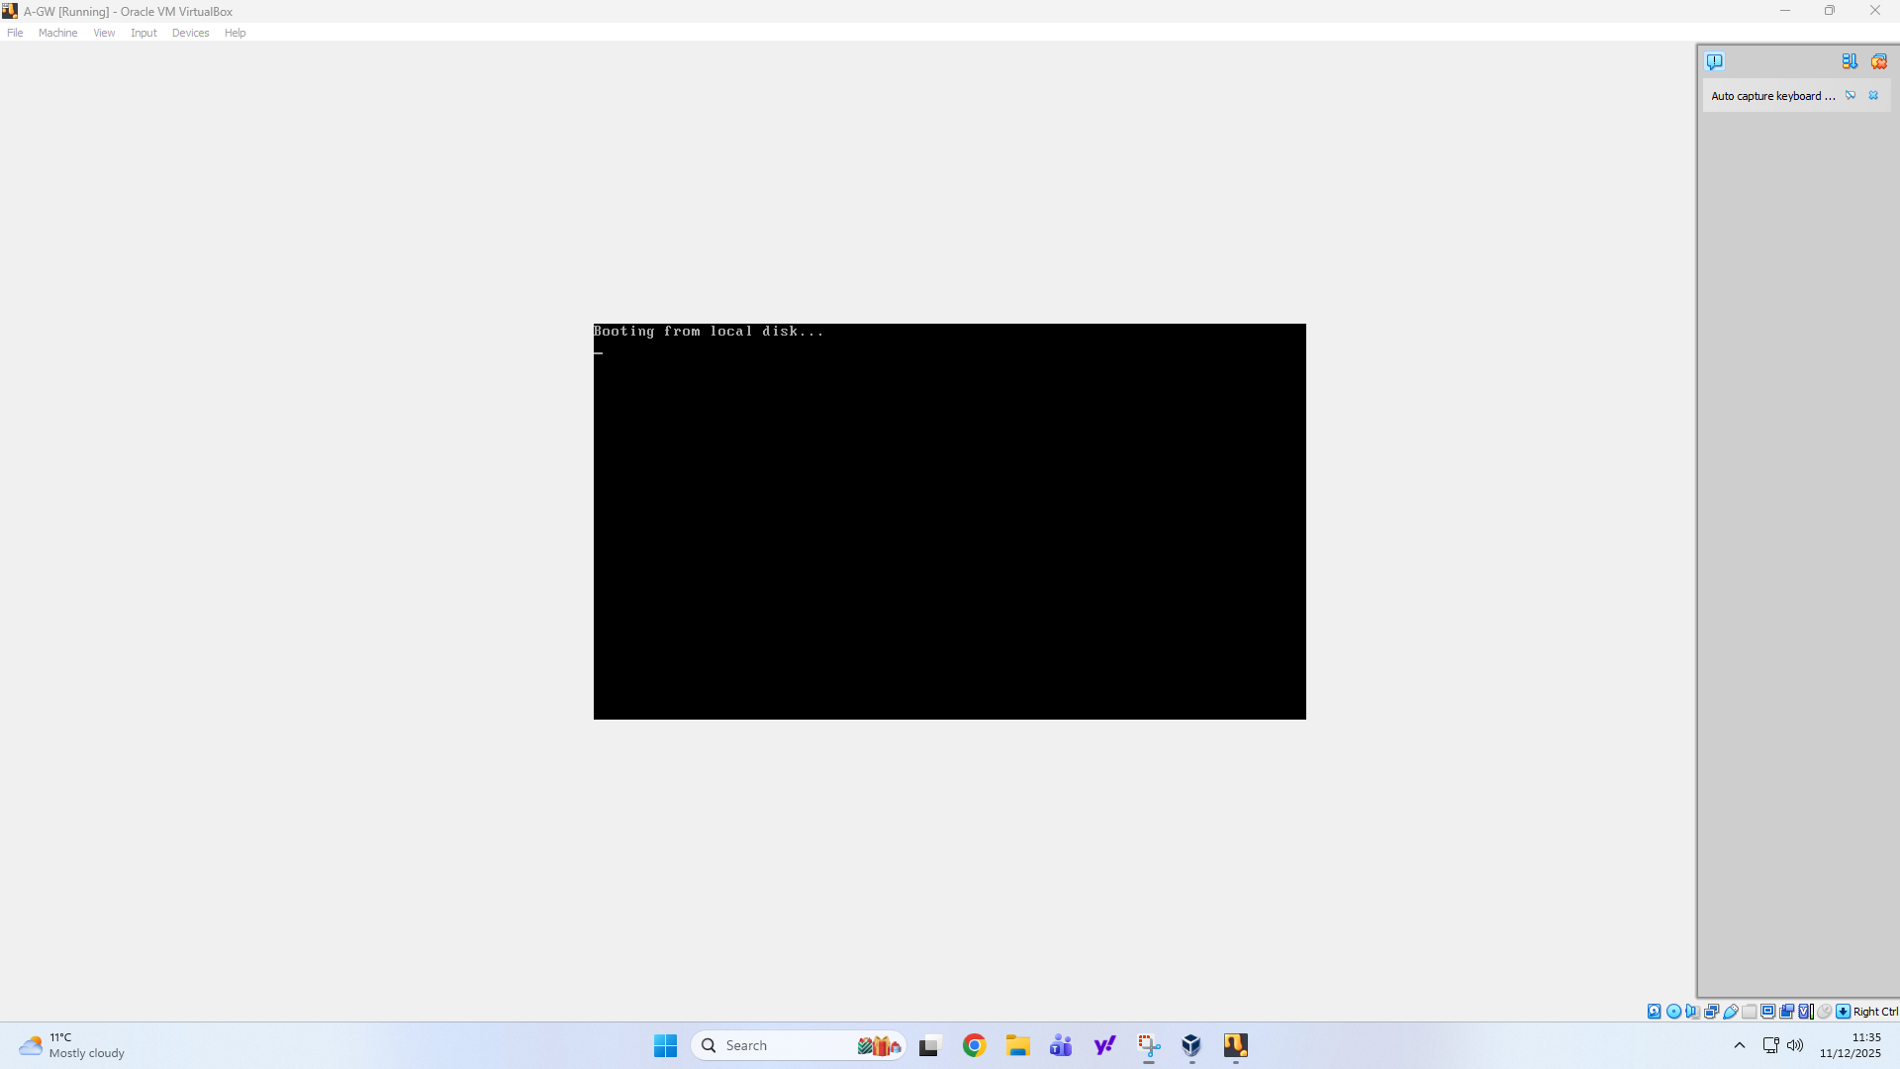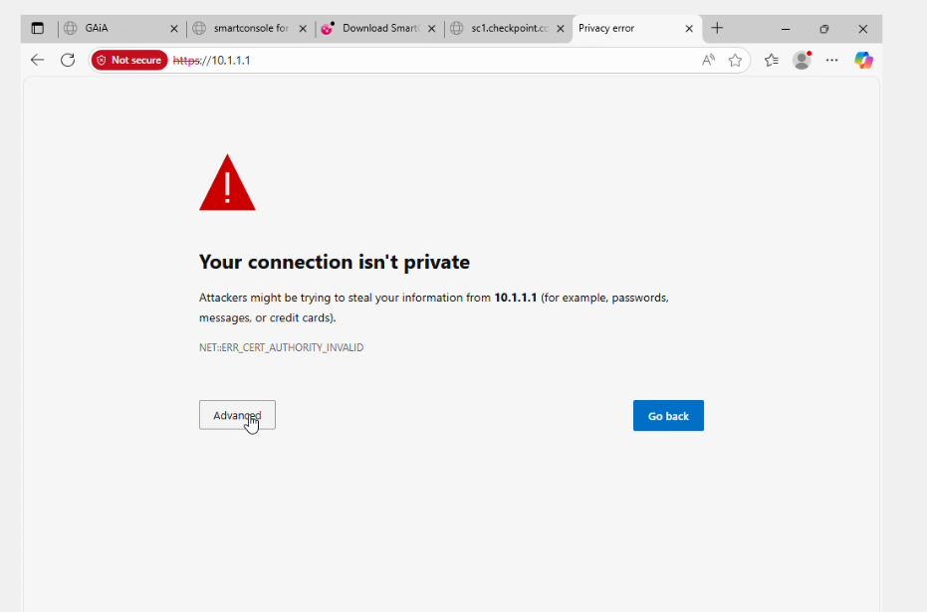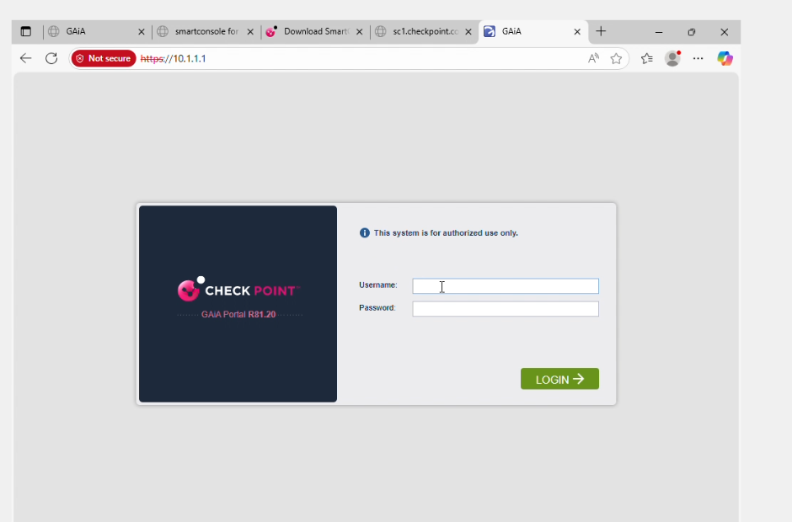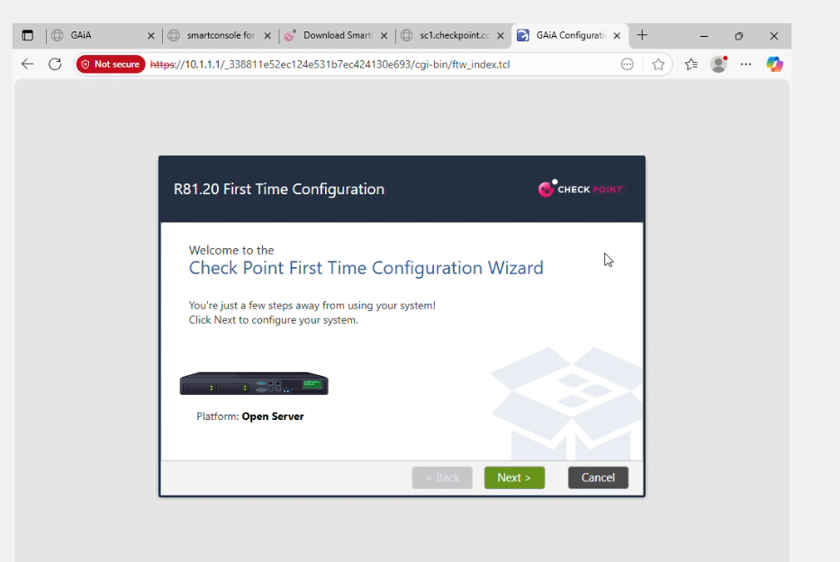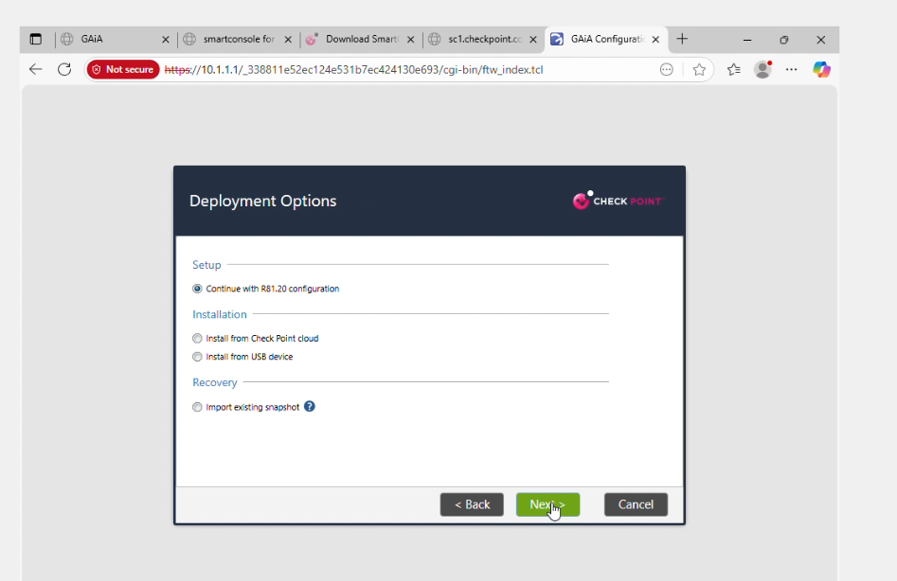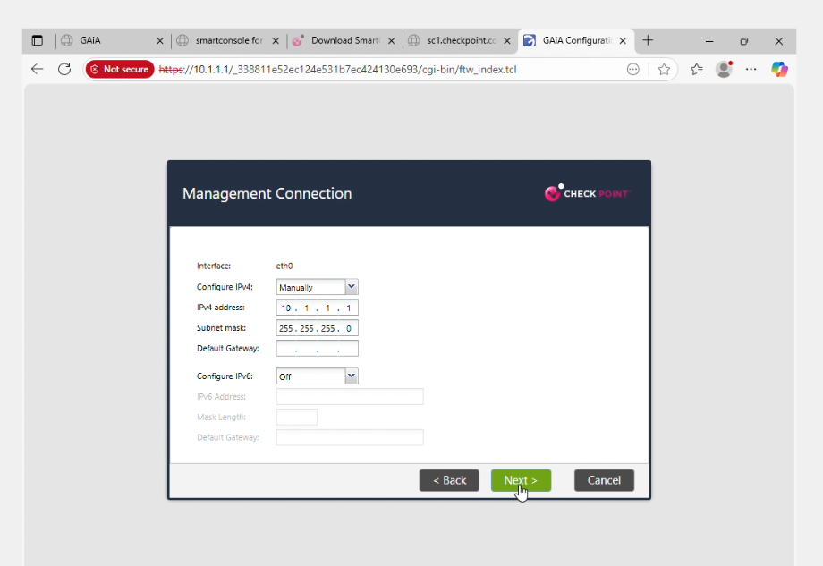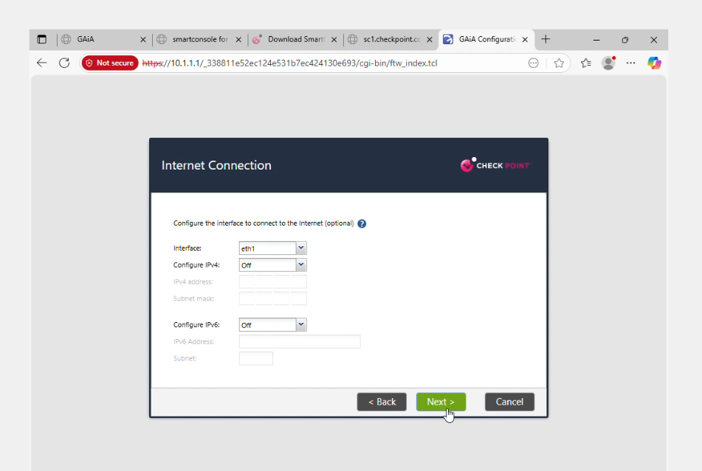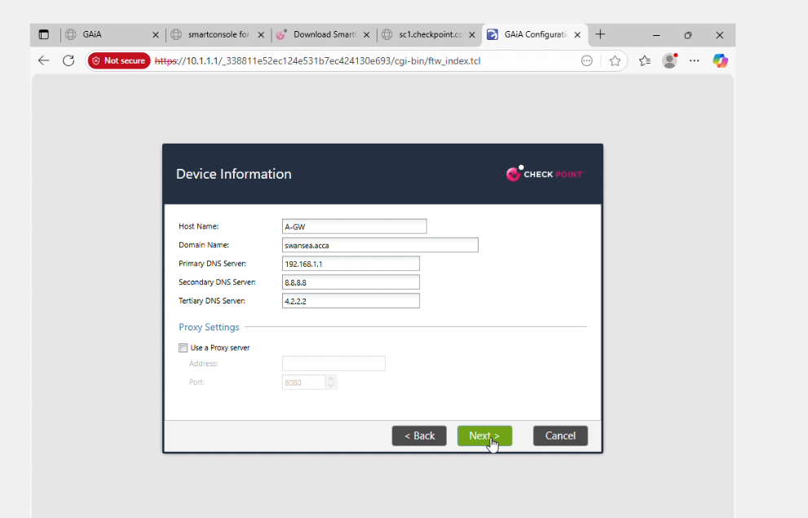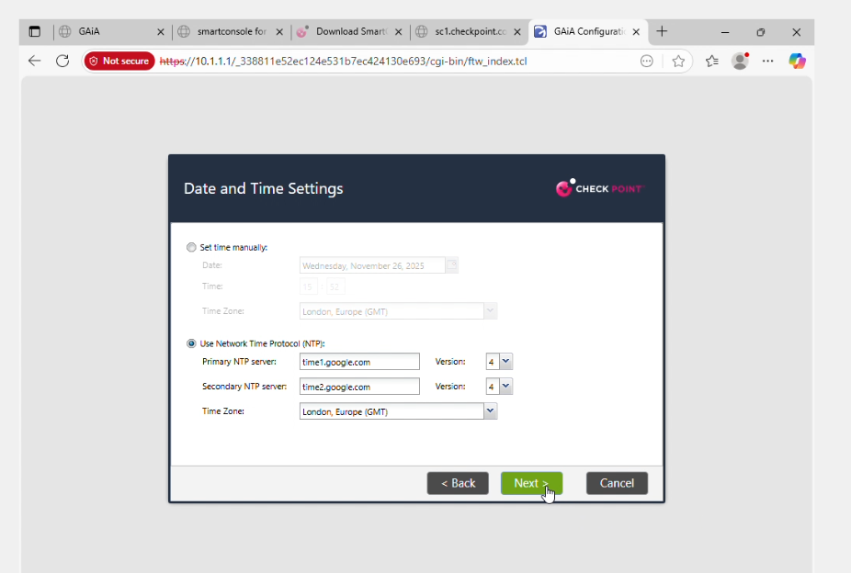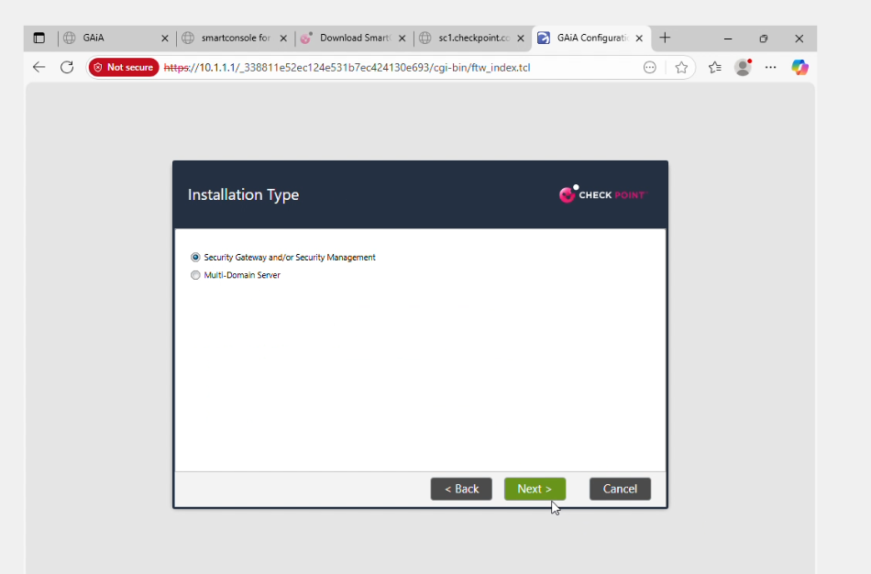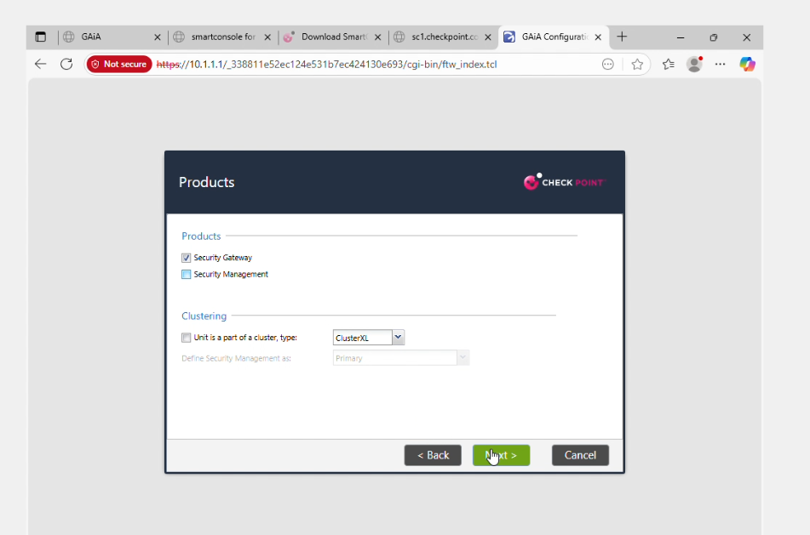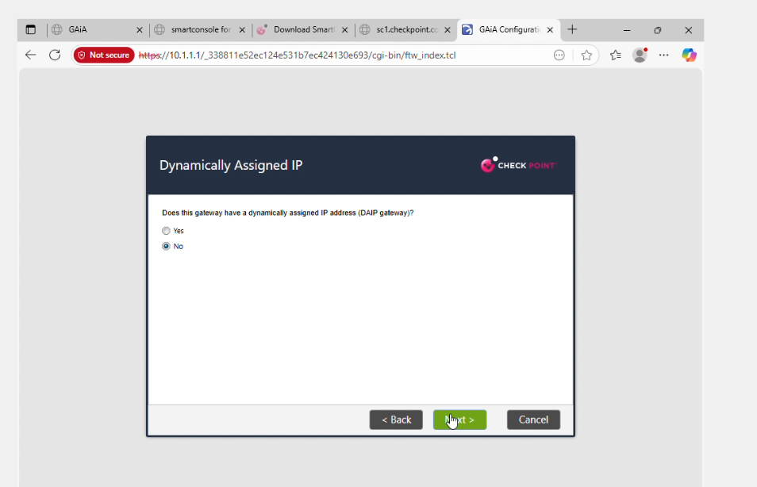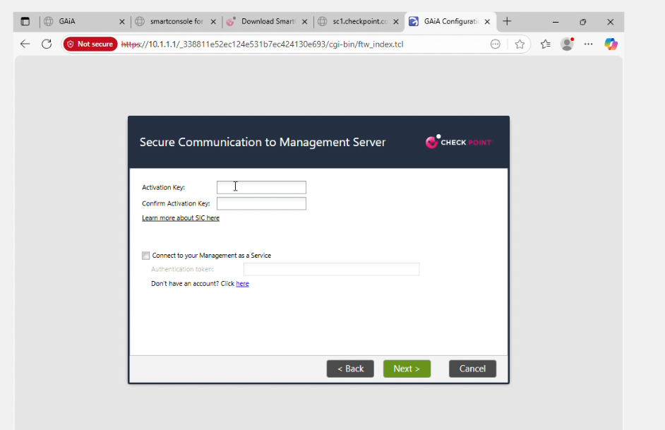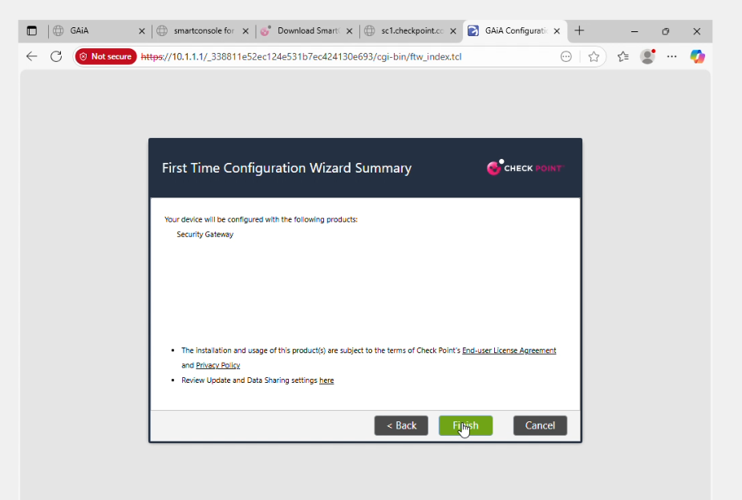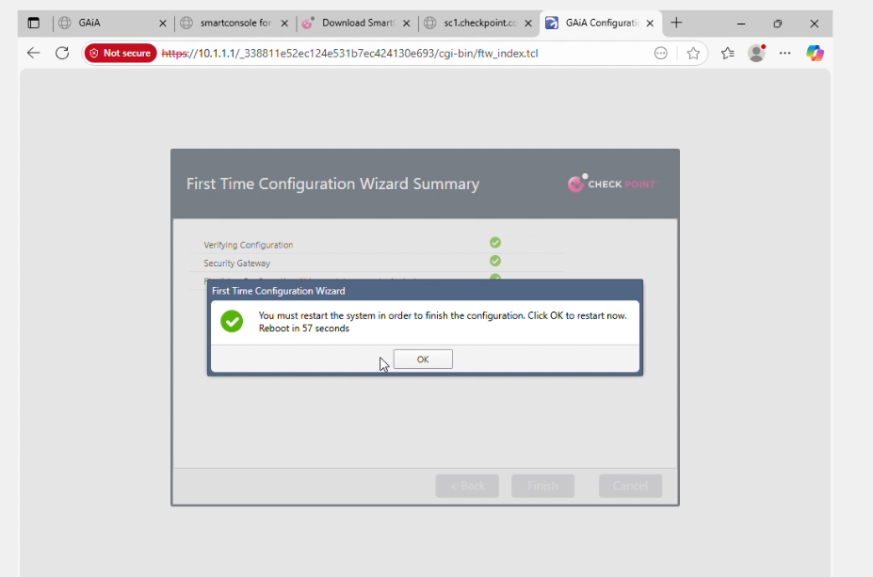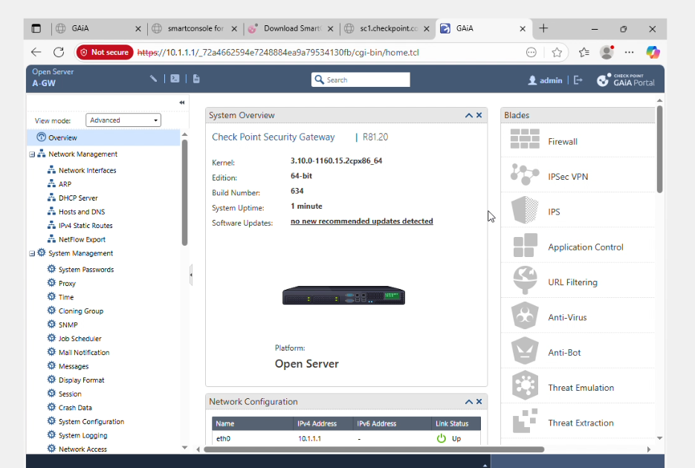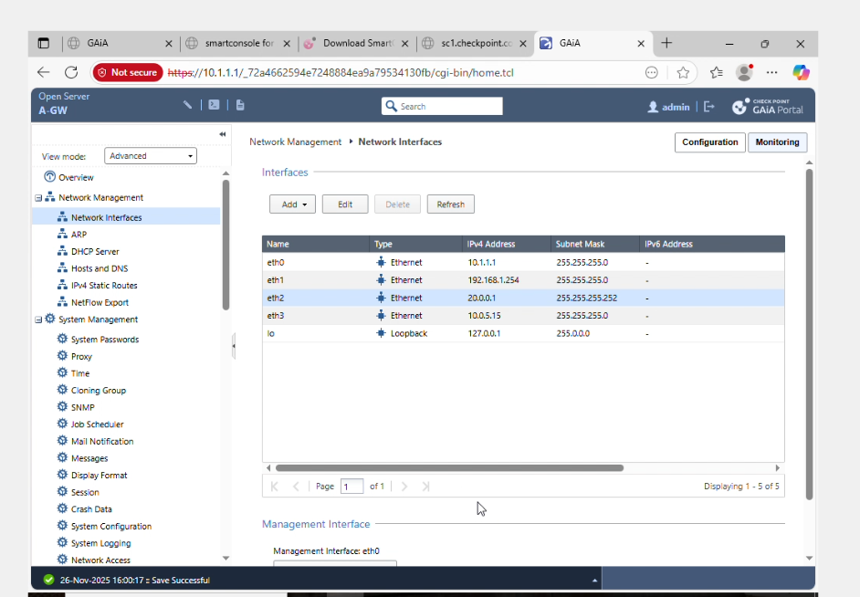
For centralized management for central administration, checkpoint Smart Console R81.20 is installed onto the workstation A-GUI and was connected to the management server on 10.1.1.101. After the initial login, a brand-new Security Management administrator account was established inside Smart Console which is distinct from Gaia OS admin account, following the principle of least privilege. It also makes the roles of security and operating system distinct. With Smart Console an object that is for A-SMS, the Management server (A-SMS) can be created by itself along with a gateway object (A-GW) was added by using its IP 10.1.1.1 and also the "Security Gateway" platform profile. In order to establish a secure connection between gateway and management, Secure Internal Communication (SIC) was set up by using a single activation code that was entered both on the A-GW first Time Wizard screen and in SmartConsole. This creates an authentic connection, as indicated by the green padlock state. The SIC channel is secured and authenticated. It is required for setting up policies as well as accessing logs of gateways within the Check Point environment .
The licensing was applied to the management server and security gateway, enabling the software blades required that are needed for lab use. Check Point supports several methods for deploying licenses, such as central management licenses, which are saved within the Security Management Server, local licenses that are tied to the device's IP addresses, as well as trials or evaluation licenses that are suitable for usage in the lab. For this particular project, Evaluation licenses were downloaded through Check Point's Check Point User Center and downloaded using the Gaia Portal as well as the smart console license tools. These adhere to the procedure for import of license files, or copying license strings into Maintenance “Licenses" - Licenses. Screenshots like "Licenes-1.jpg" and "Licenes13.jpg" illustrate the license entries that resulted for A-SMS as well as A-GW with product names (for instance, Security Management, Firewall, IPS, Application Control as well as threat Prevention bundles) as well as their IP addresses that they are associated with, and expiry dates. These can later be referenced in a report in order to demonstrate that the module is in compliance with its requirement to ensure that all devices are licensed.
Once the license was granted it was possible to have the management plane examined from beginning to end. In the smart console Gateways & Servers view displays A-GW and A-SMS with "Connected" and "Trusted" status. This confirms that A-SMS is able to connect to the gateway using SIC and that the licenses are accepted by both parties. In A-GUI, the simplest connectivity tests like Pings using ICMP from the client network using A-GW external DNS servers are performed to make sure that routing and NAT work in the same way as they would before stricter firewall policies are implemented. Within the Gaia Portal, A-GW's portal, the Blades section shows there are Firewall, IPS, Application Control, URL Filtering, Anti-Bot, and Antivirus blades are in place or may be enabled, which assists later sections in which these security features are utilized for implementing and enforcing the security policy of an enterprise. Additionally, A-SMS can be configured to serve as the central log server. It has the option of logging on policy settings to ensure that all connections and security events generated by A-GW are recorded and accessible through Smart Console's Logs and Monitoring tab.
In general, Section 1 provides an individualized management framework that includes A-SMS for policy definition in addition to licensing and logs, A-GW controls traffic at the network's perimeter. A-GUI offers administrators an integrated smart console user interface that is used for daily tasks. Careful assignment to IP numbers, segregation of gateway and management roles, the utilization of secured SIC channels, as well as the provision of valid licenses will ensure you that your Check Point deployment mirrors real-world design for enterprises and creates an adequate foundation for sophisticated firewall rules, security capabilities, and the user-based control which are discussed in subsequent sections of the document.

Section 2 - Firewall Policy and Threat Prevention
This article explains how security policies for firewalls and threats were developed and implemented on the Check Point Security Gateway (A-GW) with s mart console. It also explains the way they implement a real security framework for enterprises on the Swansea network. The Check Point R81 series of firewalls access control is controlled using an ordered rule base in which traffic is assessed beginning with the top rule, and moving upwards until the initial matches are found. Therefore, cautious rule-ordering and the implementation explicit cleanup rules are generally considered to be the best method. It was the intention to let only protocols that are business-justified ( such as HTTP/HTTPS, DNS, or SSH to manage) and to tightly manage access to management, and also stop high-risk or legacy services such as Telnet as well as unrestricted FTP and also provide advanced security which include Intrusion prevention (IPS) as well as Anti-Virus. Anti-Bot.
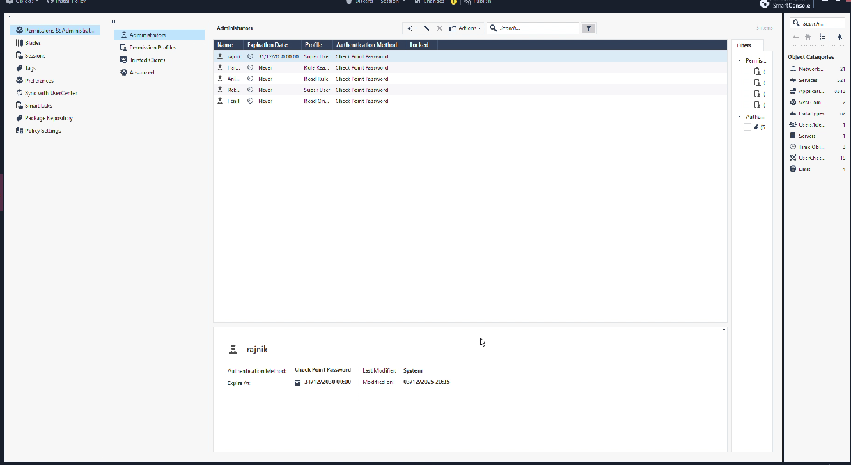

2.1 Design of the access control rule-base
The policy for access control was developed using smart console as a specific security policy program for the environment. It was installed on AGW via its Security Management Server (A-SMS). Network objects were developed for the main segments defined in Part 1. These include an inside of the Swansea LAN, the management network (10.1.1.0/24) and the Internet/external zone, as well as some particular hosts like A-SMS, AGW, internal servers and client computers. Using groups and objects instead of raw IP addresses is in line with Check Point guidelines which makes the rule-base simpler to update. Furthermore, Service objects for ICMP, DNS, HTTP, HTTPS, FTP, SSH and Telnet were utilized to ensure that rules were explicitly linked to the specific protocols and ports instead of using broad "Any" service definitions.
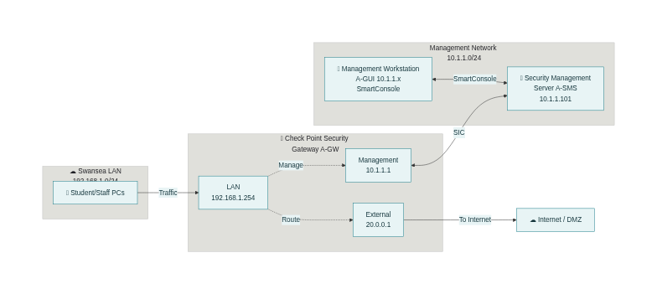
The initial rules of the policy are based on the "stealth" and "management" idea: a rule at the top of the list allows SSH as well as HTTPS access to the A-GW and A-SMS, but only through the subnet for management (e.g. A-GUI as well as designated administrators hosts) A second rule prohibits all attempts to connect to the management server or firewall. The rule prevents outside clients and vulnerable internal computers from trying to control or even probe the firewall's security, but maintaining the ability of administrators to complete basic tasks through smart console, Gaia Portal or SSH. Screenshots like "Create-Rules.jpg" and "Host_Rules.jpg" are the resultant rule entries with source set to "Admin-Network", destination set to "A-GW" or "A-SMS" and services such as HTTPS as well as SSH and the setting as "Accept with Log", to ensure that access to management is as well controlled and monitored.

Rule ID | From device / segment | To device / segment | Service / Ports | Action | Purpose in Part 2
R‑SWA | Swansea LAN client (e.g. 192.168.1.50) | Internet / External_Net | HTTP, HTTPS (80, 443) | Accept & Log | Allow Swansea users to browse the web through A‑GW while logging all outbound Internet access.
R‑SMS | A‑SMS (10.1.1.101) | A‑GW (10.1.1.1) | CPMI, SIC, HTTPS | Accept & Log | Permit security‑management traffic from A‑SMS to A‑GW so policies and logs can be centrally managed.
R‑GW | Any | A‑GW, A‑SMS | Any | Drop & Log | Stealth rule on A‑GW blocking all unsolicited access to the firewall and management server from non‑management hosts.
R‑ICMP | Mgmt network (10.1.1.0/24) | Swansea LAN + A‑GW | ICMP echo‑request/reply | Accept & Log | Allow administrators to ping internal hosts and the gateway for troubleshooting without opening ICMP from the Internet.

Based on the management guidelines and the primary rules for users were introduced to manage North-South communication between and within the Swansea network as well as the Internet.

Rule ID | From device / segment | To device / segment | Service / Ports | Action | Justification (short)
R1‑Mgmt‑HTTPS | A‑GY (management workstation, 10.1.1.x) | A‑SMS (10.1.1.101), A‑GW (10.1.1.1) | HTTPS (443), SSH (22) | Accept & Log | Allows secure administration of A‑SMS and A‑GW only from the authorised management PC; uses encrypted protocols instead of HTTP/Telnet.
R2‑Mgmt‑Stealth | Any | A‑SMS, A‑GW | Any | Drop & Log | Stealth rule preventing all other hosts (students/Internet) from reaching management IPs, protecting the control plane from scans and attacks.
R3‑Swansea‑Web | Swansea LAN clients (192.168.1.0/24) | Internet via A‑GW | HTTP, HTTPS | Accept & Log | Permits normal browsing for users through the gateway, so business/academic web access works while traffic is recorded.
R4‑Swansea‑Block‑Legacy | Swansea LAN clients | Internet / External | Telnet (23), FTP (21) | Drop & Log | Blocks insecure legacy protocols that send credentials in clear text; logs attempted misuse for evidence.
R5‑ICMP‑Admins | A‑GU, A‑SMS (10.1.1.0/24) | A‑GW and Swansea LAN servers | ICMP echo‑request/reply | Accept & Log | Lets admins ping internal hosts and the gateway for troubleshooting, while ICMP from Internet remains blocked by other rules.
R6‑Threat‑Protected‑Out | Swansea LAN clients | Internet via A‑GW | SMTP with IPS/AV profile | Accept & TP & Log | Uses Threat Prevention (IPS, Anti‑Virus, Anti‑Bot) on outbound web/mail traffic so malware and exploit attempts are detected and blocked.

A rule permits internal clients to access DNS using authorized DNS servers (internal 192.168.1.1 or external resolvers) making use of the DNS service using UDP as well as TCP This is vital to resolve name queries, but is constrained by limiting DNS restricted to only trusted DNS servers. Another rule permits HTTP and HTTPS to connect to the Swansea LAN to the Internet and allows standard internet access necessary for research, teaching and cloud services. However, it blocks all non-web outbound protocols. In order to demonstrate this, the policy can be confirmed using an example of how the internal client is able to browse through permitted websites via ports 80 or 443 and others services like outside bound Telnet as well as FTP are not allowed and logs.
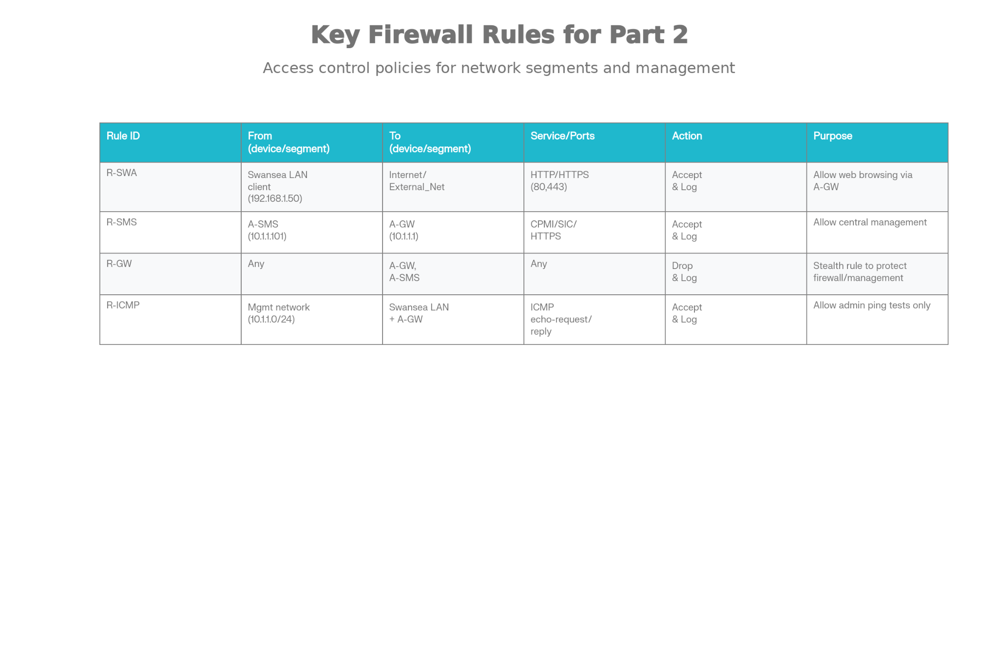
To tighten security, separate rules handle ICMP traffic. A rule allows ICMP echo requests sent by the admin subnet, to internal servers as well as A-GW, in turn, allows testing for reachability and performance tests, whereas another rule restricts ICMP traffic from the Internet for internal hosts. This setup is consistent with corporate practice, where external pings to public IP addresses could be restricted or eliminated to minimize the opportunities for reconnaissance however internal diagnostics can still be used. These logs can be used to prove the rules during demo that allow ICMP from administrators and blocking ICMP by untrusted sources.
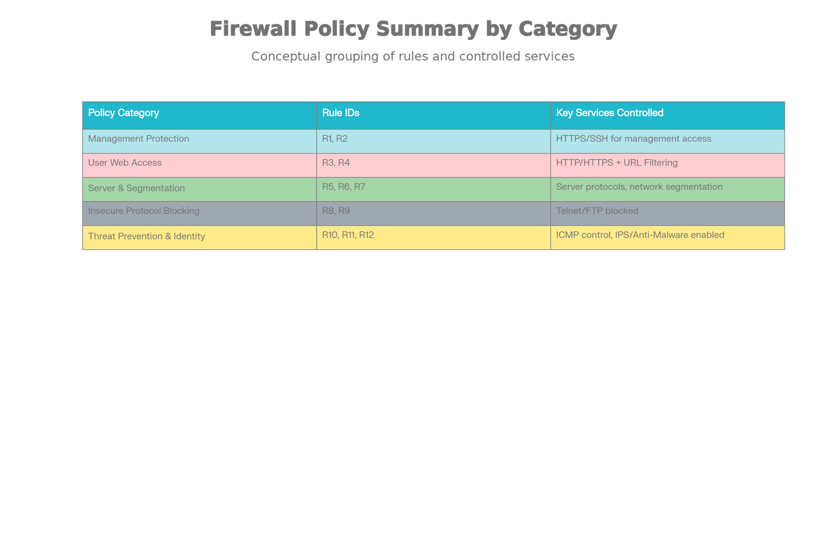
Protocols that are high risk or older receive rigorous approach. Telnet is a protocol that transmits the credentials as plain text is specifically blocked in every direction except possibly within an controlled laboratory section if required for demonstration purposes, and only then between management hosts that are defined as well as the test server. FTP can be restricted to a specific server (such for internal use as a File Server) or completely blocked to external usage, promoting users to choose safer alternatives such as SFTP and HTTPS-based uploads. The rules can be configured using the actions that is "Drop with Log" or "Reject with Log" depending on the type of feedback needed. Check Point's guidance advises users to use "Reject" for some services in order to limit the timeouts of clients but still blocking connections. In structuring the rule-base in this manner it enforces the minimal privileges and allows only the protocols and destinations that are needed instead of relieving on the default to allow for a wide range of options.
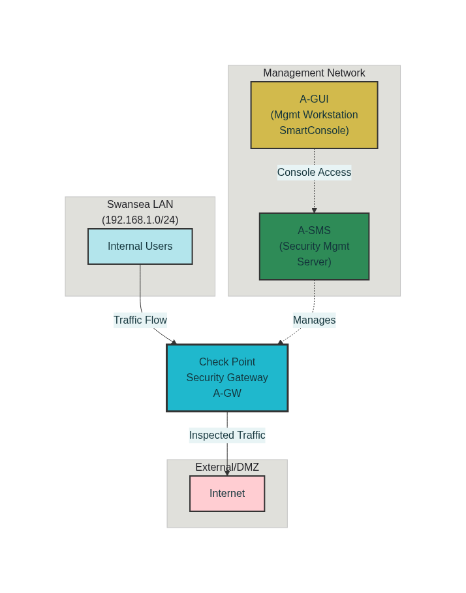
In the middle of the access control layer, an explicit cleanup rule is applied using the source "Any", destination "Any" Services "Any", and action "Drop with Log." Although Check Point automatically includes an implicit cleanup rule, creating an explicit cleanup rule is highly recommended as it will provide transparency and tracking of every unwanted connection that makes it to the conclusion of the rules base. The rule will ensure that every network that is not protected by previous particular rules will be blocked and logged, facilitating monitoring security as well as troubleshooting. In conjunction with the security rule that protects the firewall This structure complies with the Check Point best practices documented in the design of access control policies (Vodanet Systems, 2025).
Create Gateway
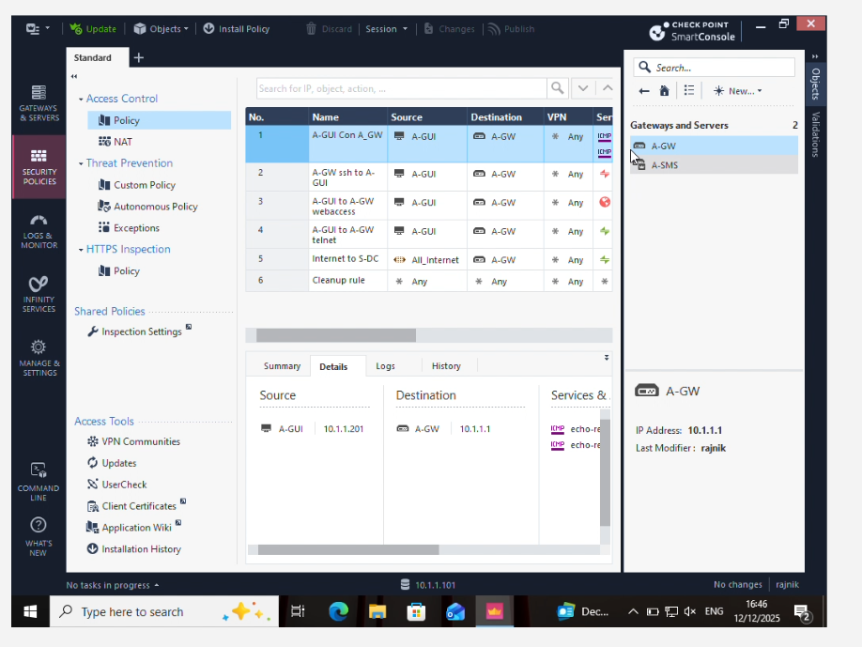
Create Rules
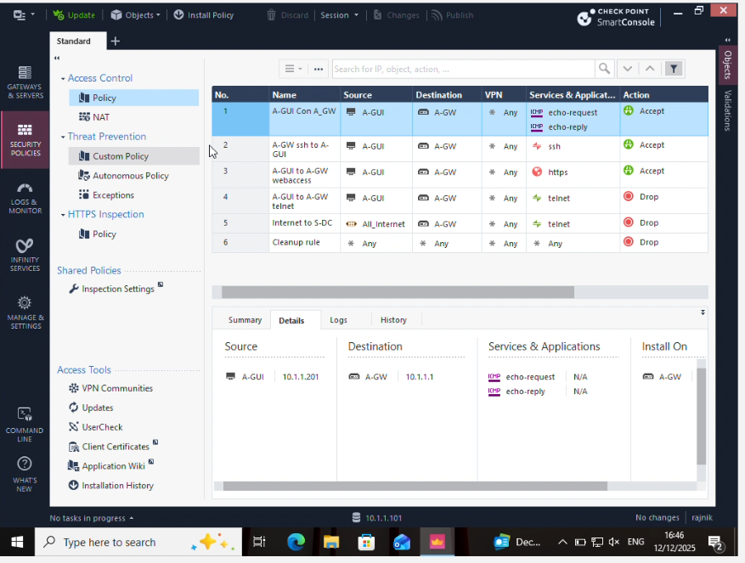

Host rules
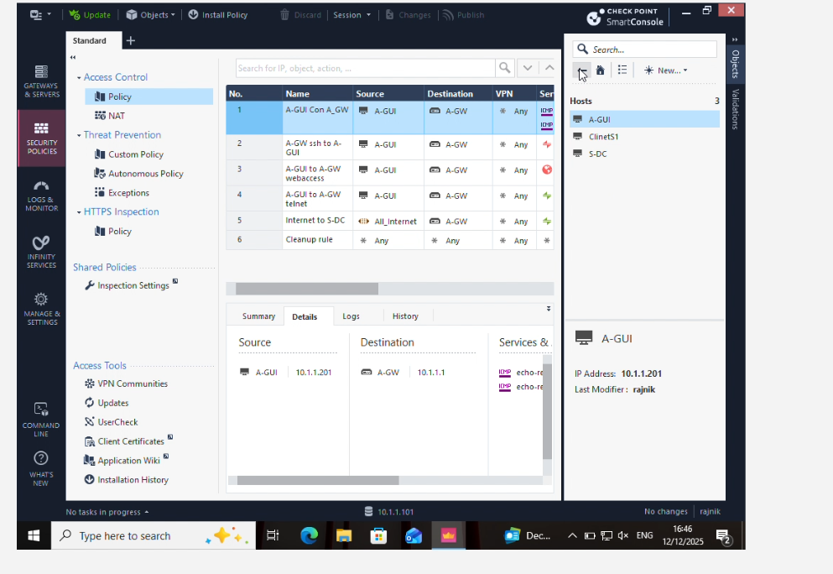

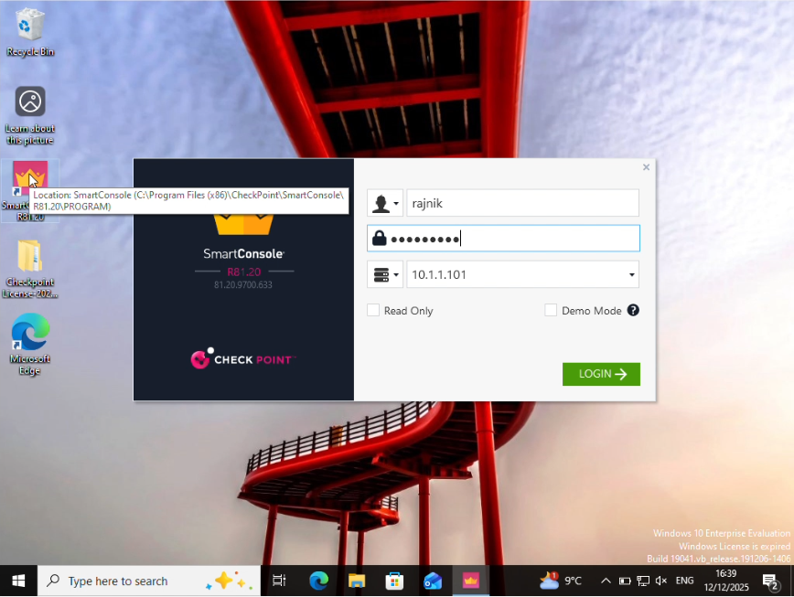

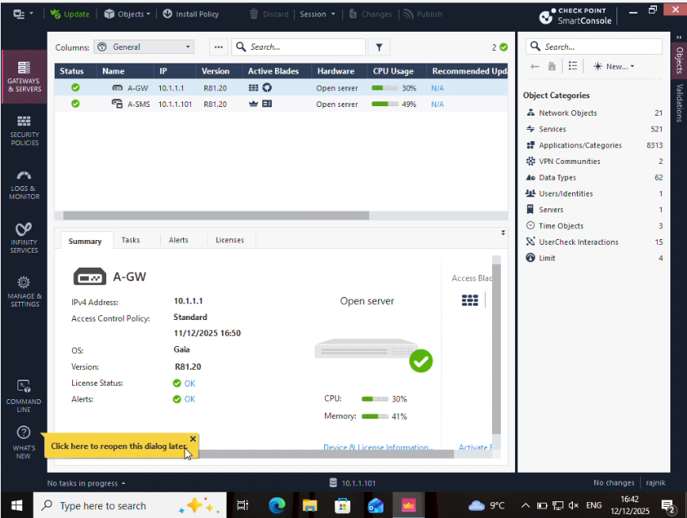

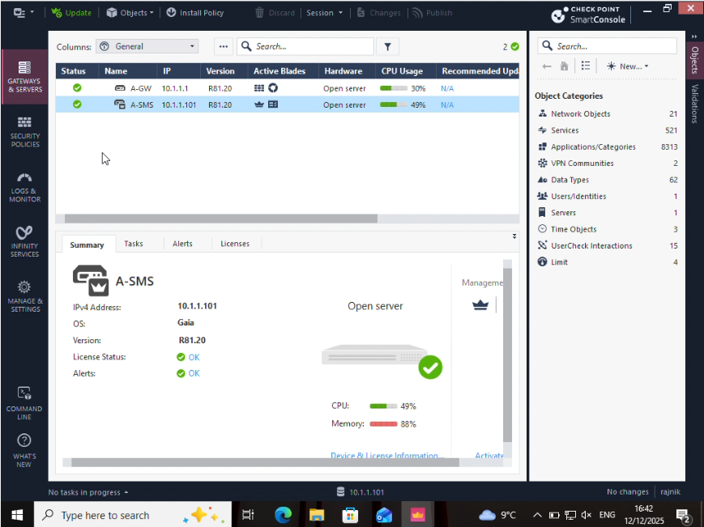

2.2 Threat Prevention: IPS, Anti-Virus and Anti-Bot
Beyond access control for basic purposes, it also allows blades of the Threat Prevention system in A-GW to guard against new attacks that could be able to bypass port-based security rules. Check Point's Threat Prevention solution is a combination of IPS as well as Anti-Virus, Antibot and additional security measures to look at data at the layer of content and prevent known exploits and malware and Command-and-Control (C&C) traffic. In Gaia R81.20 the options are managed by an additional threat Prevention policy that is attached to the gateway. This policy will be evaluated in conjunction with the Access Control policy .
A suitable Threat prevention profile was developed using Smart Console and based upon the "Optimized" or "Strict" templates suggested by Check Point for perimeter gateways The profile was then modified for the specific lab conditions. IPS was set to operate using "Prevent" mode for high-confidence security, specifically for vulnerabilities on servers, web exploits and protocols, as well as irregularities that affect HTTP, SMTP and DNS traffic. Low-confidence protections might only log or identify the security aspect, while also allowing for performance. Anti-Virus scanning was turned on for email and web protocols, so that the files that are downloaded or moved through the gateway are checked to identify signatures belonging to well-known malware families. Anti-Bot was set up to identify and shut off connections from C&C domains as well as IP addresses. This helps to block any malicious hosts which might be found within the network of the lab.
The policy on Threat Prevention includes rules referencing the same network objects that are used to control access to ensure that the protections are in place on the Swansea LAN as it interacts via the Internet. As an example, an example rules employs to the "Optimized" profile to traffic that originates from internal networks to the Internet by executing "Prevent", while another might apply a less restrictive profile to manage traffic or secure VPN channels. When using profiles, instead of making individual signatures available manually this policy is much simpler to manage and take advantage of Check Point's frequent upgrades to IPS as well as security against malware via the threat cloud service. Screenshots taken using Smart Console demonstrate A-GW having the Threat Prevention blades turned on and the selected profile being applied and proving the assertion that IPS and anti-malware are both active.
Tests were conducted to confirm that the threat prevention features perform as they should. Test tools that are safe like HTTP requests for benign URLs as well as restricted downloads of test files are used to ensure that normal Internet activity is permitted and that any activity that is suspicious or in violation of the policy is recorded or blocked. Logs that are viewed on the Smart Console "Logs & Monitoring" tab display entries marked with the appropriate blade (e.g., "IPS", "Anti-Virus", "Anti-Bot") as well as the rule number that matches to the blade, as well as a detailed protection title, for example the specific CVE or signature for malware showing that a thorough analysis is occurring over and above basic port filtering. The logs, if compared with access control logs from similar connections, provide an extensive picture of permitted business traffic as well as blocked dangers for inclusion in writing reports and during an actual demonstration.

2.3 Identity‑based and user‑aware controls
Even though complete Identity Awareness integration with Active Directory might be over minimal specifications, Check Point recommends using the information from groups and users for adjusting access rules when it is possible. The foundation for identity-based controls can be demonstrated through the creation of local user accounts as well as, whenever possible the use of identity Awareness Access Roles that categorize the machines and users in accordance with the purpose (for instance, administrators’ staff, students, and Admins). Access control rules could then be based on these access Roles instead of general IP subnets and permitting policies like "IT-Admins may SSH to servers and firewalls" as well as "Students are limited to web browsing and cannot reach management networks."

This blade, called Identity Awareness once enabled in A-GW can be used to support multiple identity sources, such as AD, RADIUS accounting, LDAP, and captive portal login. Even if a full AD environment is not available in the lab, enabling the blade and demonstrating simple identity acquisition--such as via Captive Portal or internal user database--illustrates how user-aware enforcement would operate in a production scenario. Screen shots of Identity Awareness configuration and the Access Role definitions can be added to the section 3 of this report however, they're conceptually tied to the firewall policies and threat Prevention policies as they are based on user identities and not simply IP addresses.

2.4 Monitoring, logging and the justification of regulations
An effective firewall management system involves not only having well-designed policies but also a comprehensive log and monitoring to ensure that the policies are working according to its intended purpose and support the response to incidents. This deployment ensures that the most important rules, including those that control Internet access, access to management and other high-risk applications are configured by using a tracker action such as "Log" or "Alert." This means that each pertinent connection is recorded in Smart Console that includes origin and destination, the service, matching rule as well as the actions taken the case where Threat Prevention is in play the protection in place for the specific event.
In the course of testing, situations including internal hosts trying to connect via Telnet to connect to an external server, an individual creating FTP to a non-authorized destination, or external devices pinging the internal host were tested to create both permitted and unblock log entries. Results confirm:
- Allowed DNS and web traffic through the Swansea LAN is in line with the rules, and it is accepted.
- Unauthorized management protocols or high-risk ones are detected by the block rules, and then discarded.
- Threat Prevention Events display IPS and Anti-Virus protections that activate when malicious activity is simulated.
The logs provide solid support for the demo as well as to justify the rule base in writing. the rules base. The report explains how each important rule is explained by referring to business requirements ("students require access to the internet", "admins need SSH to firewalls"), security reasons ("legacy Telnet exposes credentials in plain language", "ICMP from the Internet assists reconnaissance") in alignment with the guidelines for best practices that are documented from Check Point and general firewall design guidelines. The security and access control configurations in this section change A-GW into a router that is transformed to a new generation firewall which enforces the least privilege. It monitors all traffic for advanced security dangers, and gives complete visibility of all attempts to misuse or use the Swansea corporate network.

Section 3 - Additional Security Features
The section 3 describes the additional security features that are built over the top of the firewall as well as the Threat Prevention policies.
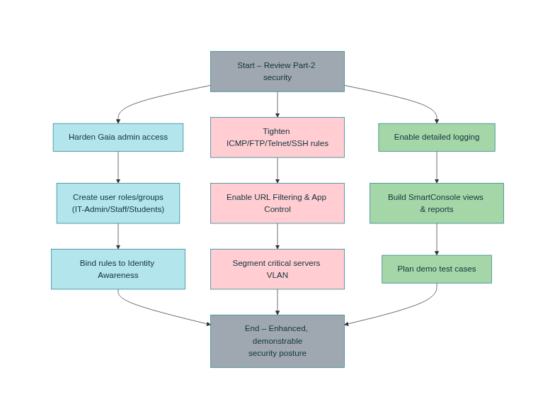
The goal is in order to improve it to bring the Swansea Enterprise Network closer to the actual best practices in the industry. The enhancements are focused on enhancing the management of GAIA appliances, and introducing groups and user-based access control and separating critical internal resources, and increasing the monitoring capabilities and resilience of the network in order to make the network be more resilient to attacks and misuse. Together, they show that A-GW and the A-SMS can be employed not only for the purpose of transferring data, but also enforce an extensive, multi-layered security strategy.


3.1 The hardening of GAIA as well as admin access
Access to administrative access for A-GW and A-SMS is streamlined through the replacement of a common "admin" account with multiple administrators with names with each one assigned a specific position (for instance, full "Super User" for senior personnel as well as "Read-Only" for monitoring-only users). The role-based system ensures the least authority and accountability because any change that is made via Gaia Portal or SSH can be tracked back to a particular user, rather than being an anonymous shared login. Password policies are configured to demand long and complex passwords that expire frequently, and to disable accounts indefinitely after numerous unsuccessful attempts, thus reducing the chance of brute force or password guessing attacks. The timeouts for sessions are also reduced to ensure that administrative sessions in idle are automatically shut down, thus limiting vulnerability if the console is inaccessible .
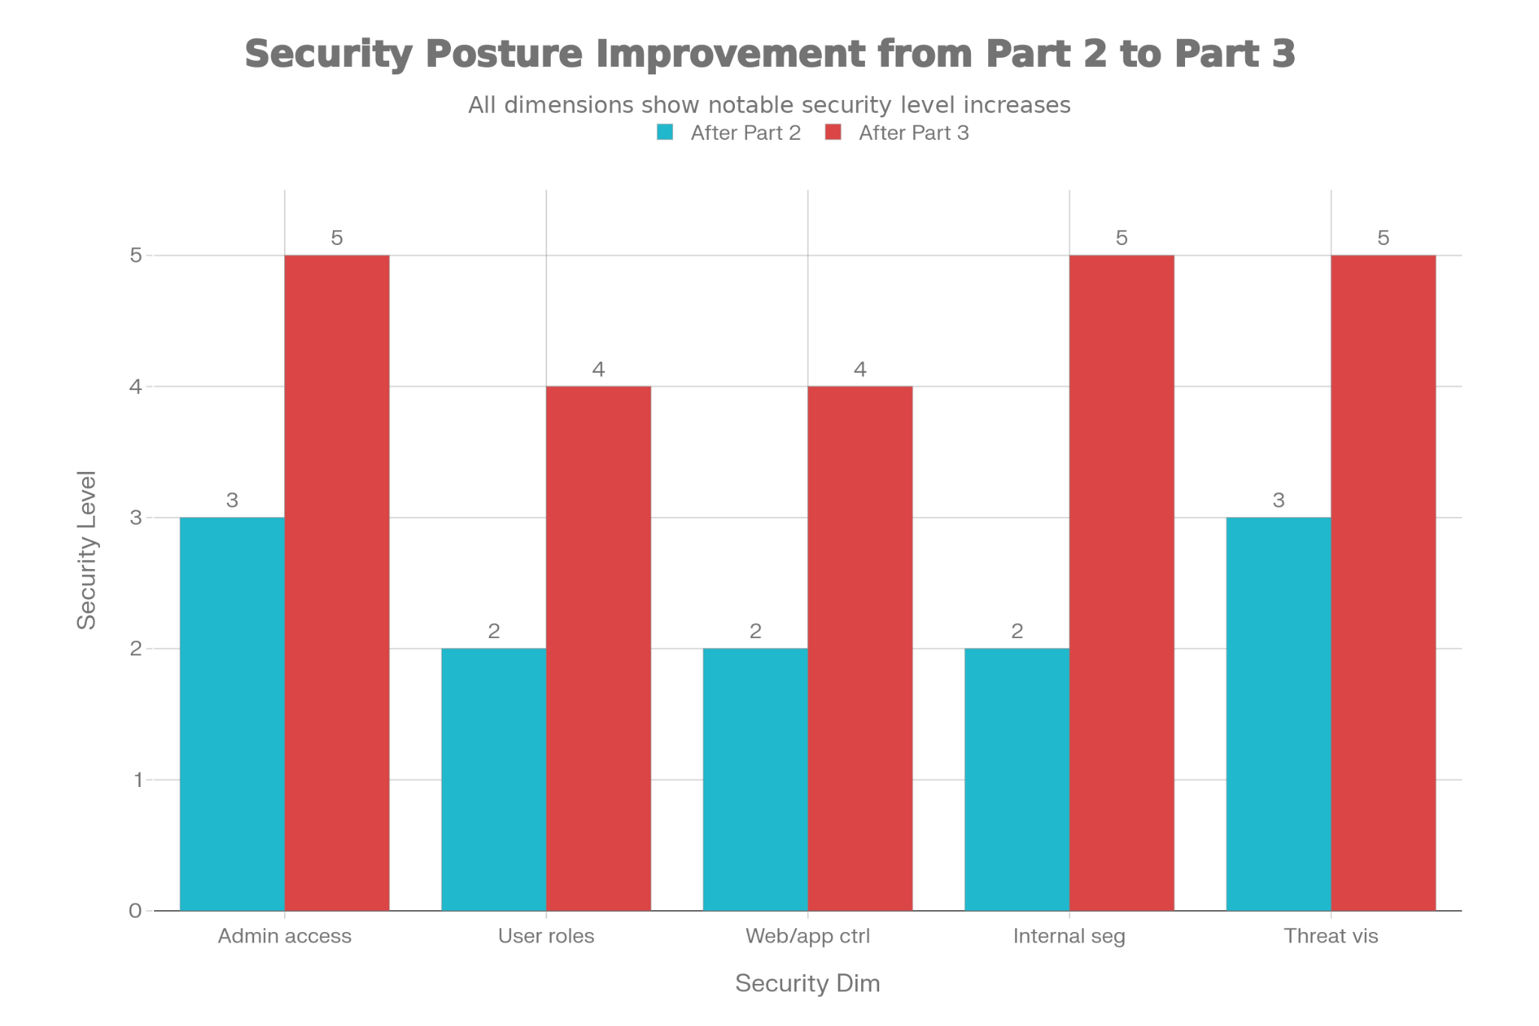
The interfaces for management have been strengthened to minimize the risk of protocol level. Plain text HTTP connection for Gaia Portal is disabled so that web administrators use HTTPS that comes with TLS encryption, which prevents the interception of configuration and credentials. SSH access is limited only to ciphers with strong encryption and the management subnet exclusively and is compatible with firewall rules which allow the management of traffic only through A-GUI as well as other authorized administration hosts. Implementing these restrictions both on the rule base and in the operating system is a defense-in-depth that even in the event that an attacker has access to the firewall's IP the security features as well as strict restrictions on source are significantly more difficult for attackers to take control.
Other than administrator accounts, extra security is provided by establishing rules that govern user roles instead of only IP subnets. Utilizing GAIA local users, or Check Point Identity Assist when are available, the logical role like "IT-Admins," "Staff," and "Students" are defined and later referenced directly in access-control rules. For instance, IT-Admins are permitted SSH access to internal servers as well as A-GW and ASM, while staff members can connect to internal application or file servers as needed, whereas students are restricted primarily to DNS and HTTP/HTTPS, and are not allowed access to any administration or server network. This model based on roles better represents the way that real organizations operate since restrictions are imposed on the user and not the device. If a person moves between PCs in labs or connects through a VPN and VPN, their permissions remain governed by their membership in the group.

Conclusion

The finished deployment demonstrated how Check Point GAIA could be used across three different parts of the Swansea project to design, deploy and operate a enterprise-grade security infrastructure for Swansea corporate networks. The first phase of the project focused on building a robust control plane. This was achieved by deploying dedicated appliances for the Security Management Server A -SMS), Security Gateway A -GW, and Management workstation A -GUI. Strict SIC licensing, DNS/NTP configuration and IP addressing ensured central administration of policies, logs and other software.
A-GW has been transformed by Part 2 from a simple firewall to an advanced next-generation firewall. It enforces clear business-driven policies for controlling access. Structured rules allowed for only required services, such DNS and Web browsing. SSH access and HTTPS management were tightly controlled. Telnet as well as unrestricted FTP inbound and outbound was explicitly blocked. ICMP access was restricted to troubleshooting purposes and limited external reconnaissance. On top of the port-based security controls, the threat prevention blades--IPS and Anti-Virus--were configured using an Optimised-profile to examine web and email traffic for exploits, malicious software, and command-and-control. SmartConsole Logs proved that the flow of legitimate traffic was not disrupted, but malicious and non-compliant behavior were detected and recorded.
Part 3 created layers of protection that are aligned with the best industry practices. GAIA hardened itself by replacing a shared admin account with a role-specific one, forcing strong authentication, restricting the management services, and limiting session timeouts. Internal segmentation divided critical servers from user networks. Further refinement was done using Identity Awareness concepts as well as user or groups-based access rules in order to distinguish between IT administrators and staff. The URL filtering and application control were employed to confine web use to appropriate categories, as well as to block potentially risky applications.
The three sections together show how a security posture can evolve from a simple, basic one to one that is mature, aware of roles, and has a well-monitored and secure environment. Swansea's security network no longer consists of just connectivity. Instead, it has been centrally administered, heavily segmented, secured by several layers of protection, and supported with detailed visibility.

