
Learning In The digital era
(VIDEO PRESENTATION)



ACCA4025_BA
2220233
Andrew Davis

Contents
1 Self Evaluation.
2 PDP.
3 Unit 5 Section Summary.
4 Video Presentation.

Task 1 Self Evaluation
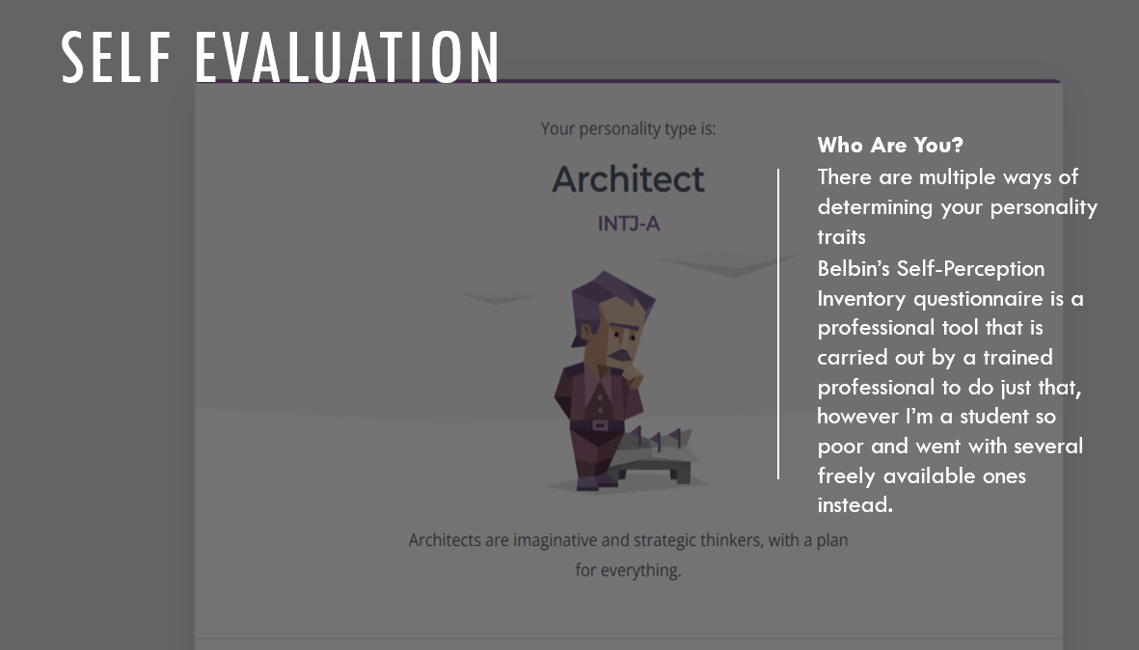
Task 2 – PDP
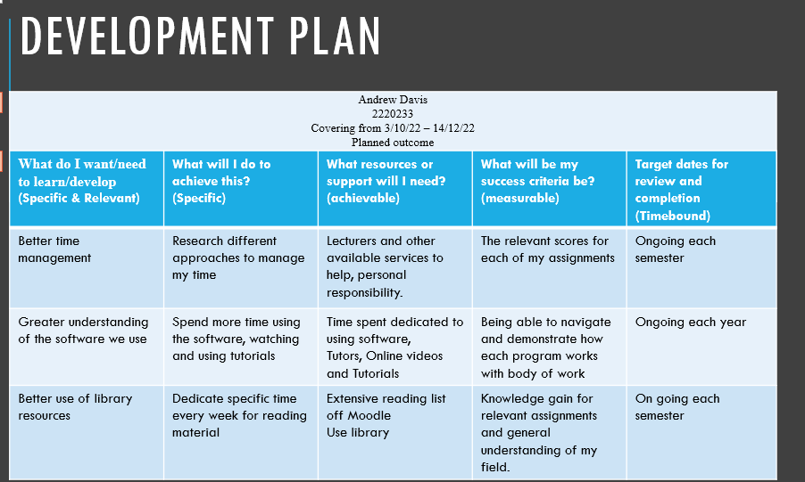
Task 3 Unit 5 section summary
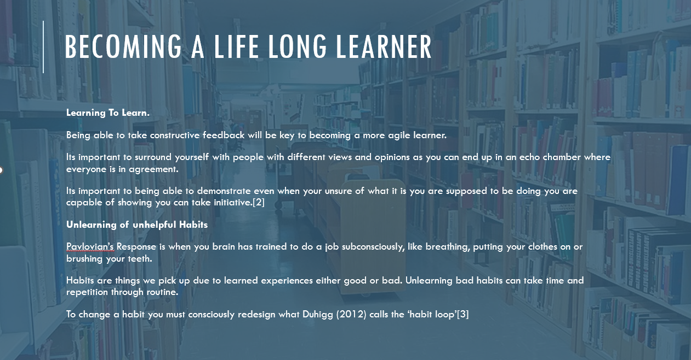

Task 4 – Video Presentation
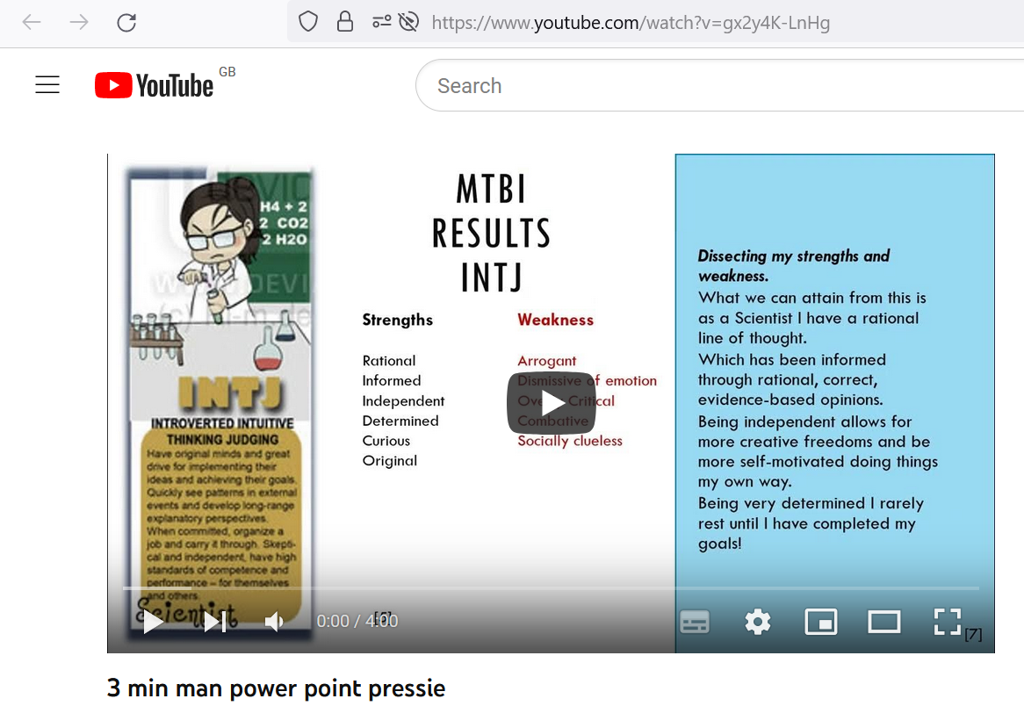
https://youtu.be/gx2y4K-LnHg

