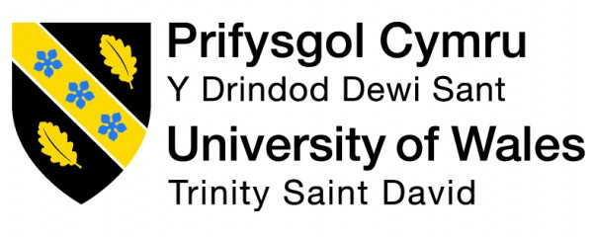

Sustainable Global Tourism & Events
(BMTP5023)
Susie-May James
2404489
Deborah Jenkins
Word Count: 2144

‘Overtourism in European Cities: Challenges & Sustainable Responses’

Executive Summary
Sustainability; what once was a buzzword, now is a real-world crisis that longs to be addressed within the travel and tourism industry. Sustainable tourism is a solution to this and can be defined as ‘development that meets the needs of the present without compromising the needs of future generations’ (World Commission on Environment & Development, 1987, as cited in Page and Connell, 2020, p.412).
While tourism brings its positives, there are undoubtedly negative aspects that come along with it, including overtourism, preserving cultural heritage, climate change challenges and locals' annoyance, all of which will be explored in further depth (University of Luxembourg, 2024). Theories including Doxey’s Irridex model will be applied to how increasing tourism affects local residents, as well as investigating the UN Sustainability goals, with a keen focus on SDG 11; Sustainable Cities and Communities.
This essay will delve into case studies revolving European cities to see how each are managing this and look for recommendations for improvement. With Amsterdam and Venice being heritage cities, there is a drive in protecting these from the effects of mass tourism and climate change.
Additionally, the concept and benefits of responsible tourism will be discussed throughout. The core idea of responsible tourism is to improve the quality of life for local habitants while also providing an enjoyable yet respectful experience for visitors (Goodwin, 2014).

Sustainable tourism has become an important way to manage the growing pressures on popular tourist destinations (European Union, 2024). UN Tourism (2025b) defines it as “tourism that takes full account of its current and future economic, social and environmental impacts, addressing the needs of visitors, the industry, the environment and host communities”. This highlights that tourism should not soley focus on the economic gains but also ensure to protect the environment, respect local culture and benefit communities.
Europe welcomed an estimated 340 million international tourists in the first half of 2025 - a rise of 4% from the previous year (UN Tourism, 2025a). This growth demonstrates the urgency of addressing overtourism, particularly as many European cities remain heavily dependent on tourism revenue (World Tourism Forum Institute, 2025). Cities such as Venice and Amsterdam present clear examples of destinations where visitor pressure threatens locals quality of life, environmental damage and cultural heritage.
This essay aims to critically evaluate the current state of sustainable tourism within popular European cities like Venice and Amsterdam, by exploring case studies to reveal the common challenges of overtourism & their responses to this. It will also explore the role of CSR policies and EU sustainability frameworks in helping balance tourist numbers, protect local culture and support the environment.

This next section will incorporate relevant case studies revolving overtourism in European heritage cities. The term ‘overtourism’ is when a destination is so overvisited that it changes its character & authenticity as a result of the influx of visitors, as described by Professor Harold Goodwin (Responsible Travel, 2018, 00:02:05). The map in (Appendix A), indicates that Europe appears to be the most affected, highlighting the significant challenges faced by heritage cities in managing these (Francis, 2025).
The main two cities that will be specifically honed into are Venice and Amsterdam.
Venice; a major tourist hotspot, welcoming around “30 million tourists to the city every year” (Perkins, 2025). While it’s known for its beautifully rich heritage, it is also widely recognised as being the ‘sinking city’ as a result of climate change and sea levels rising (Phelan, 2022). The article goes onto explain that the crisis and demand for overcoming these sustainability challenges are at an all time high as it is said that “the city could disappear beneath the waves by as early as 2100”.
The covid pandemic revealed some valuable yet concerning truths regarding the pressures of tourism on the city. During lockdown, both air and water quality from transportation significantly improved, as tourism came to a halt, allowing wildlife to return to areas that were previously affected by human activity (Ng, 2020). However, these key learnings from the pandemic have not been fully embraced, as tourism has since resumed and surpassed pre-covid levels (Sears, 2020).
A case study on overtourism in Venice reveals that there is a rapid depopulation of Venetians living in their city, whereby the population used to stand at 175,000 residents and is now fewer than 50,000 (Perkins, 2025). This arguably discloses that the acts of tourism and higher living costs that are driving locals away, however in doing so, poses potential threats in the city losing its identity and culture (Bolen, 2024). The case study explains that tourist behaviours like noise disturbances, littering and crowding, all contribute to the degradation of local’s quality of life and the sustainability of the destination. As a result, the cities attempt to mitigate these effects include the use of visitor fees during peak seasons, reducing cruise stops to the destination, regulating tour groups and monitoring numbers.
Meanwhile, Amsterdam faces similar challenges regarding overtourism. Amsterdam; a city with historic beauty featuring a plethora of museums and its stunning canals (Inkson and Minnaert, 2018, pp.9, 10). With more than 20 million visitors each year, Amsterdam’s capacity is pushed to its limits, making this level of tourism unsustainable (Cottam, 2018). With the incline in tourism, more infrastructure like accommodation were required to facilitate these demands. The case study holds a focal point that the rapid growth of Airbnb's within the city, meant that long term rental properties were harder to obtain and more expensive for locals (Inkson and Minnaert, 2018, pp.9, 10). Although tourism supports over 69,000 jobs in Amsterdam, these economic benefits risk being outweighed if residents are having to vacate due to rising costs. The study goes onto explain that in response to this issue, the city introduced a ‘City in Balance’ programme that put a ban on new tourist shops and restrictions on holiday rentals, as well as a 7% tourism tax for visitors.
Amsterdam is renowned for its unique coffee shops, red light districts and nightlife (Travelxp, 2024). Arguably this attracts a certain demographic to the city such as stag and hen do’s, however disrespectful behaviours among these visitors led to the city placing a ban on these nuisance attractions like ‘beer bikes’, as well as the ‘Enjoy & Respect’ campaign to raise awareness of acceptable and responsible behaviour in Amsterdam (Cottam, 2018).
After the city invested heavily in promoting itself as a tourism destination, it became so successful in this, that it has resulted in overtourism, where the Dutch tourism board have now shifted from ‘destination promotion’ to ‘destination management’ to ensure tourism benefits the locals (Cottam, 2018).
It is evident that both cities are facing similar struggles regarding overtourism, showing the need in continuing their efforts in combating these ongoing sustainability issues.

Corporate Social Responsibility (CSR) are when companies incorporate social and environmental considerations into their business practices (UNIDO, 2024). In Europe, CSR has shifted from it being voluntary to pushing towards being a mandate and core principle of businesses (European Commission, 2025). Although CSR’s are designed to embed these principles into practice, some businesses can misuse these. This can be described in the term ‘greenwashing’, where companies make misleading or exaggerated claims to appear environmentally friendly, without genuinely implementing these environmental practices (Page and Connell, 2020b, p.420), suggesting that businesses who do this often prioritise brand reputation over real impact. Some common examples to showcase this within European cities, include accommodation claiming to be ‘eco-friendly’ with minimal actions in this or cruise companies promote ‘green cruises’ when this is far from the reality with its obvious high emissions.
Theories and models can help bring perspective to these real life scenarios of overtourism. The Doxey’s Irridex model (See Appendix B) shows the journey of how the increase in tourism affects the local residents living within that destination (Cooper, 2022, p.138). The author discusses that while tourism begins with support from the community as the benefits present themselves, this can very quickly lead to slight annoyances and ultimately end with major animosity if tourism demand grows and issues that the residents are voicing are not being dealt with. This model applies to the case studies of Venice and Amsterdam where irritation and unfairness increase surrounding tourism taking over the city and ultimately driving locals away from their city due to rising costs & reduced quality of life there.
Cohen’s tourist typology breaks down the different types of travellers and what they seek when visiting a destination, from organised mass tourists to drifters (See Appendix C) (Tourism Teacher, 2022). While Plog’s psychocentric-allocentric model focuses on tourists' personality, suggesting that psychocentric travellers prefer more familiar and popular destinations as opposed to allocentric tourists who seek unique and adventurous experiences (Stainton, 2020). In terms of how this can be applied to European cities, these models help to explain why places like Venice and Amsterdam attract vast numbers of organised mass tourists and psychocentric visitors, contributing to the pressures of overtourism.
This links closely to cultural sensitivity, which refers to recognising and respecting the differences in cultures, customs and heritage when we visit a destination (Brenneman, 2024). While tourism rises, so does the potential for disrespectful behaviour, littering and loss of authenticity in culture. Promoting responsible tourism would help to mitigate these impacts by encouraging respectful and sustainable behaviour whilst visiting. Amsterdam is a leading example of this by already implementing their ‘Enjoy & Respect’ campaign in the aim of reminding tourists how to behave whilst visiting (Cottam, 2018).

Global sustainability frameworks are designed to help destinations address all areas of sustainability and offer benchmarks to assess performance against these global standards (Tanwar, 2023). One of the most influential examples is the United Nations 17 Sustainable Development Goals (SDG’s), which provide a breakdown for tackling environmental, economic and social challenges (Page and Connell, 2020c, pp.428, 429). It goes onto explain that goals cover areas from climate action to poverty to sustainable cities and communities to life on land & that some are relevant in the context of managing European cities. These frameworks aim to offer a structure in implementing these goals to the city in order to combat specific challenges they face.
European destinations are gradually integrating the UN Sustainability Development SDG goals on a local level, tailoring them to the specific challenges of each city (Godson, 2020). The two SDG’s that are particularly relevant for Venice and Amsterdam are SDG 11; focusing on sustainable cities and communities, in addition to SDG 13; highlighting urgent climate action. Both cities have attempted to implement these goals to suit the issue they are facing. For example, Venice has focused on protecting its lagoon from environmental damage by banning cruise ships and managing tourist numbers, while Amsterdam has adopted a more direct approach of being visitor focused by introducing awareness campaigns and programmes to manage numbers and deter overtourism.
When critically evaluating how effective these set UN Sustainability Development SDG’s are, although they offer guidance, their effectiveness is limited due to them being voluntary and heavily reliant on collaboration between various stakeholders, for example CSR’s and local governments (Cuervo-Cazurra et al., 2022). This may prove challenging to enforce as many governments prioritise economics over the potential difference it could make for future sustainability. Similarly, the SDG’s are very broad & hard to apply on a local level to a city or destination, therefore a holistic approach involving government, social and community would be needed to ensure the success of achieving these goals.

Through valuable insights gained from the previous case studies explored on the heritage cities of Venice & Amsterdam, it is evident that they share a common challenge of mass tourism. Conversely, both cities have taken different actions, approaches and efforts in managing sustainability. While Venice places took the approach of regulatory involvement and restriction based methods, for example banning cruise ships to the mainland, as well as a charge for tourists visiting for the day (Perkins, 2025). These methods appear to be a more reactive approach whereby the city have only implemented these after a build up of resident complaints and visible environmental damage. By contrast, it appears that Amsterdam have adopted a more forward thinking approach by shifting from the mindset of ‘destination promotion’ to ‘destination management’, focusing on the preservation of the city & it’s residents by promoting acceptable behaviour campaigns, Airbnb rental property restrictions and reductions of tourism relating businesses (Cottam, 2018). This response appears to be more proactive through these programmes and initiatives to educate tourists, as well as prioritising how it affects the community.
Despite their different approaches, both highlight valuable learnings on these different approaches, as well as areas for improvement. Evidently, both cities struggle to balance tourism’s economic gains with residents' perspective and reality, as well as the authentic cultural experience of the destination.

Overall, the challenges surrounding sustainability still stand within European cities, especially with the growing pressure of tourism (EU, 2025). The Venice and Amsterdam case studies revealed the current state of both cities sustainability progress and ongoing struggles.
While it is important to acknowledge the efforts and positives regarding sustainability within European cities, there is still more that can be done. These recommendations firstly include implementing visitor caps based on the capacity of what the city can handle as opposed to the economic past trends or gains. Secondly, strengthening CSR throughout businesses, to implement mandatory sustainability will help improve accountability, reduce greenwashing and promote authentic sustainability. Moreover, drawing conclusions surrounding the theories discussed of Doxey’s Irridex model to understand and learn how to not reach the point where overtourism can cause this impact on residents and instead take a community-led approach. Additionally, combining the educational campaigns with the responsible tourism approach can help inform visitors how to behave and respect the destination while they are visiting. All of these recommendations help to tackle the main issue faced by European cities of overtourism, as well as the main focus of sustainability.
Ultimately, in order to achieve authentic sustainability, it will require a collaboration between governments, communities and businesses. Only by having this holistic approach by covering all aspects of environmental protection, local’s involvement and cultural preservation, can European destinations be able to ensure that tourism remains viable and respected for future generations (seeker, 2025).

References
Andrew, H. (2017). UWTSD Logo | Discover Dylan Thomas. Discover Dylan Thomas. Available at: https://www.discoverdylanthomas.com/portfolio-items/dylan-day-poetry-share-uwtsd-carmarthen/print-2 [Accessed 30 Oct. 2025].
Bolen, H. (2024). Travel & Culture Salon. Travel & Culture Salon. [online] doi:https://doi.org/103888279/Cruise%2BShip%2BVenice.
Brenneman, K. (2024). How to Practice Cultural Sensitivity during Meaningful Tr... [online] GoAbroad.com. Available at: https://www.goabroad.com/articles/how-to-practice-cultural-sensitivity [Accessed 4 Dec. 2025].
Cooper, C. (2022). Essentials of Tourism. Fourth ed. Pearson, p.138.
Cottam, B. (2018). Overtourism in Amsterdam. [online] Responsible Travel. Available at: https://www.responsibletravel.com/holidays/the-netherlands/travel-guide/overtourism-in-amsterdam [Accessed 30 Nov. 2025].
Cuervo-Cazurra, A., Doh, J.P., Giuliani, E., Montiel, I. and Park, J. (2022). The United Nations’ Sustainable Development Goals: Pros and Cons for Managers of Multinationals. AIB Insights, [online] 22(1). doi:https://doi.org/10.46697/001c.32530.
EU (2025). Unbalanced Tourism Growth in Europe: Understanding Pressures, Impacts and Sustainable Pathways. [online] Europa.eu. Available at: https://transition-pathways.europa.eu/tourism/articles/unbalanced-tourism-growth-europe-understanding-pressures-impacts-and-sustainable [Accessed 5 Dec. 2025].
European Commission (2025). Corporate Sustainability and Responsibility. [online] European Commission. Available at: https://single-market-economy.ec.europa.eu/industry/sustainability/corporate-sustainability-and-responsibility_en [Accessed 2 Dec. 2025].
European Union (2024). Sustainable Tourism - Adapting to Climate-Induced Holiday Trends | EU Tourism Platform. [online] Europa.eu. Available at: https://transition-pathways.europa.eu/tourism/articles/sustainable-tourism-adapting-climate-induced-holiday-trends [Accessed 28 Nov. 2025].
Francis, J. (2025). Overtourism map. Helping Dreamers Do. [online] responsibletravel.com. Available at: https://www.responsibletravel.com/copy/overtourism-map [Accessed 29 Nov. 2025].
Godson, A. (2020). Paving the Way for Sustainable Cities - Eurocities. [online] Eurocities - Home. Available at: https://eurocities.eu/resources/paving-the-way-for-sustainable-cities/ [Accessed 5 Dec. 2025].
Goodwin, H. (2014). What Is Responsible Tourism? – Responsible Tourism Partnership. [online] Responsibletourismpartnership.org. Available at: https://responsibletourismpartnership.org/what-is-responsible-tourism [Accessed 2 Dec. 2025].
Grigoriadis, A. (2018). Tourists’ Classification. [online] TwinsLab Blog. Available at: https://twinslab.com/blog/tourists-classification [Accessed 3 Dec. 2025].
Inkson, C. and Minnaert, L. (2018). Tourism Management : an Introduction. Third ed. Los Angeles Etc.: Sage, pp.9, 10.
Ng, K. (2020). Venice Canals Clear up as Coronavirus Pandemic Shuts down Tourism. [online] The Independent. Available at: https://www.independent.co.uk/news/world/europe/coronavirus-pandemic-venice-canals-clear-water-tourism-shuts-a9407186.html [Accessed 29 Nov. 2025].
Page, S. and Connell, J. (2020a). Tourism : a Modern Synthesis. Fifth ed. South-Western Cengage Learning, p.412.
Page, S. and Connell, J. (2020b). Tourism : a Modern Synthesis. Fifth ed. South-Western Cengage Learning, p.420.
Page, S. and Connell, J. (2020c). Tourism : a Modern Synthesis. Fifth ed. South-Western Cengage Learning, pp.428, 429.
Perkins, R. (2025). Overtourism in Venice. [online] Responsible Travel. Available at: https://www.responsibletravel.com/holidays/italy/travel-guide/overtourism-in-venice [Accessed 29 Nov. 2025].
Phelan, J. (2022). Italy’s Plan to save Venice from Sinking. [online] Bbc.co.uk. Available at: https://www.bbc.co.uk/future/article/20220927-italys-plan-to-save-venice-from-sinking [Accessed 29 Nov. 2025].
Research Gate (2024). Figure 1. Irridex Model (Source: Doxey, 1975). [online] ResearchGate. Available at: https://www.researchgate.net/figure/rridex-Model-Source-Doxey-1975_fig1_347885224 [Accessed 2 Dec. 2025].
Responsible Travel (2018). Crowded Out: the Story of Overtourism. YouTube. Available at: https://www.youtube.com/watch?v=U-52L7hYQiE [Accessed 29 Nov. 2025].
Sears, S. (2020). Post-Virus Venice: More than looks, by Stephanie V Sears. [online] Londongrip.co.uk. Available at: https://londongrip.co.uk/2020/10/post-virus-venice-more-than-looks-by-stephanie-v-sears/ [Accessed 29 Nov. 2025].
seeker (2025). Sustainable Tourism and Its Impact on the Travel Industry – Seeker. [online] Seeker.io. Available at: https://products.seeker.io/blog/sustainable-tourism/ [Accessed 5 Dec. 2025].
Stainton, H. (2020). Plog’s Model of Allocentricity and psychocentricity: Made Easy. [online] Tourism Teacher. Available at: https://tourismteacher.com/plogs-model-of-allocentricity-and-psychocentricity/ [Accessed 3 Dec. 2025].
Tanwar, P. (2023). Sustainability Reporting Frameworks, Standards, and Protocols: a Complete Guide. [online] CarbonBetter. Available at: https://carbonbetter.com/story/esg-reporting-frameworks/ [Accessed 5 Dec. 2025].
Tourism Teacher (2022). Cohen’s Tourist typology- the 4 Major Types of Tourists - Tourism Teacher. [online] tourismteacher.com. Available at: https://tourismteacher.com/cohens-tourist-typology-types-of-tourists/ [Accessed 4 Dec. 2025].
Travelxp (2024). Travelxp - Explore the World. [online] www.travelxp.com. Available at: https://www.travelxp.com/en/blogs/holidays/amsterdam-is-famous-for [Accessed 30 Nov. 2025].
UN Tourism (2025a). International Tourism up 5% in First Half of 2025 despite Global Challenges. [online] Untourism.int. Available at: https://www.untourism.int/news/international-tourism-up-5-in-first-half-of-2025-despite-global-challenges [Accessed 28 Nov. 2025].
UN Tourism (2025b). Sustainable Development. [online] Untourism.int. Available at: https://www.untourism.int/sustainable-development [Accessed 28 Nov. 2025].
UNIDO (2024). What Is CSR? [online] United Nations Industrial Development Organization. Available at: https://www.unido.org/our-focus/advancing-economic-competitiveness/competitive-trade-capacities-and-corporate-responsibility/corporate-social-responsibility-market-integration/what-csr [Accessed 2 Dec. 2025].
University of Luxembourg (2024). The Dark Side of Tourism: Negative Impacts and Mitigation Strategies. [online] University of Luxembourg. Available at: https://www.uni.lu/en/news/the-dark-side-of-tourism/ [Accessed 28 Nov. 2025].
World Tourism Forum Institute (2025). WTFI Live. [online] Worldtourismforum.net. Available at: https://live.worldtourismforum.net/news/risk-radar/Travel-and-Tourism-A-Key-Driver-of-Europe [Accessed 28 Nov. 2025].

Appendix A – Overtourism Map
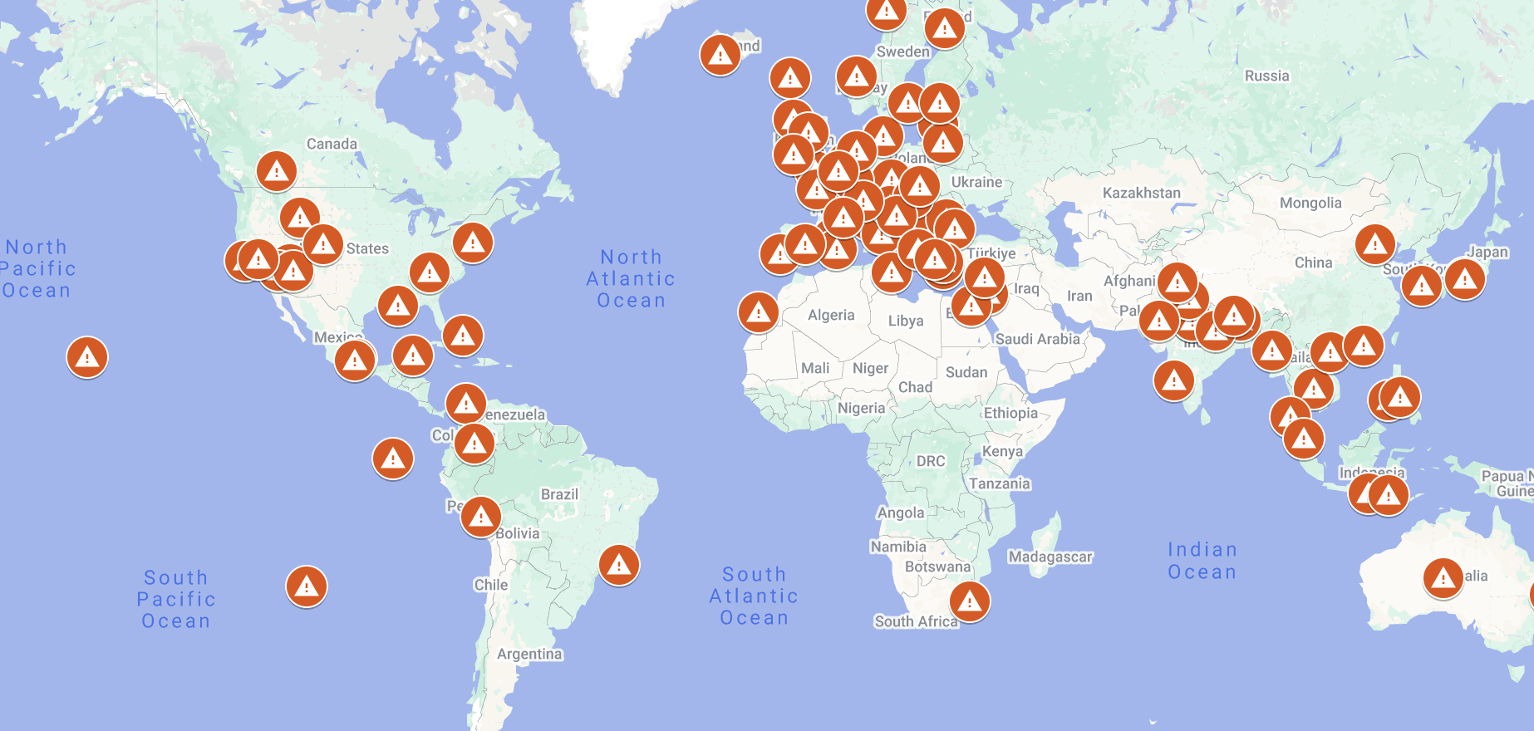

Appendix B – Doxey's Irridex Model

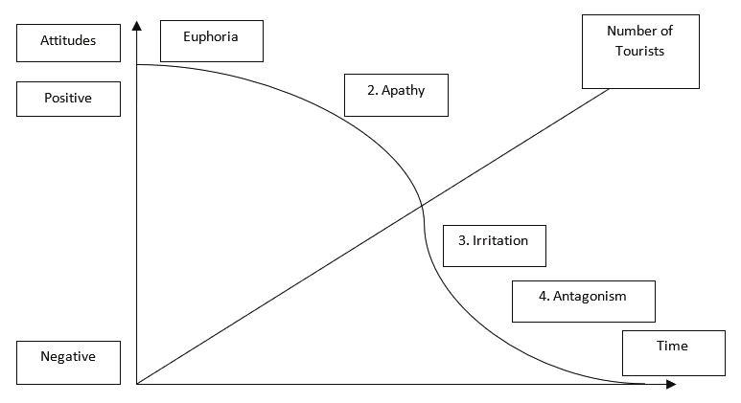
(Research Gate, 2024)

Appendix C – Cohen’s Visual Model

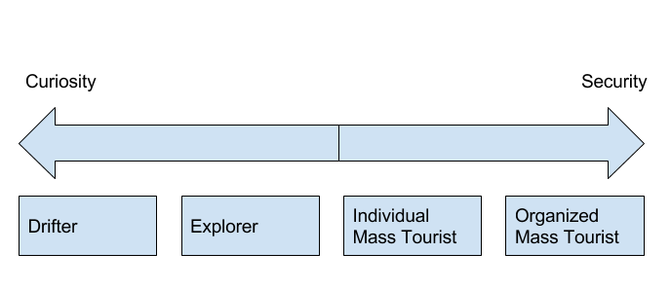
(Grigoriadis, 2018)

