Economics of Sustainability

BMSP6007

Assignment 1 – Essay





Hannah Kilburn

1805552

Anthony Burns

Introduction
The automobile industry is enormous all over the world, and the production takes time and plenty of energy, especially with the creation of electric vehicles and the batteries designed to make them work correctly. According to scientists, electric car manufacturing can produce more carbon emissions than making a traditional fuel filled vehicle. Factories use a massive amount of energy which comes with lots of greenhouse gases being emitted into the surrounding air.
“Manufacturing a mid-sized EV with an 84-mile range results in about 15 percent more emissions than manufacturing an equivalent gasoline vehicle. For larger, longer-range EVs that travel more than 250 miles per charge, the manufacturing emissions can be as much as 68 percent higher.” (Greenage, 2018)
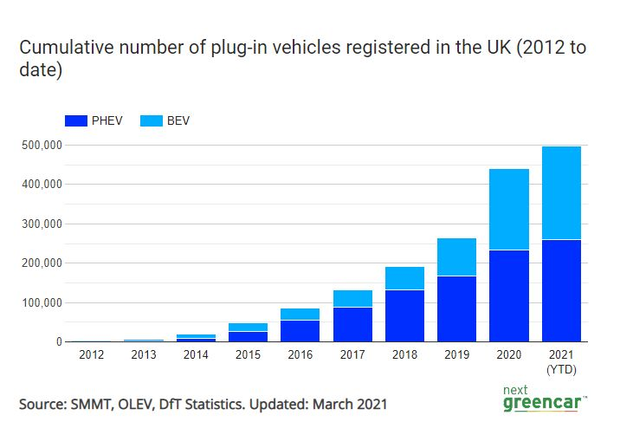
The electric car market in the UK is increasing, there are now more than 250,000 pure-electric cars as of the end of March 2021 and now over 495,000 plug-in models as well as hybrid models.

The graph above shows how sharply the increase has become over the years, although the pandemic hit in March 2020, there was still an increase in electric car sales and were affected less than other petrol or diesel vehicles. (Lilly, 2021) The emissions from electric vehicles are lower than other fuel filled cars, although they use electricity, and the production creates a huge number of emissions and the production of the batteries is the main problem. One study in Germany found the emissions from electric vehicles was up to 43% lower than diesel vehicles. Most electric battery production is using non-renewable energy sources, although companies like Tesla are changing their factories to use renewable energy sources to reduce emissions from the production side of the industry. (HAUSFATHER, 2019)
This essay will speak about how the UK and EU are focussing on reducing the emissions produced by factories when creating the battery and general equipment for electric cars and what solutions are being made and what impacts there have been on the environment. There will also be a comparison between how electric cars compare in C02 emissions with petrol or diesel vehicles.

Electric vehicles vs fuel filled vehicles and C02 emissions
Fuel filled cars are using fossil fuels to run compared to electric vehicles which are using a renewable energy source now more than ever. Electric vehicles themselves have a low emission rating, as the electricity grid becomes cleaner and renewable sources are far more popular in the UK, the carbon impact of manufacturing is now falling for new vehicles being built. In fuel filled vehicles only around 12-30% of the of the energy from the fuel is used for movement and the rest is wated on heat and noise, this is compared to 77% used from electric cars for movement and much less C02 is being produced. Pollution has been a big issue when cars are involved as they are seen to contaminate the air, although not many people are aware that the pollution from vehicles comes from the tyres and brakes as well as the exhaust. One of the bigger problems is the mining of the materials used to create the electric vehicles batteries such as issues with child labour in the Democratic Republic of the Congo and land issues in South Africa. Car companies can help some of these issues as they should only source their materials from places that can prove a safe working environment with fair pay and treating the environment correctly. The government can help by putting money into researching new technology to find batteries that have a cleaner production and regulate the car companies that they are aiming to reach 100% recycling of their batteries. (Greenpeace, 2020)
In the UK, car manufacturers are beginning to create batteries to fit into vehicles, although they must encounter and follow specific EU rules and regulations. There were plans to raise £2.6 billion to build a factory in the North-East of England to start the production of electric vehicle batteries by the end of 2023, this will be the first gigaplant in the UK. (Haill, 2021)
“A typical passenger vehicle emits about 4.6 metric tons of carbon dioxide per year. This number can vary based on a vehicle’s fuel, fuel economy, and the number of miles driven per year.” (EPA, 2018)
“According to research done by the Swedish Environment Institute, the moment an electric car is manufactured up to 17.5 tons of carbon dioxide is emitted by the making of the average electric car battery. That measurement is even larger with the production of some of the larger batteries.” (Almond, 2021)

The cycle of manufacturing a car has many components which are not all environmentally friendly, whether it is an electric powered vehicle or fuel filled, although electric vehicles are the ones generating more carbon emissions. The batteries are made of lithium, nickel, cobalt or graphite which has to be extracted from beneath the Earths surface, also the batteries are not always recycled, and, in the EU, they have been placed into landfill which is therefore causing pollution which could be avoided. Electric vehicles are not totally CO2 free as the produce pollution during manufacturing, energy production and the life cycle of the vehicle. (Gonçalves, 2018)
Overall, it seems that the CO2 being produced from vehicles is decreasing as the years go on and there are different technologies being produced to ensure pollution levels are being reduced. “A 2018 car has on average CO2 emissions 31.2% lower than in 2000 and 20% lower than the average car in use.” The cost of taxing a personal vehicle is estimated on the amount of emissions your vehicle produces, the higher the emission rating, the higher amount of tax the individual has to pay, this is meant as an incentive to buy a more environmentally friendly vehicle. (SMMT, 2018)
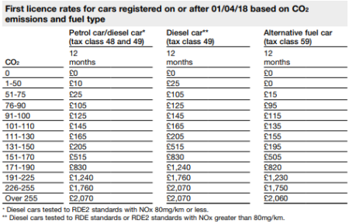

Air pollution and emissions from vehicles can have an impact of human health overtime which can cause concern for car manufacturers to ensure they are reducing any unnecessary harm to the public population.
“The average carbon dioxide (CO2) emissions from new passenger cars registered in the European Union (EU), Iceland, Norway and the United Kingdom (UK), increased in 2019, for the third consecutive year, rising to 122.4 grams of CO2 per kilometre.” Zero-emission cars are being encouraged to be sold more to reduce these CO2 emissions in our atmosphere, although the production will have to be considered as the target set for cars for 2021 is 95gCO2/km. (European-Environemt-Agency, 2021)
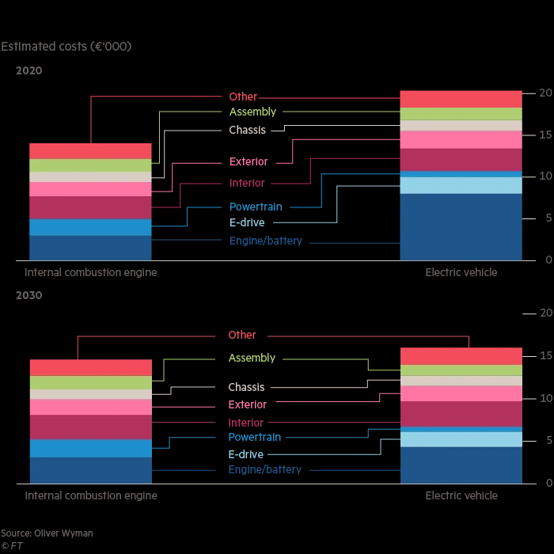
Electric cars are more expensive to manufacture than fuel filled vehicles which means it is important to look into the profit margin of manufacturing these vehicles.

As the graph shows, it looks as though electric vehicle cost will start to decrease by 2030 and the cost of the battery is set to almost halve by this time, and the cost of fuel filled vehicles is not set to change dramatically by 2030. (Miller, 2020)
The cost of production for an electric car is set to reduce by more than a fifth in 2030 to around £13,500 but that is still 9% higher than manufacturing a fuel filled vehicle. Larger battery factories are set to improve the economies of scale and therefore reach a technological breakthrough which studies have predicted. (Edelstein, 2020)
The main issue that was being created was the CO2 emissions causing pollution in the environment which if carried on for too long, would cause serious damage to the air and eventually begin to take effect on people’s health. Increasing tax of vehicles that produce a higher amount of emissions and introducing electric vehicles was the main target for all car manufacturers. The main producer is the car manufacturer, and the consumer is therefore the individual purchasing the vehicle, the CO2 emissions which enter the atmosphere as air pollution is a negative externality which had to be dealt with.
Marginal cost production is “The change in total production cost that comes from making or producing one additional unit. To calculate marginal cost, divide the change in production costs by the change in quantity.” The marginal costs can be shown by the use of the graphs below which represent the cost and quantity along with the costs and output which the car manufacturers have to consider when producing the vehicles and the environmental factors. (TUOVILA, 2021)
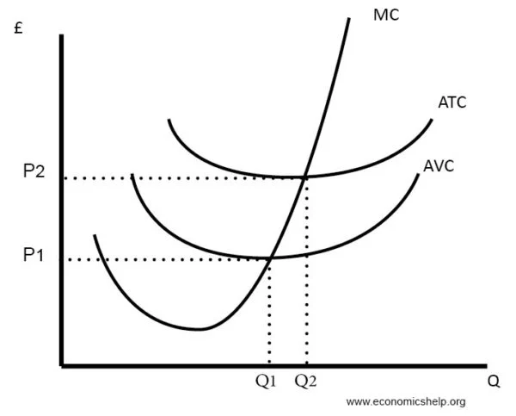
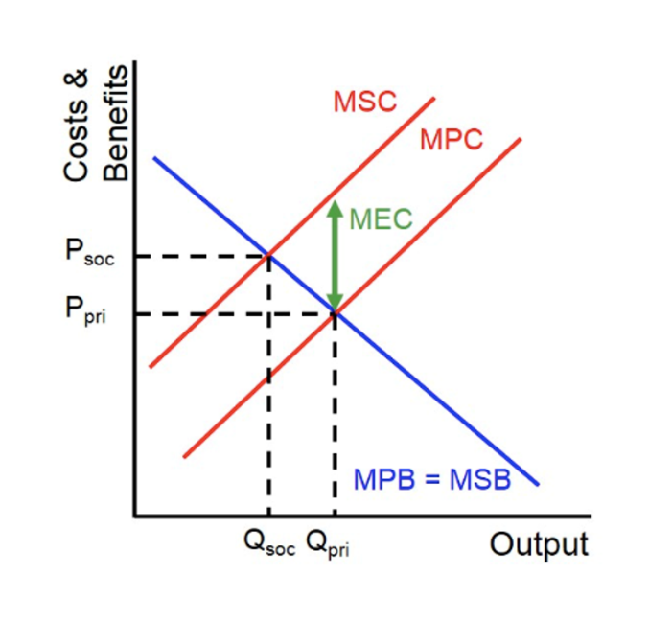

To ensure that the producer of the electric vehicles is creating a benefit for the environment rather than a cost, it is important to work out the specific guidelines in place and ensure that the cost of producing the vehicle is profitable for the company but also for the environmental CO2 levels and not creating a loss which could mean that the externality costs would not be factored in. The CO2 emissions from vehicles is measured specifically now and since 2020 new vehicles being produced must not limit a certain amount of CO2 production due to new guidelines in place. “95% of all new cars registered in 2020 must meet this 95g CO2 per km target, effectively giving a one-year phase in of the 2021 target.” Also, by 2025 these measurement will change again and must be reduced by a further 15% and then by another 25% in 2030 according to the 2021 baseline guidelines, 2030 is also the year that the government want to reduce fuel filled cars completely and only be manufacturing and producing electric vehicles for all. The UK have a higher mass of vehicles in production so therefore the UK target will be slightly higher before they can match the EU regulation levels, the UK work slightly differently than the EU countries as they have additional measures such as using biofuels at fuel stations and manual gear shifting which can improve driving efficiency. (GOV.uk, 2020)
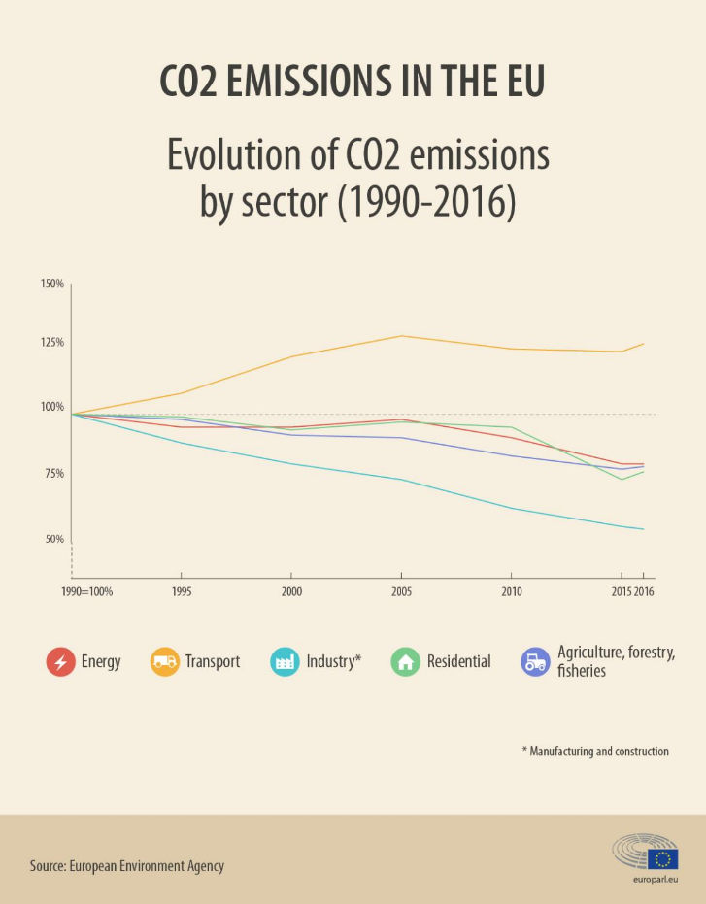
Car manufacturers had to make a change to the way they were producing their cars and the way the cars performed environmentally to stop them from failing specific guidelines. One study says that “battery production is associated with 56 to 494 kilograms of carbon dioxide per kilowatt-hour of battery capacity (kg CO2/kWh) for electric vehicles.” The life cycle of the battery also has to be considered with a careful life-cycle assessment to make any decisions about the carbon intensity of the battery. The lifecycle includes the number of emissions produced during the manufacturing, fuel cycle and general use of the vehicle, as mentioned previously the greenhouse gases and emissions produced when manufacturing the electric vehicles is a higher amount than a fuel filled vehicle as the lithium-ion batteries are extracted from earths rare materials and more energy is required. (Hall, 2018)
“Life cycle emissions include all emissions related to fuel and vehicle production, processing, distribution, use, and recycling/disposal.” (Energy.gov, 2020)


The use of cars in general produces a negative externality of consumption as the number of emissions produced leads to a negative effect on the third party and marginal social benefit being less than the marginal personal benefit as there are health risks from the CO2 to the general public and the over consumption of cars can be a massive issue, there is also a negative externality being created by the producers of the vehicles. (Mytutor.co.uk, 2020)
Taxation is a method that has been introduced to ensure people are paying for the number of emissions, “A pure private good is a good whose production and consumption neither harm nor benefit people uninvolved in its production or consumption.” It was important for car manufacturers to ensure they changed the amount of CO2 produced in the long term to create a more sustainable future for the next generation of vehicles produced so no further damage could be related to humans or the environment. (Mankiw, 2001)
Governments have been aware of emissions being produced and have had climate change in mind since the 1990s and have focused a lot more on fuel efficiency. A solution that has been in place in Central London since April 2019 is an ultra-low emission zone which applies to all vehicles as they are also introducing clean air zones to tackle air pollution, electric vehicles are the way forward when it comes to eliminating emissions as technology will soon be advanced enough to completely lower production emissions by 2030. (TheAA, 2020)

Conclusion
Overall, it is understood that the car production industry has improved over time as there have been government rules and regulations in place which have to be followed by everyone and ensure a sustainable future for the upcoming generation of people and for the vehicle industry. As previously discussed, it is in plan for the production of electric cars to increase dramatically and fuel filled car production to reduce to almost nothing to ensure the emissions get lowered to slow down climate change in our environment.
Electric car batteries are the main issues to consider but with the research and development of new technologies, it should not be long before we see a dramatic change in the CO2 emissions being created from car production. The industry was failing many years ago as the CO2 emissions were high and there was only tax being introduced to try and convince people to change to a better, more economical vehicle, now that electric vehicles have been introduced, they will make a big difference when analysing the facts and figures for climate change.
There will always be some sort of emissions being produced for the future as the technology is not readily available and it will take time to see a dramatic change. There are government plans in place in the UK to make sure that vehicles are not created a certain amount of CO2 per kilowatt hour by 2025. There is still a lot to consider when eliminating CO2 from vehicles as they are used every day by millions on a daily basis and the benefits should begin to outweigh the social costs.

References
Almond, J. (2021, March 31). Retrieved from www.motorbiscuit.com: https://www.motorbiscuit.com/do-electric-cars-produce-a-lot-of-carbon-dioxide-co2/
Edelstein, S. (2020, September 2). Retrieved from www.greencarreports.com: https://www.greencarreports.com/news/1129461_evs-cost-more-to-build-even-after-batteries-get-cheaper
Energy.gov. (2020, March). Retrieved from www.energy.gov: https://www.energy.gov/eere/electricvehicles/reducing-pollution-electric-vehicles
EPA. (2018, May 10). Retrieved from www.epa.gov: https://www.epa.gov/greenvehicles/greenhouse-gas-emissions-typical-passenger-vehicle#:~:text=typical%20passenger%20vehicle%3F-,A%20typical%20passenger%20vehicle%20emits%20about%204.6%20metric%20tons%20of,8%2C887%20grams%20of%20CO2.
European-Environemt-Agency. (2021, May). Retrieved from www.eea.europe.eu: https://www.eea.europa.eu/data-and-maps/indicators/average-co2-emissions-from-motor-vehicles/assessment-2
Gonçalves, A. (2018, September 25). Retrieved from www.youmatter.world/en: https://youmatter.world/en/are-electric-cars-eco-friendly-and-zero-emission-vehicles-26440/
GOV.uk. (2020, October 13). Retrieved from www.gov.uk: https://www.gov.uk/government/consultations/regulating-co2-emission-standards-for-new-cars-and-vans-after-transition/co2-emission-performance-standards-for-new-passenger-cars-and-light-commercial-vehicles#:~:text=95%25%20of%20all%20new%20cars,2%20per%20km
Greenage. (2018, June). Retrieved from www.thegreenage.co.uk: https://www.thegreenage.co.uk/tech/environmental-footprint-electric-cars/#:~:text=Scientific%20studies%20have%20shown%20that,than%20building%20a%20traditional%20car.&text=For%20larger%2C%20longer%2Drange%20EVs,much%20as%2068%20percent%20higher.
Greenpeace. (2020, September 11). Retrieved from www.greenpeace.org.uk: https://www.greenpeace.org.uk/news/electric-cars-greener-petrol-cars/?source=GA&subsource=GOFRNAOAGA034J&gclid=Cj0KCQjws-OEBhCkARIsAPhOkIbuq9ZD8GRUKctJmx-jZ_Cph2Tx7yQi5aUsTZQRLoyRKxLb-EZFr2AaApzGEALw_wcB
Haill, O. (2021, February 10). Retrieved from www.proactiveinvestors.co.uk: https://www.proactiveinvestors.co.uk/companies/news/940960/uk-looking-to-power-up-electric-car-battery-manufacturing-940960.html
Hall, D. (2018, February ). Retrieved from www.theicct.org: https://theicct.org/sites/default/files/publications/EV-life-cycle-GHG_ICCT-Briefing_09022018_vF.pdf
HAUSFATHER, Z. (2019, May 13). Retrieved from www.carbonbrief.org: https://www.carbonbrief.org/factcheck-how-electric-vehicles-help-to-tackle-climate-change
Lilly, C. (2021, April 9). Retrieved from www.nextgreencar.com: https://www.nextgreencar.com/electric-cars/statistics/
Mankiw, G. (2001). Retrieved from www,csun.edu: https://www.csun.edu/sites/default/files/micro9.pdf
Miller, J. (2020, August 31). Retrieved from www.ft.com: https://www.ft.com/content/a7e58ce7-4fab-424a-b1fa-f833ce948cb7
Mytutor.co.uk. (2020, December). Retrieved from www.mytutor.co.uk: https://www.mytutor.co.uk/answers/26694/IB/Economics/Explain-the-possible-negative-externalities-that-might-arise-from-the-increased-use-of-cars-10-marks/
SMMT. (2018, July). Retrieved from www.smmt.co.uk: https://www.smmt.co.uk/industry-topics/emissions/facts-and-figures/
TheAA. (2020, December). Retrieved from www.theaa.com: https://www.theaa.com/driving-advice/fuels-environment/reducing-air-pollution
TUOVILA, A. (2021, March 8). Retrieved from www.investopedia.com: https://www.investopedia.com/terms/m/marginalcostofproduction.asp

