  Component One:  What are the key skills required when working in the housekeeping team? 750 words (+/- 10%)  Contribution to Overall Module Assessment: 25% | Student No: | Roxana Ionica Macarie (2133909)
 | Module Title: | Operating Hotel Facilities
 | Module Code: | BMIH4006
 | Lecturer: | Lisa Bassler
Housekeeping includes ensuring that the hotel and its grounds are neat, tidy, and free of potential fire dangers by sweeping, shining, dusting, and collecting garbage (such as paper, cardboard, and food scraps). Regarding hotels, housekeeping is responsible for keeping the property pristine and always fostering a pleasant atmosphere (Mullins and Dossor, 2013). It necessitates paying close attention to particulars, including the workplace's overall layout, aisle marking, the sufficiency of storage facilities, and regular maintenance.
When it comes to the UK economy, the hotel business is massive. Various eating and drinking establishments are included. As a result, the hospitality workforce has been a major contributor to the country's economy and tourist sector. The hotel employs a sizable portion of the country, accounting for almost 10% of all jobs. With their spending, the estimated 40 million annual visitors help boost the economy by 3.6%, owing to the hospitality sector (Mordor Intelligence, 2022).
The hospitality business has a heightened need for housekeeping services. Those who work in the hospitality industry do a wide variety of tasks, including those related to the cleanliness and upkeep of guest rooms, common areas, and other facilities (Raghubalan and Raghubalan, 2015). Guests are made more at ease, the guests' health and safety are protected, the establishments' reputations are cultivated and maintained, excellent efficiency is achieved, and the relevant laws and regulations of the country are followed.
For this service, specific expertise is required. The ability to effectively manage customers and excellent communication skills for interacting with visitors and clients, as per Casado (2011). The hotel sector has a wide range of nationalities and backgrounds.
So, from what I have observed during my placement, hotels and staff need to be able to communicate and act warmly towards guests. Organizations like this rely significantly on effective communication.
It is crucial to communicate with and handle the customers' needs; therefore, mastering customer management abilities is essential (O’Fallon and Rutherford, 2019). Mainly while delivering room service. Because even the most minor missteps can significantly impact the guest's opinion of the hotel, staff must pay close attention to every detail when servicing rooms. Consequently, it is vital to recognize hotels and other hospitality facilities.
Time management is another crucial ability for a housekeeper to have from my point of view. No guest will accept late room service, and no restaurant will risk losing customers because of slow service (Jones, 2010). I think that efficient time management is crucial for housework. In that case, they need to be able to work together effectively. From what I have noticed at the hotel where I have done my placement, workers in the hospitality industry are expected to cooperate and work as a unit.
Skills in problem-solving are essential for resolving a wide range of real-world issues that may arise when working with customers. In my opinion,the best way to handle client complaints is for staff members to hone their problem-solving talents and use them appropriately. Problem-solving abilities, along with adaptability, are essential. Staff members must exercise extreme caution about time management and be able to think on their feet to solve the challenge presented by the guests (Tesone, 2009).
During my placement at the Premier Inn hotel, I also worked in the housekeeping department. My problem-solving, communication, and time-management abilities are above average, and my ability to empathize with guests has been praised. That is why I must focus on honing my time-management and people-management chops at work. Establishing and maintaining a positive brand image necessitates focusing on basic housekeeping and health and safety precautions (Wood, 2013). In my opinion, the hospitality company's reputation will improve if its employees adhere to essential health and safety standards and manage their time effectively. Guests in hotels generally have high standards for the condition of their bathrooms and other personal areas (Mullins and Dossor, 2013). Filthy restrooms might cause negative first impressions of a hotel or restaurant. I think housekeeping services should routinely inspect the restrooms' cleanliness. The issue may be remedied with careful consideration and a suitable substance for cleaning and sanitising the bathroom.
Because of how frequently people use them, banquet halls and conference centres must always be kept spotless. As I have seen first-hand, being unhygienic while performing a task at a conference or banquet may quickly escalate into a disaster (O’Fallon and Rutherford, 2019). Considering the high volume of people involved in planning, preparing for, and attending such events, the venue will inevitably become dirty and require periodic thorough cleaning and upkeep. At the Premier Inn, the restrooms and the lounge are the most heavily trafficked parts of the venue. I need to be more watchful and adaptable and better manage my time to keep the place clean.
Word Count | 783

Component Two:

Problem | Why did it happen? | What are you going to do? | How will you prevent this from happening in the future? | What measures would you introduce to improve team effectiveness?
Being in an unsanitary and uncomfortable environment. | An unpleasant stench is coming from a distant area of the room, as Hu and Bose (2019) reported, indicating that a necessary part of the cleaning procedure was overlooked. | Several experts in the fields of hospitality management and organizational behaviour, such as Mullins and Dossor (2013) and Raghubalan and Raghubalan (2016), advise making use of housekeeping resources, apologizing for any inconvenience, and making use of existing cleaning tools to resolve the issue as quickly as possible. | Dinçer and Alrawadieh (2017) point out that utilizing various coloured towels to clean different sections of a room should be adequate. It is also crucial to utilize the appropriate tools for the job and do so in the correct sequence. | Sahin and Kitapci (2017) recommend introducing new tools for specific aspects of room service, such as mops for floor cleaning and disinfectant mixed with a pleasant fragrance to enhance guests' first impression of the room.  Bridger (2018) and Leiter and Bakker (2010) highlight the importance of employee involvement in keeping the room service clean and high-quality.
The place is littered with dust rags. | To begin with, the housekeeping staff was unprepared for the cleaning session since they raced through it and did not do an excellent job. According to (Rutherford and O'Fallon, 2010) | Upon receiving a complaint, housekeeping is expected to employ appropriate cleaning equipment, such as vacuum cleaners, to remove dust from the room and provide additional services. I am referring to (Rutherford and O’Fallon, 2010). | Microfiber towels, preferable to typical cleaning rags because they capture dust rather than merely spread it, may help prevent such incidents. Another alternative is to use a vacuum to remove debris from the floor and any nooks and crannies in the room. See also (Rutherford and O'Fallon, 2010). | If future incidents like this are to be avoided, supervisors must be taught the importance of paying great attention to details during construction inspections.  Housekeepers need to collaborate to clean a large number of rooms effectively. Cleaning schedules at hotels should be coordinated by management to accommodate guests' arrival and departure timings (Rutherford and O'Fallon,2010)
The room's flooring is dirty. | Some room areas may be overlooked, and faulty equipment may be employed throughout cleaning (Jones, 2018). | If a visitor complains about the floor or carpet being unclean, I should immediately have a co-worker clean it up. Communicating with guests after cleaning to let them know what was done demonstrates care and a desire to improve (Smith, 2020). | Implementing regular cleaning schedules, using floor mats and shoe coverings, and instructing the housekeeping staff on the significance of cleanliness and hygiene are all required to prevent similar situations in the future (Brown, 2017). | The number of complaints and employee satisfaction with cleanliness may be used to gauge the preventative measures' success. Carpet and mat cleaning more regularly and sprucing up the space are also reasonable preventative measures (Johnson, 2019).
A lack of attention to bathroom hygiene | One significant way more hotel cleaning personnel may positively affect guests' stays is in the area of restroom access. Guest restrooms must be cleaned regularly, but this may become a burden if there are not enough educated and equipped staff members to handle the volume of visitors. | To make visitors feel heard and appreciated, it is essential to address their concerns as soon as possible. If hotels respond quickly, they may stop the situation from worsening and save face with their customers. It is also crucial to check in with the visitor after that to see whether the issue has been resolved to their satisfaction and to indicate that hotels value their feedback. | Preventing problems from occurring in the first place is an ideal scenario. All hotel toilets should be cleaned and maintained regularly to lessen the chances of problems and keep them in excellent working order. The cleaning staff's efficiency and effectiveness may be enhanced by providing them with the tools and training to spot and fix problems as soon as they arise. | Regarding the hospitality industry, nothing is more important than the happiness of the company's paying consumers. Customers with a good experience are likelier to return and recommend their business to others. However, complying with all rules while consistently providing high-quality service takes time and effort. It requires a commitment to constant improvement.  Regular inspections are one approach to finding these issues and fixing them. Guests' pleasure may be restored more quickly if the hotel can identify problems and implement solutions. Comparing the hotel against others in the area might give hotels an idea of its strengths and areas for growth.  Previous guests' feedback is just as crucial for improving the experience of future guests. Guests' satisfaction with their stay may be gauged via evaluations and questionnaires. If this data is utilized to make changes and improvements, future visitors will have a much better experience.  However, more than just modifying things is required. Keeping everything in order is essential to make a good impression on guests. Employees need to be taught the proper way to clean and be held to a very high level. By using key performance indicators and checklists, we can ensure that the same standard of cleanliness is always maintained.  It takes a commitment to ongoing innovation and refinement to stay in line with industry standards and provide a better experience for visitors. Using KPIs and checklists to establish cleanliness standards and conducting regular inspections may improve the hotel's position in the industry and the level of happiness among its patrons.

Component Three:

Introduction:
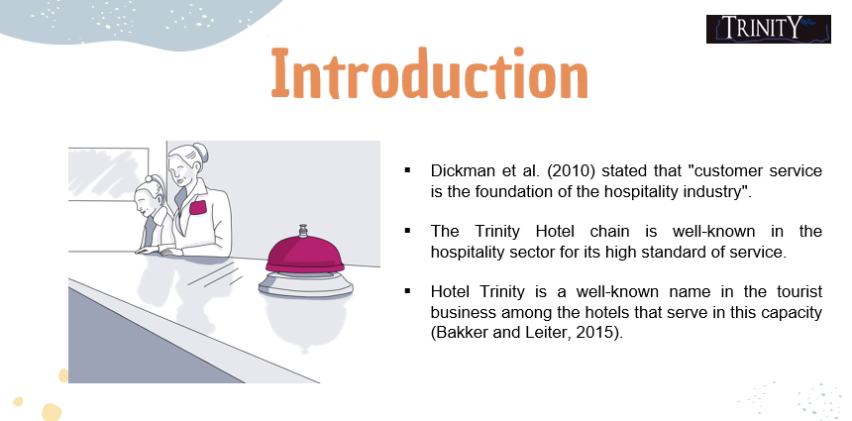
Training Notes: Dickman et al. (2010) stated that "customer service is the foundation of the hospitality industry". The Trinity Hotel chain is well-known in the hospitality sector for its high standard of service. Since the hotel's many departments provide such a wide variety of services, they need committed employees who are committed to constant growth and development. As the Housekeeping Manager, I have taken the concerns of first-time customers and used them to create a training presentation for my staff. Hotel Trinity is a well-known name in the tourist business among the hotels that serve in this capacity (Bakker and Leiter, 2015).
Concept of Tourism and Hospitality:
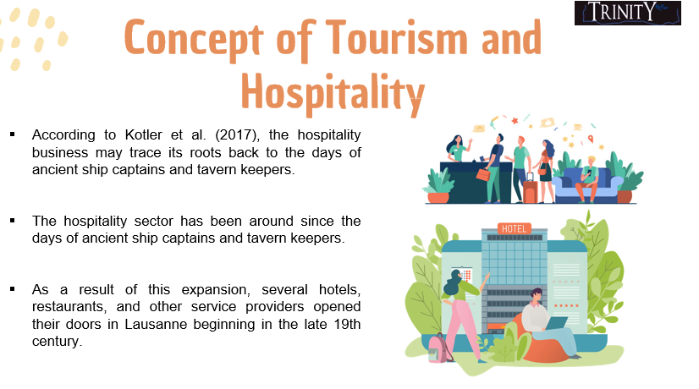
Training Notes: According to Kotler et al. (2017), the hospitality business may trace its roots back to the days of ancient ship captains and tavern keepers. The hospitality sector has been around since the days of ancient ship captains and tavern keepers. Switzerland was one of the first European nations to provide tourists with specialised lodgings and entertainment options typical of the modern economy. In the nineteenth century, Europe saw a rise in wealthy tourists who travelled there to enjoy the outdoors and learn about the local culture. As a result of this expansion, several hotels, restaurants, and other service providers opened their doors in Lausanne beginning in the late 19th century.
Brand standards of the Trinity Hotel
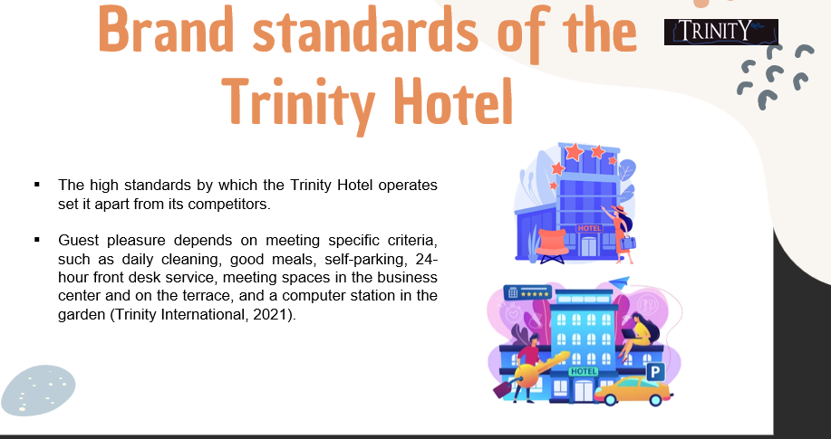
Training Notes: The high standards by which the Trinity Hotel operates set it apart from its competitors. Guest pleasure depends on meeting specific criteria, such as daily cleaning, good meals, self-parking, 24-hour front desk service, meeting spaces in the business centre and on the terrace, and a computer station in the garden (Trinity International, 2021).
Privacy and Procedure of the Trinity Hotel
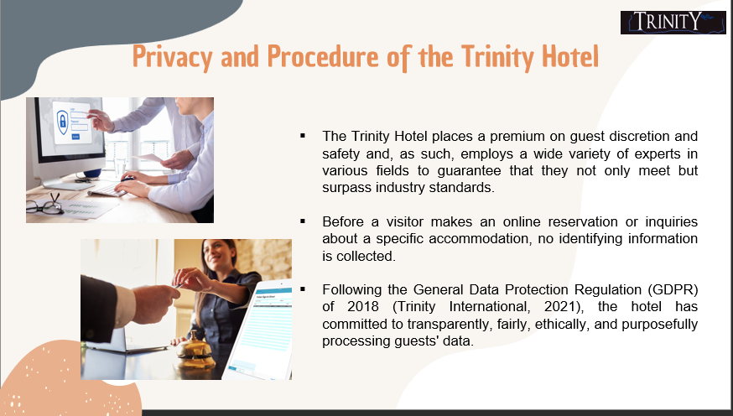
Training Notes: The Trinity Hotel places a premium on guest discretion and safety and, as such, employs a wide variety of experts in various fields to guarantee that they not only meet but surpass industry standards. Before a visitor makes an online reservation or inquiries about a specific accommodation, no identifying information is collected. In the past, they used anonymous data to learn about website visitors' habits. To assist commercial transactions, they only gather personal data like email addresses, newsletter signups, and answers to questions posed in pre-formatted emails. Following the General Data Protection Regulation (GDPR) of 2018 (Trinity International, 2021), the hotel has committed to transparently, fairly, ethically, and purposefully processing guests' data.
Common Safety and security Issue
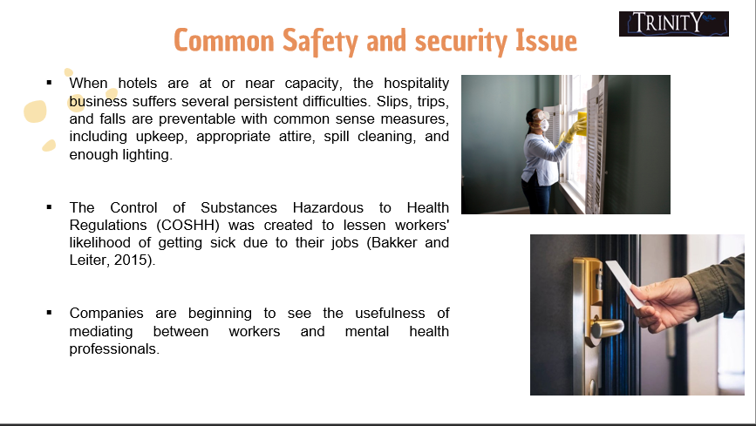
Training Notes: When hotels are at or near capacity, the hospitality business suffers several persistent difficulties. Slips, trips, and falls are preventable with common sense measures, including upkeep, appropriate attire, spill cleaning, and enough lighting. Heavy lifting is a common need in the service business, and improper technique may cause serious injury to the spine and other nerves. Workers dealing with hazardous substances are obligated to follow protocols and wear PPE. The Control of Substances Hazardous to Health Regulations (COSHH) was created to lessen workers' likelihood of getting sick due to their jobs (Bakker and Leiter, 2015). Companies are beginning to see the usefulness of mediating between workers and mental health professionals. Workers using stoves containing flammable chemicals need to be aware of fire hazards and the proper procedures for evacuating the building in an emergency.

Concept of Employee Engagement
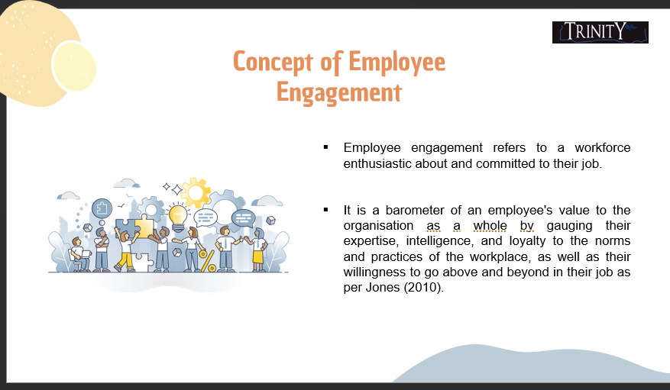
Training Notes: Employee engagement refers to a workforce enthusiastic about and committed to their job. The company's culture and values are reflected and shaped by this practice. It is a barometer of an employee's value to the organisation as a whole by gauging their expertise, intelligence, and loyalty to the norms and practices of the workplace, as well as their willingness to go above and beyond in their job as per Jones (2010).
Employee Engagement Model
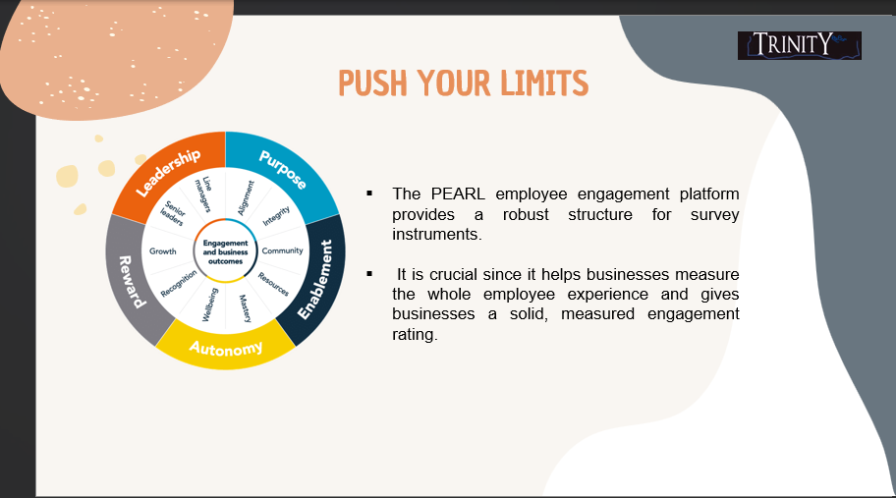
Training Notes: The goal of an employee engagement model is to help workers feel more invested in the company's success and less stressed about dealing with personal issues that might influence their job performance. The approach prioritises making the workplace pleasant, encouraging personal and professional development, praising and rewarding hard work, and encouraging two-way communication and feedback. Businesses may boost productivity, morale, and work satisfaction by emphasising employee involvement. As Ferdinand and Kitchin (2017) argued, employee involvement is crucial since it reflects and influences the values and culture of an organisation. It is a gauge of how well-versed, intelligent, and dedicated a person is to adhering to the norms and practices of the workplace.
Importance of Employee Engagement
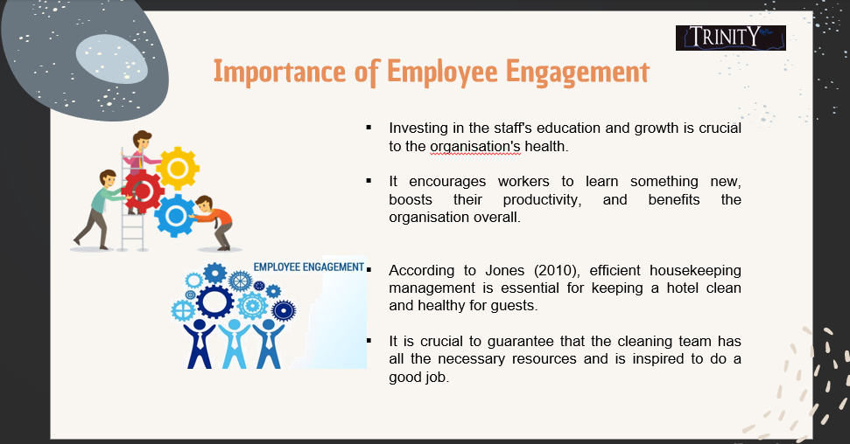
Training Notes: Investing in the staff's education and growth is crucial to the organisation's health. It encourages workers to learn something new, boosts their productivity, and benefits the organisation overall. By investing in their future via training, companies may increase employee enthusiasm. It can boost morale, promote work satisfaction, and decrease turnover. Better customer service and improved revenues are expected outcomes for businesses that invest heavily in their employees' learning and growth opportunities. According to Jones (2010), efficient housekeeping management is essential for keeping a hotel clean and healthy for guests. It is crucial to guarantee that the cleaning team has all the necessary resources and is inspired to do a good job.
Recommendation to the GM of the Trinity Hotel
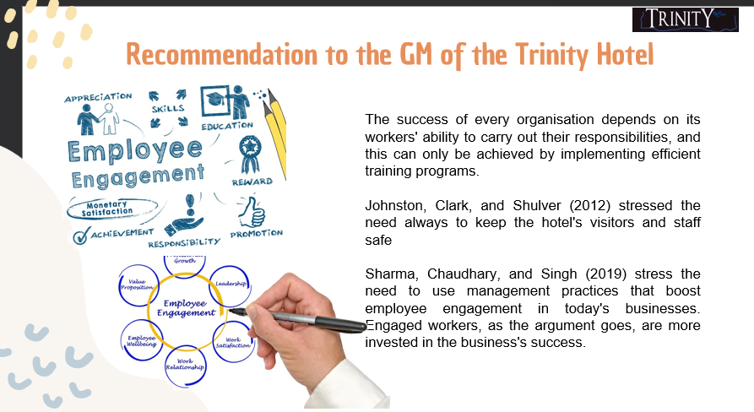
Training Notes: The success of every organisation depends on its workers' ability to carry out their responsibilities, and this can only be achieved by implementing efficient training programs. These approaches must be modified according to the nature of the company and its workforce. On-the-job instruction, electronic learning modules, live seminars and workshops, and mentorship and coaching schemes are just a few of the methods that have proven successful. Training effectiveness may be ensured, and new abilities can be reinforced via post-training feedback and follow-up. Johnston, Clark, and Shulver (2012) stressed the need always to keep the hotel's visitors and staff safe. They recommend keeping the area well-maintained, wearing appropriate footwear, cleaning up spills, and having sufficient illumination to reduce the likelihood of trips and falls. Sharma, Chaudhary, and Singh (2019) stress the need to use management practices that boost employee engagement in today's businesses. Engaged workers, as the argument goes, are more invested in the business's success.
Conclusion
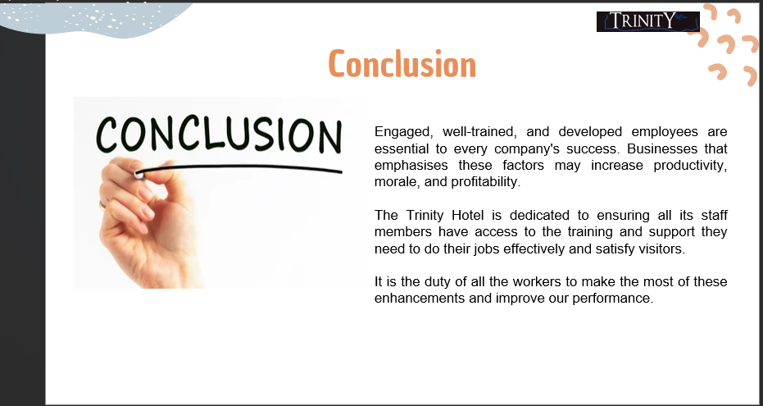
Training Notes: Engaged, well-trained, and developed employees are essential to every company's success. Businesses that emphasise these factors may increase productivity, morale, and profitability. The Trinity Hotel is dedicated to ensuring all its staff members have access to the training and support they need to do their jobs effectively and satisfy visitors. It is the duty of all the workers to make the most of these enhancements and improve our performance.

References

Bakker, A.B. and Leiter, M.P. (2015) Work engagement: A handbook of essential theory and research. Hove England, England: Psychology Press.
Bakker, A. B., & Demerouti, E. (2008). Towards a model of work engagement. Career development international, 13(3), 209-223.
Bridger, E. (2018). Employee engagement: A practical introduction. London: CIPD and Kogan Page.
Brown, L. (2017). Housekeeping practices in the hospitality industry. Journal of Hospitality and Tourism Management, pp. 33, 44–51.
Casado, M.A. (2011). Housekeeping Management, 2nd Edition. Wiley Global Education.
Dinçer, F., and Alrawadieh, Z. (2017). An analysis of hotel housekeeping work: The case of five hotels in Ankara, Turkey. Journal of Tourism and Hospitality Management, 5(4), 91-104.
Dickman, M., Lee-Ross, D., Lomanno, M., and Harrington, R. J. (2010). The Routledge companion to the hospitality industry. Routledge.
Ferdinand, N. and Kitchin, P. (2017) Events Management - An International Approach. 2nd ed. London: SAGE Publications Ltd.
Harter, J. K., Schmidt, F. L., & Hayes, T. L. (2002). Business-unit-level relationship between employee satisfaction, employee engagement, and business outcomes: a meta-analysis. Journal of applied psychology, 87(2), 268.
Hu, X., and Bose, S. (2019). Investigation of a cleaning process to reduce microbial contamination in a hospital room. American Journal of Infection Control, 47(3), 261–266.
Jones, T.J.A. (2010). Professional Management of Housekeeping Operations. Hoboken, N.J.: John Wiley & Sons.
Johnson, R. (2019). Effective hotel housekeeping management: A comprehensive guide. Cognella.
Jones, P. (2018). Housekeeping management. Routledge.
Johnston, R., Clark, G. and Shulver, M. (2012) Service Operations Management. London: Pearson.
Jones, T. (2010) Professional Management of Housekeeping Operations. London: Wiley.
Kotler, P., Bowen, J. T., Makens, J. C., and Baloglu, S. (2017). Marketing for hospitality and tourism. Pearson.
Leiter, M. P., and Bakker, A. B. (2010). Work engagement: A handbook of essential theory and research. Hove, England: Psychology Press.
Mordor Intelligence (2022). Hospitality Industry in the United Kingdom - Growth, Trends, and Forecasts (2020 - 2025). [online] www.mordorintelligence.com. Available at: https://www.mordorintelligence.com/industry-reports/hospitality-industry-in-the-united-kingdom [Accessed 11 May 2023].
Mullins, L.J. and Dossor, P. (2013). Hospitality Management and Organisational Behaviour. Harlow: Pearson.
O’Fallon, M.J. and Rutherford, D.G. (2019). Hotel Management and Operations. Hoboken, N.J.: Wiley.
Raghubalan, G. and Raghubalan, S. (2015). Hotel Housekeeping: Operations and Management. New Delhi, India: Oxford University Press.
Raghubalan, G., and Raghubalan, S. (2016). Hotel Housekeeping - Operations and Management. India: Oxford University Press.
Rutherford, D. G., and O'Fallon, M. J. (2010). Hotel Management and Operations. John Wiley & Sons.
Sahin, S., and Kitapci, O. (2017). A holistic approach to housekeeping management: A case study of a resort hotel. Journal of Hospitality and Tourism Management, 32, 71-80.
Smith, J. (2020). Effective hotel management techniques to improve guest satisfaction. International Journal of Hospitality Management, p. 91, 102670.
Sharma, N., Chaudhary, N. and Singh, V. (2019) Management Techniques for Employee Engagement in Contemporary Organisations. Hershey, Pennsylvania: IGI Global.
Tesone, D.V. (2009). Principles of Management for the Hospitality Industry. Oxford: Butterworth-Heinemann.
Trinity International. (2021). Courtyard by Trinity: Designing a superior guest experience. Retrieved from https://faculty.wharton.upenn.edu/wp-content/uploads/2012/04/8902_Courtyard_by_Trinity_Designing_a.pdf
Trinity International. (2021). Trinity International’s Commitment to Privacy. Retrieved from https://www.Trinity.com/about/privacy.mi
Walker, R. (2018). Health and safety management in the hospitality industry. Routledge.
Wood, R.C. (2013). Key Concepts in Hospitality Management. SAGE.

